NEALT membership report October 2019

* By 2 October 2019, NEALT has 176 registered members from 20 countries
* Distribution of members by country:

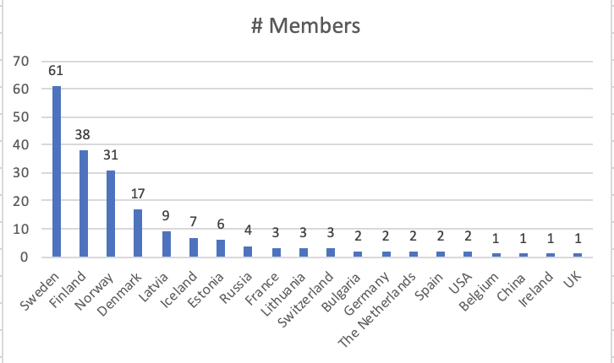

* + Sweden: 52
  + Finland: 35
  + Norway: 27
  + Denmark: 16
  + Latvia: 8
  + Iceland: 6
  + Estonia: 6
  + Russia: 3
  + France: 3
  + Lithuania: 3
  + Switzerland: 3
  + Bulgaria: 2
  + Germany: 2
  + The Netherlands: 2
  + Spain: 2
  + USA: 2
  + Belgium: 1
  + China: 1
  + Ireland: 1
  + UK: 1