**ASSIGNMENT 1 FRONT SHEET**

|  |  |  |  |
| --- | --- | --- | --- |
| **Qualification** | **TEC Level 5 HND Diploma in Computing** | | |
| **Unit number and title** | **Unit 04: Database Design & Development** | | |
| **Submission date** |  | **Date Received 1st submission** |  |
| **Re-submission Date** |  | **Date Received 2nd submission** |  |
| **Student Name** |  | **Student ID** |  |
| **Class** |  | **Assessor name** |  |
| **Student declaration**  I certify that the assignment submission is entirely my own work and I fully understand the consequences of plagiarism. I understand that making a false declaration is a form of malpractice. | | | |
|  |  | **Student’s signature** |  |

**Grading grid**

|  |  |  |
| --- | --- | --- |
| P1 | M1 | D1 |
|  |  |  |

|  |  |  |
| --- | --- | --- |
| **❒ Summative Feedback: ❒ Resubmission Feedback:** | | |
| **Grade:** | **Assessor Signature:** | **Date:** |
| **Signature & Date:** | | |

I. Introduction

II. Content

1. Database design

- Database is an organized collection of data that is usually accessed from a computer system or exists as a file in a database management system. Database can also be stored on memory devices such as memory cards, hard disks, CDs, etc.

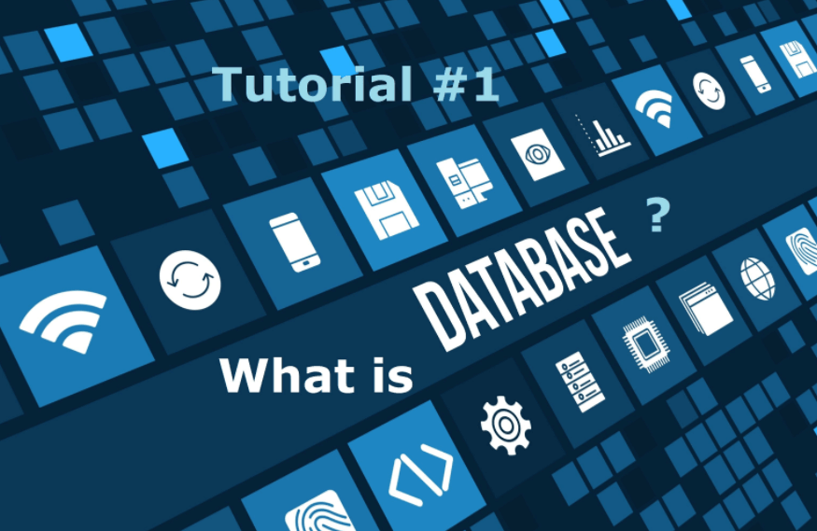

- The wrongly designed database makes it easier to create, update and exploit information. The data will be updated regularly and will not be duplicated at all. Using a database helps to create more professional products, systematically store them, and easily manage them.



We have some commonly used databases:

#1. MySQL. 

#2. MariaDB. 

#3. Oracle. 

#5. PostgreSQL. 

#6. Microsoft SQL Server. 

2. Scenario of the chosen system

- Provide a choice scenario for system design

Currently, FPT is in need of exam management software to score students' test scores. Examination management database includes the following information:

+ Students include information such as: StudentID, StudentName, Class.

+ The test includes information such as: StudentID, StudentName, Point, Subject, Class

+ Teachers include information such as: TeacherID, TestID, Class

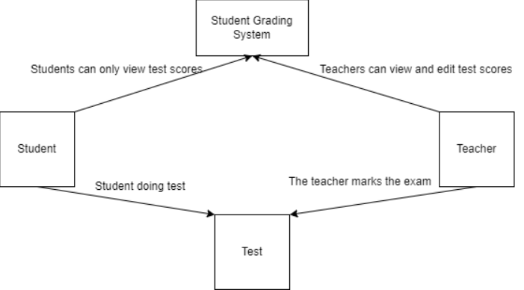

Functions corresponding to each user:

Students can take the test and view the test scores in the grading system.

Teachers can grade students' tests, edit and view student test scores.

3. Database Design

- Building Entities

|  |  |  |  |
| --- | --- | --- | --- |
| Entity | Description of  Entity | Attribute | Description of  Attribute |
| Students | All students in  website | StudentID | Primary key. It is  a unique  identifier for  each student in  the application |
| StudentName | Name of the student |
| Class | Class of the student |
| Teacher | The teacher marks the students' exams | TeacherID | Primary key. It is  a unique  identifier for  each Teacher in  the application |
| Class | Class of the Teacher |
| TestID | TestID to distinguish the tests from each other |
| Test | The test is the student's work | TestID | Primary key. It is  a unique  identifier for  each test in  the application |
| StudentName | Name of the student do test |
| Class | Class of the student do test |
| StudentID | StudentID of the student do test |
| Point | point of the test |
| Subject | Suject of the test |

Relationships between objects:

- 1 student has many test

- 1 test is belongs to 1 student-

- One test can be graded by multiple teachers

- 1 teacher can have more than one teacher grader

- Multiple teachers can grade multiple tests

- 1 test can be graded by multiple teachers

