**ASSIGNMENT 2 FRONT SHEET**

|  |  |  |  |
| --- | --- | --- | --- |
| **Qualification** | **TEC Level 5 HND Diploma in Computing** | | |
| **Unit number and title** | **Unit 04: Database Design & Development** | | |
| **Submission date** |  | **Date Received 1st submission** |  |
| **Re-submission Date** |  | **Date Received 2nd submission** |  |
| **Student Name** |  | **Student ID** |  |
| **Class** |  | **Assessor name** |  |
| **Student declaration**  I certify that the assignment submission is entirely my own work and I fully understand the consequences of plagiarism. I understand that making a false declaration is a form of malpractice. | | | |
|  |  | **Student’s signature** |  |

**Grading grid**

|  |  |  |
| --- | --- | --- |
| P1 | M1 | D1 |
|  |  |  |

|  |  |  |
| --- | --- | --- |
| **❒ Summative Feedback: ❒ Resubmission Feedback:** | | |
| **Grade:** | **Assessor Signature:** | **Date:** |
| **Signature & Date:** | | |

III. Implement a query language into the relational database system (P3)

1.1. Insert

- When we want to add new values into the table column, we can use this query.

- The common syntax is: INSERT INTO (table name) VALUES (value 1, value2, value 3…)

For example:

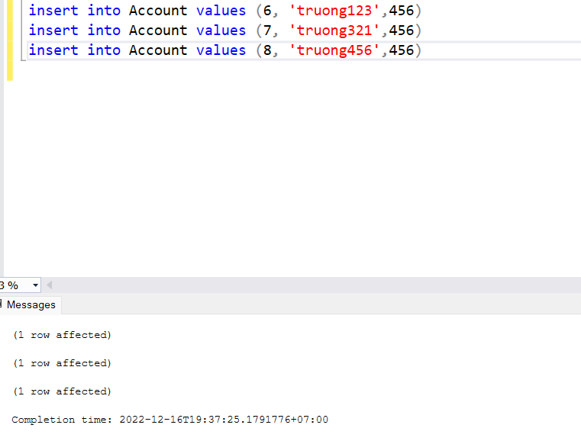

1.2. Update

- When you want to modify a new value in a table column, you can use this command query.

The usual syntax is:

UPDATE table_name

SET column1 = value1, column2 = value2...., columnN = valueN

WHERE [condition];

For example:

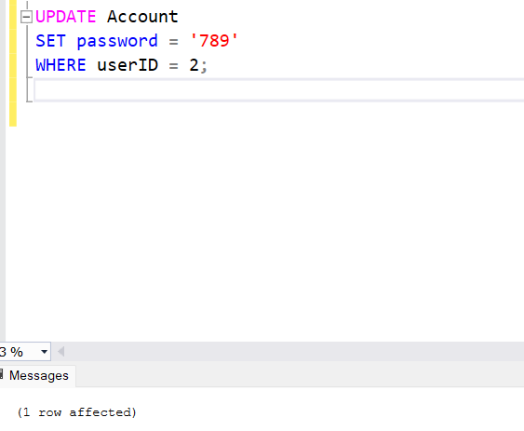

1.3. Delete

- When you want to delete the value of 1 row of the table, you can use this query command.

The usual syntax is:

DELETE FROM table_name

WHERE [condition];

For example:

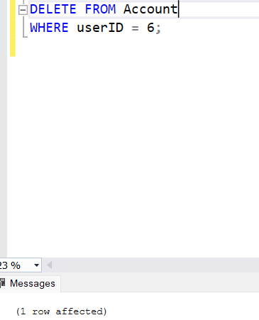

1.4. Select

- When you want to get data from a certain table, you can use this command to query.

The usual syntax is:

SELECT column1, column2, columnN FROM table_name;

or If you want to get all the fields available in the table then you can use the following syntax.

SELECT * FROM table_name;

For example:

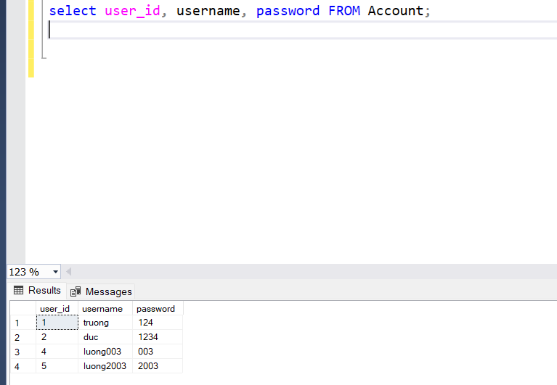

1.5. Join

Join is used to get data from multiple tables, occurs when 2 or more tables are joined together in one SQL statement.

The usual syntax is:

SELECT cot

FROM table1

INNER JOIN table2

ON table1.colunm = table2.colunm;

For example:

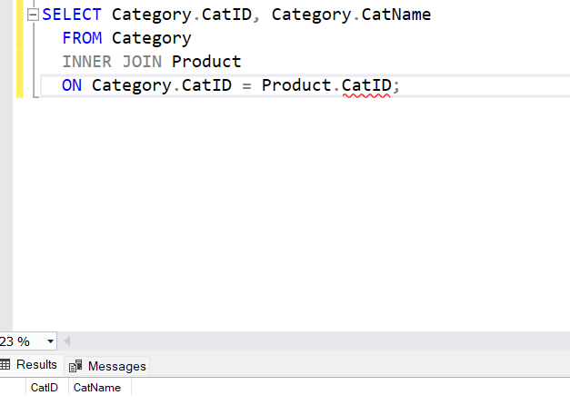

1.6. SELECT MAX

When we want to find the maximum value in a certain column, you can use this command to query.

The usual syntax is:

SELECT MAX(colunm)

FROM table

[WHERE condition];

For example:

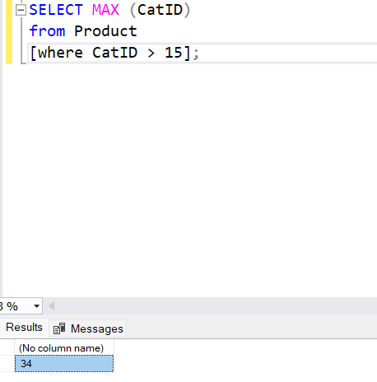

1.7 COUNT

When we want to count the number of records in a data table. Then we will use the query.

The usual syntax is:

SELECT COUNT(colunm)

FROM table

[WHERE condition];

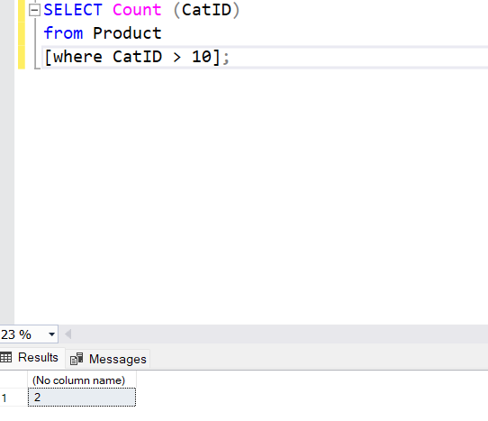

IV. Test the system against user and system requirements. = test plan và test cases (P4)

1. Test plan

Test

case

Content

Times

Expected result

1

Insert data into the table

1

Success

2

Update date into the table

1

Success

3

Delete data into the table

1

Success

4

Select data into the table

1

Success

Test

case

Content

Times

Expected result

1

Insert data into the table

1

Success

2

Update date into the table

1

Success

3

Delete data into the table

1

Success

4

Select data into the table

1

Success

Test

case

Content

Times

Expected result

1

Insert data into the table

1

Success

2

Update date into the table

1

Success

3

Delete data into the table

1

Success

4

Select data into the table

1

Success

Test

case

Content

Times

Expected result

1

Insert data into the table

1

Success

2

Update date into the table

1

Success

3

Delete data into the table

1

Success

4

Select data into the table

1

Success

Test

case

Content

Times

Expected result

1

Insert data into the table

1

Success

2

Update date into the table

1

Success

3

Delete data into the table

1

Success

4

Select data into the table

1

Success

est

case

Content

Times

Expected result

1

Insert data into the table

1

Success

2

Update date into the table

1

Success

3

Delete data into the table

1

Success

4

Select data into the table

1

|  |  |  |  |
| --- | --- | --- | --- |
| Test No | Content | Time | Expected result |
| 1 | Insert data into the table | 1 | Success |
| 2 | Update date into the table | 1 | Success |
| 3 | Delete data into the table | 1 | Success |
| 4 | Select data into the table | 1 | Success |

2. Test case

|  |  |  |  |  |  |  |
| --- | --- | --- | --- | --- | --- | --- |
| Test No | Purpose | Steps | Data | Expected result | Actual result | Status |
| 1 |  |  |  |  |  |  |
| 2 |  |  |  |  |  |  |
| 3 |  |  |  |  |  |  |
| 4 |  |  |  |  |  |  |