1. Plugin Camera to PC(OS: windows), and then run USBDownloadTool.exe

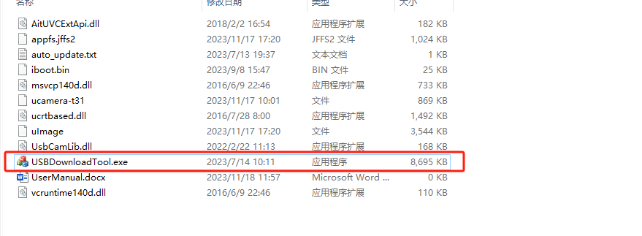

1. Check current firmware version

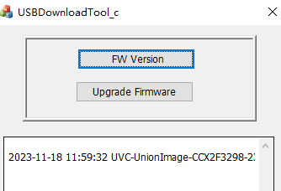

1. Click Upgrade Firmware and wait about 10 seconds, It start to download firmware

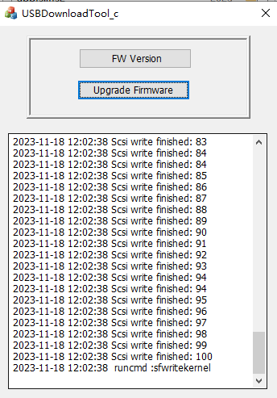

1. Waiting about 2 minute for downloading to end

