**Tasks**

i) **Complete the diagram so that it correctly represents the scenario described above.**

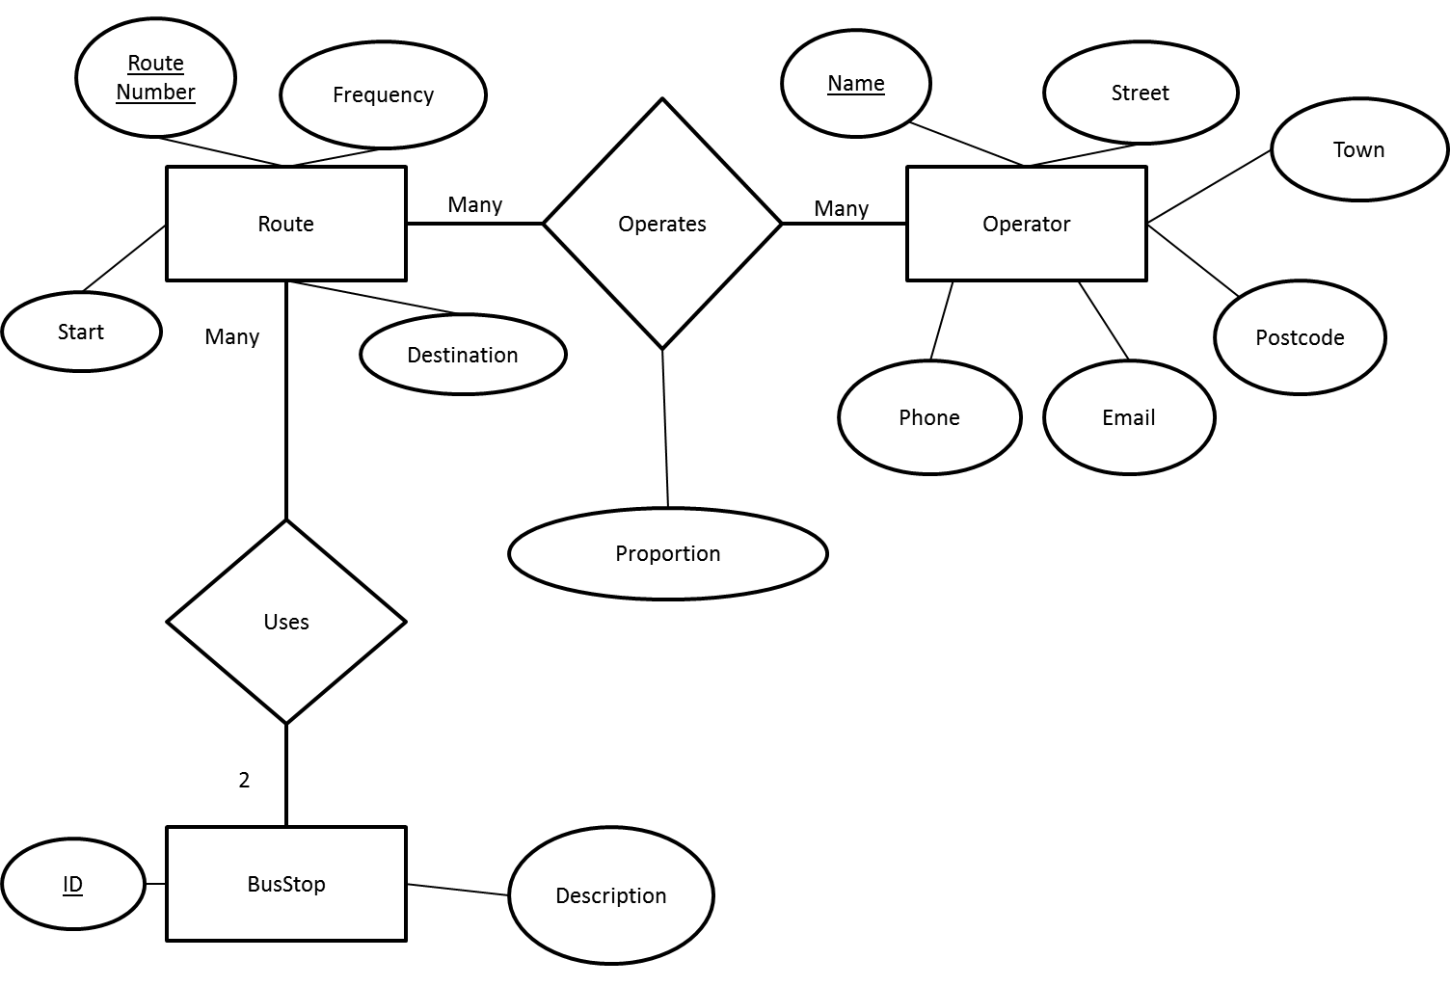

ii) **Decide on the database tables you will need to implement the database, using the E-R diagram to help you. Create ALL of these tables in MySQL. In your answer document, you MUST show the CREATE TABLE statements you use. Populate your database with the sample data given at the end of this assignment.**

CREATE TABLE `Operator` (

`Name` varchar(25) NOT NULL,

`Street` varchar(20) NOT NULL,

`Town` varchar(15) NOT NULL,

`Postcode` varchar(9) NOT NULL,

`email` varchar(35) NOT NULL,

`Phone` varchar(13) NOT NULL,

PRIMARY KEY (`Name`)

) ENGINE=InnoDB DEFAULT CHARSET=latin1$$

CREATE TABLE `Route` (

`RouteNumber` varchar(11) NOT NULL,

`Start` varchar(4) NOT NULL,

`Destination` varchar(4) NOT NULL,

`Frequency` int(11) NOT NULL,

PRIMARY KEY (`RouteNumber`),

KEY `Start` (`Start`),

KEY `Destination` (`Destination`),

CONSTRAINT `Start` FOREIGN KEY (`Start`) REFERENCES `BusStop` (`ID`) ON DELETE NO ACTION ON UPDATE NO ACTION,

CONSTRAINT `Destination` FOREIGN KEY (`Destination`) REFERENCES `BusStop` (`ID`) ON DELETE NO ACTION ON UPDATE NO ACTION

) ENGINE=InnoDB DEFAULT CHARSET=latin1$$

CREATE TABLE `BusStop` (

`ID` varchar(4) NOT NULL,

`Description` varchar(25) NOT NULL,

PRIMARY KEY (`ID`)

) ENGINE=InnoDB DEFAULT CHARSET=latin1$$

CREATE TABLE `Operates` (

`RouteNumber` varchar(11) NOT NULL,

`Operator` varchar(25) NOT NULL,

`Proportion` int(11) NOT NULL,

PRIMARY KEY (`RouteNumber`,`Operator`),

KEY `Operator` (`Operator`),

KEY `Route_Number` (`RouteNumber`),

CONSTRAINT `Route_Number` FOREIGN KEY (`RouteNumber`) REFERENCES `Route` (`RouteNumber`) ON DELETE NO ACTION ON UPDATE NO ACTION,

CONSTRAINT `Operator` FOREIGN KEY (`Operator`) REFERENCES `Operator` (`Name`) ON DELETE NO ACTION ON UPDATE NO ACTION

) ENGINE=InnoDB DEFAULT CHARSET=latin1$$

iii) **Give the SQL for the following and show screenshots of the results for each query.**

1. **What is the location of the bus stop with the highest stop ID?**

SELECT Description

FROM BusStop

WHERE BusStop.ID = (SELECT MAX(BusStop.ID) FROM BusStop);

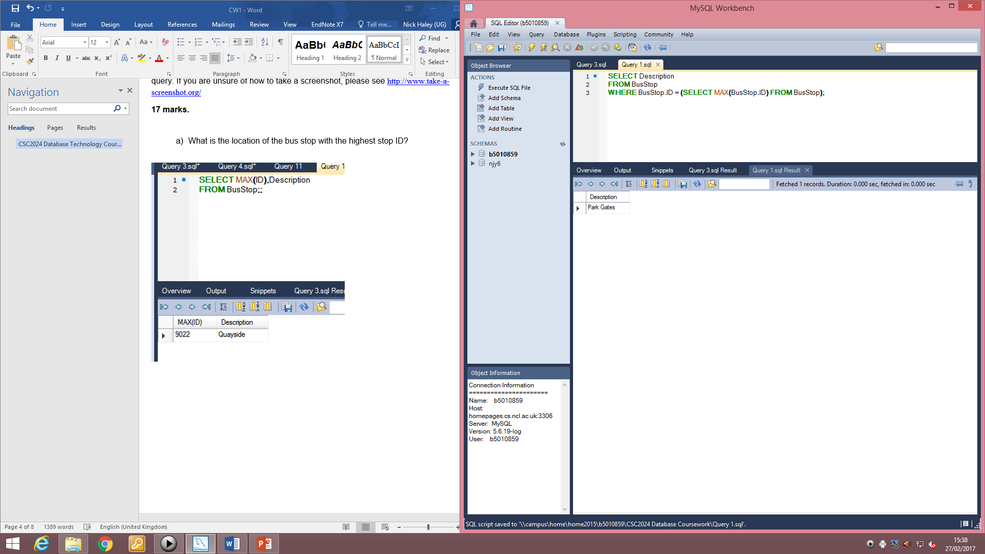

1. **List as briefly as you can, the name and phone number of the bus operators serving the Shopping Centre.**

SELECT DISTINCT O.Name, O.Phone

FROM Operator O, Route R, Operates OP

WHERE R.RouteNumber = OP.RouteNumber AND OP.Operator = O.Name AND (R.Start = "7628" OR R.Destination = "7628");

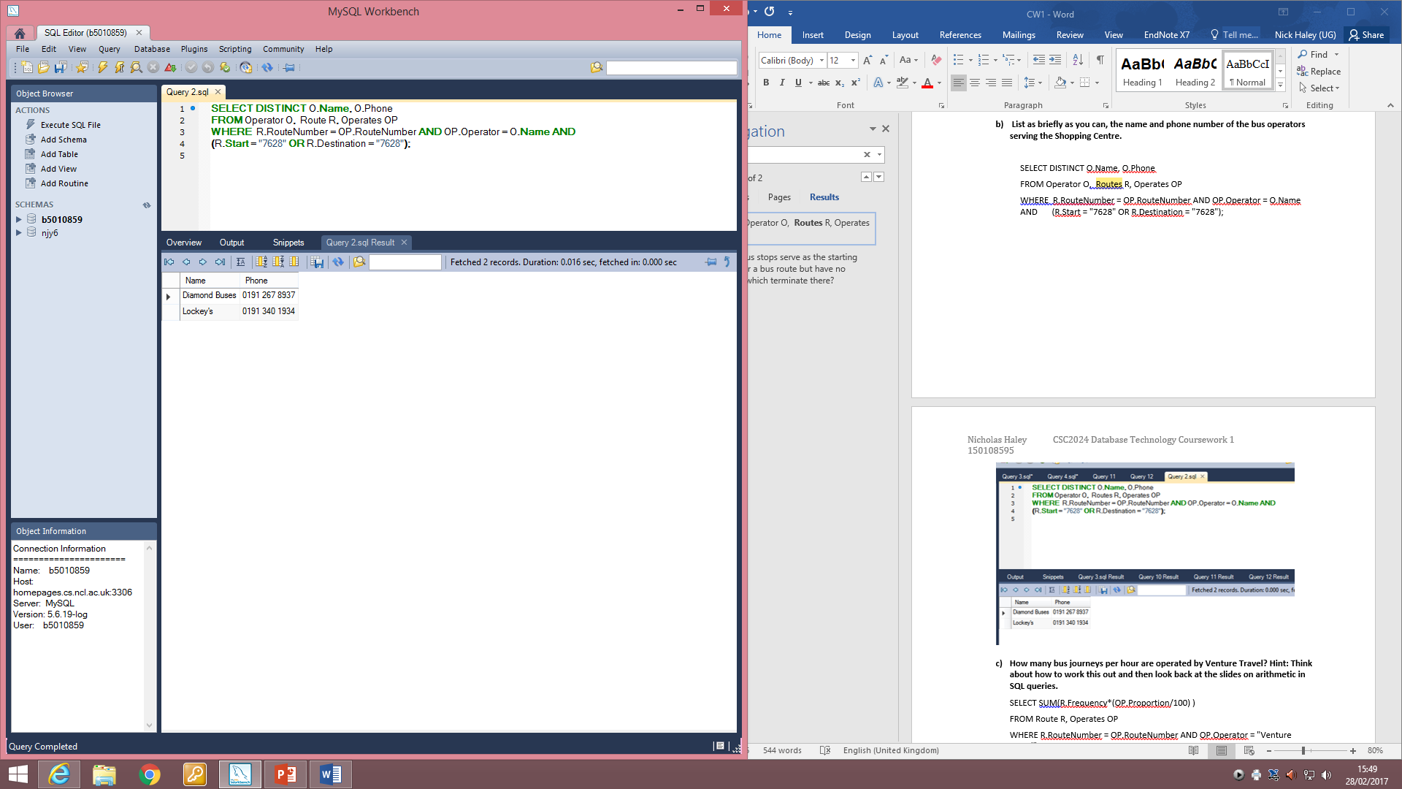

1. **How many bus journeys per hour are operated by Venture Travel? Hint: Think about how to work this out and then look back at the slides on arithmetic in SQL queries.**

SELECT SUM(R.Frequency*(OP.Proportion/100) )

FROM Route R, Operates OP

WHERE R.RouteNumber = OP.RouteNumber AND OP.Operator = "Venture Travel";

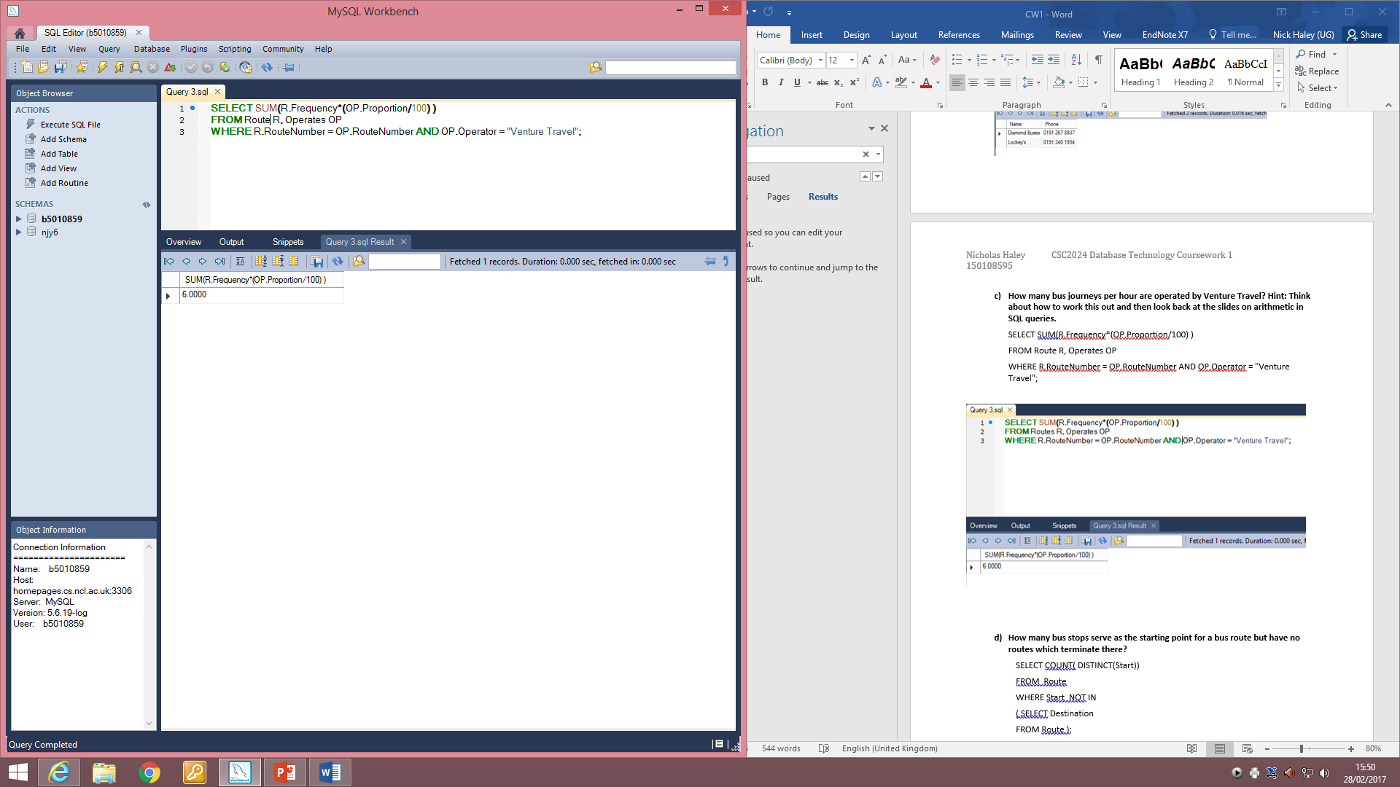

1. **How many bus stops serve as the starting point for a bus route but have no routes which terminate there?**

SELECT COUNT( DISTINCT(Start))

FROM Route

WHERE Start NOT IN

( SELECT Destination

FROM Route );

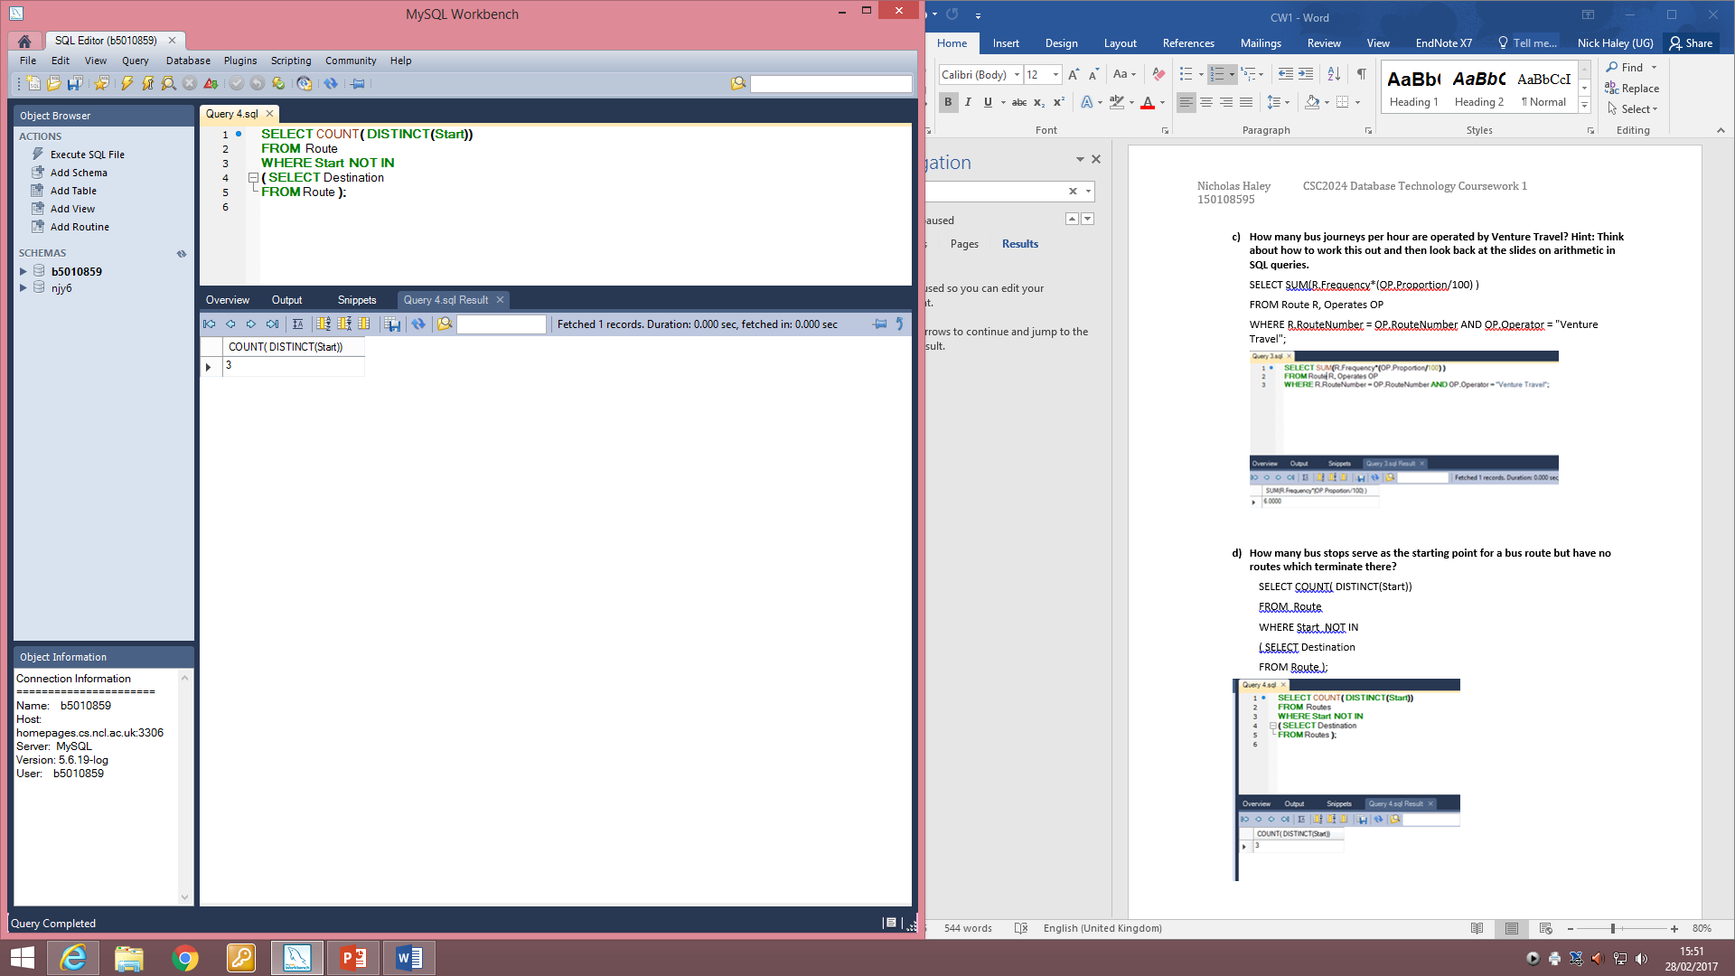

iv) **Modify the entity-relationship diagram to include this extension.**

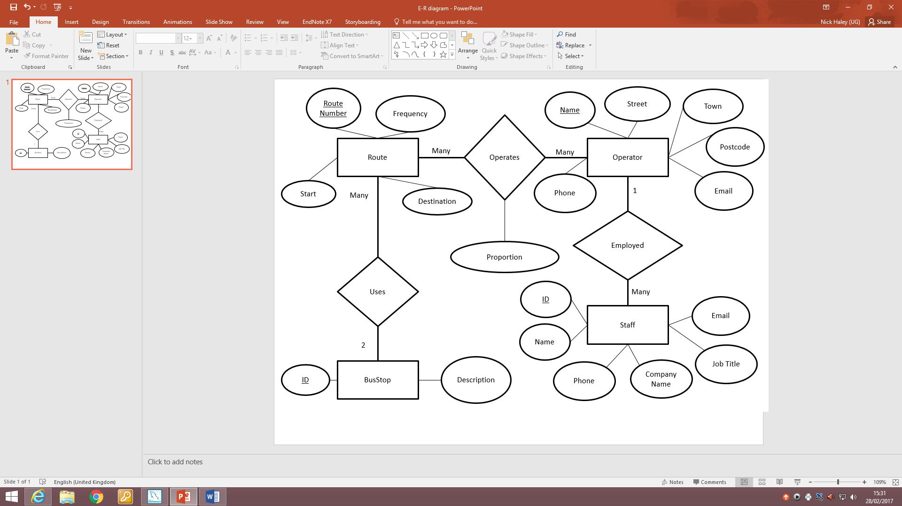

v) List the changes you would need to make to the E-R diagram and the database if this approach was to be used.

* Remove start and destination columns from Route table
* BusStop to Route relationship becomes many to many as there is now an unlimited number of bus stops in a route.

The scenario in this assignment said that the council only wanted to store the start and destination of each bus route. However, they are now considering a more detailed approach which would store every single bus stop served by each route. You may assume there is no limit on the number of stops that can be served by a route and that the council do not want to distinguish which of these stops is the start and which is the destination.

**6 marks.**