**CSC1021 Programming I**

Project 1

Nicholas E M Haley

Student Number: 150108595

Summary:

Throughout this project I have taken the approach to breakdown each part into smaller more manageable steps. When looking at part 1, I made a separate array for the coursework weighting of each module in which I entered the accurate values taken from Blackboard in the summary section. These values will remain constant throughout the program so there was no need for a user interface.

I made my arrays for “examMark” and “courseworkMark” so that they contained exactly six elements. When it came to testing in the early stages of the project I would change these arrays to assign values to identify if my calculations worked correctly. I also made sure that the output printed in the console was formulated into a table to easily display the module mark and result according to that mark.

Once I knew that my calculation, for loops and if statements worked correctly I then proceeded to create the user interface using a scanner. I did this before the bar chart because I wanted to be able to assign my own values to construct the bars in the console.

When it came to making the bar chart, I made each of the individual bars, making them visible and giving the bars values for size and position. I then made an array of these bars so that I could use a for loop and an if statement to change the colour of the bars depending on the result for “computedModuleMark”.

Testing:

In regard to testing the final program I decided to input values into the console, before running the program I would work out what I would expect to see in the output table and bar chart so that I had something to compare. Here are some examples of such testing:

Exam Marks entered into the console when prompted: 50,50,50,50,50,50

Coursework Marks entered into the console when prompted: 50,50,50,50,50,50

Result:

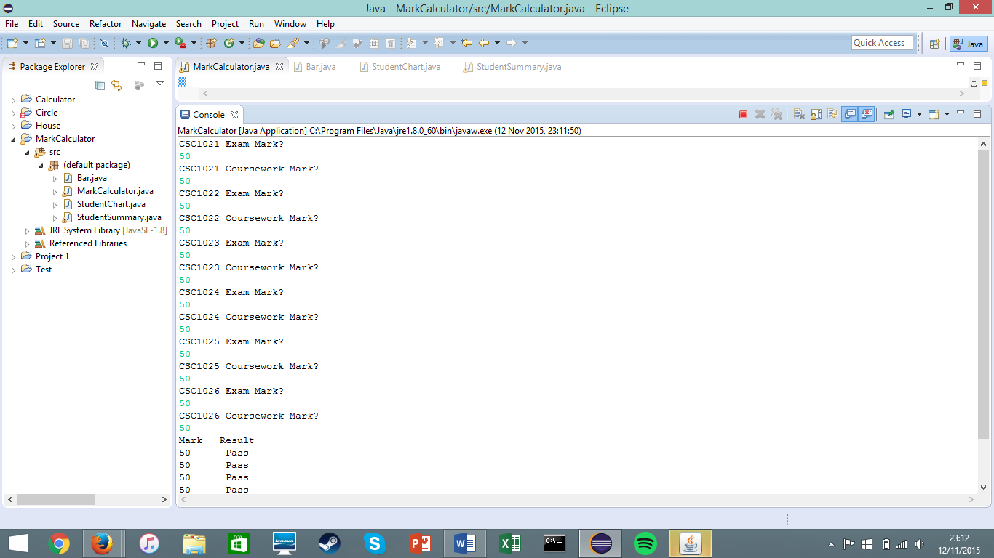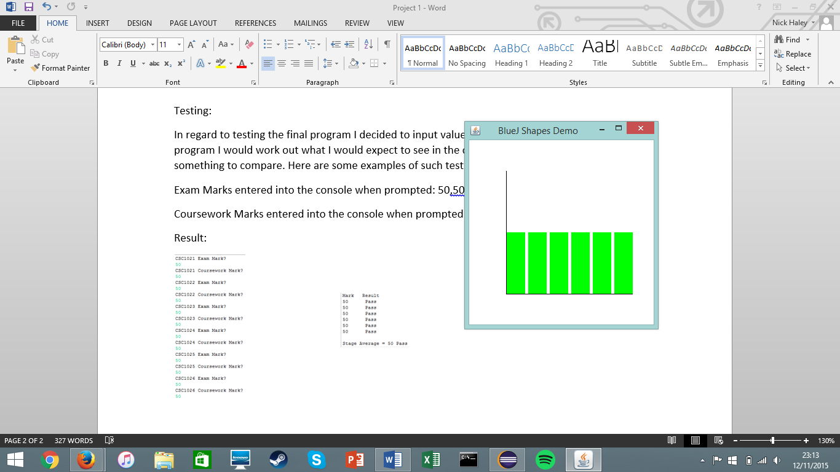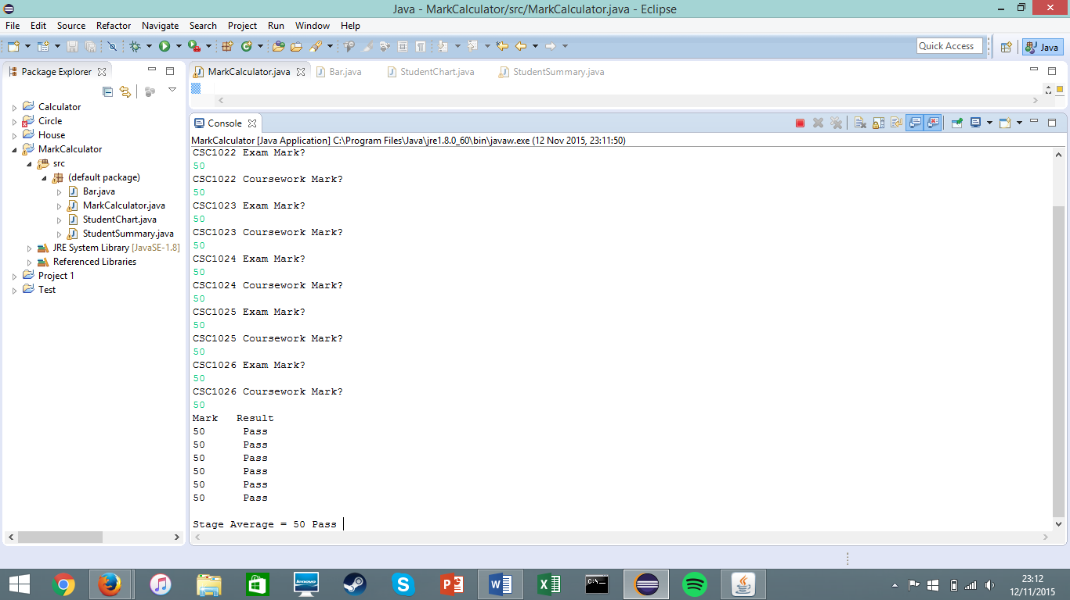

Console Output

Input

Console Output

Canvas

Input

Exam Marks entered into the console when prompted: 35, 40, 0, 40, 40, 40

Coursework Marks entered into the console when prompted: 35, 40, 35, 40, 40, 40

Canvas

Console Output

Input

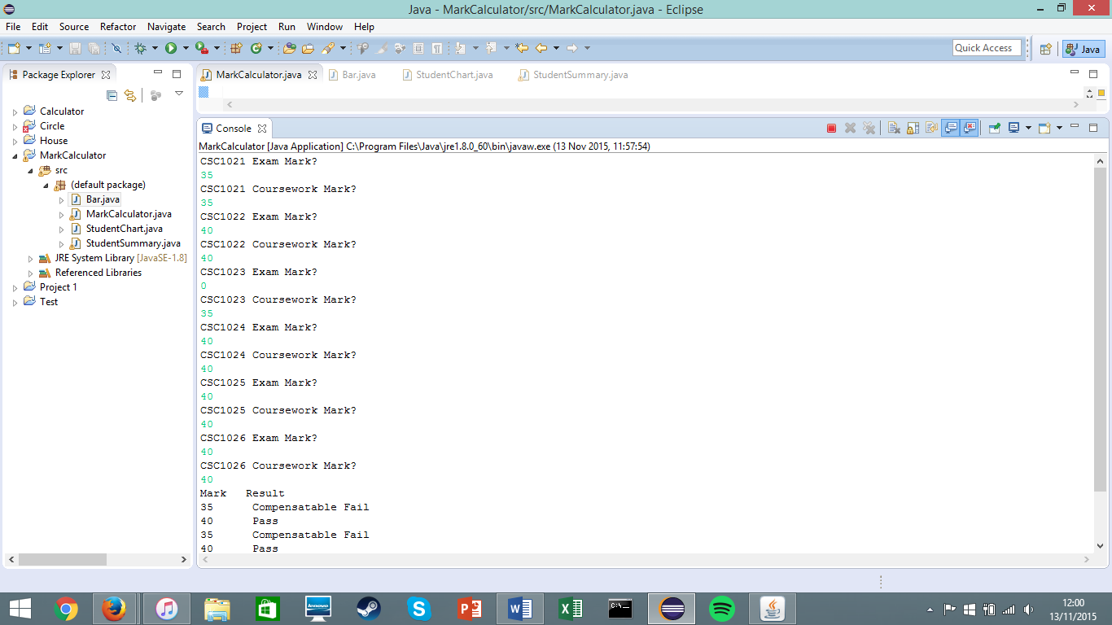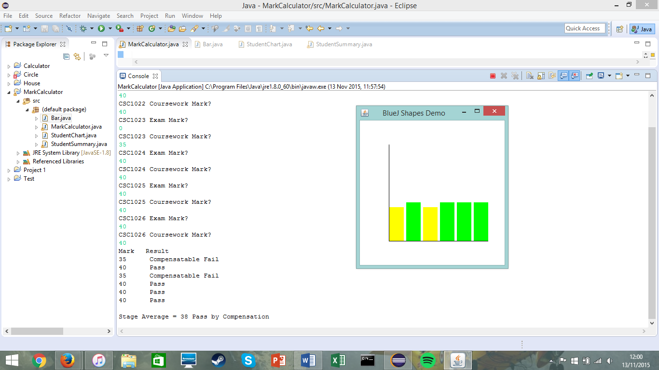

Exam Marks entered into the console when prompted: 30, 5, 30, 30, 40, 30

Coursework Marks entered into the console when prompted: 30, 40, 50, 30, 50, 30

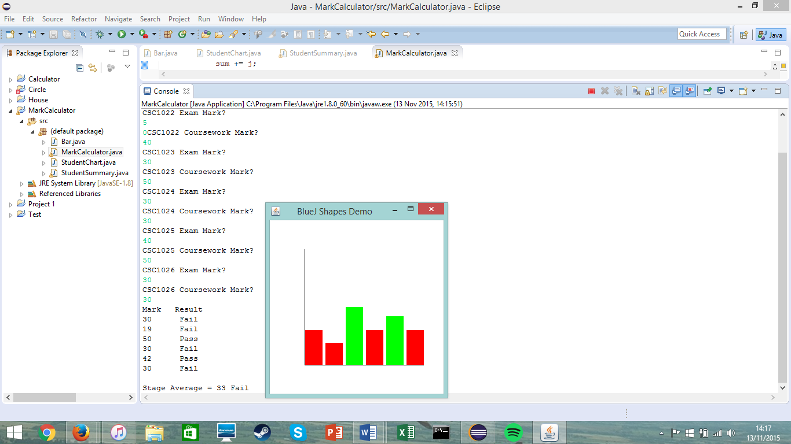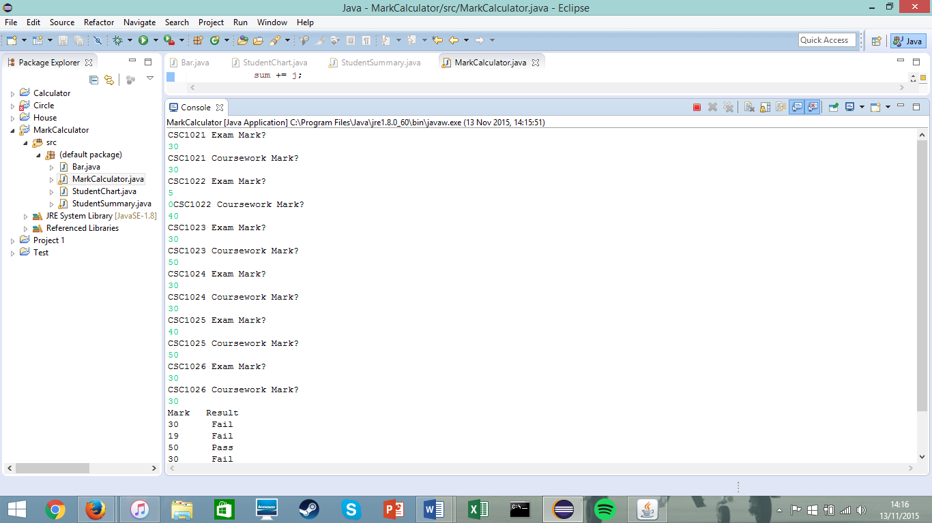



Console Output

Canvas

Input

Exam Marks entered into the console when prompted: 70, 40, 40, 20, 20, 20

Coursework Marks entered into the console when prompted: 70, 40, 30, 30, 30, 30

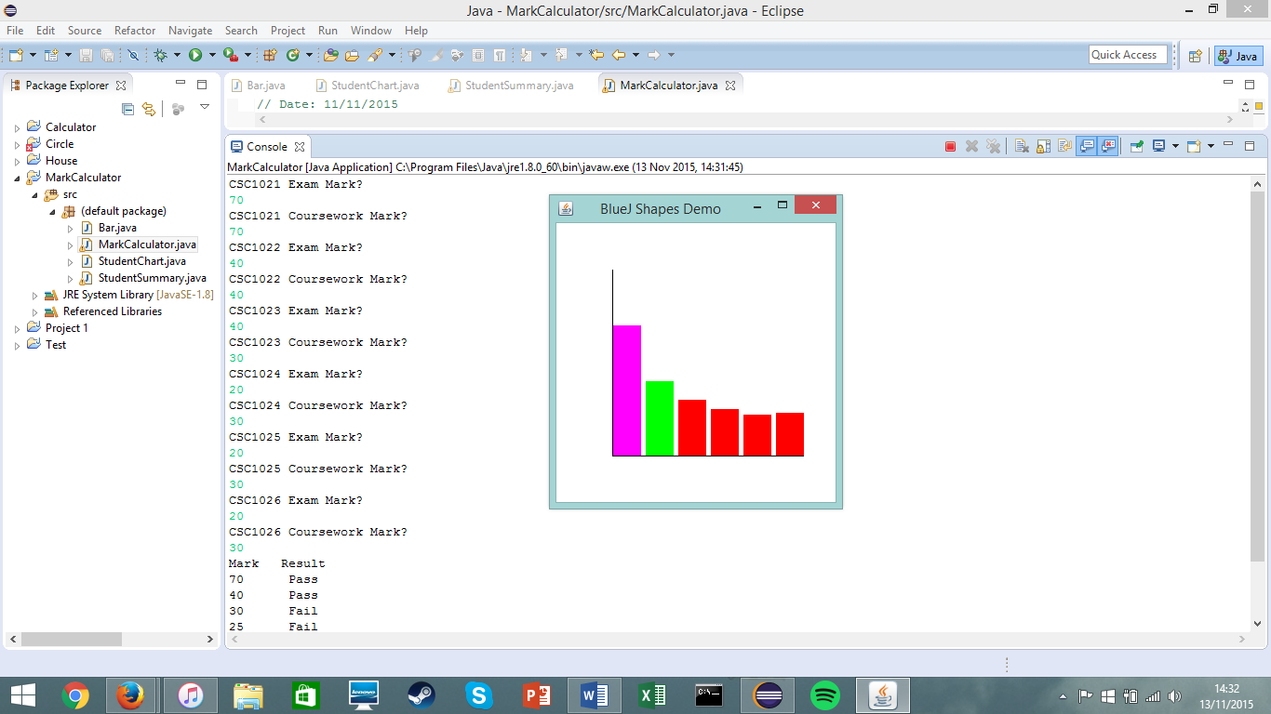

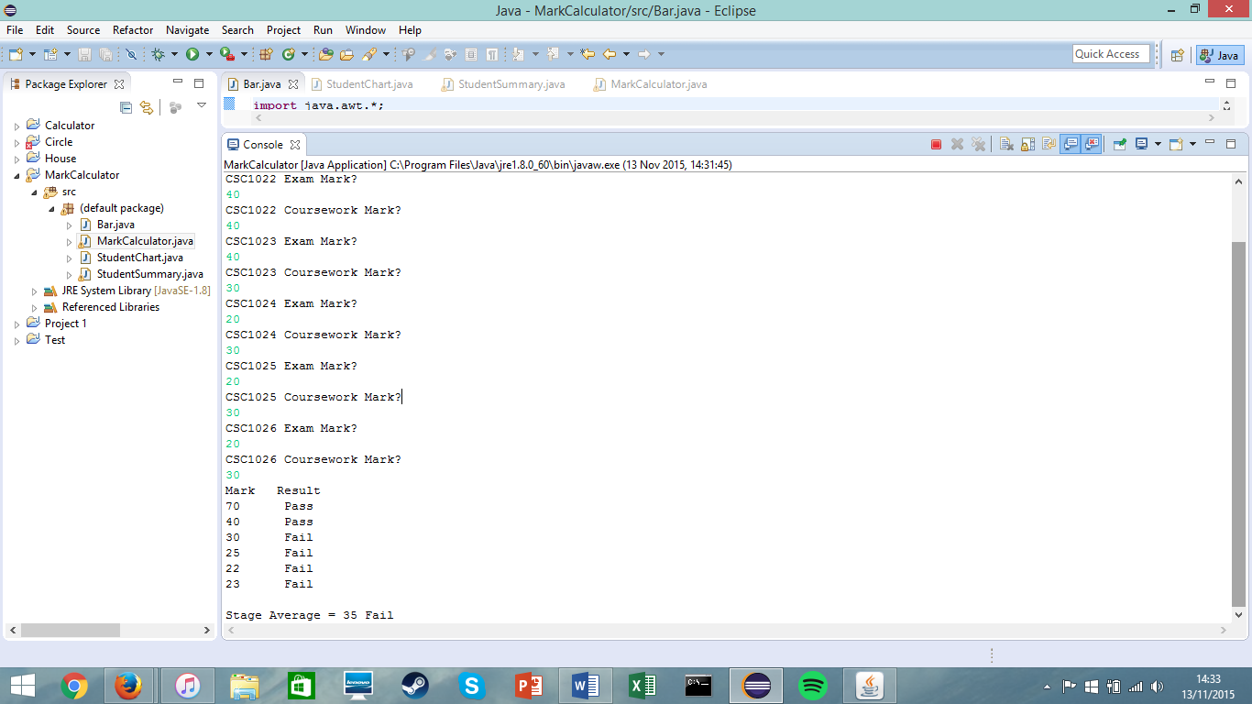

Console Output

Canvas

Input

Exam Marks entered into the console when prompted: 90, 60, 0, 60, 60, 60

Coursework Marks entered into the console when prompted: 80, 35, 70, 60, 60, 60

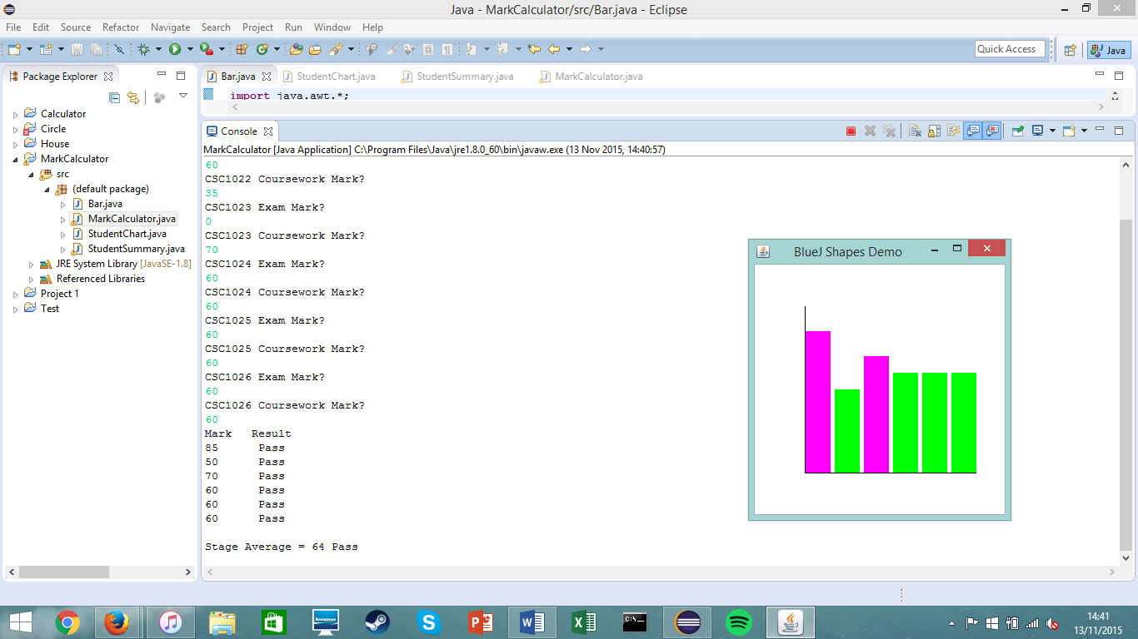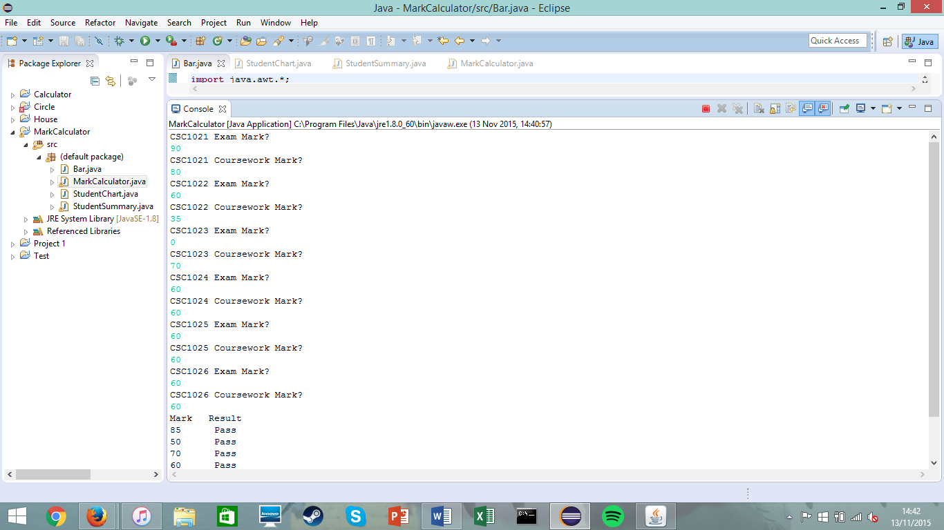



Console Output

Canvas

Input

Conclusion:

In conclusion my testing shows that my program works as I am able to input values in the console. These results undergo the calculation I made in my methods I have made and are presented in a table in the console. The results from the table are then used to construct the bar chart as shown on the canvas. I performed the testing five time so that I could make sure the results were reliable.