NEOLIFE WELLNESS CENTER
AYUSH DIGITAL CARE

2026
Neolife Wellness Center Management Portal
Project Type: Web-Based Healthcare and Wellness Management System and E-Commerce System.
Purpose of the Project:
The purpose of the Neolife Wellness Center Management System is to provide a centralized digital platform for managing healthcare services, patient interactions, online consultations, appointments, and Ayurvedic product sales. The system aims to improve operational efficiency, enhance patient experience, and support the digital transformation of wellness center services.
Objectives:
- To enable patients to register and access healthcare services online.
- To facilitate appointment booking and online consultation scheduling.
- To provide secure communication between patients and healthcare practitioners.
- To support the online sale and management of Ayurvedic products.
- To provide administrators with tools for managing patients, appointments, consultations, products, and orders efficiently.
- To enhance the overall quality of healthcare service delivery through digital technology.
Expected Benefits:
- Faster appointment and consultation management.
- Improved patient engagement and convenience.
- Efficient product inventory and order management.
- Increased operational efficiency for the wellness center.
- Secure storage and retrieval of healthcare-related information.
- Better customer satisfaction through integrated healthcare and e-commerce services.

Flowchart Diagram:
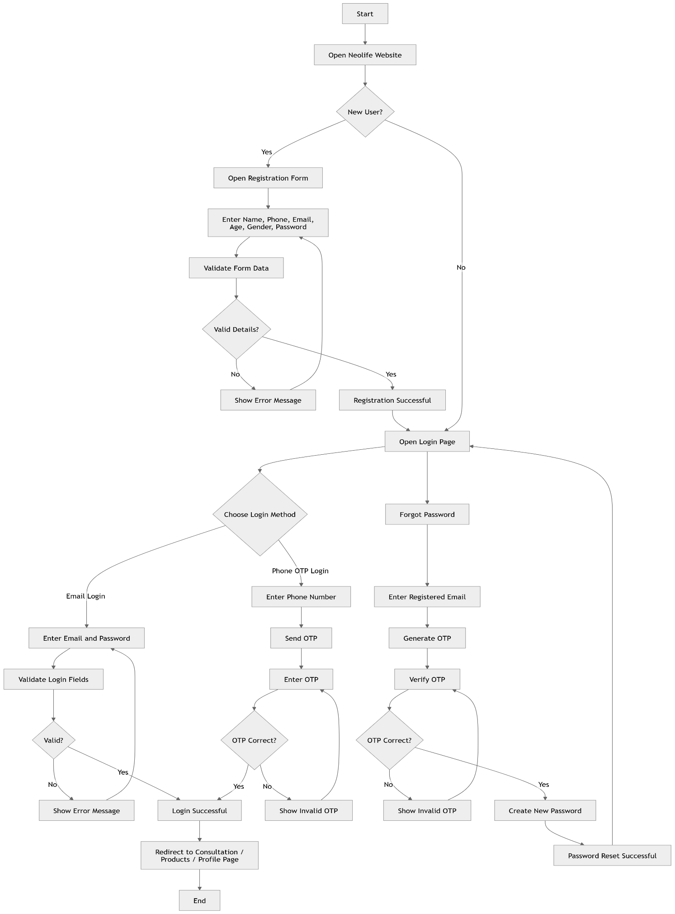
register.html
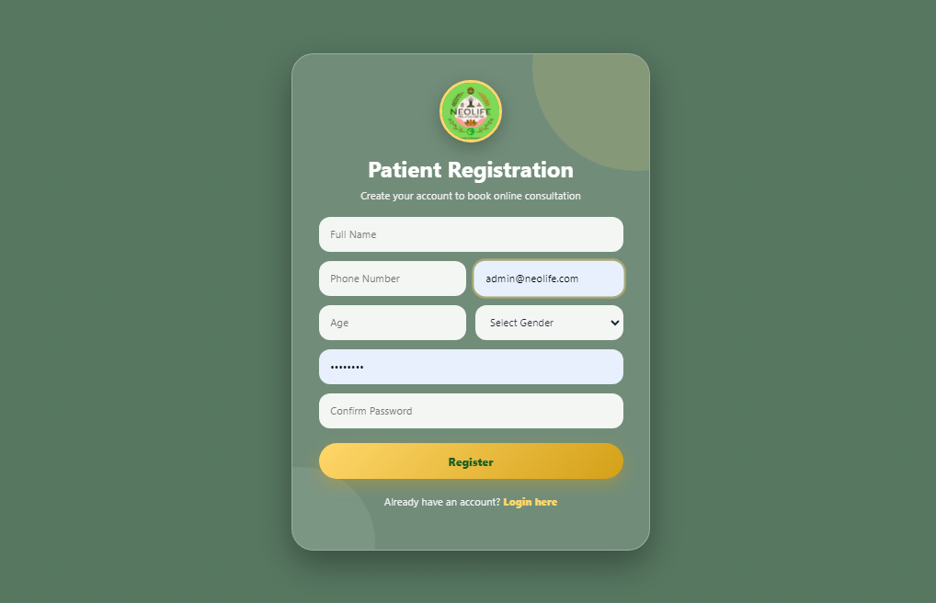

Module Name
User Registration / Patient Registration

Purpose
This module allows a new user or patient to create an account in the Neolife Wellness Center system.
After registration, the user can:
- Login to the website.
- Book online consultations.
- Book clinic appointments.
- Place product orders.
- View profile details.

Frontend Page
register.html

Registration Fields
Field | Type | Required | Description
fullName | String | Yes | User full name
phone | String | Yes | 10-digit mobile number
email | String | Yes | User email address
age | Integer | Yes | User age
gender | String | Yes | Male, Female, or Other
password | String | Yes | Login password
confirmPassword | String | Yes | Used only for frontend password confirmation

Frontend Validation Rules

Full Name
Required.
Should not be empty.
Example:
Dr. N. G. Muraleedhara

Phone Number
Required.
Only numbers allowed.
Must be exactly 10 digits.
Frontend removes non-numeric characters automatically.
Example:
9876543210
Invalid examples:
98765
98765abc10
123456789

Email
Required.
Must be valid email format.
Example:
user@gmail.com

Age
Required.
Minimum value:
1
Maximum value:
120

Gender
Required.
Allowed values:
Male
Female
Other

Password
Required.
Minimum length:
6 characters

Confirm Password
Required.
Must match password.
This field should not be stored in database.

login.html
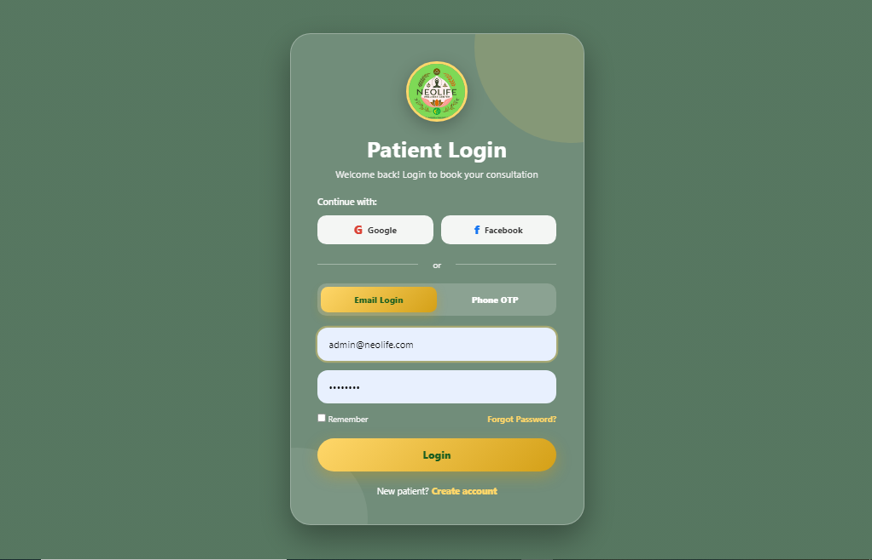

Module Name
User Authentication (Login)

Purpose
This module allows users/patients to log in to the Neolife Wellness Center system using:
- Email + Password Login
- Phone Number + OTP Login
After successful login, users can:
- Book consultations
- Book appointments
- Place orders
- View profile
- View order history

Frontend Page
login.html

Login Methods

1. Email Login
Fields
Field | Required | Validation
Email | Yes | Valid email format
Password | Yes | Cannot be empty

2. Phone OTP Login
Step 1
Enter Phone Number
↓
Send OTP
↓
Enter OTP
↓
Verify OTP
↓
Login Successful

Email
Required
Must be valid email format.
Example:
ramesh@gmail.com

Password
Required
Cannot be empty.
Minimum length:
6 characters

forgot-password.html
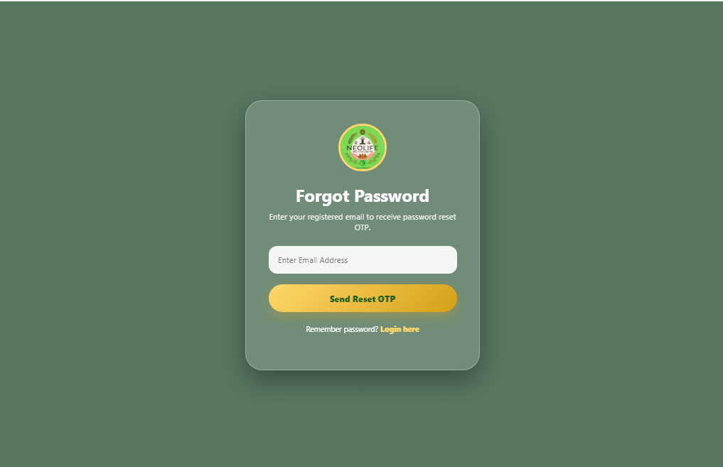

Module Name
Forgot Password

Purpose
This module allows registered users to reset their password if they forget it.
Password reset flow:
User enters email
↓
OTP sent to registered email
↓
User enters OTP
↓
OTP verification
↓
User enters new password
↓
Password updated

Frontend Page
forgot-password.html

Current Frontend Fields
Field | Type | Required | Description
email | String | Yes | Registered email address

Validation Rules

Email
Required.
Must not be empty.
Must follow email format.
Example:
user@gmail.com
Invalid:
usergmail.com
abc@

verify-otp.html
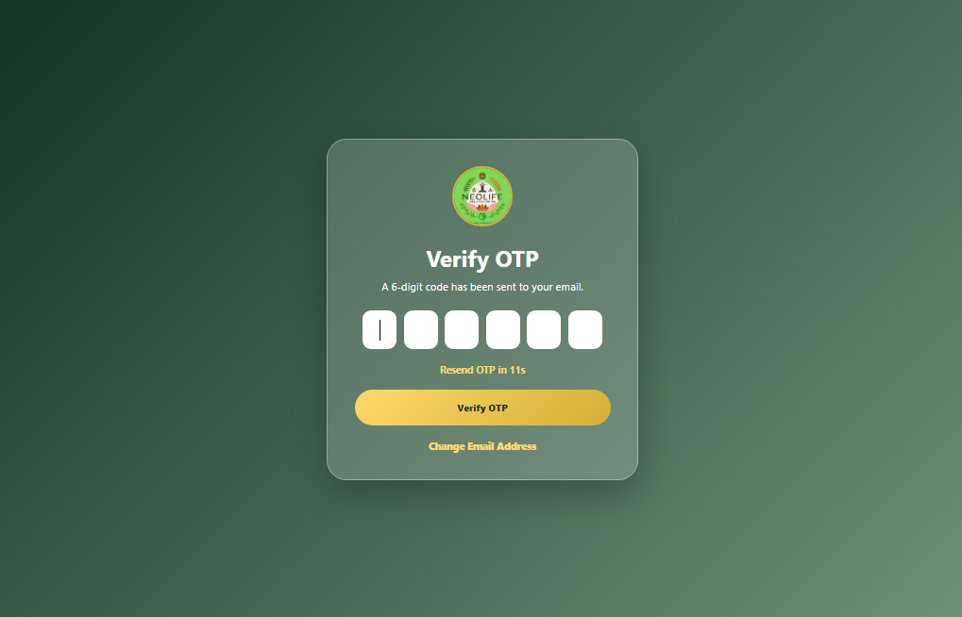

Module Name
Verify Reset OTP

Purpose
This module verifies the 6-digit OTP sent to the user's registered email during the Forgot Password process.
After OTP verification, the user is allowed to reset the password.

Frontend Page
verify-otp.html

Page Flow
Forgot Password Page
↓
User enters registered email
↓
Backend sends OTP to email
↓
User opens Verify OTP page
↓
User enters 6-digit OTP
↓
Backend verifies OTP
↓
If valid, redirect to reset-password.html

Frontend Fields
Field | Type | Required | Description
OTP Digit 1 | Number | Yes | First digit
OTP Digit 2 | Number | Yes | Second digit
OTP Digit 3 | Number | Yes | Third digit
OTP Digit 4 | Number | Yes | Fourth digit
OTP Digit 5 | Number | Yes | Fifth digit
OTP Digit 6 | Number | Yes | Sixth digit

reset-password.html
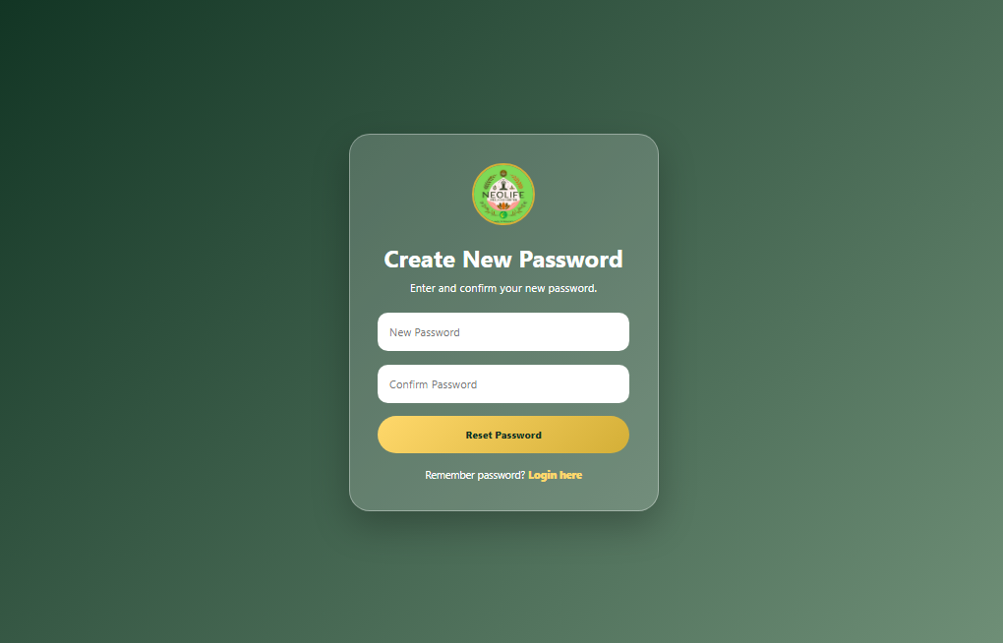

Module Name
Reset Password

Purpose
This module allows users to create a new password after verifying the OTP sent during the Forgot Password process.

Frontend Page
reset-password.html

Page Flow
Forgot Password
↓
Verify OTP
↓
Reset Password
↓
Login

Frontend Fields
Field | Type | Required | Description
newPassword | String | Yes | New password entered by user
confirmPassword | String | Yes | Used to confirm new password

Frontend Validation Rules

New Password
Required.
Minimum length:
6 characters

Confirm Password
Required.
Must match New Password.

Appointment Booking Interface Module
The Appointment Booking Interface Module is responsible for providing a frontend user interface where users can choose between an in-clinic appointment and an online consultation. This module is developed using HTML, CSS, and JavaScript. It handles user input, form switching, appointment slot checking, frontend validation, and confirmation messages.
This module is frontend-only and does not store appointment data in a database. The availability checking is currently handled using predefined booked slot data inside JavaScript.

Main Functionalities

1. Booking Type Selection
The page provides two main options:
- Book Appointment
- Online Consultation
When the user clicks Book Appointment, the appointment form is displayed and the online consultation form is hidden.
When the user clicks Online Consultation, the online consultation form is displayed and the appointment form is hidden.
This is handled using the following JavaScript functions:
- showAppointmentForm()
- showOnlineForm()

2. Appointment Booking Form
The appointment form collects the following details from the user:
- Patient name
- Phone number
- Email address
- Appointment type
- Appointment date
- Preferred time
The user must check doctor availability before submitting the appointment request.

3. Online Consultation Form
The online consultation form collects more detailed patient information because the consultation happens remotely.
The form includes:
- Patient name
- Phone number
- Email address
- Age
- Gender
- Consultation type
- Preferred date
- Preferred time
- Health issue description
- Voice message recording option
The online consultation section also displays important consultation steps such as:
- Select consultation type
- Select date and time
- Check availability
- Pay ₹200
- Get meeting link

4. Availability Checking
Availability checking is handled on the frontend using predefined booked slots.
Example:
const bookedSlots = {
ayurveda: {
"2026-06-18": ["11:00 AM"],
"2026-06-19": ["10:00 AM", "04:00 PM"]
}
};
The system compares the selected consultation type, date, and time with the booked slot list.
If the selected slot is already booked, the system displays a not-available message and shows alternative available slots.
If the selected slot is free, the system displays an available message.
Availability checking is handled using:
- checkAppointmentAvailability()
- checkOnlineAvailability()
- checkAvailabilityCommon()

5. Alternative Slot Suggestion
If the selected time is not available, the system automatically displays other available time slots.
Example available slots:
- 10:00 AM
- 11:00 AM
- 12:00 PM
- 04:00 PM
- 05:00 PM
- 06:00 PM
When the user clicks an available slot, that slot is automatically selected in the form.

6. Form Validation
The module includes basic frontend validation to improve user experience.
Validation includes:
- Required field validation
- 10-digit phone number validation
- Date and time selection validation
- Availability check before submission
- Availability check before payment
Phone number validation is handled using JavaScript regular expression:
/^[0-9]{10}$/
The phone input also prevents alphabets and special characters while typing.

7. Appointment Submission
The appointment form can be submitted only after:
- A valid 10-digit phone number is entered
- Doctor availability is checked
- Selected appointment slot is available
After successful validation, the frontend displays:
Appointment request submitted successfully.
This is handled by:
submitAppointment()

8. Online Consultation Submission
The online consultation form can be submitted only after:
- A valid 10-digit phone number is entered
- Doctor availability is checked
- Selected online consultation slot is available
After successful validation, the frontend displays:
Slot confirmed. Redirecting to payment page.
This is handled by:
submitOnlineConsultation()
Currently, the payment gateway is not integrated. The message is only shown as frontend confirmation.

9. Voice Message Recording
The online consultation form includes a voice message feature that allows the user to record their health issue using the microphone.
Voice recording features include:
- Start recording
- Stop recording
- Recording timer
- Audio playback
- Delete recorded audio
This feature uses the browser microphone through:
navigator.mediaDevices.getUserMedia({ audio:true })
The recorded audio is stored temporarily in the browser as an audio blob. It is not uploaded or saved because backend integration is not included in this frontend-only version.

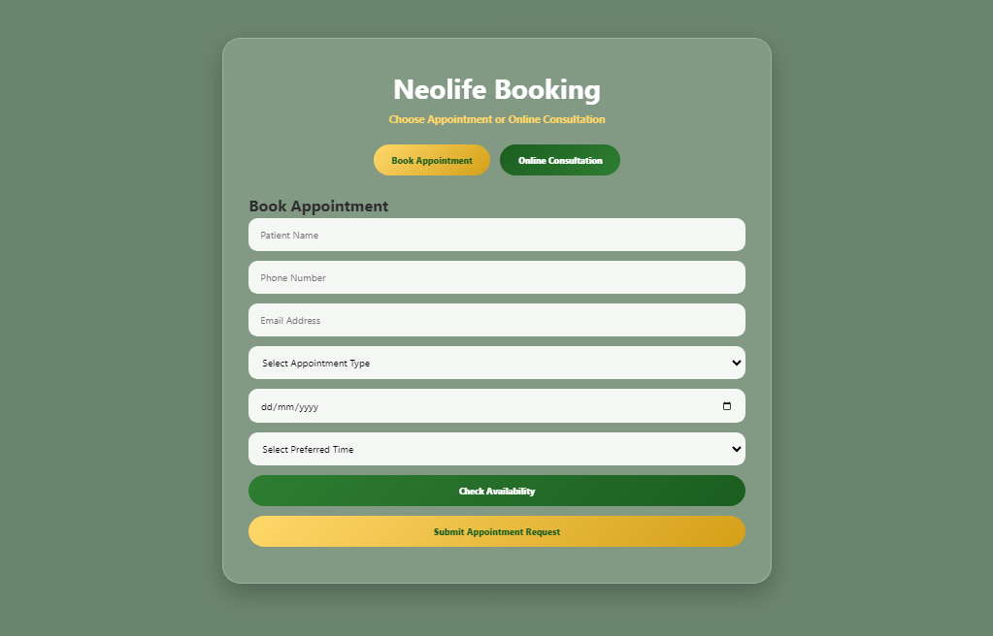
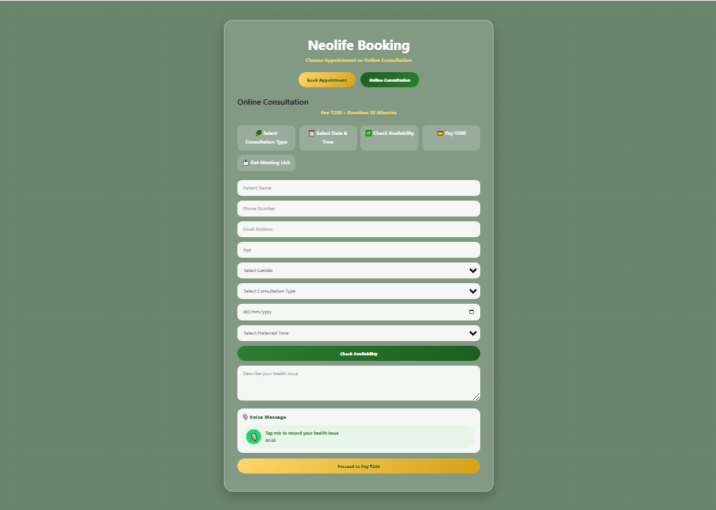

Booking Module Working
The booking module allows users to access healthcare services through two options: Appointment Booking and Online Consultation. When the booking page is opened, users are given the choice to select either of these services. Based on the selected option, the corresponding form is displayed.
Appointment Booking
In the appointment section, the user provides personal details and selects the desired consultation type, preferred date, and time. Before submitting the request, the system checks the doctor's availability for the selected slot. If the doctor is unavailable, alternative available slots are suggested to the user. Once a suitable slot is selected, the appointment request can be submitted successfully.
Online Consultation
The online consultation section collects additional information such as age, gender, and health-related details. Users can describe their health issues either by typing a message or by recording a voice note. Similar to appointment booking, the system verifies whether the doctor is available at the chosen date and time. If the selected slot is unavailable, the user is provided with other available time slots. After confirming an available slot, the user proceeds to the payment stage for the consultation.
Doctor Availability Checking
The system maintains a list of already booked time slots. Whenever a user selects a consultation type, date, and time, the system compares the selected slot with the existing bookings. If the slot is occupied, the system informs the user and displays other available timings. This prevents multiple bookings for the same doctor at the same time.
Voice Message Facility
For online consultations, users have the option to record a voice message describing their health condition. The browser requests microphone permission before recording. After recording, the audio can be played back and deleted if necessary. This feature helps users communicate their symptoms more effectively.
Overall Working
The booking module provides a simple and user-friendly process that enables users to select a healthcare service, enter the required information, verify doctor availability, and complete the booking process. This ensures efficient appointment management and avoids scheduling conflicts.

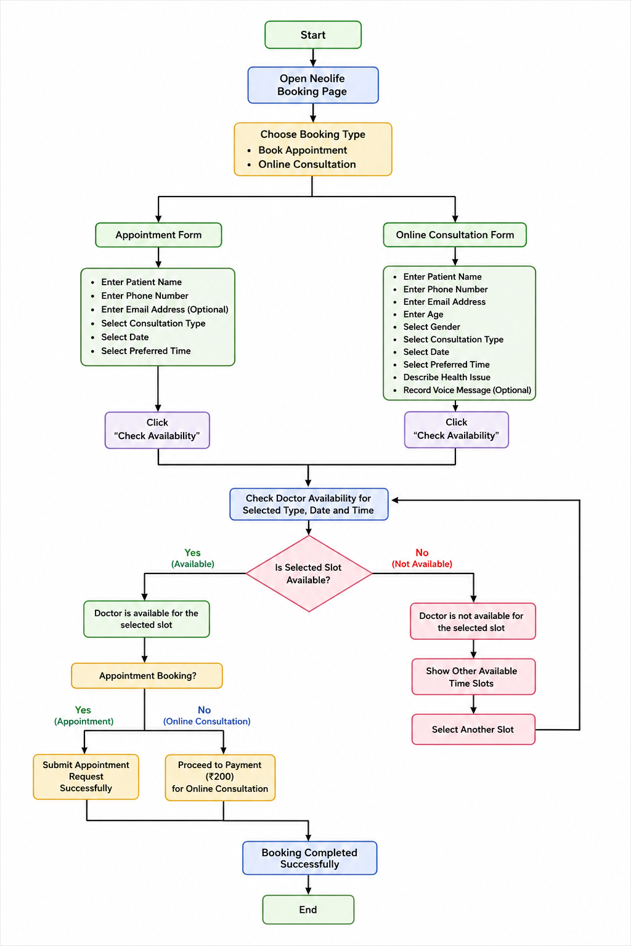
profile.html
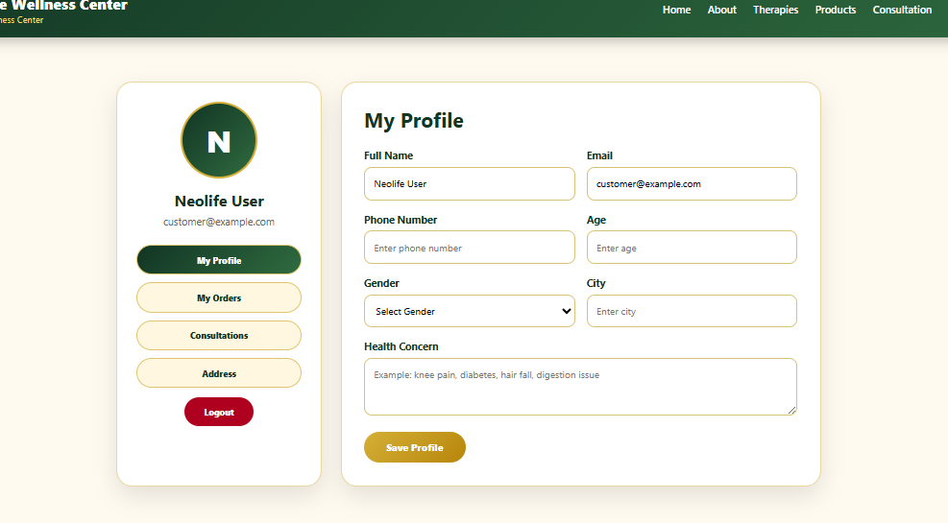

Module Name
User Profile Management

Purpose
This module allows logged-in users to view and update their personal profile details.
Users can manage:
- Profile information
- Contact details
- Health concern
- Address
- Orders section
- Consultation history section
- Logout

Frontend Page
profile.html

Access Rule
Only logged-in users can access this page.
If user is not logged in:
Redirect to:
login.html

Profile Fields
Field | Type | Required | Description
fullName | String | Yes | User full name
email | String | Yes | User email
phone | String | Yes | User phone number
age | Integer | Optional | User age
gender | String | Optional | Male, Female, Other
city | String | Optional | User city
healthConcern | String | Optional | User health issue or concern

Address Fields
Field | Type | Required
address | Text | Yes
pincode | String | Yes
city | String | Yes
state | String | Yes

Admin Dashboard Interface Module
The Admin Dashboard Interface Module provides frontend screens for managing website operations.
Features
- Dashboard summary cards
- Product management UI
- Order management UI
- Consultation management UI
- Appointment management UI
- Patient list UI
- Status dropdowns
- View details buttons

admin-login.html
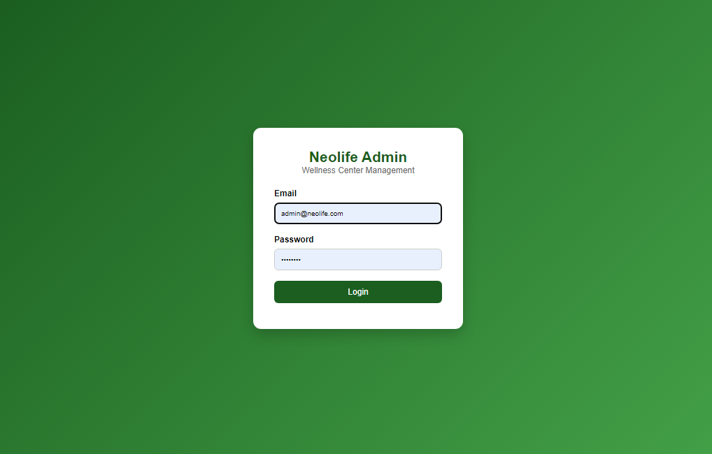

admin-dashboard.html
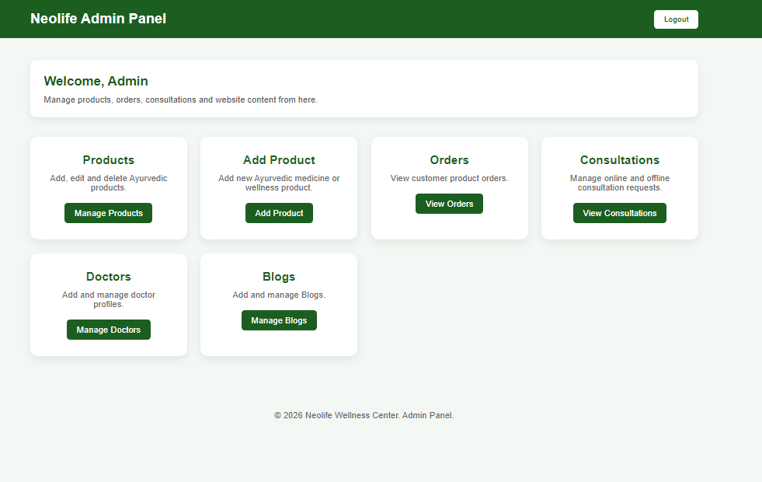

Admin Dashboard Module Documentation

Module Name
Admin Dashboard

Purpose
The Admin Dashboard acts as the central management system for Neolife Wellness Center.
Only authenticated users with ADMIN role can access this module.
It provides navigation and summary access to:
- Product Management
- Order Management
- Consultation Management
- Doctor Management
- Blog Management

admin-product.html
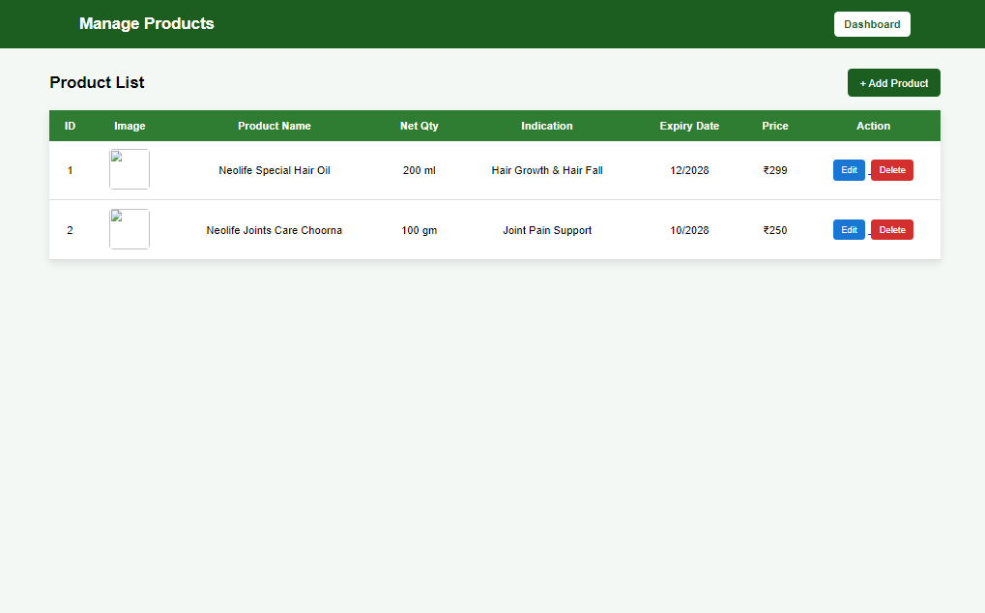

Manage Products Module Documentation

Module Name
Manage Products

Purpose
This module allows administrators to:
- View all products.
- Search products.
- Edit product details.
- Delete products.
- Navigate to Add Product page.
- Manage inventory.
Only ADMIN users should have access.

Frontend Page
admin-products.html

Features

View Product List
Displays:
- Product ID
- Product Image
- Product Name
- Net Quantity
- Indication
- Expiry Date
- Price
- Actions

edit-product.html
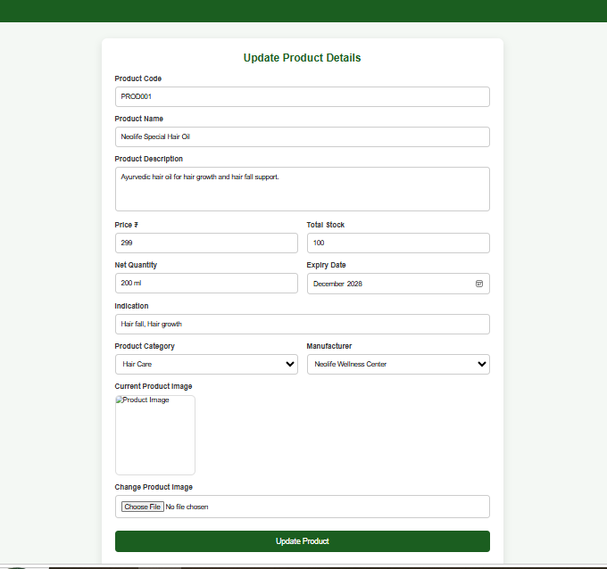
Edit Product Module Documentation
Module Name
Edit Product
Purpose
This module allows administrators to update existing product details such as price, stock quantity, category, manufacturer, image, and other information.
Only ADMIN users should have permission to edit products.

Frontend Fields
Field | Type | Required | Description
productId | Long | Yes | Internal product id
productNo | String | Yes | Unique product code
name | String | Yes | Product name
description | String | Yes | Product description
price | Decimal | Yes | Product price
stock | Integer | Yes | Available quantity
netQty | String | Yes | Net quantity
expiryDate | Date | Yes | Product expiry date
indication | String | Yes | Product indication
category | String | Yes | Product category
manufacturer | String | Yes | Manufacturer
image | File | Optional | Product image

add-product.html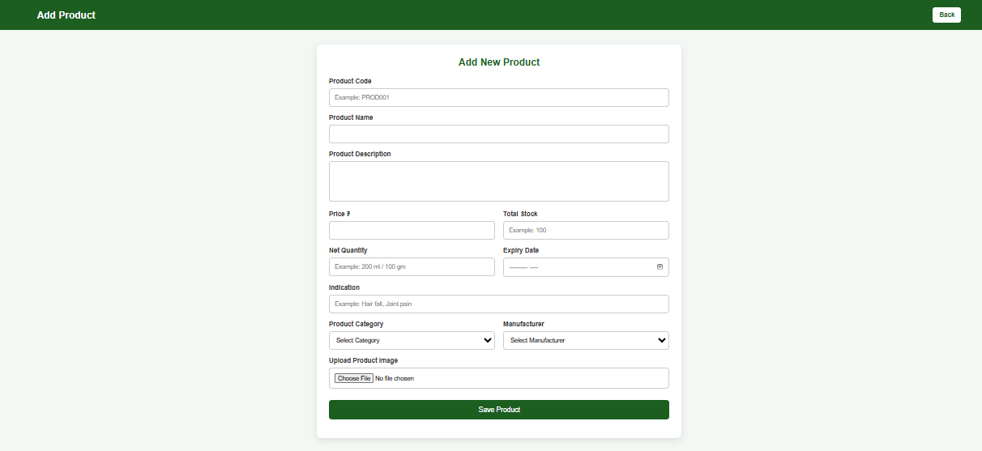

Module Name
Product Management

Purpose
This module is used to add, retrieve, update, and delete products in the Neolife Wellness Center application. It supports product inventory and e-commerce functionality.

Product Fields
Field | Type | Required | Description
productNo | String | Yes | Unique product code
name | String | Yes | Product name
description | String | Yes | Product description
price | Decimal | Yes | Product price
stock | Integer | Yes | Available quantity
netQty | String | Yes | Net quantity (200 ml, 100 gm, etc.)
expiryDate | Date | Yes | Expiry month and year
indication | String | Yes | Usage indication
category | String | Yes | Product category
manufacturer | String | Yes | Manufacturer name
imageUrl | String | Yes | Product image URL/path

admin-orders.html
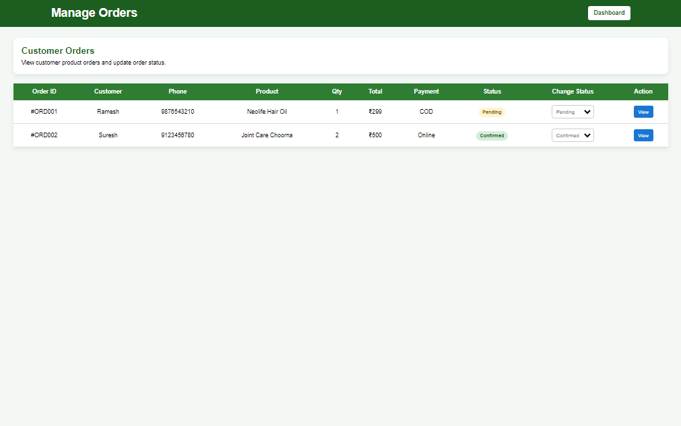

Module Name
Admin Orders Management

Purpose
This module allows administrators to:
- View all customer orders.
- View complete order details.
- Change order status.
- Track payment method.
- Manage delivery process.
Only ADMIN users can access this module.

Frontend Page
admin-orders.html

Features
View Orders
Displays:
- Order ID
- Customer Name
- Phone Number
- Product Name
- Quantity
- Total Amount
- Payment Method
- Order Status
- Change Status
- View Details

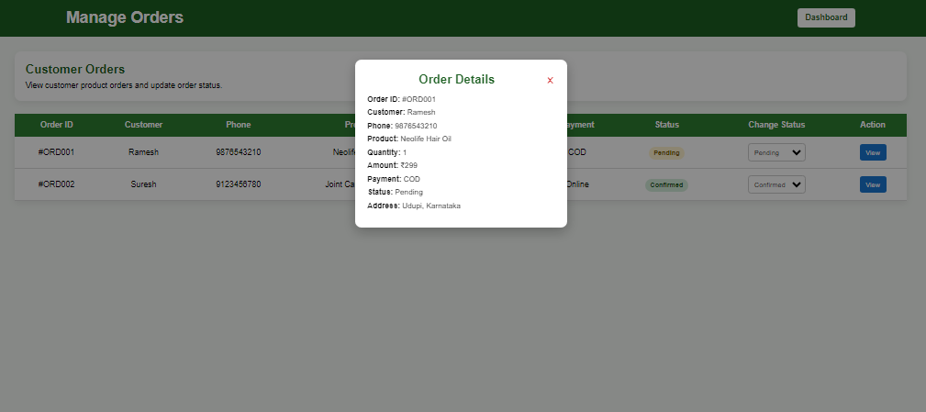
admin-consultation.html
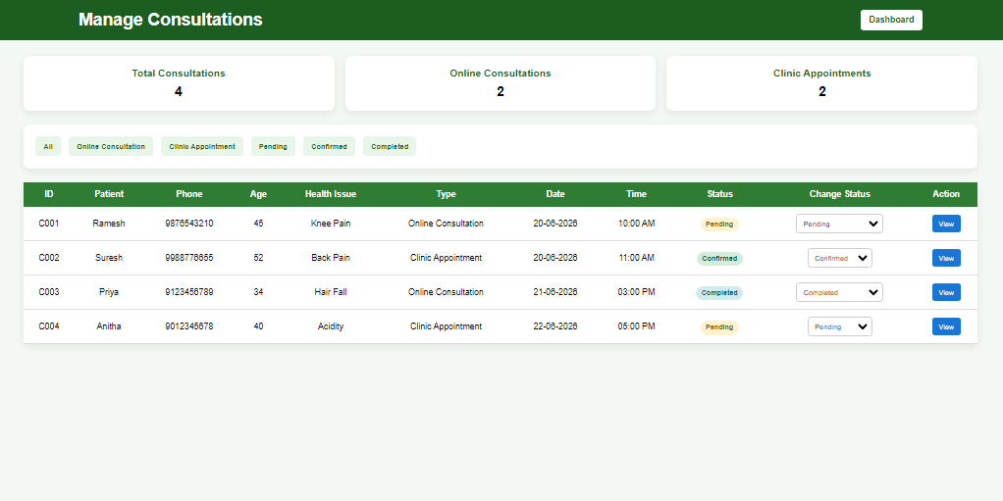 Module Name
Admin Consultation Management

Purpose
This module enables administrators to manage:
- Online Consultations
- Clinic Appointments
- Consultation Status
- Meeting Link Generation
- Patient Information
- Consultation Statistics
Only users with ADMIN role should have access.

Frontend Page
admin-consultations.html

Consultation Types
Online Consultation
Video consultation after payment.
Statuses:
Pending
Confirmed
Meeting Link Sent
Completed

Clinic Appointment
Physical visit to clinic.
Statuses:
Pending
Confirmed
Visited
Completed

Dashboard Statistics
Displays:
Total Consultations
Online Consultations
Clinic Appointments
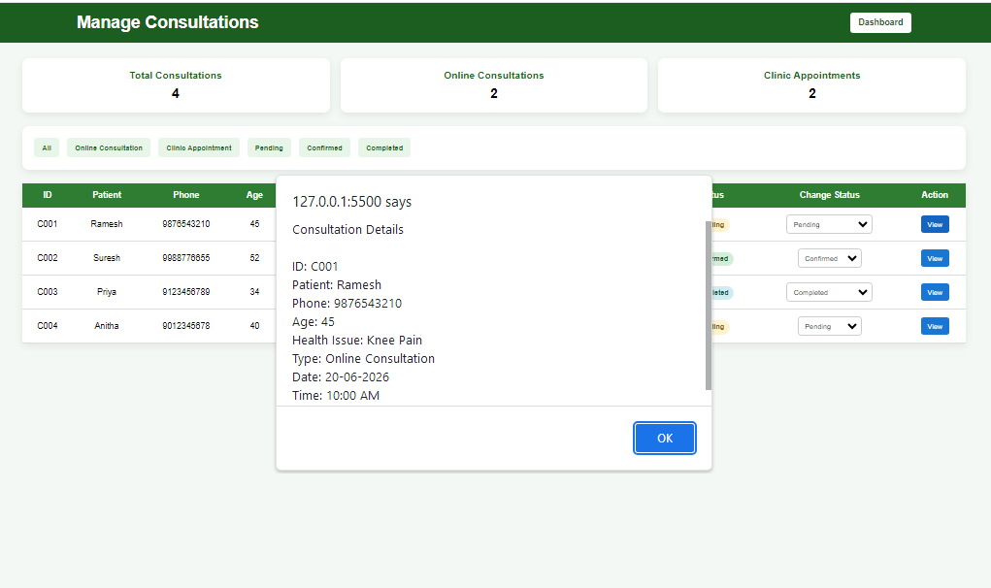 admin-doctors.html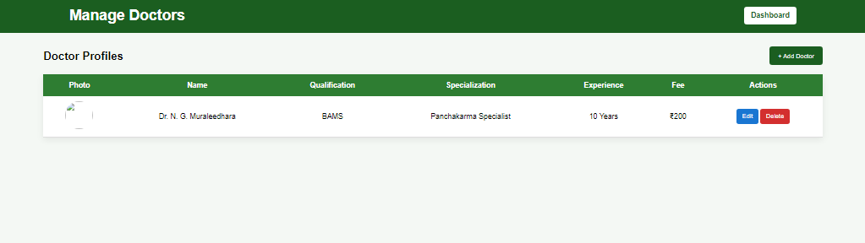 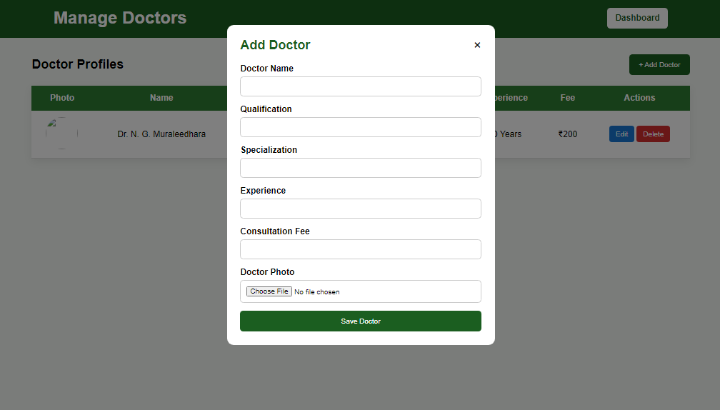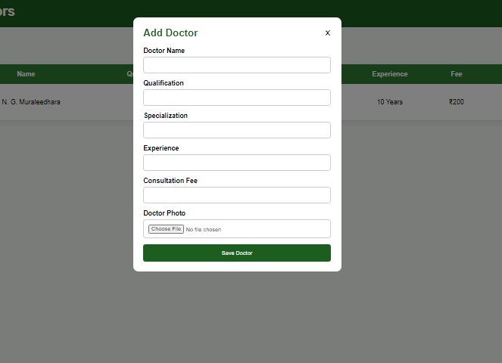

Doctor Management Module Documentation

Module Name
Doctor Management

Purpose
This module allows administrators to:
- View doctor profiles.
- Add new doctors.
- Update doctor information.
- Delete doctor profiles.
- Manage consultation fees and specializations.
- Upload doctor photographs.
Only ADMIN users should have access to this module.

Frontend Page
admin-doctors.html

Features

View Doctors
Displays:
- Doctor Photo
- Doctor Name
- Qualification
- Specialization
- Experience
- Consultation Fee
- Actions

Add Doctor
Admin can add:
- Doctor Name
- Qualification
- Specialization
- Experience
- Consultation Fee
- Doctor Photo

Edit Doctor
Admin can modify:
- Name
- Qualification
- Specialization
- Experience
- Consultation Fee

Delete Doctor
Admin can remove doctor profiles.
Confirmation popup should be displayed before deletion.
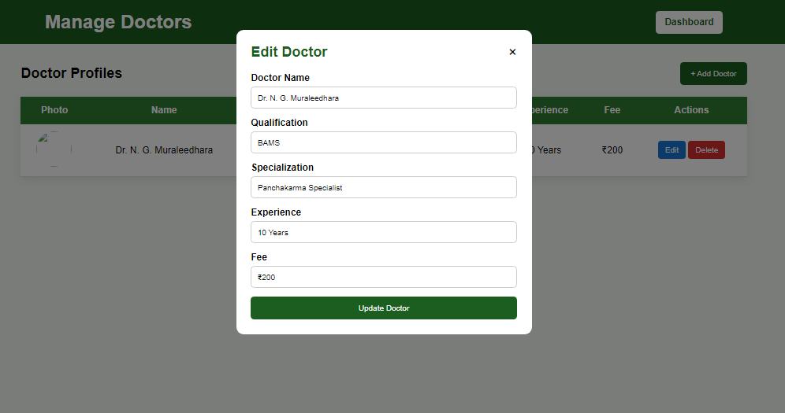

admin-blog.html

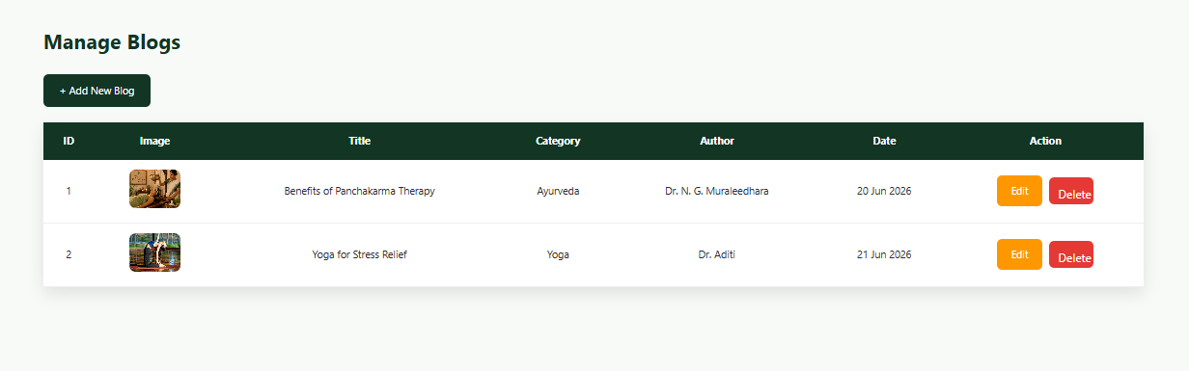

Module Name
Blog Management

Purpose
This module enables administrators to:
- View all blogs.
- Create new blogs.
- Edit existing blogs.
- Delete blogs.
- Categorize blogs.
- Display blogs on the public website.
Only users with ADMIN role should have access to blog management.

Frontend Page
admin-blogs.html

Features

View Blog List
Displays:
- Blog ID
- Blog Image
- Blog Title
- Category
- Author
- Published Date
- Edit Action
- Delete Action

Add Blog
Redirects to:
add-blog.html
Admin can enter:
- Blog Title
- Blog Category
- Author Name
- Blog Content
- Featured Image
- Publish Date

Edit Blog
Redirects to:
edit-blog.html?id={id}
Admin can modify:
- Title
- Category
- Content
- Image
- Author
- Publish Status

Delete Blog
Remove blog from database.
Confirmation popup should be shown before deletion.

add-blog.html

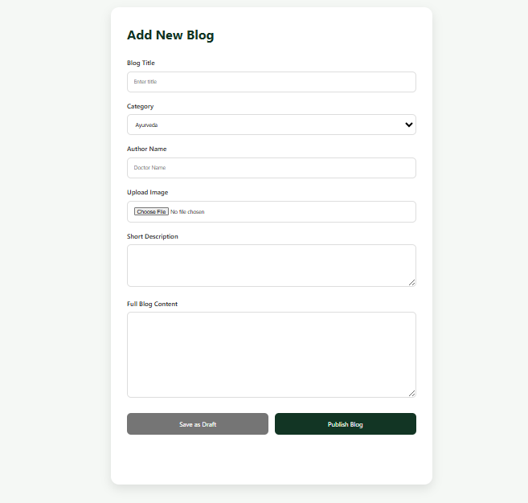

Module Name
Add Blog

Purpose
This module allows administrators to create new blogs and save blogs as drafts before publishing them to the website.
Only users with ADMIN role should have access.

Frontend Page
add-blog.html

Features

Create New Blog
Admin can enter:
- Blog Title
- Category
- Author Name
- Blog Image
- Short Description
- Full Blog Content

Save as Draft
Blog status:
DRAFT
Draft blogs are stored in database but are not visible to users.

Publish Blog
Blog status:
PUBLISHED
Published blogs become visible on:
- blog.html
- blog-details.html
- Home page blog section

Blog Categories
Supported Categories
- Ayurveda
- Yoga
- Panchakarma
- Naturopathy
- Lifestyle
Additional categories can be added later.
edit-blog.html

Module Name
Edit Blog

Purpose
This module allows administrators to update existing blog posts.
Administrators can:
- Modify blog title.
- Change category.
- Update author information.
- Replace blog image.
- Edit short description.
- Edit complete blog content.
- Save changes.
Only users with ADMIN role should have access.

Frontend Page
edit-blog.html

Features

Load Existing Blog
When admin clicks Edit from Blog List:
edit-blog.html?id=1
Frontend calls:
GET /api/blogs/{id}
and fills the form with existing blog data.

Editable Fields

Blog Title
Type:
String
Example:
Benefits of Panchakarma Therapy

Category
Supported Categories
- Ayurveda
- Yoga
- Panchakarma
- Naturopathy
- Lifestyle

Author Name
Example:
Dr. N. G. Muraleedhara

Current Image
Display existing image.

Change Image
Upload new image.

Short Description
Example:
Panchakarma is a traditional Ayurvedic detox therapy that supports body cleansing, rejuvenation and long-term wellness.

Full Blog Content
Example:
Panchakarma is one of the most important detoxification and rejuvenation therapies in Ayurveda. It helps cleanse the body, balance doshas and support natural healing.

