Picarro Timestamp Troubleshooting:

1. Determine if the timestamp is actually still a problem.

Log into the LC and collect a few streams of data. Then, use the date command to get a time comparison from the LC. Below is an example from CPER.

user@D10-CPER-LC1:~$ vd -s 0x00032d24289f -r 10

Type:01,Stream:010,Status:00,2021-08-03 21:28:32.222000000,00032D24289F, 00032D24289F, +403.447998047, 1

Type:01,Stream:010,Status:00,2021-08-03 21:28:33.371000000,00032D24289F, 00032D24289F, +403.454010010, 2

Type:01,Stream:010,Status:00,2021-08-03 21:28:33.724000000,00032D24289F, 00032D24289F, +403.454010010, 3

Type:01,Stream:010,Status:00,2021-08-03 21:28:34.921000000,00032D24289F, 00032D24289F, +403.510009766, 4

Type:01,Stream:010,Status:00,2021-08-03 21:28:35.891000000,00032D24289F, 00032D24289F, +403.519012451, 5

^C

user@D10-CPER-LC1:~$ date Tue Aug 3 21:28:40 UTC 2021

The difference between the Picarro and LC clock here is about 4-5 seconds. A difference of 4-8 seconds is acceptable and does not require any action. Be sure to account for how long it takes to get the ‘date’ command entered in the comparison.

1. If there is a timestamp drift, log into the Picarro and compare the Windows clock to the time on the LC. Rerun the ‘date’ command as needed to get an up to date comparison time.

Click on the clock in the corner of the screen to bring up the detailed view.

Comparing the Picarro clock to the LC time.

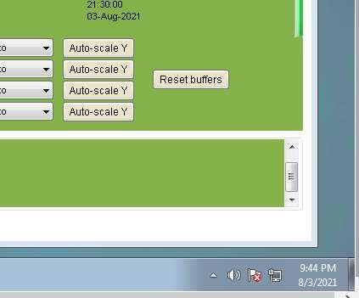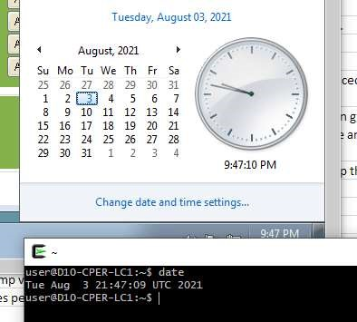

You can also use <https://time.gov/> to check how far behind the Picarro’s computer is by checking the right panel on the webpage.

([www.time.gov](http://www.time.gove) is in the background)

Additionally, we can check to see if the time sync is running. In a command prompt enter the following:

w32tm /query /status

If the time sync is working properly you should see the following:

If not, the time sync is not active, ENG will have to troubleshoot from here.

Sometimes the reason the time sync is not working is because it has not been schedule in the Window Task Scheduler. Open Task Scheduler and check if it’s listed. If it is it will look like so:

If the Windows time matches the LC time the drift can usually be corrected by restarting the Picarro software.

Select the shutdown button on the Picarro interface, then the ‘Stop Analyzer Software Only’ option.

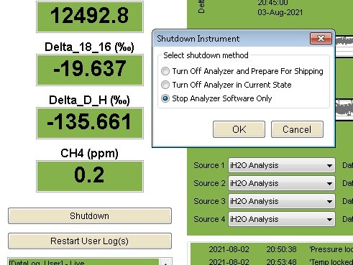

Wait for the Picarro software to shut down, then wait another 60-90 seconds after the window closes for the software to finish closing in the background. After this wait select the ‘Start Instrument’ icon on the desktop to restart the analyzer software.



Repeat the check in step 1 once the analyzer begins measuring again to verify the drift problem is corrected.

1. If the Windows clock does not match the LC time in step 2, the analyzer computer may need to be restarted. This can be done without assistance if on site. Select the shutdown button on the analyzer software and choose the ‘Turn Off Analyzer in Current State’ option. The analyzer will take a few minutes to power down. Wait 1015 seconds after the green light on the front of the unit goes out before pressing the power button to power it on again. The analyzer software will start automatically once the system has booted.

Repeat the check in step 1 once the analyzer begins measuring again to verify the drift problem is corrected.

1. Contact engineering for assistance if the drift still exists after the troubleshooting in steps 1-3, or if you are not on site to execute step 3.