Efficiency of COVID-19 Pandemic response under the context of the UK’s Paris 2050 ambitions

Quick Summary

Using a simple economic-pandemic model we explore how the efficiency of recovery from the pandemic might affect the long-term emissions targets. The link between mobility and R is well established in the context of the COVID-19 pandemic (P. Nouvellet *et al 2020)*. By assuming an exponential rate of adaptation that decouples this relationship we can explore how the easing of lockdown, and by extension the rate of economic recovery, might play out in the medium to long-term. Exploring five scenarios ranging from overtly cautious (quick adaptation and slow easing of lockdown), to a “reckless” strategy (little adaptation and quick lockdown easing) (See Figure 1). We find that quick adaptation with the pandemic will transpire to have little impact on the overall projected trajectory of emissions (Figure 2). While a prolonging he period of lockdown (>5-years) will supress economic growth and by extension emissions in the long-term.

Results

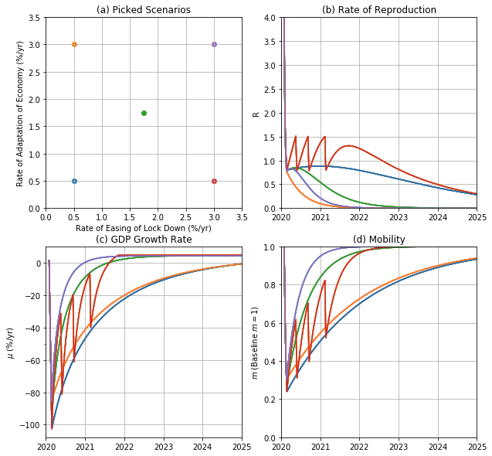

Figure Pandemic-Economic Model. Looking at the short term (2020-2050), we choose 5 scenarios (panel a) of different easing of lockdowns vs economic adaptation to the pandemic. Panel( b) displays the resultant variation of the $R$ number over time, note that the weak adaptation strong easing of lockdown (red) demonstrates repeated waves of coronavirus and lockdowns.

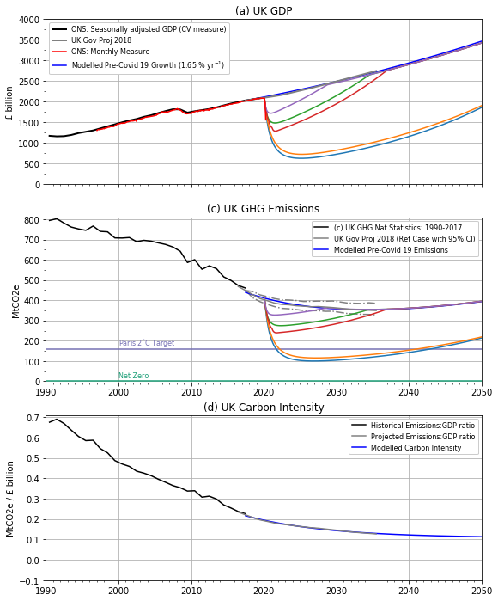

Figure , shows the climate-economic system up to 2050. (a) Historical (from the ONS) and projected GDP (from the UK government Pre-Covid), were fitted using our economic model uncoupled from the pandemic model. Also shown are forecasted emissions for each scenario from figure 1. In Panel (b) we demonstrate that in certain scenarios we reach the Paris target before 2050, however the quick easing of lockdown scenarios result in emissions returning to the non-Covid trajectory relatively quickly. We assume that across all scenarios that carbon intensity (the amount of emissions per GDP) decline exponentially towards a baseline (b), we assume this intensity is unaffected by the pandemic.

Data Sources:

Number of Hospital and Care home deaths: <https://coronavirus.data.gov.uk/> Accessed: 19/06/2020

Google LLC "Google COVID-19 Community Mobility Reports". <https://www.google.com/covid19/mobility/> Accessed: 18/05/2020

Month Index from Jan 1997 using Gross Value Added from the Office for National Statistics: <https://www.ons.gov.uk/economy/grossdomesticproductgdp/bulletins/gdpmonthlyestimateuk/april2020>

Percent changes based on 2018 policies are given from the Department for Business, Energy & Industrial Strategy: <https://www.gov.uk/government/publications/updated-energy-and-emissions-projections-2018>

GDP data from the Office for National Statistics: <https://www.ons.gov.uk/economy/grossdomesticproductgdp/timeseries/abmi/pn2>

Emission forecast from the Department for Business, Energy & Industrial Strategy: <https://www.gov.uk/government/publications/updated-energy-and-emissions-projections-2018>

Emission data from the Department for Business, Energy & Industrial Strategy: <https://www.gov.uk/government/statistics/final-uk-greenhouse-gas-emissions-national-statistics-1990-2017>