Oort Tutorial for ontolgy release

- Install the OBOReleaseManager
http://code.google.com/p/owltools/downloads/list

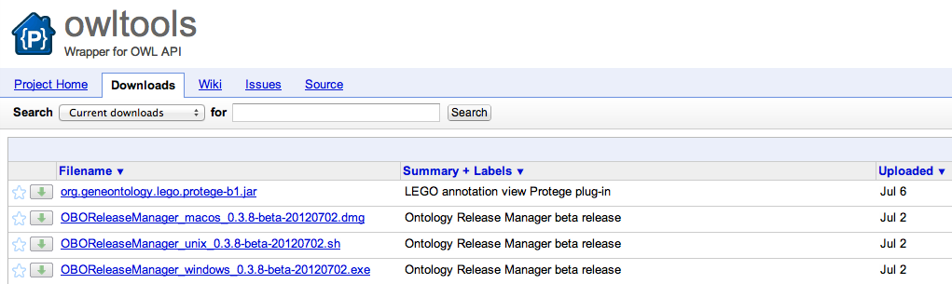

Select the version for your system and follow the installation instructions (use all default settings).

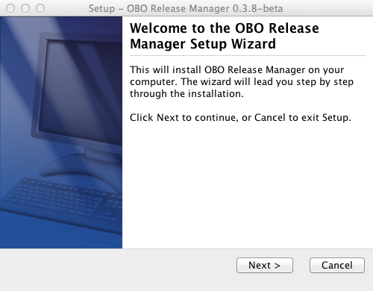
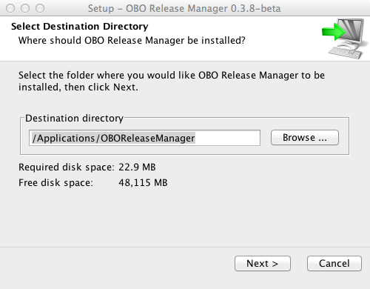

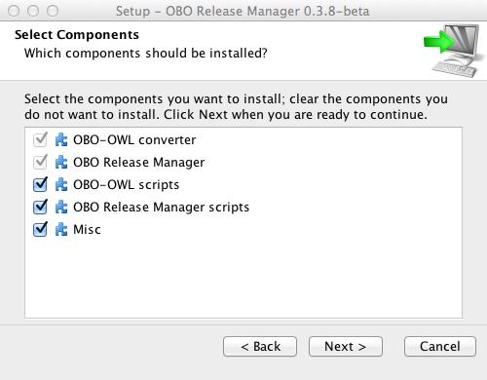

NOTE: you will get the invaluable OBOtoOWL converter with the OORT installation. There are some directions about this component below.

2) With Protégé, open the eagle-i ontology ero.owl
You find it in the SVN under material_for_course/fri/tutorial/EI/core/ero.owl in the SVN

3) Merge all the files into one single file.

- Select the “Merge ontologies…” option under the “Refactor” menu:
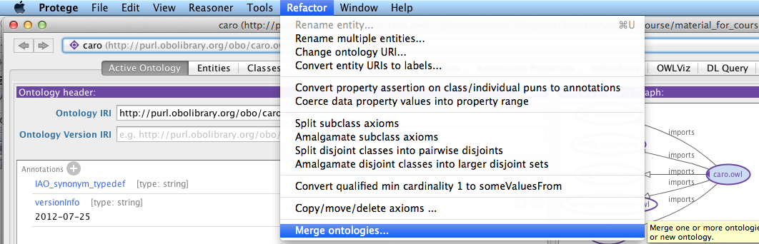

- Select all the ontologies (Shift + Click) and click to Continue. Make sure to scroll down to select all the imported ontologies.
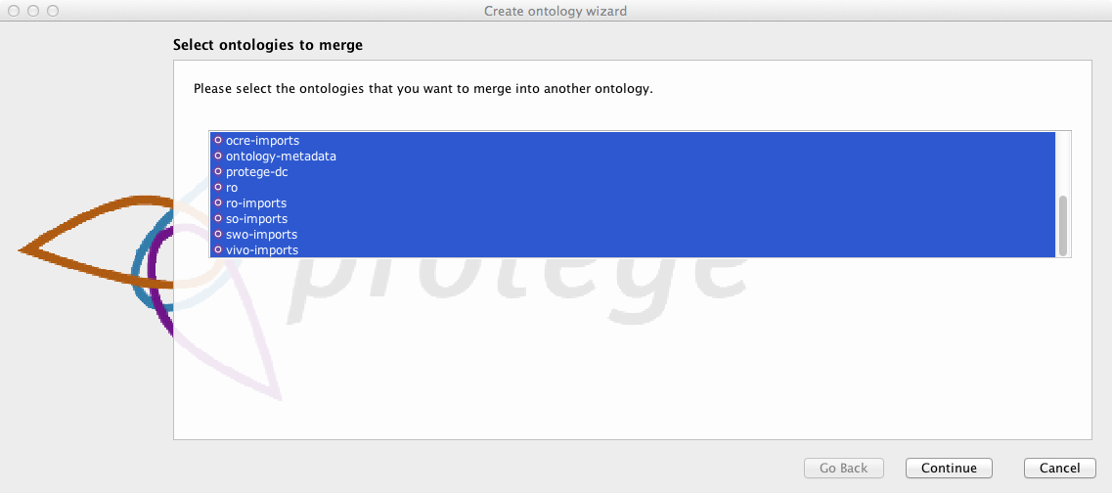

- When prompted, select “Merge into new ontology” and click “Continue”
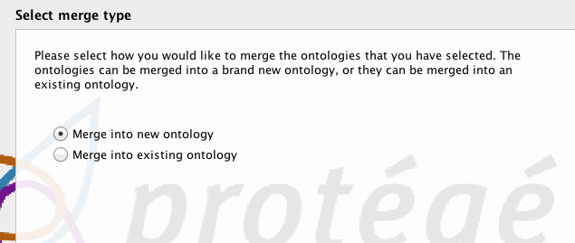

- Change the Ontology IRI and the version IRI as in figure below and click on Continue.
Ontology IRI: http://purl.obolibrary.org/obo/ero_test_release.owl
Version IRI: http://purl.obolibrary.org/obo/ero/releases/2012-08-01/ero_test_release.owl

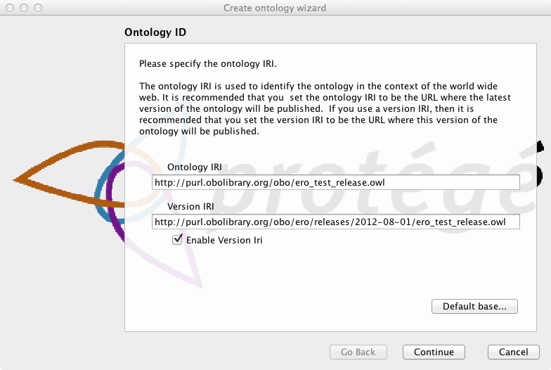

- Create a folder called “merged” under your local machine.
- Select that folder in the “Physical Location” dialog (shown below) and click on “Continue”

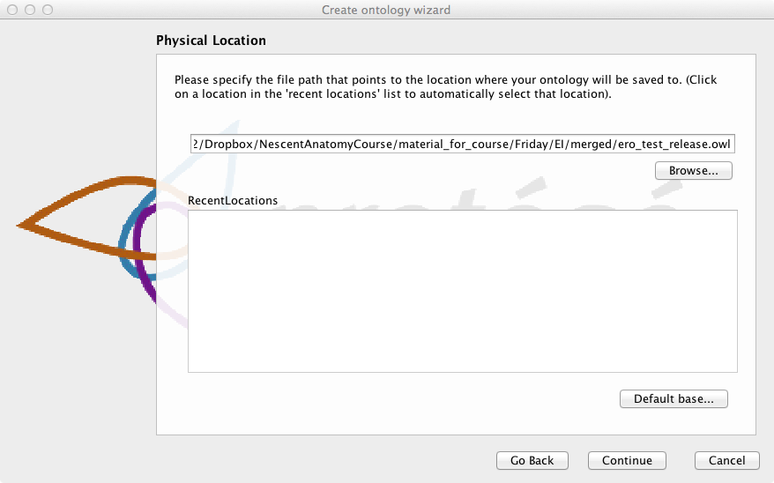

- Select RDF/XML as format and click on Continue.

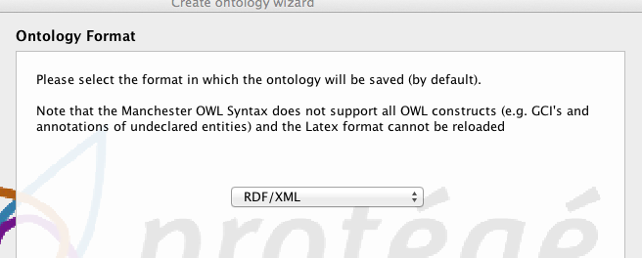

- Choose “Save as” in Protégé and select the /merged directory.
Save the ontology as “ero_test_release.owl. Yes, Protégé should have saved it already but it doesn’t. ;-)!!!!!!

4) Open the OBO Release Manager by navigating to the location you’ve installed it and double clicking it

5) On the landing screen, click “Add File” and select the ero_test_release.owl

6) Change the output folder to /ero/releases by clicking on “Select” button. Create the directory if it doesn’t exist.

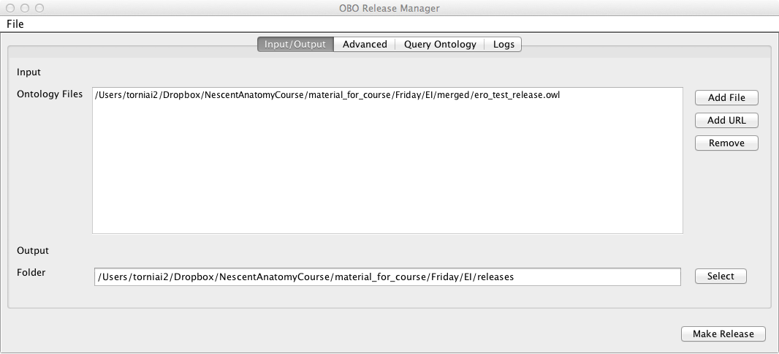

In the “Advanced” tab, select the following options:
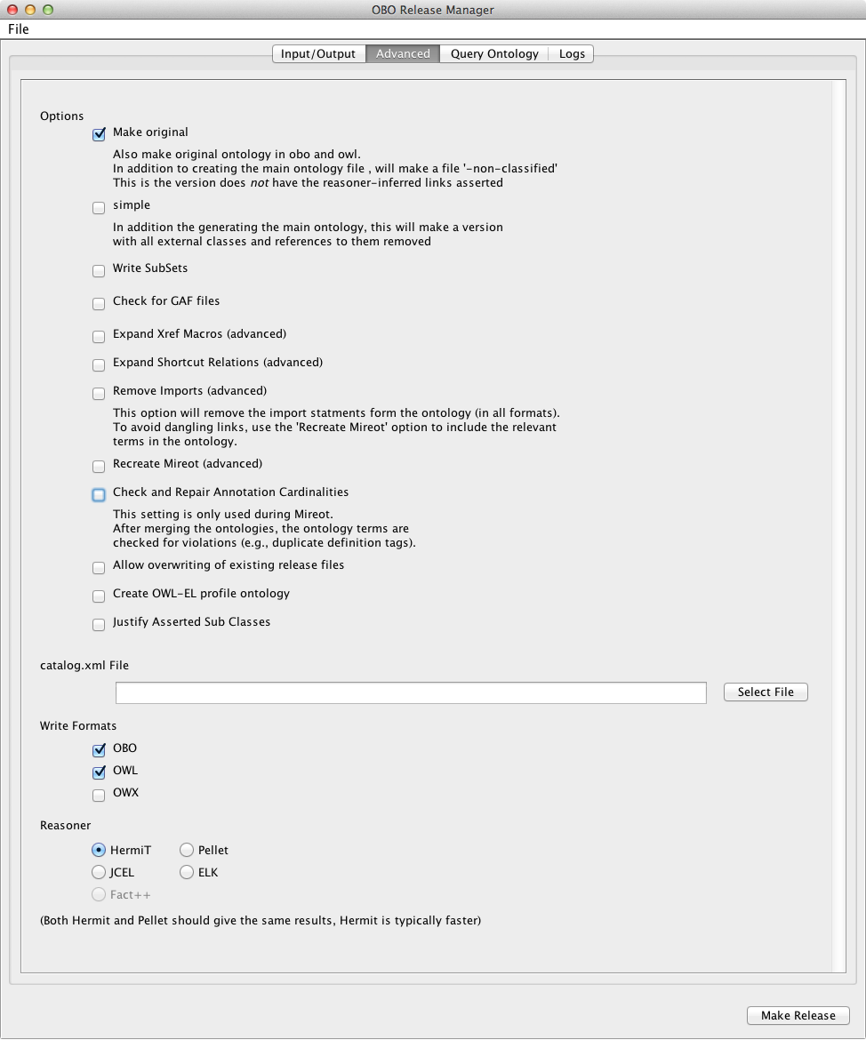

Click “Make Release.”

8) Inspect the released files. The files are under releases/releases/2012-08-01
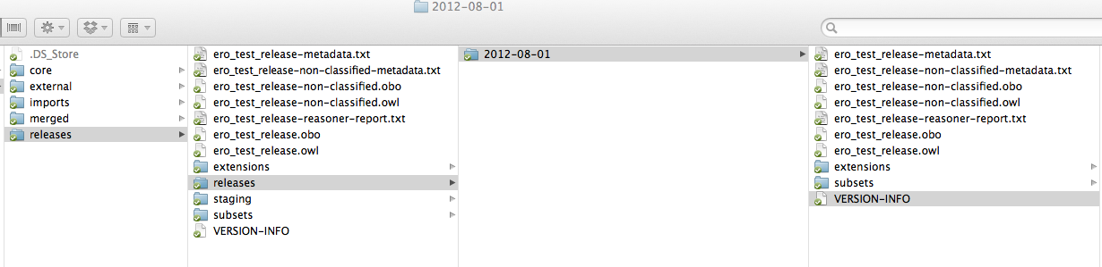
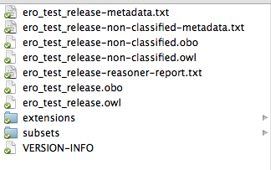

9) Compare the ero_test_release.owl with ero_test_non-classified.owl. In particular, expand the hierarchy under ‘material entity’ in ero_test_non-classified.owl and find the terms that are absent from the hierarchy under ‘material entity’ in the ero_test_release.owl file.
Also compare the defined classes under the class ‘instrument’ across the two files.

The OBO to OWL converter

1. Find where you installed Oort, and identify the obo to owl converter. Locate a local OBO or OWL file, as well as a target location. At the bottom choose the appropriate direction. It’s pretty straightforward from there…

