Initial Preparation

These exercises were tested under Protégé 4.2 beta 278.

Exercise files will be downloaded via SVN as directed by the instructors. [svn repository to be made publically available and listed here]

The tutorial was given in conjunction with associated slides (available: [to complete]) and accompanying discussion/lecture.

OntoFox Tutorial

1) Go to the OntoFox page http://ontofox.hegroup.org/index.php

2) Select the ontology “NCBI organismal classification (NCBITaxon)” (1). Select the term ‘Homo sapiens’ from the NCBI Taxonomy in the low level source term field (2a). To specify the superclass of our ‘Homo sapiens’ term, search for ‘Homo sapiens’ again in field 2b. In this example, we would like to specify that ‘Homo sapiens’ is a direct subclass of the OBI class ‘organism’ (use OntoBee to determine the term appropriate URI from OBI). Once you’ve found the correct URI, copy and paste it into field 2b as shown in the figure below.

Hint: In order to save time you can select “Example 1” on the OntoFox page and modify the value of the input to match the figure below

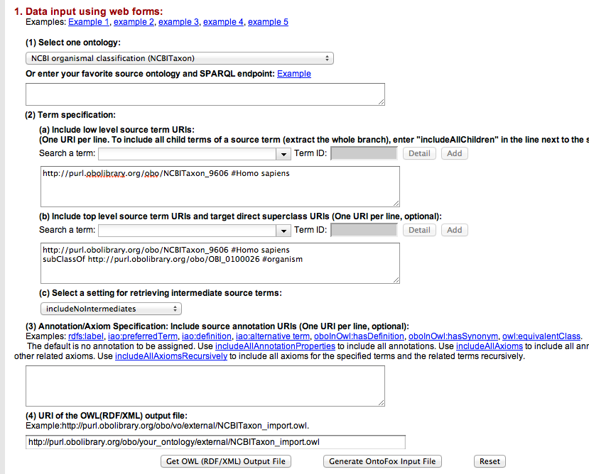

3) For this example, be sure to change field 2c, the settings for retrieving intermediate source terms, to “includeNoIntermediates” and that field 3, a field used to specify which annotations and axioms to include, is empty as shown in the figure above.

4) You are now ready to generate the OntoFox input file. Do this by clicking the button labelled “Generate OntoFox Input File”. Copy/paste (or just click save as from your browser) and save this text on your machine using your preferred text editor.

The text generated by OntoFox should look like the following content:

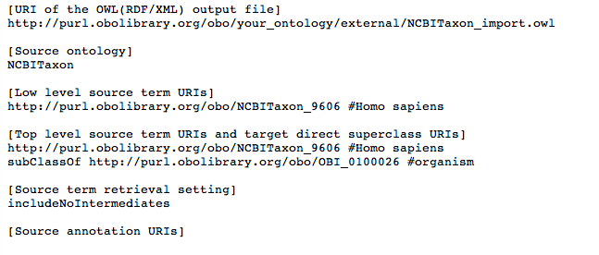

With the actions to this point, you’ve created a simple text file which can be used to access OntoFox programmatically.

Sometimes it is useful (in particular when you have complex mappings to Annotation ontologies and a long list of terms) to save this input text file and modify it manually, and to pass it back to OntoFox in the form of your text file instead of re-entering your terms into the web interface as we’ve done in this example.

5) You are now ready to use OntoFox to generate an .owl file for our example NCBI Taxon imports. To do so, open the OntoFox window you used in steps 1 and 2, scroll so that field 4 is in view and click the higher of the two “Get (RDF/XML) Output File” buttons visible on the screen.

6) In the new browser window that opens, right click on the hyperlinked “the output file” text to download your .owl output file. Select the “Save Link As” option and rename the file as “homo_sapiens_simple.owl” to your desktop or to another folder in your machine.

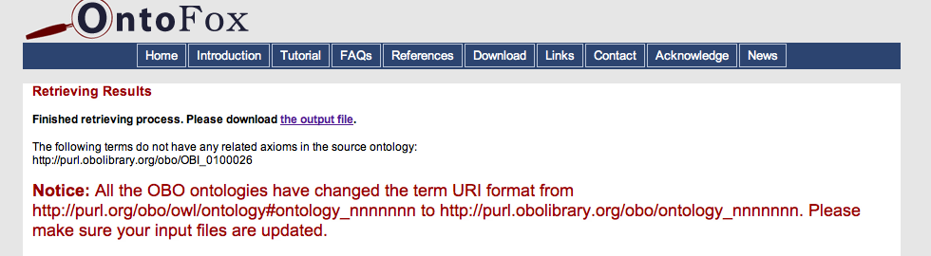

Open Protégé, find the file that we’ve just generated, and inspect the file. It should look much like the figure below.

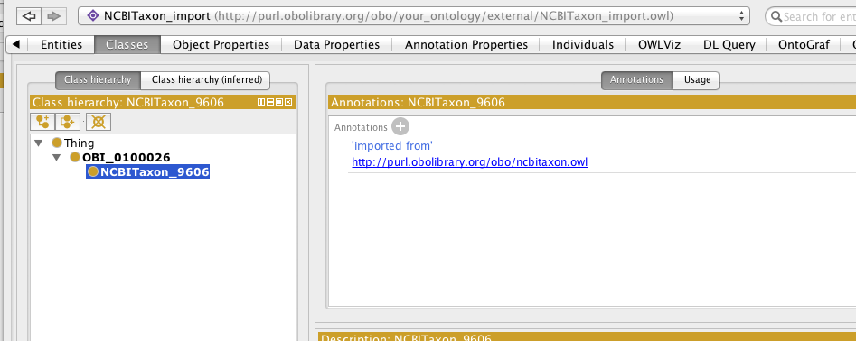

You should notice that the file we’ve generated is completely without annotations. For the settings we chose, we’ve generated an import file which includes only the class declaration as subClassOf the OBI organism class.

This is nice, but OntoFox offers much more than simply managing the hierarchy of imports. Now, let’s add some metadata.

7) Going back to the OntoFox page we used in the first example, change the value in field 3 to all annotation properties by clicking on “includeAllAnnotationProperties”. The screen should look the same as the figure below.

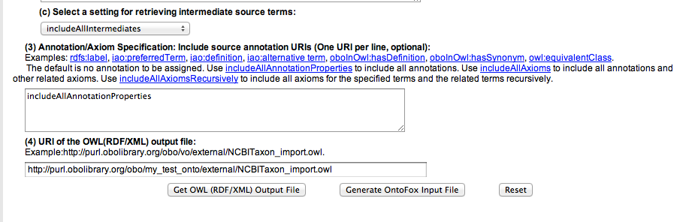

Note that the dialog box of intermediate source terms (field 2c) will change to “includeAllIntermediates” (it won’t affect the result in this case).

8) As before, click the “Get OWL (RDF/XML) Output File” below field 4, saving it to your desktop (see step 6 above for a refresher). Open the file in Protégé. Notice that now labels, as well as declarations of Annotation Properties, are included in the .owl file.
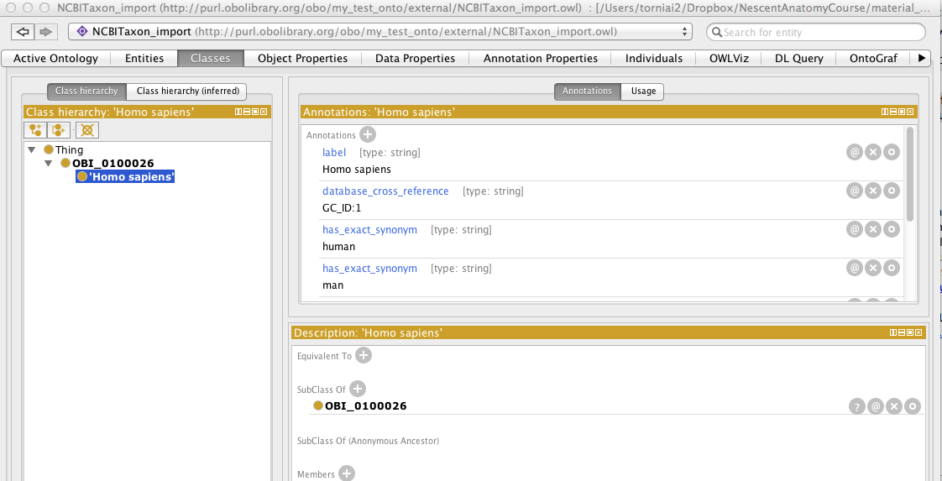

Let’s add some complexity. Assume that we would like to have some additional taxa and not just Homo sapiens as organisms in our new ontology.

9) To do this, we can modify the OntoFox input by making Homo sapiens a subclass of Eukaryota and including a hierarchy below Organism.

10) Configure the web form as follows:
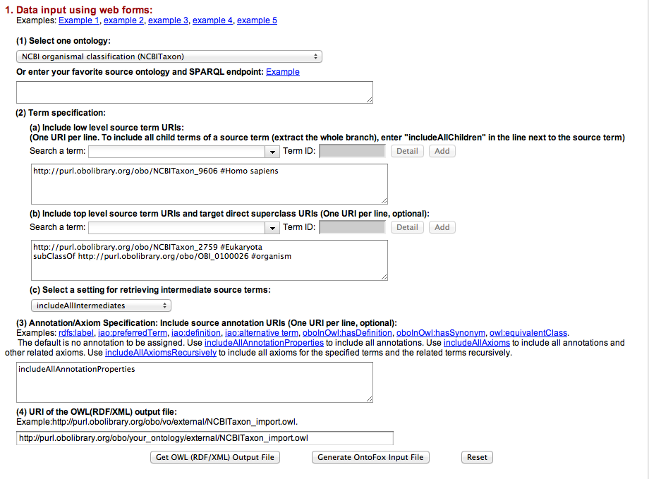
11) As before, save the output file and open it in Protégé.
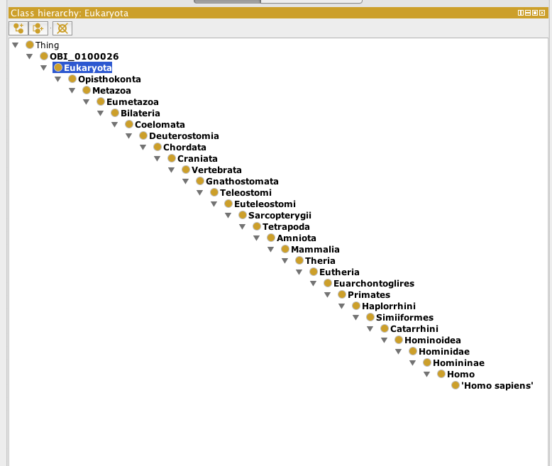
As expected, you have now included all of the hierarchy between Homo Sapiens and Eukaryota.

12) Let’s do something else. Let’s import all the subclasses of the term ‘organ growth’ from GO. In order to do this, you should have the web interface configured as follows:

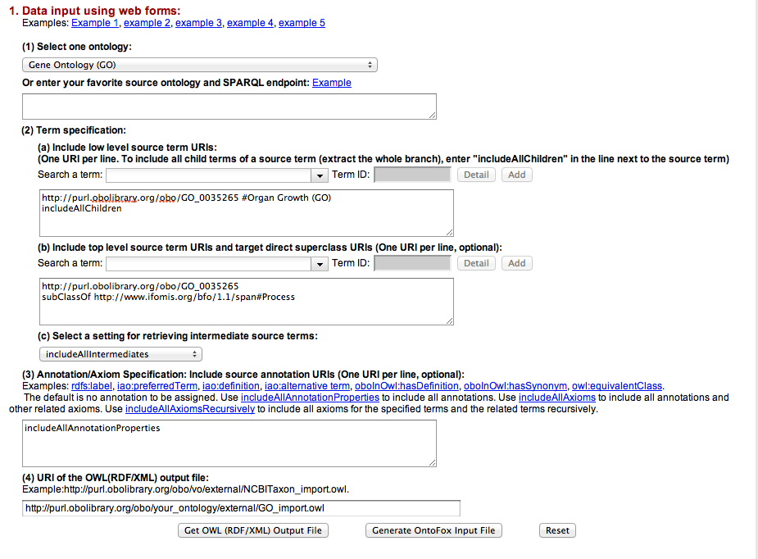

13) Save the output and open the file in Protégé. As you will notice, there is a class you may not expect to see. Why is that class there?
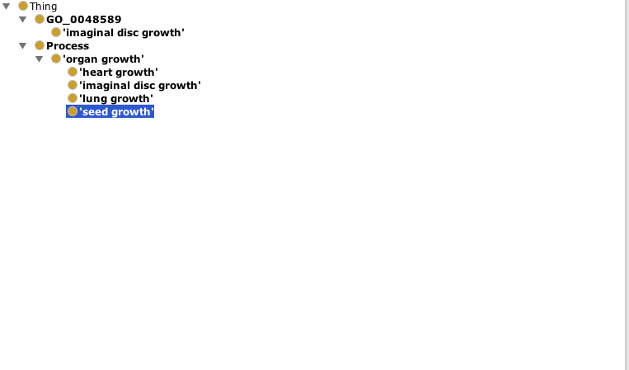

Now, a simple example on how to map Annotation values to different Annotation properties.
You might have noticed that this file includes the created_by property (http://www.geneontology.org/formats/oboInOwl#created_by)

What if our ontology uses the IAO property ‘editor’ instead? To solve this problem, we can map the created_by values of to the term ‘editor’ in IAO. (http://purl.obolibrary.org/obo/IAO_0000117)

14) To accomplish this, change the OntoFox web input as below (note the changes to field 3):
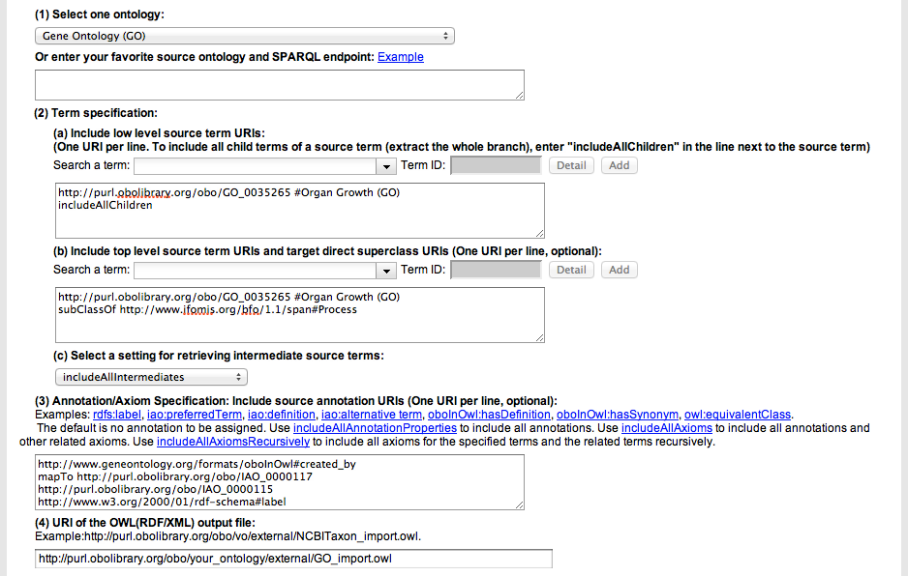

Note that in removing the “includeAllProperties”directive, OntoFox requires that you list all the properties you would like to include as shown below in the “Source annotation URIs” field:

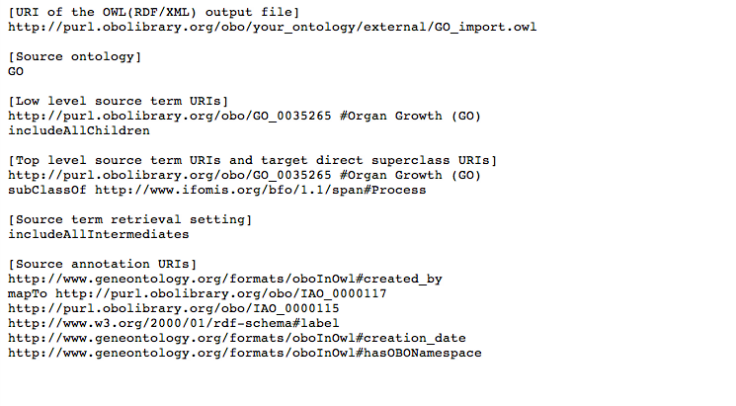
15) Open the file in Protégé and verify that the annotation property has been mapped.

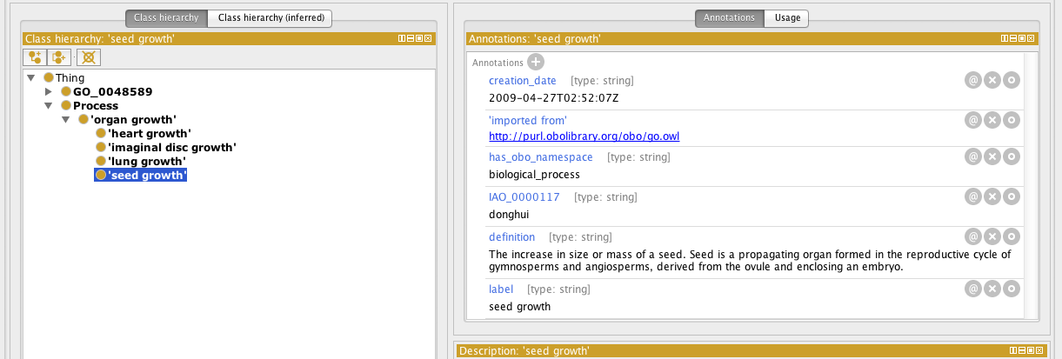

EXERCISE: OntoFox

Open the read me file under ontofox_exercise and follow the instructions there.

