# EXERCISE: Create and classify individuals

- Create a new ontology.

- Give it the IRI: <http://purl.obolibrary.org/obo/test_instances.owl>

- Create the following Classes as Subclass of Thing:

- cell

- muscle

- tendon

- bone

- Now go to the Object property panel. Create the object property ‘attached_to’ with:  
Domain: muscle and Range: bone

To do this, click the + sign next to Domain (Restriction) and Range (Restriction) respectively and select the proper class.

- Let's create some individuals. Go to the Individuals tab. Create an instance named ("my_muscle"). To do this, click on the diamond symbol with a + in the left corner of the Individuals panel (see picture below).

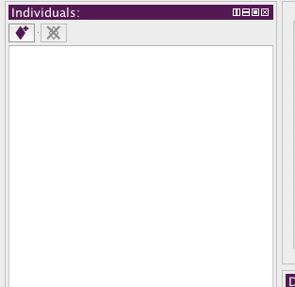

- Assert that that instance is of Type (Class) muscle: click on the + symbol next to “Types” under the description panel and selecting the class muscle in the dialog (make sure you have the newly created ‘my_muscle’ individual selected).

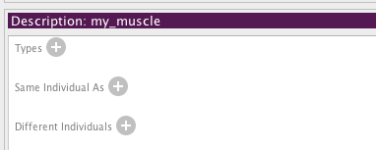

- Create another individual named ‘my_bone’, in the same way you created the ‘my_muscle’ individual. **Don't assert any type (class) for that.**

- Now select again the ‘my_muscle’ individual and add an Object property assertion in the Property Assertion panel.

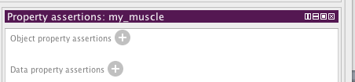

- Click on the + sign next to Object Property assertion. Then select the attached_to property and the my_muscle instance as in the picture below:

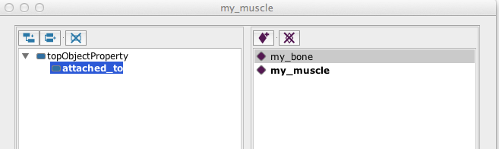

- Save the file in your personal folder.

- Now start the Reasoner (make sure you have Hermit selected).

- Inspect the type of bone.

What is inferred? What are my_bone and my_muscle types of?

- Play around a bit creating more properties, instances and defined classes as you wish.