OBOEdit tutorial Answers

## Exercise 1: Searching ontologies

1. Search ZFA for any text field contains = “kidney”.
   1. What are the synonyms of “head kidney” and of what type are they?

*Anterior kidney, kidney marrow, both exact synonyms.*

* 1. What are the parents (any type of relation) of “head kidney”?

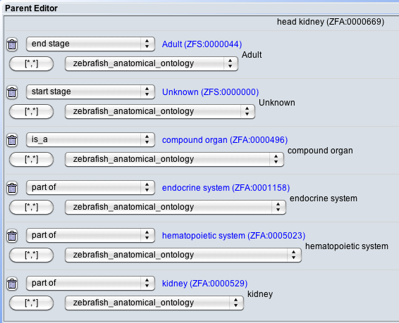

* 1. In which fields does ‘pronephros’ reference the string “kidney”?

*In both the Definition and in a synonym “embryonic kidney”.*

1. Search for all the parts of the retina. To specify your search, click the button with the gear icon under the search box.

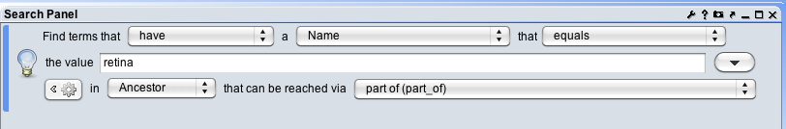

* 1. How many results do you get? *27 results*

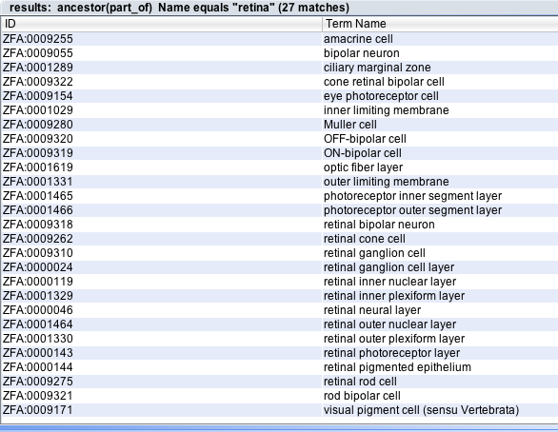

* 1. Look at the details of the first result. Is “retina” an immediate parent of this term? If not, why did it appear in the search results?

*No it isn’t an immediate parent. It is part_of the retinal inner nuclear layer, which is part_of the retinal neural layer, which is part_of the retina.*

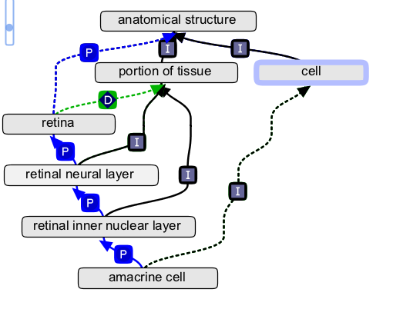

1. Add to the search criteria for #2 using the **+** button at the lower-left of the Search panel. Find terms that are part of the retina and have “cell” in their name.

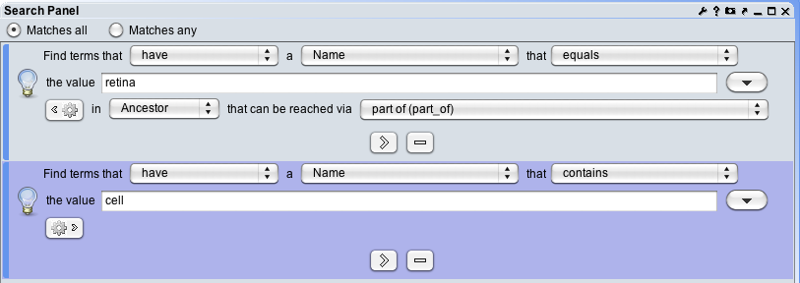

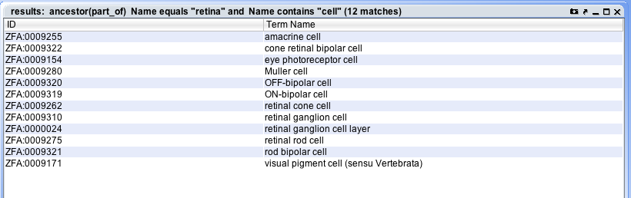

1. Find all classes that have been asserted to be subclasses of the class CL:cell. * Note that while the results of this query may be similar to that shown above, you will need to leverage file header subclass assertions. Show your work. Explain why the resulting results number is different than the example shown above (where we searched for all classes that were subsumed by the class “cell”).

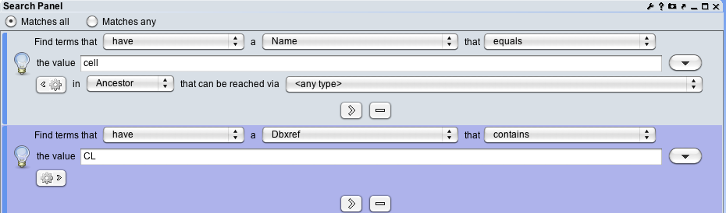

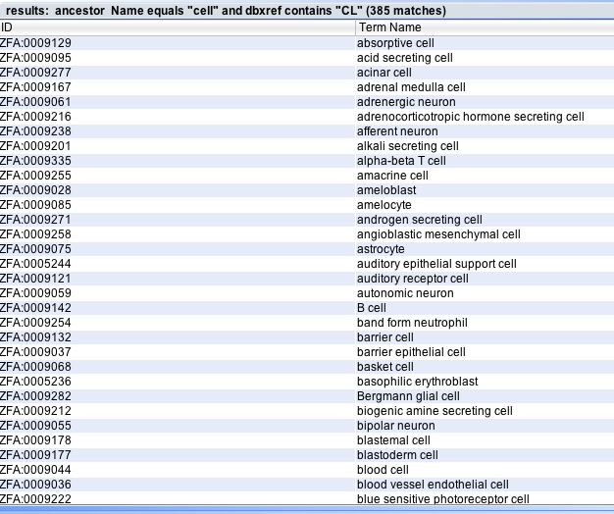

1. Bonus Question: Find anatomical structures that start their existence at ‘Pharyngula:Prim-5’ and are present until ‘Adult’ OR have an ‘Unknown’ stage ending? HINT: This is a nested query. How many results do you get?

*This is a tricky question, because you have to first use a nested query that looks for classes with a ‘Pharyngula:Prim-5’ start stage AND (‘Adult’ endstage OR ‘Unknown’ endstage). Then, you also have to know to look for parents and not ancestors, since the stage relation is not transitive, we are interested in only those that have an immediate relationship to the given stages.*

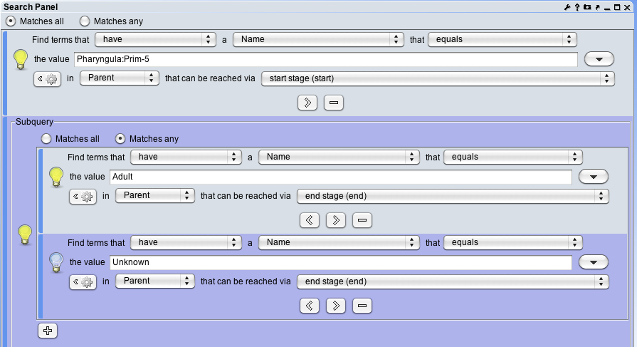

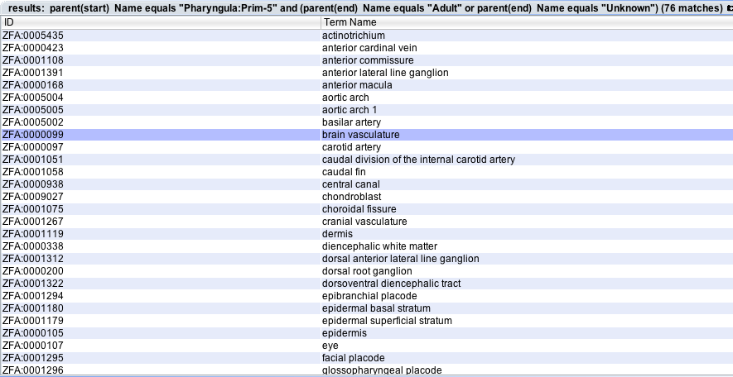

## Exercise 2: Combining search, rendering, and the Graph Editor and Tree Editors.

1. In the Graph Editor, color classes that have Xrefs to TAO, CARO, and CL differently. Take a picture showing your colourful distribution of classes using the camera icon in the upper right corner. Include classes with no xrefs, one xref of each, and multiple xrefs. NOTE: There are a lot of Xrefs to TAO because it was cloned from ZFA. What happens when there are Xrefs to more than one ontology?

Here are the filters:

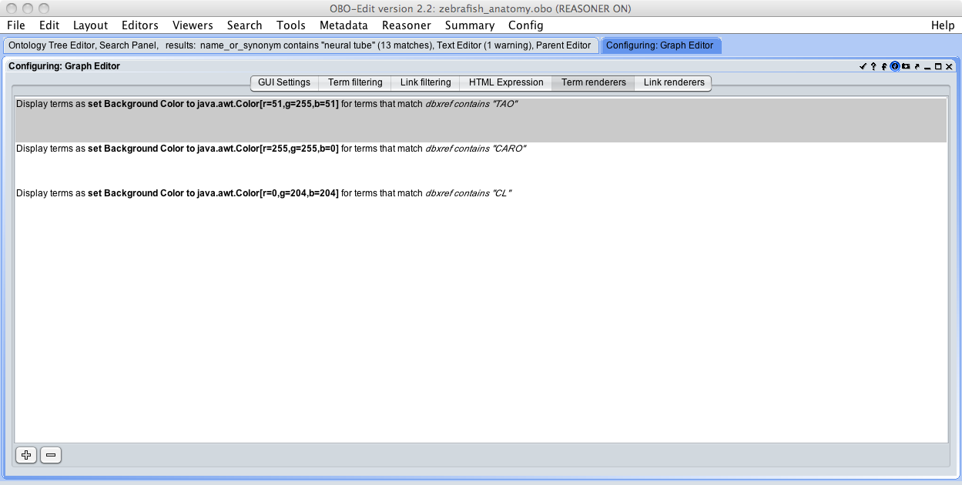

And here is the resulting display. *Note the color blending between classes with multiple Xrefs.*

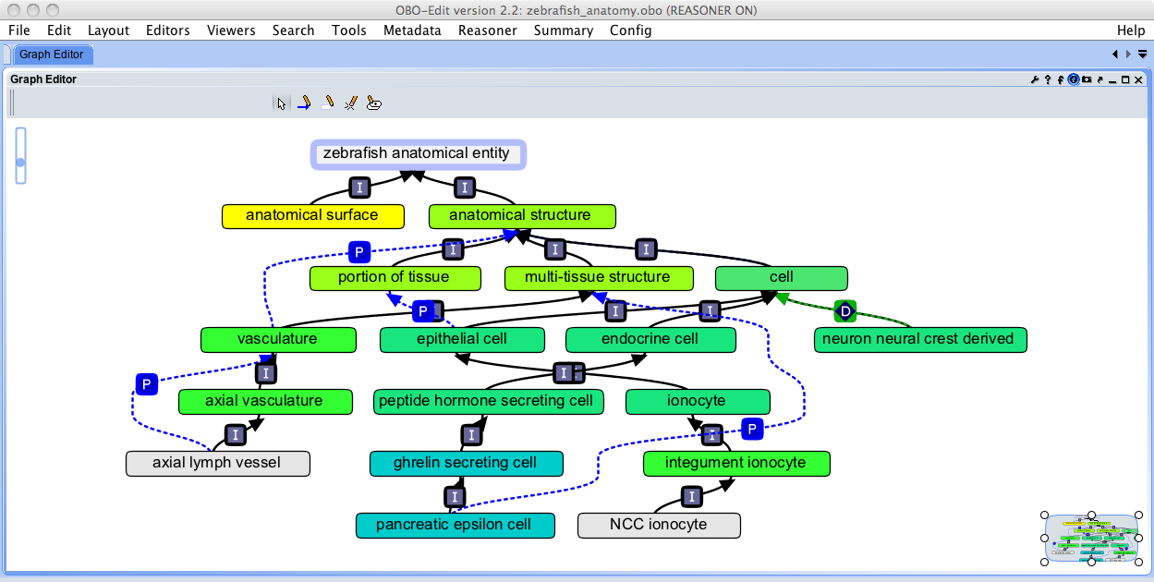

1. In the Tree Editor, color code classes that develop_from ‘mesoderm’ and are types of ‘compound organ’.

Here is the filter configuration:

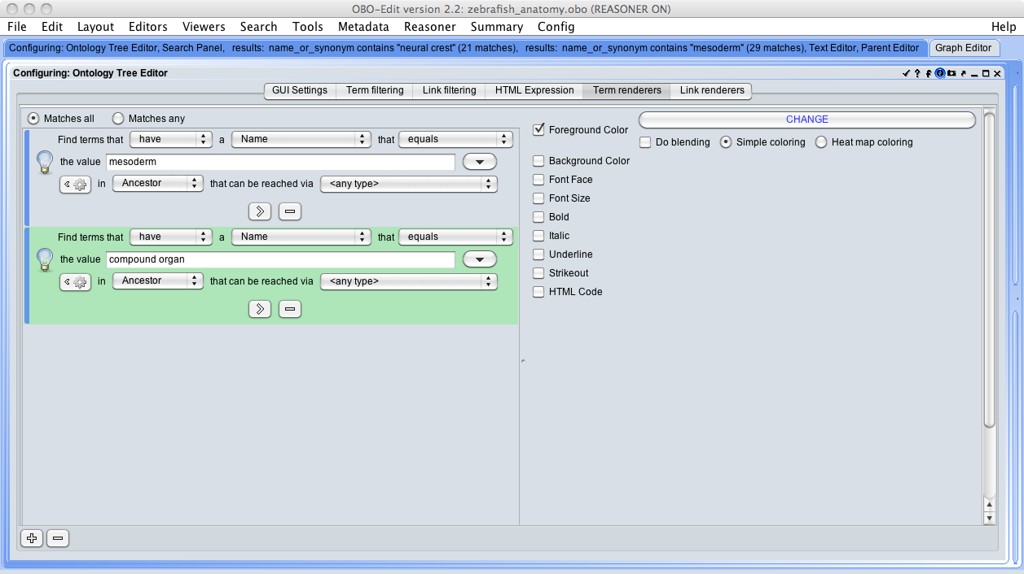

And here is the result:

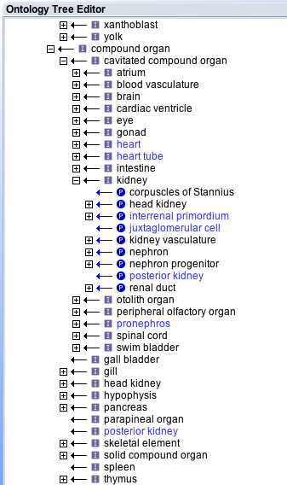

Can you see how it can be helpful for troubleshooting in that obviously mesodermally derived organs are not labelled – indicated that they need to have the develops_from relations added (For example, ‘skeletal element’).