Initial Preparation

These tutorial and related excercise tested under Protégé 4.3 build 304.

Exercise files will be downloaded via SVN as directed by the instructors.

The tutorial was given in conjunction with associated slides (available at material_for_course/thur/imports_mireot_ontofox.ppt) and accompanying discussion/lecture.

Installing and configuring OWLViz

The following steps will help you to install the GraphViz plug-in to view and manage your imports. Note this is optional for the tutorial but it will help you to visualize the imports chain.

1) Download and install the GraphViz executable files

Windows: http://www.graphviz.org/Download_windows.php
Mac: http://www.graphviz.org/Download_macos.php

For instance, for Mac you will need to:

- download the .pkg for your version of MacOS using the link above

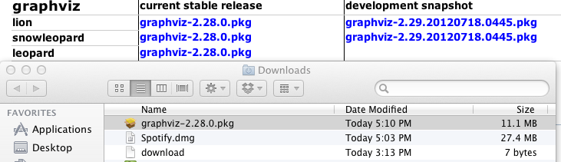

- double click on the .pkg file
- follow the instructions on screen until the installation process ends successfully

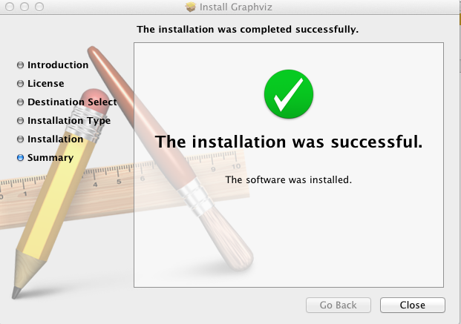
- configure Protégé by Selecting -> Protégé -> Preferences > OWLViz and setting the Path to /usr/local/bin/dot (note that Windows and Unix users will need to set the path according to their specific setup)

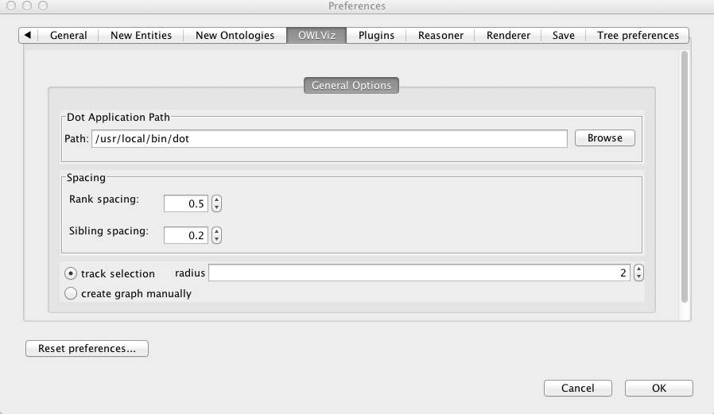

- Go to the Active Ontology Tab and select from the menu: Window > Views > Ontology views > OWLViz Imports Graph (as in figure below)

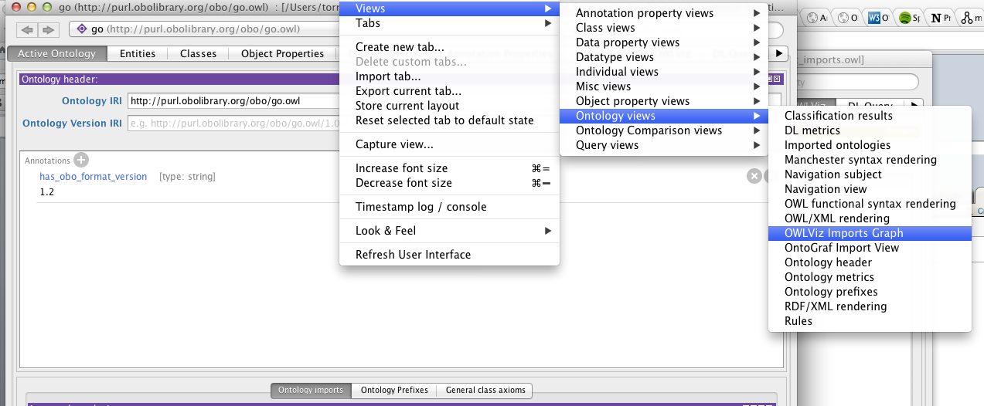

- Place the panel on the right of the Active ontology view:

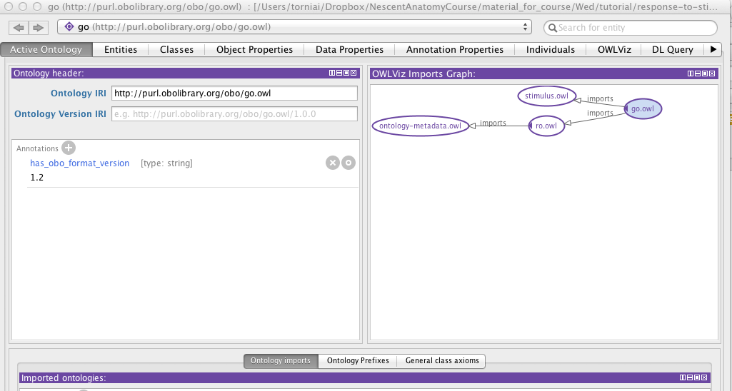

Importing external Ontologies in Protégé

- In Protégé, open the file under: /thur/imports_exercise/caro_2/caro_2.owl

The imports diagram you see should look like the following:

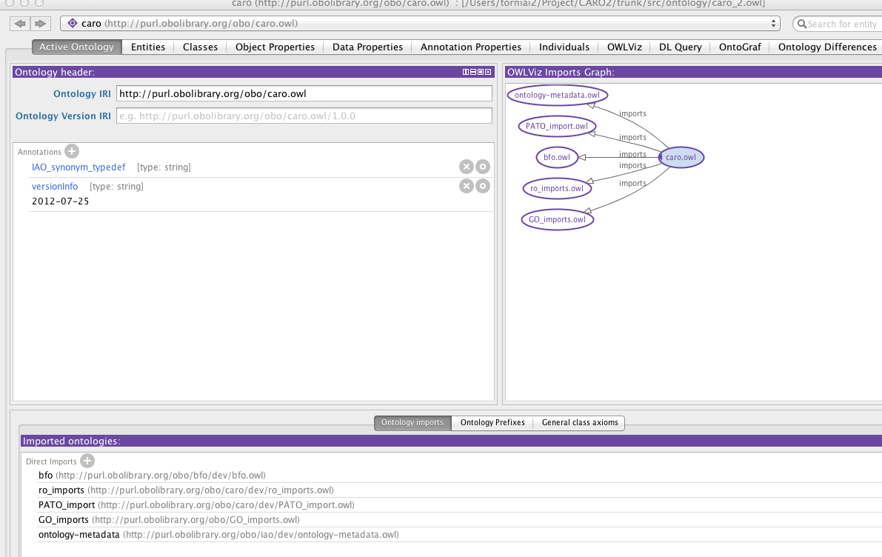

Notice the panel about imported ontologies at the bottom of the window.
As discussed, the ontologies are referenced in the file by the <owl:imports> directive. In order to understand, in this case, if the ontologies are loaded form a local file or from the web, you need to check where the ontology sources live. This can be done by viewing the ontology sources (found under File > Loaded ontology sources…).

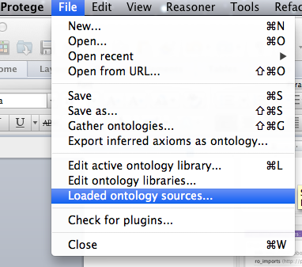

In this case you will notice that all the ontologies are loaded form a local source:

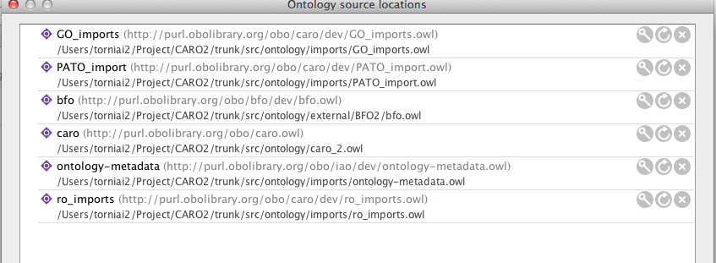
Note that the local path of the ontology files is shown together with the ontology IRIs.

How does Protégé know where to get the ontologies?
The answer is: the ontology libraries.

Ontology libraries

Having to wait for Protégé to download ontologies from the web can be rather time consuming. Luckily, Protégé has a mechanism for you to define ontology libraries that enable you to store mapping between ontology IRIs and files on your filesystem. You can create, edit, or view your ontology library via the File -> Edit ontology libraries… menu item.

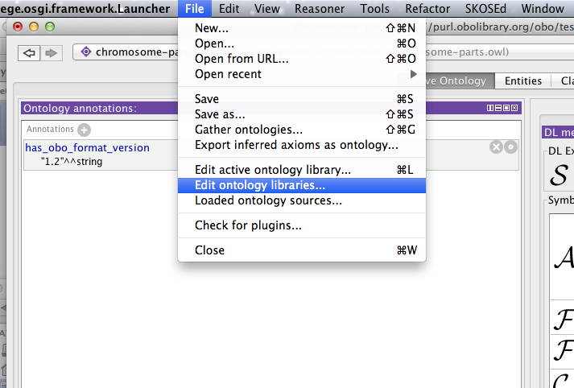

Ontology libraries are stored in a file on your system called catalog-001.xml. When you start working with Protégé, you will begin to notice many of these files cropping up on your file system. Go to Protégé > File > Edit ontology libraries...
Choose the catalog-001.xml file under the caro2 directory. A panel with the Ontology libraries will appear (see the Figure below).
From this panel, you can see all the mappings between ontologies and physical files.

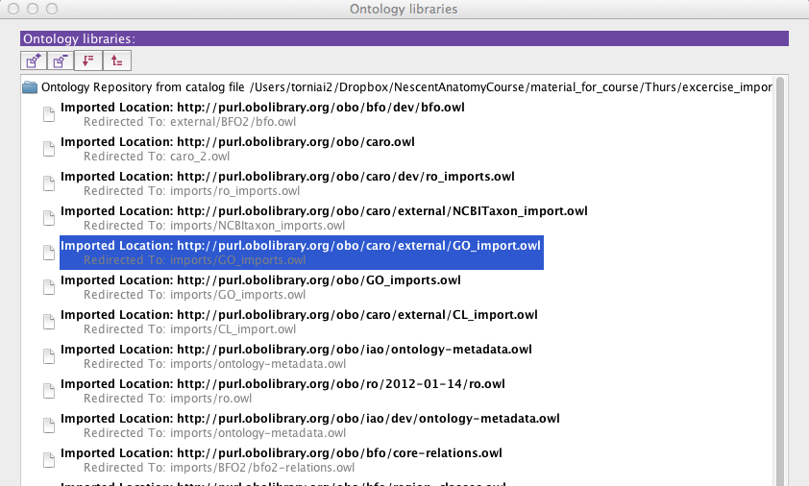

From this window, you can also add additional files to the ontology library.
Click on the + icon on the top left corner. The following dialog box will appear:

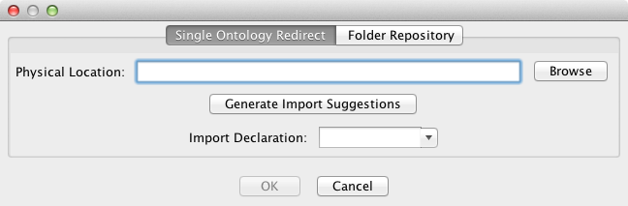

Choose the Single Ontology Redirect tab, and click on “Browse”.
Under /course_material/thur/imports_excercise/caro2/imports/ select NCBITaxon_imports.owl
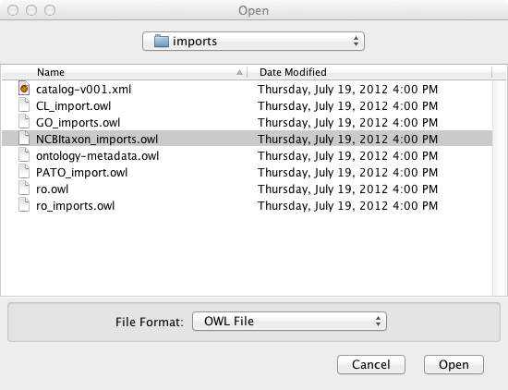
Click on “Open”.
Click on “OK” on the previous dialog:
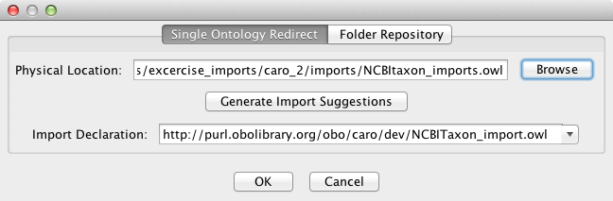

Now you will be back on the Ontology Library panel and you will see the NCBITaxon_imports.owl at the top:

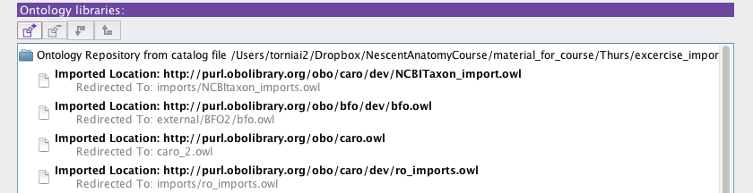

Now, you can import the file you’ve added through the ontology library.

Go to the “Active Ontology” panel in Protégé when you have the caro2.owl file open. Click on the + sign under Imported ontologies, next to Direct Imports:

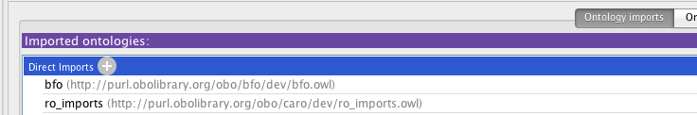

In the “Import type” dialog select “Import an Ontology that is contained in one of the ontology libraries” and click “Continue”:

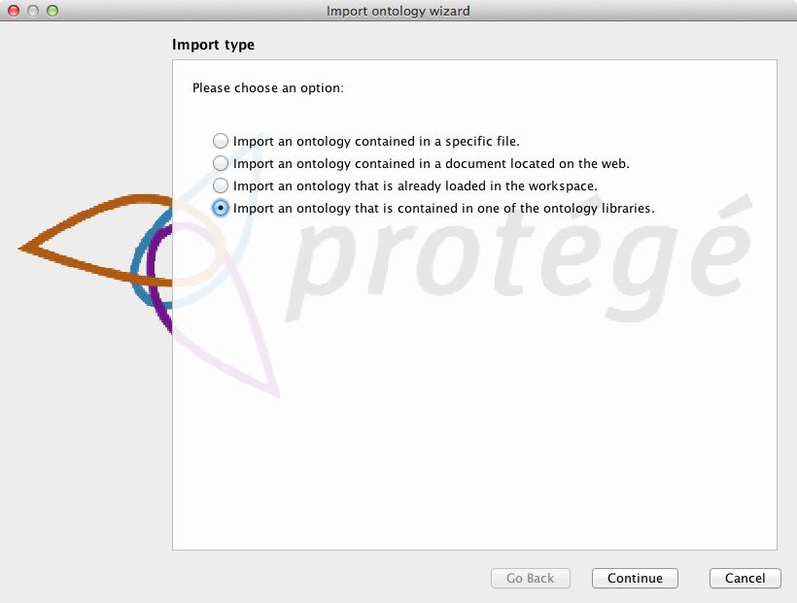

Select the NCBITaxon_import.owl from the list by clicking and highlighting it, and click on “Continue”:
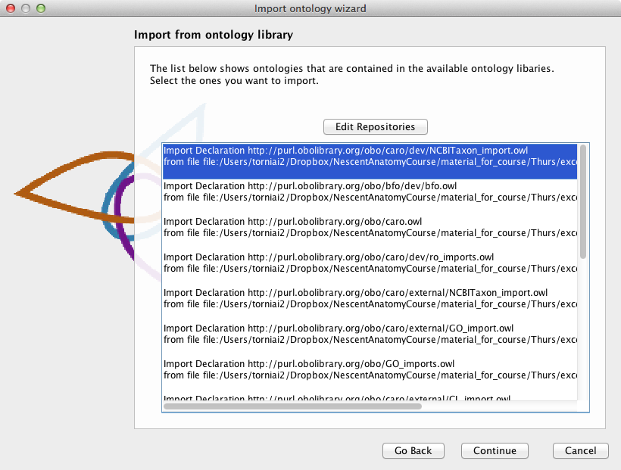

Click on Finish in the next dialog.

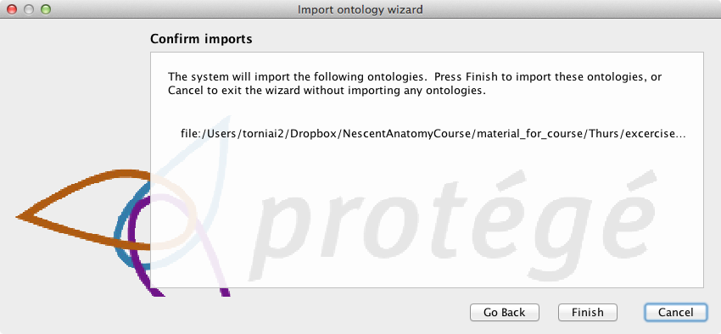

Now, you can see the NCBITaxon_imports.owl in the imports chain.

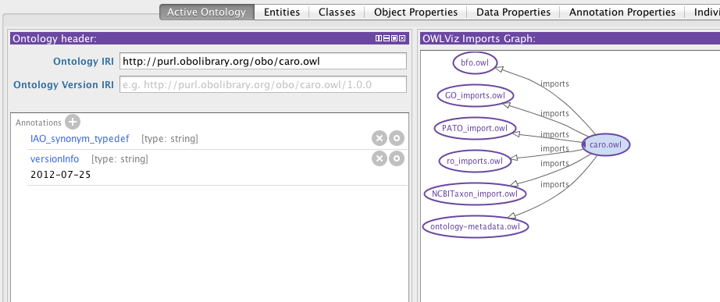

EXERCISE: Playing with imports and Protégé catalog file

For this exercise you will need to go to the material_for_course/thur/imports_excercise and follow the instructions in the README.txt

