Software Requirements Specification

for

MyHealthCare

Version 1.0 approved

2022. 05. 04

Table of Contents

Table of Contents ii

1. Introduction 1

1.1 Purpose 1

1.2 Document Conventions 1

1.3 Intended Audience and Reading Suggestions 1

1.4 Product Scope 1

1.5 References 2

2. Overall Description 2

2.1 Product Perspective 2

2.2 Product Functions 2

2.3 User Classes and Characteristics 2

2.4 Operating Environment 3

3. External Interface Requirements 3

3.1 User Interfaces 3

3.2 Hardware Interfaces 4

3.3 Software Interfaces 4

3.4 Communications Interfaces 4

4. System Features 4

4.1 System Feature 1 4

4.2 System Feature 2 4

4.3 System Feature 3 4

4.4 System Feature 4 5

4.5 System Feature 5 5

4.6 System Feature 6 5

4.7 System Feature 7 5

4.8 System Feature 8 5

4.9 System Feature 9 6

4.10 System Feature 10 6

4.11 System Feature 11 6

5. Other Nonfunctional Requirements 6

5.1 Performance Requirements 6

5.2 Safety Requirements 6

5.3 Security Requirements 7

# Introduction

## Purpose

The purpose of this document is to give a detailed description of the requirements for the “MyHealthCare” software, which is a well-structured platform for the health industry, with the scope to facilitates the interaction and communication between the client and the employees of this industry.

This Software Requirements Specification document will illustrate the purpose and complete declaration for the development of system. It will also explain system constraints, interface and interactions with other external applications. This document is primarily intended to be proposed to a customer for its approval and a reference for developing the first version of the system for the development team.

## Document Conventions

|  |  |
| --- | --- |
| **Term** | **Definition** |
| User | Someone who interacts with the mobile phone application |
| Admin/Administrator | System administrator who is given specific permission for managing and controlling the system |
| Employee of health indusrty | Someone who working in the health industry |
| DESC | Description |
| RAT | Rational |
| DEP | Dependency |

## Intended Audience and Reading Suggestions

This project is a prototype for the health industry management system. This has been implemented under the guidance of a college professor. This project is useful for the employees of health industry and as well as to the clients.

## Product Scope

The purpose of the online health management system is to ease health management and to create a convenient and easy-to-use application for clients, trying to make appointments. The system is based on a relational database with its health management and reservation functions. We will have a database server supporting many major hospitals around the world as well as many medical employees in various departments. Above all, we hope to provide a comfortable user experience along with the best service available.

## References

List any other documents or Web addresses to which this SRS refers:

* <https://krazytech.com/projects>
* http://www.cse.chalmers.se

# Overall Description

## Product Perspective

This system will consist of two parts: one mobile application and one backend service. The mobile application will be used to find the proper service and view information about them while the backend service will be used for managing the information about the appointments and the system as a whole.

The mobile application will need to communicate with a database through an API, and with the firebase authenticator to solve registration, log-in, reset password scenarios.

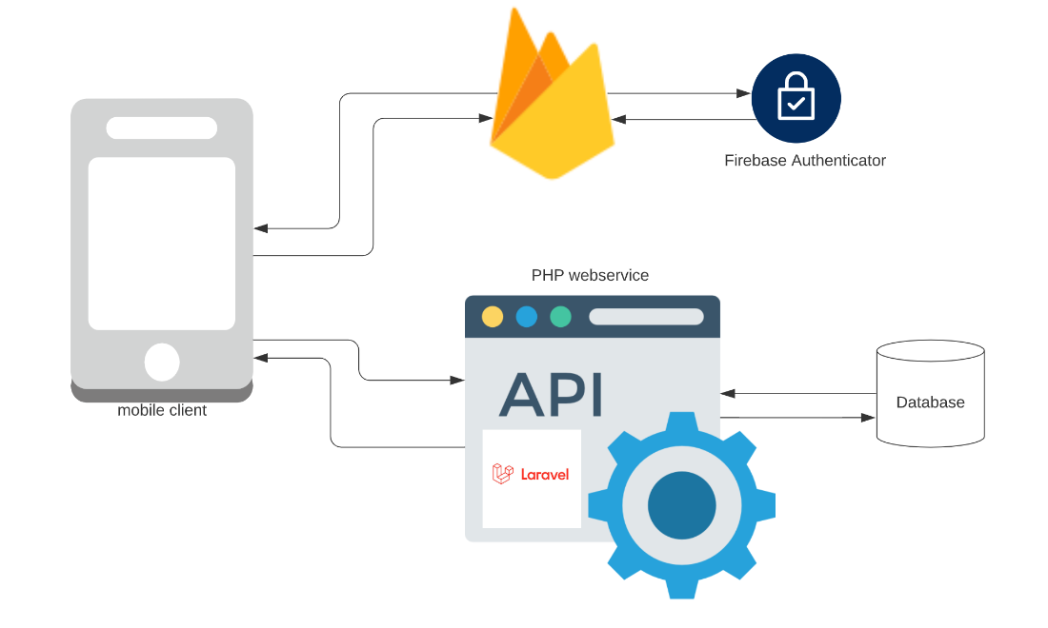

Figure 1 - Architecture

## Product Functions

With the mobile application, the users will be able to search for hospitals, and within that for medical departments. The result will be based on the criteria the user inputs.

The result of the hospitals search will be viewed in a list view. The list view will have one list item for each hospitals matching the search criteria. For the medical departments the search is the same as for the hospitals. After selecting the hospital and the medical department the user will be able to make the appointment by selecting the doctor, the date and the hour of the appointment.

## User Classes and Characteristics

There are three types of users that interact with the system: clients, employees of the health industry and administrators. Each of these three types of users has different use of the system so each of them has their own requirements.

The clients can only use the application to find a restaurant. This means that the user has to be able to search for the suitable treatment, choose a hospital, a medical department, and after that a medic from that search and then navigate to it.

The employees of the health industry will use the mobile application too. There they will get notified about their appointments, they get information like the client's data, the day and the hour of the appointment.

The administrators don’t have an interface to interact with. Implementing that type of interface will be our software next step.

## Operating Environment

Operating environment for the MyHealthCare system is as listed below.

* Operating system: Android
* Database: MySQL database
* Platform: Kotlin
* Backend: PHP

# External Interface Requirements

## User Interfaces

A first-time user of the mobile application should see the log-in page when he/she opens the application, see Figure 2.

If the user is not a first-time user, he/she should be able to see the search page directly when the application is opened, see Figure 3. Here the user can scroll on the list of hospitals or he/she can search for them by name.

Every user should have a profile page where they can see their full name, e-mail address, personal code and the registration date, see Figure 4.

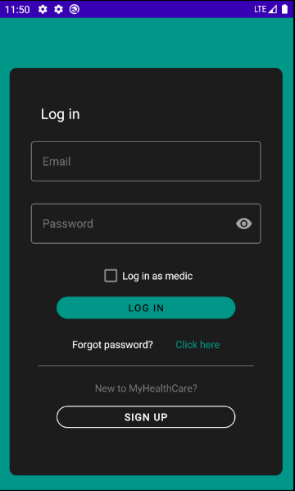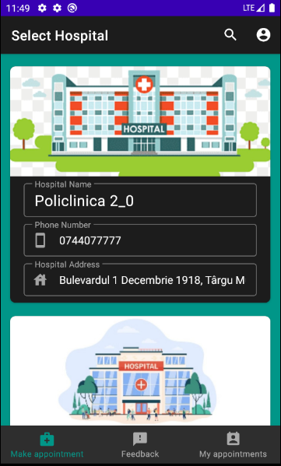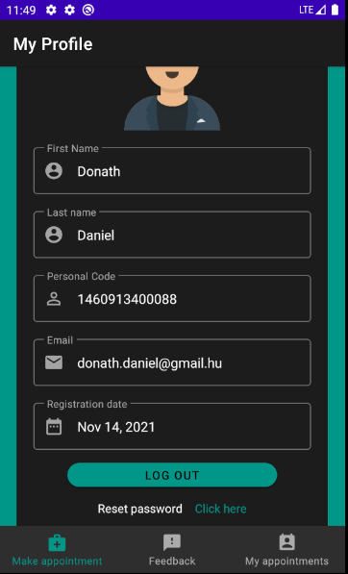

Figure 2 - Login page Figure 3 – Search page Figure 4 – Profile page

The user of the mobile application has to do the following movements for making an appointment (Figure 5, Figure 6, Figure 7).

After the user selected a hospital, he/she can scroll on the list of medical departments or he/she can search for them by name, see Figure 5.

After the user selected a medical department, he/she can select the medic on a horizontal list, after that the user can click on the first “+” button to select the date of the appointment, and after that click on the second “+” button to select the hour and the minute of the appointment, see Figure 6.

And finally, after the clicking the “Make appointment” button, the user can check that the information about the appointment is right, and he/she can accept it, or cancel it, see Figure 7.

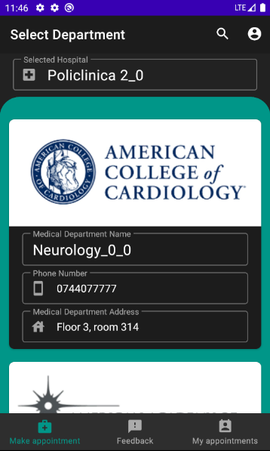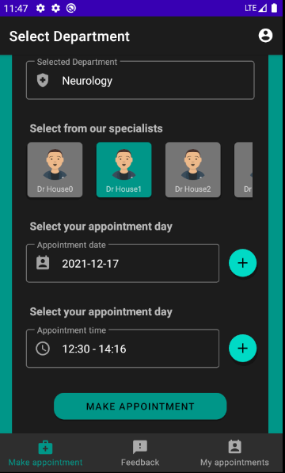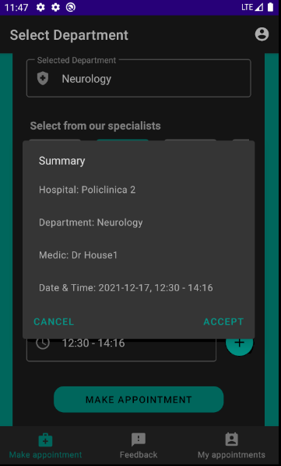

Figure 5 – Department page Figure 6 – Appointment page Figure 7 – Accept appointment

## Hardware Interfaces

The system requires a device which has Android 5.0 (Lollipop) operating system or above.

## Software Interfaces

The mobile application communicates with the database in order to get the information about the hospitals, medical departments and medics, see Figure 1. The communication between the database and the mobile application consists of operation concerning both reading and modifying the data.

## Communications Interfaces

The communication between the different parts of the system is important since they depend on each other. However, in what way the communication is achieved is not important for the system and is therefore handled by the underlying operating systems for the mobile application.

# System Features

## System Feature 1

*ID: SF1*

*TITLE: User registration - Mobile application*

*DESC: The mobile application is downloaded, then the user should be able to register through the mobile application. The user must provide his/her full name, password, e-mail address and personal code. The user can choose to provide a regularly used phone number.*

*RAT: In order for a user to register on the mobile application.*

*DEP: None*

## System Feature 2

*ID: SF2*

*TITLE: User log-in - Mobile application*

*DESC: Given that a user has registered, then the user should be able to log in to the mobile application. The log-in information will be stored on the phone and in the future the user should be logged in automatically.*

*RAT: In order for a user to log-in on the mobile application.*

*DEP: SF1*

## System Feature 3

*ID: SF3*

*TITLE: User reset password - Mobile application*

*DESC: Given that a user has registered, then the user should be able to reset his/her password. The user should get an email with the new password in it.*

*RAT: In order for a user to reset his/her password on the mobile application.*

*DEP: SF1*

## System Feature 4

*ID: SF4*

*TITLE: Mobile application - Search for a hospitals*

*DESC: Given that a user is logged in to the mobile application, then the first page that is shown should be the list of hospitals page. The user should be able to search for a hospital by name.*

*RAT: In order for a user to search for a hospital.*

*DEP: SF2*

## System Feature 5

*ID: SF5*

*TITLE: Mobile application - Search for a medical department*

*DESC: Given that a user selected a hospital, then the next page that is shown should be the list of medical departments (which are in the selected hospital) page. The user should be able to search for a medical department by name.*

*RAT: In order for a user to search for a medical department*

*DEP: SF4*

## System Feature 6

*ID: SF6*

*TITLE: Mobile application – Make appointment*

*DESC: Given that a user selected a medical department, then the user should be able to select a medic, a date and an hour for making the appointment.*

*RAT: In order for a user to make an appointment*

*DEP: SF5*

## System Feature 7

*ID: SF7*

*TITLE: Mobile application - Profile page*

*DESC: On the mobile application, a user should have a profile page. On the profile page a user can check his/her information, which includes his/her full name, e-mail address, personal code and registration date.*

*RAT: In order for a user to have a profile page on the mobile application.*

*DEP: SF2*

## System Feature 8

*ID: SF8*

*TITLE: Mobile application - "My appointments" page*

*DESC: On the mobile application, a user should have a "My appointments" page. On this page a user can check information about his/her future appointments, like the name of the medic, the chosen hospital, medical department and date.*

*RAT: In order for a user to have a "My appointments" s page on the mobile application.*

*DEP: SF2*

## System Feature 9

*ID: SF9*

*TITLE: Mobile application - "Feedbacks" page*

*DESC: On the mobile application, a user should have a "Feedbacks" page. On this page a user can check information about his/her past appointments, like the name of the medic, the chosen hospital, medical department, date and the message report about that appointment.*

*RAT: In order for a user to have a "Feedbacks" page on the mobile application.*

*DEP: SF2*

## System Feature 10

*ID: SF10*

*TITLE: Employee of the health industry log-in - Mobile application*

*DESC: The mobile application is downloaded, then an employee of the health industry should be able to log-in through the mobile application. On the log-in page he/she had to check the “Log in as medic” checkbox.*

*RAT: In order for an employee of the health industry to log-in on the mobile application.*

*DEP: None*

## System Feature 11

*ID: SF11*

*TITLE: Mobile application - "My appointments" page for the employees of the health industry*

*DESC: On the mobile application, an employee should have a "My appointments" page. On this page the employee can check information about his/her future appointments, like name of the client and the date.*

*RAT: In order for an employee to have a "My appointments" s page on the mobile application.*

*DEP: SF10*

# Other Nonfunctional Requirements

## Performance Requirements

* *The system should be able to support 100 simultaneous users.*
* *The mean time to view a screen over a 56Kbps modem connection shall not exceed 3 seconds.*

## Safety Requirements

* The log-in page shall provide typing the password hidden.
* The system shall provide the possibility of resetting the user password.

## Security Requirements

* *The system shall provide password protected access to the user account.*
* *Transaction data must be transmitted in encrypted form.*