**Assignment 3**

**III. Proposed Solution**

We propose a solution that enables the university to measure the quality of education delivered by them, using the following performance metrics (considering the weightage of each factor)

1. Student Feedback - Coursework, faculty
2. Jobs bagged by the students in the current semester/year
3. General feedback - alumni and employers.

The above mentioned metrics are described as follows-

1. **Student feedback** - Students have to provide feedback for their respective courses and faculty. This will indirectly help the university to understand different problems students are facing and take necessary measures in the future.
2. **Jobs bagged by the students** -Provides the rate of students who could get a job as compared to the total students enrolled under the same department.
3. **General Feedback** - Department sends out invites to alumni and employers requesting for Feedback. Alumni and employers are to give feedback to the associated departments.

**We identify the following people as responsible for providing good quality of education in our model :**

1. **University** - Provides the right environment for the growth of its students keeping in mind the effective education system that can be implemented.
2. **Faculty** - Teaches various courses under different departments to the students.
3. **Students** - Studying in the university, responsible for their coursework, enrolling in courses, completing coursework and related activities. Applying for jobs and getting a job by the end of the course.

**How to improve education and growth of their graduates?**

The approach will be to look into how an educational system in terms of faculty and courses contribute to the growth of their graduates over a 5-year period.

1. Introducing different Modes of Teaching - *Online* and *In-person* classes. This can be implemented by introducing a connection between student and university objects.
2. Dividing the Faculty based on different departments in the university
3. Setting up a Course Schedule for each Department
4. Dividing Faculty based on the mode of teaching under the same Department
5. Providing workshops for online teaching faculty for smooth running of online classes
6. Providing workshops for Students who are in need of additional knowledge in a Subject
7. Managing Student/Faculty/Course records in the University portal
8. Administering a University portal to maintain different categories of search in-order to ease the process for both Students and Faculty.

**Additional features that can be accommodated by the University to improve the education quality :**

* Make up classes conducted by Professors
* Co-op opportunity to Students
* Workshops on soft-skills for Students
* Informative Speaker sessions by the Alumni

Our own ranking system for students to decide where they want to go for their studies or not will be based on the ratings we will calculate.

**VII. Sequence Diagram**

1. **Feedback gathered from Students, Alumni and Employers**

Please refer Figure 1

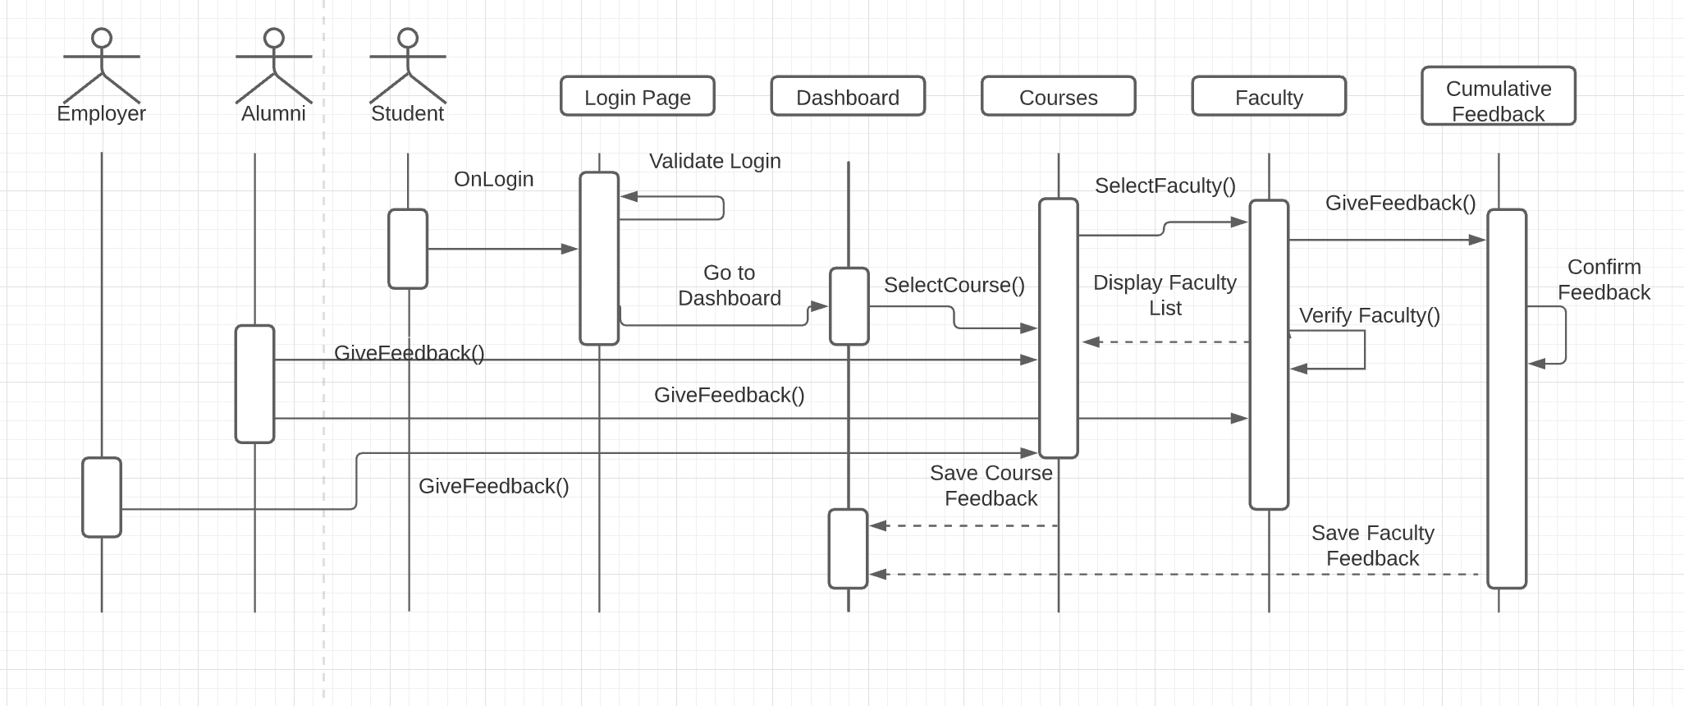

Figure 1- Sequence diagram for feedback gathering.