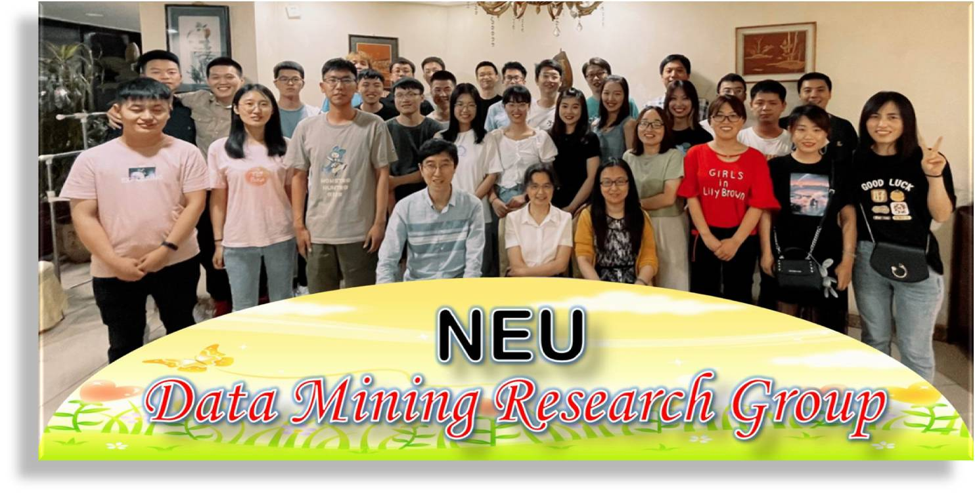

[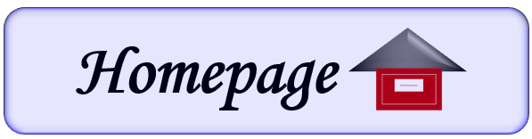](https://neu-datamining.github.io) [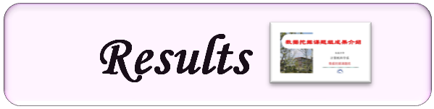](https://neu-datamining.github.io/DM-Group-introduction.htm) [](https://neu-datamining.github.io/DM-Group-publication.htm) [](https://neu-datamining.github.io/DM-Group-patent.htm) [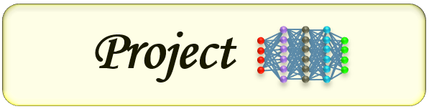](https://neu-datamining.github.io/DM-Group-project.htm) [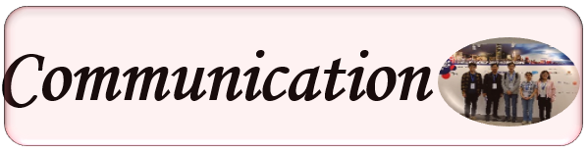](https://neu-datamining.github.io/DM-Group-communication.htm) [](https://neu-datamining.github.io/DM-Group-chinese.htm)

**Selected Publication (CCF A, B)**

* + Yongkang Liu, Shi Feng, Wei Gao, Daling Wang, Yifei Zhang: DialogConv: [A Lightweight Fully Convolutional Network for Multi-view Response Selection.](https://aclanthology.org/2022.emnlp-main.828/) EMNLP 2022: 12086-12098 **(CCF B)**
  + Qian Li, Shafiq Joty, Daling Wang, Shi Feng and Yifei Zhang: [Alleviating Sparsity of Open Knowledge Graphs with Ternary Contrastive Learning.](https://aclanthology.org/2022.findings-emnlp.168/) EMNLP (Findings) 2022: 2279-2291 **(CCF B)**
  + Qian Li, Daling Wang, Shi Feng, Kaisong Song, Yifei Zhang, Ge Yu: [OERL: Enhanced Representation Learning Via Open Knowledge Graphs.](https://ieeexplore.ieee.org/document/9935254) IEEE Transactions on Knowledge and Data Engineering. Online published. 2022.11.2 **(CCF A)**
  + Qian Li, Daling Wang, Shi Feng, Cheng Niu, Yifei Zhang: [Global Graph Attention Embedding Network for Relation Prediction in Knowledge Graphs.](https://ieeexplore.ieee.org/document/9452178) IEEE Trans. Neural Networks Learn. Syst. 33(11): 6712-6725 (2022) **(CCF B)**
  + Yongkang Liu, Shi Feng, Daling Wang, Yifei Zhang: MulZDG: [Multilingual Code-Switching Framework for Zero-shot Dialogue Generation.](https://aclanthology.org/2022.coling-1.54/) COLING 2022: 648-659 **(CCF B)**
  + Dongshi Ju, Shi Feng, Pengcheng Lv, Daling Wang, Yifei Zhang: [Learning to Improve Persona Consistency in Multi-party Dialogue Generation via Text Knowledge Enhancement.](https://aclanthology.org/2022.coling-1.23/) COLING 2022: 298-309 **(CCF B)**
  + Minghao Xu, Daling Wang, Shi Feng, Zhenfei Yang, Yifei Zhang: [KC-ISA: An Implicit Sentiment Analysis Model Combining Knowledge Enhancement and Context Features.](https://aclanthology.org/2022.coling-1.601/) COLING 2022: 6906-6915 **(CCF B)**
  + Ying Zhu, Shi Feng, Daling Wang, Yifei Zhang, Donghong Han: [Knowledge-Enhanced Interactive Matching Network for Multi-turn Response Selection in Medical Dialogue Systems](https://link.springer.com/chapter/10.1007/978-3-031-00129-1_19). DASFAA (3) 2022: 255-262 **(CCF B)**
  + Longcan Wu, Daling Wang, Shi Feng, Kaisong Song, Yifei Zhang, Ge Yu: [Collaborative Filtering for Recommendation in Geometric Algebra](https://link.springer.com/chapter/10.1007/978-3-031-00126-0_17). DASFAA (2) 2022: 256-263 **(CCF B)**
  + Xiaocui Yang, Shi Feng, Daling Wang, Yifei Zhang: [Image-text Multimodal Emotion Classification via Multi-view Attentional Network](https://ieeexplore.ieee.org/document/9246699). IEEE Transactions on Multimedia. 23: 4014-4026 (2021) **(CCF B)**
  + Shi Feng, Jia Wei, Xiaocui Yang, Daling Wang, Zhenfei Yang, Ge Yu: [SINN: A Speaker Influence Aware Neural Network Model for Emotion Detection in Conversations.](https://link.springer.com/article/10.1007%2Fs11280-021-00954-8) World Wide Web 24(6): 2019-2048 (2021) **(CCF B)**
  + Weichao Wang, Wei Gao, Shi Feng, Ling Chen, Daling Wang: [Adaptive Posterior Knowledge Selection for Improving Knowledge-Grounded Dialogue Generation.](https://dl.acm.org/doi/10.1145/3459637.3482314) CIKM 2021: 1989-1998 **(CCF B)**
  + Xiangju Li, Wei Gao, Shi Feng, Wang Daling, Shafiq Joty: [Span-Level Emotion Cause Analysis by BERT-based Graph Attention Network.](https://dl.acm.org/doi/10.1145/3459637.3482185) CIKM 2021: 3221-3226 **(CCF B)**
  + Xiangju Li, Wei Gao, Shi Feng, Wang Daling, Shafiq Joty: [Span-level Emotion Cause Analysis with Neural Sequence Tagging.](https://dl.acm.org/doi/10.1145/3459637.3482186) CIKM 2021: 3227-3231 **(CCF B)**
  + Xiaocui Yang, She Feng, Yifei Zhang, Daling Wang: [Multimodal Sentiment Detection Based on Multi-channel Graph Neural Network](https://aclanthology.org/2021.acl-long.28/). ACL/IJCNLP (1) 2021: 328-339 **(CCF A)**
  + Xiangju Li, Wei Gao, Shi Feng, Yifei Zhang, Daling Wang: [Boundary Detection with BERT for Span-level Emotion Cause Analysis](https://aclanthology.org/2021.findings-acl.60/). ACL/IJCNLP (Findings) 2021: 676-682 **(CCF A)**
  + Longcan Wu, Daling Wang, Shi Feng, Kaisong Song, Yifei Zhang, Ge Yu: [Which Node Pair and What Status? Asking Expert for Better Network Embedding](https://link.springer.com/chapter/10.1007%2F978-3-030-73194-6_11). DASFAA (1) 2021: 141-157 **(CCF B)**
  + Yongkang Liu, Shi Feng, Daling Wang, Kaisong Song, Feiliang Ren, Yifei Zhang: [A Graph Reasoning Network for Multi-turn Response Selection via Customized Pre-training](https://ojs.aaai.org/index.php/AAAI/article/view/17585). AAAI 2021: 13433-13442 **(CCF A)**
  + Pengcheng Lv, Shi Feng, Daling Wang, Yifei Zhang, Ge Yu: [PersonaGAN: Personalized Response Generation via Generative Adversarial Networks.](https://link.springer.com/chapter/10.1007%2F978-3-030-59410-7_38) DASFAA (1) 2020: 570-586 **(CCF B)**
  + Shifeng Li, Shi Feng, Daling Wang, Kaisong Song, Yifei Zhang, Weichao Wang: [EmoElicitor: An Open Domain Response Generation Model with User Emotional Reaction Awareness.](https://www.ijcai.org/Proceedings/2020/0503.pdf) IJCAI 2020: 3637-3643 **(CCF A)**
  + Weichao Wang, Shi Feng, Wei Gao, Daling Wang, Yifei Zhang: [A Cue Adaptive Decoder for Controllable Neural Response Generation](https://dl.acm.org/doi/10.1145/3366423.3380008). WWW 2020: 2570-2576 **(CCF A)**
  + Weichao Wang, Shi Feng, Daling Wang, Yifei Zhang: [Answer-guided and Semantic Coherent Question Generation in Open-domain Conversation](http://faculty.neu.edu.cn/dlwang/paper/EMNLP2019.pdf). EMNLP 2019(1): 5069-5079 **(CCF B)**
  + Longcan Wu, Daling Wang, Shi Feng, Yifei Zhang, Ge Yu: [MDAL: Multi-task Dual Attention LSTM Model for Semi-supervised Network Embedding.](http://faculty.neu.edu.cn/dlwang/paper/DASFAA2019.pdf) DASFAA (1) 2019: 468-483 **(CCF B)**
  + Shi Feng, Yang Wang, Liran Liu, Daling Wang, Ge Yu: [Attention based hierarchical LSTM network for context-aware microblog sentiment classification.](http://faculty.neu.edu.cn/dlwang/paper/WWW%20J%202019.pdf) World Wide Web 22(1): 59-81 (2019) **(CCF B)**
  + Xiangju Li, Kaisong Song, Shi Feng, Daling Wang, Yifei Zhang: [A Co-attention Neural Network Model for Emotion Cause Analysis with Emotional Context Awareness.](http://faculty.neu.edu.cn/dlwang/paper/EMNLP2018-1.pdf) EMNLP 2018: 4752-4757 **(CCF B)**
  + Weichao Wang, Shi Feng, Wei Gao, Daling Wang, Yifei Zhang: [Personalized Microblog Sentiment Classification via Adversarial Cross-lingual Multi-task Learning.](http://faculty.neu.edu.cn/dlwang/paper/EMNLP2018-2.pdf) EMNLP 2018: 338-348 **(CCF B)**
  + Kaisong Song, Wei Gao, Shi Feng, Daling Wang, Kam-Fai Wong, Chengqi Zhang: [Recommendation vs Sentiment Analysis: A Text-Driven Latent Factor Model for Rating Prediction with Cold-Start Awareness.](http://faculty.neu.edu.cn/dlwang/paper/IJCAI2017.pdf) IJCAI 2017: 2744-2750 **(CCF A)**
  + Wen Qu, Daling Wang, Shi Feng, Yifei Zhang, Ge Yu: [A novel cross-modal hashing algorithm based on multimodal deep learning.](http://faculty.neu.edu.cn/dlwang/paper/Science%20China%202017.pdf) SCIENCE CHINA Information Sciences 60(9): 092104:1-092104:14 (2017) **(CCF B)**
  + Kaisong Song, Wei Gao, Ling Chen, Shi Feng, Daling Wang, Chengqi Zhang: [Build Emotion Lexicon from the Mood of Crowd via Topic-Assisted Joint Non-negative Matrix Factorization.](http://faculty.neu.edu.cn/dlwang/paper/SIGIR2016.pdf) SIGIR 2016: 773-776 **(CCF A)**
  + Kaisong Song, Ling Chen, Wei Gao, Shi Feng, Daling Wang, Chengqi Zhang: [PerSentiment: A Personalized Sentiment Classification System for Microblog Users.](http://faculty.neu.edu.cn/dlwang/paper/WWW2016.pdf) WWW (Companion Volume) 2016: 255-258 **(CCF A)**
  + Kaisong Song, Shi Feng, Wei Gao, Daling Wang, Ge Yu, Kam-Fai Wong: [Personalized Sentiment Classification Based on Latent Individuality of Microblog Users.](http://faculty.neu.edu.cn/dlwang/paper/IJCAI2015.pdf) IJCAI 2015: 2277-2283 **(CCF A)**
  + Shi Feng, Kaisong Song, Daling Wang, Ge Yu: [A word-emoticon mutual reinforcement ranking model for building sentiment lexicon from massive collection of microblogs.](http://faculty.neu.edu.cn/dlwang/paper/WWW%20J%202015.pdf) World Wide Web 18(4): 949-967 (2015) **(CCF B)**
  + Wen Qu, Kaisong Song, Yifei Zhang, Shi Feng, Daling Wang, Ge Yu: [A Novel Approach Based on Multi-View Content Analysis and Semi-Supervised Enrichment for Movie Recommendation.](http://faculty.neu.edu.cn/dlwang/paper/JCST2013.pdf) J. Comput. Sci. Technol. 28(5): 776-787 (2013) **(CCF B)**
  + Shi Feng, Le Zhang, Binyang Li, Daling Wang, Ge Yu, Kam-Fai Wong: [Is Twitter A Better Corpus for Measuring Sentiment Similarity?](http://faculty.neu.edu.cn/dlwang/paper/EMNLP2013.pdf) EMNLP 2013: 897-902 **(CCF B)**
  + Shi Feng, Daling Wang, Ge Yu, Wei Gao, Kam-Fai Wong: [Extracting common emotions from blogs based on fine-grained sentiment clustering.](http://faculty.neu.edu.cn/dlwang/paper/KIS2011.pdf) Knowl. Inf. Syst. 27(2): 281-302 (2011) **(CCF B)**
  + Shi Feng, Daling Wang, Ge Yu, Binyang Li, Kam-Fai Wong: [Summarizing and Extracting Online Public Opinion from Blog Search Results.](http://faculty.neu.edu.cn/dlwang/paper/DASFAA2010.pdf) DASFAA (1) 2010: 476-490 **(CCF B)**
  + Xiaoguang Li, Ge Yu, Daling Wang: MMPClust: A Skew Prevention Algorithm for Model-Based Document Clustering. DASFAA 2005: 536-547 **(CCF B)**