|  |  |
| --- | --- |
| **WORKSHEET-1.2** | |
| **Student Name: Shubham Kumar** | **UID: 21BCS7104** |
| **Branch: CSE** | **Section/Group: 614-A** |
| **Semester: 6th** | **Date of Performance: 17-01-2024** |
| **Subject Name: Advanced Programming Lab-2** | **Subject Code: 21CSP-351** |

**1. Aim:** String Matching

A) Given two strings s and goal, return true if and only if s can become goal after some number of shifts on s.(Rotate String)

B) Given two strings needle and haystack, return the index of the first occurrence of needle in haystack, or -1 if needle is not part of haystack.( Find the Index of the First Occurrence in a String)

**2. Source Code/Output:**

**A)**

class Solution {

public:

bool rotateString(string s, string goal) {

return s.size() == goal.size() && strstr((s + s).data(), goal.data());

}

};

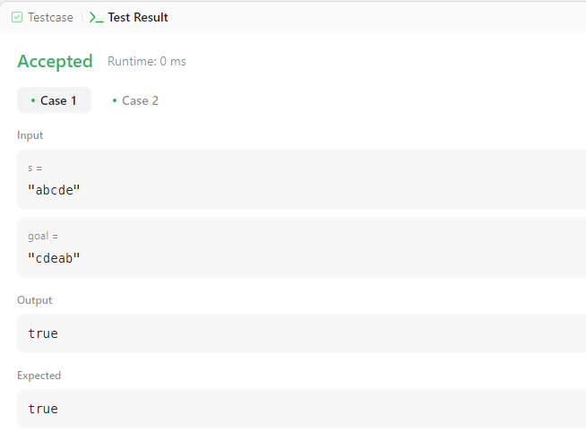

B)

class Solution {

public:

int strStr(string haystack, string needle) {

const int m = haystack.length();

const int n = needle.length();

for (int i = 0; i < m - n + 1; i++)

if (haystack.substr(i, n) == needle)

return i;

return -1;

}

};

