|  |  |
| --- | --- |
| **Experiment-2.3** | |
| **Student Name: Shubham Kumar** | **UID: 21BCS7104** |
| **Branch: CSE** | **Section/Group: 614-A** |
| **Semester: 6th** | **Date of Performance: 28-02-2024** |
| **Subject Name: Advanced Programming Lab-2** | **Subject Code: 21CSP-351** |

**1. Aim:** Divide and Conquer.

A) You are given a 0-indexed string s that you must perform k replacement operations on. The replacement operations are given as three 0-indexed parallel arrays, indices, sources, and targets, all of length k..(833. Find And Replace in String)

B) You are given two jugs with capacities jug1Capacity and jug2Capacity liters. There is an infinite amount of water supply available. Determine whether it is possible to measure exactly targetCapacity liters using these two jugs.(365. Water and Jug Problem)

**2. Source Code/Output:**

**A) Code:**

class Solution {

public:

string findReplaceString(string s, vector<int>& indices, vector<string>& sources, vector<string>& targets) {

int n = s.size();

vector<int> d(n, -1);

for (int k = 0; k < indices.size(); ++k) {

int i = indices[k];

if (s.compare(i, sources[k].size(), sources[k]) == 0) {

d[i] = k;

}

}

string ans;

for (int i = 0; i < n;) {

if (~d[i]) {

ans += targets[d[i]];

i += sources[d[i]].size();

} else {

ans += s[i++];

}

}

return ans;

}

};

**Description:**

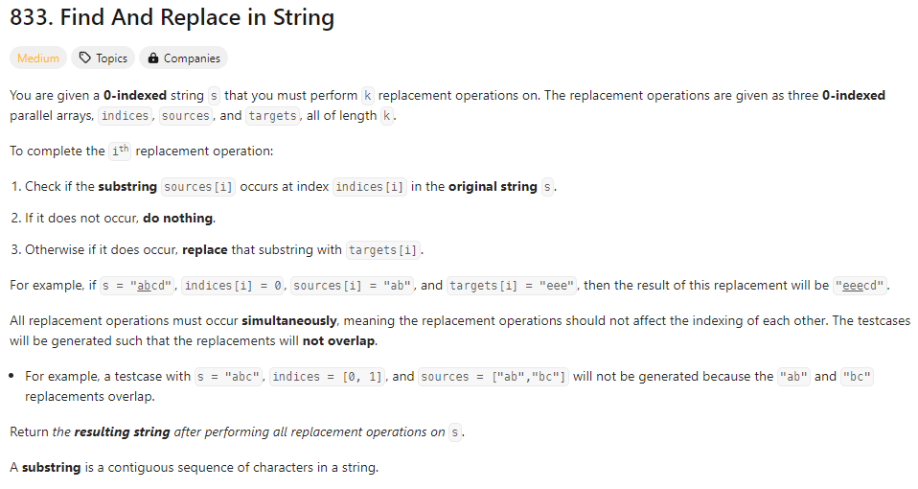

**Output:**

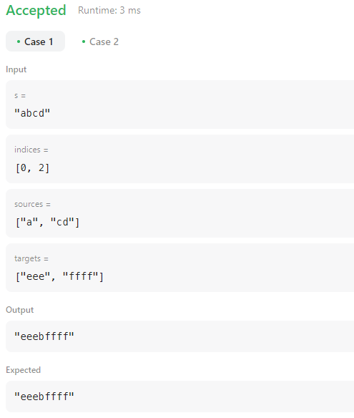

**B)** **Code:**

class Solution {

public:

bool canMeasureWater(int jug1Capacity, int jug2Capacity, int targetCapacity) {

return targetCapacity == 0 ||

jug1Capacity + jug2Capacity >= targetCapacity &&

targetCapacity % __gcd(jug1Capacity, jug2Capacity) == 0;

}

};

**Description:**

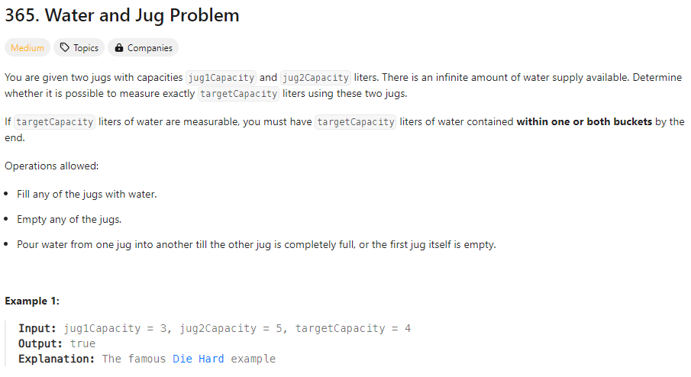

**Output:**

