|  |  |
| --- | --- |
| **Experiment-3.3** | |
| **Student Name: Shubham Kumar** | **UID: 21BCS7104** |
| **Branch: CSE** | **Section/Group: 614-A** |
| **Semester: 6th** | **Date of Performance: 03-04-2024** |
| **Subject Name: Advanced Programming Lab-2** | **Subject Code: 21CSP-351** |

**1. Aim:** Dynamic Programming.

A) Return the maximum profit you can achieve from this transaction. If you cannot achieve any profit, return 0.( 121. Best Time to Buy and Sell Stock)

B) Given a string s containing only digits, return the number of ways to decode it.( 91. Decode Ways)

**2. Source Code/Output:**

**A) Code:**

class Solution {

public:

int maxProfit(vector<int>& prices) {

int ans = 0, mi = prices[0];

for (int& v : prices) {

ans = max(ans, v - mi);

mi = min(mi, v);

}

return ans;

}

};

**Description:**

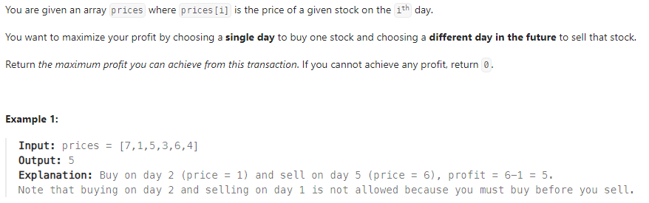

**Output:**

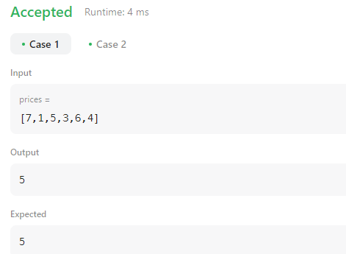

**B)** **Code:**

class Solution {

public:

int numDecodings(string s) {

int n = s.size();

int f = 0, g = 1;

for (int i = 1; i <= n; ++i) {

int h = s[i - 1] != '0' ? g : 0;

if (i > 1 && (s[i - 2] == '1' || (s[i - 2] == '2' && s[i - 1] <= '6'))) {

h += f;

}

f = g;

g = h;

}

return g;

}

};

**Description:**

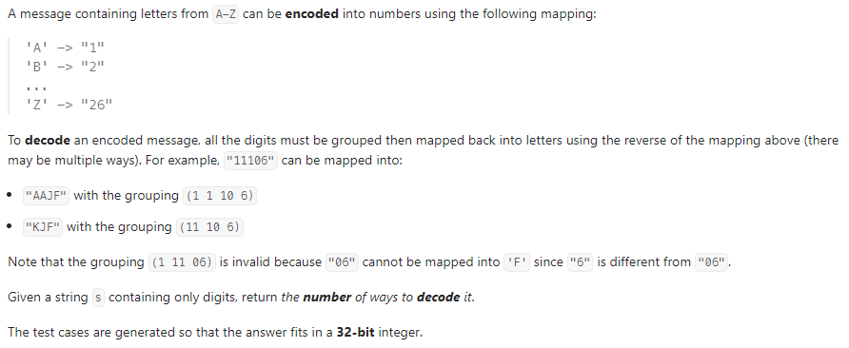

**Output:**

