🌙✨ Anna's Personal Website✨🌸
Profile Gallery Hobbies Section Website

🌸 Personal Portrait 🌙
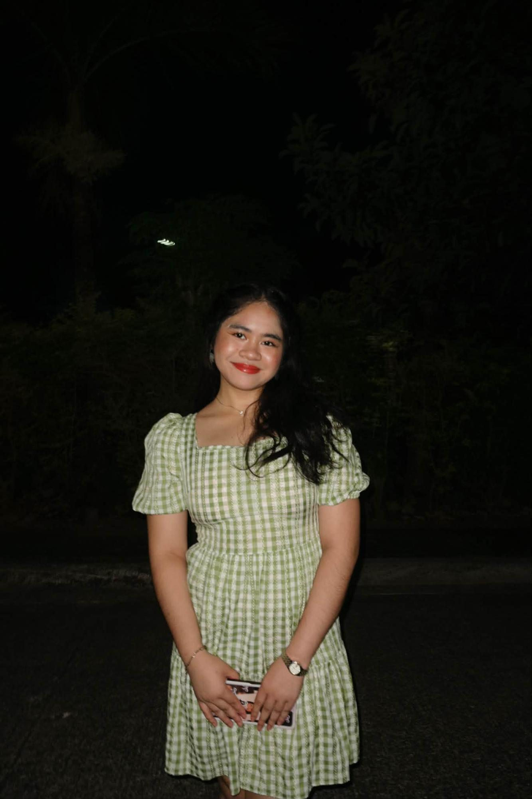

Anna Rose P. Arangga
Libra ♎ • 15 years old
Favorite Color: Purple 💜

💫 Personal Info
Name: Anna Rose P. Arangga
Nickname: Anna
Birthday: September 26, 2010
Age: 15

🌸 About Me
Favorite Color: Purple 💜
Zodiac Sign: Libra ♎
Personality: ISFP / INFP

🌸✨ Playlist (OPM) ✨🌸
- 🌙 “Musika” — Dionela
- 🌸 “Oksihina” — Dionela
- 💫 “Bahaghari” — Dionela
- ✨ “Isa Lang” — Arthur Nery
- 🌌 “Ikot” — Over October
- 🌺 “Maharani” — Alamat
- 🌠 “Mundo” — IV of Spades
- 🌷 “Sandali” — mrld
- 🌫 “Bumalik Ka Na Sa'kin” — Silent Sanctuary
Created by: Anna Rose P. Arangga

