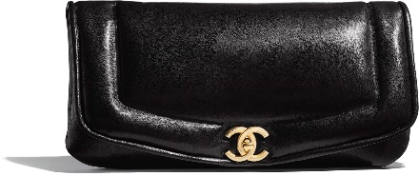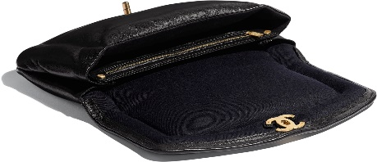

**Clutch**

Lambskin & Gold-Tone Metal

Black

17 × 31 × 4 cmin

Reference: AS1184 B01517 94305

**CAN$4,550**