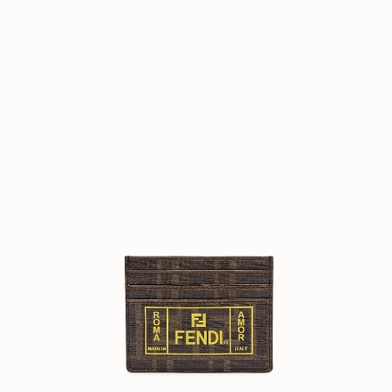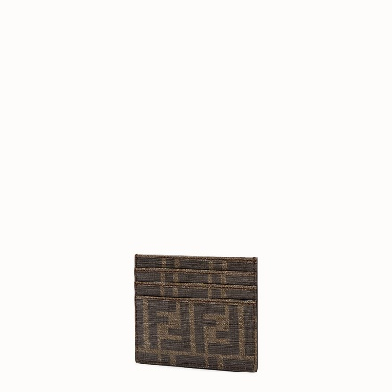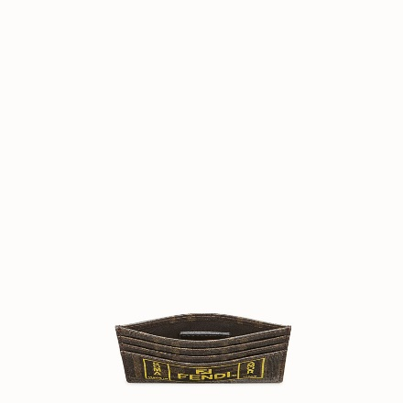

[PreviousNext](file:///D:\Final\Tong%20hop%20Fendi\fendi_1m\fen1.html#carouselExampleControls)

FENDI-BIFOLD

$290.00

COLOR :RED/YELLOW  
SIZE : ONE SIZE  
IN STOCK

[Detail](file:///D:\\Final\\Tong%20hop%20Fendi\\fendi_1m\\fen1.html" \l "collapse)

Card holder with six slots and flat central pocket. Made of PU with brown FF motif. Fendi Label print in yellow. Made in Italy.

• Length:3.9 inches

• Height:3.1 inches

• Depth:inches

• Composition:45% Cotton, 40% Polyurethane, 15% Polyester

Universal Style #: Product Code:7M0164A7SBF17HW

[CARE & COMPOSITION](file:///D:\Final\Tong%20hop%20Fendi\fendi_1m\fen1.html#collapse1)

• Leather

• Imported