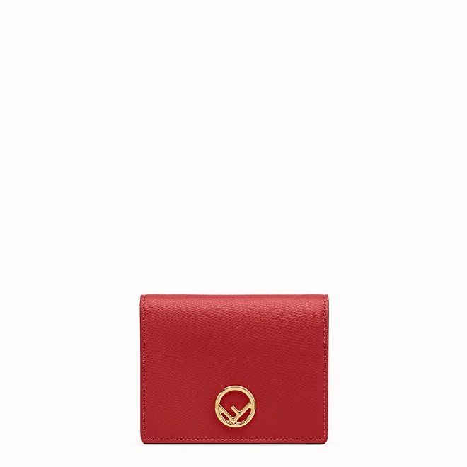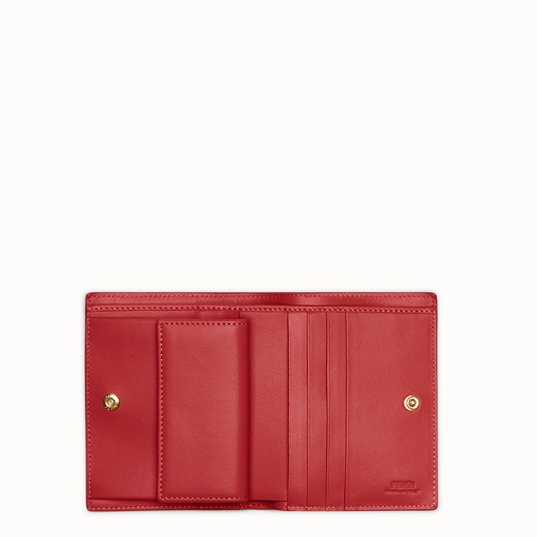

FENDI-BIFOLDA

$490.00

COLOR :Red leather compact wallet  
SIZE : ONE SIZE  
IN STOCK

[Detail](http://127.0.0.1:60314/content/_Xo85KH1nWbI42luAAAc/58Hk5bZ/Pnap3YO/wYQDLtt/Vy5FcU8#collapse)

F is Fendi compact bi-fold wallet. Interior organized with a flat pocket, a coin pocket with press stud and four card slots. Made of red tumbled Cruise leather. Decorated with the F is Fendi logo. Gold-finish metalware.Made in Italy.

• Length:3.5 inches

• Height:4.5 inches

• Depth:1 inches

• Composition:100% Calfskin

Universal Style: Product Code:8M0387A18BF0MVV

[CARE & COMPOSITION](http://127.0.0.1:60314/content/_Xo85KH1nWbI42luAAAc/58Hk5bZ/Pnap3YO/wYQDLtt/Vy5FcU8#collapse1)

• Leather

• Imported