WEEK 5 TASK

Evaluation and Comparative
Analysis of Cybersecurity Tools
Wazuh • Suricata • OWASP ZAP
Prepared for: E-Governance & Digital Services Cybersecurity Internship
Prepared by: Kalyan Baraik
Date: 3 November 2026

Executive Summary
This report evaluates three publicly available cybersecurity tools—Wazuh, Suricata, and OWASP ZAP—for their suitability within digital services and e-governance infrastructures. They address complementary layers: Wazuh provides centralized security monitoring and SIEM/XDR capabilities; Suricata analyzes network traffic as an IDS/IPS and network security monitoring engine; and OWASP ZAP tests web applications and APIs for security weaknesses.
The evaluation considers functional coverage, usability, performance considerations, integration, automation, cost-effectiveness, support, and relevance to public-service systems. Open-source licensing can reduce direct license costs, but operational expenses remain: infrastructure, storage, trained personnel, tuning, maintenance, and incident response. The tools should not be treated as substitutes. A layered approach is recommended: Wazuh for central monitoring, Suricata for network visibility and detection, and ZAP in the secure software development lifecycle for authorized application testing. Adoption should be phased and validated through a proof of concept.

1. Introduction
E-governance platforms provide citizen-facing services such as applications, certificates, payments, grievance handling, and departmental portals. These services require confidentiality, integrity, availability, accountability, and public trust. Threats include compromised endpoints, credential abuse, vulnerable web applications, misconfiguration, malicious traffic, data leakage, and delayed detection. No single security product covers every layer. Organizations need preventive testing, continuous monitoring, evidence collection, and repeatable incident response.
This report compares three open-source tools with different primary roles and examines how they can fit into an e-governance technology stack. Ratings are qualitative desk-assessment judgments, not laboratory benchmarks; a real deployment should validate them against local requirements.

2. Selected Cybersecurity Tools

2.1 Wazuh — SIEM and XDR
Wazuh is an open-source security platform combining SIEM and XDR capabilities. Its architecture commonly includes agents, a server, an indexer, and a dashboard. It collects endpoint and workload telemetry, analyzes logs using decoders and rules, supports file-integrity monitoring, security configuration assessment, vulnerability detection, alerting, and selected active-response actions. It can ingest syslog and integrate with cloud and third-party sources.
Benefits: centralized visibility; customizable rules; endpoint monitoring; dashboards and reporting; no mandatory core license fee.
Limitations: requires infrastructure, storage planning, skilled tuning, and analyst time; alert noise and active-response misconfiguration need controls.

2.2 Suricata — Network IDS/IPS/NSM
Suricata is an open-source network security engine that can operate as an intrusion detection system (IDS), intrusion prevention system (IPS), or network security monitoring (NSM) tool. It uses signatures and protocol-aware inspection, analyzes live traffic or PCAP files, and generates structured EVE JSON events for downstream systems.
Benefits: network-level visibility; protocol-aware detections; PCAP analysis; flexible sensor deployment; structured logs.
Limitations: sensor placement determines coverage; encryption limits payload inspection; tuning and traffic capacity require expertise; inline prevention can disrupt services.

2.3 OWASP ZAP — Web Application Security Testing
OWASP Zed Attack Proxy (ZAP) is a free, open-source web application security testing tool. It supports proxy-based manual testing, passive and active scanning, automation, scripting, and an API. It is useful for developer-led security testing and regression checks for web applications and APIs.
Benefits: GUI for manual work; automation and API; CI/CD integration; community documentation; helps identify common web security weaknesses.
Limitations: active scans may affect application behavior or data; results require validation; authenticated and complex workflows need configuration; it is not a SIEM or network IDS.

3. Evaluation Criteria and Rationale
A 1–5 scale is used: 1 = limited, 2 = below average, 3 = adequate, 4 = strong, and 5 = very strong for the stated use case. Weighting emphasizes capability and integration because government environments have diverse assets and legacy systems.
Criterion | Rationale | Weight
Functional coverage | Fit to endpoint/log, network, or application security needs | 20%
Usability & learning curve | Operational efficiency for administrators and developers | 15%
Integration & interoperability | Compatibility with agents, APIs, syslog, JSON, cloud, and CI/CD | 20%
Automation | Repeatable detection, testing, and workflows | 15%
Cost-effectiveness | License plus infrastructure, staffing, training, and maintenance | 15%
Support & ecosystem | Documentation, community, updates, troubleshooting | 10%
Performance & scalability | Ability to handle realistic data and grow safely | 5%

4. Detailed Comparative Analysis
Dimension | Wazuh | Suricata | OWASP ZAP
Primary role | Endpoint/log SIEM + XDR | Network IDS/IPS/NSM | Web/API security testing
Main functions | Log correlation, endpoint telemetry, FIM, security assessment, vulnerability detection, alerts | Signature detection, protocol analysis, traffic/PCAP logging | Proxy, passive/active scans, manual testing, automation/API
Coverage | Hosts, workloads, logs, selected cloud sources | Traffic visible at sensor interfaces/segments | Web applications and APIs in authorized scope
User interface | Central dashboard; configuration learning curve | Configuration/log oriented; often paired with dashboards | Desktop GUI and automation options
Integration | Agents, syslog, APIs, cloud/log pipelines | EVE JSON, syslog, analytics pipelines | API, scripts, Docker, CI/CD
Automation | Rules, alerts, selected response actions | Rules and structured event outputs; IPS modes | Automation Framework, API, CI pipelines
Cost model | Open source; compute, storage, people cost | Open source; sensor capacity and operations cost | Free/open source; testing environment and staff cost
Best use | Centralized monitoring and investigation | Network threat visibility and detection | Secure SDLC and application testing
Operational risk | Alert fatigue, storage growth, response misconfiguration | Sensor blind spots, encrypted traffic, inline disruption | Scan impact, false positives, unauthorized scope

5. Qualitative Scorecard
Indicative analyst ratings (1 = limited; 5 = strong). Ratings vary with configuration, skill, and environment.
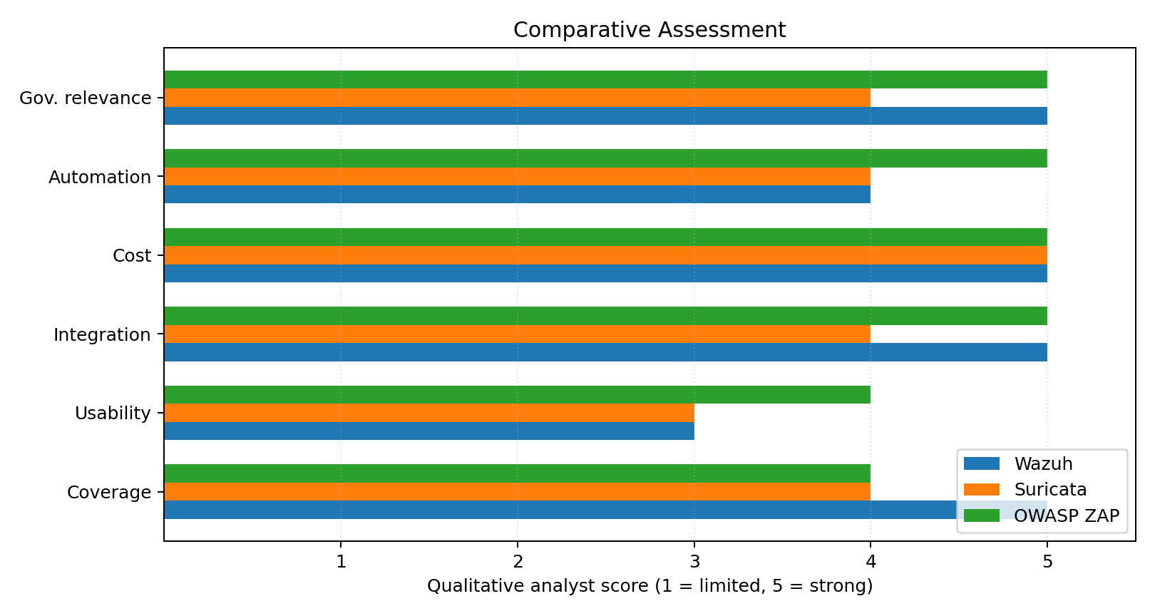
Interpretation: Wazuh scores strongly for centralized monitoring and governance-oriented visibility; Suricata is strongest within network detection; ZAP is strong for application-security automation and developer integration. These ratings do not replace measured throughput, detection accuracy, or false-positive tests.

6. Cost-Effectiveness and Total Cost of Ownership
Although the tools have no mandatory license fee for their open-source editions, a realistic total cost of ownership includes:
- Compute, memory, storage, backups, network interfaces, and possible cloud hosting.
- Installation, upgrades, secure configuration, rule/signature updates, and tool-health monitoring.
- Staff time for triage, alert tuning, scan review, incident response, and evidence handling.
- Training, knowledge transfer, documentation, and periodic reassessment.
- Service-impact controls: inline IPS and active web scanning require staging, approvals, and rollback plans.
Cost conclusion: open-source tools are attractive for budget-constrained departments and pilot programs. However, an understaffed deployment can create hidden costs through missed alerts or outages. Decision-makers should estimate three-year TCO and compare self-managed operations with managed services.

7. Proposed Integration Architecture
A layered workflow for a hypothetical e-governance platform:
- Citizen portal, departmental applications, and APIs → OWASP ZAP testing in an authorized staging environment.
- Servers, endpoints, identity systems, and application logs → Wazuh agents or supported log ingestion.
- Approved network segments/perimeter → Suricata sensors; begin in passive-monitoring mode.
- Suricata EVE JSON and relevant logs → centralized analytics/dashboard and alert triage.
- Alerts → incident ticket, escalation matrix, and documented response playbooks.
- Evidence/reports → role-restricted storage, retention policy, synchronized time, and audit trail.
Prerequisites: asset inventory, log-source mapping, network diagrams, service-owner approvals, role-based access, secure API credentials, time synchronization, retention requirements, and named incident ownership. Minimize sensitive citizen data in logs and use masked test datasets where possible.

8. Risks and Safeguards
Risk | Possible impact | Recommended control
False positives / alert fatigue | Important alerts may be overlooked | Baseline, tune rules, assign ownership, measure alert quality
Active response / inline IPS | Unintended blocking or outage | Monitor-only first; testing; change approval; rollback
Active web scan | Unexpected workflow/data impact or load | Written authorization; staging; safe policy; maintenance window
Sensitive logs/test data | Privacy exposure or excessive retention | Data minimization, masking, access control, retention schedule
Incomplete coverage | Unmonitored assets or traffic | Inventory; agent/sensor health checks; periodic coverage review
Skill/continuity gaps | Slow response or unmaintained configuration | Runbooks, training, backups, named owners, handover

9. Findings and Recommendations

Major findings
- The tools are complementary, not interchangeable; choosing only one leaves important security layers uncovered.
- Wazuh is a strong foundation for centralized endpoint/log visibility, investigation, and reporting.
- Suricata provides network detection and forensic context where sensor placement gives adequate visibility.
- OWASP ZAP is most useful when embedded in the development lifecycle and scoped to authorized staging systems.
- Open-source licensing reduces direct licensing costs, but competent staffing and operational readiness determine outcomes.

Phased adoption plan
Phase | Action | Success indicator
1 — Foundation | Pilot Wazuh on representative servers; define sources and baselines | Coverage, alert quality, and storage forecast documented
2 — Network visibility | Deploy Suricata passively on an approved segment; tune and forward EVE JSON | Validated detections, sensor health, and known blind spots
3 — Secure development | Run ZAP on staging applications/APIs; add baseline automation to CI/CD | Findings triaged, false positives reviewed, remediation tracked
4 — Operationalization | Create SOPs, incident playbooks, access/retention policies, metrics, review cadence | Named owners; escalation and rollback tested

Final recommendation: use Wazuh as the central monitoring foundation, Suricata as a network visibility/detection complement, and OWASP ZAP as an application-security testing control. Begin with a time-boxed proof of concept that validates compatibility, performance, staffing, privacy, and service continuity. A department with limited capacity may start with Wazuh and ZAP in staging, then expand network monitoring according to risk and resources.

10. Conclusion
Effective cybersecurity for digital government requires defense in depth. Wazuh, Suricata, and OWASP ZAP contribute distinct capabilities: centralized detection and investigation, network-level visibility, and application-layer testing. Their open-source models provide flexibility and can lower licensing barriers, but implementation still requires planning, skills, maintenance, and governance. A phased approach enables decision-makers to validate measurable benefits and reduce operational risk while preserving the reliability and trustworthiness of citizen services.

11. References and Further Reading
- Wazuh documentation — Quickstart — https://documentation.wazuh.com/current/quickstart.html
- Wazuh documentation — Getting started — https://documentation.wazuh.com/current/getting-started/index.html
- Wazuh platform — SIEM — https://wazuh.com/platform/siem/
- Wazuh platform — XDR — https://wazuh.com/platform/xdr/
- Wazuh — Case studies — https://wazuh.com/resources/case-studies/
- Suricata — What is Suricata? — https://docs.suricata.io/en/latest/what-is-suricata.html
- Suricata — Features — https://suricata.io/features/
- Suricata — Feature overview — https://suricata.io/features/all-features/
- OWASP ZAP — Documentation — https://www.zaproxy.org/docs/
- OWASP ZAP — API — https://www.zaproxy.org/docs/api/
- OWASP ZAP — Automation Framework — https://www.zaproxy.org/docs/automate/
Research note: official project documentation was prioritized for capabilities and integration descriptions. Public case studies are project/vendor-published and should be treated as illustrative, not independent controlled benchmarks. The scorecard is a qualitative desk assessment and should be validated in an organization-specific pilot.

Appendix A — Submission Description (200+ Words)
This report presents a structured evaluation and comparative analysis of three widely used open-source cybersecurity tools—Wazuh, Suricata, and OWASP ZAP—with a focus on their suitability for digital services and e-governance infrastructures. It begins with an executive summary and introduction describing the security requirements of public digital platforms, including confidentiality, integrity, availability, accountability, and public trust. Each selected tool is then explained in terms of its principal functions, strengths, limitations, and the security layer it addresses.
A standard evaluation framework is used to compare functional coverage, usability and learning curve, integration and interoperability, automation, cost-effectiveness, support and ecosystem, and performance/scalability. A comparative table presents the tools side by side, while a qualitative score visualization communicates their relative strengths. The report also examines total cost of ownership, explaining that open-source licensing does not eliminate costs for infrastructure, implementation, maintenance, training, and skilled security operations.
To make the findings practical, the report proposes a layered integration architecture for a hypothetical e-governance platform: Wazuh for centralized endpoint and log monitoring; Suricata for authorized network traffic visibility and detection; and OWASP ZAP for web application and API testing in staging and CI/CD workflows. It identifies operational and governance risks such as false positives, active-response disruption, scan impact, privacy-sensitive logs, incomplete monitoring coverage, and skill gaps. Recommended safeguards include written authorization, least privilege, rule tuning, change approval, rollback planning, data minimization, and documented incident playbooks.
The conclusion recommends phased adoption through a proof of concept, with measurable success indicators and clear ownership before production rollout. Official project documentation and publicly available case-study resources are included to support transparency and further verification. The report is intended to assist informed cybersecurity tool selection rather than claim that any single product can independently secure an entire government platform.

