Game Design Document

Fill up the following document

1. Write the title of your project.

The Travelling Light

1. What is the goal of the game?

The goal of the game is to find the way through a dark path in a cave and reach the outside world.

1. Write a brief story of your game.

The player finds himself in a completely dark area, secluded from the outside world. The player lights a little of his surounding(showing a bit of the path like in real life even in a completely dark area you can see a bit.).Then as he travells he find obstacles in his path that stop him,these blocks can be pushed down(like in <https://youtu.be/ZBBW48d8D4U>), also the player will receive feedback and some mysterios text like in the video itself.While travelling he will light the path behind.The player will collect a faitn glowing object to get energy to light up. In between for the difficulty of the game there will be opponents,these mysterious creatures are the ones keeping the cave cold and dark,you have to shoot light to beat them. He keeps travelling untill he sees light from the exit of the cave.The game in general is a finite runner game.

1. Which are the playing characters of this game?

* Playing characters are the ones who respond to the user based on the input from the user.
* Cars, monkeys, dinos, wizards, etc., are the playing characters in the game.

|  |  |  |
| --- | --- | --- |
| Number | Character Name | What can this character do? |
| 1 | Player | This character is the one used ot explore |
| 2 | Opponents | Block your path and need to be defeated using energy to continue. |
| 3 |  |  |
| 4 |  |  |
| 5 |  |  |
| 6 |  |  |
| 7 |  |  |
| 8 |  |  |

1. Which are the Non-Playing Characters of this game?

* Non-Playing characters are the ones that don't have an action or behavior when the user interacts with the game.
* Hurdles, stones, bananas, coins, etc., are non-playing characters in the game.

|  |  |  |
| --- | --- | --- |
| Number | Character Name | What can this character do? |
| 1 | Giant Block hurdles | This stops the path but can fall down |
| 2 | Glowing energy | Gives energy to the player to light |
| 3 | Light stands | Takes energy from the player to light themselves |
| 4 |  |  |
| 5 |  |  |
| 6 |  |  |
| 7 |  |  |
| 8 |  |  |

Draw your imagination of this game. What does this game look like?

* Draw the game either on your computer or on paper.
* Add images of the game scenes to show each of the playing and non-playing characters at least once.

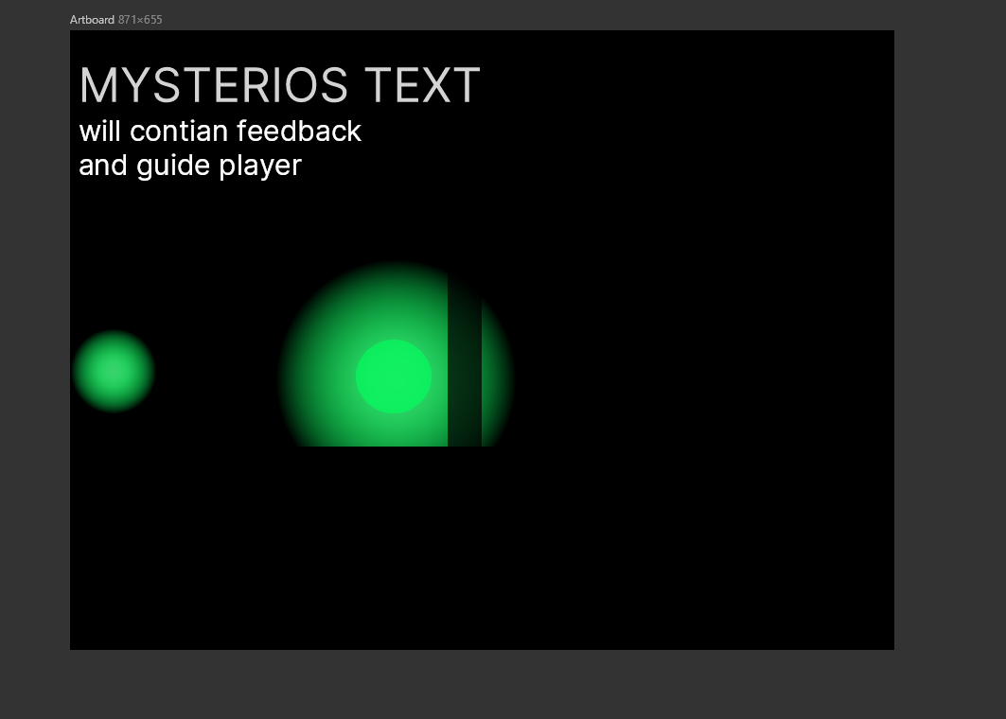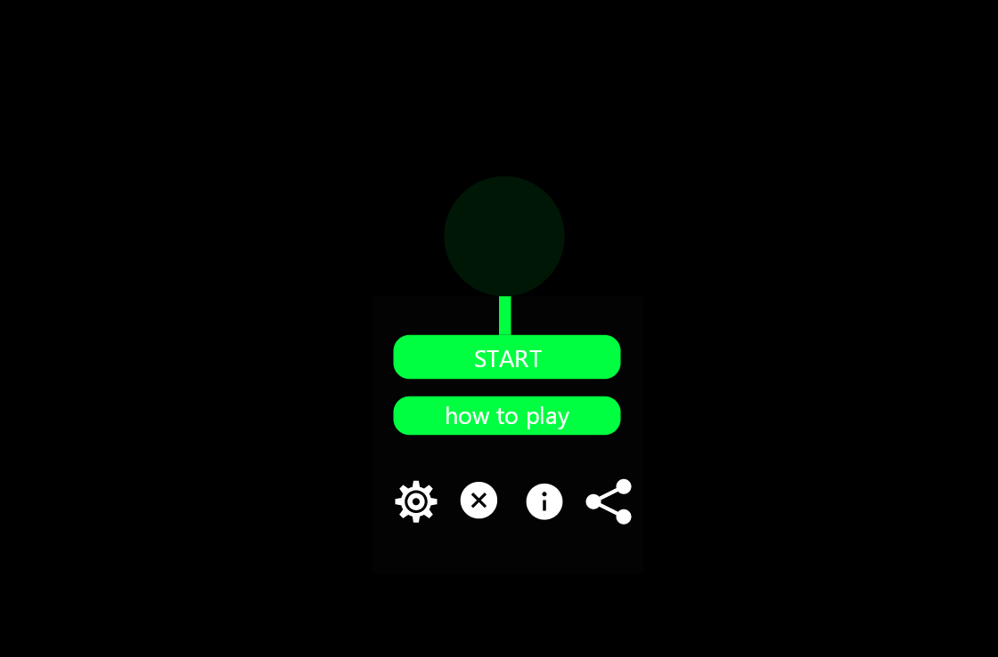

How do you plan to make your game engaging?

The game is made intresting by the lighting effect in the game. The player is a neon ball. Which will light only a segement of the dark background and unviel it. But there will be stops in the background on crossing them the path behind will get lit.The core enchanting visuals will be when you reach the outside.The music will change to hopfull when the person is not able to find a way(violet evergarden :- wherever you are,wherever you must be).Music will change to calm epic on reachin the outside.There will be 1 or 2 opponents on the way(violet evergarden ost across the violet sky/Rust.),while fighting there will be music(Flaiming fry/cold type music not found

)the player can also chose the color of their player.Main background music(not decided,note all the music are not final)