Applied Bayesian Data Analysis

Assignment 4

Fredrik Nyström

2019-10-28

## Table of Contents

* Task A.1
  + Slice sampler

## Task A.2

* name: a1 ## Task 1 Recreate Figure 6.4 using STAN and/or slice sampling.
* Priors, beta(100, 100), beta(18.25, 6.75), beta(1, 1)
* Bernoulli likelihood
* Data, z = 17, N = 20

.center[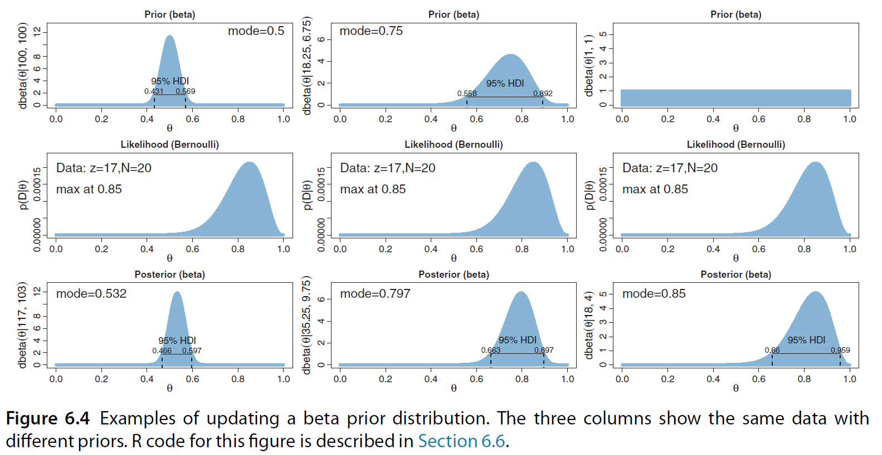]

## Stan model code: Prior & Likelihood

// prior  
parameters {  
 real<lower = 0, upper = 1> theta;  
}  
model {  
 theta ~ beta(`${a}`, `${b}`);  
}

// likelihood  
data {  
 int<lower = 0> N;  
 int y[N];  
}  
  
parameters {  
 real<lower = 0, upper = 1> theta;  
}  
model {  
 y ~ bernoulli(theta);  
}

## String interpolation for prior parameters

# Specify the shape parameters for the beta priors,   
# used for string interpolation  
beta_left <- list(a = 100, b = 100)  
beta_middle <- list(a = 18.25, b = 6.75)  
beta_right <- list(a = 1, b = 1)  
  
# Prepare the prior code for each prior by string interpolation  
left_prior_code <- str_interp(prior_code, beta_left)  
middle_prior_code <- str_interp(prior_code, beta_middle)  
right_prior_code <- str_interp(prior_code, beta_right)  
  
# Prepare the posterior code for each prior by string interpolation  
left_posterior_code <- str_interp(posterior_code, beta_left)  
middle_posterior_code <- str_interp(posterior_code, beta_middle)  
right_posterior_code <- str_interp(posterior_code, beta_right)

## Stan compilation

# Compile the code. Sampling from the likelihood and the posterior needs the   
# data supplied as an argument  
left_prior <- stan(model_code = left_prior_code)  
left_likelihood <- stan(model_code = likelihood_code, data = get_data(y))  
left_posterior <- stan(model_code = left_posterior_code, data = get_data(y))  
  
middle_prior <- stan(model_code = middle_prior_code)  
middle_likelihood <- stan(model_code = likelihood_code, data = get_data(y))  
middle_posterior <- stan(model_code = middle_posterior_code, data = get_data(y))  
  
right_prior <- stan(model_code = right_prior_code)  
right_likelihood <- stan(model_code = likelihood_code, data = get_data(y))  
right_posterior <- stan(model_code = right_posterior_code, data = get_data(y))

## Construct the plots

left_prior_plot <- ~plotPost(left_prior_samples, showMode = TRUE, cex = 1,  
 main = "Prior beta(100, 100)", xlab = "theta")  
left_likelihood_plot <- ~plotPost(left_likelihood_samples, showMode = TRUE, cex = 1,  
 main = "Likelihood (Bernoulli)", xlab = "theta")  
left_posterior_plot <- ~plotPost(left_posterior_samples, showMode = TRUE, cex = 1,  
 main = "Posterior (beta)", xlab = "theta")  
  
middle_prior_plot <- ~plotPost(middle_prior_samples, showMode = TRUE, cex = 1,  
 main = "Prior beta(18.25, 6.75)", xlab = "theta")  
middle_likelihood_plot <- ~plotPost(middle_likelihood_samples, showMode = TRUE, cex = 1,  
 main = "Likelihood (Bernoulli)", xlab = "theta")  
middle_posterior_plot <- ~plotPost(middle_posterior_samples, showMode = TRUE, cex = 1,  
 main = "Posterior (beta)", xlab = "theta")  
  
right_prior_plot <- ~plotPost(right_prior_samples, showMode = TRUE, cex = 1,  
 main = "Prior beta(1, 1)", xlab = "theta")  
right_likelihood_plot <- ~plotPost(right_likelihood_samples, showMode = TRUE, cex = 1,  
 main = "Likelihood (Bernoulli)", xlab = "theta")  
right_posterior_plot <- ~plotPost(right_posterior_samples, showMode = TRUE, cex = 1,  
 main = "Posterior (beta)", xlab = "theta")

## Recreated Figure 6.4 using MCMC with Stan

.center[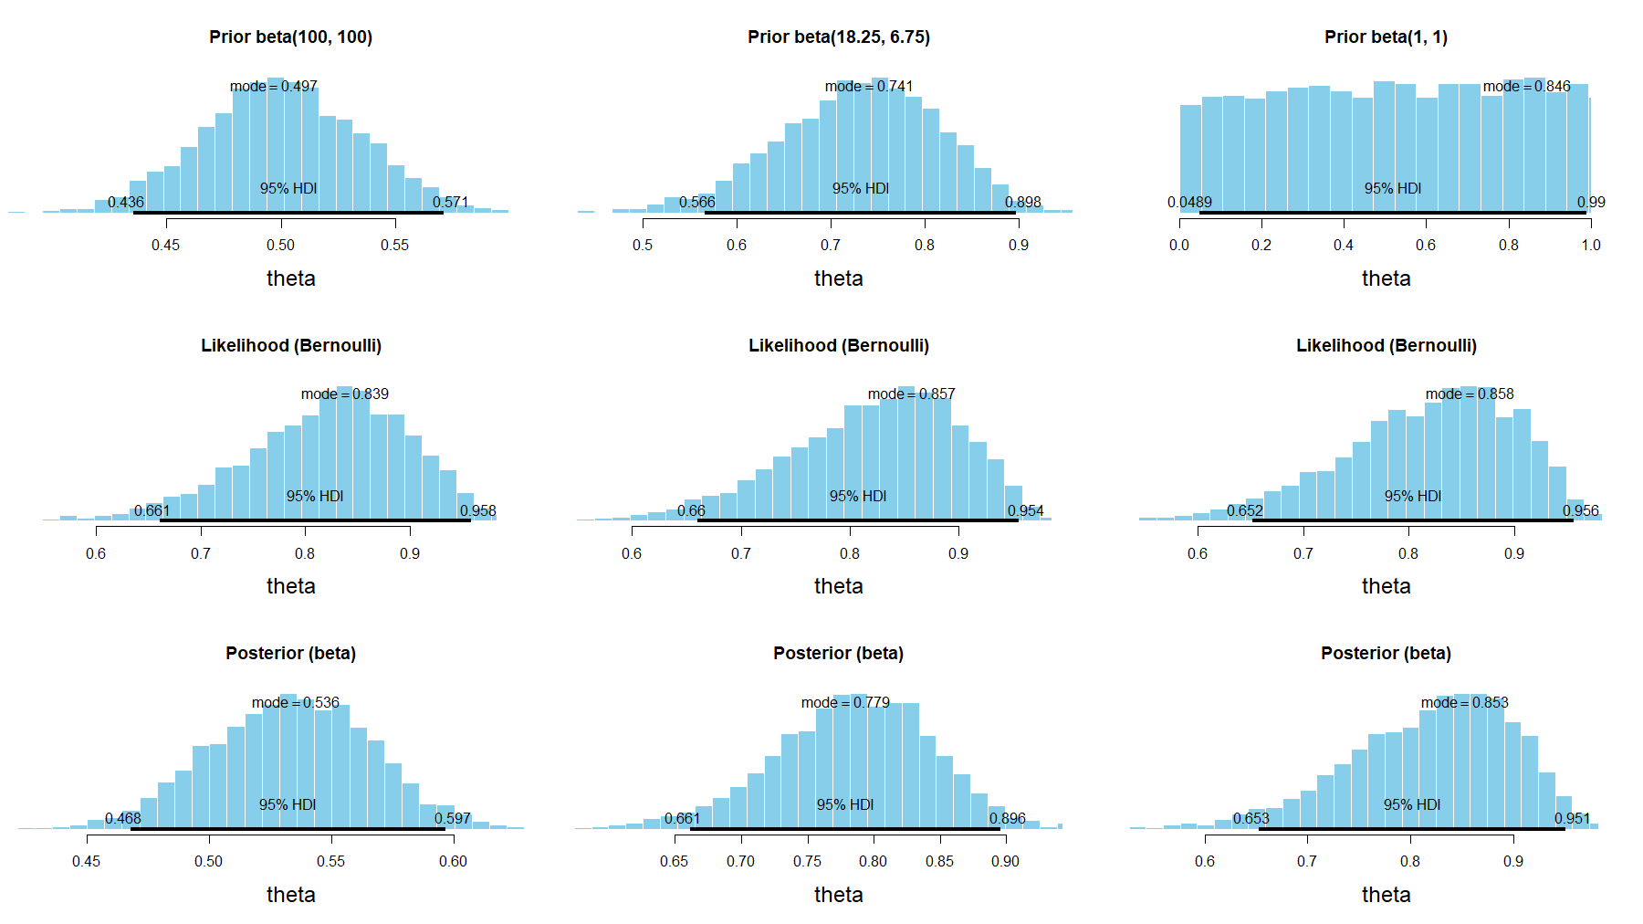]

## Slice sampler

slice_sampling <- function(posterior, initial_point, scale_estimates, iter = 2000, warmup = floor(iter/2)) {  
 chain_length <- iter - warmup  
 samples <- data.frame(matrix(vector(), iter, length(initial_point)))  
   
 samples[1,] <- slice_sample(f = posterior, x_0 = initial_point, w = scale_estimates)  
 for (i in 2:iter) {  
 samples[i, ] <- slice_sample(f = posterior, x_0 = unlist(samples[i - 1,]), w = scale_estimates)   
 }  
   
 colnames(samples) <- paste0("param", seq_along(colnames(samples)))  
 return(tail(samples, n = chain_length))  
}

name: a2 ## Task A.2

Given the following measurements $y=[1,0,1,1,0,1,1,1,0,1,1,1,1,1]$.

1. What is the probability of getting a head? Give a 95% credible interval of this probability.
2. What is the probability that $θ>0.5$?

–

data {  
 int<lower = 0> N;  
 int y[N];  
}  
  
parameters {  
 real<lower = 0, upper = 1> theta;  
}  
  
model {  
 y ~ bernoulli(theta);  
}  
  
generated quantities {  
 int prob05;  
 prob05 = theta > 0.5;   
}

## Summary from Stan

samples

## Inference for Stan model: f26aeaff8c4fa11f5fab3854aaa025d5.  
## 4 chains, each with iter=12000; warmup=6000; thin=1;   
## post-warmup draws per chain=6000, total post-warmup draws=24000.  
##   
## mean se_mean sd 2.5% 25% 50% 75% 97.5% n_eff Rhat  
## theta 0.75 0.00 0.11 0.52 0.68 0.76 0.83 0.92 9698 1  
## prob05 0.98 0.00 0.14 1.00 1.00 1.00 1.00 1.00 16978 1  
## lp__ -9.51 0.01 0.73 -11.60 -9.68 -9.23 -9.05 -9.00 9691 1  
##   
## Samples were drawn using NUTS(diag_e) at Wed Oct 30 15:02:32 2019.  
## For each parameter, n_eff is a crude measure of effective sample size,  
## and Rhat is the potential scale reduction factor on split chains (at   
## convergence, Rhat=1).

## Visualizing the posterior

params %>% ggplot(aes(x = theta)) + geom_histogram(binwidth = 0.01) +   
 geom_vline(xintercept = mean(params[["theta"]]), color = "blue") +   
 geom_vline(xintercept = map_estimate(params[["theta"]]), color = "green") +   
 geom_vline(xintercept = median(params[["theta"]]), color = "red")

## 

## Expected probability of getting a head?

We know since Chapter 6 with a prior of beta(1, 1), bernoulli likelihood and data of z = 11, N = 14, that the posterior will be a beta(1+11, 1 + 14 - 11) = beta(12, 4).

Expected value of a beta distribution: $E[θ]=\frac{a}{a+b}=0.75$

mean(params[["theta"]])

## [1] 0.7485882

Other estimators:

map_estimate(params[["theta"]])

## MAP = 0.79

median(params[["theta"]])

## [1] 0.7595861

## What is the probability that $θ>0.5$

generated quantities {  
 int prob05;  
 prob05 = theta > 0.5;   
}

glimpse(params["prob05"])

## Observations: 24,000  
## Variables: 1  
## $ prob05 <dbl> 1, 1, 1, 1, 1, 1, 1, 1, 0, 1, 1, 1, 1, 1, 1, 1, 1, 1, 1...

mean(params[["prob05"]])

## [1] 0.9809583

sum(params[["theta"]] > 0.5)/length(params[["theta"]])

## [1] 0.9809583

## Sampling from the MCMC

y <- c(1, 0, 1, 1, 0, 1, 1, 1, 0, 1, 1, 1, 1, 1)  
z <- c(1, 0, 0, 0, 0, 0, 0, 1, 1, 0)  
data <- list(  
 y = y, Ny <- length(y),  
 z = z, Nz <- length(z)  
)  
  
# Compile the stan model  
model <- stan_model(file = model_file, model_name = "Task A.2")  
samples <- sampling(model, data = data, iter = 12000)

## Sampling from the MCMC

params <- rstan::extract(samples)

1. Calculating the probability that $θ_{y}>θ_{z}$.
2. Creating a new variable $dθ=θ_{y}−θ_{z}$, and calculating a 95% CI.

mean(params[["y_gr_z"]])

## [1] 0.9901667

hdi(params[["d_theta"]], ci = 0.95)

## # Highest Density Interval  
##   
## 95% HDI  
## [0.10, 0.74]

## Histogram of $p(dθ|y,z)$

1. Plot a histogram of $p(dθ|y,z)$. Is it beta distributed?

d_theta_hdi <- hdi(params[["d_theta"]], ci = 0.95)  
params %>% ggplot(aes(x = d_theta)) + geom_histogram(binwidth = 0.05) +   
 geom_segment(x = d_theta_hdi$CI_low, xend = d_theta_hdi$CI_high, y = 0, yend = 0, color = "blue", size = 2)

.pull-left[ 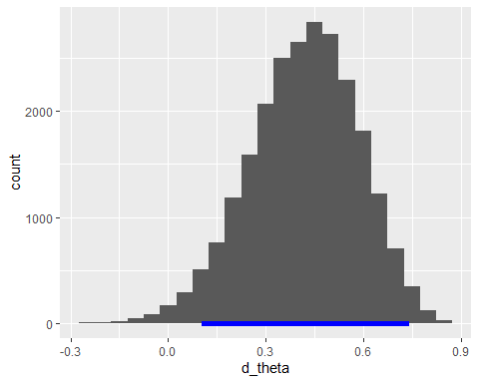]

.pull-right[ A beta distribution is defined on the interval $[0,1]$. The distribution for $dθ$ is not bounded on that interval, therefore it cannot be a beta distribution.]