Project Proposal

A Survey on Blockchain Technology: Different Approaches

And on-going development

CS550 – Advanced Operating Systems

January 24th 2018

Navjot Sharma

(A20376692)

1. Introduction:

Blockchain technology is a public ledger system that maintains the integrity of the transaction data. It is a distributed database solution that maintains a continuously growing list of data records confirmed by the participating nodes/entities. This data is recorded in a public ledger, including completed transaction information. Blockchain is a decentralized solution i.e. it does not require any third party organization in the middle. The information is transparent to all the nodes, since the data is available to all nodes.

Additionally, the nodes are all anonymous, which helps in making transaction confirmation by other nodes more secure. Bitcoin – the first application that introduced Blockchain technology, where a decentralized environment was created for cryptocurrency, enabling the participants to buy and exchange goods with digital money.

There are three merits of using Blockchain Technology:

1. No downtime required
2. Makes falsification extremely hard
3. Inexpensive system.

Even though, It seems to a suitable solution for transaction processing using cryptocurrencies, it still has some challenges and limitations that need to be studied and addressed. 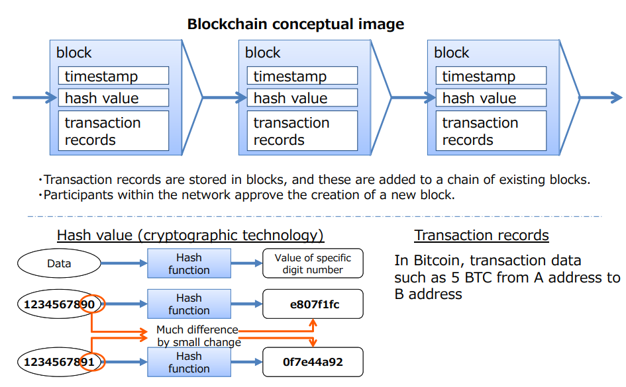

In this project we will be doing a thorough survey on Blockchain by identifying few domains and the solutions implemented in those domains, such as insurance, energy trading, ride sharing, Supplychain, banking, education, healthcare, etc. Although there are number of domains where Blockchain has been implemented, we decided to narrow down the research topic to three domains. Our objective is to find and map all the papers with technical viewpoints on Blockchain. Hence we are interested in finding research topics related to various technical areas such as performance, scalability, privacy, security and data integrity.

1. Background Information:

Thesis by Satoshi Nakamoto

It all started with a thesis by Satosh Nakamoto first time, in the end of November 2008, called Peer to Peer Electronic cash system. This was a thesis on a US mailing list where cryptographers exchange information. This is the very beginning of Bitcoin. After discussions held on the mailing list for a while, the first block was created in January 2009 and the operation of Bitcoin and Bitcoin Blockchain was commenced. Since then, the Bitcoin system has never been suspended and users have been increasing worldwide

We’ll be discussing about main technologies in Bitcoin Blockchain:

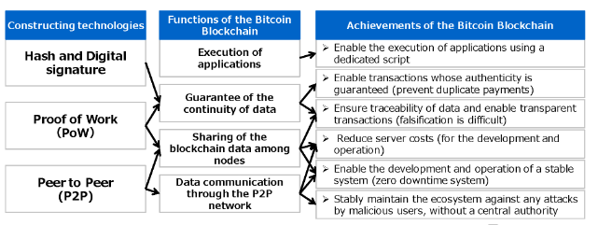

1. Problem Statement:

The conventional transaction system for currency transaction between persons or companies are centralized, i.e. all the information and data are often controlled and managed by a third party organization, rather than the two entities that are involved in the transaction. For instance if we need to make a digital payment or currency transfer, we require a bank or credit card provider as a middleman to complete transaction, similar is the case with other domains such as music, games, software etc. This problem was addressed by Blockchain technology.

Unlike traditional databases that are stored and maintained on private and centralized servers, a Blockchain is decentralized, publicly distributed, and transparent. This public distribution means that the data being maintained is effectively unforgeable, incorruptible, and has no center point of failure. Identity protection is a common problem in today’s digitized world. Seemingly every other week, headlines reveal some hacker has gained access to a centralized server resulting in the theft of millions of financial records, medical records, or identities. This problem is likely to get worse before it gets better. As of 2016, there are 13 billion devices connected to the internet. Many of these devices hold our personal information, bank records, and credit card numbers. By 2020 this number is set to reach 40 billion leaving us more exposed than ever.

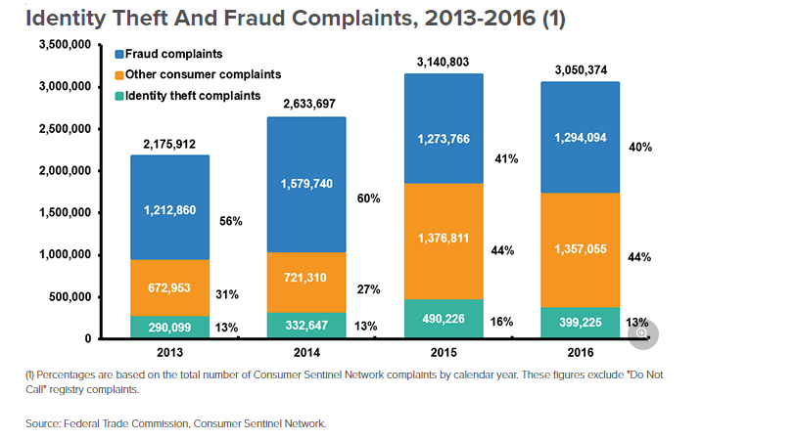

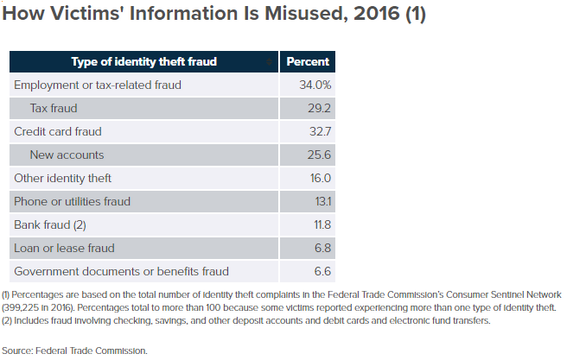

1. Related Work:

This decentralized environment for transaction has been enhanced for various domains as below:

* Insurance
* Energy trading
* Ride sharing
* Supplychain
* Banking
* Education
* Healthcare, etc.

We’ll be discussing about the advantages and disadvantages of the Blockchain solutions available in few of these domains.

1. Solutions:

There are number of implementations available for Blockchain, We’ll be focusing on few of the below mentioned implementations:-

* Bitcoin
* ZCash
* Ethereum
* Ripple
* Hyperledger Fabric
* Corda
* Intel Sawtooth

1. Evaluation

The evaluation of this project is comprised by the following:

* Comparison of different type of Blockchain technology solutions available based on the domains like insurance, energy trading, ride sharing, supplychain, banking, education, healthcare, etc.
* For the sake of comparison we will also be identifying their pros and cons and how they have been implemented and evolved over time.
* We will also be summarizing the progress of the on-going development in this area.

1. Conclusions

Blockchain technology runs the Bitcoin cryptocurrency. It is a decentralized environment for transactions, where all the transactions are recorded to a public ledger, visible to everyone. The goal of Blockchain is to provide anonymity, security, privacy, and transparency to all its users. However, these attributes set up a lot of technical challenges and limitations that need to be addressed.

In order to do this survey, we need to understand where the current research on Blockchain technology positions itself, hence we will be systematically mapping various researches together in order to evaluate different type of solutions available in different domain and analyze the on-going development that is happening in this area too.

8. Deliverables

* One final Project Report in PDF form.
* One final Power point presentation.

# **References**

1. Statistics for Identity theft/cybercrime as identified by Federal Trade Commission (FTC)

<https://www.ftc.gov/news-events/press-releases/2017/03/ftc-releases-annual-summary-consumer-complaints>

<https://www.iii.org/fact-statistic/facts-statistics-identity-theft-and-cybercrime>

1. Swan M. Blockchain: Blueprint for a New Economy. “ O’Reilly Media, Inc.”; 2015
2. Nakamoto S. Bitcoin: A peer-to-peer electronic cash system. Consulted. 2008;1(2012):28.
3. <https://link.springer.com/chapter/10.1007%2F978-1-4614-2110-8_2>
4. Meti- Survey on Blockchain Technologies and services - Information Economy Division Commerce and Information Policy Bureau <http://www.meti.go.jp/english/press/2016/pdf/0531_01e.pdf>
5. Thesis by Satoshi Nakamoto – Bitcoin: P2P <https://bitcoin.org/bitcoin.pdf>
6. Identity theft management - <https://medium.com/@philfrancis77/blockchain-the-byzantine-general-problem-and-the-future-of-identity-management-6b50a2eb815d>
7. 7 Blockchain implementations: <https://medium.com/@gaurangtorvekar/7-blockchain-technologies-to-watch-out-for-in-2017-4b3fc7a85707>