**Correction: Best Practices for Wake Model Optimization Algorithm Selection in Wind Farm Layout Optimization**

**Author(s) Name:** Nicholas F. Baker1, Andrew P. J. Stanley1, Jared J. Thomas1, Andrew Ning1, and Katherine Dykes2

**Author(s) Affiliations:** 1. Brigham Young University. 2. National Renewable Energy Laboratory

# Correction Notice

(1/2) Table 3 regarding the 36 turbine case omitted the data from *sub6* in the results. For comparative AEP return amongst the other participants *sub6* was ranked number 10, and the full table as it should have appeared is given here:

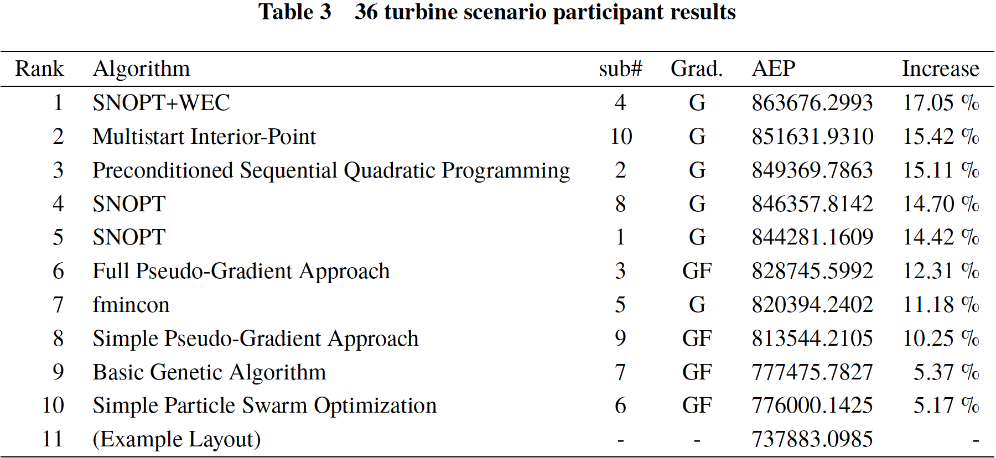

(2/2) Tables 6-10 mislabeled the wake model and algorithms used by *sub4* and *sub5*. The Bastankhah wake model using the SNOPT+WEC optimization algorithm was used by sub4, the Simplified Bastankhah wake model using the fmincon optimization algorithm was used by *sub5*. The inverse was listed in the tables. Tables 6-10 correctly tied Rank, AEP data, and % Difference to the submission numbers on the same horizontal line, only the wake model and optimization algorithm names were mislabeled. Furthermore all descriptions in the paper’s corresponding paragraphs refer correctly to what wake model and optimization algorithm the two submissions used, the only error was in the table “Wake Model” and “Algorithm” columns. The corrected tables as they should have appeared are given here:

