# Introduction

In order to better understand the effects of different Engineering Wake Model (EWM) selections and optimization algorithm implementations, we propose that two simple wind farm layout optimization (WFLO) case studies be tried by a broad spectrum of participants working on the WFLO problem.

Two of the major factors that affect the results of wind farm layout studies are 1) EWM characteristics and 2) optimization algorithm implementation. Two case studies have been designed in an attempt to quantify the effects of both choices. The first case (described in Section 2.1) study focuses on different optimization techniques each paired with a single simplified EWM. The second case study (described in Section 2.2) observes the effects of various combinations of EWM and optimization method.1

To isolate optimization method variability, we have implemented a representative wake model, and permit participants to use any optimization strategy they think will achieve the maximum Annual Energy Production (AEP) for the specified wind farm. This collaboration will be called the Optimization Only Case Study, and is described below in Section 2.1.

Since an EWM’s compatibility with gradient-based or gradient-free optimization methods dictate which algorithms can be applied, designing a case study which restricts participants to a single optimization algorithm would unnecessarily limit the scope of EWMs studied. With the aim of acquiring as much empirical data in order to determine best practices for the industry as a whole, our second case study will permit collaborating participant selection of not only EWM, but also implemented optimization algorithm. It will be called the Combined Physics Model/Optimization Algorithm Case Study, and is described below in Section 2.2.

The wind farm characteristics of these two cases are similar, and were selected to be both restrictive enough to maintain simplicity, yet general enough to aid in solving and interpreting the results of more complex and realistic problems.

At this point, it is more important to give the short overview of *what* the researchers are to do and *why* it is important, without excessive details. In place of the previous three paragraphs, I would recommend a paragraph overviewing the *what* (Researchers will perform each case study *x* number of times and submit a report/zip file with information necessary to reproduce and compare their results) and a closing paragraph that reiterates the *why*, which is given in the opening paragraph but can now be expanded upon with the context provided in the other paragraphs.

# Problem Definitions

## The Optimization-Only Case Study

The intent of this case study is to determine best optimization practices when given an EWM that permits both gradient-based and gradient-free methods to be used. As a representative EWM, we select a simplified version of Bastankhah’s Gaussian wake model [1, 2, 3]. We supply a Python implementation of this wake model, as well as a description of the model in Appendix C for those who wish to implement it in another language.

With the wake model fixed, participants are free to use whichever computational optimization strategies they choose, with the objective of obtaining the maximum Annual Energy Production (AEP) for the defined farm. In this case study the wind farm boundaries, directional wind frequency, wind turbine attributes, and wake model physics are fixed—turbine location is the only design variable participants are permitted to alter.

Since problem size strongly affects optimization algorithm performance, three wind farms of increasing size are specified in Section 2.1.1. These scenarios, roughly doubling in number of turbines, exist to avoid a bias towards algorithms optimized for wind farms of a specific dimension,

1Comparisons just between EWMs does not involve optimization and multiple studies already exist in this area.

and in order to observe how increased complexity correlates to algorithm performance. Perfect squares are used to permit grid turbine arrangements, if desired.

The goal of this collaboration is to compare participant results when using different optimization strategies under a single wake model, in order to understand the performance differences resulting from optimization algorithm selection in similar scenarios. While the provided wind farm scenarios are very simple, we expect the results to assist researchers in understanding the differences that occur in WFLO due to various numerical methods. A greater understanding of the trade-offs in algorithm selection for this simplified problem is expected to aid in solving and interpreting the results of more complex and realistic problems.

### Wind Farm Definition

There are three (3) wind farm size scenarios which will be optimized by all participants:

* + - 1. Wind farm of sixteen (16) turbines, boundary radius of 1,300 m.
      2. Wind farm of thirty-six (36) turbines, boundary radius of 2,000 m.
      3. Wind farm of sixty-four (64) turbines, boundary radius of 3,400 m.

For all wind farm sizes, the wind farm boundary is circular, as depicted Fig. 1. The origin is at the center of the farm, coincident with the depicted reference turbine, and the specified boundary radius for each farm is measured from the origin. The radii magnitudes were determined by evenly distributing the specified number of turbines in concentric circles, with no less than 5-diameter spacing between adjacent turbines, and rounding up to the nearest 100 m.

All wind farms will be populated with the IEA37 3.35 MW onshore reference turbine [4], whose main attributes are summarized in Appendix A.

Note that the farm boundary restricts only turbine hub locations. The blade radius is permitted to extend beyond, but hub locations must be on or within the boundary. Hub locations are further restricted from being placed closer to each other than two diameters apart.

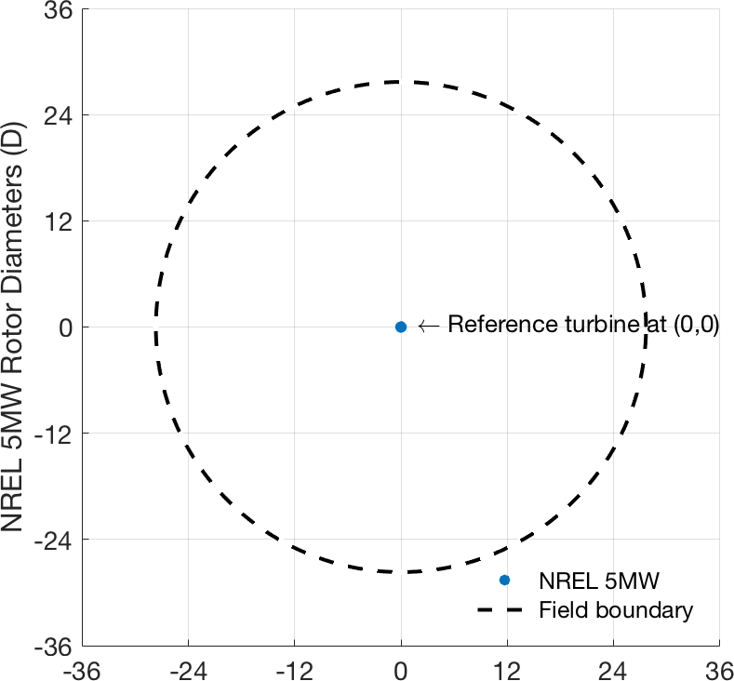

Figure 1: Depiction of 1300 m circular farm boundary, reference turbine (to scale) placed at origin.

### Baseline Layouts

To assist in validation, a baseline wind turbine layout is supplied as a check for each farm size.

The AEP for these baseline layouts, as determined by our wake model implementation, is included in the .csv file for each size scenario, listed in the .zip file accompanying this document. If you choose to utilize your own implementation of the wake model and AEP functions described in

Appendix C instead of the Python implementation provided, ensure that your implementation reports the same AEP for these locations.

You are also to conduct a single baseline optimization from these baseline layouts, and report your resulting optimized turbine location and AEP values from these starting locations. You are not required to start *each* of your optimizations from these layouts; only report the results from a single run using these starting baselines. For your other optimization attempts, feel free to use random starts, warm starts, intuition, or any other selection method you choose to initialize turbine locations. The exact coordinates for the turbine locations in each of these baseline layouts

are also included in .csv files listed in the .zip file accompanying this document. The format

for these files is described later in Section 3.2.1. The baseline layouts are depicted graphically in

Fig. 2

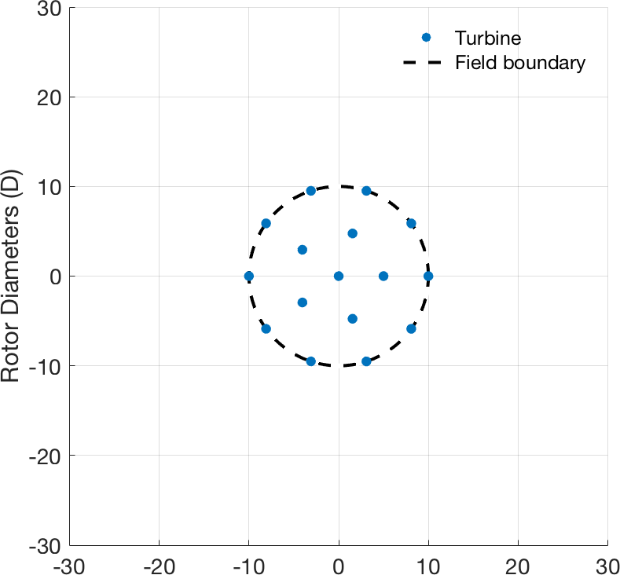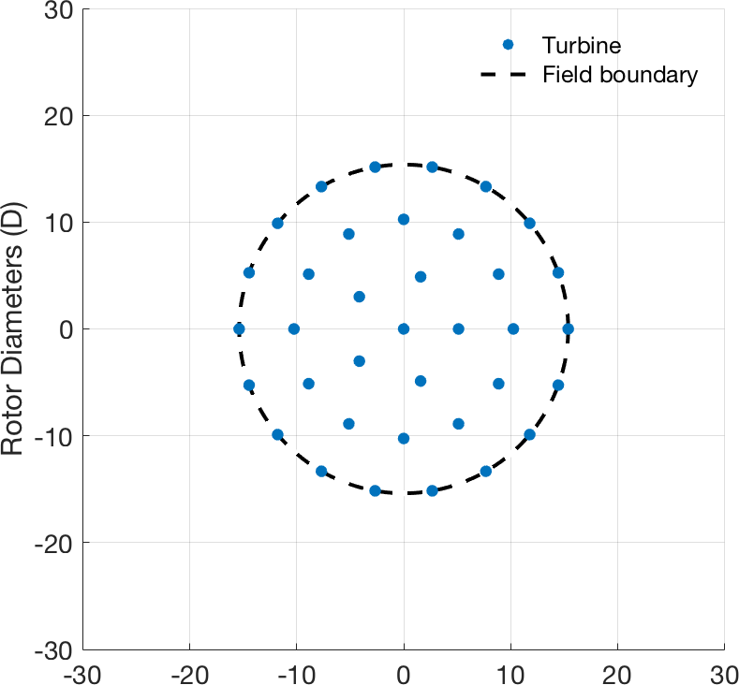

(a) 16 Turbine Farm (b) 36 Turbine Farm

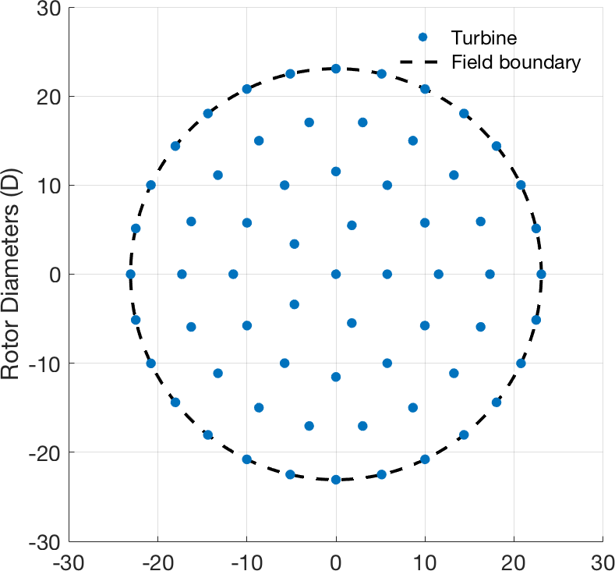Figure 2: Baseline turbine locations, depicted with dashed wind farm boundaries and blue NREL 3.35 MW onshore reference turbines (to scale)

(c) 64 Turbine Farm

### Wake Model and Code Description

The wake model implemented in this case study is Bastankhah’s Gaussian wake model [1, 2, 3]. A description of the model’s governing equations, data on the wind farm’s wind speed and direction

probability, and formulations for AEP calculations are included in Appendix C. The pertinent equations are coded in Python, and are provided alongside this document in a .zip directory, in order for each participant to focus on the optimization aspect and apply their unique methods.

The wake model routine takes turbine grid locations as inputs, and returns as output a single AEP value calculated from the input turbine locations.

Though not necessary, alteration to the released Python code is permitted, if required to maximize optimizer effectiveness. Care must be taken, however, that the governing physics equations are not altered to deliver deviated AEP results. For this reason, baseline turbine locations and AEP calculations are described in Section 2.1.2, to be used for validation.

## The Combined Physics Model/Optimization Algorithm Case Study

This case study closely matches the one described in Section 2.1, with the exception that no wake model is provided, and only a single wind farm size is to be optimized. Participants are free to choose their preferred EWM and optimization method. The objective is to obtain the maximum Annual Energy Production (AEP) for the defined turbine farm. Participants will adjust resultant AEP through choice of EWM utilized, and manipulation of turbine locations.

The intent of this case study is to determine best EWM selection and optimization practices for this representative wind farm scenario. Since different EWMs approximate the aerodynamic characteristics effecting power production differently, reported AEP from participants using different EWMs are not comparable. As a benchmark measuring tool for these case studies, we will run all participant results of optimized turbine locations through a Large Eddy Simulation (LES). Using LES as a tool for analysis, participant results will be analyzed based on which participant results (regardless of EWM used) give the highest LES-calculated AEP.

Like the previous case study defined in Section 2.1, the wind farm boundary for this case study is circular, and the number of turbines in the farm is a perfect square in order to permit a grid arrangement, if desired. To limit the LES computation time required for us to assess results, the wind farm size for this case study is limited to 9 turbines.

This study differs from the first, in that it assesses not only the optimization methods measured by previous case, but also the effects that different physics model approximations have on turbine location recommendations. While the provided wind farm is very simple, we expect the results to assist researchers in understanding the differences that occur in WFLO due to various aerodynamic approximations and optimization methods. A greater understanding of the trade-offs in EWM selection and optimization algorithm implementation for this simplified problem is expected to aid in solving and interpreting the results of more complex and realistic problems.

### Wind Farm Definition

* + - * The wind farm consists of nine turbines, boundary radius of 900 m.
      * If necessary, the turbulence intensity is 0.075.

Assume the freestream wind speeds given in this document are at hub height. If you need a wind shear, use a power law relationship with a shear exponent of 0.15.

*•*

The wind farm boundary is circular, as depicted in Fig. 3. The origin is at the center of the farm, coincident with the depicted reference turbine, and the specified boundary radius is measured from the origin. The radius magnitude was determined by evenly distributing the specified number of turbines in a circle, with no less than 5-diameter spacing between adjacent turbines, and rounding up to the nearest 100 m.

All wind farms will be populated with NREL 3.35 MW onshore reference turbine [4], whose main attributes are summarized in Appendix A

Note that the farm boundary restricts only turbine hub locations. The blade radius is permitted to extend beyond, but hub locations must be on or within the boundary. Hub locations are further restricted from being placed closer than two diameters apart from each other.

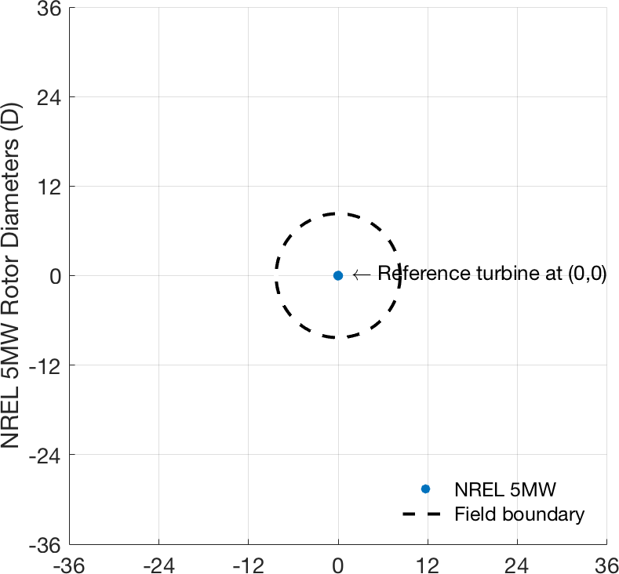

Figure 3: Depiction of circular farm boundary, reference turbine (to scale) placed at origin.

### Baseline Layout

To better understand EWM characteristics and optimization methods, a baseline wind turbine layout is supplied. You are to conduct a single baseline optimization from this baseline layout, and report your resulting optimized turbine location and AEP values.

You are not required to start *each* of your optimizations from these layouts, only to report the results from a single run using this starting baseline. For your other optimization attempts, feel free to use random starts, warm starts, intuition, or any other selection method you choose to initialize turbine locations. The exact coordinates for the turbine locations in each of these baseline

layouts are included in .csv files listed in the .zip file accompanying this document.

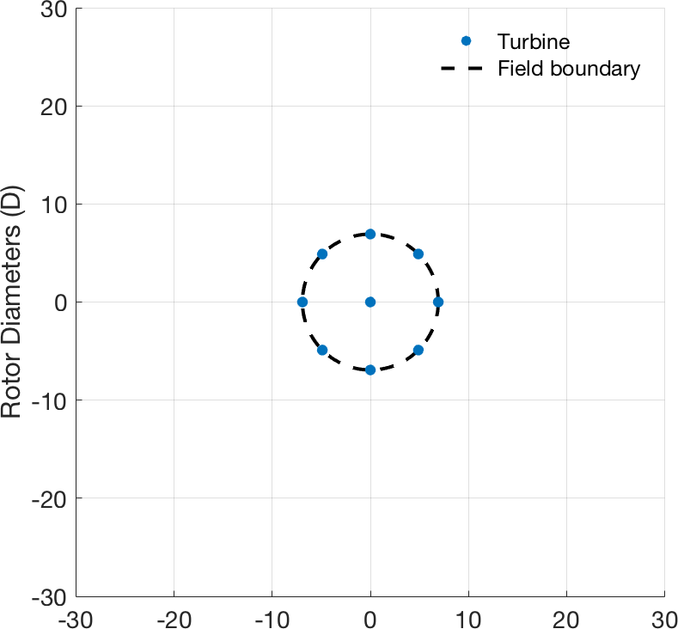

Figure 4: Baseline turbine locations, depicted with dashed wind farm boundaries and blue NREL

3.35 MW onshore reference turbines (to scale)