What is Research Data Management?
In early 2020, the COVID-19 disease, caused by the coronavirus SARS-CoV2, broke out globally, which led to the closure of many shops and businesses for quarantine reasons. The result, especially in the USA, was a large number of unemployed people who urgently needed money for their next rent payment, food or other expenses. As a consequence, the government decided to set up a relief package for anyone who registers as unemployed - but why didn't the money get to the people?
The reason for this was the overload of critical systems on which COBOL is still running. COBOL is a programming language that was developed in the late 1950s to control commercial applications. From today's perspective, the programming language is very outdated and no longer taught in the training of programmers. That is why there was no personnel to take care of the systems when they collapsed. Unfortunately, many applications with the outdated programming language are still running in the business sector.
Source: FDM Thüringen: Scarytales, Licensed under CC-BY 4.0
Exercise:
Suggest two possible process changes that could have prevented the outcome of the scenario:
Solution:
There are several solutions possible: Existing systems should be questioned, since requirements can change and established habits can lead to problems from today's perspective. For example, at some point data might no longer be able to be called up or might exist in formats that are increasingly difficult to be processed. A thorough documentation of the programs might also help in some cases to rebuild them in other languages. For timely relief, the administration called out to retired COBOL programmers to work on the issues.
While maybe not as critical for society at large, scientists can face similar problems when trying to access old data or programmes that were written for other purposes but are now needed for current tasks: Data are insufficiently labeled, have been overwritten, commercial computer programmes have been discontinued or process details were not recorded.
Research Data Management (RDM) aims to break this dynamic by ensuring a sustainable and coherent strategy for all data types throughout the research process, enabling researchers to store, access and re-use their own work effectively and safely and opening their findings worldwide to improve on cross-disciplinary collaboration, monitoring and replication.
RDM includes all activities associated with processing, storage, preserving and publication of research data.

The Research Data Lifecycle

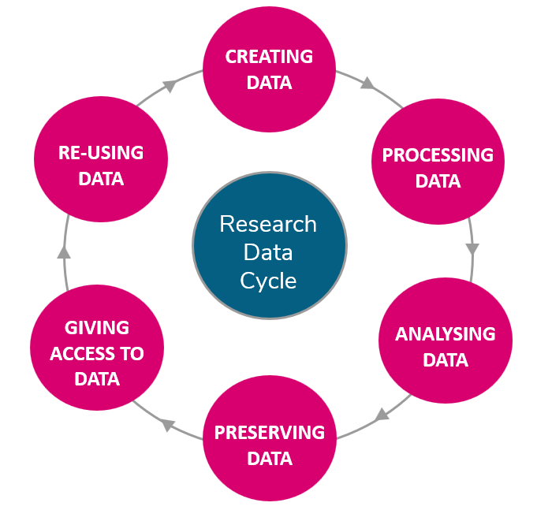
The Research Data Lifecycle. Original source: UK Data Service, recreated by A. Ahrens. Licensed under CC-BY-4.0
The "Research Data Lifecycle" describes a cyclic process of data generation and management. First, data is created, then processed. The next step is analyzing data, followed by preserving the results. Now, it is time to give access to the data. Ideally, the cycle closes at this point: Data is being re-used and new, well-documented data is being created.
Exercise: Look at each step of the cycle with your data in mind:
- Which steps do you actively apply in your research process?
- Which tools or software do you use at each step?
- How well is the data protected against data loss? Where are possible flaws where data or information could get lost?
- Does the cycle "close"? Which repositories or platforms do you use to store your results?

Benefits of RDM
Are you frustrated with the time you invest in searching for data? Do you want to apply structured RDM cost-effectively? But in the moment, you lack the expertise, resources, or incentives to share your data with your group and in your field? Perhaps you worry whether your data is transferable at all because some data have ethical or epistemological restrictions or your project includes many stakeholders with competing interests in your project? In this chapter, we will prove to you that Research Data Management is not as tricky as you think.
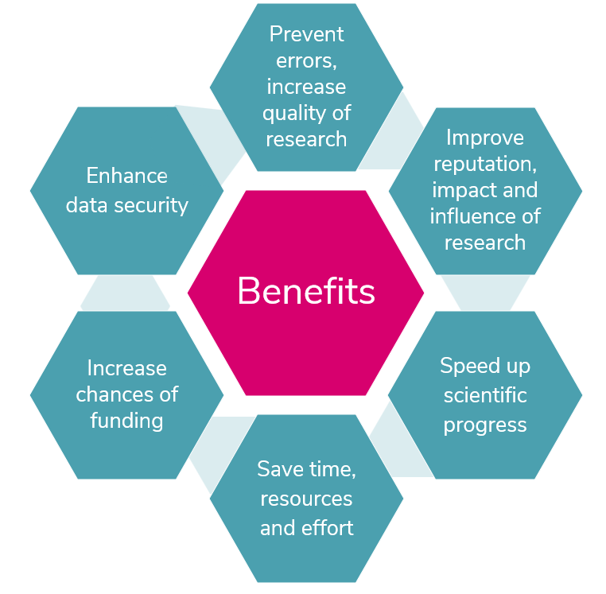
If done right, RDM will...
- Save time, resources, effort and money:
  - preserve time that is otherwise lost while searching for, recovering, and deciphering data
  - make data reusable
  - enable you to benefit from high quality datasets from other researchers
- improve impact and speed up scientific progress:
  - make research reproducible and reusable, so others can verify and build upon your findings. This strengthens integrity and increases your citations.
  - improve your research reputation and increase your visibility
  - continually influence research developments long after the original research has been completed
  - will permit new and innovative research to be built on existing information, especially within and across disciplines.
- help to prevent error and enhance data security:
  - secure your data against loss and protect sensitive data against misuse, theft, damage and disaster.
  - ensure records are synchronized, complete and reliable.
  - improve research workflows to make them more resilient to human error and software vulnerability
- show compliance with research obligations of your institution and funder:
  - fulfill grant requirements and comply with practices conducted in industry and commerce in order to demonstrate a high-quality research output.
  - ensure transparency since individual contributions are documented on-the-fly throughout the complete research and archiving process.
  - increase your chances of funding since many funding organizations require a DMP.
  - simplify cooperation and collaboration (e.g. through better documentation and affiliation of the data collected).

