Question 3.5

After creating 3 instances of the class AuditeurCnam

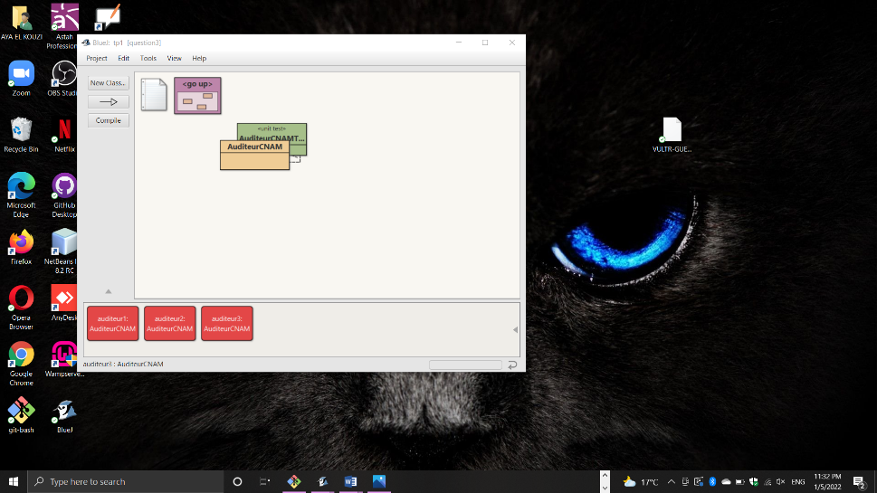

After inspecting all 3 instances

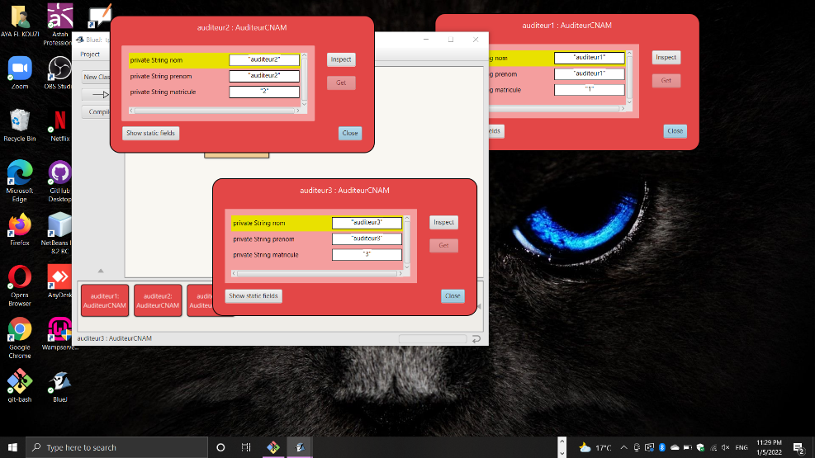

Question 3.6

