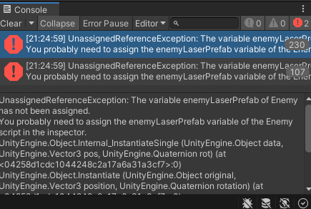

This had an error since when the player (using the Enemy script) was touching the collision, the collision disappeared but the player didn’t have a laser prefab installed, so to solve it, a new script was created with the same code but did not insert any lasers since the player does not shoot.

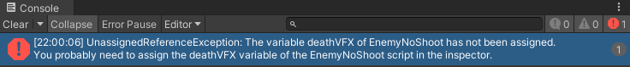

Basically, the old person prefab was not assigned the explosion particle prefab and had this error.