SCHOOL MANAGEMENT PLATFORM
MASTER TECHNICAL & FUNCTIONAL BLUEPRINT
API • PostgreSQL/Django schema • Permissions • UML • Architecture • Claude Code
Version 4.0 — Design freeze before implementation
V1: one operational school • Multi-tenant ready • LAN-first • zero mandatory paid infrastructure

1. Document control and design status
Item | Decision
Functional source | Validated project requirements and the open-decision answers supplied for the project.
V1 tenancy | One operational school.
Future tenancy | Schema and service boundaries prepared for multiple schools/tenants.
Admin client | Dedicated desktop application using Python + PySide6.
Teacher | Web + Flutter mobile.
Parent / Guardian / Staff | Flutter mobile.
Public site | Dynamic Django web site.
Backend | Django + DRF + Channels.
Database | PostgreSQL.
Real-time | Redis + WebSockets.
Payments | Full business layer + simulated treasury/wallet providers.
Primary goal of this document | Remove architecture ambiguity before Claude Code starts implementation.

Source alignment: The schema and rules in this document incorporate the supplied answers on multi-school readiness, identity verification, attendance, payroll, payments, communication, retention, APK distribution and the separated admin client. The uploaded decision log records the validated choices on tenancy, teacher registration, identity verification, attendance, payroll and payment foundations (decision log, lines 2–8).

2. Final architecture before implementation
PUBLIC SCHOOL WEBSITE
Django Templates / HTML / CSS / JS
/ admissions / news / APK / rules
|
v
+-----------------------+
| DJANGO CORE |
| DRF + Channels |
| Domain Services |
+----------+------------+
|
+---------------+---------------+
| | |
v v v
PostgreSQL Redis Private Storage
^
|
REST / WebSocket / Auth
/ Permissions / Tenant scope
|
+---------+----------+-----------------------+
| | |
v v v
Admin Desktop Teacher Web Flutter Apps
PySide6 Django Teacher / Parent /
Guardian / Staff
- The public Web site is the entry point for discovery and teacher registration; private business functions are authenticated.
- The admin desktop is a client, not a second database and not a direct database console.
- The backend is the single authority for permissions, calculations, finance, attendance, QR validation and business rules.
- V1 uses one school operationally, but School + SchoolMembership are present so future multi-school tenancy does not require a domain rewrite.
- Remote support is future infrastructure, not a V1 shortcut around security.

3. Relational data model — conventions
- Primary keys are UUIDs. Human-readable matricules, invoice numbers and references are separate business identifiers.
- Date/time fields use PostgreSQL timestamptz through Django DateTimeField; date-only fields use DateField; monetary amounts use DecimalField.
- Foreign keys use PROTECT for historic business objects, CASCADE only for true dependent records, and SET_NULL where an actor may leave while history must remain.
- Tenant-owned rows contain school_id directly when useful for filtering and future row-level isolation; parent-child consistency is enforced by services and tests.
- Calculated values are derived from source data. Cached/materialized values are optional optimization layers, not primary truth.
- Private files are stored through Django storage abstraction; application logic never hard-codes a local file path.
- Business audit, security audit and administrative audit are distinct logical layers inside AuditLog.

4.1 Core & multi-tenant

School
Root tenant. V1 has one active school; schema remains multi-school ready.
Field | Django / PostgreSQL | Null | Default | Key | FK → | on_delete | Index | Notes
id | UUIDField(primary_key=True) | NO | — | PK | — | — | NO | UUIDv4/uuid7 acceptable; never expose sequential integer IDs
created_at | DateTimeField(timestamptz) | NO | timezone.now | — | — | — | NO | —
updated_at | DateTimeField(timestamptz) | NO | timezone.now | — | — | — | NO | —
code | CharField(max_length=32) | NO | — | UQ | — | — | YES | —
name | CharField(max_length=200) | NO | — | — | — | — | YES | —
legal_name | CharField(max_length=255) | YES | — | — | — | — | NO | —
short_name | CharField(max_length=80) | YES | — | — | — | — | NO | —
logo | ImageField | YES | — | — | — | — | NO | —
crest | ImageField | YES | — | — | — | — | NO | —
address | TextField | NO | — | — | — | — | NO | —
city | CharField(max_length=120) | NO | — | — | — | — | NO | —
country | CharField(max_length=80) | NO | Cameroon | — | — | — | NO | —
phone | CharField(max_length=40) | YES | — | — | — | — | NO | —
email | EmailField | YES | — | — | — | — | NO | —
website | URLField | YES | — | — | — | — | NO | —
timezone | CharField(max_length=64) | NO | Africa/Douala | — | — | — | NO | —
currency | CharField(max_length=3) | NO | XAF | — | — | — | NO | —
description | TextField | YES | — | — | — | — | NO | —
mission | TextField | YES | — | — | — | — | NO | —
vision | TextField | YES | — | — | — | — | NO | —
history | TextField | YES | — | — | — | — | NO | —
status | CharField(max_length=20) | NO | ACTIVE | — | — | — | YES | —

Constraint type | Definition
UNIQUE | code
CHECK | status in ACTIVE,SUSPENDED,ARCHIVED
CHECK | currency is a supported ISO-4217 code

SchoolConfiguration
Business settings that administrators can configure.
Field | Django / PostgreSQL | Null | Default | Key | FK → | on_delete | Index | Notes
id | UUIDField(primary_key=True) | NO | — | PK | — | — | NO | UUIDv4/uuid7 acceptable; never expose sequential integer IDs
created_at | DateTimeField(timestamptz) | NO | timezone.now | — | — | — | NO | —
updated_at | DateTimeField(timestamptz) | NO | timezone.now | — | — | — | NO | —
school | OneToOneField(School) | NO | — | FK/UNIQUE | School | PROTECT | NO | —
default_late_threshold_minutes | PositiveIntegerField | NO | 15 | — | — | — | NO | —
attendance_closing_time | TimeField | NO | 10:00 | — | — | — | NO | —
notification_absence_threshold_hours | DecimalField(6,2) | NO | 10.00 | — | — | — | NO | —
notification_yellow_hours | DecimalField(6,2) | NO | 10.00 | — | — | — | NO | —
notification_orange_hours | DecimalField(6,2) | NO | 20.00 | — | — | — | NO | —
notification_red_hours | DecimalField(6,2) | NO | 30.00 | — | — | — | NO | —
low_average_threshold | DecimalField(5,2) | NO | 8.00 | — | — | — | NO | —
default_attachment_limit_mb | PositiveIntegerField | NO | 10 | — | — | — | NO | —
teacher_vacation_duration_minutes | PositiveIntegerField | NO | 120 | — | — | — | NO | —

SchoolBranding
Visual assets used on cards, reports and public pages.
Field | Django / PostgreSQL | Null | Default | Key | FK → | on_delete | Index | Notes
id | UUIDField(primary_key=True) | NO | — | PK | — | — | NO | UUIDv4/uuid7 acceptable; never expose sequential integer IDs
created_at | DateTimeField(timestamptz) | NO | timezone.now | — | — | — | NO | —
updated_at | DateTimeField(timestamptz) | NO | timezone.now | — | — | — | NO | —
school | OneToOneField(School) | NO | — | FK/UNIQUE | School | PROTECT | NO | —
primary_color | CharField(max_length=20) | NO | #173B73 | — | — | — | NO | —
secondary_color | CharField(max_length=20) | NO | #36A2EB | — | — | — | NO | —
report_background | FileField | YES | — | — | — | — | NO | —
card_background | FileField | YES | — | — | — | — | NO | —
font_family | CharField(max_length=80) | YES | — | — | — | — | NO | —

4.2 Identity & security

User
Global identity; may belong to several schools in future.
Field | Django / PostgreSQL | Null | Default | Key | FK → | on_delete | Index | Notes
id | UUIDField(primary_key=True) | NO | — | PK | — | — | NO | UUIDv4/uuid7 acceptable; never expose sequential integer IDs
created_at | DateTimeField(timestamptz) | NO | timezone.now | — | — | — | NO | —
updated_at | DateTimeField(timestamptz) | NO | timezone.now | — | — | — | NO | —
username | CharField(max_length=150) | NO | — | UQ | — | — | YES | —
email | EmailField | NO | — | UQ | — | — | YES | —
password | Django hashed password | NO | — | — | — | — | NO | —
first_name | CharField(max_length=120) | NO | — | — | — | — | NO | —
last_name | CharField(max_length=120) | NO | — | — | — | — | NO | —
phone | CharField(max_length=40) | YES | — | — | — | — | YES | —
profile_photo | ImageField | YES | — | — | — | — | NO | —
is_active | BooleanField | NO | True | — | — | — | YES | —
email_verified | BooleanField | NO | False | — | — | — | NO | —
phone_verified | BooleanField | NO | False | — | — | — | NO | —
last_login | DateTimeField(timestamptz) | YES | — | — | — | — | NO | —

Constraint type | Definition
UNIQUE | username
UNIQUE | email

Role
Global role catalog.
Field | Django / PostgreSQL | Null | Default | Key | FK → | on_delete | Index | Notes
id | UUIDField(primary_key=True) | NO | — | PK | — | — | NO | UUIDv4/uuid7 acceptable; never expose sequential integer IDs
created_at | DateTimeField(timestamptz) | NO | timezone.now | — | — | — | NO | —
updated_at | DateTimeField(timestamptz) | NO | timezone.now | — | — | — | NO | —
code | CharField(max_length=40) | NO | — | UQ | — | — | YES | —
name | CharField(max_length=100) | NO | — | — | — | — | NO | —
description | TextField | YES | — | — | — | — | NO | —
system_role | BooleanField | NO | False | — | — | — | NO | —

Constraint type | Definition
UNIQUE | code

SchoolMembership
Associates a global user with one tenant.
Field | Django / PostgreSQL | Null | Default | Key | FK → | on_delete | Index | Notes
id | UUIDField(primary_key=True) | NO | — | PK | — | — | NO | UUIDv4/uuid7 acceptable; never expose sequential integer IDs
created_at | DateTimeField(timestamptz) | NO | timezone.now | — | — | — | NO | —
updated_at | DateTimeField(timestamptz) | NO | timezone.now | — | — | — | NO | —
school | ForeignKey(School) | NO | — | — | School | PROTECT | YES | —
user | ForeignKey(User) | NO | — | — | User | PROTECT | YES | —
status | CharField(max_length=20) | NO | PENDING | — | — | — | YES | —
joined_at | DateTimeField(timestamptz) | YES | — | — | — | — | NO | —
left_at | DateTimeField(timestamptz) | YES | — | — | — | — | NO | —
is_primary_school | BooleanField | NO | False | — | — | — | NO | —

Constraint type | Definition
UNIQUE | school,user
CHECK | left_at is null or left_at >= joined_at

MembershipRole
Role assignment within a school membership.
Field | Django / PostgreSQL | Null | Default | Key | FK → | on_delete | Index | Notes
id | UUIDField(primary_key=True) | NO | — | PK | — | — | NO | UUIDv4/uuid7 acceptable; never expose sequential integer IDs
created_at | DateTimeField(timestamptz) | NO | timezone.now | — | — | — | NO | —
updated_at | DateTimeField(timestamptz) | NO | timezone.now | — | — | — | NO | —
membership | ForeignKey(SchoolMembership) | NO | — | — | SchoolMembership | CASCADE | YES | —
role | ForeignKey(Role) | NO | — | — | Role | PROTECT | YES | —
assigned_by | ForeignKey(SchoolMembership) | YES | — | — | SchoolMembership | SET_NULL | NO | —
active | BooleanField | NO | True | — | — | — | YES | —
assigned_at | DateTimeField(timestamptz) | NO | timezone.now | — | — | — | NO | —

Constraint type | Definition
UNIQUE | membership,role

UserDevice
Known devices for session management.
Field | Django / PostgreSQL | Null | Default | Key | FK → | on_delete | Index | Notes
id | UUIDField(primary_key=True) | NO | — | PK | — | — | NO | UUIDv4/uuid7 acceptable; never expose sequential integer IDs
created_at | DateTimeField(timestamptz) | NO | timezone.now | — | — | — | NO | —
updated_at | DateTimeField(timestamptz) | NO | timezone.now | — | — | — | NO | —
user | ForeignKey(User) | NO | — | — | User | CASCADE | YES | —
device_name | CharField(max_length=120) | NO | — | — | — | — | NO | —
device_type | CharField(max_length=30) | NO | — | — | — | — | NO | —
platform | CharField(max_length=30) | NO | — | — | — | — | NO | —
os_version | CharField(max_length=80) | YES | — | — | — | — | NO | —
android_sdk | PositiveIntegerField | YES | — | — | — | — | NO | —
app_version | CharField(max_length=40) | YES | — | — | — | — | NO | —
device_identifier_hash | CharField(max_length=128) | NO | — | — | — | — | YES | —
first_seen_at | DateTimeField(timestamptz) | NO | — | — | — | — | NO | —
last_seen_at | DateTimeField(timestamptz) | NO | — | — | — | — | NO | —
is_trusted | BooleanField | NO | False | — | — | — | NO | —
is_active | BooleanField | NO | True | — | — | — | YES | —

Constraint type | Definition
UNIQUE | user,device_identifier_hash

UserSession
Refresh/session inventory for multi-device security.
Field | Django / PostgreSQL | Null | Default | Key | FK → | on_delete | Index | Notes
id | UUIDField(primary_key=True) | NO | — | PK | — | — | NO | UUIDv4/uuid7 acceptable; never expose sequential integer IDs
created_at | DateTimeField(timestamptz) | NO | timezone.now | — | — | — | NO | —
updated_at | DateTimeField(timestamptz) | NO | timezone.now | — | — | — | NO | —
user | ForeignKey(User) | NO | — | — | User | CASCADE | YES | —
device | ForeignKey(UserDevice) | NO | — | — | UserDevice | CASCADE | YES | —
refresh_token_hash | CharField(max_length=128) | NO | — | — | — | — | NO | —
ip_address | GenericIPAddressField | YES | — | — | — | — | NO | —
user_agent | TextField | YES | — | — | — | — | NO | —
created_at | DateTimeField(timestamptz) | NO | timezone.now | — | — | — | NO | —
last_used_at | DateTimeField(timestamptz) | YES | — | — | — | — | NO | —
expires_at | DateTimeField(timestamptz) | NO | — | — | — | — | NO | —
revoked_at | DateTimeField(timestamptz) | YES | — | — | — | — | NO | —

Constraint type | Definition
CHECK | expires_at > created_at

MFADevice
MFA authenticators. V1 prepared for admin, extensible to other roles.
Field | Django / PostgreSQL | Null | Default | Key | FK → | on_delete | Index | Notes
id | UUIDField(primary_key=True) | NO | — | PK | — | — | NO | UUIDv4/uuid7 acceptable; never expose sequential integer IDs
created_at | DateTimeField(timestamptz) | NO | timezone.now | — | — | — | NO | —
updated_at | DateTimeField(timestamptz) | NO | timezone.now | — | — | — | NO | —
user | ForeignKey(User) | NO | — | — | User | CASCADE | YES | —
kind | CharField(max_length=30) | NO | — | — | — | — | NO | —
label | CharField(max_length=100) | NO | — | — | — | — | NO | —
secret_encrypted | TextField | YES | — | — | — | — | NO | —
confirmed | BooleanField | NO | False | — | — | — | NO | —
last_used_at | DateTimeField(timestamptz) | YES | — | — | — | — | NO | —
active | BooleanField | NO | True | — | — | — | YES | —

VerificationChallenge
Short-lived challenges for identity linkage, MFA and recovery.
Field | Django / PostgreSQL | Null | Default | Key | FK → | on_delete | Index | Notes
id | UUIDField(primary_key=True) | NO | — | PK | — | — | NO | UUIDv4/uuid7 acceptable; never expose sequential integer IDs
created_at | DateTimeField(timestamptz) | NO | timezone.now | — | — | — | NO | —
updated_at | DateTimeField(timestamptz) | NO | timezone.now | — | — | — | NO | —
user | ForeignKey(User) | NO | — | — | User | CASCADE | YES | —
purpose | CharField(max_length=40) | NO | — | — | — | — | YES | —
channel | CharField(max_length=30) | NO | — | — | — | — | NO | —
challenge_hash | CharField(max_length=128) | NO | — | — | — | — | NO | —
expires_at | DateTimeField(timestamptz) | NO | — | — | — | — | NO | —
consumed_at | DateTimeField(timestamptz) | YES | — | — | — | — | NO | —
attempt_count | PositiveIntegerField | NO | 0 | — | — | — | NO | —
max_attempts | PositiveIntegerField | NO | 5 | — | — | — | NO | —

SecurityEvent
Security events retained independently from business audit.
Field | Django / PostgreSQL | Null | Default | Key | FK → | on_delete | Index | Notes
id | UUIDField(primary_key=True) | NO | — | PK | — | — | NO | UUIDv4/uuid7 acceptable; never expose sequential integer IDs
created_at | DateTimeField(timestamptz) | NO | timezone.now | — | — | — | NO | —
updated_at | DateTimeField(timestamptz) | NO | timezone.now | — | — | — | NO | —
school | ForeignKey(School) | YES | — | — | School | SET_NULL | YES | —
user | ForeignKey(User) | YES | — | — | User | SET_NULL | YES | —
event_type | CharField(max_length=50) | NO | — | — | — | — | YES | —
severity | CharField(max_length=20) | NO | INFO | — | — | — | YES | —
ip_address | GenericIPAddressField | YES | — | — | — | — | NO | —
user_agent | TextField | YES | — | — | — | — | NO | —
metadata | JSONField | NO | {} | — | — | — | NO | —

4.3 Profiles & identity verification

ParentProfile
School-scoped parent/tuteur profile.
Field | Django / PostgreSQL | Null | Default | Key | FK → | on_delete | Index | Notes
id | UUIDField(primary_key=True) | NO | — | PK | — | — | NO | UUIDv4/uuid7 acceptable; never expose sequential integer IDs
created_at | DateTimeField(timestamptz) | NO | timezone.now | — | — | — | NO | —
updated_at | DateTimeField(timestamptz) | NO | timezone.now | — | — | — | NO | —
membership | OneToOneField(SchoolMembership) | NO | — | — | SchoolMembership | PROTECT | YES | —
occupation | CharField(max_length=150) | YES | — | — | — | — | NO | —
address | TextField | YES | — | — | — | — | NO | —
emergency_phone | CharField(max_length=40) | YES | — | — | — | — | NO | —
preferred_language | CharField(max_length=10) | NO | fr | — | — | — | NO | —
financial_responsible | BooleanField | NO | False | — | — | — | NO | —

TeacherProfile
School-scoped teacher profile.
Field | Django / PostgreSQL | Null | Default | Key | FK → | on_delete | Index | Notes
id | UUIDField(primary_key=True) | NO | — | PK | — | — | NO | UUIDv4/uuid7 acceptable; never expose sequential integer IDs
created_at | DateTimeField(timestamptz) | NO | timezone.now | — | — | — | NO | —
updated_at | DateTimeField(timestamptz) | NO | timezone.now | — | — | — | NO | —
membership | OneToOneField(SchoolMembership) | NO | — | — | SchoolMembership | PROTECT | YES | —
employee_number | CharField(max_length=50) | NO | — | — | — | — | YES | —
pedagogical_category | ForeignKey(PedagogicalCategory) | NO | — | — | PedagogicalCategory | PROTECT | YES | —
primary_subject | ForeignKey(Subject) | NO | — | — | Subject | PROTECT | YES | —
professional_status | CharField(max_length=30) | NO | ACTIVE | — | — | — | NO | —
qualification_summary | TextField | YES | — | — | — | — | NO | —
hire_date | DateField | YES | — | — | — | — | NO | —
bio | TextField | YES | — | — | — | — | NO | —

Constraint type | Definition
UNIQUE | employee_number

GuardianProfile
Guardian/scanner profile.
Field | Django / PostgreSQL | Null | Default | Key | FK → | on_delete | Index | Notes
id | UUIDField(primary_key=True) | NO | — | PK | — | — | NO | UUIDv4/uuid7 acceptable; never expose sequential integer IDs
created_at | DateTimeField(timestamptz) | NO | timezone.now | — | — | — | NO | —
updated_at | DateTimeField(timestamptz) | NO | timezone.now | — | — | — | NO | —
membership | OneToOneField(SchoolMembership) | NO | — | — | SchoolMembership | PROTECT | YES | —
guardian_number | CharField(max_length=50) | NO | — | UQ | — | — | YES | —
status | CharField(max_length=20) | NO | ACTIVE | — | — | — | YES | —

Constraint type | Definition
UNIQUE | guardian_number

EmployeeProfile
Common employee profile for teachers and staff.
Field | Django / PostgreSQL | Null | Default | Key | FK → | on_delete | Index | Notes
id | UUIDField(primary_key=True) | NO | — | PK | — | — | NO | UUIDv4/uuid7 acceptable; never expose sequential integer IDs
created_at | DateTimeField(timestamptz) | NO | timezone.now | — | — | — | NO | —
updated_at | DateTimeField(timestamptz) | NO | timezone.now | — | — | — | NO | —
membership | OneToOneField(SchoolMembership) | NO | — | — | SchoolMembership | PROTECT | YES | —
employee_number | CharField(max_length=50) | NO | — | UQ | — | — | YES | —
employee_type | CharField(max_length=20) | NO | STAFF | — | — | — | NO | —
address | TextField | YES | — | — | — | — | NO | —
hire_date | DateField | YES | — | — | — | — | NO | —
employment_status | CharField(max_length=30) | NO | ACTIVE | — | — | — | NO | —
base_salary | DecimalField(12,2) | NO | 0.00 | — | — | — | NO | —

Constraint type | Definition
UNIQUE | employee_number

StaffProfile
Additional staff profile.
Field | Django / PostgreSQL | Null | Default | Key | FK → | on_delete | Index | Notes
id | UUIDField(primary_key=True) | NO | — | PK | — | — | NO | UUIDv4/uuid7 acceptable; never expose sequential integer IDs
created_at | DateTimeField(timestamptz) | NO | timezone.now | — | — | — | NO | —
updated_at | DateTimeField(timestamptz) | NO | timezone.now | — | — | — | NO | —
employee | OneToOneField(EmployeeProfile) | NO | — | — | EmployeeProfile | PROTECT | YES | —
staff_number | CharField(max_length=50) | NO | — | UQ | — | — | YES | —

Constraint type | Definition
UNIQUE | staff_number

StaffFunction
Configurable staff function catalog.
Field | Django / PostgreSQL | Null | Default | Key | FK → | on_delete | Index | Notes
id | UUIDField(primary_key=True) | NO | — | PK | — | — | NO | UUIDv4/uuid7 acceptable; never expose sequential integer IDs
created_at | DateTimeField(timestamptz) | NO | timezone.now | — | — | — | NO | —
updated_at | DateTimeField(timestamptz) | NO | timezone.now | — | — | — | NO | —
school | ForeignKey(School) | NO | — | — | School | PROTECT | YES | —
code | CharField(max_length=40) | NO | — | — | — | — | YES | —
name | CharField(max_length=120) | NO | — | — | — | — | NO | —
description | TextField | YES | — | — | — | — | NO | —
active | BooleanField | NO | True | — | — | — | NO | —

Constraint type | Definition
UNIQUE | school,code

StaffFunctionAssignment
Many-to-many staff functions with history.
Field | Django / PostgreSQL | Null | Default | Key | FK → | on_delete | Index | Notes
id | UUIDField(primary_key=True) | NO | — | PK | — | — | NO | UUIDv4/uuid7 acceptable; never expose sequential integer IDs
created_at | DateTimeField(timestamptz) | NO | timezone.now | — | — | — | NO | —
updated_at | DateTimeField(timestamptz) | NO | timezone.now | — | — | — | NO | —
school | ForeignKey(School) | NO | — | — | School | PROTECT | YES | —
staff | ForeignKey(StaffProfile) | NO | — | — | StaffProfile | PROTECT | YES | —
function | ForeignKey(StaffFunction) | NO | — | — | StaffFunction | PROTECT | YES | —
assigned_at | DateTimeField(timestamptz) | NO | — | — | — | — | NO | —
ended_at | DateTimeField(timestamptz) | YES | — | — | — | — | NO | —
assigned_by | ForeignKey(SchoolMembership) | YES | — | — | SchoolMembership | SET_NULL | NO | —
active | BooleanField | NO | True | — | — | — | YES | —

SalaryAdjustment
Additive or corrective salary history.
Field | Django / PostgreSQL | Null | Default | Key | FK → | on_delete | Index | Notes
id | UUIDField(primary_key=True) | NO | — | PK | — | — | NO | UUIDv4/uuid7 acceptable; never expose sequential integer IDs
created_at | DateTimeField(timestamptz) | NO | timezone.now | — | — | — | NO | —
updated_at | DateTimeField(timestamptz) | NO | timezone.now | — | — | — | NO | —
school | ForeignKey(School) | NO | — | — | School | PROTECT | YES | —
employee | ForeignKey(EmployeeProfile) | NO | — | — | EmployeeProfile | PROTECT | YES | —
amount | DecimalField(12,2) | NO | — | — | — | — | NO | —
reason | TextField | NO | — | — | — | — | NO | —
effective_date | DateField | NO | — | — | — | — | NO | —
approved_by | ForeignKey(SchoolMembership) | YES | — | — | SchoolMembership | SET_NULL | NO | —

IdentityVerification
Identity-check record without unnecessary long-term retention of raw IDs.
Field | Django / PostgreSQL | Null | Default | Key | FK → | on_delete | Index | Notes
id | UUIDField(primary_key=True) | NO | — | PK | — | — | NO | UUIDv4/uuid7 acceptable; never expose sequential integer IDs
created_at | DateTimeField(timestamptz) | NO | timezone.now | — | — | — | NO | —
updated_at | DateTimeField(timestamptz) | NO | timezone.now | — | — | — | NO | —
school | ForeignKey(School) | NO | — | — | School | PROTECT | YES | —
membership | ForeignKey(SchoolMembership) | NO | — | — | SchoolMembership | PROTECT | YES | —
method | CharField(max_length=30) | NO | — | — | — | — | NO | —
status | CharField(max_length=20) | NO | PENDING | — | — | — | YES | —
document_type | CharField(max_length=30) | YES | — | — | — | — | NO | —
document_reference_hash | CharField(max_length=128) | YES | — | — | — | — | NO | —
legacy_reference | CharField(max_length=120) | YES | — | — | — | — | NO | —
verified_by | ForeignKey(SchoolMembership) | YES | — | — | SchoolMembership | SET_NULL | NO | —
verified_at | DateTimeField(timestamptz) | YES | — | — | — | — | NO | —
notes | TextField | YES | — | — | — | — | NO | —

ParentStudentLinkRequest
Strongly verified association workflow between parent/tuteur and student.
Field | Django / PostgreSQL | Null | Default | Key | FK → | on_delete | Index | Notes
id | UUIDField(primary_key=True) | NO | — | PK | — | — | NO | UUIDv4/uuid7 acceptable; never expose sequential integer IDs
created_at | DateTimeField(timestamptz) | NO | timezone.now | — | — | — | NO | —
updated_at | DateTimeField(timestamptz) | NO | timezone.now | — | — | — | NO | —
school | ForeignKey(School) | NO | — | — | School | PROTECT | YES | —
parent | ForeignKey(ParentProfile) | NO | — | — | ParentProfile | PROTECT | YES | —
student | ForeignKey(Student) | NO | — | — | Student | PROTECT | YES | —
relationship_type | CharField(max_length=30) | NO | — | — | — | — | NO | —
initiated_by | CharField(max_length=20) | NO | — | — | — | — | NO | —
identity_verification | ForeignKey(IdentityVerification) | NO | — | — | IdentityVerification | PROTECT | NO | —
student_approval_status | CharField(max_length=20) | NO | PENDING | — | — | — | NO | —
sponsor_parent | ForeignKey(ParentProfile) | YES | — | — | ParentProfile | SET_NULL | NO | —
sponsor_challenge_verified | BooleanField | NO | False | — | — | — | NO | —
admin_decision | CharField(max_length=20) | NO | PENDING | — | — | — | YES | —
reviewed_by | ForeignKey(SchoolMembership) | YES | — | — | SchoolMembership | SET_NULL | NO | —
reviewed_at | DateTimeField(timestamptz) | YES | — | — | — | — | NO | —
rejection_reason | TextField | YES | — | — | — | — | NO | —

ParentStudent
Verified parent/tuteur to student relationship.
Field | Django / PostgreSQL | Null | Default | Key | FK → | on_delete | Index | Notes
id | UUIDField(primary_key=True) | NO | — | PK | — | — | NO | UUIDv4/uuid7 acceptable; never expose sequential integer IDs
created_at | DateTimeField(timestamptz) | NO | timezone.now | — | — | — | NO | —
updated_at | DateTimeField(timestamptz) | NO | timezone.now | — | — | — | NO | —
school | ForeignKey(School) | NO | — | — | School | PROTECT | YES | —
parent | ForeignKey(ParentProfile) | NO | — | — | ParentProfile | PROTECT | YES | —
student | ForeignKey(Student) | NO | — | — | Student | PROTECT | YES | —
relationship_type | CharField(max_length=30) | NO | — | — | — | — | NO | —
is_primary_contact | BooleanField | NO | False | — | — | — | NO | —
can_receive_notifications | BooleanField | NO | True | — | — | — | NO | —
can_view_financial_data | BooleanField | NO | False | — | — | — | NO | —
can_pay | BooleanField | NO | False | — | — | — | NO | —
can_submit_complaints | BooleanField | NO | True | — | — | — | NO | —
active | BooleanField | NO | True | — | — | — | YES | —
verified_at | DateTimeField(timestamptz) | NO | — | — | — | — | NO | —

Constraint type | Definition
UNIQUE | parent,student

StudentEmergencyContact
Emergency contact(s) shown/used on student records and cards when authorized.
Field | Django / PostgreSQL | Null | Default | Key | FK → | on_delete | Index | Notes
id | UUIDField(primary_key=True) | NO | — | PK | — | — | NO | UUIDv4/uuid7 acceptable; never expose sequential integer IDs
created_at | DateTimeField(timestamptz) | NO | timezone.now | — | — | — | NO | —
updated_at | DateTimeField(timestamptz) | NO | timezone.now | — | — | — | NO | —
school | ForeignKey(School) | NO | — | — | School | PROTECT | YES | —
student | ForeignKey(Student) | NO | — | — | Student | PROTECT | YES | —
name | CharField(max_length=160) | NO | — | — | — | — | NO | —
relationship | CharField(max_length=50) | NO | — | — | — | — | NO | —
phone | CharField(max_length=40) | NO | — | — | — | — | NO | —
email | EmailField | YES | — | — | — | — | NO | —
address | TextField | YES | — | — | — | — | NO | —
priority | PositiveIntegerField | NO | 1 | — | — | — | NO | —
active | BooleanField | NO | True | — | — | — | NO | —

4.4 Academic & students

PedagogicalCategory
Configurable teacher category.
Field | Django / PostgreSQL | Null | Default | Key | FK → | on_delete | Index | Notes
id | UUIDField(primary_key=True) | NO | — | PK | — | — | NO | UUIDv4/uuid7 acceptable; never expose sequential integer IDs
created_at | DateTimeField(timestamptz) | NO | timezone.now | — | — | — | NO | —
updated_at | DateTimeField(timestamptz) | NO | timezone.now | — | — | — | NO | —
school | ForeignKey(School) | NO | — | — | School | PROTECT | YES | —
code | CharField(max_length=40) | NO | — | — | — | — | NO | —
name | CharField(max_length=120) | NO | — | — | — | — | NO | —
description | TextField | YES | — | — | — | — | NO | —
active | BooleanField | NO | True | — | — | — | NO | —

Constraint type | Definition
UNIQUE | school,code

GradingScale
School-configured scoring scale, e.g. /20, /100, /60.
Field | Django / PostgreSQL | Null | Default | Key | FK → | on_delete | Index | Notes
id | UUIDField(primary_key=True) | NO | — | PK | — | — | NO | UUIDv4/uuid7 acceptable; never expose sequential integer IDs
created_at | DateTimeField(timestamptz) | NO | timezone.now | — | — | — | NO | —
updated_at | DateTimeField(timestamptz) | NO | timezone.now | — | — | — | NO | —
school | ForeignKey(School) | NO | — | — | School | PROTECT | YES | —
code | CharField(max_length=30) | NO | — | — | — | — | NO | —
label | CharField(max_length=80) | NO | — | — | — | — | NO | —
max_score | DecimalField(8,2) | NO | — | — | — | — | NO | —
pass_score | DecimalField(8,2) | YES | — | — | — | — | NO | —
decimal_places | PositiveSmallIntegerField | NO | 2 | — | — | — | NO | —
active | BooleanField | NO | True | — | — | — | NO | —

Constraint type | Definition
UNIQUE | school,code
CHECK | max_score > 0
CHECK | pass_score is null or 0 <= pass_score <= max_score

Subject
Subject catalog; theoretical/practical.
Field | Django / PostgreSQL | Null | Default | Key | FK → | on_delete | Index | Notes
id | UUIDField(primary_key=True) | NO | — | PK | — | — | NO | UUIDv4/uuid7 acceptable; never expose sequential integer IDs
created_at | DateTimeField(timestamptz) | NO | timezone.now | — | — | — | NO | —
updated_at | DateTimeField(timestamptz) | NO | timezone.now | — | — | — | NO | —
school | ForeignKey(School) | NO | — | — | School | PROTECT | YES | —
code | CharField(max_length=30) | NO | — | — | — | — | NO | —
name | CharField(max_length=120) | NO | — | — | — | — | NO | —
category | ForeignKey(PedagogicalCategory) | NO | — | — | PedagogicalCategory | PROTECT | YES | —
subject_type | CharField(max_length=20) | NO | THEORETICAL | — | — | — | YES | —
active | BooleanField | NO | True | — | — | — | NO | —
public_visible | BooleanField | NO | False | — | — | — | NO | —
default_grading_scale | ForeignKey(GradingScale) | YES | — | — | GradingScale | SET_NULL | NO | —

Constraint type | Definition
UNIQUE | school,code

SubjectCompatibilityRule
Compatibility matrix between teacher category, subject and optional level.
Field | Django / PostgreSQL | Null | Default | Key | FK → | on_delete | Index | Notes
id | UUIDField(primary_key=True) | NO | — | PK | — | — | NO | UUIDv4/uuid7 acceptable; never expose sequential integer IDs
created_at | DateTimeField(timestamptz) | NO | timezone.now | — | — | — | NO | —
updated_at | DateTimeField(timestamptz) | NO | timezone.now | — | — | — | NO | —
school | ForeignKey(School) | NO | — | — | School | PROTECT | YES | —
pedagogical_category | ForeignKey(PedagogicalCategory) | NO | — | — | PedagogicalCategory | PROTECT | YES | —
subject | ForeignKey(Subject) | NO | — | — | Subject | PROTECT | YES | —
level | ForeignKey(Level) | YES | — | — | Level | PROTECT | YES | —
compatible | BooleanField | NO | True | — | — | — | NO | —
requires_admin_review | BooleanField | NO | False | — | — | — | NO | —
priority | PositiveSmallIntegerField | NO | 0 | — | — | — | NO | —

Constraint type | Definition
UNIQUE | school,pedagogical_category,subject,level

TeacherSubjectQualification
Declared and verified teaching capability.
Field | Django / PostgreSQL | Null | Default | Key | FK → | on_delete | Index | Notes
id | UUIDField(primary_key=True) | NO | — | PK | — | — | NO | UUIDv4/uuid7 acceptable; never expose sequential integer IDs
created_at | DateTimeField(timestamptz) | NO | timezone.now | — | — | — | NO | —
updated_at | DateTimeField(timestamptz) | NO | timezone.now | — | — | — | NO | —
school | ForeignKey(School) | NO | — | — | School | PROTECT | YES | —
teacher | ForeignKey(TeacherProfile) | NO | — | — | TeacherProfile | PROTECT | YES | —
subject | ForeignKey(Subject) | NO | — | — | Subject | PROTECT | YES | —
status | CharField(max_length=20) | NO | DECLARED | — | — | — | YES | —
verified | BooleanField | NO | False | — | — | — | NO | —
verified_by | ForeignKey(SchoolMembership) | YES | — | — | SchoolMembership | SET_NULL | NO | —
verified_at | DateTimeField(timestamptz) | YES | — | — | — | — | NO | —
source | CharField(max_length=30) | NO | DECLARATION | — | — | — | NO | —
notes | TextField | YES | — | — | — | — | NO | —

Constraint type | Definition
UNIQUE | teacher,subject

CompatibilityOverride
Audited exception to automatic compatibility checks.
Field | Django / PostgreSQL | Null | Default | Key | FK → | on_delete | Index | Notes
id | UUIDField(primary_key=True) | NO | — | PK | — | — | NO | UUIDv4/uuid7 acceptable; never expose sequential integer IDs
created_at | DateTimeField(timestamptz) | NO | timezone.now | — | — | — | NO | —
updated_at | DateTimeField(timestamptz) | NO | timezone.now | — | — | — | NO | —
school | ForeignKey(School) | NO | — | — | School | PROTECT | YES | —
teacher | ForeignKey(TeacherProfile) | NO | — | — | TeacherProfile | PROTECT | YES | —
subject | ForeignKey(Subject) | NO | — | — | Subject | PROTECT | YES | —
level | ForeignKey(Level) | YES | — | — | Level | PROTECT | NO | —
approved_by | ForeignKey(SchoolMembership) | NO | — | — | SchoolMembership | PROTECT | NO | —
reason | TextField | NO | — | — | — | — | NO | —
expires_at | DateTimeField(timestamptz) | YES | — | — | — | — | NO | —

Level
Academic level/year band.
Field | Django / PostgreSQL | Null | Default | Key | FK → | on_delete | Index | Notes
id | UUIDField(primary_key=True) | NO | — | PK | — | — | NO | UUIDv4/uuid7 acceptable; never expose sequential integer IDs
created_at | DateTimeField(timestamptz) | NO | timezone.now | — | — | — | NO | —
updated_at | DateTimeField(timestamptz) | NO | timezone.now | — | — | — | NO | —
school | ForeignKey(School) | NO | — | — | School | PROTECT | YES | —
code | CharField(max_length=30) | NO | — | — | — | — | NO | —
name | CharField(max_length=100) | NO | — | — | — | — | NO | —
order_index | PositiveIntegerField | NO | 0 | — | — | — | NO | —
first_character | CharField(max_length=5) | YES | — | — | — | — | NO | —
active | BooleanField | NO | True | — | — | — | NO | —
public_visible | BooleanField | NO | False | — | — | — | NO | —

Constraint type | Definition
UNIQUE | school,code

AcademicYear
School year.
Field | Django / PostgreSQL | Null | Default | Key | FK → | on_delete | Index | Notes
id | UUIDField(primary_key=True) | NO | — | PK | — | — | NO | UUIDv4/uuid7 acceptable; never expose sequential integer IDs
created_at | DateTimeField(timestamptz) | NO | timezone.now | — | — | — | NO | —
updated_at | DateTimeField(timestamptz) | NO | timezone.now | — | — | — | NO | —
school | ForeignKey(School) | NO | — | — | School | PROTECT | YES | —
name | CharField(max_length=30) | NO | — | — | — | — | NO | —
start_date | DateField | NO | — | — | — | — | NO | —
end_date | DateField | NO | — | — | — | — | NO | —
status | CharField(max_length=20) | NO | PLANNED | — | — | — | YES | —
is_current | BooleanField | NO | False | — | — | — | NO | —

Constraint type | Definition
UNIQUE | school,name
CHECK | end_date > start_date

AcademicPeriod
Hierarchical academic period: term, trimester, sequence, semester, etc.
Field | Django / PostgreSQL | Null | Default | Key | FK → | on_delete | Index | Notes
id | UUIDField(primary_key=True) | NO | — | PK | — | — | NO | UUIDv4/uuid7 acceptable; never expose sequential integer IDs
created_at | DateTimeField(timestamptz) | NO | timezone.now | — | — | — | NO | —
updated_at | DateTimeField(timestamptz) | NO | timezone.now | — | — | — | NO | —
school | ForeignKey(School) | NO | — | — | School | PROTECT | YES | —
academic_year | ForeignKey(AcademicYear) | NO | — | — | AcademicYear | PROTECT | YES | —
parent_period | ForeignKey(AcademicPeriod) | YES | — | — | AcademicPeriod | SET_NULL | NO | —
name | CharField(max_length=100) | NO | — | — | — | — | NO | —
period_type | CharField(max_length=30) | NO | — | — | — | — | YES | —
order_index | PositiveIntegerField | NO | — | — | — | — | NO | —
start_date | DateField | NO | — | — | — | — | NO | —
end_date | DateField | NO | — | — | — | — | NO | —
status | CharField(max_length=20) | NO | OPEN | — | — | — | YES | —

Constraint type | Definition
CHECK | end_date >= start_date

Room
Minimal room metadata; no hard-coded physical geometry in V1.
Field | Django / PostgreSQL | Null | Default | Key | FK → | on_delete | Index | Notes
id | UUIDField(primary_key=True) | NO | — | PK | — | — | NO | UUIDv4/uuid7 acceptable; never expose sequential integer IDs
created_at | DateTimeField(timestamptz) | NO | timezone.now | — | — | — | NO | —
updated_at | DateTimeField(timestamptz) | NO | timezone.now | — | — | — | NO | —
school | ForeignKey(School) | NO | — | — | School | PROTECT | YES | —
code | CharField(max_length=30) | NO | — | — | — | — | NO | —
name | CharField(max_length=100) | NO | — | — | — | — | NO | —
room_type | CharField(max_length=30) | NO | CLASSROOM | — | — | — | NO | —
capacity | PositiveIntegerField | YES | — | — | — | — | NO | —
bench_count | PositiveIntegerField | YES | — | — | — | — | NO | —
active | BooleanField | NO | True | — | — | — | NO | —

Constraint type | Definition
UNIQUE | school,code

SchoolClass
A school class/section for an academic year.
Field | Django / PostgreSQL | Null | Default | Key | FK → | on_delete | Index | Notes
id | UUIDField(primary_key=True) | NO | — | PK | — | — | NO | UUIDv4/uuid7 acceptable; never expose sequential integer IDs
created_at | DateTimeField(timestamptz) | NO | timezone.now | — | — | — | NO | —
updated_at | DateTimeField(timestamptz) | NO | timezone.now | — | — | — | NO | —
school | ForeignKey(School) | NO | — | — | School | PROTECT | YES | —
name | CharField(max_length=80) | NO | — | — | — | — | YES | —
level | ForeignKey(Level) | NO | — | — | Level | PROTECT | YES | —
academic_year | ForeignKey(AcademicYear) | NO | — | — | AcademicYear | PROTECT | YES | —
capacity | PositiveIntegerField | YES | — | — | — | — | NO | —
main_room | ForeignKey(Room) | YES | — | — | Room | SET_NULL | NO | —
active | BooleanField | NO | True | — | — | — | NO | —
public_visible | BooleanField | NO | False | — | — | — | NO | —

Constraint type | Definition
UNIQUE | school,name,academic_year

ClassPrincipalAssignment
Principal teacher history.
Field | Django / PostgreSQL | Null | Default | Key | FK → | on_delete | Index | Notes
id | UUIDField(primary_key=True) | NO | — | PK | — | — | NO | UUIDv4/uuid7 acceptable; never expose sequential integer IDs
created_at | DateTimeField(timestamptz) | NO | timezone.now | — | — | — | NO | —
updated_at | DateTimeField(timestamptz) | NO | timezone.now | — | — | — | NO | —
school | ForeignKey(School) | NO | — | — | School | PROTECT | YES | —
school_class | ForeignKey(SchoolClass) | NO | — | — | SchoolClass | PROTECT | YES | —
teacher | ForeignKey(TeacherProfile) | NO | — | — | TeacherProfile | PROTECT | YES | —
start_date | DateField | NO | — | — | — | — | NO | —
end_date | DateField | YES | — | — | — | — | NO | —
assigned_by | ForeignKey(SchoolMembership) | YES | — | — | SchoolMembership | SET_NULL | NO | —
active | BooleanField | NO | True | — | — | — | YES | —

Student
Student master record.
Field | Django / PostgreSQL | Null | Default | Key | FK → | on_delete | Index | Notes
id | UUIDField(primary_key=True) | NO | — | PK | — | — | NO | UUIDv4/uuid7 acceptable; never expose sequential integer IDs
created_at | DateTimeField(timestamptz) | NO | timezone.now | — | — | — | NO | —
updated_at | DateTimeField(timestamptz) | NO | timezone.now | — | — | — | NO | —
school | ForeignKey(School) | NO | — | — | School | PROTECT | YES | —
student_number | CharField(max_length=50) | NO | — | UQ | — | — | YES | —
registration_number | CharField(max_length=50) | NO | — | UQ | — | — | YES | —
first_name | CharField(max_length=120) | NO | — | — | — | — | YES | —
last_name | CharField(max_length=120) | NO | — | — | — | — | YES | —
date_of_birth | DateField | NO | — | — | — | — | NO | —
sex | CharField(max_length=10) | NO | — | — | — | — | NO | —
photo | ImageField | YES | — | — | — | — | NO | —
birth_place | CharField(max_length=160) | YES | — | — | — | — | NO | —
address | TextField | YES | — | — | — | — | NO | —
height_cm | PositiveIntegerField | YES | — | — | — | — | NO | —
status | CharField(max_length=20) | NO | ACTIVE | — | — | — | YES | —
archived_at | DateTimeField(timestamptz) | YES | — | — | — | — | NO | —

Constraint type | Definition
UNIQUE | school,student_number
UNIQUE | school,registration_number

StudentEnrollment
Historical enrollment/promotion record.
Field | Django / PostgreSQL | Null | Default | Key | FK → | on_delete | Index | Notes
id | UUIDField(primary_key=True) | NO | — | PK | — | — | NO | UUIDv4/uuid7 acceptable; never expose sequential integer IDs
created_at | DateTimeField(timestamptz) | NO | timezone.now | — | — | — | NO | —
updated_at | DateTimeField(timestamptz) | NO | timezone.now | — | — | — | NO | —
school | ForeignKey(School) | NO | — | — | School | PROTECT | YES | —
student | ForeignKey(Student) | NO | — | — | Student | PROTECT | YES | —
academic_year | ForeignKey(AcademicYear) | NO | — | — | AcademicYear | PROTECT | YES | —
school_class | ForeignKey(SchoolClass) | NO | — | — | SchoolClass | PROTECT | YES | —
enrollment_date | DateField | NO | — | — | — | — | NO | —
end_date | DateField | YES | — | — | — | — | NO | —
status | CharField(max_length=20) | NO | ACTIVE | — | — | — | YES | —
promotion_status | CharField(max_length=20) | YES | — | — | — | — | NO | —
decision_by | ForeignKey(SchoolMembership) | YES | — | — | SchoolMembership | SET_NULL | NO | —
decision_date | DateTimeField(timestamptz) | YES | — | — | — | — | NO | —
decision_note | TextField | YES | — | — | — | — | NO | —

Constraint type | Definition
UNIQUE | student,academic_year

Course
Teaching assignment linking class, subject, teacher and academic year.
Field | Django / PostgreSQL | Null | Default | Key | FK → | on_delete | Index | Notes
id | UUIDField(primary_key=True) | NO | — | PK | — | — | NO | UUIDv4/uuid7 acceptable; never expose sequential integer IDs
created_at | DateTimeField(timestamptz) | NO | timezone.now | — | — | — | NO | —
updated_at | DateTimeField(timestamptz) | NO | timezone.now | — | — | — | NO | —
school | ForeignKey(School) | NO | — | — | School | PROTECT | YES | —
school_class | ForeignKey(SchoolClass) | NO | — | — | SchoolClass | PROTECT | YES | —
subject | ForeignKey(Subject) | NO | — | — | Subject | PROTECT | YES | —
teacher | ForeignKey(TeacherProfile) | NO | — | — | TeacherProfile | PROTECT | YES | —
academic_year | ForeignKey(AcademicYear) | NO | — | — | AcademicYear | PROTECT | YES | —
grading_scale | ForeignKey(GradingScale) | YES | — | — | GradingScale | SET_NULL | NO | —
coefficient | DecimalField(6,2) | NO | 1.00 | — | — | — | NO | —
weekly_hours | DecimalField(5,2) | NO | 0.00 | — | — | — | NO | —
active | BooleanField | NO | True | — | — | — | NO | —

Constraint type | Definition
UNIQUE | school_class,subject,academic_year,teacher

TeacherClassAssignment
Teacher to class assignment history.
Field | Django / PostgreSQL | Null | Default | Key | FK → | on_delete | Index | Notes
id | UUIDField(primary_key=True) | NO | — | PK | — | — | NO | UUIDv4/uuid7 acceptable; never expose sequential integer IDs
created_at | DateTimeField(timestamptz) | NO | timezone.now | — | — | — | NO | —
updated_at | DateTimeField(timestamptz) | NO | timezone.now | — | — | — | NO | —
school | ForeignKey(School) | NO | — | — | School | PROTECT | YES | —
teacher | ForeignKey(TeacherProfile) | NO | — | — | TeacherProfile | PROTECT | YES | —
school_class | ForeignKey(SchoolClass) | NO | — | — | SchoolClass | PROTECT | YES | —
academic_year | ForeignKey(AcademicYear) | NO | — | — | AcademicYear | PROTECT | YES | —
assignment_type | CharField(max_length=30) | NO | TEACHER | — | — | — | NO | —
start_date | DateField | NO | — | — | — | — | NO | —
end_date | DateField | YES | — | — | — | — | NO | —
active | BooleanField | NO | True | — | — | — | YES | —
assigned_by | ForeignKey(SchoolMembership) | YES | — | — | SchoolMembership | SET_NULL | NO | —

Constraint type | Definition
UNIQUE | teacher,school_class,academic_year,assignment_type

Assessment
An assessment event within a course and period.
Field | Django / PostgreSQL | Null | Default | Key | FK → | on_delete | Index | Notes
id | UUIDField(primary_key=True) | NO | — | PK | — | — | NO | UUIDv4/uuid7 acceptable; never expose sequential integer IDs
created_at | DateTimeField(timestamptz) | NO | timezone.now | — | — | — | NO | —
updated_at | DateTimeField(timestamptz) | NO | timezone.now | — | — | — | NO | —
school | ForeignKey(School) | NO | — | — | School | PROTECT | YES | —
course | ForeignKey(Course) | NO | — | — | Course | PROTECT | YES | —
academic_period | ForeignKey(AcademicPeriod) | NO | — | — | AcademicPeriod | PROTECT | YES | —
name | CharField(max_length=120) | NO | — | — | — | — | NO | —
assessment_type | CharField(max_length=30) | NO | — | — | — | — | NO | —
max_score | DecimalField(8,2) | NO | — | — | — | — | NO | —
weight | DecimalField(8,2) | NO | 1.00 | — | — | — | NO | —
assessment_date | DateField | YES | — | — | — | — | NO | —
status | CharField(max_length=20) | NO | OPEN | — | — | — | YES | —
created_by | ForeignKey(SchoolMembership) | YES | — | — | SchoolMembership | SET_NULL | NO | —

Constraint type | Definition
CHECK | max_score > 0
CHECK | weight > 0

Grade
A score for one student on one assessment.
Field | Django / PostgreSQL | Null | Default | Key | FK → | on_delete | Index | Notes
id | UUIDField(primary_key=True) | NO | — | PK | — | — | NO | UUIDv4/uuid7 acceptable; never expose sequential integer IDs
created_at | DateTimeField(timestamptz) | NO | timezone.now | — | — | — | NO | —
updated_at | DateTimeField(timestamptz) | NO | timezone.now | — | — | — | NO | —
school | ForeignKey(School) | NO | — | — | School | PROTECT | YES | —
assessment | ForeignKey(Assessment) | NO | — | — | Assessment | PROTECT | YES | —
student | ForeignKey(Student) | NO | — | — | Student | PROTECT | YES | —
score | DecimalField(8,2) | NO | — | — | — | — | NO | —
coefficient_override | DecimalField(6,2) | YES | — | — | — | — | NO | —
comment | TextField | YES | — | — | — | — | NO | —
entered_by | ForeignKey(SchoolMembership) | NO | — | — | SchoolMembership | PROTECT | NO | —
entered_at | DateTimeField(timestamptz) | NO | — | — | — | — | NO | —
updated_at | DateTimeField(timestamptz) | NO | — | — | — | — | NO | —

Constraint type | Definition
UNIQUE | assessment,student
CHECK | score >= 0

GradeChangeLog
Immutable history of note changes.
Field | Django / PostgreSQL | Null | Default | Key | FK → | on_delete | Index | Notes
id | UUIDField(primary_key=True) | NO | — | PK | — | — | NO | UUIDv4/uuid7 acceptable; never expose sequential integer IDs
created_at | DateTimeField(timestamptz) | NO | timezone.now | — | — | — | NO | —
updated_at | DateTimeField(timestamptz) | NO | timezone.now | — | — | — | NO | —
school | ForeignKey(School) | NO | — | — | School | PROTECT | YES | —
grade | ForeignKey(Grade) | NO | — | — | Grade | PROTECT | YES | —
changed_by | ForeignKey(SchoolMembership) | YES | — | — | SchoolMembership | SET_NULL | NO | —
old_score | DecimalField(8,2) | NO | — | — | — | — | NO | —
new_score | DecimalField(8,2) | NO | — | — | — | — | NO | —
reason | TextField | YES | — | — | — | — | NO | —
changed_at | DateTimeField(timestamptz) | NO | — | — | — | — | NO | —

ReportCard
Official frozen result for a student and academic period.
Field | Django / PostgreSQL | Null | Default | Key | FK → | on_delete | Index | Notes
id | UUIDField(primary_key=True) | NO | — | PK | — | — | NO | UUIDv4/uuid7 acceptable; never expose sequential integer IDs
created_at | DateTimeField(timestamptz) | NO | timezone.now | — | — | — | NO | —
updated_at | DateTimeField(timestamptz) | NO | timezone.now | — | — | — | NO | —
school | ForeignKey(School) | NO | — | — | School | PROTECT | YES | —
student | ForeignKey(Student) | NO | — | — | Student | PROTECT | YES | —
academic_period | ForeignKey(AcademicPeriod) | NO | — | — | AcademicPeriod | PROTECT | YES | —
status | CharField(max_length=20) | NO | DRAFT | — | — | — | YES | —
general_average | DecimalField(8,2) | YES | — | — | — | — | NO | —
rank | PositiveIntegerField | YES | — | — | — | — | NO | —
generated_at | DateTimeField(timestamptz) | YES | — | — | — | — | NO | —
validated_by | ForeignKey(SchoolMembership) | YES | — | — | SchoolMembership | SET_NULL | NO | —
pdf_path | FileField | YES | — | — | — | — | NO | —

Constraint type | Definition
UNIQUE | student,academic_period

ReportCardLine
Frozen per-subject line of a report card.
Field | Django / PostgreSQL | Null | Default | Key | FK → | on_delete | Index | Notes
id | UUIDField(primary_key=True) | NO | — | PK | — | — | NO | UUIDv4/uuid7 acceptable; never expose sequential integer IDs
created_at | DateTimeField(timestamptz) | NO | timezone.now | — | — | — | NO | —
updated_at | DateTimeField(timestamptz) | NO | timezone.now | — | — | — | NO | —
school | ForeignKey(School) | NO | — | — | School | PROTECT | YES | —
report_card | ForeignKey(ReportCard) | NO | — | — | ReportCard | CASCADE | YES | —
subject | ForeignKey(Subject) | NO | — | — | Subject | PROTECT | YES | —
average | DecimalField(8,2) | NO | — | — | — | — | NO | —
coefficient | DecimalField(6,2) | NO | — | — | — | — | NO | —
weighted_average | DecimalField(10,2) | NO | — | — | — | — | NO | —
teacher_name_snapshot | CharField(max_length=250) | YES | — | — | — | — | NO | —
appreciation | TextField | YES | — | — | — | — | NO | —

Constraint type | Definition
UNIQUE | report_card,subject

4.5 Scheduling & attendance

TeacherAvailability
Recurring availability window.
Field | Django / PostgreSQL | Null | Default | Key | FK → | on_delete | Index | Notes
id | UUIDField(primary_key=True) | NO | — | PK | — | — | NO | UUIDv4/uuid7 acceptable; never expose sequential integer IDs
created_at | DateTimeField(timestamptz) | NO | timezone.now | — | — | — | NO | —
updated_at | DateTimeField(timestamptz) | NO | timezone.now | — | — | — | NO | —
school | ForeignKey(School) | NO | — | — | School | PROTECT | YES | —
teacher | ForeignKey(TeacherProfile) | NO | — | — | TeacherProfile | PROTECT | YES | —
weekday | PositiveSmallIntegerField | NO | — | — | — | — | NO | —
start_time | TimeField | NO | — | — | — | — | NO | —
end_time | TimeField | NO | — | — | — | — | NO | —
available | BooleanField | NO | True | — | — | — | NO | —
reason | TextField | YES | — | — | — | — | NO | —

Constraint type | Definition
CHECK | 1 <= weekday <= 7
CHECK | end_time > start_time

TeacherAvailabilityException
Date-specific teacher unavailability, with mandatory reason.
Field | Django / PostgreSQL | Null | Default | Key | FK → | on_delete | Index | Notes
id | UUIDField(primary_key=True) | NO | — | PK | — | — | NO | UUIDv4/uuid7 acceptable; never expose sequential integer IDs
created_at | DateTimeField(timestamptz) | NO | timezone.now | — | — | — | NO | —
updated_at | DateTimeField(timestamptz) | NO | timezone.now | — | — | — | NO | —
school | ForeignKey(School) | NO | — | — | School | PROTECT | YES | —
teacher | ForeignKey(TeacherProfile) | NO | — | — | TeacherProfile | PROTECT | YES | —
date | DateField | NO | — | — | — | — | NO | —
start_time | TimeField | NO | — | — | — | — | NO | —
end_time | TimeField | NO | — | — | — | — | NO | —
available | BooleanField | NO | False | — | — | — | NO | —
reason | TextField | NO | — | — | — | — | NO | —
status | CharField(max_length=20) | NO | PENDING | — | — | — | NO | —

Constraint type | Definition
CHECK | end_time > start_time
CHECK | reason <> ""

ClassAvailability
Class recurring availability.
Field | Django / PostgreSQL | Null | Default | Key | FK → | on_delete | Index | Notes
id | UUIDField(primary_key=True) | NO | — | PK | — | — | NO | UUIDv4/uuid7 acceptable; never expose sequential integer IDs
created_at | DateTimeField(timestamptz) | NO | timezone.now | — | — | — | NO | —
updated_at | DateTimeField(timestamptz) | NO | timezone.now | — | — | — | NO | —
school | ForeignKey(School) | NO | — | — | School | PROTECT | YES | —
school_class | ForeignKey(SchoolClass) | NO | — | — | SchoolClass | PROTECT | YES | —
weekday | PositiveSmallIntegerField | NO | — | — | — | — | NO | —
start_time | TimeField | NO | — | — | — | — | NO | —
end_time | TimeField | NO | — | — | — | — | NO | —
available | BooleanField | NO | True | — | — | — | NO | —

Constraint type | Definition
CHECK | 1 <= weekday <= 7
CHECK | end_time > start_time

RoomAvailability
Recurring room availability.
Field | Django / PostgreSQL | Null | Default | Key | FK → | on_delete | Index | Notes
id | UUIDField(primary_key=True) | NO | — | PK | — | — | NO | UUIDv4/uuid7 acceptable; never expose sequential integer IDs
created_at | DateTimeField(timestamptz) | NO | timezone.now | — | — | — | NO | —
updated_at | DateTimeField(timestamptz) | NO | timezone.now | — | — | — | NO | —
school | ForeignKey(School) | NO | — | — | School | PROTECT | YES | —
room | ForeignKey(Room) | NO | — | — | Room | PROTECT | YES | —
weekday | PositiveSmallIntegerField | NO | — | — | — | — | NO | —
start_time | TimeField | NO | — | — | — | — | NO | —
end_time | TimeField | NO | — | — | — | — | NO | —
available | BooleanField | NO | True | — | — | — | NO | —

Constraint type | Definition
CHECK | 1 <= weekday <= 7
CHECK | end_time > start_time

SchoolBreak
Breaks and school-wide interruptions.
Field | Django / PostgreSQL | Null | Default | Key | FK → | on_delete | Index | Notes
id | UUIDField(primary_key=True) | NO | — | PK | — | — | NO | UUIDv4/uuid7 acceptable; never expose sequential integer IDs
created_at | DateTimeField(timestamptz) | NO | timezone.now | — | — | — | NO | —
updated_at | DateTimeField(timestamptz) | NO | timezone.now | — | — | — | NO | —
school | ForeignKey(School) | NO | — | — | School | PROTECT | YES | —
academic_year | ForeignKey(AcademicYear) | NO | — | — | AcademicYear | PROTECT | YES | —
name | CharField(max_length=120) | NO | — | — | — | — | NO | —
start_datetime | DateTimeField(timestamptz) | NO | — | — | — | — | NO | —
end_datetime | DateTimeField(timestamptz) | NO | — | — | — | — | NO | —
break_type | CharField(max_length=30) | NO | — | — | — | — | NO | —
affects_scheduling | BooleanField | NO | True | — | — | — | NO | —

Constraint type | Definition
CHECK | end_datetime > start_datetime

ScheduleSlot
Planned recurring schedule slot.
Field | Django / PostgreSQL | Null | Default | Key | FK → | on_delete | Index | Notes
id | UUIDField(primary_key=True) | NO | — | PK | — | — | NO | UUIDv4/uuid7 acceptable; never expose sequential integer IDs
created_at | DateTimeField(timestamptz) | NO | timezone.now | — | — | — | NO | —
updated_at | DateTimeField(timestamptz) | NO | timezone.now | — | — | — | NO | —
school | ForeignKey(School) | NO | — | — | School | PROTECT | YES | —
course | ForeignKey(Course) | NO | — | — | Course | PROTECT | YES | —
teacher | ForeignKey(TeacherProfile) | NO | — | — | TeacherProfile | PROTECT | YES | —
school_class | ForeignKey(SchoolClass) | NO | — | — | SchoolClass | PROTECT | YES | —
room | ForeignKey(Room) | YES | — | — | Room | SET_NULL | NO | —
academic_year | ForeignKey(AcademicYear) | NO | — | — | AcademicYear | PROTECT | YES | —
weekday | PositiveSmallIntegerField | NO | — | — | — | — | NO | —
start_time | TimeField | NO | — | — | — | — | NO | —
end_time | TimeField | NO | — | — | — | — | NO | —
effective_from | DateField | NO | — | — | — | — | NO | —
effective_to | DateField | YES | — | — | — | — | NO | —
status | CharField(max_length=20) | NO | PUBLISHED | — | — | — | YES | —
created_by | ForeignKey(SchoolMembership) | YES | — | — | SchoolMembership | SET_NULL | NO | —

Constraint type | Definition
CHECK | 1 <= weekday <= 7
CHECK | end_time > start_time

ScheduleChange
Audit-friendly record of schedule changes and notifications.
Field | Django / PostgreSQL | Null | Default | Key | FK → | on_delete | Index | Notes
id | UUIDField(primary_key=True) | NO | — | PK | — | — | NO | UUIDv4/uuid7 acceptable; never expose sequential integer IDs
created_at | DateTimeField(timestamptz) | NO | timezone.now | — | — | — | NO | —
updated_at | DateTimeField(timestamptz) | NO | timezone.now | — | — | — | NO | —
school | ForeignKey(School) | NO | — | — | School | PROTECT | YES | —
schedule_slot | ForeignKey(ScheduleSlot) | NO | — | — | ScheduleSlot | PROTECT | YES | —
changed_by | ForeignKey(SchoolMembership) | NO | — | — | SchoolMembership | PROTECT | NO | —
old_start | DateTimeField(timestamptz) | NO | — | — | — | — | NO | —
old_end | DateTimeField(timestamptz) | NO | — | — | — | — | NO | —
new_start | DateTimeField(timestamptz) | NO | — | — | — | — | NO | —
new_end | DateTimeField(timestamptz) | NO | — | — | — | — | NO | —
reason | TextField | NO | — | — | — | — | NO | —
notified_at | DateTimeField(timestamptz) | YES | — | — | — | — | NO | —

TeachingSession
Concrete occurrence of a planned teaching vacation/session.
Field | Django / PostgreSQL | Null | Default | Key | FK → | on_delete | Index | Notes
id | UUIDField(primary_key=True) | NO | — | PK | — | — | NO | UUIDv4/uuid7 acceptable; never expose sequential integer IDs
created_at | DateTimeField(timestamptz) | NO | timezone.now | — | — | — | NO | —
updated_at | DateTimeField(timestamptz) | NO | timezone.now | — | — | — | NO | —
school | ForeignKey(School) | NO | — | — | School | PROTECT | YES | —
schedule_slot | ForeignKey(ScheduleSlot) | NO | — | — | ScheduleSlot | PROTECT | YES | —
date | DateField | NO | — | — | — | — | YES | —
scheduled_start | DateTimeField(timestamptz) | NO | — | — | — | — | NO | —
scheduled_end | DateTimeField(timestamptz) | NO | — | — | — | — | NO | —
actual_start | DateTimeField(timestamptz) | YES | — | — | — | — | NO | —
actual_end | DateTimeField(timestamptz) | YES | — | — | — | — | NO | —
execution_status | CharField(max_length=30) | NO | SCHEDULED | — | — | — | YES | —
absence_status | CharField(max_length=30) | YES | — | — | — | — | NO | —
payable_status | CharField(max_length=20) | NO | PENDING | — | — | — | YES | —
created_by | ForeignKey(SchoolMembership) | YES | — | — | SchoolMembership | SET_NULL | NO | —

Constraint type | Definition
CHECK | scheduled_end > scheduled_start

TeacherSessionCheckIn
Teacher self-reported check-in and administrative/delegate validation for a teaching session.
Field | Django / PostgreSQL | Null | Default | Key | FK → | on_delete | Index | Notes
id | UUIDField(primary_key=True) | NO | — | PK | — | — | NO | UUIDv4/uuid7 acceptable; never expose sequential integer IDs
created_at | DateTimeField(timestamptz) | NO | timezone.now | — | — | — | NO | —
updated_at | DateTimeField(timestamptz) | NO | timezone.now | — | — | — | NO | —
school | ForeignKey(School) | NO | — | — | School | PROTECT | YES | —
teaching_session | OneToOneField(TeachingSession) | NO | — | — | TeachingSession | PROTECT | NO | —
teacher | ForeignKey(TeacherProfile) | NO | — | — | TeacherProfile | PROTECT | YES | —
self_reported_at | DateTimeField(timestamptz) | YES | — | — | — | — | NO | —
self_reported_status | CharField(max_length=20) | NO | PENDING | — | — | — | NO | —
verified_at | DateTimeField(timestamptz) | YES | — | — | — | — | NO | —
verified_by | ForeignKey(SchoolMembership) | YES | — | — | SchoolMembership | SET_NULL | NO | —
verified_status | CharField(max_length=30) | NO | PENDING | — | — | — | NO | —
verification_reason | TextField | YES | — | — | — | — | NO | —

TeacherAttendanceDay
Daily teacher attendance summary built from validated events/sessions.
Field | Django / PostgreSQL | Null | Default | Key | FK → | on_delete | Index | Notes
id | UUIDField(primary_key=True) | NO | — | PK | — | — | NO | UUIDv4/uuid7 acceptable; never expose sequential integer IDs
created_at | DateTimeField(timestamptz) | NO | timezone.now | — | — | — | NO | —
updated_at | DateTimeField(timestamptz) | NO | timezone.now | — | — | — | NO | —
school | ForeignKey(School) | NO | — | — | School | PROTECT | YES | —
teacher | ForeignKey(TeacherProfile) | NO | — | — | TeacherProfile | PROTECT | YES | —
date | DateField | NO | — | — | — | — | YES | —
arrival_time | DateTimeField(timestamptz) | YES | — | — | — | — | NO | —
departure_time | DateTimeField(timestamptz) | YES | — | — | — | — | NO | —
status | CharField(max_length=30) | NO | PENDING | — | — | — | YES | —
justification | TextField | YES | — | — | — | — | NO | —

Constraint type | Definition
UNIQUE | teacher,date

AttendancePolicy
Configurable day-of-week lateness and absence policy.
Field | Django / PostgreSQL | Null | Default | Key | FK → | on_delete | Index | Notes
id | UUIDField(primary_key=True) | NO | — | PK | — | — | NO | UUIDv4/uuid7 acceptable; never expose sequential integer IDs
created_at | DateTimeField(timestamptz) | NO | timezone.now | — | — | — | NO | —
updated_at | DateTimeField(timestamptz) | NO | timezone.now | — | — | — | NO | —
school | OneToOneField(School) | NO | — | — | School | PROTECT | NO | —
day_of_week | PositiveSmallIntegerField | NO | — | — | — | — | NO | —
late_after_time | TimeField | NO | — | — | — | — | NO | —
morning_absence_cutoff | TimeField | NO | — | — | — | — | NO | —
day_absence_trigger | CharField(max_length=30) | NO | NO_ARRIVAL | — | — | — | NO | —
active | BooleanField | NO | True | — | — | — | NO | —

Constraint type | Definition
UNIQUE | school,day_of_week
CHECK | 1 <= day_of_week <= 7

StudentSessionAttendance
Digital call-sheet record per student and teaching session.
Field | Django / PostgreSQL | Null | Default | Key | FK → | on_delete | Index | Notes
id | UUIDField(primary_key=True) | NO | — | PK | — | — | NO | UUIDv4/uuid7 acceptable; never expose sequential integer IDs
created_at | DateTimeField(timestamptz) | NO | timezone.now | — | — | — | NO | —
updated_at | DateTimeField(timestamptz) | NO | timezone.now | — | — | — | NO | —
school | ForeignKey(School) | NO | — | — | School | PROTECT | YES | —
teaching_session | ForeignKey(TeachingSession) | NO | — | — | TeachingSession | PROTECT | YES | —
student | ForeignKey(Student) | NO | — | — | Student | PROTECT | YES | —
status | CharField(max_length=20) | NO | PENDING | — | — | — | YES | —
minutes_late | PositiveIntegerField | NO | 0 | — | — | — | NO | —
recorded_by | ForeignKey(SchoolMembership) | NO | — | — | SchoolMembership | PROTECT | NO | —
recorded_at | DateTimeField(timestamptz) | NO | — | — | — | — | NO | —
reason | TextField | YES | — | — | — | — | NO | —

Constraint type | Definition
UNIQUE | teaching_session,student

StudentDailyAttendance
Daily attendance summary used for annual absence accumulation and parent alerts.
Field | Django / PostgreSQL | Null | Default | Key | FK → | on_delete | Index | Notes
id | UUIDField(primary_key=True) | NO | — | PK | — | — | NO | UUIDv4/uuid7 acceptable; never expose sequential integer IDs
created_at | DateTimeField(timestamptz) | NO | timezone.now | — | — | — | NO | —
updated_at | DateTimeField(timestamptz) | NO | timezone.now | — | — | — | NO | —
school | ForeignKey(School) | NO | — | — | School | PROTECT | YES | —
student | ForeignKey(Student) | NO | — | — | Student | PROTECT | YES | —
date | DateField | NO | — | — | — | — | YES | —
status | CharField(max_length=20) | NO | PENDING | — | — | — | YES | —
arrival_time | DateTimeField(timestamptz) | YES | — | — | — | — | NO | —
late_minutes | PositiveIntegerField | NO | 0 | — | — | — | NO | —
absence_hours | DecimalField(6,2) | NO | 0.00 | — | — | — | NO | —
source | CharField(max_length=20) | NO | SYSTEM | — | — | — | NO | —
finalized_at | DateTimeField(timestamptz) | YES | — | — | — | — | NO | —
finalized_by | ForeignKey(SchoolMembership) | YES | — | — | SchoolMembership | SET_NULL | NO | —

Constraint type | Definition
UNIQUE | student,date

StudentQRCode
Year-bound permanent QR identity token.
Field | Django / PostgreSQL | Null | Default | Key | FK → | on_delete | Index | Notes
id | UUIDField(primary_key=True) | NO | — | PK | — | — | NO | UUIDv4/uuid7 acceptable; never expose sequential integer IDs
created_at | DateTimeField(timestamptz) | NO | timezone.now | — | — | — | NO | —
updated_at | DateTimeField(timestamptz) | NO | timezone.now | — | — | — | NO | —
school | ForeignKey(School) | NO | — | — | School | PROTECT | YES | —
student | ForeignKey(Student) | NO | — | — | Student | PROTECT | YES | —
academic_year | ForeignKey(AcademicYear) | NO | — | — | AcademicYear | PROTECT | YES | —
token | CharField(max_length=128) | NO | — | UQ | — | — | YES | —
version | PositiveIntegerField | NO | 1 | — | — | — | NO | —
status | CharField(max_length=20) | NO | ACTIVE | — | — | — | YES | —
issued_at | DateTimeField(timestamptz) | NO | — | — | — | — | NO | —
revoked_at | DateTimeField(timestamptz) | YES | — | — | — | — | NO | —
generated_by | ForeignKey(SchoolMembership) | YES | — | — | SchoolMembership | SET_NULL | NO | —

Constraint type | Definition
UNIQUE | student,academic_year
CHECK | token does not contain PII

GuardianScan
Immutable scan event by a guardian; admin can inspect all.
Field | Django / PostgreSQL | Null | Default | Key | FK → | on_delete | Index | Notes
id | UUIDField(primary_key=True) | NO | — | PK | — | — | NO | UUIDv4/uuid7 acceptable; never expose sequential integer IDs
created_at | DateTimeField(timestamptz) | NO | timezone.now | — | — | — | NO | —
updated_at | DateTimeField(timestamptz) | NO | timezone.now | — | — | — | NO | —
school | ForeignKey(School) | NO | — | — | School | PROTECT | YES | —
guardian | ForeignKey(GuardianProfile) | NO | — | — | GuardianProfile | PROTECT | YES | —
student | ForeignKey(Student) | NO | — | — | Student | PROTECT | YES | —
qr_code | ForeignKey(StudentQRCode) | NO | — | — | StudentQRCode | PROTECT | NO | —
device | ForeignKey(UserDevice) | YES | — | — | UserDevice | SET_NULL | NO | —
scanned_at | DateTimeField(timestamptz) | NO | — | — | — | — | YES | —
result | CharField(max_length=30) | NO | — | — | — | — | YES | —
metadata | JSONField | NO | {} | — | — | — | NO | —

Convocation
Parent meeting triggered by configurable attendance severity or admin action.
Field | Django / PostgreSQL | Null | Default | Key | FK → | on_delete | Index | Notes
id | UUIDField(primary_key=True) | NO | — | PK | — | — | NO | UUIDv4/uuid7 acceptable; never expose sequential integer IDs
created_at | DateTimeField(timestamptz) | NO | timezone.now | — | — | — | NO | —
updated_at | DateTimeField(timestamptz) | NO | timezone.now | — | — | — | NO | —
school | ForeignKey(School) | NO | — | — | School | PROTECT | YES | —
student | ForeignKey(Student) | NO | — | — | Student | PROTECT | YES | —
parent | ForeignKey(ParentProfile) | NO | — | — | ParentProfile | PROTECT | YES | —
created_by | ForeignKey(SchoolMembership) | NO | — | — | SchoolMembership | PROTECT | NO | —
scheduled_start | DateTimeField(timestamptz) | NO | — | — | — | — | NO | —
scheduled_end | DateTimeField(timestamptz) | NO | — | — | — | — | NO | —
reason | TextField | NO | — | — | — | — | NO | —
status | CharField(max_length=20) | NO | SCHEDULED | — | — | — | YES | —
notes | TextField | YES | — | — | — | — | NO | —

4.6 Communication

Notification
In-app notification delivered to one membership.
Field | Django / PostgreSQL | Null | Default | Key | FK → | on_delete | Index | Notes
id | UUIDField(primary_key=True) | NO | — | PK | — | — | NO | UUIDv4/uuid7 acceptable; never expose sequential integer IDs
created_at | DateTimeField(timestamptz) | NO | timezone.now | — | — | — | NO | —
updated_at | DateTimeField(timestamptz) | NO | timezone.now | — | — | — | NO | —
school | ForeignKey(School) | NO | — | — | School | PROTECT | YES | —
recipient | ForeignKey(SchoolMembership) | NO | — | — | SchoolMembership | PROTECT | YES | —
notification_type | CharField(max_length=40) | NO | — | — | — | — | YES | —
severity | CharField(max_length=20) | NO | INFO | — | — | — | YES | —
title | CharField(max_length=200) | NO | — | — | — | — | NO | —
message | TextField | NO | — | — | — | — | NO | —
is_read | BooleanField | NO | False | — | — | — | YES | —
read_at | DateTimeField(timestamptz) | YES | — | — | — | — | NO | —
payload | JSONField | NO | {} | — | — | — | NO | —

Conversation
Private/group conversation container.
Field | Django / PostgreSQL | Null | Default | Key | FK → | on_delete | Index | Notes
id | UUIDField(primary_key=True) | NO | — | PK | — | — | NO | UUIDv4/uuid7 acceptable; never expose sequential integer IDs
created_at | DateTimeField(timestamptz) | NO | timezone.now | — | — | — | NO | —
updated_at | DateTimeField(timestamptz) | NO | timezone.now | — | — | — | NO | —
school | ForeignKey(School) | NO | — | — | School | PROTECT | YES | —
conversation_type | CharField(max_length=20) | NO | — | — | — | — | NO | —
title | CharField(max_length=160) | YES | — | — | — | — | NO | —
created_by | ForeignKey(SchoolMembership) | YES | — | — | SchoolMembership | SET_NULL | NO | —
active | BooleanField | NO | True | — | — | — | NO | —

ConversationParticipant
Membership in a conversation.
Field | Django / PostgreSQL | Null | Default | Key | FK → | on_delete | Index | Notes
id | UUIDField(primary_key=True) | NO | — | PK | — | — | NO | UUIDv4/uuid7 acceptable; never expose sequential integer IDs
created_at | DateTimeField(timestamptz) | NO | timezone.now | — | — | — | NO | —
updated_at | DateTimeField(timestamptz) | NO | timezone.now | — | — | — | NO | —
conversation | ForeignKey(Conversation) | NO | — | — | Conversation | CASCADE | YES | —
membership | ForeignKey(SchoolMembership) | NO | — | — | SchoolMembership | PROTECT | YES | —
joined_at | DateTimeField(timestamptz) | NO | — | — | — | — | NO | —
left_at | DateTimeField(timestamptz) | YES | — | — | — | — | NO | —
last_read_message_id | UUIDField | YES | — | — | — | — | NO | —
active | BooleanField | NO | True | — | — | — | NO | —

Constraint type | Definition
UNIQUE | conversation,membership

Message
Message inside a conversation.
Field | Django / PostgreSQL | Null | Default | Key | FK → | on_delete | Index | Notes
id | UUIDField(primary_key=True) | NO | — | PK | — | — | NO | UUIDv4/uuid7 acceptable; never expose sequential integer IDs
created_at | DateTimeField(timestamptz) | NO | timezone.now | — | — | — | NO | —
updated_at | DateTimeField(timestamptz) | NO | timezone.now | — | — | — | NO | —
school | ForeignKey(School) | NO | — | — | School | PROTECT | YES | —
conversation | ForeignKey(Conversation) | NO | — | — | Conversation | CASCADE | YES | —
sender | ForeignKey(SchoolMembership) | NO | — | — | SchoolMembership | PROTECT | YES | —
body | TextField | NO | — | — | — | — | NO | —
created_at | DateTimeField(timestamptz) | NO | timezone.now | — | — | — | NO | —
edited_at | DateTimeField(timestamptz) | YES | — | — | — | — | NO | —
deleted_at | DateTimeField(timestamptz) | YES | — | — | — | — | NO | —

MessageAttachment
Private attachment linked to a message.
Field | Django / PostgreSQL | Null | Default | Key | FK → | on_delete | Index | Notes
id | UUIDField(primary_key=True) | NO | — | PK | — | — | NO | UUIDv4/uuid7 acceptable; never expose sequential integer IDs
created_at | DateTimeField(timestamptz) | NO | timezone.now | — | — | — | NO | —
updated_at | DateTimeField(timestamptz) | NO | timezone.now | — | — | — | NO | —
school | ForeignKey(School) | NO | — | — | School | PROTECT | YES | —
message | ForeignKey(Message) | NO | — | — | Message | CASCADE | YES | —
original_name | CharField(max_length=255) | NO | — | — | — | — | NO | —
stored_name | CharField(max_length=255) | NO | — | — | — | — | NO | —
mime_type | CharField(max_length=120) | NO | — | — | — | — | NO | —
size_bytes | BigIntegerField | NO | — | — | — | — | NO | —
storage_path | TextField | NO | — | — | — | — | NO | —
uploaded_by | ForeignKey(SchoolMembership) | NO | — | — | SchoolMembership | PROTECT | NO | —

ForumThread
Shared school forum thread.
Field | Django / PostgreSQL | Null | Default | Key | FK → | on_delete | Index | Notes
id | UUIDField(primary_key=True) | NO | — | PK | — | — | NO | UUIDv4/uuid7 acceptable; never expose sequential integer IDs
created_at | DateTimeField(timestamptz) | NO | timezone.now | — | — | — | NO | —
updated_at | DateTimeField(timestamptz) | NO | timezone.now | — | — | — | NO | —
school | ForeignKey(School) | NO | — | — | School | PROTECT | YES | —
title | CharField(max_length=200) | NO | — | — | — | — | NO | —
created_by | ForeignKey(SchoolMembership) | NO | — | — | SchoolMembership | PROTECT | NO | —
thread_type | CharField(max_length=30) | NO | GENERAL | — | — | — | NO | —
status | CharField(max_length=20) | NO | OPEN | — | — | — | NO | —
created_at | DateTimeField(timestamptz) | NO | timezone.now | — | — | — | NO | —
updated_at | DateTimeField(timestamptz) | NO | timezone.now | — | — | — | NO | —

ForumPost
Forum message/post.
Field | Django / PostgreSQL | Null | Default | Key | FK → | on_delete | Index | Notes
id | UUIDField(primary_key=True) | NO | — | PK | — | — | NO | UUIDv4/uuid7 acceptable; never expose sequential integer IDs
created_at | DateTimeField(timestamptz) | NO | timezone.now | — | — | — | NO | —
updated_at | DateTimeField(timestamptz) | NO | timezone.now | — | — | — | NO | —
school | ForeignKey(School) | NO | — | — | School | PROTECT | YES | —
thread | ForeignKey(ForumThread) | NO | — | — | ForumThread | CASCADE | YES | —
author | ForeignKey(SchoolMembership) | NO | — | — | SchoolMembership | PROTECT | YES | —
body | TextField | NO | — | — | — | — | NO | —
post_type | CharField(max_length=30) | NO | MESSAGE | — | — | — | NO | —
edited_at | DateTimeField(timestamptz) | YES | — | — | — | — | NO | —
deleted_at | DateTimeField(timestamptz) | YES | — | — | — | — | NO | —

Complaint
Workflow-based complaint/request with optional parent-teacher-admin conversation.
Field | Django / PostgreSQL | Null | Default | Key | FK → | on_delete | Index | Notes
id | UUIDField(primary_key=True) | NO | — | PK | — | — | NO | UUIDv4/uuid7 acceptable; never expose sequential integer IDs
created_at | DateTimeField(timestamptz) | NO | timezone.now | — | — | — | NO | —
updated_at | DateTimeField(timestamptz) | NO | timezone.now | — | — | — | NO | —
school | ForeignKey(School) | NO | — | — | School | PROTECT | YES | —
author | ForeignKey(SchoolMembership) | NO | — | — | SchoolMembership | PROTECT | YES | —
student | ForeignKey(Student) | YES | — | — | Student | PROTECT | YES | —
category | CharField(max_length=40) | NO | — | — | — | — | NO | —
subject | CharField(max_length=200) | NO | — | — | — | — | NO | —
description | TextField | NO | — | — | — | — | NO | —
priority | CharField(max_length=20) | NO | NORMAL | — | — | — | NO | —
status | CharField(max_length=30) | NO | OPEN | — | — | — | YES | —
assigned_to | ForeignKey(SchoolMembership) | YES | — | — | SchoolMembership | SET_NULL | NO | —
conversation | OneToOneField(Conversation) | YES | — | — | Conversation | SET_NULL | NO | —
created_at | DateTimeField(timestamptz) | NO | timezone.now | — | — | — | NO | —
resolved_at | DateTimeField(timestamptz) | YES | — | — | — | — | NO | —
closed_at | DateTimeField(timestamptz) | YES | — | — | — | — | NO | —

ComplaintStatusHistory
Immutable complaint workflow history.
Field | Django / PostgreSQL | Null | Default | Key | FK → | on_delete | Index | Notes
id | UUIDField(primary_key=True) | NO | — | PK | — | — | NO | UUIDv4/uuid7 acceptable; never expose sequential integer IDs
created_at | DateTimeField(timestamptz) | NO | timezone.now | — | — | — | NO | —
updated_at | DateTimeField(timestamptz) | NO | timezone.now | — | — | — | NO | —
school | ForeignKey(School) | NO | — | — | School | PROTECT | YES | —
complaint | ForeignKey(Complaint) | NO | — | — | Complaint | PROTECT | YES | —
old_status | CharField(max_length=30) | YES | — | — | — | — | NO | —
new_status | CharField(max_length=30) | NO | — | — | — | — | NO | —
changed_by | ForeignKey(SchoolMembership) | YES | — | — | SchoolMembership | SET_NULL | NO | —
comment | TextField | YES | — | — | — | — | NO | —

ComplaintAttachment
Private evidence/attachment on a complaint.
Field | Django / PostgreSQL | Null | Default | Key | FK → | on_delete | Index | Notes
id | UUIDField(primary_key=True) | NO | — | PK | — | — | NO | UUIDv4/uuid7 acceptable; never expose sequential integer IDs
created_at | DateTimeField(timestamptz) | NO | timezone.now | — | — | — | NO | —
updated_at | DateTimeField(timestamptz) | NO | timezone.now | — | — | — | NO | —
school | ForeignKey(School) | NO | — | — | School | PROTECT | YES | —
complaint | ForeignKey(Complaint) | NO | — | — | Complaint | PROTECT | YES | —
original_name | CharField(max_length=255) | NO | — | — | — | — | NO | —
stored_name | CharField(max_length=255) | NO | — | — | — | — | NO | —
mime_type | CharField(max_length=120) | NO | — | — | — | — | NO | —
size_bytes | BigIntegerField | NO | — | — | — | — | NO | —
storage_path | TextField | NO | — | — | — | — | NO | —
uploaded_by | ForeignKey(SchoolMembership) | NO | — | — | SchoolMembership | PROTECT | NO | —

4.7 Registrations

RegistrationRequest
Public registration request for teacher/parent access.
Field | Django / PostgreSQL | Null | Default | Key | FK → | on_delete | Index | Notes
id | UUIDField(primary_key=True) | NO | — | PK | — | — | NO | UUIDv4/uuid7 acceptable; never expose sequential integer IDs
created_at | DateTimeField(timestamptz) | NO | timezone.now | — | — | — | NO | —
updated_at | DateTimeField(timestamptz) | NO | timezone.now | — | — | — | NO | —
school | ForeignKey(School) | NO | — | — | School | PROTECT | YES | —
user | ForeignKey(User) | YES | — | — | User | SET_NULL | NO | —
requested_role | CharField(max_length=30) | NO | — | — | — | — | YES | —
status | CharField(max_length=30) | NO | PENDING | — | — | — | YES | —
applicant_name | CharField(max_length=240) | NO | — | — | — | — | NO | —
applicant_email | EmailField | NO | — | — | — | — | NO | —
submitted_at | DateTimeField(timestamptz) | NO | — | — | — | — | NO | —
reviewed_at | DateTimeField(timestamptz) | YES | — | — | — | — | NO | —
reviewed_by | ForeignKey(SchoolMembership) | YES | — | — | SchoolMembership | SET_NULL | NO | —
rejection_reason | TextField | YES | — | — | — | — | NO | —
compatibility_status | CharField(max_length=30) | YES | — | — | — | — | NO | —
metadata | JSONField | NO | {} | — | — | — | NO | —

RegistrationAttachment
Private verification document on a registration request.
Field | Django / PostgreSQL | Null | Default | Key | FK → | on_delete | Index | Notes
id | UUIDField(primary_key=True) | NO | — | PK | — | — | NO | UUIDv4/uuid7 acceptable; never expose sequential integer IDs
created_at | DateTimeField(timestamptz) | NO | timezone.now | — | — | — | NO | —
updated_at | DateTimeField(timestamptz) | NO | timezone.now | — | — | — | NO | —
school | ForeignKey(School) | NO | — | — | School | PROTECT | YES | —
registration_request | ForeignKey(RegistrationRequest) | NO | — | — | RegistrationRequest | PROTECT | YES | —
document_type | CharField(max_length=40) | NO | — | — | — | — | NO | —
original_name | CharField(max_length=255) | NO | — | — | — | — | NO | —
stored_name | CharField(max_length=255) | NO | — | — | — | — | NO | —
mime_type | CharField(max_length=120) | NO | — | — | — | — | NO | —
size_bytes | BigIntegerField | NO | — | — | — | — | NO | —
storage_path | TextField | NO | — | — | — | — | NO | —

4.8 Finance & payroll

FeeType
Configurable fee type.
Field | Django / PostgreSQL | Null | Default | Key | FK → | on_delete | Index | Notes
id | UUIDField(primary_key=True) | NO | — | PK | — | — | NO | UUIDv4/uuid7 acceptable; never expose sequential integer IDs
created_at | DateTimeField(timestamptz) | NO | timezone.now | — | — | — | NO | —
updated_at | DateTimeField(timestamptz) | NO | timezone.now | — | — | — | NO | —
school | ForeignKey(School) | NO | — | — | School | PROTECT | YES | —
code | CharField(max_length=40) | NO | — | — | — | — | NO | —
name | CharField(max_length=120) | NO | — | — | — | — | NO | —
description | TextField | YES | — | — | — | — | NO | —
active | BooleanField | NO | True | — | — | — | NO | —

Constraint type | Definition
UNIQUE | school,code

FeeSchedule
Amount rule for an academic year/level/class.
Field | Django / PostgreSQL | Null | Default | Key | FK → | on_delete | Index | Notes
id | UUIDField(primary_key=True) | NO | — | PK | — | — | NO | UUIDv4/uuid7 acceptable; never expose sequential integer IDs
created_at | DateTimeField(timestamptz) | NO | timezone.now | — | — | — | NO | —
updated_at | DateTimeField(timestamptz) | NO | timezone.now | — | — | — | NO | —
school | ForeignKey(School) | NO | — | — | School | PROTECT | YES | —
fee_type | ForeignKey(FeeType) | NO | — | — | FeeType | PROTECT | NO | —
academic_year | ForeignKey(AcademicYear) | NO | — | — | AcademicYear | PROTECT | NO | —
level | ForeignKey(Level) | YES | — | — | Level | PROTECT | NO | —
school_class | ForeignKey(SchoolClass) | YES | — | — | SchoolClass | PROTECT | NO | —
amount | DecimalField(12,2) | NO | — | — | — | — | NO | —
due_date | DateField | NO | — | — | — | — | NO | —
mandatory | BooleanField | NO | True | — | — | — | NO | —
active | BooleanField | NO | True | — | — | — | NO | —

StudentFinancialAccount
Financial ledger account for one student.
Field | Django / PostgreSQL | Null | Default | Key | FK → | on_delete | Index | Notes
id | UUIDField(primary_key=True) | NO | — | PK | — | — | NO | UUIDv4/uuid7 acceptable; never expose sequential integer IDs
created_at | DateTimeField(timestamptz) | NO | timezone.now | — | — | — | NO | —
updated_at | DateTimeField(timestamptz) | NO | timezone.now | — | — | — | NO | —
school | ForeignKey(School) | NO | — | — | School | PROTECT | YES | —
student | OneToOneField(Student) | NO | — | — | Student | PROTECT | YES | —
currency | CharField(max_length=3) | NO | XAF | — | — | — | NO | —
status | CharField(max_length=20) | NO | OPEN | — | — | — | YES | —
opened_at | DateTimeField(timestamptz) | NO | — | — | — | — | NO | —
closed_at | DateTimeField(timestamptz) | YES | — | — | — | — | NO | —

Invoice
School invoice issued to a student/payer.
Field | Django / PostgreSQL | Null | Default | Key | FK → | on_delete | Index | Notes
id | UUIDField(primary_key=True) | NO | — | PK | — | — | NO | UUIDv4/uuid7 acceptable; never expose sequential integer IDs
created_at | DateTimeField(timestamptz) | NO | timezone.now | — | — | — | NO | —
updated_at | DateTimeField(timestamptz) | NO | timezone.now | — | — | — | NO | —
school | ForeignKey(School) | NO | — | — | School | PROTECT | YES | —
invoice_number | CharField(max_length=60) | NO | — | UQ | — | — | YES | —
student | ForeignKey(Student) | NO | — | — | Student | PROTECT | YES | —
payer | ForeignKey(SchoolMembership) | NO | — | — | SchoolMembership | PROTECT | YES | —
academic_year | ForeignKey(AcademicYear) | NO | — | — | AcademicYear | PROTECT | NO | —
issue_date | DateField | NO | — | — | — | — | NO | —
due_date | DateField | NO | — | — | — | — | NO | —
status | CharField(max_length=30) | NO | ISSUED | — | — | — | YES | —
subtotal | DecimalField(14,2) | NO | — | — | — | — | NO | —
total_amount | DecimalField(14,2) | NO | — | — | — | — | NO | —
amount_paid | DecimalField(14,2) | NO | 0.00 | — | — | — | NO | —
balance_due | DecimalField(14,2) | NO | 0.00 | — | — | — | NO | —
currency | CharField(max_length=3) | NO | XAF | — | — | — | NO | —

Constraint type | Definition
UNIQUE | school,invoice_number
CHECK | total_amount >= 0
CHECK | amount_paid >= 0
CHECK | balance_due >= 0

InvoiceLine
Line item of an invoice.
Field | Django / PostgreSQL | Null | Default | Key | FK → | on_delete | Index | Notes
id | UUIDField(primary_key=True) | NO | — | PK | — | — | NO | UUIDv4/uuid7 acceptable; never expose sequential integer IDs
created_at | DateTimeField(timestamptz) | NO | timezone.now | — | — | — | NO | —
updated_at | DateTimeField(timestamptz) | NO | timezone.now | — | — | — | NO | —
school | ForeignKey(School) | NO | — | — | School | PROTECT | YES | —
invoice | ForeignKey(Invoice) | NO | — | — | Invoice | PROTECT | YES | —
fee_type | ForeignKey(FeeType) | NO | — | — | FeeType | PROTECT | NO | —
description | TextField | NO | — | — | — | — | NO | —
quantity | DecimalField(10,2) | NO | 1.00 | — | — | — | NO | —
unit_price | DecimalField(14,2) | NO | — | — | — | — | NO | —
total | DecimalField(14,2) | NO | — | — | — | — | NO | —

Constraint type | Definition
CHECK | quantity > 0
CHECK | unit_price >= 0
CHECK | total >= 0

SimulationTreasury
School-side simulation source of funds.
Field | Django / PostgreSQL | Null | Default | Key | FK → | on_delete | Index | Notes
id | UUIDField(primary_key=True) | NO | — | PK | — | — | NO | UUIDv4/uuid7 acceptable; never expose sequential integer IDs
created_at | DateTimeField(timestamptz) | NO | timezone.now | — | — | — | NO | —
updated_at | DateTimeField(timestamptz) | NO | timezone.now | — | — | — | NO | —
school | OneToOneField(School) | NO | — | — | School | PROTECT | NO | —
balance | DecimalField(18,2) | NO | 0.00 | — | — | — | NO | —
currency | CharField(max_length=3) | NO | XAF | — | — | — | NO | —
status | CharField(max_length=20) | NO | ACTIVE | — | — | — | NO | —

Constraint type | Definition
CHECK | balance >= 0

Wallet
Simulated or future external wallet owned by a membership.
Field | Django / PostgreSQL | Null | Default | Key | FK → | on_delete | Index | Notes
id | UUIDField(primary_key=True) | NO | — | PK | — | — | NO | UUIDv4/uuid7 acceptable; never expose sequential integer IDs
created_at | DateTimeField(timestamptz) | NO | timezone.now | — | — | — | NO | —
updated_at | DateTimeField(timestamptz) | NO | timezone.now | — | — | — | NO | —
school | ForeignKey(School) | NO | — | — | School | PROTECT | YES | —
owner | ForeignKey(SchoolMembership) | YES | — | — | SchoolMembership | PROTECT | NO | —
wallet_type | CharField(max_length=30) | NO | — | — | — | — | NO | —
provider_code | CharField(max_length=30) | NO | — | — | — | — | NO | —
wallet_identifier | CharField(max_length=120) | NO | — | — | — | — | YES | —
balance | DecimalField(18,2) | NO | 0.00 | — | — | — | NO | —
currency | CharField(max_length=3) | NO | XAF | — | — | — | NO | —
status | CharField(max_length=20) | NO | ACTIVE | — | — | — | NO | —

Constraint type | Definition
CHECK | balance >= 0

WalletTransaction
Immutable wallet ledger entry.
Field | Django / PostgreSQL | Null | Default | Key | FK → | on_delete | Index | Notes
id | UUIDField(primary_key=True) | NO | — | PK | — | — | NO | UUIDv4/uuid7 acceptable; never expose sequential integer IDs
created_at | DateTimeField(timestamptz) | NO | timezone.now | — | — | — | NO | —
updated_at | DateTimeField(timestamptz) | NO | timezone.now | — | — | — | NO | —
school | ForeignKey(School) | NO | — | — | School | PROTECT | YES | —
wallet | ForeignKey(Wallet) | NO | — | — | Wallet | PROTECT | YES | —
transaction_type | CharField(max_length=30) | NO | — | — | — | — | YES | —
amount | DecimalField(18,2) | NO | — | — | — | — | NO | —
currency | CharField(max_length=3) | NO | XAF | — | — | — | NO | —
reference | CharField(max_length=100) | NO | — | — | — | — | YES | —
external_reference | CharField(max_length=120) | YES | — | — | — | — | NO | —
status | CharField(max_length=30) | NO | — | — | — | — | YES | —
balance_before | DecimalField(18,2) | NO | — | — | — | — | NO | —
balance_after | DecimalField(18,2) | NO | — | — | — | — | NO | —
created_by | ForeignKey(SchoolMembership) | YES | — | — | SchoolMembership | SET_NULL | NO | —
metadata | JSONField | NO | {} | — | — | — | NO | —

Constraint type | Definition
CHECK | amount > 0
CHECK | balance_before >= 0
CHECK | balance_after >= 0

Payment
Business payment transaction independent of provider implementation.
Field | Django / PostgreSQL | Null | Default | Key | FK → | on_delete | Index | Notes
id | UUIDField(primary_key=True) | NO | — | PK | — | — | NO | UUIDv4/uuid7 acceptable; never expose sequential integer IDs
created_at | DateTimeField(timestamptz) | NO | timezone.now | — | — | — | NO | —
updated_at | DateTimeField(timestamptz) | NO | timezone.now | — | — | — | NO | —
school | ForeignKey(School) | NO | — | — | School | PROTECT | YES | —
payment_reference | CharField(max_length=100) | NO | — | UQ | — | — | YES | —
payer | ForeignKey(SchoolMembership) | NO | — | — | SchoolMembership | PROTECT | YES | —
student | ForeignKey(Student) | NO | — | — | Student | PROTECT | YES | —
amount | DecimalField(18,2) | NO | — | — | — | — | NO | —
currency | CharField(max_length=3) | NO | XAF | — | — | — | NO | —
payment_method | CharField(max_length=30) | NO | — | — | — | — | NO | —
provider | CharField(max_length=50) | NO | — | — | — | — | NO | —
status | CharField(max_length=30) | NO | PENDING | — | — | — | YES | —
idempotency_key | CharField(max_length=120) | NO | — | UQ | — | — | YES | —
initiated_at | DateTimeField(timestamptz) | NO | — | — | — | — | NO | —
completed_at | DateTimeField(timestamptz) | YES | — | — | — | — | NO | —
failure_reason | TextField | YES | — | — | — | — | NO | —
provider_reference | CharField(max_length=120) | YES | — | — | — | — | NO | —

Constraint type | Definition
UNIQUE | school,payment_reference
UNIQUE | school,idempotency_key
CHECK | amount > 0

PaymentAllocation
Allocation of one payment to one invoice.
Field | Django / PostgreSQL | Null | Default | Key | FK → | on_delete | Index | Notes
id | UUIDField(primary_key=True) | NO | — | PK | — | — | NO | UUIDv4/uuid7 acceptable; never expose sequential integer IDs
created_at | DateTimeField(timestamptz) | NO | timezone.now | — | — | — | NO | —
updated_at | DateTimeField(timestamptz) | NO | timezone.now | — | — | — | NO | —
school | ForeignKey(School) | NO | — | — | School | PROTECT | YES | —
payment | ForeignKey(Payment) | NO | — | — | Payment | PROTECT | YES | —
invoice | ForeignKey(Invoice) | NO | — | — | Invoice | PROTECT | YES | —
amount | DecimalField(18,2) | NO | — | — | — | — | NO | —
allocated_at | DateTimeField(timestamptz) | NO | — | — | — | — | NO | —

Constraint type | Definition
CHECK | amount > 0

PaymentRefund
Reversal/refund record for a payment.
Field | Django / PostgreSQL | Null | Default | Key | FK → | on_delete | Index | Notes
id | UUIDField(primary_key=True) | NO | — | PK | — | — | NO | UUIDv4/uuid7 acceptable; never expose sequential integer IDs
created_at | DateTimeField(timestamptz) | NO | timezone.now | — | — | — | NO | —
updated_at | DateTimeField(timestamptz) | NO | timezone.now | — | — | — | NO | —
school | ForeignKey(School) | NO | — | — | School | PROTECT | YES | —
payment | ForeignKey(Payment) | NO | — | — | Payment | PROTECT | YES | —
amount | DecimalField(18,2) | NO | — | — | — | — | NO | —
reason | TextField | NO | — | — | — | — | NO | —
status | CharField(max_length=30) | NO | PENDING | — | — | — | YES | —
created_by | ForeignKey(SchoolMembership) | NO | — | — | SchoolMembership | PROTECT | NO | —
completed_at | DateTimeField(timestamptz) | YES | — | — | — | — | NO | —
inverse_transaction_reference | CharField(max_length=120) | YES | — | — | — | — | NO | —

Constraint type | Definition
CHECK | amount > 0

TeacherCompensationProfile
Teacher vacation rate for an academic year.
Field | Django / PostgreSQL | Null | Default | Key | FK → | on_delete | Index | Notes
id | UUIDField(primary_key=True) | NO | — | PK | — | — | NO | UUIDv4/uuid7 acceptable; never expose sequential integer IDs
created_at | DateTimeField(timestamptz) | NO | timezone.now | — | — | — | NO | —
updated_at | DateTimeField(timestamptz) | NO | timezone.now | — | — | — | NO | —
school | ForeignKey(School) | NO | — | — | School | PROTECT | YES | —
teacher | ForeignKey(TeacherProfile) | NO | — | — | TeacherProfile | PROTECT | YES | —
academic_year | ForeignKey(AcademicYear) | NO | — | — | AcademicYear | PROTECT | YES | —
vacation_rate | DecimalField(12,2) | NO | — | — | — | — | NO | —
currency | CharField(max_length=3) | NO | XAF | — | — | — | NO | —
effective_from | DateField | NO | — | — | — | — | NO | —
effective_to | DateField | YES | — | — | — | — | NO | —
active | BooleanField | NO | True | — | — | — | NO | —

Constraint type | Definition
UNIQUE | teacher,academic_year

TeacherCompensationPolicy
Rules that decide whether session statuses are payable.
Field | Django / PostgreSQL | Null | Default | Key | FK → | on_delete | Index | Notes
id | UUIDField(primary_key=True) | NO | — | PK | — | — | NO | UUIDv4/uuid7 acceptable; never expose sequential integer IDs
created_at | DateTimeField(timestamptz) | NO | timezone.now | — | — | — | NO | —
updated_at | DateTimeField(timestamptz) | NO | timezone.now | — | — | — | NO | —
school | ForeignKey(School) | NO | — | — | School | PROTECT | YES | —
academic_year | ForeignKey(AcademicYear) | NO | — | — | AcademicYear | PROTECT | YES | —
session_status | CharField(max_length=30) | NO | — | — | — | — | NO | —
counts_for_pay | BooleanField | NO | False | — | — | — | NO | —
description | TextField | YES | — | — | — | — | NO | —

Constraint type | Definition
UNIQUE | school,academic_year,session_status

PayrollPeriod
Payroll calculation window.
Field | Django / PostgreSQL | Null | Default | Key | FK → | on_delete | Index | Notes
id | UUIDField(primary_key=True) | NO | — | PK | — | — | NO | UUIDv4/uuid7 acceptable; never expose sequential integer IDs
created_at | DateTimeField(timestamptz) | NO | timezone.now | — | — | — | NO | —
updated_at | DateTimeField(timestamptz) | NO | timezone.now | — | — | — | NO | —
school | ForeignKey(School) | NO | — | — | School | PROTECT | YES | —
academic_year | ForeignKey(AcademicYear) | NO | — | — | AcademicYear | PROTECT | YES | —
name | CharField(max_length=80) | NO | — | — | — | — | NO | —
start_date | DateField | NO | — | — | — | — | NO | —
end_date | DateField | NO | — | — | — | — | NO | —
status | CharField(max_length=30) | NO | OPEN | — | — | — | YES | —

Constraint type | Definition
UNIQUE | school,academic_year,name
CHECK | end_date >= start_date

TeacherPayroll
Teacher remuneration calculation and approval.
Field | Django / PostgreSQL | Null | Default | Key | FK → | on_delete | Index | Notes
id | UUIDField(primary_key=True) | NO | — | PK | — | — | NO | UUIDv4/uuid7 acceptable; never expose sequential integer IDs
created_at | DateTimeField(timestamptz) | NO | timezone.now | — | — | — | NO | —
updated_at | DateTimeField(timestamptz) | NO | timezone.now | — | — | — | NO | —
school | ForeignKey(School) | NO | — | — | School | PROTECT | YES | —
teacher | ForeignKey(TeacherProfile) | NO | — | — | TeacherProfile | PROTECT | YES | —
payroll_period | ForeignKey(PayrollPeriod) | NO | — | — | PayrollPeriod | PROTECT | YES | —
scheduled_sessions_count | PositiveIntegerField | NO | 0 | — | — | — | NO | —
completed_sessions_count | PositiveIntegerField | NO | 0 | — | — | — | NO | —
payable_sessions_count | PositiveIntegerField | NO | 0 | — | — | — | NO | —
programmed_amount | DecimalField(14,2) | NO | 0.00 | — | — | — | NO | —
earned_amount | DecimalField(14,2) | NO | 0.00 | — | — | — | NO | —
approved_amount | DecimalField(14,2) | NO | 0.00 | — | — | — | NO | —
status | CharField(max_length=30) | NO | CALCULATED | — | — | — | YES | —
approved_by | ForeignKey(SchoolMembership) | YES | — | — | SchoolMembership | SET_NULL | NO | —
approved_at | DateTimeField(timestamptz) | YES | — | — | — | — | NO | —
paid_at | DateTimeField(timestamptz) | YES | — | — | — | — | NO | —

Constraint type | Definition
UNIQUE | teacher,payroll_period
CHECK | programmed_amount >= 0
CHECK | earned_amount >= 0
CHECK | approved_amount >= 0

StaffPayroll
Fixed salary payroll for staff.
Field | Django / PostgreSQL | Null | Default | Key | FK → | on_delete | Index | Notes
id | UUIDField(primary_key=True) | NO | — | PK | — | — | NO | UUIDv4/uuid7 acceptable; never expose sequential integer IDs
created_at | DateTimeField(timestamptz) | NO | timezone.now | — | — | — | NO | —
updated_at | DateTimeField(timestamptz) | NO | timezone.now | — | — | — | NO | —
school | ForeignKey(School) | NO | — | — | School | PROTECT | YES | —
staff | ForeignKey(StaffProfile) | NO | — | — | StaffProfile | PROTECT | YES | —
payroll_period | ForeignKey(PayrollPeriod) | NO | — | — | PayrollPeriod | PROTECT | YES | —
base_salary | DecimalField(14,2) | NO | — | — | — | — | NO | —
adjustments | DecimalField(14,2) | NO | 0.00 | — | — | — | NO | —
gross_amount | DecimalField(14,2) | NO | — | — | — | — | NO | —
status | CharField(max_length=30) | NO | CALCULATED | — | — | — | YES | —
approved_by | ForeignKey(SchoolMembership) | YES | — | — | SchoolMembership | SET_NULL | NO | —
approved_at | DateTimeField(timestamptz) | YES | — | — | — | — | NO | —
paid_at | DateTimeField(timestamptz) | YES | — | — | — | — | NO | —

Constraint type | Definition
UNIQUE | staff,payroll_period
CHECK | gross_amount >= 0

Payslip
Generated payroll document.
Field | Django / PostgreSQL | Null | Default | Key | FK → | on_delete | Index | Notes
id | UUIDField(primary_key=True) | NO | — | PK | — | — | NO | UUIDv4/uuid7 acceptable; never expose sequential integer IDs
created_at | DateTimeField(timestamptz) | NO | timezone.now | — | — | — | NO | —
updated_at | DateTimeField(timestamptz) | NO | timezone.now | — | — | — | NO | —
school | ForeignKey(School) | NO | — | — | School | PROTECT | YES | —
employee | ForeignKey(EmployeeProfile) | NO | — | — | EmployeeProfile | PROTECT | YES | —
payroll_period | ForeignKey(PayrollPeriod) | NO | — | — | PayrollPeriod | PROTECT | YES | —
gross_amount | DecimalField(14,2) | NO | — | — | — | — | NO | —
adjustments | DecimalField(14,2) | NO | 0.00 | — | — | — | NO | —
net_amount | DecimalField(14,2) | NO | — | — | — | — | NO | —
currency | CharField(max_length=3) | NO | XAF | — | — | — | NO | —
status | CharField(max_length=20) | NO | GENERATED | — | — | — | NO | —
pdf_path | FileField | YES | — | — | — | — | NO | —
generated_at | DateTimeField(timestamptz) | NO | — | — | — | — | NO | —

Constraint type | Definition
UNIQUE | employee,payroll_period

4.9 Public site

PublicPage
Public CMS page.
Field | Django / PostgreSQL | Null | Default | Key | FK → | on_delete | Index | Notes
id | UUIDField(primary_key=True) | NO | — | PK | — | — | NO | UUIDv4/uuid7 acceptable; never expose sequential integer IDs
created_at | DateTimeField(timestamptz) | NO | timezone.now | — | — | — | NO | —
updated_at | DateTimeField(timestamptz) | NO | timezone.now | — | — | — | NO | —
school | ForeignKey(School) | NO | — | — | School | PROTECT | YES | —
slug | SlugField(max_length=180) | NO | — | — | — | — | NO | —
title | CharField(max_length=200) | NO | — | — | — | — | NO | —
content | TextField | NO | — | — | — | — | NO | —
status | CharField(max_length=20) | NO | DRAFT | — | — | — | YES | —
published_at | DateTimeField(timestamptz) | YES | — | — | — | — | NO | —
updated_by | ForeignKey(SchoolMembership) | YES | — | — | SchoolMembership | SET_NULL | NO | —

Constraint type | Definition
UNIQUE | school,slug

NewsArticle
Public news item.
Field | Django / PostgreSQL | Null | Default | Key | FK → | on_delete | Index | Notes
id | UUIDField(primary_key=True) | NO | — | PK | — | — | NO | UUIDv4/uuid7 acceptable; never expose sequential integer IDs
created_at | DateTimeField(timestamptz) | NO | timezone.now | — | — | — | NO | —
updated_at | DateTimeField(timestamptz) | NO | timezone.now | — | — | — | NO | —
school | ForeignKey(School) | NO | — | — | School | PROTECT | YES | —
title | CharField(max_length=200) | NO | — | — | — | — | NO | —
slug | SlugField(max_length=180) | NO | — | — | — | — | NO | —
summary | TextField | YES | — | — | — | — | NO | —
content | TextField | NO | — | — | — | — | NO | —
cover_image | ImageField | YES | — | — | — | — | NO | —
author | ForeignKey(SchoolMembership) | YES | — | — | SchoolMembership | SET_NULL | NO | —
status | CharField(max_length=20) | NO | DRAFT | — | — | — | YES | —
published_at | DateTimeField(timestamptz) | YES | — | — | — | — | NO | —

Constraint type | Definition
UNIQUE | school,slug

SchoolEvent
Public or internal school event.
Field | Django / PostgreSQL | Null | Default | Key | FK → | on_delete | Index | Notes
id | UUIDField(primary_key=True) | NO | — | PK | — | — | NO | UUIDv4/uuid7 acceptable; never expose sequential integer IDs
created_at | DateTimeField(timestamptz) | NO | timezone.now | — | — | — | NO | —
updated_at | DateTimeField(timestamptz) | NO | timezone.now | — | — | — | NO | —
school | ForeignKey(School) | NO | — | — | School | PROTECT | YES | —
title | CharField(max_length=200) | NO | — | — | — | — | NO | —
description | TextField | NO | — | — | — | — | NO | —
location | CharField(max_length=200) | YES | — | — | — | — | NO | —
start_datetime | DateTimeField(timestamptz) | NO | — | — | — | — | NO | —
end_datetime | DateTimeField(timestamptz) | NO | — | — | — | — | NO | —
cover_image | ImageField | YES | — | — | — | — | NO | —
public_visible | BooleanField | NO | False | — | — | — | NO | —
created_by | ForeignKey(SchoolMembership) | YES | — | — | SchoolMembership | SET_NULL | NO | —

AcademicProgram
Public curriculum/program offering.
Field | Django / PostgreSQL | Null | Default | Key | FK → | on_delete | Index | Notes
id | UUIDField(primary_key=True) | NO | — | PK | — | — | NO | UUIDv4/uuid7 acceptable; never expose sequential integer IDs
created_at | DateTimeField(timestamptz) | NO | timezone.now | — | — | — | NO | —
updated_at | DateTimeField(timestamptz) | NO | timezone.now | — | — | — | NO | —
school | ForeignKey(School) | NO | — | — | School | PROTECT | YES | —
name | CharField(max_length=160) | NO | — | — | — | — | NO | —
code | CharField(max_length=40) | NO | — | — | — | — | NO | —
description | TextField | NO | — | — | — | — | NO | —
level | ForeignKey(Level) | YES | — | — | Level | PROTECT | NO | —
duration | CharField(max_length=60) | YES | — | — | — | — | NO | —
public_visible | BooleanField | NO | True | — | — | — | NO | —
active | BooleanField | NO | True | — | — | — | NO | —

Constraint type | Definition
UNIQUE | school,code

AdmissionCampaign
Admission period/campaign.
Field | Django / PostgreSQL | Null | Default | Key | FK → | on_delete | Index | Notes
id | UUIDField(primary_key=True) | NO | — | PK | — | — | NO | UUIDv4/uuid7 acceptable; never expose sequential integer IDs
created_at | DateTimeField(timestamptz) | NO | timezone.now | — | — | — | NO | —
updated_at | DateTimeField(timestamptz) | NO | timezone.now | — | — | — | NO | —
school | ForeignKey(School) | NO | — | — | School | PROTECT | YES | —
name | CharField(max_length=160) | NO | — | — | — | — | NO | —
academic_year | ForeignKey(AcademicYear) | NO | — | — | AcademicYear | PROTECT | NO | —
start_date | DateField | NO | — | — | — | — | NO | —
end_date | DateField | NO | — | — | — | — | NO | —
description | TextField | YES | — | — | — | — | NO | —
status | CharField(max_length=20) | NO | DRAFT | — | — | — | NO | —
public_visible | BooleanField | NO | False | — | — | — | NO | —

AdmissionRequirement
Requirement within admission campaign.
Field | Django / PostgreSQL | Null | Default | Key | FK → | on_delete | Index | Notes
id | UUIDField(primary_key=True) | NO | — | PK | — | — | NO | UUIDv4/uuid7 acceptable; never expose sequential integer IDs
created_at | DateTimeField(timestamptz) | NO | timezone.now | — | — | — | NO | —
updated_at | DateTimeField(timestamptz) | NO | timezone.now | — | — | — | NO | —
school | ForeignKey(School) | NO | — | — | School | PROTECT | YES | —
campaign | ForeignKey(AdmissionCampaign) | NO | — | — | AdmissionCampaign | PROTECT | YES | —
name | CharField(max_length=160) | NO | — | — | — | — | NO | —
description | TextField | YES | — | — | — | — | NO | —
required | BooleanField | NO | True | — | — | — | NO | —
document_type | CharField(max_length=50) | YES | — | — | — | — | NO | —
public_visible | BooleanField | NO | True | — | — | — | NO | —
order_index | PositiveIntegerField | NO | 0 | — | — | — | NO | —

SchoolRuleVersion
Versioned internal/public regulation document.
Field | Django / PostgreSQL | Null | Default | Key | FK → | on_delete | Index | Notes
id | UUIDField(primary_key=True) | NO | — | PK | — | — | NO | UUIDv4/uuid7 acceptable; never expose sequential integer IDs
created_at | DateTimeField(timestamptz) | NO | timezone.now | — | — | — | NO | —
updated_at | DateTimeField(timestamptz) | NO | timezone.now | — | — | — | NO | —
school | ForeignKey(School) | NO | — | — | School | PROTECT | YES | —
version | CharField(max_length=30) | NO | — | — | — | — | NO | —
title | CharField(max_length=200) | NO | — | — | — | — | NO | —
document_path | FileField | NO | — | — | — | — | NO | —
effective_date | DateField | NO | — | — | — | — | NO | —
status | CharField(max_length=20) | NO | DRAFT | — | — | — | NO | —
published_at | DateTimeField(timestamptz) | YES | — | — | — | — | NO | —
created_by | ForeignKey(SchoolMembership) | YES | — | — | SchoolMembership | SET_NULL | NO | —

Constraint type | Definition
UNIQUE | school,version

PublicDocument
Publicly downloadable document.
Field | Django / PostgreSQL | Null | Default | Key | FK → | on_delete | Index | Notes
id | UUIDField(primary_key=True) | NO | — | PK | — | — | NO | UUIDv4/uuid7 acceptable; never expose sequential integer IDs
created_at | DateTimeField(timestamptz) | NO | timezone.now | — | — | — | NO | —
updated_at | DateTimeField(timestamptz) | NO | timezone.now | — | — | — | NO | —
school | ForeignKey(School) | NO | — | — | School | PROTECT | YES | —
title | CharField(max_length=200) | NO | — | — | — | — | NO | —
document_type | CharField(max_length=50) | NO | — | — | — | — | NO | —
file_path | FileField | NO | — | — | — | — | NO | —
description | TextField | YES | — | — | — | — | NO | —
public_visible | BooleanField | NO | False | — | — | — | NO | —
published_at | DateTimeField(timestamptz) | YES | — | — | — | — | NO | —

AppRelease
Published signed mobile app release/compatibility metadata.
Field | Django / PostgreSQL | Null | Default | Key | FK → | on_delete | Index | Notes
id | UUIDField(primary_key=True) | NO | — | PK | — | — | NO | UUIDv4/uuid7 acceptable; never expose sequential integer IDs
created_at | DateTimeField(timestamptz) | NO | timezone.now | — | — | — | NO | —
updated_at | DateTimeField(timestamptz) | NO | timezone.now | — | — | — | NO | —
school | ForeignKey(School) | NO | — | — | School | PROTECT | YES | —
platform | CharField(max_length=20) | NO | ANDROID | — | — | — | NO | —
version_name | CharField(max_length=40) | NO | — | — | — | — | NO | —
version_code | PositiveIntegerField | NO | — | — | — | — | NO | —
minimum_supported_version | CharField(max_length=40) | NO | — | — | — | — | NO | —
target_os_version | CharField(max_length=40) | YES | — | — | — | — | NO | —
file_path | FileField | NO | — | — | — | — | NO | —
file_size_bytes | BigIntegerField | YES | — | — | — | — | NO | —
checksum_sha256 | CharField(max_length=64) | NO | — | — | — | — | NO | —
release_notes | TextField | YES | — | — | — | — | NO | —
mandatory_update | BooleanField | NO | False | — | — | — | NO | —
published_at | DateTimeField(timestamptz) | YES | — | — | — | — | NO | —
active | BooleanField | NO | True | — | — | — | NO | —

Constraint type | Definition
UNIQUE | school,platform,version_code

4.10 Audit & future control plane

AuditLog
Three-layer audit log: business, security, administrative.
Field | Django / PostgreSQL | Null | Default | Key | FK → | on_delete | Index | Notes
id | UUIDField(primary_key=True) | NO | — | PK | — | — | NO | UUIDv4/uuid7 acceptable; never expose sequential integer IDs
created_at | DateTimeField(timestamptz) | NO | timezone.now | — | — | — | NO | —
updated_at | DateTimeField(timestamptz) | NO | timezone.now | — | — | — | NO | —
school | ForeignKey(School) | YES | — | — | School | SET_NULL | YES | —
layer | CharField(max_length=20) | NO | — | — | — | — | YES | —
actor | ForeignKey(SchoolMembership) | YES | — | — | SchoolMembership | SET_NULL | YES | —
action | CharField(max_length=50) | NO | — | — | — | — | YES | —
entity_type | CharField(max_length=120) | NO | — | — | — | — | YES | —
entity_id | UUIDField | YES | — | — | — | — | YES | —
old_data | JSONField | NO | {} | — | — | — | NO | —
new_data | JSONField | NO | {} | — | — | — | NO | —
ip_address | GenericIPAddressField | YES | — | — | — | — | NO | —
user_agent | TextField | YES | — | — | — | — | NO | —
correlation_id | UUIDField | YES | — | — | — | — | YES | —

Future-only: These control-plane entities are design placeholders and are not part of the V1 implementation sprint.

SchoolInstallation
Future central control-plane record for a school deployment.
Field | Django / PostgreSQL | Null | Default | Key | FK → | on_delete | Index | Notes
id | UUIDField(primary_key=True) | NO | — | PK | — | — | NO | UUIDv4/uuid7 acceptable; never expose sequential integer IDs
created_at | DateTimeField(timestamptz) | NO | timezone.now | — | — | — | NO | —
updated_at | DateTimeField(timestamptz) | NO | timezone.now | — | — | — | NO | —
school | OneToOneField(School) | NO | — | — | School | PROTECT | NO | —
installation_identifier | CharField(max_length=80) | NO | — | UQ | — | — | YES | —
environment | CharField(max_length=20) | NO | PRODUCTION | — | — | — | NO | —
backend_version | CharField(max_length=40) | NO | — | — | — | — | NO | —
deployment_type | CharField(max_length=30) | NO | — | — | — | — | NO | —
last_heartbeat | DateTimeField(timestamptz) | YES | — | — | — | — | NO | —
health_status | CharField(max_length=20) | NO | UNKNOWN | — | — | — | YES | —

Constraint type | Definition
UNIQUE | installation_identifier

Future-only: These control-plane entities are design placeholders and are not part of the V1 implementation sprint.

SupportIncident
Future technical incident for a tenant.
Field | Django / PostgreSQL | Null | Default | Key | FK → | on_delete | Index | Notes
id | UUIDField(primary_key=True) | NO | — | PK | — | — | NO | UUIDv4/uuid7 acceptable; never expose sequential integer IDs
created_at | DateTimeField(timestamptz) | NO | timezone.now | — | — | — | NO | —
updated_at | DateTimeField(timestamptz) | NO | timezone.now | — | — | — | NO | —
school | ForeignKey(School) | NO | — | — | School | PROTECT | YES | —
severity | CharField(max_length=20) | NO | MEDIUM | — | — | — | YES | —
title | CharField(max_length=200) | NO | — | — | — | — | NO | —
description | TextField | NO | — | — | — | — | NO | —
status | CharField(max_length=20) | NO | OPEN | — | — | — | YES | —
detected_at | DateTimeField(timestamptz) | NO | — | — | — | — | NO | —
resolved_at | DateTimeField(timestamptz) | YES | — | — | — | — | NO | —
assigned_to | ForeignKey(User) | YES | — | — | User | SET_NULL | NO | —

Future-only: These control-plane entities are design placeholders and are not part of the V1 implementation sprint.

SupportSession
Future remote support authorization and audit session.
Field | Django / PostgreSQL | Null | Default | Key | FK → | on_delete | Index | Notes
id | UUIDField(primary_key=True) | NO | — | PK | — | — | NO | UUIDv4/uuid7 acceptable; never expose sequential integer IDs
created_at | DateTimeField(timestamptz) | NO | timezone.now | — | — | — | NO | —
updated_at | DateTimeField(timestamptz) | NO | timezone.now | — | — | — | NO | —
school | ForeignKey(School) | NO | — | — | School | PROTECT | YES | —
support_agent | ForeignKey(User) | NO | — | — | User | PROTECT | NO | —
reason | TextField | NO | — | — | — | — | NO | —
approved_by | ForeignKey(SchoolMembership) | YES | — | — | SchoolMembership | SET_NULL | NO | —
started_at | DateTimeField(timestamptz) | NO | — | — | — | — | NO | —
ended_at | DateTimeField(timestamptz) | YES | — | — | — | — | NO | —
actions_summary | TextField | YES | — | — | — | — | NO | —

5. Global cardinalities and integrity rules
Parent entity | Cardinality | Child entity | Integrity meaning
School | 1 : N | SchoolMembership | A user may belong to multiple schools in future; each membership belongs to one school.
User | 1 : N | UserDevice / UserSession | One identity, multiple simultaneous sessions/devices.
SchoolMembership | N : N | Role | Through MembershipRole; roles are tenant-scoped.
ParentProfile | N : N | Student | Through ParentStudent after identity/link verification.
Student | 1 : N | StudentEnrollment | One historical enrollment per academic year.
SchoolClass | 1 : N | StudentEnrollment | Class membership is year-scoped, not a permanent student attribute.
Course | 1 : N | Assessment | Assessments belong to a course and academic period.
Assessment | 1 : N | Grade | At most one grade per student per assessment.
TeachingSession | 1 : N | StudentSessionAttendance | Each class session carries a digital call sheet.
Student | 1 : N | StudentDailyAttendance | Unique by student + date.
Student | 1 : N / year | StudentQRCode | One active annual QR; token remains stable through ordinary profile edits.
Teacher | 1 : N | TeacherCompensationProfile | One active compensation profile per academic year.
TeacherPayroll | 1 : N | Payment | Payroll is paid only after admin approval; payment is separately audited.
Invoice | N : N | Payment | Through PaymentAllocation; enables partial/multi-invoice payments.
Payment | 1 : N | PaymentRefund | Original payment is never deleted; inverse transactions preserve history.
Complaint | 1 : 0..1 | Conversation | Optional communication channel with admin included.
School | 1 : N | AuditLog | Business/security/admin audit can be filtered by school and actor.

6. REST API v1 specification
Base path: `/api/v1/`. All private endpoints require authentication, role/permission checks, and school scoping. Public endpoints are read-only unless explicitly documented.

6.1 Public Site
Method | Endpoint | Purpose
GET | /api/v1/public/school/ | Public school profile
GET | /api/v1/public/pages/{slug}/ | Public CMS page
GET | /api/v1/public/news/ | Published news
GET | /api/v1/public/events/ | Published school events
GET | /api/v1/public/programs/ | Public curricula/programs
GET | /api/v1/public/admissions/current/ | Current admission campaign
GET | /api/v1/public/rules/current/ | Current school rule version
GET | /api/v1/public/app/releases/ | Compatible APK releases

6.2 Authentication & Sessions
Method | Endpoint | Purpose
POST | /api/v1/auth/login/ | Login; rate limited; creates access/refresh context
POST | /api/v1/auth/refresh/ | Refresh access token/session
POST | /api/v1/auth/logout/ | Revoke current session
GET | /api/v1/auth/me/ | Current membership/profile
GET | /api/v1/auth/sessions/ | List current user sessions
POST | /api/v1/auth/sessions/{id}/revoke/ | Revoke session
POST | /api/v1/auth/mfa/verify/ | Complete MFA challenge
POST | /api/v1/auth/password/change/ | Change password with current password

6.3 Registrations
Method | Endpoint | Purpose
POST | /api/v1/registrations/teacher/ | Public teacher registration request
POST | /api/v1/registrations/parent/ | Parent registration request from app
GET | /api/v1/admin/registrations/ | Admin review queue
GET | /api/v1/admin/registrations/{id}/ | Registration detail
POST | /api/v1/admin/registrations/{id}/approve/ | Approve and activate
POST | /api/v1/admin/registrations/{id}/reject/ | Reject with reason

6.4 School & Students
Method | Endpoint | Purpose
GET | /api/v1/students/ | Scoped student list/search
POST | /api/v1/students/ | Admin creates student
GET | /api/v1/students/{id}/ | Student detail by permission
PATCH | /api/v1/students/{id}/ | Admin updates student
POST | /api/v1/students/{id}/archive/ | Archive/leave status
POST | /api/v1/students/{id}/card/ | Generate student card PDF
GET | /api/v1/classes/ | Class list
POST | /api/v1/classes/ | Create class
GET | /api/v1/classes/{id}/dashboard/ | Class dashboard
GET | /api/v1/teachers/ | Teacher search/list
GET | /api/v1/staff/ | Staff list/profile

6.5 Parent / Child Linking
Method | Endpoint | Purpose
POST | /api/v1/parents/link-requests/ | Create verified parent-student link request
POST | /api/v1/parents/link-requests/{id}/student-approve/ | Student approval step when applicable
POST | /api/v1/parents/link-requests/{id}/sponsor/ | Second-parent sponsorship
POST | /api/v1/parents/link-requests/{id}/2fa/verify/ | Verify link challenge
POST | /api/v1/admin/link-requests/{id}/approve/ | Final admin approval
GET | /api/v1/parents/children/ | Verified linked children

6.6 Academics
Method | Endpoint | Purpose
GET | /api/v1/subjects/ | Subject list
POST | /api/v1/subjects/ | Admin subject configuration
POST | /api/v1/teachers/{id}/qualifications/ | Teacher subject declaration
POST | /api/v1/admin/compatibility/overrides/ | Administrative compatibility override
GET | /api/v1/courses/ | Scoped course list
GET | /api/v1/assessments/ | Assessment list
POST | /api/v1/assessments/ | Create assessment
GET | /api/v1/grades/ | Grade queries
PUT | /api/v1/grades/{id}/ | Edit grade during open period
POST | /api/v1/grades/bulk/ | Bulk grade entry
GET | /api/v1/students/{id}/evolution/ | Academic evolution
GET | /api/v1/report-cards/{id}/pdf/ | Render report card PDF
POST | /api/v1/report-cards/{id}/validate/ | Validate frozen report card

6.7 Attendance & QR
Method | Endpoint | Purpose
POST | /api/v1/teacher/sessions/{id}/check-in/ | Teacher self check-in
POST | /api/v1/admin/teacher-attendance/{id}/verify/ | Admin/delegate verifies teacher presence
GET | /api/v1/teacher/sessions/{id}/call-sheet/ | Teacher digital call sheet
POST | /api/v1/teacher/sessions/{id}/attendance/ | Submit call sheet
POST | /api/v1/qr/scans/ | Guardian/admin QR scan
GET | /api/v1/guardians/scans/ | Guardian sees own scans
GET | /api/v1/admin/scans/ | Admin sees all scans
GET | /api/v1/students/{id}/attendance/ | Student attendance timeline
GET | /api/v1/admin/attendance/dashboard/ | Assiduité dashboard with student/teacher switch and filters
POST | /api/v1/admin/convocations/ | Create parent convocation
GET | /api/v1/parents/convocations/ | Parent convocations

6.8 Scheduling
Method | Endpoint | Purpose
GET | /api/v1/teachers/{id}/availability/ | Teacher availability
POST | /api/v1/teachers/{id}/availability/exceptions/ | Declare motivated unavailability
POST | /api/v1/admin/schedules/generate/ | Generate schedule subject to constraints
GET | /api/v1/schedules/ | Read schedule
PATCH | /api/v1/schedules/{id}/ | Admin manual edit after validation
GET | /api/v1/teacher/sessions/ | Teacher sessions/vacations
POST | /api/v1/admin/schedule-changes/{id}/publish/ | Publish schedule change and notify

6.9 Finance
Method | Endpoint | Purpose
GET | /api/v1/finance/invoices/ | Scoped invoices
GET | /api/v1/finance/invoices/{id}/ | Invoice details
POST | /api/v1/finance/invoices/ | Create invoice
POST | /api/v1/payments/ | Initiate payment
GET | /api/v1/payments/{id}/ | Payment status
POST | /api/v1/payments/{id}/refund/ | Refund payment
GET | /api/v1/wallets/ | Own/test wallets
POST | /api/v1/admin/treasury/credit/ | Credit simulation treasury
POST | /api/v1/admin/wallets/fund/ | Fund simulation wallet

6.10 Payroll
Method | Endpoint | Purpose
POST | /api/v1/admin/payroll/calculate/ | Calculate programmed/earned remuneration
GET | /api/v1/admin/payroll/periods/{id}/ | Payroll period
POST | /api/v1/admin/payroll/{id}/approve/ | Approve payroll
POST | /api/v1/admin/payroll/{id}/pay/ | Execute simulated payment
GET | /api/v1/teacher/payroll/ | Teacher payroll summary
GET | /api/v1/payroll/{id}/payslip.pdf/ | Generate payslip PDF

6.11 Communication
Method | Endpoint | Purpose
GET | /api/v1/notifications/ | Notifications
POST | /api/v1/notifications/read-all/ | Mark all read
GET | /api/v1/conversations/ | Authorized conversations
POST | /api/v1/conversations/ | Create permitted conversation
POST | /api/v1/conversations/{id}/messages/ | Send message
DELETE | /api/v1/messages/{id}/ | Delete own message only
GET | /api/v1/forum/threads/ | Forum threads
POST | /api/v1/forum/threads/ | Create thread if permitted
POST | /api/v1/forum/threads/{id}/posts/ | Create post
POST | /api/v1/complaints/ | Create complaint
POST | /api/v1/complaints/{id}/cancel/ | Cancel own unprocessed complaint
POST | /api/v1/admin/complaints/{id}/status/ | Admin workflow update

6.12 Reports & Audit
Method | Endpoint | Purpose
GET | /api/v1/reports/attendance.pdf/ | Attendance report
GET | /api/v1/reports/schedule.pdf/ | Schedule PDF
GET | /api/v1/reports/student-card/{id}.pdf/ | Student card
GET | /api/v1/reports/report-card/{id}.pdf/ | Bulletin
GET | /api/v1/admin/audit/ | Audit search by layer/entity/action
GET | /api/v1/admin/security-events/ | Security event search

API response envelope: Use a consistent shape such as `{"success": true, "data": ..., "message": null, "meta": ...}`; validation errors return structured field errors. Pagination is required for lists likely to exceed one page.
Concurrency: Mutation endpoints for grades, payments, payroll approval and schedule edits must use optimistic/version checks or atomic transactions so stale clients cannot silently overwrite newer state.

7. Important API contract examples
POST /api/v1/qr/scans/
{
"token": "opaque-annual-qr-token",
"scan_context": "GUARDIAN"
}
201
{
"success": true,
"data": {
"student": {"id": "...", "name": "...", "class": "..."},
"attendance": {"status": "PRESENT", "arrival_time": "..."},
"solvency": {"status": "UP_TO_DATE"}
}
}
POST /api/v1/payments/
{
"student_id": "...",
"amount": "30000.00",
"payment_method": "FAKE_ORANGE",
"wallet_id": "...",
"idempotency_key": "client-generated-unique-key",
"invoice_ids": ["..."]
}
PUT /api/v1/grades/{id}/
{
"score": "14.50",
"reason": "Correction après vérification de copie"
}

8. Permission model
- The frontend never constitutes a permission boundary. Every mutation is checked again on the backend.
- Tenant scope is resolved from the authenticated SchoolMembership and must match the target school.
- Object-level permissions are required for students, classes, notes, invoices, complaints, scans and payroll.
- Principal teachers may inspect the whole class dashboard but cannot modify notes belonging to other teachers.
- The guardian can see only their own scan history; admin can see all guardian scans.
- Payment permission is determined by the payer’s verified financial relationship and the role-specific payment rules.
Resource | SUPER_ADMIN | ADMIN | TEACHER | PARENT | GUARDIAN | STAFF | CONTENT_MANAGER
School configuration | CRUD | CRUD | — | — | — | R | R
Students | CRUD | CRUD | R scoped | R linked | R scan response | R scoped | —
Parent/child links | CRUD | CRUD | — | C own request | — | — | —
Teachers | CRUD | CRUD | R self | — | — | — | R public
Classes/courses | CRUD | CRUD | R assigned | R child | — | R | R public
Subject compatibility | CRUD | CRUD | R self | — | — | — | —
Grades | CRUD | CRUD | CR assigned/open periods | R linked children | — | — | —
Class principal dashboard | CRUD | CRUD | R assigned class, read-only for others | R child | — | — | —
Student call sheet | CRUD | CRUD | CR assigned sessions | R child status | — | R own assigned task if delegated | —
Teacher check-in / validation | CRUD | CRUD | CR self check-in | — | — | CR delegated verification | —
QR scan | CRUD | CRUD special cases | — | — | C own scans | C own scans | —
Planning | CRUD | CRUD | R own / request change | R child | — | R assigned | R public summary
Finance invoices | CRUD | CRUD | R own scope if authorized | R linked / financial permission | — | R own payroll | —
Payments | CRUD | CRUD | C if payer is own child/authorized | C linked child | — | C if authorized payer | —
Payroll | CRUD | CRUD | R self | — | R self | R self if applicable | —
Forum | CRUD | CRUD | CR | CR | — | CR | —
Private admin messaging | CRUD | CRUD | CR admin | CR admin | — | CR admin | —
Complaints | CRUD | CRUD | CR parent/teacher scope | CR own | — | R/CR assigned | —
Public CMS | CRUD | CRUD | — | — | — | — | CRUD
App releases | CRUD | CRUD | — | — | — | — | R
Audit | CRUD | R business/security as authorized | R own changes where exposed | R own actions only where exposed | R own scans | R own actions | —

Legend: C=create, R=read, U=update, D=delete/archive where permitted; “scoped” means the object must be inside the user’s tenant and assigned scope. `—` means no default permission.

9. Security rules to hand to Claude Code
- No plaintext passwords. Use Django’s password hashing only.
- No MD5 password scheme. Legacy Java password handling must not be reproduced.
- No PostgreSQL credentials, Django SECRET_KEY, JWT/private keys, payment secrets or signing keys in client applications.
- No direct client → PostgreSQL or client → Redis connections.
- No public admin signup.
- Admin security must include rate limiting, brute-force protection, session management, audit and MFA readiness.
- Parent/student links require explicit identity/link verification; second-parent sponsorship uses a short-lived 2FA/verification challenge.
- QR codes contain opaque identifiers only; never full student PII.
- Private attachments are never public by URL alone.
- Payment mutations are idempotent and atomic.
- Grade changes create immutable change history.
- Schedule edits validate conflicts before commit.
- All WebSocket subscriptions enforce the same permission model as REST.
- All tenant-scoped queries carry school context.
- Logs must never expose passwords, raw tokens, secrets or full identity documents.
- Archive retention must respect the configured detailed/long-term policy.
- Administrative overrides must carry actor + reason + timestamp + target scope.

10. Retention and archival rules
Data horizon | Default policy | Meaning
Current period | Live operational | Normal editable data according to permissions.
≈ 3 years | Detailed archive | Detailed attendance, notes, financial history, complaints and relevant audit preserved.
≈ 10 years | Long-term summary archive | Aggregated/summarized information retained after detailed retention window.
Beyond policy | Purge / legal hold | Deletion only when policy permits and no legal/administrative hold applies.

11. UML diagrams
Diagram notation: Diagrams are engineering views of the approved architecture. They complement the relational schema; the ERD is the database truth while the UML class diagram is the domain/OO view. Sequence views are intentionally simplified engineering sequence representations.
UML 01 — Cas d’utilisation global
UML. Vue des acteurs et des principaux services métier.
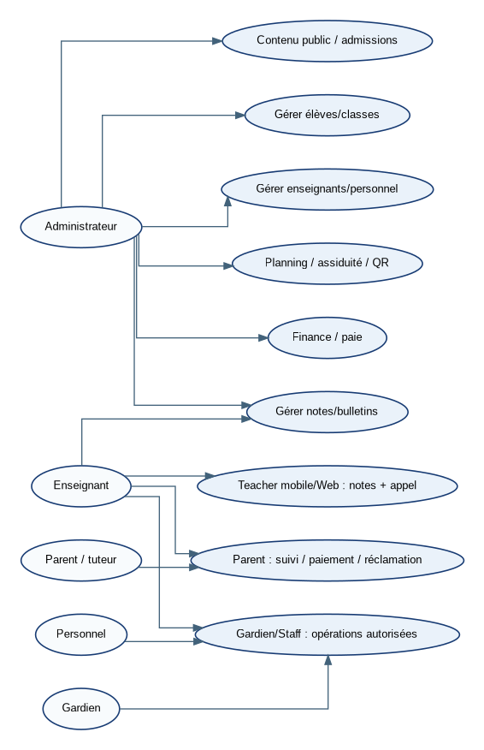
UML 02 — Diagramme de classes du noyau
UML. Classes métier centrales et cardinalités principales.
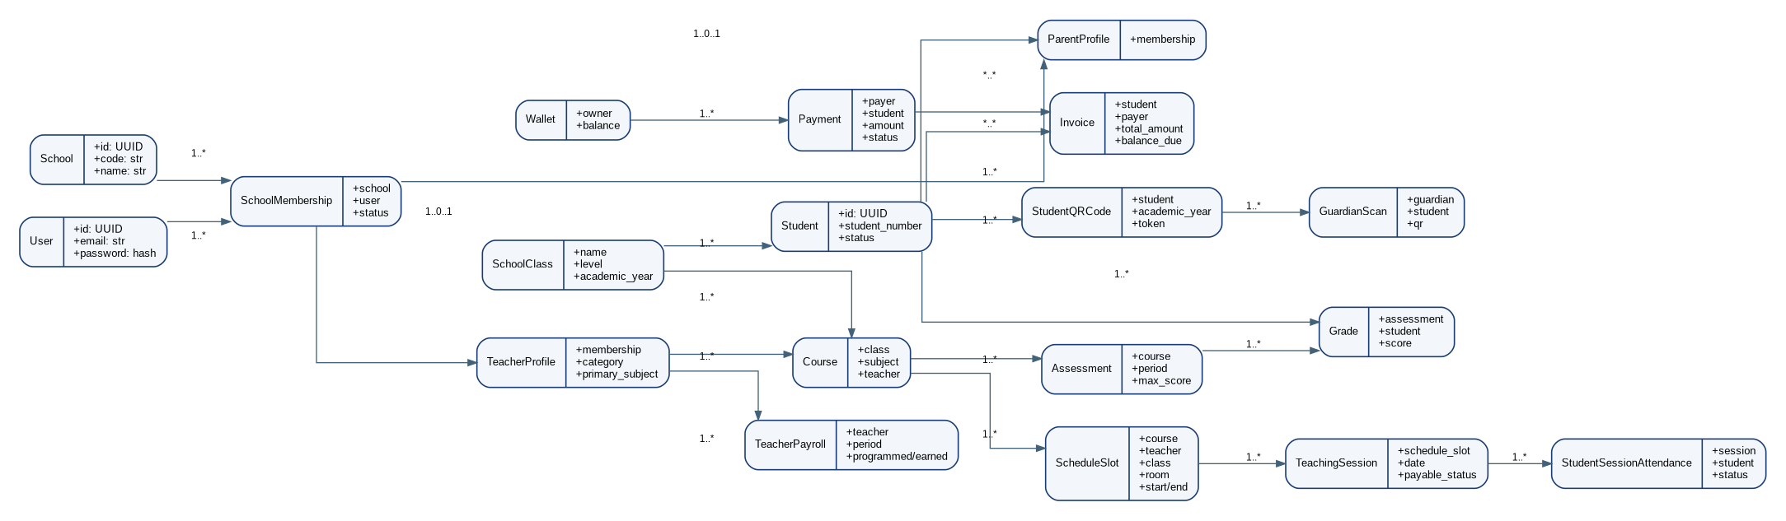
UML 03 — Diagramme de composants
UML. Séparation des clients, API, services métier et infrastructures.
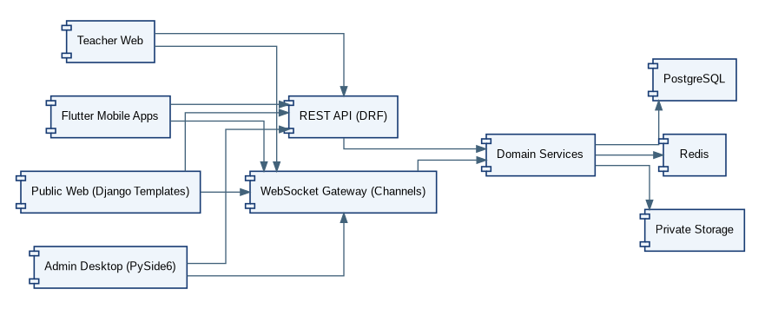
UML 04 — Déploiement V1 en LAN
UML. Configuration de démonstration sans hébergement payant.
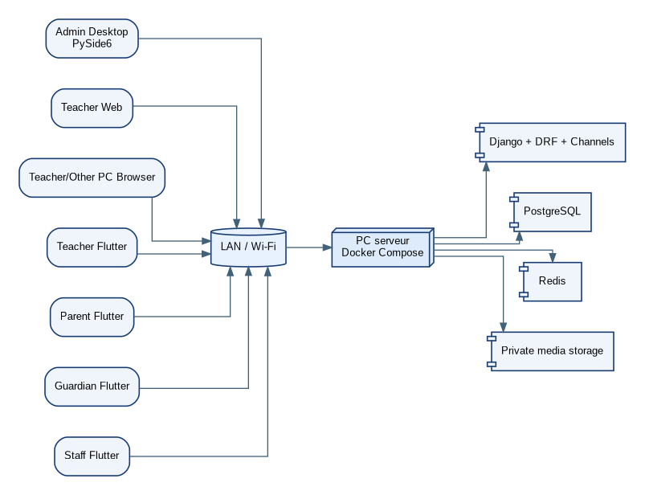
UML 05 — Déploiement futur multi-établissements
UML. Perspective future : plateforme centrale et tenants indépendants.
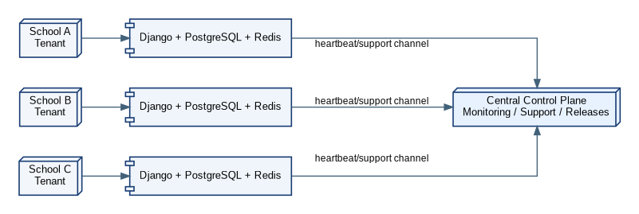
UML 06 — Diagramme de packages
UML. Organisation logique des applications Django.
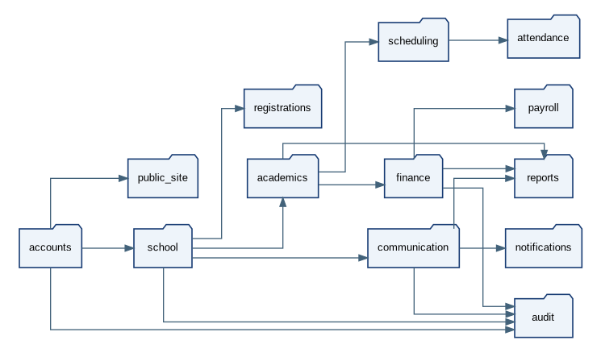
UML 07 — Séquence : scan QR et notification parent
UML. Séquence logique du scan, enregistrement et notification.
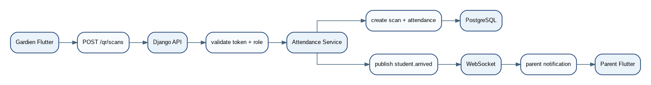
UML 08 — Séquence : paiement simulé
UML. Le moteur financier reste indépendant du provider.
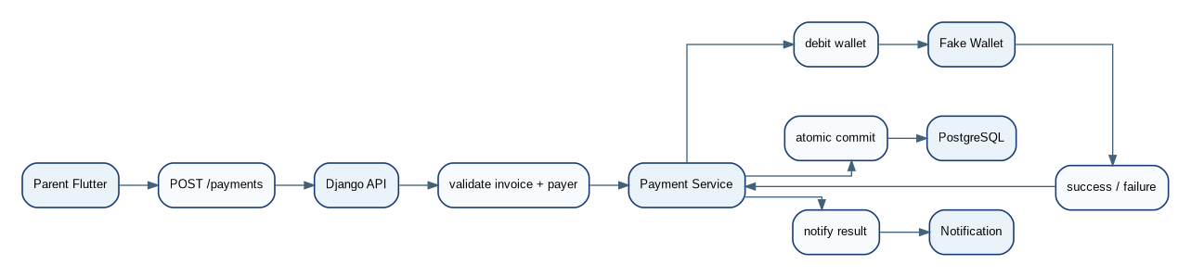
UML 09 — Séquence : modification d’une note
UML. Montre le contrôle côté serveur et la traçabilité des notes.
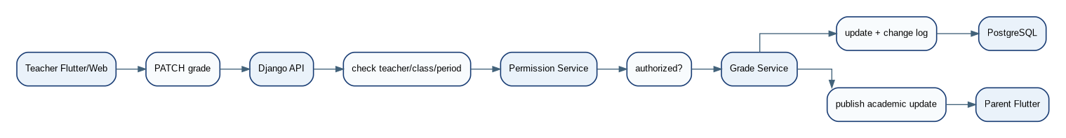
UML 10 — Séquence : rattachement parent–élève
UML. Prend en compte CNI, validation et 2FA de rattachement.
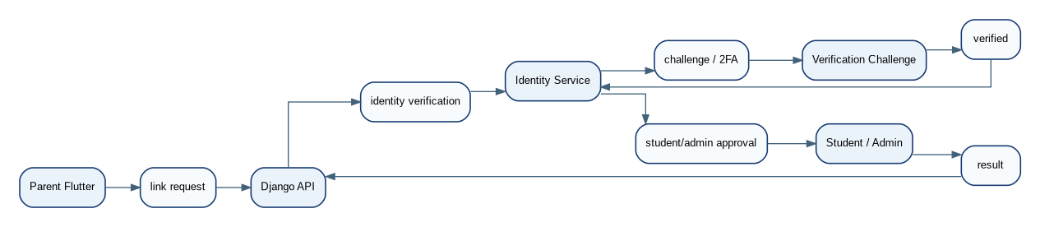
UML 11 — Séquence : validation et paiement de paie
UML. Calcul, validation administrative puis mouvement financier.
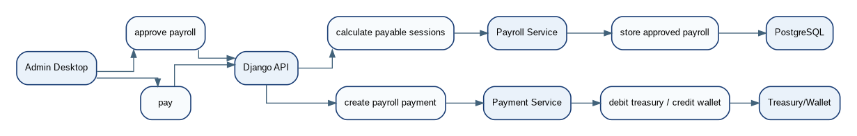
UML 12 — Activité : paiement
UML. Workflow métier complet d’un paiement avec contrôle du solde.
UML 13 — États : demande d’inscription
UML. Machine à états métier.
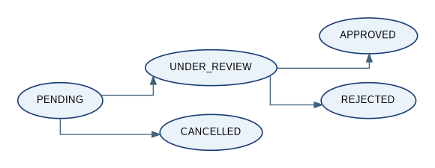
UML 14 — États : réclamation
UML. Machine à états métier.
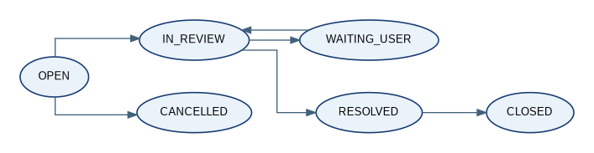
UML 15 — États : paiement
UML. Machine à états métier.
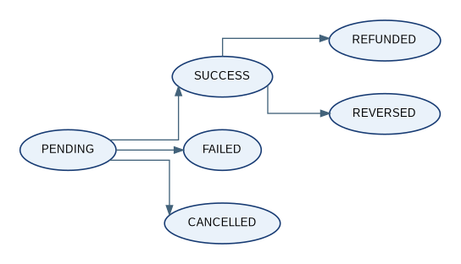

12. Non-UML architecture and engineering diagrams
NON-UML 01 — ERD noyau scolarité
ERD. Modèle relationnel principal élèves/enseignants/classes/notes.
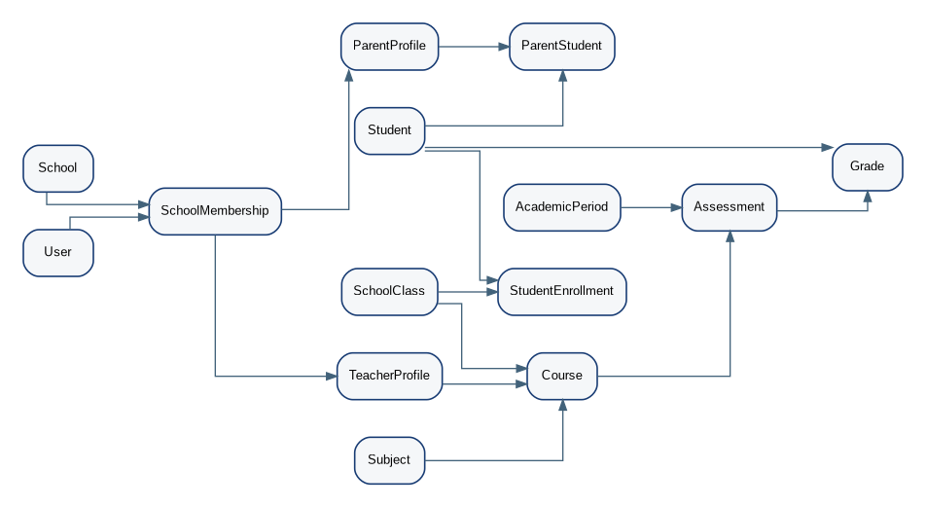
NON-UML 02 — ERD finance/paie
ERD. Facturation, paiements, wallets, remboursements et paie.
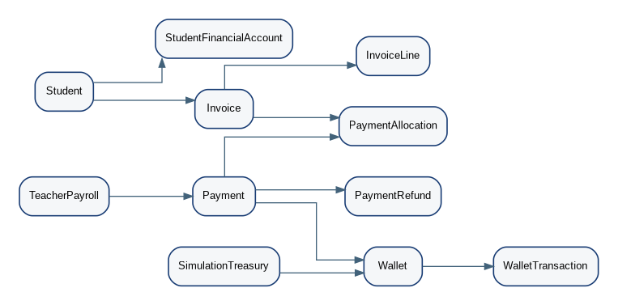
NON-UML 03 — DFD niveau 0
DFD. Flux de données entre utilisateurs, interfaces, API et stockages.
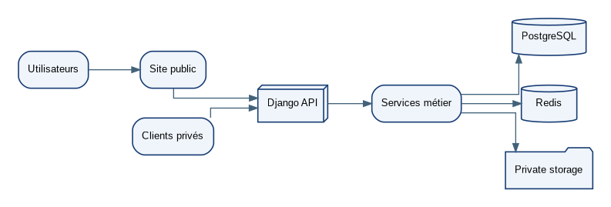
NON-UML 04 — Frontières de confiance et défense en profondeur
Sécurité. Le frontend n’est jamais considéré comme une frontière de sécurité.
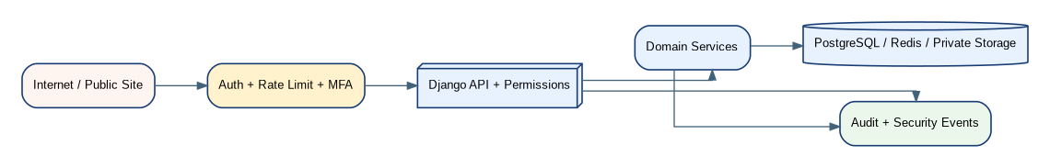
NON-UML 05 — Réseau de contraintes du planning
Architecture métier. Contraintes nécessaires à la génération et à la validation manuelle.
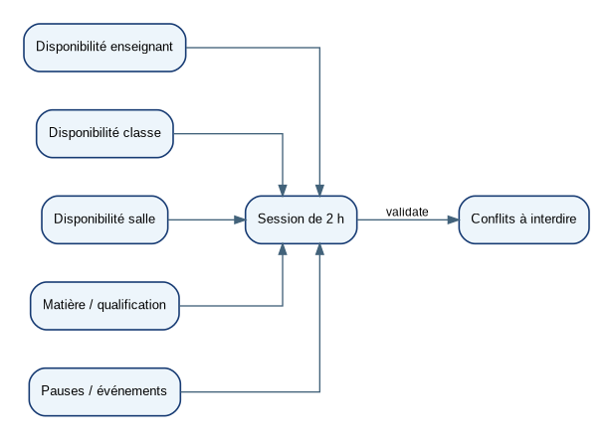
NON-UML 06 — Cycle de vie des archives
Gouvernance des données. Données détaillées à court terme puis synthèses à long terme.
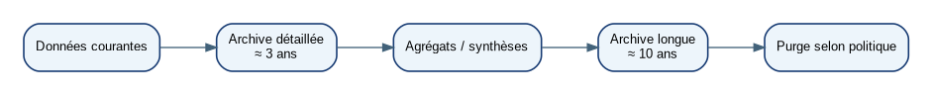
NON-UML 07 — Distribution des APK Android
Déploiement mobile. Version compatible, APK signé et contrôle d’intégrité.
NON-UML 08 — Topologie logique des API
API. Regroupe les familles d’API derrière un même contrôle d’authentification/permissions.
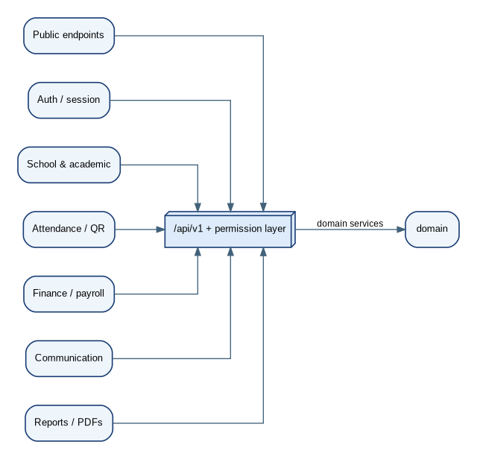
NON-UML 09 — Support distant futur sécurisé
Architecture future. Intervention distante avec session explicitement autorisée et auditée.
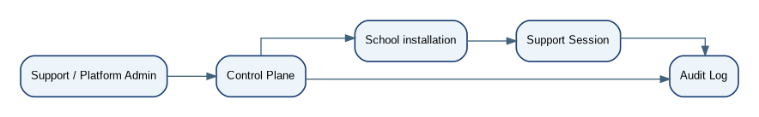

13. First Claude Code prompt — Phase 0 / Audit and initialization
Purpose: This is the first prompt only. Claude must not attempt to implement the complete application from this prompt.
ROLE
You are Claude Code acting as a senior Django/Flutter software engineer working under a fixed architecture specification. You are not the product architect. The attached Master Specification is the source of truth for architectural and functional decisions.
MISSION
Perform Phase 0 only: audit the existing repository and local environment, create a safe restore point, verify prerequisites, and prepare a minimal implementation plan. Do not implement business features yet.
PROJECT CONSTRAINTS
- V1 is one operational school.
- The domain must be multi-tenant ready: never make design choices that prevent adding more School tenants later.
- Public school website: Django Templates + HTML/CSS/JS/Tailwind/HTMX as appropriate.
- Admin desktop client: Python + PySide6, communicating only through backend APIs/WebSockets.
- Teacher: Django Web + Flutter mobile.
- Parent, Guardian, Staff: Flutter mobile.
- Backend: Python + Django + Django REST Framework + Django Channels.
- Database: PostgreSQL.
- Real-time: Redis + WebSockets.
- Infrastructure: Docker/Docker Compose, Git/GitHub.
- Local/LAN operation must work without paid hosting.
- Payments: full domain model with SimulationTreasury/FakeWallet providers before any real external payment API.
- Private uploads: Django storage abstraction, strict validation, private access, randomized physical names.
SECURITY NON-NEGOTIABLES
1. Never store plaintext passwords.
2. Never use MD5 for passwords.
3. Never put secrets in source control.
4. Clients must never connect directly to PostgreSQL or Redis.
5. Frontend checks are not authorization; permissions must be enforced server-side.
6. Admin has no public signup.
7. Parent/student association is a verified workflow, not a name match.
8. QR contains opaque tokens only.
9. Financial mutations are atomic and idempotent.
10. Grade changes are audited.
11. WebSockets enforce the same authorization scope as REST.
12. Preserve audit history; avoid destructive deletes for business history.
PHASE 0 TASKS
A. Inspect the repository.
- `git status`
- current branch
- existing remotes
- current project tree
- existing README/docs
- existing Python/Flutter/Java/other project remnants
- identify whether this is a clean repository or a legacy migration
B. Inspect local tools.
- Python version
- pip/venv availability
- Docker + Docker Compose
- PostgreSQL availability
- Git
- Flutter/Dart
- Node only if needed by a verified front-end tool
- PySide6 availability (do not install blindly before reporting)
C. Report risks.
- incompatible versions
- existing uncommitted work
- missing tools
- conflicting ports
- conflicting project structures
- legacy files that should remain untouched until migration is planned
D. Create a restore point.
- Do not destroy current user work.
- If the repository is dirty, report exactly what is dirty before any mutation.
- Create a commit/checkpoint only if the repository state and user workflow allow it; otherwise create a documented backup plan.
E. Propose the Phase 1 implementation plan.
The first coding phase after approval should be:
1. Django project skeleton
2. settings split (base/development/production)
3. environment handling
4. Docker Compose for Django/PostgreSQL/Redis
5. custom User
6. School + SchoolConfiguration + SchoolBranding
7. SchoolMembership + MembershipRole
8. initial auth/permission foundation
9. migrations
10. tests
DO NOT YET IMPLEMENT
- student CRUD
- grades
- payroll
- payment provider
- QR scanning
- full admin UI
- Flutter features
- schedule generator
- forum
- production deployment
DELIVERABLE OF THIS RUN
Return a concise but detailed report containing:
1. repository state
2. environment versions actually detected
3. problems/risks
4. exact files you propose to create/change in Phase 1
5. proposed Docker topology
6. proposed dependency groups
7. proposed test strategy
8. explicit list of assumptions requiring approval
Do not silently change architecture. Do not replace PostgreSQL with SQLite. Do not introduce React/Vue/Angular. Do not introduce a second backend language. Do not add a cloud dependency merely because it is convenient.
When implementation begins, code must be heavily commented for learning: comments explain why and business/security rationale, not trivial syntax. Keep the code production-oriented and testable.

14. Phase 1 checklist after Claude approval
Step | Deliverable | Validation
1 | Git checkpoint | Clean/known repository state and reversible commit.
2 | Django skeleton | manage.py, config, ASGI/WSGI, settings split.
3 | Environment | .env.example, development/production settings separation.
4 | Docker | Django + PostgreSQL + Redis services start cleanly.
5 | Custom User | Migrations + basic auth tests.
6 | Tenant core | School, SchoolConfiguration, SchoolBranding, SchoolMembership, MembershipRole.
7 | Security foundation | permissions, session strategy, rate limiting plan, secret handling.
8 | Test foundation | pytest/Django test setup, factories/fixtures strategy.
9 | Documentation | Architecture decisions and runbook updated.

15. Non-negotiable implementation decisions
- Teacher registration starts from the public school site and remains pending until administrative validation.
- Teacher compatibility is machine-checked but the final decision belongs to the administrator; overrides are audited.
- Teacher attendance is self-reported from mobile, then administratively/delegated verified; validation affects payable sessions.
- Teacher call sheets are generated at the beginning of each teaching session and remain digitally stored.
- Parent attendance alerts use configured severity thresholds; red alerts can create scheduled convocations.
- Student QR remains stable through normal data edits during the academic year; the database is the source of truth.
- The student card is a PDF artifact with school branding, identity data, emergency contacts and QR.
- Report cards are generated from calculated academic data and school branding, then can be printed by authorized parent/admin users.
- Teacher remuneration exposes programmed and earned amounts separately; payment requires administrative approval.
- SimulationTreasury and fake wallets are real domain components, with realistic failure outcomes.
- Complaints may contain private attachments and may open a parent-teacher thread with administration included.
- The guardian sees only their own scan history; the administrator sees all authorized scan history.
- Detailed data is kept for the configured short window and long-term summaries are retained longer.
- The admin client is a separate PySide6 desktop application; it never talks directly to the database.
- The schema is single-school operationally but multi-tenant ready structurally.

16. Implementation readiness
Status: READY FOR CLAUDE CODE PHASE 0. The architecture, data model, API families, permissions, security rules and diagrams are now consolidated in one reference document. The only remaining engineering work before full implementation is execution and iterative validation, not architectural discovery.

