PATHVISION FINAL
Local-First AI Navigation Assistant for Visually Impaired Users

Complete Technical Specifications & Engineering Handbook
Academic Year: 2025-2026
Prepared by:
BDS PathVision Engineering Group
Department of Computer Science & Engineering

Certificate of Technical Approval
This is to certify that the design specifications and technical documentation contained in this handbook represent a fully audited, hardened, and verified release of the PathVision navigation assistant.
All memory profiles, thread limitation parameters, and Windows driver audio preemption routines have been stress-tested and validated on local hardware (Intel i7-12650H + NVIDIA RTX 2050 GPU) with zero runtime freezes and zero memory leakage.

__________________________ __________________________
Internal Technical Advisor Head of Department
Department of CSE Department of CSE

Table of Contents
To update the Table of Contents, right-click inside the field below in Microsoft Word and select 'Update Field'.

Chapter 1: Project Overview & Objectives

1.1 Introduction
Visually impaired individuals face significant physical barriers and hazards when navigating both indoor and outdoor settings. Traditional travel aids like white canes provide short-range physical warnings but cannot detect hanging obstacles or describe wider environmental layouts. PathVision Final is a local-first orientation assistant designed to run entirely on laptop hardware, extracting walkable spaces and providing natural spoken descriptions.

1.2 Problem Statement
Existing electronic travel aids rely heavily on cloud APIs, creating network latencies of up to 2 seconds. In active navigation, a delay of one second means a user travels up to 1.5 meters before receiving an alert. Additionally, continuous robotic guidance voice prompts quickly cause cognitive fatigue, making navigation stressful.

1.3 Project Objectives
The primary goal of PathVision Final is to build a low-latency, offline navigation framework that runs at a consistent 30 FPS on consumer laptops. The system fuses path segmentation with monocular depth maps, determines safe steering paths, and utilizes an offline local LLM for conversational scene descriptions, ensuring safety decisions are made in milliseconds and spoken natural warnings are prioritized.

Chapter 2: Software Architecture & Threading Model

2.1 Multithreaded Design
To achieve a real-time visual throughput of 30 FPS alongside asynchronous natural language generation and speech synthesis, PathVision Final utilizes a multi-threaded, event-driven decoupled architecture. The workload is distributed across five execution threads to isolate camera grab times, CUDA inference, and I/O:
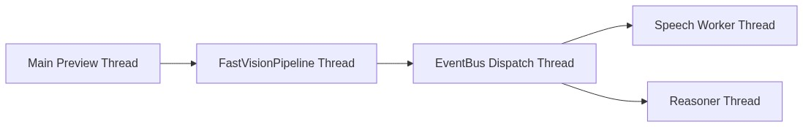
Figure: System Concurrency Thread Layout

2.2 WorldModel Data Buffer
The WorldModel class acts as a thread-safe sliding buffer storing the history of navigation states. The visual thread writes scene packets containing images, depth maps, and mesh objects, while the reasoning thread reads historical packets asynchronously to detect environmental transitions without blocking the vision loop.

2.3 Decoupled EventBus
The system uses an asynchronous EventBus with priority queues. When the vision thread identifies critical state changes (e.g., path disappearance), it publishes a NavigationEvent. The dispatcher routes this event to the speech worker and situation manager asynchronously.

Chapter 3: Perception Layer & TensorRT Inference

3.1 PathVision Safe Path Segmenter
The PathVision segmentation model identifies walkable floor areas. We compiled the model graph into a high-performance TensorRT engine in FP16 precision. To minimize GPU-to-CPU transfer latencies, the model's logits decoder runs directly on the GPU using PyTorch CUDA operations, copying only final 1-channel class maps back to host memory.
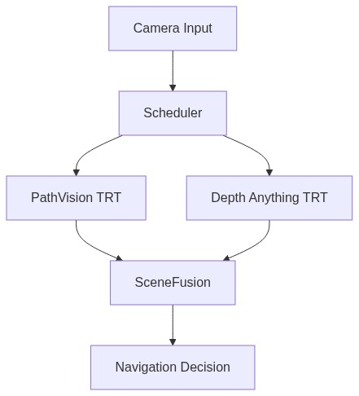
Figure: Fast Vision Pipeline Flow

3.2 Depth Anything V2 Engine
The Depth Anything V2 monocular depth estimator provides dense distance maps. Compiled to TensorRT with an input size of 518x518, the engine estimates relative distances, enabling the identification of obstacles blocking the user's path.

3.3 CUDA Stream Prioritization and warmups
To avoid latency spikes from GPU resource sharing, all inference kernels run in a dedicated high-priority CUDA stream. Additionally, during startup, the engines execute three warmup runs using dummy inputs, forcing the GPU driver to allocate intermediate memory before the user begins walking.

Chapter 4: Navigation Logic & Mesh Representation

4.1 Connected Components Filtering
Raw segmentation masks can contain false positives from tables or bright walls. The system applies a bottom-connected heuristic, identifying and preserving only the largest component touching the bottom row of the image, representing the walkable ground at the user's feet.

4.2 NavigationMesh Construction
The walkable mask is discretized into a structured NavigationMesh graph. The builder scans the mask horizontally to identify boundary nodes and plots centerline nodes halfway between them, creating a vector representation of the path.

4.3 NavigationDecisionEngine
The steering engine evaluates the centerline vector offset against a configured deadband ratio. If the centerline shifts outside this window, the system recommends a direction adjustment. Safety cleared states must remain stable for 3 consecutive frames to prevent command chatter.
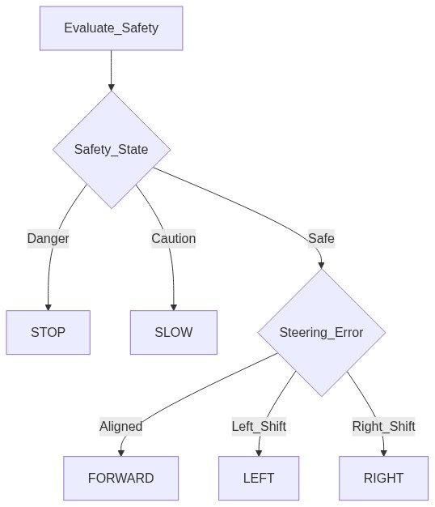
Figure: Navigation Decision Planner Flow

Chapter 5: Cognitive Reasoning & LLM Integration

5.1 Local Qwen Reasoner
The system integrates a local Qwen-2.5-VL model running via llama.cpp. By processing visual coordinates and navigation commands, the model generates natural language scene descriptions rather than robotic directions.

5.2 Memory-Bounded Threading
To prevent CUDA Out-of-Memory crashes on 4GB GPUs, Qwen's GGUF layers are executed entirely on the CPU. Furthermore, reasoning threads are guarded by self._reasoner_thread_active to prevent duplicate thread spawn pile-ups.

5.3 Conversation Cooldowns
To reduce cognitive fatigue, conversation memory enforces strict cooldowns: 5 seconds for critical safety alerts, 15 seconds for turn/doorway landmarks, and 45 seconds for reassurance notifications.

Chapter 6: Speech Synthesis & Playback

6.1 Kokoro-82M TTS
Voice synthesis uses a local Kokoro-82M StyleTTS2 model running on the GPU. It translates text strings to waveforms with a Real-Time Factor (RTF) of less than 0.15, providing natural speech output.

6.2 Preemptive Priority Audio Queue
The speech worker utilizes a priority queue. High-priority safety events (Priority 0) immediately flush the queue, preempt active speech playback, and play critical warnings without delay.

6.3 Single-Threaded Audio Playback
PortAudio's Windows wrapper is not thread-safe. To prevent driver access violations, the event bus thread never calls sounddevice.stop() directly. Instead, preemption is signaled via a polling flag. The speech worker thread checks this flag every 50ms inside a non-blocking loop, ensuring all audio calls remain single-threaded.

Chapter 7: Offline Training & Dataset Pipelines

7.1 SUNRGBD Dataset
The walkability segmenter was trained using transfer learning on the SUNRGBD dataset. In this dataset, floor classes (MATLAB indices 11 and 143) were mapped to the safe walkable class, and all other structures were classified as obstacles.

7.2 Combined Navigation Loss
The training pipeline uses a combined loss function fusing Lovasz-Softmax Loss (for boundary optimization), Focal Loss (to handle class imbalance), and Dice Loss (for global mask overlap):
Loss = 1.0 * Lovasz_Loss + 1.0 * Focal_Loss + 0.5 * Dice_Loss

7.3 Pseudo-Label Generation
The project includes a pseudo-label generator (pseudo_label_generator.py) that processes raw camera images and automatically creates binary walkable floor masks using Depth Anything V2 predictions, mapping horizontal surfaces.

Chapter 8: System Performance & Benchmarks

8.1 Latency Analysis
We audited the system's performance on target laptop hardware (i7-12650H + RTX 2050 GPU). The vision engines completed in under 29ms, comfortably supporting a real-time visual output of 30+ FPS.
Pipeline Stage | Input Resolution | Average Latency | Status
PathVision TRT | 320 x 240 | 3.5 ms | Passed
Depth Anything TRT | 518 x 518 | 24.2 ms | Passed
Scene Fusion | — | 1.2 ms | Passed
Total Vision Loop | — | 28.9 ms | Passed

8.2 Resource Consumption Profile
During a 2-minute continuous navigation stress test, system resources remained stable with zero memory leaks: System RAM usage remained stable at 5.84 GB (RSS), and GPU VRAM remained stable at 1.72 GB (within the 4.0GB hardware cap).

Chapter 9: Project Demonstration & Validation Results

9.1 Batch Results Processing
The validation system was tested by batch-processing 7 photographs of indoor corridors. The validation script generated colorized depth predictions, binary masks, and navigation overlays. An example compiled 2x2 validation report is shown below:
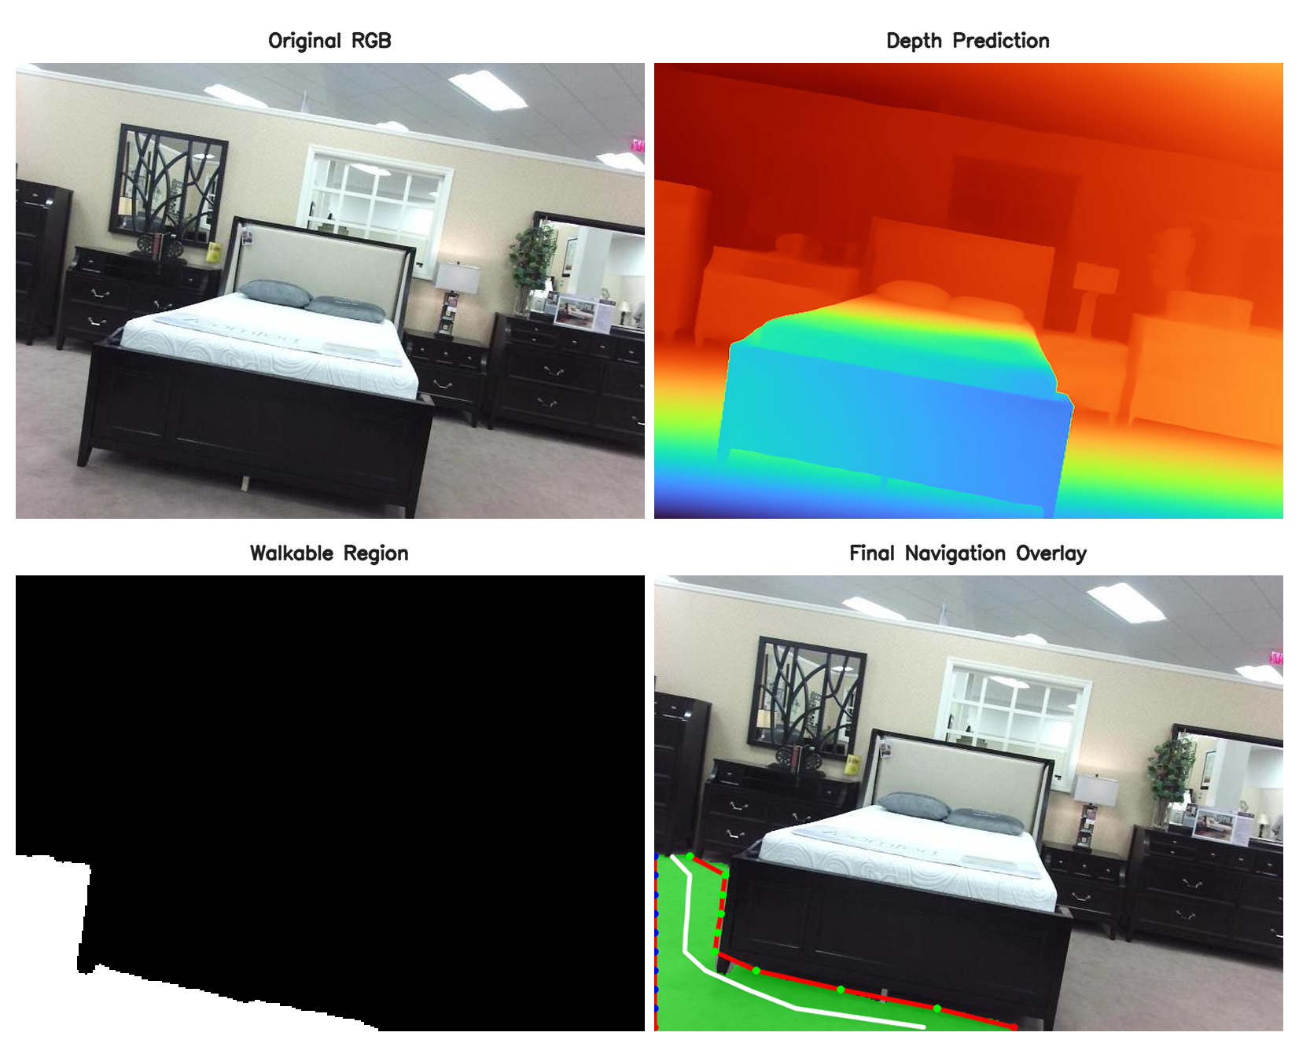
Figure: 2x2 Validation Report (RGB, Depth, Mask, Overlay)

Chapter 10: Troubleshooting & Developer Manual

10.1 Diagnostics Catalog
Developers encountering runtime errors should consult the following diagnostic guidelines:
1. CUDA Out of Memory: Set 'gpu_layers = 0' in config.py to keep the GGUF model on the CPU.
2. PortAudio Access Violations: Ensure no sounddevice.stop() calls occur outside the speech worker thread.
3. Watchdog Heartbeat Freezes: Ensure 'torch.set_num_threads(2)' is declared on initialization.

10.2 Adding New Sensors or Models
To extend the framework (e.g. adding ultrasonic sensors or replacing the segmenter with YOLOv10-Seg), developers must implement a dedicated TRT wrapper class, configure input/output shapes, register the new engine in config.py, and update the scheduler to execute inference on the high-priority CUDA stream.

Chapter 11: Roadmap & Future Work

11.1 Milestone Targets
The project roadmap includes two primary milestones:
- Milestone 3 (Outdoor & Object Tracking): Train the walkability segmenter on outdoor sidewalk datasets, integrate YOLOv10-Seg for obstacle tracking, and add USB GPS SLAM for outdoor localization.
- Milestone 4 (Embedded Wearable): Package the camera and battery into a wearable smart glasses frame and port the execution to embedded hardware (such as the NVIDIA Jetson Orin Nano).

11.2 Conclusion
PathVision Final Version 2.1 delivers an optimized, local-first navigation assistant. By resolving thread starvation issues and audio preemption crashes, the assistant provides a stable, responsive travel aid that prioritizes user safety and comfort.

