2016 Panama ENSO gas exchange campaign metadata

February to May 2016

Compiled by Kim Ely, BNL, June 30, 2016

*Summary*

Diurnal gas exchange, CO2 response (ACi curves), leaf water potential and leaf spectra were recorded from top of canopy at monthly intervals (Feb, Mar, Apr, May) during the 2016 ENSO period. Each monthly measurement round comprised four measurement days; one day of diurnal measurements, with some ACi, and one day focused on ACi, at each of two sites. Leaf water potential and samples for NSC and Ph were only collected from diurnal gas exchange samples.

In March, measurements were also made at BCI (leaf water potential and leaf sampling only. No gas exchange or spectra).

In April, diurnal measurements were interrupted by a power outage that prevented canopy crane access. The resulting diurnal curve comprises 3 rounds from the morning of 25th April and 3 rounds from the afternoon of 26th April.

In May, leaf water potential and diurnal gas exchange were measured, and leaf samples collected for non-structural carbohydrate measurement. No spectra or ACi curves were measured.

*Protocols*

The following protocols were established for this field campaign and made available on NGEE Tropics Teamwork.

|  |  |
| --- | --- |
| Measurement | Protocol |
| Spectrometry: instrument use | Spectral_Evolution_PSR+_Protocol |
| Spectrometry: instrument use | SVC_HR-1024i_Protocol |
| Spectrometry: measurements | NGEE-Tropics_leaf_spectral_collection_protocols |
| Gas Exchange: measurements | NGEE_Tropics_ENSO_Diurnal_Protocol |
| Gas Exchange: measurements | NGEE_Tropics_ENSO_ACi_Protocol |
| Leaf water potential: measurement | NGEE_Tropics_ENSO_Leaf_Water_Potential_Protocol |
| Leaf sampling: measurements | NGEE_Tropics_ENSO_leaf_sample_protocol |

*Work flow*

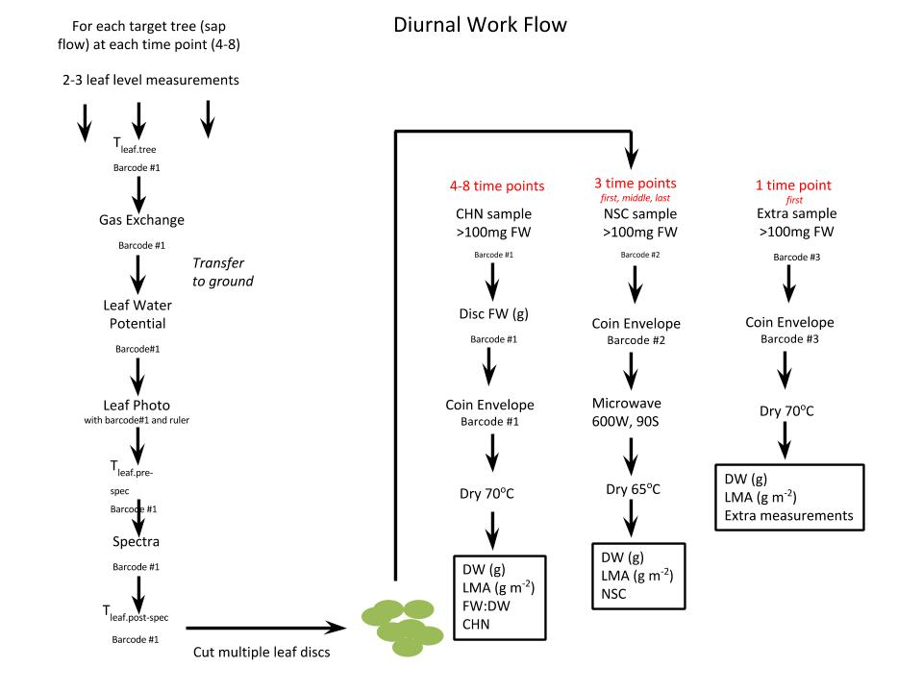

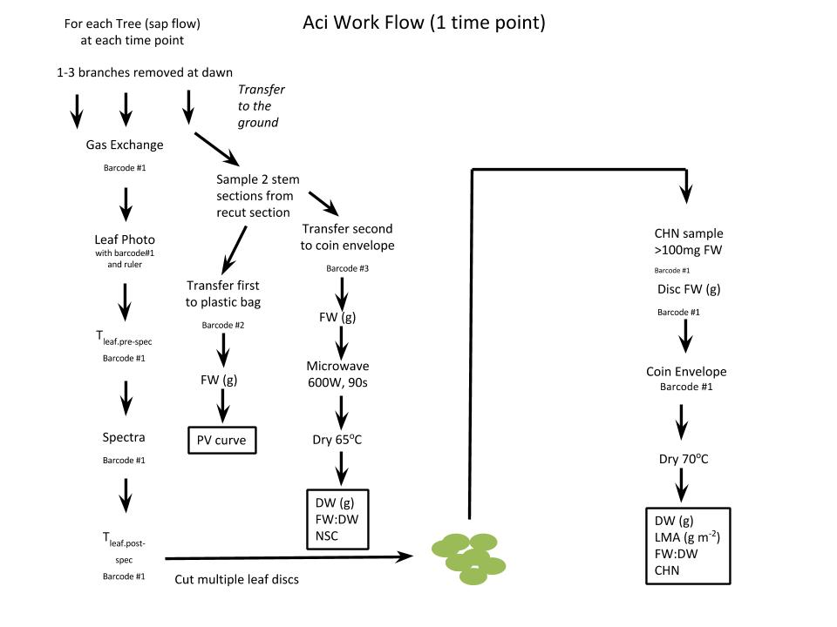

*Sample numbers and Data products*

Data products for each sample are linked by sample number. Sample details, including date, location, species and a photograph, are all recorded in the LeafSamples and WoodSamples data packages. If multiple aliquots of sample were obtained from a single leaf (i.e. sample material for separate CHN and NSC analysis), these aliquots were assigned individual sample numbers. The LeafSamples spreadsheet shows where material from a single leaf has been assigned multiple sample numbers.

Data products from the 2016 Panama ENSO field campaign will be uploaded to the NGEE Tropics data archive as separate data packages. Not all products are available for all samples.

*Locations*

Parque Natural Metropolitano (PA-PNM), Panama City. 8.994517°N, -79.542975°E (crane tower)

San Lorenzo (Fort Sherman) (PA-SLZ). 9.280225°N, -79.975527°E

Barro Colorado Island (PA-BCI)

*Campaign measurements and equipment used*

|  |  |  |  |  |  |
| --- | --- | --- | --- | --- | --- |
| **Date** | **Location** | **Leaf water potential** | **Gas exchange** | **Spectroradiometer** | **White reference** |
| 2016-02-13 | PNM | LWP | diurnal, ACi | SVC | 0826 |
| 2016-02-14 | PNM | NA | ACi | SVC | 0827 |
| 2016-02-16 | San Lorenzo | NA | ACi | SVC | 0826 |
| 2016-02-17 | San Lorenzo | LWP | diurnal | SVC | 0826 |
| 2016-03-10 | San Lorenzo | NA | diurnal, ACi | SVC | 0827 |
| 2016-03-11 | San Lorenzo | NA | ACi | SVC | 0827 |
| 2016-03-12 | BCI | LWP | NA | NA | NA |
| 2016-03-14 | PNM | NA | diurnal, ACi | PSR | 0827 |
| 2016-03-15 | PNM | NA | ACi | PSR | 0827 |
| 2016-04-21 | San Lorenzo | LWP | diurnal, ACi | SVC | 0826 |
| 2016-04-22 | San Lorenzo | NA | ACi | SVC | 0827 |
| 2016-04-25 | PNM | LWP | diurnal, ACi | SVC | 0827 |
| 2016-04-26 | PNM | LWP | diurnal, ACi | SVC | 0827 |
| 2016-05-17 | PNM | LWP | diurnal | NA | NA |
| 2016-05-24 | San Lorenzo | LWP | diurnal | NA | NA |

*Equipment*

|  |  |  |  |  |  |
| --- | --- | --- | --- | --- | --- |
| Instrument type | Owner | Manufacturer | Model/software | Serial number | Working name |
| gas analyzer | BNL | LI-COR | 6400XT v. 6.3.2 | PSC3698 | Andy |
| gas analyzer | BNL | LI-COR | 6400XT v. 6.3.2 | PSC0570 | Derek |
| gas analyzer | BNL | LI-COR | 6400XT v. 6.3.2 | PSC3699 | Jorge |
| gas analyzer | BNL | LI-COR | 6400XT v. 6.3.2 | PSC0464 | Mariano |
| gas analyzer | BNL | LI-COR | 6400XT v. 6.3.2 | PSC3613 | Bernie |
| gas analyzer | University of Utah | LI-COR | 6400XT v. 6.3.2 | PSC0748 | Johnny |
| spectroradiometer | BNL | Spectra Vista Corporation | HR-1024i | 6142041 | SVC |
| spectroradiometer | BNL | Spectral Evolution | PSR+ | 1586067 | PSR |
| thermocouple | BNL | Omega | HH801B HandHeld thermocouple | 150115 |  |
| thermocouple | BNL | Omega | HH801B HandHeld thermocouple | 150266 |  |
| pressure chamber | LANL | PMS instrument company | Model 1000 |  |  |
| balance | BNL | Fisher Science Education | SLF303 | B515819592 |  |

*Trees sampled (canopy tree IDs the same as for sap flow measurements)*

|  |  |  |  |
| --- | --- | --- | --- |
| Location | Sampling location | Species code | Species |
| PA-PNM | sunlit canopy | CASTEL | Castilla elastica |
| PA-PNM | sunlit canopy | LUEHSE | Luehea seemannii |
| PA-PNM | sunlit canopy | ANACEX | Anacardium excelsum |
| PA-PNM | sunlit canopy | CORDAL | Cordia alliodora |
| PA-PNM | sunlit canopy | CAL2CA | Calycophyllum candidissimum |
| PA-PNM | sunlit canopy | FICUIN | Ficus insipida |
| PA-PNM | sunlit canopy | ALBIED | Pseudosamanea guachapele |
| PA-PNM | sunlit canopy | ANTITR | Pittoniotis trichantha |
| PA-PNM | sunlit canopy | PSE1SE | Pseudobombax septenatum |
| PA-PNM | sunlit canopy | CECRPE | Cecropia peltata |
| PA-SLZ | sunlit canopy | TERMAM | Terminalia amazonia |
| PA-SLZ | sunlit canopy | TOCOPI | Tocoyena pittieri |
| PA-SLZ | sunlit canopy | CARAGU | Carapa guianensis |
| PA-SLZ | sunlit canopy | TACHVE | Tachigali versicolor |
| PA-SLZ | sunlit canopy | VOCHFE | Vochysia ferruginea |
| PA-SLZ | sunlit canopy | VIROSP | Virola multiflora |
| PA-SLZ | sunlit canopy | MICOBO | Miconia borealis |
| PA-SLZ | sunlit canopy | APEIME | Apeiba membranacea |
| PA-SLZ | sunlit canopy | GUATDU | Guatteria dumetorum |
| PA-SLZ | sunlit canopy | CECRIN | Cecropia insignis |
|  |  |  |  |
| PA-BCI | sunlit canopy | GUSTDU | Gustavia superba |
| PA-BCI | sunlit canopy | INGAPE | Inga pezizifera |
| PA-BCI | sunlit canopy | MICOAR | Miconia argentea |
| PA-BCI | sunlit canopy | SIMAM | Simarouba amara |
| PA-BCI | sunlit canopy | ALSEBL | Alseis blackiana |
|  |  |  |  |
| PA-PNM | understory | ALBIAD | Albisia adenophela |
| PA-PNM | understory | ANACEX | Anacardium excelsum |
| PA-PNM | understory | CAL1 | Callichlamys latifolia |
| PA-PNM | understory | CALYCA | Calycophyllum candidissimum |
| PA-PNM | understory | CAPI | Capparis indica |
| PA-PNM | understory | CASTEL | Castilla elastica |
| PA-PNM | understory | PIT1RU | Cojoba rufescens |
| PA-PNM | understory | CUPACI | Cupania cinerea |
| PA-PNM | understory | LUEHSE | Luehea seemannii |
| PA-PNM | understory | PPRE | Piper reticulatum |
| PA-PNM | understory | POSOLA | Posoqueria latifolia |
| PA-PNM | understory | AST2GR | Astronium graveolens |
|  |  |  |  |

*Sampling position and leaf age*

Leaves were sampled from fully sunlight top of canopy. Sampled leaves were “most recent fully expanded”. At PA-PNM in April understory plants were measured for CO2 response when the canopy was inaccessible due to power outage. Spectra and chemistry samples were also collected for these plants.