**Update I-V relationship to improve SOFC-MP accuracy**

***Summary:*** Binary diffusion is presently considered in the I-V curve, but gas phase diffusion in the thin porous structures has a great impact on the actual mass transfer process in modern SOFC electrodes and hence affects the cell performance. SOFC-MP has been updated to better simulate real-world SOFC operation by adding gas diffusion in porous media to the solution procedure.

Diffusion processes within a porous structure can be distinguished as two types. First is normal diffusion in which one gas diffuses through another, with negligible influence of the pore size on the rate of diffusion. This has been considered in the original SOFC-MP to determine the current-voltage (I-V) curve. This type of diffusion applies when the mean free path of the molecules is much less than the pore diameter. The other type of diffusion applies when the mean free path of the molecules is greater than the pore dimeter, which is referred as Knudsen Diffusion. For SOFC-MP, the Knudsen diffusion should not be neglected [1].

For each gas species, the Knudsen diffusion depends on three fuel cell properties: the diameter of electrically conducting particles *de*, the number fraction of electrically conducting particles *ne* and the particle size ratio of ionic to electronic conducting particles *α*. Considering Knudsen diffusion in I-V curve, sensitivity studies have been conducted to evaluate what’s the influence of Knudsen diffusion in voltage output. Fuel composition, CH4 reforming and SOFC properties refer to published studies [2-3]. Figure 1 shows the influence of the diameter of electrically conductor in I-V curves for current density from 0.01 to 1.0 A/cm2. As one can see, voltage output comes down as considering Knudsen diffusion. Smaller diameter of electrically conductor yields more significant decrease.

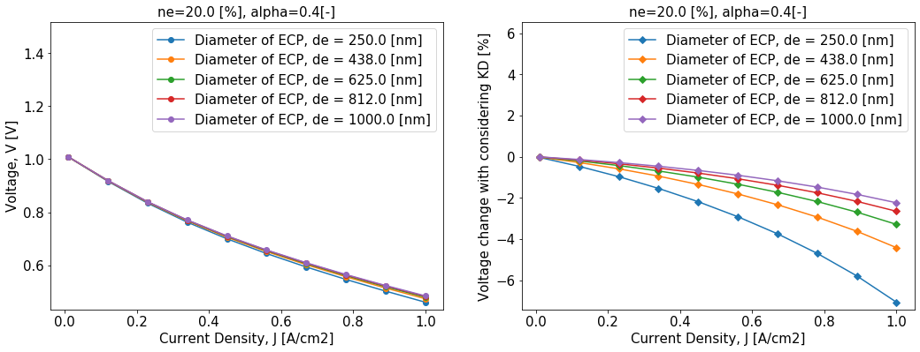

**Figure 1.** I-V curve with different electrically conducting particle size.

Similar studies have been conducted on the other two properties: the number fraction of electrically conducting particles and the particle size ratio of ionic to electrically conducting particle, as shown in Figure 2 and Figure 3. It reveals that smaller diameter of electrically conductor, lower number fraction of electrically conductor and particle size ratio of ionic to electrically conducting particle = 0.5 yields the maximum decrease of the voltage output. The voltage output in this limit case is shown in Figure 4. As can be seen, the relative difference of voltage between with and without considering Knudsen diffusion can be up to 8%.

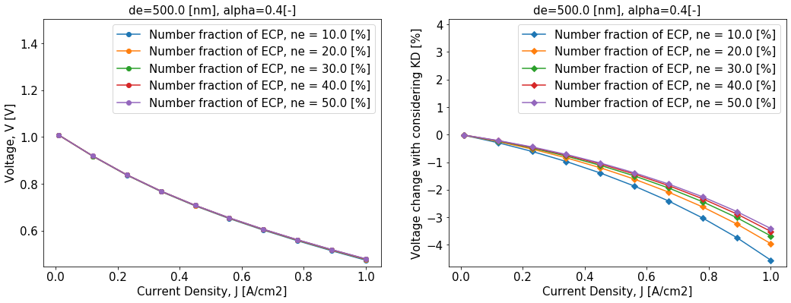

**Figure 2.** I-V curve with different number fraction of electrically conducting particles.

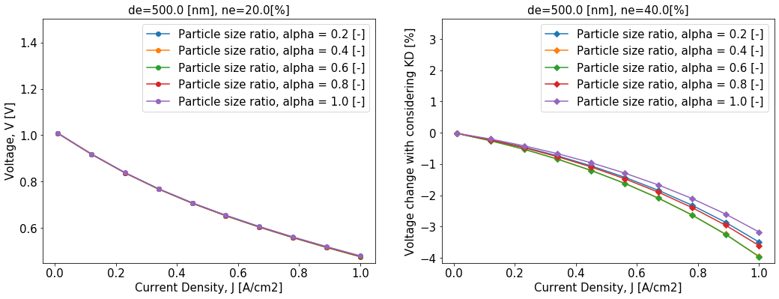 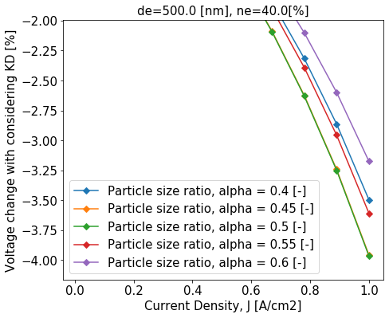

**Figure 3.** I-V curve with different particle size ratio.

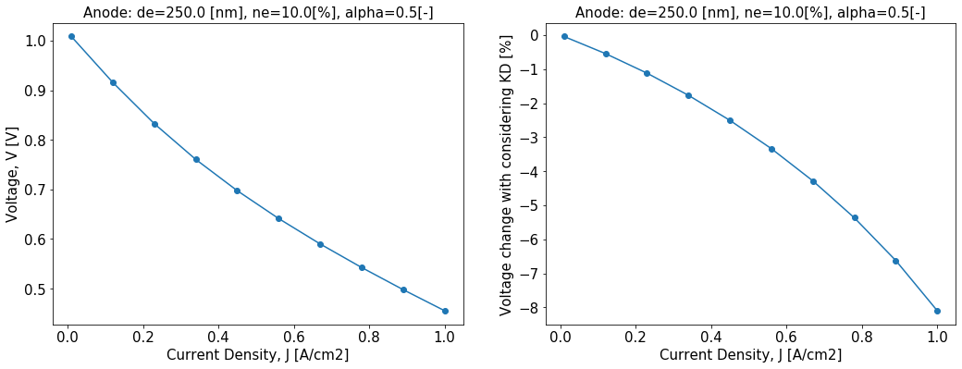

**Figure 4.** I-V curve of the limit case.

Currently, as a subroutine of the SOFC_MP, the I-V relationship is revealed as a script written by the script language LUA, as shown in Figure 5. Updating the I-V curve by considering the Knudsen diffusion and sending it for actual simulations, the voltage outputs are compared with the original I-V curve. Two examples are given in Figure 6. For the first case in Figure 6(a), it shows the influence of Knudsen diffusion can be minimal, here within 0.3%. But with a different case as shown in Figure 6(b), the decrease of voltage output caused by the Knudsen diffusion can be up to 4.5%.

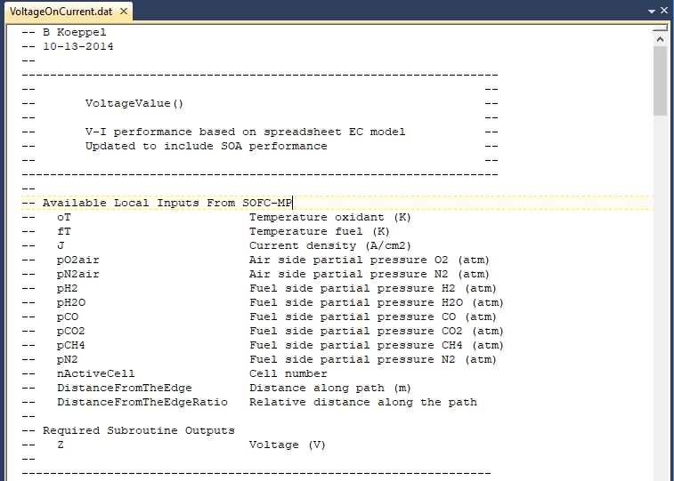

**Figure 5.** The I-V subroutine written by LUA.



**Figure 6.** Actual simulation cases, with the system pressure (a) of 1 atm; (b) of 3 atm.

**References**

1. Wang, C. "Microscale correlations adoption in solid oxide fuel cell." *Journal of Fuel Cell Science and Technology* 12.4 (2015).
2. Jiang, S. P., W. Wang, and Y. D. Zhen. "Performance and electrode behavior of nano-YSZ impregnated nickel anodes used in solid oxide fuel cells." *Journal of power sources* 147.1-2 (2005): 1-7.
3. Zhao, Qing, et al. "Steam reforming of CH4 at low temperature on Ni/ZrO2 catalyst: Effect of H2O/CH4 ratio on carbon deposition." *International Journal of Hydrogen Energy* (2020).