**PARSIMONIOUS REPRESENTATION APPLIED ON THE DIRECTIONAL WAVE SPECTRA**

1. **Introduction:**

This report aims to explain the results of segmentation problem examined on both artificial and real directional wave spectra. These results are obtained by applying a variety of approaches such as segmenting directly on the spectra (Watershed method) or modeling these spectra as a combination of many spectrum units modeled by a specific probability distribution function and utilizing optimization tools to find spare vectors that represents these spectra corresponding to the determined type of distribution function.

In experiences, we primarily use a Gaussian distribution function to model the directional ocean wave spectra. In the later, we will do extension researches on the JONSWAP spectra, which is widely used in modeling the directional ocean wave spectra.

A directional ocean wave spectrum could be though as a combination of several spectrum components, which follow a specific distribution law. Moreover, we can represent these spectra mathematically as the following formula:

(1)

Where the A matrix considered as a dictionary whose columns are generated by applying a type of atom, which follows a probability distribution law. The y vector is the observation vector of the directional ocean wave spectrum. In addition, our tasks are need to find an x vector so that we can represent the observation vector with the smallest number of elements of the dictionary A. We define our objective as the following representation:

(2)

In the optimization, we call that is the l0-minimization, the non-convex problem, and the NP-hard problem in general. Extensive researches realized to try to represent the NP-hard optimization problem represented in the [2] formula in different ways, and to find solution for this problem. One of them will be used in our application to the directional ocean wave spectrum shown below:

(3)

Mathematically, the two representations in the formula [2] and [3] will give us almost the same solution. The objective is to find an x vector to minimize the function in the formula [3]. Depending on the size of the A matrix, we address to two different problems. The case, in which the A matrix contains a finite number of columns, is called the LASSO problem which is well resolved by the FISTA method. The other case is called BLASSO problem in which the A matrix contain an infinite number of column vectors and this problem are well addressed by the Sliding Frank-Wolfe method (the development of the Frank-Wolfe method).

1. **Gaussian Directional Ocean Wave Spectra**

We assume that the atoms used to generate the spectrum components follow the Gaussian probability distribution. These atoms take the means and the variances in the two dimensional Cartesian coordinate system of the distribution as parameters, here is the general two-dimensional Gaussian distribution:

(4)

In our experience, we try to generate artificial directional ocean wave spectra by using the Gaussian atom with changes in its variance and mean values.

* 1. *The Gaussian atom with fixed values of variances*

This experience uses the Gaussian atom with fixed values of variances to examine the efficiency of the FISTA method and the SFW method recovering the artificial spectrum units.

|  |  |
| --- | --- |
|  | 0.4 |
|  | 0.2 |
|  | variable |
|  | variable |

Table 2.1 Gaussian atom variables.

* + 1. *The artificial Gaussian spectrum with three separating spectrum components:*
* *Generating an artificial spectrum:*

We generated three different Gaussian spectra, which are far away from each other. The following table show the variable values used to generate the artificial spectrum components:

|  |  |  |  |
| --- | --- | --- | --- |
|  | 1st spec unit | 2nd spec unit | 3rd spec unit |
|  | -0.46939 | 1.2463 | -2.8278 |
|  | -1.1182 | -1.9983 | -2.3061 |
| coeff | 1.1544 | 1.4273 | 1.4413 |

Table 2.2 Three separating spectrum components.

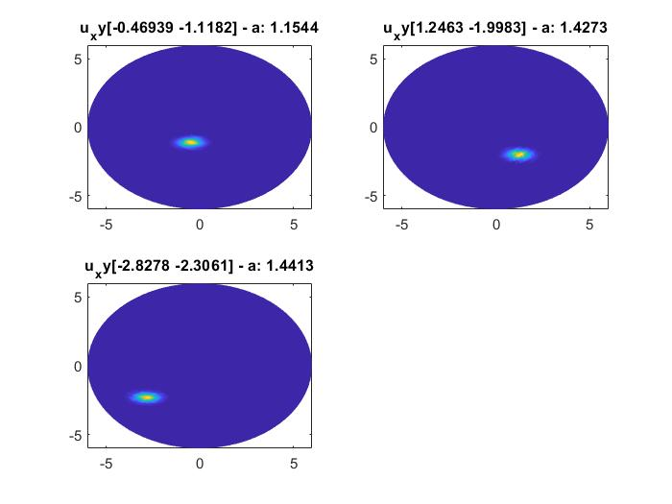

Fig 2.1 Three separating spectrum components.

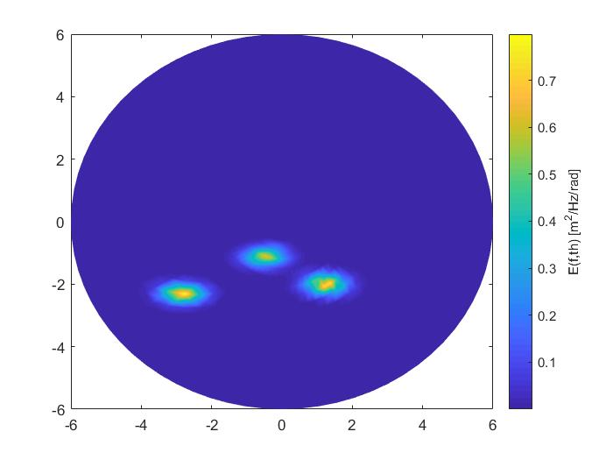

Fig 2.2 Separating spectrum combination.

* *Recovery the spectrum units by using the discrete dictionary (LASSO problem):*

The FISTA method deals with the LASSO problem by using its own grid of variable values. In addition, we use this grid to generate the atoms for the discrete dictionary, so that the dictionary has a limited number of elements in its structure. Here we use the two dimensional grid, whose axis represent several values of means along two axis in the Cartesian coordinate.

Because of the limited resolution of the grid, we do not usually get a good result in this method. The table below show an approximation of several reconstructed components compared with the ground truths. By observing through the reconstructed spectra, there are three different cluster of spectra, which corresponds to the three original spectrum components. Remarkably, the sum of all coefficients in each cluster have the same value as the corresponding spectrum coefficient value. In this study, the FISTA algorithm struggled with the computational cost; it took eight minutes to execute more than two thousands iterations, but did not converge the stopping criteria.

|  |  |  |  |
| --- | --- | --- | --- |
|  |  |  | coeff |
| 1st spectrum | -3.1128 | -2.1796 | 0.1021 |
| 2nd spectrum | -3.1947 | -2.2369 | 0.10963 |
| 3rd spectrum | -2.7578 | -2.314 | 1.0769 |
| 4th spectrum | -2.8344 | -2.3783 | 0.16829 |
| 5th spectrum | -0.50714 | -1.10876 | 0.47211 |
| 6th spectrum | -0.5494 | -1.1782 | 0.15523 |
| 7the spectrum | -0.41042 | -1.1276 | 0.52732 |
| 8th spectrum | 1.15 | -1.9919 | 0.65958 |
| 9th spectrum | 1.2 | -2.0785 | 0.23284 |
| 10th spectrum | 1.3766 | -1.966 | 0.51895 |

Table 2.3 Spectrum components obtained by the FISTA method.

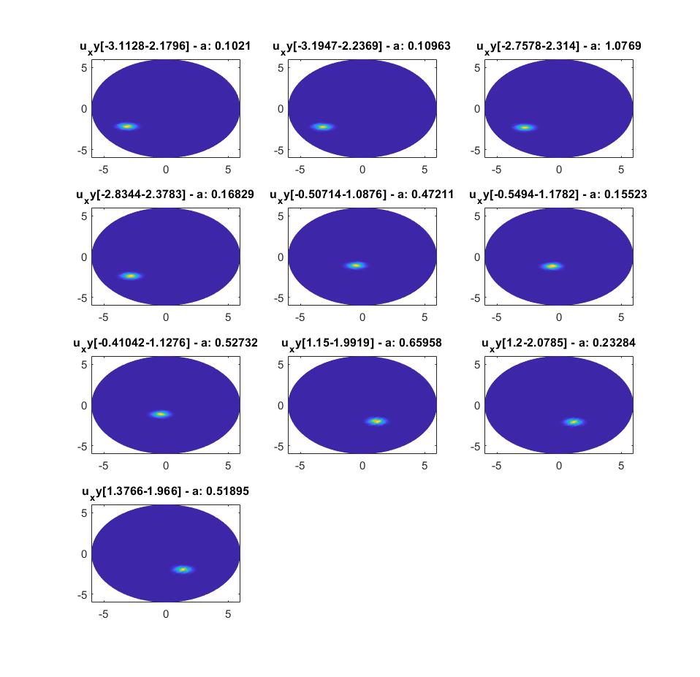

Fig 2.3 Visualization of spectrum units obtained by the FISTA method.

* *Recovery the spectrum units by using the continuous dictionary (BLASSO problem)*:

The Sliding Frank-Wolfe method has overcome the limits of the FISTA method. The variables now can take continuous values on certain ranges. This allows us to localize exactly where the atoms are, therefore give us more precis about the coefficient values of each atom. No surprisingly, the method show a very high accuracy in reconstructing the original spectrum components where the atoms vary only their mean values. One more robust of this method is very efficient in the computational time.

|  |  |  |  |
| --- | --- | --- | --- |
|  |  |  | coeff |
| 1st spectrum | -0.46888 | -1.1179 | 1.1427 |
| 2nd spectrum | 1.2458 | -1.998 | 1.4046 |
| 3rd spectrum | -2.8269 | -2.3059 | 1.4063 |

Table 2.4 Spectrum components obtained by the SFW method.

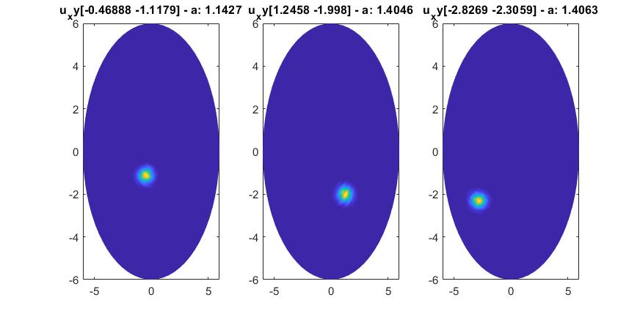

Fig 2.4 Visualization of spectrum units obtained by the SFW method.

* + 1. *The artificial Gaussian spectrum with three closed spectrum components:*
* *Generating an artificial spectrum:*

To study effectiveness of the two methods, we simulate a more complicated spectrum in which the three spectrum components are closing each other. Here is the simulated values of the variables.

|  |  |  |  |
| --- | --- | --- | --- |
|  | 1st spec unit | 2nd spec unit | 3rd spec unit |
|  | -2.3566 | -2.0135 | -2.8283 |
|  | -2.4864 | -2.6624 | -2.724 |
| coeff | 1.1544 | 1.4273 | 1.4413 |

Table 2.5 Three closing spectrum components.

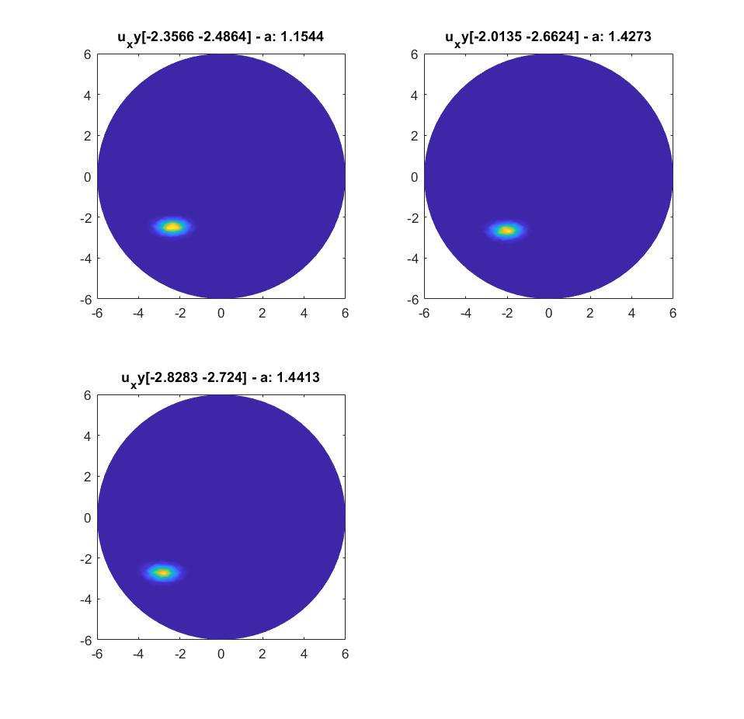

Fig 2.5 Closing spectrum component visualization.

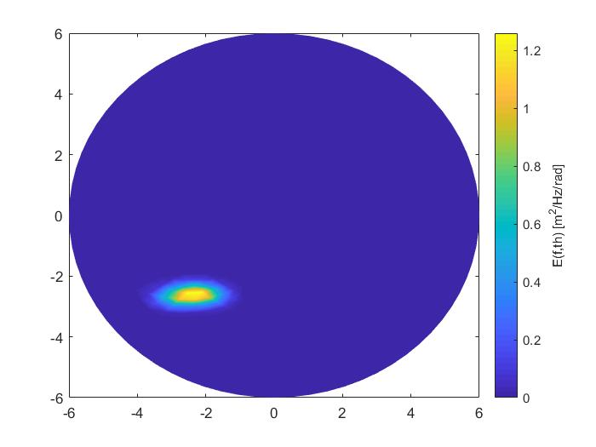

Fig 2.6 Closing spectra combination.

* *Recovery the spectrum units by using the discrete dictionary (LASSO problem):*

When the spectrum components are very closing from each other, we need a grid with high resolution to obtain a more robust result. This signifies that we need more atoms to generate the discrete dictionary, when the dictionary size is enormous that will slow down the algorithm. To evaluate the efficiency of the algorithm, we propose to use the same dictionary as the above case to recovery the original spectrum components. As expected, the algorithm had the difficulty localizing the spectrum component positions and their coefficients and that will give us more spectrum components than the number of the original spectrum components. The result shows four clusters of spectra in total, the first spectrum is out of the three original ones and it deviated the coefficient value determination of the rest.

|  |  |  |  |
| --- | --- | --- | --- |
|  |  |  | coeff |
| 1st spectrum | -3.0642 | -2.5712 | 0.22341 |
| 2nd spectrum | -2.4749 | -2.4749 | 0.53034 |
| 3rd spectrum | -2.687 | -2.687 | 0.23283 |
| 4th spectrum | -2.7577 | -2.7577 | 1.0445 |
| 5th spectrum | -2.1212 | -2.5279 | 0.57251 |
| 6th spectrum | -2.1855 | -2.6046 | 0.78239 |
| 7th spectrum | -1.8928 | -2.7032 | 0.59331 |

Table 2.6 Spectrum components obtained by the FISTA method.

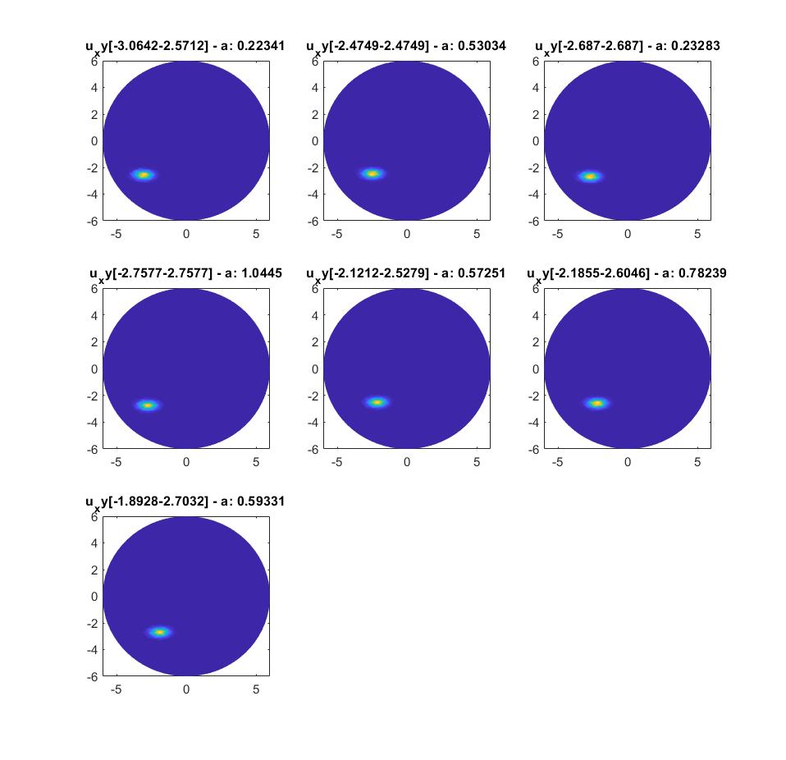

Fig 2.7 Visualization of spectrum units obtained via the FISTA method.

* *Recovery the spectrum units by using the continuous dictionary (BLASSO problem)*:

The SFW still proves its efficiency in recovering the original spectrum components even in the case they are closing from each other. The algorithm found four spectrum components, and principally three clusters. We can merge the two last spectrum components into one component because their similarities in the mean values. Moreover, the algorithm take four second to converge to the stopping criteria, this amount of time is significantly reduced compared with the FISTA method.

|  |  |  |  |
| --- | --- | --- | --- |
|  |  |  | coeff |
| 1st spectrum | -2.8215 | -2.7221 | 1.4123 |
| 2nd spectrum | -2.3906 | -2.4804 | 0.83823 |
| 3rd spectrum | -2.0621 | -2.6362 | 1.423 |
| 4th spectrum | -1.9012 | -2.7261 | 0.17882 |

Table 2.7 Spectrum units obtained by the SFW method.

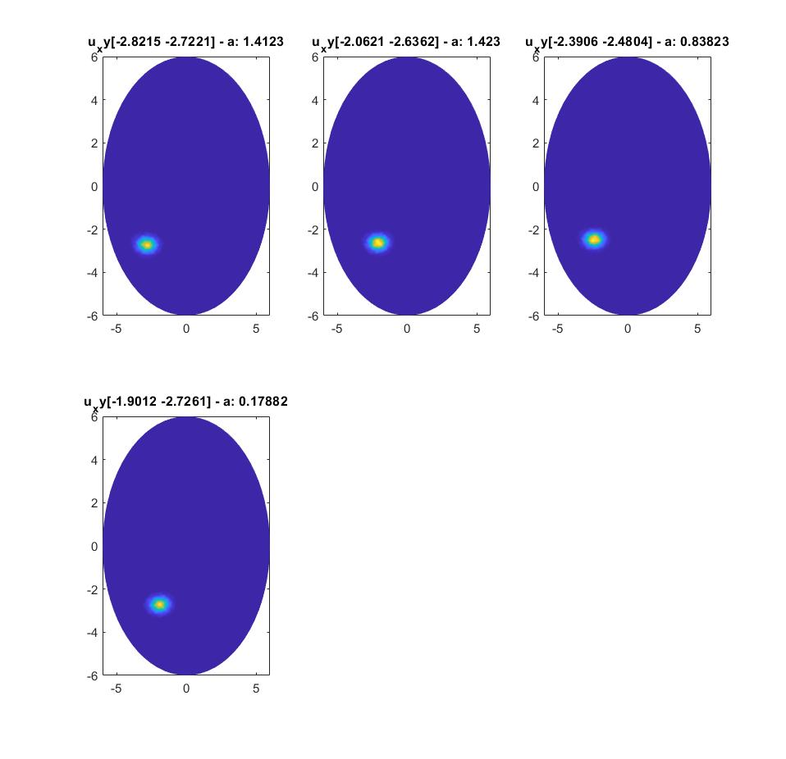

Fig 2.8 Visualization of spectrum units obtained via the SFW method.

* 1. *The Gaussian atom with changes in variance and mean values*

Throughout the above experiences, we have observed that the FISTA method has some limits in accuracies and in computational time, and the SWF method achieved better performance in both terms. For generating the discrete dictionary as we change the variance values, we need to build an enormous matrix which is hard to save and to use on the memory’s computer and it will take more time to process than the previous cases. In addition, the SWF method offers more advantages to overcome the difficulties and that is why we will test only the SWF algorithm in the high dimensional case. We will try to know whether the SFW method still perform well in the more than two dimensional space. The table below shows a range of each variable values used to simulate spectra:

|  |  |
| --- | --- |
|  | [0.1 1] |
|  | [0.1 1] |
|  | [-4 4] |
|  | [-4 4] |

Table 2.8 Gaussian atom variables.

* + 1. *The Gaussian artificial spectrum with three separated spectrum components:*
* *Generating an artificial spectrum:*

The following table shows different spectrum components and their Gaussian variables:

|  |  |  |  |  |  |
| --- | --- | --- | --- | --- | --- |
|  |  |  |  |  | coeff |
| 1st spectrum | -0.66382 | -1.5813 | 0.26763 | 0.58494 | 1.1481 |
| 2nd spectrum | 1.7626 | -2.826 | 0.411 | 0.47728 | 2.8003 |
| 3rd spectrum | -3.9991 | -3.2613 | 0.45709 | 0.7167 | 0.4806 |

Table 2.9 Three separating spectrum components.

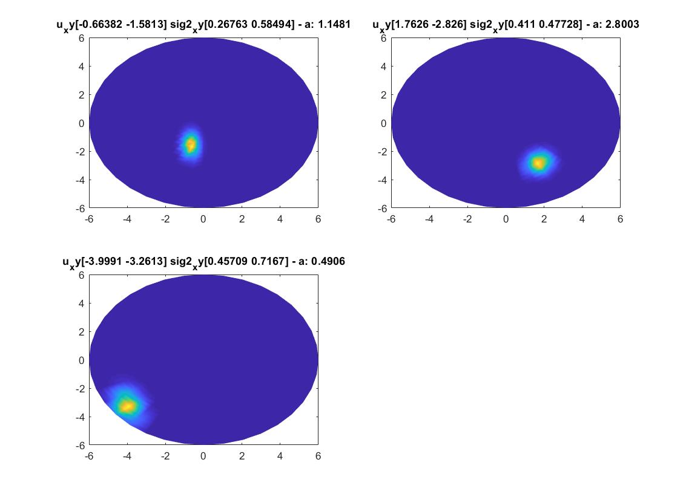

Fig 2.9 Visualization of spectrum components.

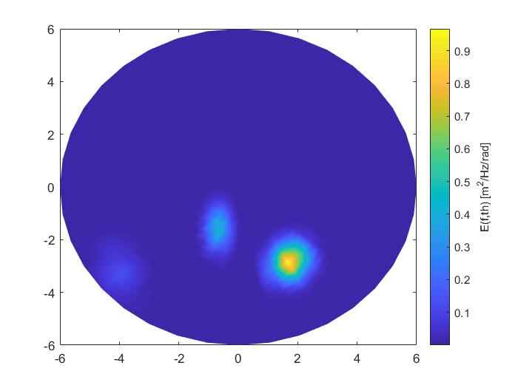

Fig 2.10 Visualization of the spectra.

* *Recovery the spectrum units by using the continuous dictionary (BLASSO problem)*:

In the complex Gaussian artificial spectrum, the algorithm need much time to figure out where are the original spectrum components and their variable values. In this case, the algorithm find thirteen main components (those who has the coefficient greater than 0.1) instead of three, and these components compose three main clusters based on their similarity value of the parameters. Some small deviation between the spectrum’s mean and variance can create a new spectrum, whose coefficient is a small fraction of the ground truth. And that’ why the algorithm show us many spectrum components, we need to find a better condition to merge several closing spectrum into a common spectrum component. The following are the results obtained:

|  |  |  |  |  |  |
| --- | --- | --- | --- | --- | --- |
|  |  |  |  |  | coeff |
| 1st spectrum | 1.7716 | -2.8201 | 0.36817 | 0.4396 | 0.40803 |
| 2nd spectrum | 1.7377 | -2.8683 | 0.42214 | 0.53706 | 0.46802 |
| 3rd spectrum | 1.1882 | -2.7879 | 0.4375 | 0.4375 | 0.33624 |
| 4th spectrum | 1.7374 | -2.8687 | 0.4375 | 0.4375 | 0.27962 |
| 5th spectrum | 1.7378 | -2.7869 | 0.39731 | 0.51597 | 0.56567 |
| 6th spectrum | 1.7374 | -2.7879 | 0.4375 | 0.4375 | 0.2257 |
| 7th spectrum | 1.8172 | -2.8672 | 0.37884 | 0.49987 | 0.32243 |
| 8th spectrum | -0.66055 | -1.5677 | 0.23918 | 0.59131 | 0.55343 |
| 9th spectrum | -0.6866 | -1.7373 | 0.2972 | 0.64612 | 0.10974 |
| 10th spectrum | -0.60713 | -1.5755 | 0.29787 | 0.53165 | 0.14364 |
| 11th spectrum | -0.68664 | -1.495 | 0.28672 | 0.64069 | 0.12268 |
| 12th spectrum | -0.68706 | -1.5756 | 0.29862 | 0.53232 | 0.2096 |
| 13th spectrum | -3.9999 | -3.2473 | 0.48502 | 0.73005 | 0.25136 |

Table 2.10 Spectrum components obtained by the SFW method.

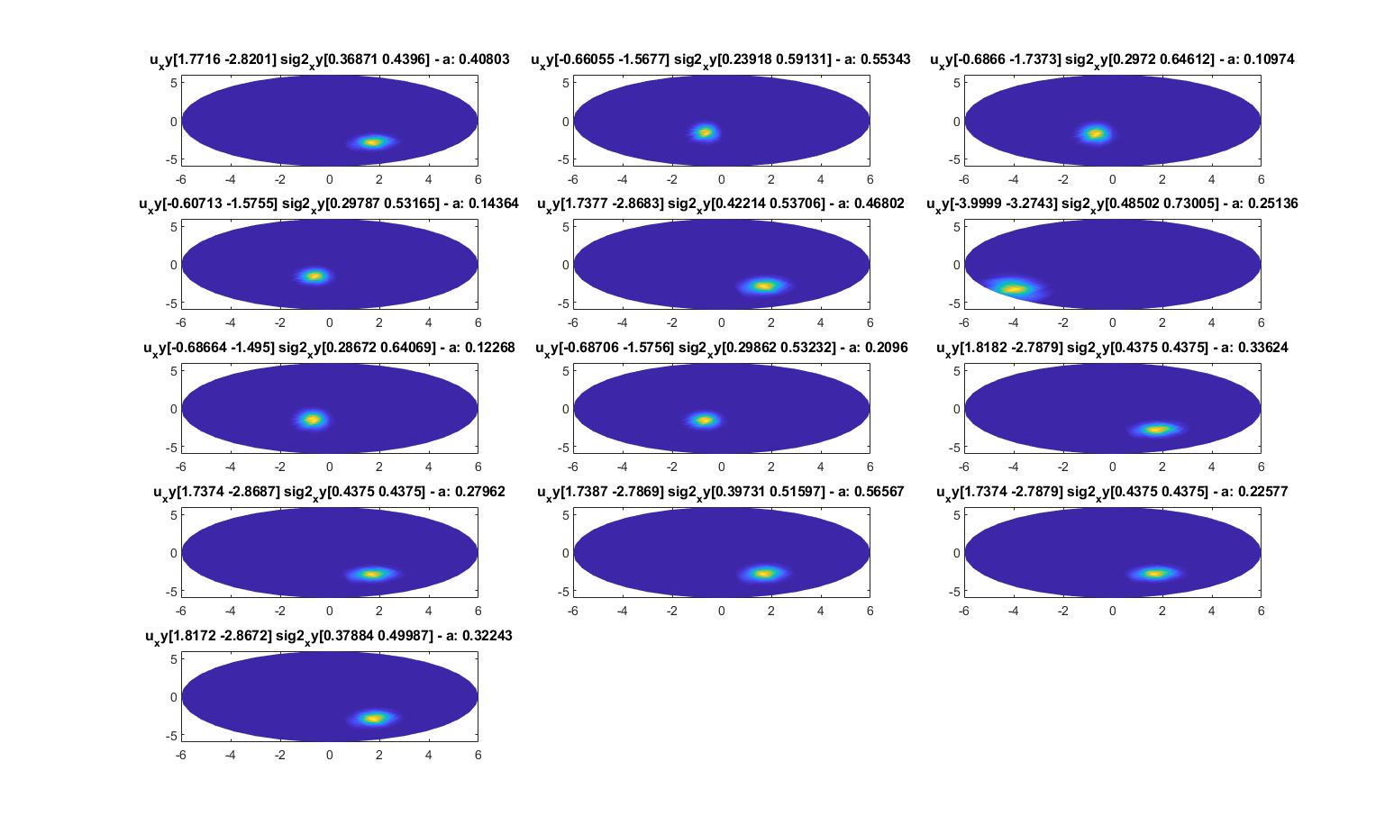

Fig 2.11 Visualization of the spectra obtained by the SFW method.

* + 1. *The Gaussian artificial spectrum with three closing spectrum components*
* *Generating an artificial spectrum:*

Here we generate a more realistic spectrum modeled by the Gaussian distribution:

|  |  |  |  |  |  |
| --- | --- | --- | --- | --- | --- |
|  |  |  |  |  | coeff |
| 1st spectrum | -2.6731 | -2.9887 | 0.93125 | 0.86072 | 3.9667 |
| 2nd spectrum | -3.8123 | -3.1313 | 0.47502 | 0.37625 | 2.1471 |
| 3rd spectrum | -3.979 | -2.4777 | 0.3591 | 0.92403 | 3.0223 |

Table 2.11 Three close spectrum units

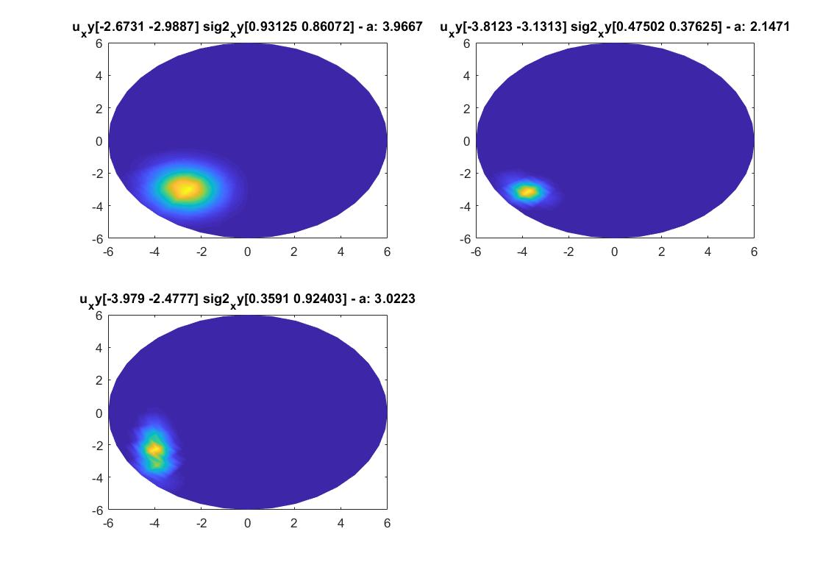

Fig 2.12 Visualization of spectrum components.

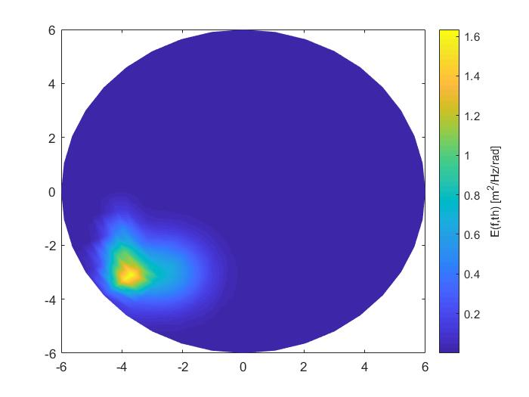

Fig 2.13 Visualization of the spectrum.

* *Recovery the spectrum units by using the continuous dictionary (BLASSO problem)*:

|  |  |  |  |  |  |
| --- | --- | --- | --- | --- | --- |
|  |  |  |  |  | coeff |
| 1st spectrum | -3.4505 | -2.8953 | 0.1 | 0.1 | 0.21817 |
| 2nd spectrum | -3.9101 | -3.2809 | 0.1 | 0.1 | 0.23967 |
| 3rd spectrum | -4 | -3.4375 | 0.25701 | 0.15909 | 0.39115 |
| 4th spectrum | -3.677 | -3.0854 | 0.1 | 0.1 | 0.37156 |
| 5th spectrum | -2.7879 | -2.9495 | 1 | 0.8875 | 2.8706 |
| 6th spectrum | -3.0303 | -3.1111 | 1 | 0.6625 | 0.79317 |
| 7th spectrum | -2.7071 | -3.0303 | 1 | 0.8875 | 0.14937 |
| 8th spectrum | -2.8687 | -3.0303 | 1 | 0.775 | 0.2216 |
| 9th spectrum | -2.8687 | -3.0303 | 1 | 0.775 | 0.12607 |
| 10th spectrum | -4 | -2.5451 | 0.40101 | 0.87706 | 0.86644 |
| 11th spectrum | -4 | -2.4646 | 0.325 | 1 | 1.4591 |
| 12th spectrum | -4 | -2.5455 | 0.325 | 0.8875 | 0.28642 |
| 13th spectrum | -3.919 | -2.7068 | 0.40202 | 0.75469 | 0.30995 |

Table 2.12 Spectrum components obtained by the SFW method.

The result shows many different reconstructed spectrum components composing the original spectrum components. As explained above, some variations in the variance and mean values can create a new spectrum component. The reconstructed spectrum positions are near to the original one, and the sum of all coefficients of each cluster is approximately to the coefficient of the original spectrum. Therefore, we need a better merge condition to find solution with less number of spectrum components.

1. **Real Directional Ocean Wave spectrum Tests**
   1. *Sliding Frank-Wolfe algorithm with the Gaussian atom*

In the real spectrum tests, we suppose that the natural directional wave spectrum is a sum of many directional wave spectra that follow a Gaussian distribution. The following table shows a range of each Gaussian variable:

|  |  |
| --- | --- |
|  | [0.001 2] |
|  | [0.001 2] |
|  | [2*min(min(fx)) 2*max(max(fx))] |
|  | [2*min(min(fy)) 2*max(max(fy))] |

Table 3.1 Gaussian atom variables on the real spectrum tests.

Where fx, fy are the spatial frequencies measured on the real spectra. These conditions guarantee that the Gaussian variable values can cover all the possible values of Gaussian atoms combining the directional wave spectra. Another important attention on choosing the value of the variance is that it should take small values but not get zeros, because it might exist several spectra that include many Gaussian atoms with small variances. This choice helps the algorithm converging to the stopping criteria and obtaining approximate result from the ground truth.

* *Test on the wind sea system:*

This test is implemented on the system where there is only one wind sea appearing in the spectrum. The tested spectrum was measured on the NODE008919(12-Jan-2010 17:00:00).

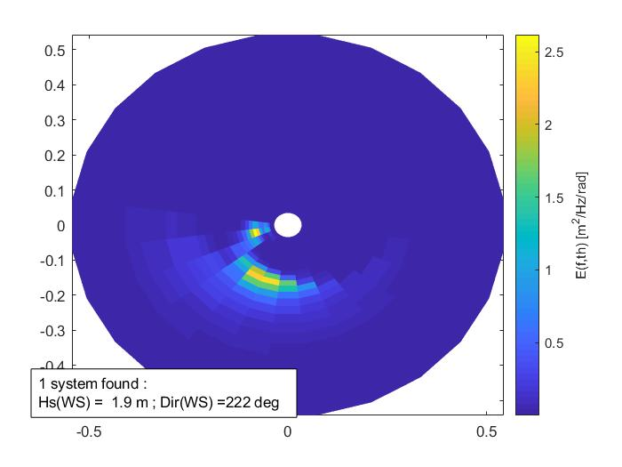

Fig 3.1 Visualization of the real wind sea system.

The SFW method took about twelve minutes to implement 118 iterations to converge to the stopping criteria. The algorithm detects 117 different atoms. The atoms have their coefficients with different values, which decide how much influence (amplitude and direction) that each atom contributes to recover the original spectrum. Approximately, we can examine the atoms, which contribute significantly to recover the spectrum. The following table shows the values of these atoms.

|  |  |  |  |  |  |
| --- | --- | --- | --- | --- | --- |
|  |  |  |  |  | coeff |
| 1st atom | -0.1061 | -0.1418 | 0.0501 | 0.0501 | 0.1937 |
| 2nd atom | -0.2762 | -0.0068 | 0.2324 | 0.0001 | 0.3036 |
| 3rd atom | -0.2222 | -0.0102 | 0.2307 | 0.0001 | 0.5064 |
| 4th atom | 0.0165 | -0.0102 | 0.2015 | 0.001 | -0.2073 |
| 5th atom | -0.1316 | -0.1465 | 0.0660 | 0.0001 | 0.1701 |
| 6th atom | -0.1502 | -0.1258 | 0.0660 | 0.0001 | 0.1131 |
| 7th atom | -0.0674 | -0.2335 | 0.0001 | 0.1234 | 0.1095 |

Table 3.2 Principle atom components.

In this table, we can clearly see that there are not only atoms that have positive impacts (positive direction) on enhancing the energy of the original spectrum but also there exist at the same time the atoms weaken the amplitude of the spectrum’s energy (negative direction). We can imagine that, in reality the wind seas can move in any direction and a combination of them creating one final direction that caused by the predominant atoms. The following figure shows a combination of all atoms found by the SFW method.

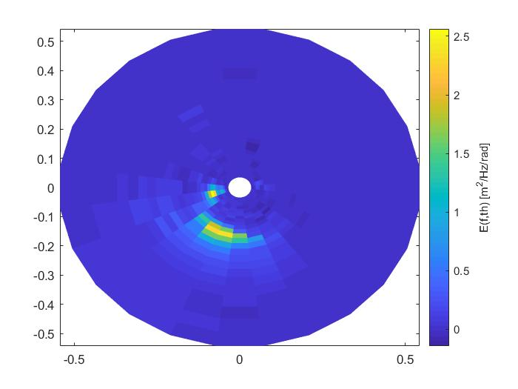

Fig 3.2 Gaussian atom combination found by the SFW method

Compared with the original spectrum in the figure 2.1, we can see that the recovered spectrum has almost the same altitudes and the same directions as the original one. It proves that the directional wave spectrum can be modeled as a sum of many spectral units that following the Gaussian distribution. Below are several different tests recovering different spectra, which can exist many components in each spectrum.

* *Test on the swell system:*

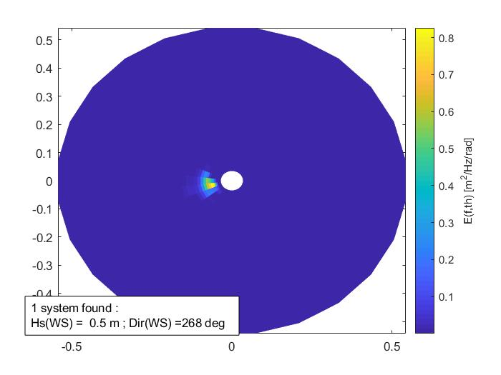

Fig 3.3 The swell system.

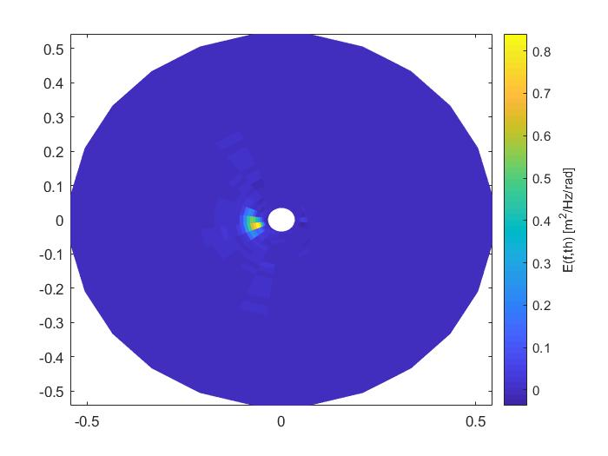

Fig 3.4 The recovered swell system by using the SFW method.

Just like as the above experience, the algorithm recovery successfully the original spectrum. Moreover, the algorithm detects more than 60 different atom components. Several of them have very small values of coefficients.

* *Test on the system wind sea + swell:*

When the system becomes more complexity, i.e. it includes several types of waves, the algorithm struggle to converge to the stopping criteria. For example, in this experience the directional wave spectrum includes a wind sea and swell. To find spectrum components following the Gaussian distribution law combining the original spectrum, the system took more than 83 minutes to iterate 200 times, but it did not reach the stopping criteria. The result shows 172 spectrum components that constructs the original spectrum. Most of the components have almost the same values of coefficients, so it is hard to recognize which ones are dominant in building the original spectrum. Two figures below show the original spectrum and the recovered one by combining several spectrum units found by using the SFW method.

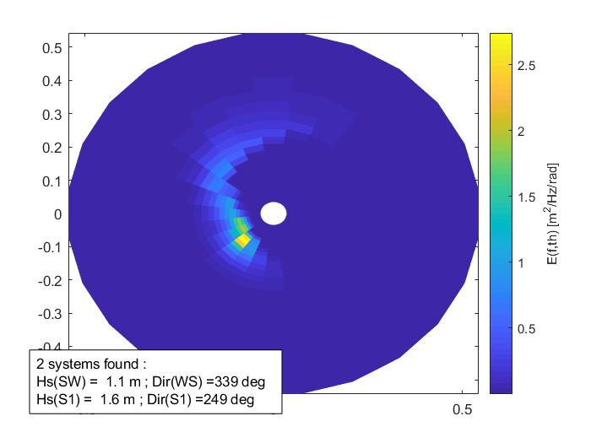

Fig 3.5 The original system (a wind sea + swell).

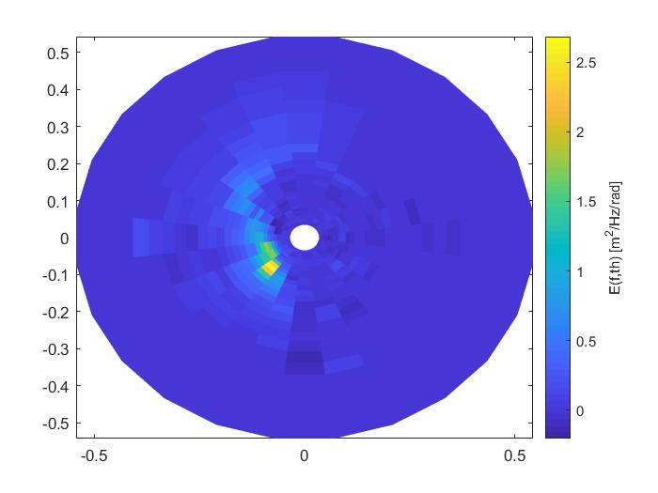

Fig 3.6 The recovered system by using the SFW method.

Until now, it seems that the components of real directional ocean wave spectrum do not follow the Gaussian distribution. All most results show we need more than a decade of spectrum components to reconstruct the original spectrum. We interest the spectrum component structure with which we need only a few of them to reconstruct the original spectrum. A research extension of the report will consider a real directional wave spectrum modeled as the JONSWAP spectrum will discuss in the chapter IV.

* 1. *Classical approach of the Watershed method on the directional ocean wave spectrum*

Generally, the Watershed algorithm is typically used to segment many kinds of images. Now, we apply this approach on the directional ocean wave spectrum; aim to find where the centroid of each spectrum components is.

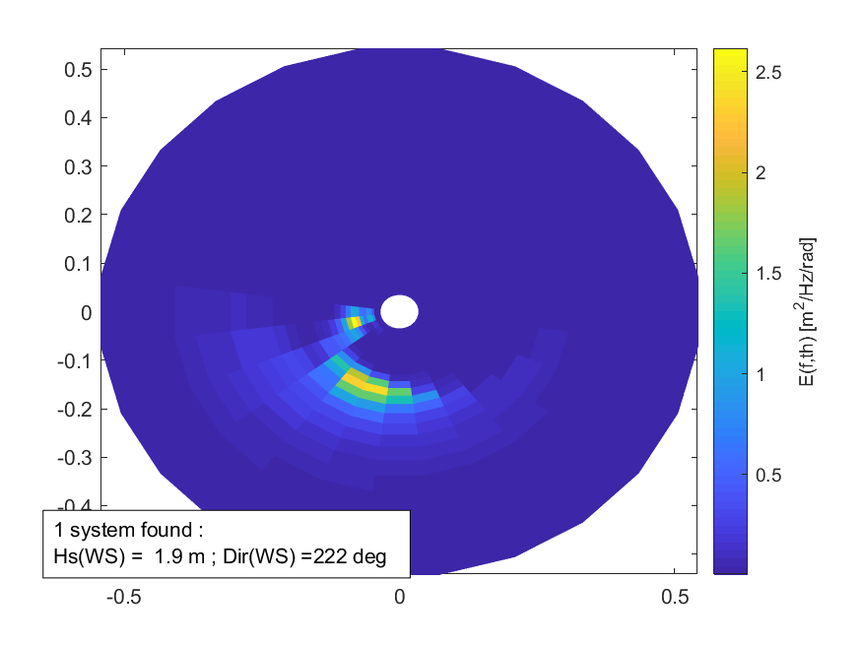

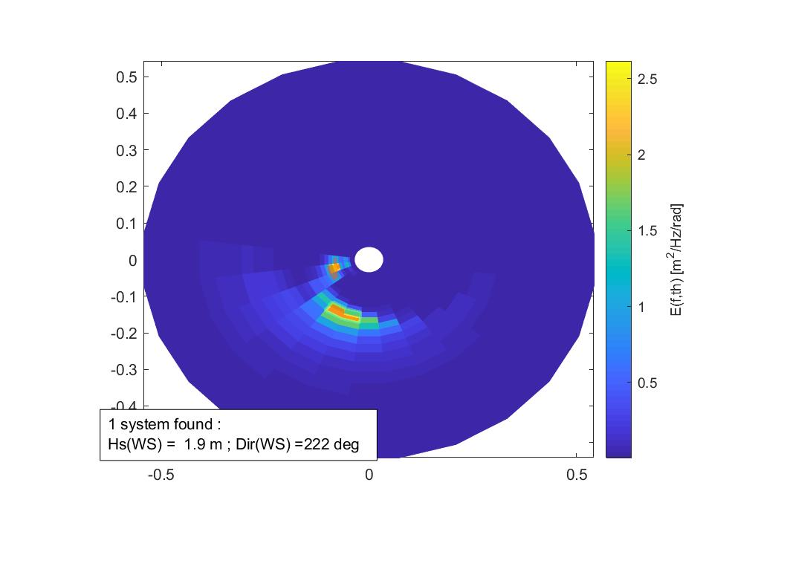

Fig 3.7 The ground truth wind sea system (above) and

its segmented version (below) by using the Watershed method.

The result shows that there are two directional waves in this spectrum instead one wind sea shown in the ground truth. This method takes little time to solve the system and to recognize how many directional waves existed in the system. Nevertheless, the drawback of this method, we cannot know exactly which distribution law each directional wave follows. It might exist several components, which follow a specific probability distribution law (ex. Gaussian), combining each of the segment of the segmented spectrum by using the Watershed method.

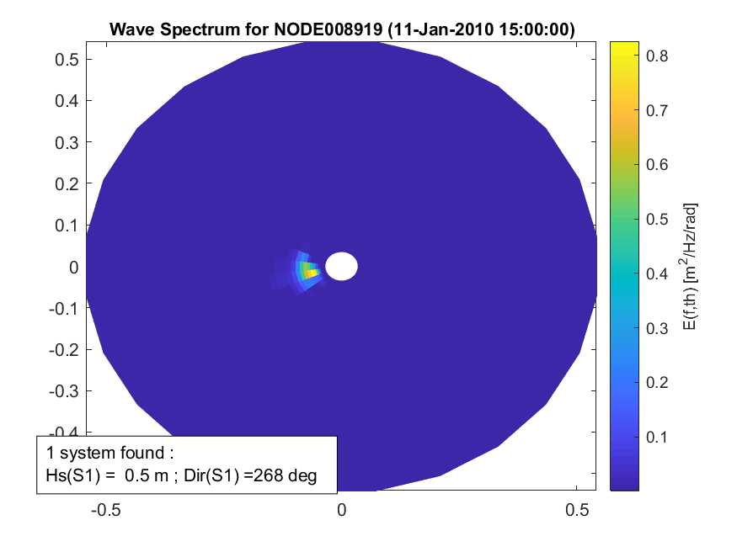

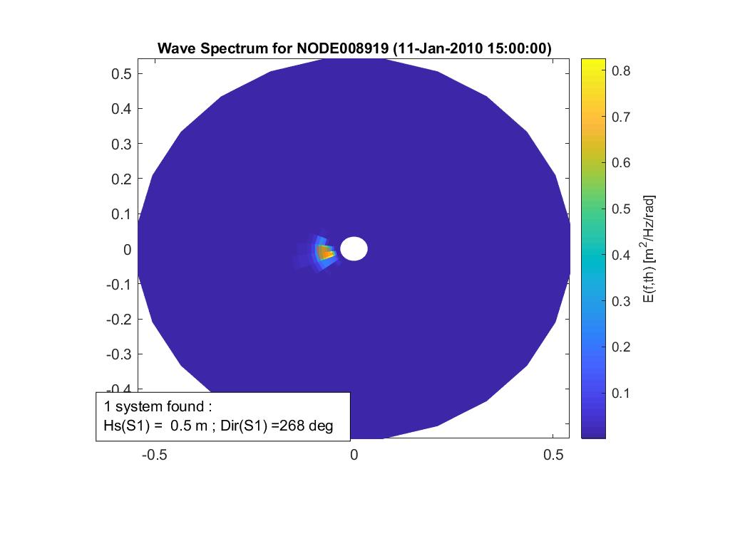

Fig 3.8 The ground truth swell system (above) and

its segmented version by the Watershed method(below).

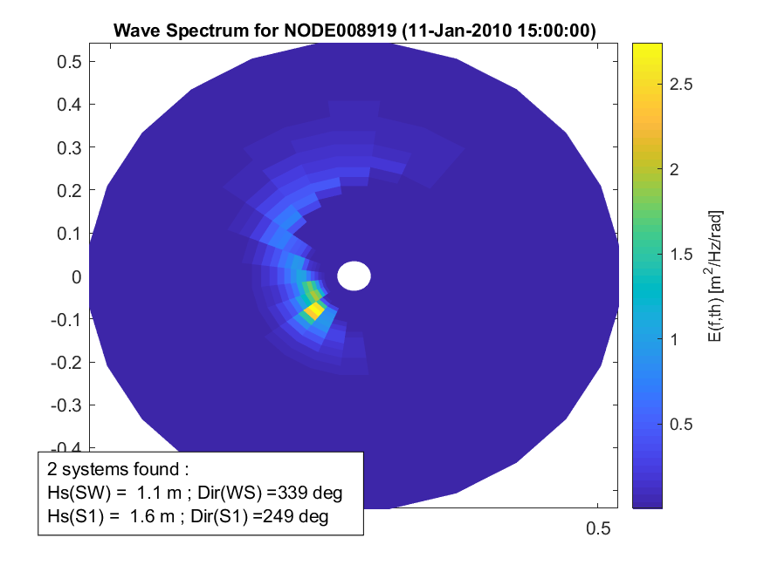

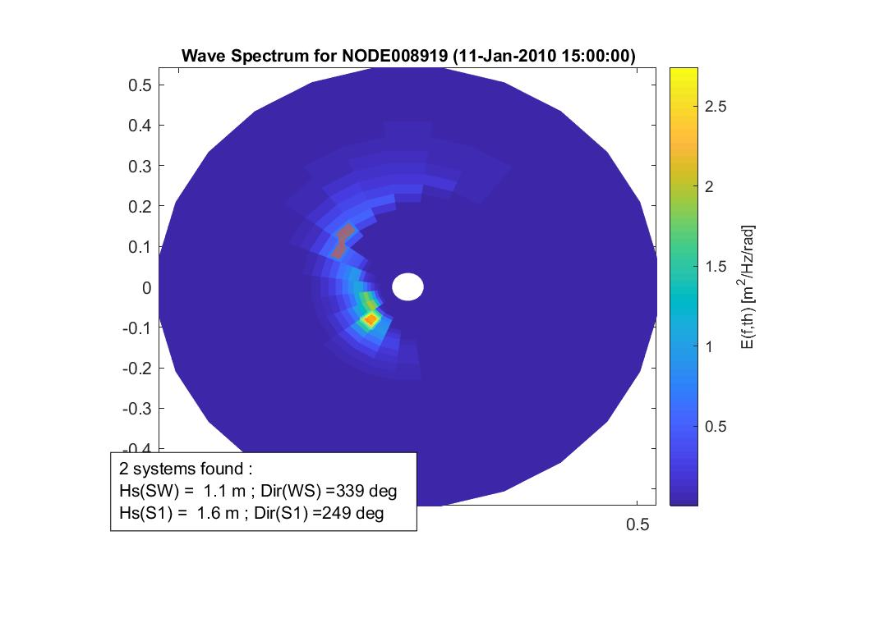

Fig 3.9 The system including a wind sea and swell (above) and

its segmented version by using the Watershed method.

Through some experiences with this method, we see that the method successfully segment the directional ocean wave spectrum in which their spectrum components are far away from each other. It is hard to imagine this algorithm can differentiate spectrum components, which are merged together. In addition, the segmentation result depend strongly on the method’s parameters (such as structuring element’s radius in a morphological operation) as the variety of directional wave spectrum forms.

1. **SFW Method with The JONSWAP Frequency Spectrum and Its Implementation on Real Spectrum** 
   1. *A new model of directional ocean wave spectrum*

The directional ocean wave spectrum is traditionally factorized as follows:

(5)

Where is the frequency spectrum and the so-called spreading function satisfying. Throughout many empirical experience researches, we see that the JONSWAP type seems to fit accurately a large range of the recorded deep-water data [1]. The parametric form of this frequency spectrum is shown in the following formula:

(6)

with , where assumed to be a jump function of :

and the parameter , the shape parameter , and the spectral peak to be specified as follows:

Where:

is a significant height wave (1/3 of highest waves)

is a average period measured by the zero-down method.

In almost case, the directional wave spectrum depends on the . The popular spreading function represents this relation is the Mitsuyasu-type spreading function:

(7)

where:

is the mean wave direction.

C is the method parameter.

is the normalization constant.

We usually fix the shape parameter value (empirical experiences) to model the directional ocean wave spectrum. Figure below shows a demonstration of the directional wave spectrum, the JONSWAP frequency spectrum and its Mitsuyasu – type spreading function, when:

|  |  |
| --- | --- |
|  | 3.3 |
|  | 1 m |
|  | 5 s |
|  | π/3 |
| C | 20 |

Table 4.1 variable values for illustration

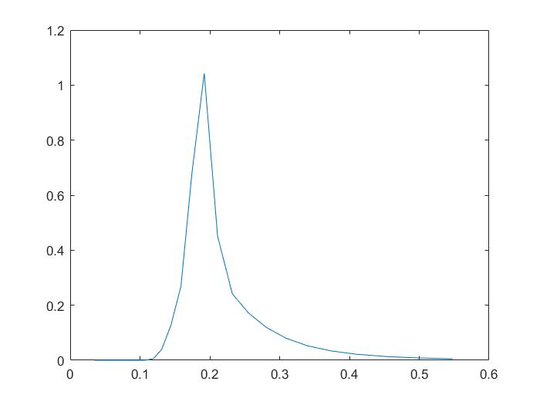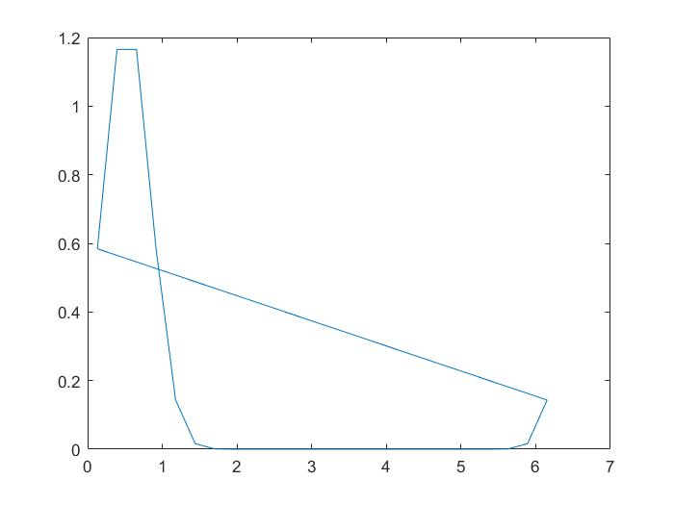

a. JONSWAP frequency spectrum b. Mitsuyasu-type spreading function

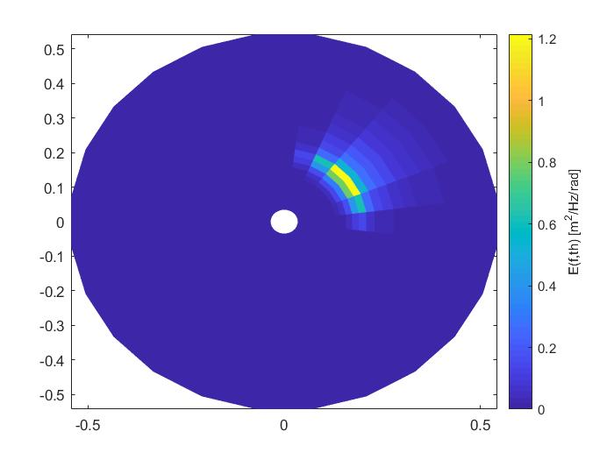

c. Directional wave spectrum

Fig 4.2 The illustration of the new directional wave spectrum.

* 1. SFW implementation on the new type of directional ocean wave spectrum

We experience the new type of directional wave spectrum presented in the formula [5]. We will call atoms of this new type spectrum are the JONSWAP atoms, which we use to generate elements of the continuous dictionary. As mentioned above, we will fix the shape parameter value (empirical experiences) and vary others parameters. The table below shows different parameters for the JONSWAP atoms.

|  |  |  |
| --- | --- | --- |
| Param | Signification | Range of value |
|  | Significant height wave (m) | [0.1 1.5] |
|  | Significant wave period (s) |  |
|  | Mean direction wave (rad) | [0 2π] |
| C | Mitsuyasu-type constant |  |

In the following experiences, we will also manipulate the parameter in the formula [3] to see how the parameter affect the reconstruction of the original ocean wave spectrum (number of elements, their coefficients).

* Test on the wind sea system