Coming into Spring 2025, we have this model:

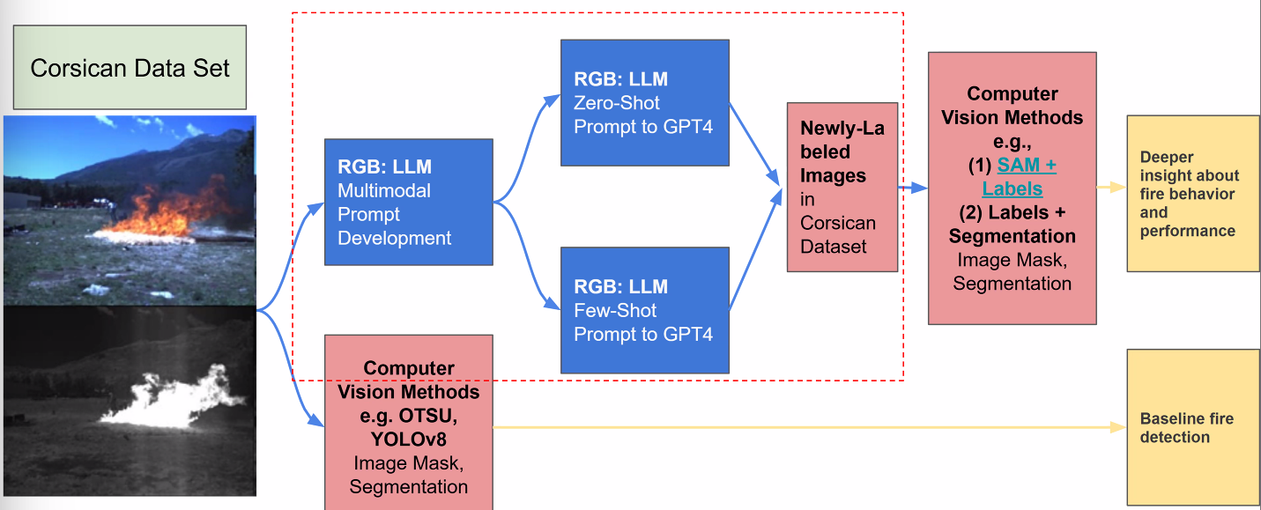

Data located [here](https://drive.google.com/drive/folders/1kV79pwxz4n8LRhD3bvmDYR3zu6DyPpW6?usp=drive_link)

More information about [dataset](https://cfdb.univ-corse.fr/catalog_repository/uploads/7/Donnees_image__Corsican_Fire_Database_en.pdf) from CFDB website

Current Goals:

* Propose:
  + Hypothesis: How to improve wildfire frameworks?

Mar 13, 2025

* Navigate our purpose with research questions
  + Use APIs to extract descriptors such as colors to compare with ground truth/ human annotation
    - Gemini, etc.
* Possibility to use non-corsican dataset
  + Expanding dataset variability,
* Temporal fire analysis
  + Shape what contribution the work can provide
* Look at some relevant papers on the topic
  + Not necessarily wildfire paper
    - Autonomous vehicle
  + Image quantification data
* What are the hypotheses for the enable outcome (in Future Directions)
* Outcomes for each direction
  + Explore 1-2 papers related to the topic
  + What does it mean to have insights in these topics
  + What methods are in these directions