EE 320 COURSE

PROJECT REPORT

Project No. 1

Buck Converter Design

**September 30, 2015**

Written by: Nathan Genetzky Instructor: Mr. Mettler

Objective of this investigation is to design a buck converter to converter a 120Vrms, 60 Hz signal with ± 10% variability into a 60 VDC with 5W of power. The efficiency, η, was assumed to be 80%. The nominal values from lecture were used to verify the calculations. Values were determined for a nominal input of 120 Vrms but then they were determined for scenarios where the input increases by 10% or decreased by 10%. A switching frequency of 10kHz was used.

The circuit, Fig. 1, created in PSpice contains the grid input of 120 $V_{rms}$, full wave rectifier, filter capacitor and a buck convertor. The values shown reflect the calculations performed for the nominal input value.

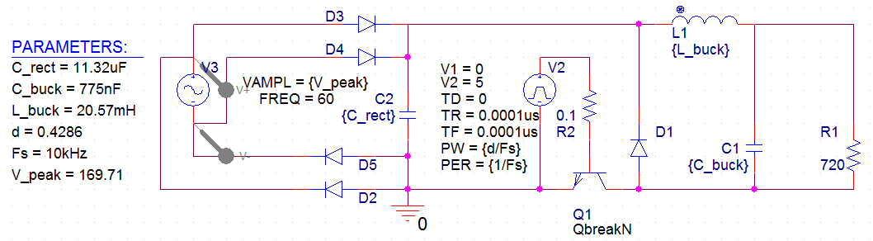

Figure 1: 120V AC to 60V DC converter using nominal input calculations.

The effect changing the input amplitude is minimal. It only seems to shift the output up or down by a factor related to the duty cycle. This shifting could cause problems for electronics that depend on a steady DC voltage. One of the desired improvements of the circuit is to decrease the variability in the output. The final design should create a output that has less than 5 $V_{pp}$ ripple and have less than 10% variance in the output for a change in the input amplitude.



Figure 2: Output voltages for low, nominal, and high input sinewaves.

1. Table of values for 3 possible inputs

Table 1: Calculations performed for low, nom and high Vac input.

|  |  |  |  |
| --- | --- | --- | --- |
|  | Low input | Nom input | High input |
| Input voltage (rms) [V] | 108 | 120 | 132 |
| Input voltage (peak) [V] | 152.735 | 169.706 | 186.676 |
| Rectifier Cap [F] | 2.79E-05 | 1.13E-05 | 6.83E-06 |
| Rectifier Ripple [V] | 12.092 | 26.882 | 40.534 |
| Converter Duty Cycle | 0.4286 | 0.4286 | 0.4286 |
| Output current [A] | 8.33E-02 | 8.33E-02 | 8.33E-02 |
| Output Resistance [Ω] | 720 | 720 | 720 |
| Transistor Current [A] | 3.57E-02 | 3.57E-02 | 3.57E-02 |
| Diode Current [A] | 4.76E-02 | 4.76E-02 | 4.76E-02 |
| Converter Inductance [H] | 2.06E-02 | 2.06E-02 | 2.06E-02 |
| Converter Capacitance [F] | 1.72E-06 | 7.75E-07 | 5.14E-07 |

1. Graph of Nominal Voltage (input and output)



Figure 3: Output voltage(red) for Nominal input sinewave(green dashed).

1. Graph of Inductor Current



Figure 4: Plot of inductor current showing the behavior throughout the nominal sinewave’s period



Figure 5: Plot of Inductor current for low, nominal, and high input sinewaves scaled to the level of the switching periods

1. Analysis of adjusting the duty cycle. This section should be written in paragraph format and include figures. Show examples of how changing the duty cycle affected the results.

A parametric sweep of the duty cycle reveals that as the duty cycle increases the overall voltage increased but so does the amount of ripple in the output, Fig. 5. The 60% duty cycle has around ripple voltage of around 20-25 V but the 40% ripple has a ripple voltage closer to 10 V. The max current that flows through the inductor is directly related to the duty cycle. As duty cycle increases the peak current through the inductor also increases. The amount of time the inductor spends charging decreases from 60 ns to 20 ns as the duty cycle decreases from 60% to 20%, Fig. 6.



Figure 6: Output voltage for Nominal input sinewave and a buck converter with duty cycle from 0.2 to 0.6.



Figure 7: Inductor current for Nominal input sinewave and a buck converter with duty cycle from 0.2 to 0.6.

1. Analysis of operating mode, modifications, proof the modifications worked. This section should be written in paragraph format and include figures.

The current operating mode is constant conduction mode but is dangerously close to critical conduction mode; the current through the inductor is 0 A for a very brief amount of time for the designed duty cycle, Fig. 5. Discontinuous conduction mode can be observed for 20% and 30% duty cycle, Fig. 7. It is desired to be in continuous conduction mode in order to obtain a more steady DC output. Discontinuous mode is also useful when the output should be less dependent on changes in the input, but it was determined to not be worth the tradeoffs (less stable DC output) in this case.

Based on the measurements observed for the initial design when the nominal input was applied it is clear that the current through the diode exceeds rated values. The max current through the diode was measured to be 1698 A. No figure was included because the current vs time graph was very cluttered; pspice’s “max” measurement was used to obtain measurements. There does not seem a practical way to significantly reduce this measurement.

Based on the relation between inductance and the three conduction modes it was decided to observe the effects of inductance by doing a parametric sweep of $L_{buck}.$ The parametric sweep did not yield promising results. The output voltage oscillated at 120 Hz at approximately the same voltage for every inductor; however as the inductance increased amplitude the oscillations at the switch frequency decreased significantly.

A parametric sweep of the Capacitor used in the rectifier yields valuable results. The rectifier capacitance values used for the first sweep were taken from the calculations, table 1, for low, nom, and high input sinewaves. The simulation indicates that as the capacitor increase the amount of ripple in the final output decreases, Fig. 8. This finding supports the equation that states that the voltage ripple is indirectly related to the rectifier capacitance. A broader range of capacitances were investigated and it behavior over one period was observed, Fig. 9.



Figure 8: Output voltage for Nom. input and a rectifier with capacitance of 27.9uF (top), 11.3uF 0.2, and 6.8uF (bottom).



Figure 9: Output voltage for Nom. input and a rectifier with capacitance from 6.25uF (bottom) to 100uF (top).

1. Table of design choices with explanation for: Diode, Transistor, Capacitor, Inductor

The issue that needs to be fixed is that the change in the input translates into a moderate change in the output voltage. In order to decrease the effect on the output voltage the duty cycle must be decreased. In order to decrease this value but retain the desired output voltage the average output voltage of the rectifier must be larger. In order to obtain a larger output voltage (lower ripple voltage) the rectifier capacitance can be increased.

The buck inductance and capacitance was not modified since both values were found to only affect the wave function that that defines the high frequency signals (those switching at a rate closer to Fs). The values were measured using the PSpice function as much as possible. The currents listed in the table are the maximum values. Note that the rectifier ripple decreased significantly after modifying the component values, Table 2.

Table 2: Table of values that were measured before and after the component values were changed.

|  |  |  |
| --- | --- | --- |
|  | Nominal measured values | Improved measured values |
| Input voltage (rms) [V] | 120 | 120 |
| Input voltage (peak) [V] | 169.71 | 169.710 |
| Rectifier Cap [F] | 1.13E-05 | 1.00E-04 |
| Rectifier Ripple [V] | 23.645 | 2.346 |
| Converter Duty Cycle | 4.29E-01 | 0.3400 |
| Output current [A] | 8.35E-02 | 8.67E-02 |
| Output Resistance [Ω] | 7.20E+02 | 720 |
| Transistor Current [A] | 226.876 | 8.89E+01 |
| Diode Current [A] | 1698 | 3.46E+02 |
| Converter Inductance [H] | 2.06E-02 | 2.06E-02 |
| Converter Capacitance [F] | 7.75E-07 | 8.14E-06 |

1. Graph of Voltage output with Low voltage input and Inductor Current



Figure 10: Output voltage of Buck Converter when low voltage sinewave is applied at the input.



Figure 11: Output current through the inductor of Buck Converter when low voltage sinewave is applied at the input.

1. Graph of Voltage output with Nom voltage input and Inductor Current



Figure 12: Output voltage of Buck Converter when nominal voltage sinewave is applied at the input.

**

Figure 13: Output current through the inductor of Buck Converter when nominal voltage sinewave is applied at the input.

1. Graph of Voltage output with High voltage input and Inductor Current



Figure 14: Output voltage of Buck Converter when high voltage sinewave is applied at the input.

**

Figure 15: Output current through the inductor of Buck Converter when high voltage sinewave is applied at the input.