Nathan Genetzky and Patrick Schroeder

EE315 Linear Control System Project assigned by Dr. Hietpas

Twilight Zone Tower of Terror II

Group 1 (part1)

# Introduction

Concepts learned in Linear Control Systems were used to analyze a system which contains both mechanical and electrical components. Mechanical components were modeled using a Force/Torque-Velocity analogy. Block diagrams resulted from the relationships between the components and signals. Set-up has been done so the system can be simulated in Simulink with the given design parameters.

# Theory



Figure Tower of Terror System Diagram

The system diagram was used to construct a Force/Torque-Velocity electrical analog shown in Fig (2) below. The first diagram shows all of the components individually while Fig (3) then shows the simplified model. In Fig (3) the spring representing the elevator cable was assumed to have an coefficient .

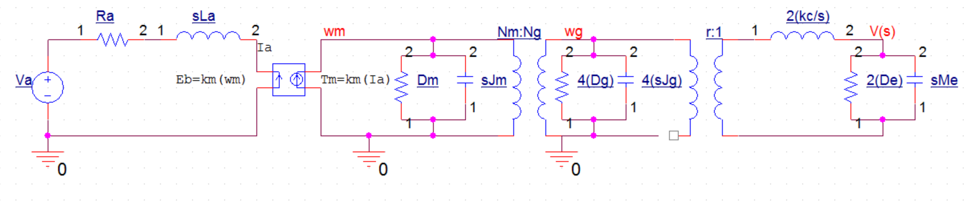

Figure Expanded diagram of electromechanical circuit

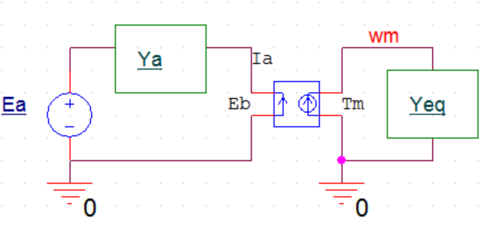

Figure Simplified diagram of electromechanical circuit

A Block diagram was created to aid in analysis of the electrical equivalent model. Figure (4) below shows the Simulink diagram and the hand drawn block diagram is shown in Fig (5). The transfer functions used in the block diagrams are listed in Table 1.

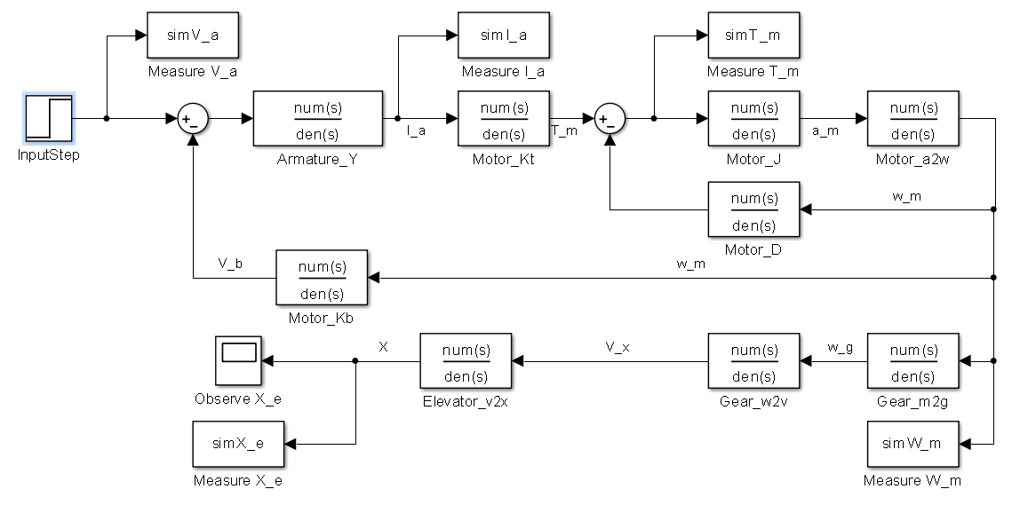

Figure Block diagram in Simulink for system

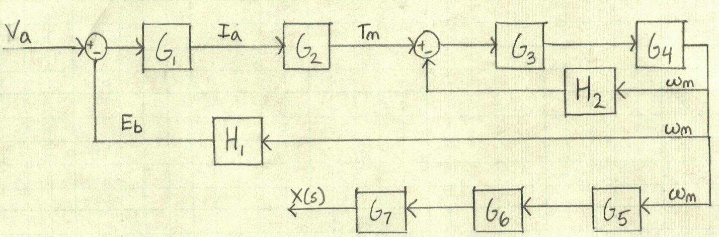

Figure Block Diagram for system (hand-drawn)

Table Transfer Functions used in Block Diagram

|  |  |  |
| --- | --- | --- |
| Simulink Name | Variable | Defined as |
| Armature_Y |  |  |
| Motor_Kt |  |  |
| Motor_J |  |  |
| Motor_a2w |  |  |
| Gear_m2g |  |  |
| Gear_w2v |  |  |
| Elevator_v2x |  |  |
| Motor_Kb |  |  |
| Motor_D |  |  |

The open-loop transfer function G(s) was derived by using both stand Circuits II approaches as well as Mason’s Gain Rule. Table (2) shows the coefficients of the numerator and denominator in terms of the variables provided in Fig 1 above and in the format dictated by (1).

 (1)

Table Coefficients of system’s transfer function

|  |  |
| --- | --- |
| Label | Values determined from |
|  |  |
|  |  |
|  |  |
|  |  |
|  | 0 |

Table Coefficients of system’s transfer function

The Motor in the system must have the following constraints. The nominal supply voltage must be between 440 and 470 Vdc. The nominal speed range between 710 and 910 rpm. The nominal output power capability range between 375 and 475 HP (279.6-354.2 kW). The applicable motors found in ABB Catalog for DC motors are shown in table 4 [1]. The proceeding analysis of this system will be using Motor #12. The summarized system component specifications are shown in table 5.

Table Motors that fit criteria from catalog (in bold is the motor used for calculation)



Table System Component specifications

|  |  |  |
| --- | --- | --- |
| Element | Value | Units |
|  | 7500 |  |
|  | 250 |  |
|  | 11 |  |
|  | 151.6 |  |
|  | 75.8 |  |
|  | 0.117 |  |
|  | 0.92 |  |
|  | 54.8 |  |
|  | 5.44 |  |
|  | 4.87 |  |
|  |  |  |
|  |  | teeth |
|  |  | teeth |
|  |  |  |

# Procedure:

The system’s diagram as provided in Figure 1 were converted into an electromechanical circuit as seen in Figure (2). The circuit diagram and circuit theory were used to solve for the transfer function, G(s), as described in appendix. A block diagram, figure 5, was formed with transfer functions from table 1. Mason’s gain rule was used to arrive at the same transfer function as described in appendix. This transfer function is in the form (1) with the coefficients listed in table 2. The constraints for the motor were used to create table from the motors in the ABB catalog found to fit the criteria. Table 5 defines criteria of the system, but the motor related variables were obtained from motor #12 in table 4. The motor coefficients, and , were then determined numerically given the specifications of the motors and the equations that define the coefficients.

# Results and Analysis

# Conclusions

# References

[1] ABB Catalog for DC Motors, Type DMI/ Type DMI/ Typ DMI, <http://www05.abb.com/global/scot/scot234.nsf/veritydisplay/4a43defb2e83aea2c125784f00380340/$file/dc_motors_dmi_catalog_low%20res.pdf> downloaded January 11, 2015.

# Appendix

## Hand Written Work

### Solving for Transfer function using circuits approach

Equations by reference

|  |  |
| --- | --- |
| 1. |  |
| 2. |  |
| 3. KVL |  |
| 4. KCL |  |
| 5. |  |
| 6. |  |
| 7. |  |
| 8. |  |
| 9. |  |
| 10. |  |

1 and 2 are by definition. 3 is KVL of the electrical side of motor. 4 is KCL of the mechanical side of motor. 5 is obtained by using 2 and 3 on 4. 6 is obtains by using 2 and 5 on 3. 7 is made by rearranging 6. 8 is a series of small transformations to move between signals and . 9 is created by using 9 to change in 7.

### Solving for Transfer function using Mason’s gain rule

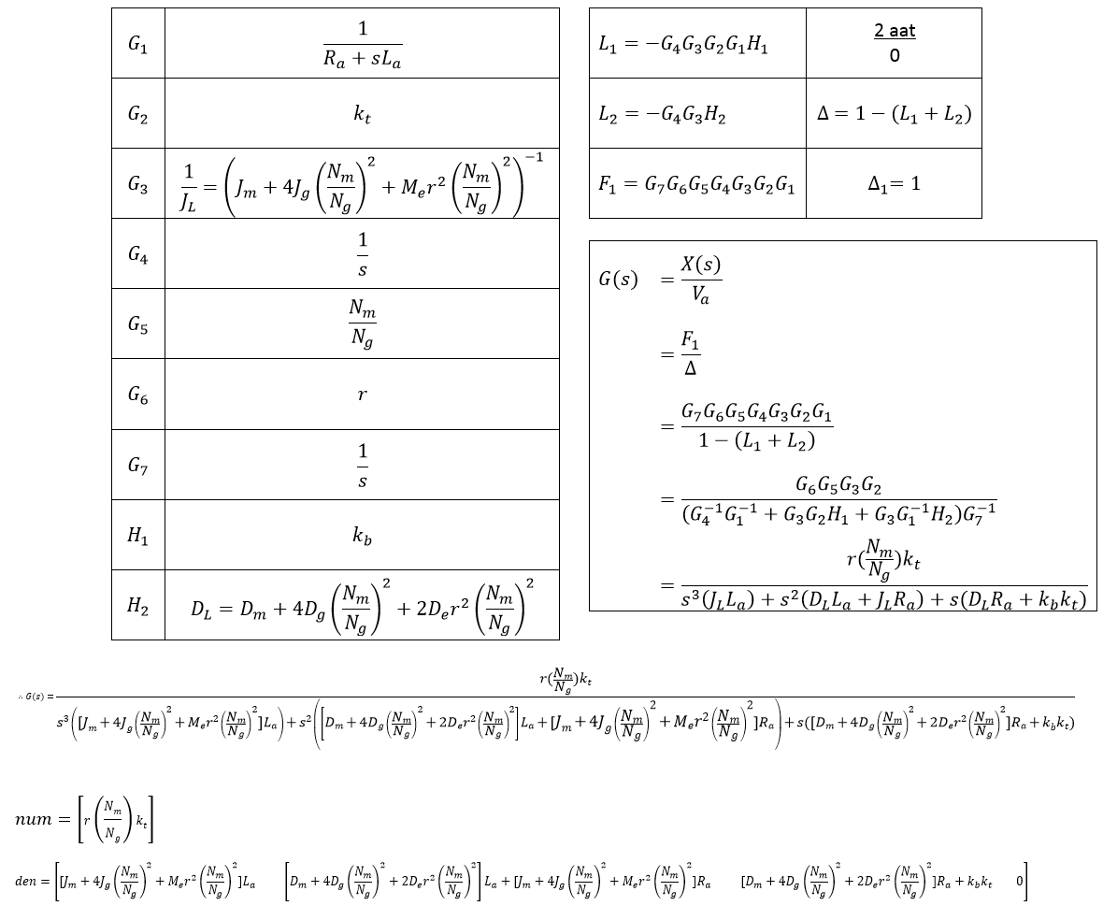

Using the values of G and H as seen from Figure (5).

### Solving for Motor constants and