eas

Twilight Zone Tower of Terror II

Group 1 (par 3)

EE 315: Linear Control System Project

|  |  |
| --- | --- |
| Author(s): Patrick Schroeder | Date Performed: 4/29/15 |
| Nathan Genetzky | Section 1: M,W,F 9-10 a.m. |
| Instructor: Dr. Hietpas |  |

# Introduction

## Objective

Starting from where part two of the project left off, functional simulations of the ideal system, now real world constraints and desired specifications must be applied. The management at Disney World wants their engineers to design an elevator that offers their customers a fun and enjoyable experience. To achieve this result, real world constraints will have to be taken into consideration, and some design specification must be set to the approval of the customers. Therefore the elevator must have a minimum height overshoot at requested by the customers, the timing must not inhibit the overall experience, so the speed, acceleration, and ride duration must be carefully selected, and physical limitation of the elevator and motor must be considered.

## Specifications

### System Constraints

Management at Disney World has given some constraints that must be adhered to; these include limitations on the motor used, the maximum height, and the speed of the elevator. The height of the elevator shaft is 61 meters; by assuming the height of the cabin is 3 meters the maximum position the elevator can be is 58 meters (the position is referenced by the bottom of the cabin). The engineers at Disney World want to avoid this elevator from being uncomfortably fast or accelerating too quickly. The maximum velocity of the elevator cabin should be 20 m/s and maximum acceleration should be 7.7 m/s^2; these values are based off the performance of CTF Financial Centre skyscraper elevator [3]. The motor drive imposes limits on the current and voltage, maximum startup current is 4050 A, and maximum voltage is 1410 V. The motor drive has a voltage range of ± 12 V, and the selected motor has a maximum torque of 9968 N∙m. Table 1 shows a summary of the constraints imposed upon this project, either from the physical limitation of the resources at hand or from the expectations of the end user, the customers.

Table : Summary of System Constraints

|  |  |  |
| --- | --- | --- |
| Item | Metric | Constraints (MKS Units) |
| 1 | Maximum elevator height | 61 m |
| 2 | Maximum elevator speed | 20 m/s |
| 3 | Maximum elevator acceleration | 7.7 m/s2 |
| 4 | Maximum startup motor drive output current | 6 X Nominal Current (In) = 4050 A* |
| 5 | Maximum motor drive output voltage | 3 X Nominal Voltage (Un) = 1410 V* |
| 6 | Motor drive input voltage (VDRV) range | -12 V <= VDRV <= + 12 V |
| 7 | Maximum Torque | N∙m |

Table : Motors that fit criteria from catalog (in bold is the motor used for calculation)



The Motor in the system must have the following constraints. The nominal supply voltage must be between 440 and 470 Vdc. The nominal speed range between 710 and 910 rpm. The nominal output power capability range between 375 and 475 HP (279.6-354.2 kW). The applicable motors found in ABB Catalog for DC motors are shown in Table 2. The proceeding analysis of this system will be using Motor #12.

### Performance Specifications

To ensure that the ride is satisfactory to the customer, the elevator must have at least a 5 m overshoot, but the elevator is 3 m tall, therefore the maximum steady state height the passengers may travel is 53 m. It has been decided that while 5 m overshoot is good a slightly higher overshoot would be better, to achieve this the engineers has decided to set the steady state height to be 50 m, which gives a possible overshoot of 8 m without the elevator exceeding maximum height. The percent overshoot will be designed to be 12% (6m). The minimum rise time should be 2.6 s, and in an attempt to ensure the customer does not become bored riding the elevator the maximum rise time has been set to 5 s and the settling time has been set to 20 s.

Table 2 shows a summary of all the desired design specifications, those were primarily chosen to satisfy the customers and improve their experience on the ride.

Table : Summary of Design Specifications

|  |  |  |
| --- | --- | --- |
| Item | Metric | Desired Performance Specifications  (MKS Units) |
| 1 | Maximum steady-state height | 50 m |
| 2 | Percent overshoot |  |
| 3 | Minimum rise time | 2.6 < Tr sec |
| 4 | Maximum rise time | Tr < 4.9 sec |
| 5 | Settling time | Ts < 20 sec |
| 6 | Steady-state error | (for a step input)  (ramp input) |

# Theory

The project was introduced with the model shown in Fig. 1, a system level diagram, which was used to create an electromechanical model that is shown in Fig 2. The system has mechanical components and electrical components that have non ideal components that are accounted for.

 Figure : Tower of Terror System Diagram

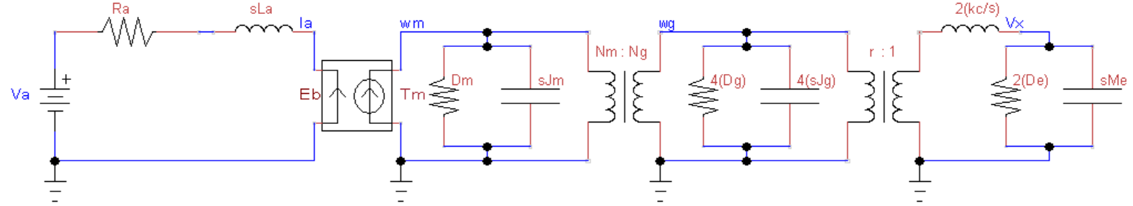

Figure : Expanded diagram of electromechanical circuit

Figure 2 is the resulting electromechanical circuit derived from the starting system level diagram, all of the components are individually shown. That circuit was then used to create a block diagram representation of the system, with the spring coefficients being infinity, which was used to analyze the system using the MGR method; the following block diagram was used to create the initial Simulink simulation model.

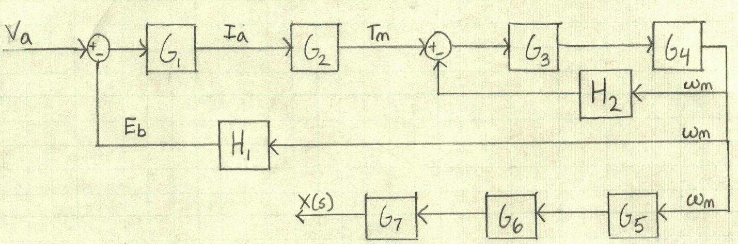

Figure 3: Block Diagram for system (hand-drawn)

### Solving for Motor constants and

Figure 3 is the original block diagram which was primarily used to solve for the system using the MGR method and was later used to create the block diagram used in Simulink which is shown in Fig. 4.

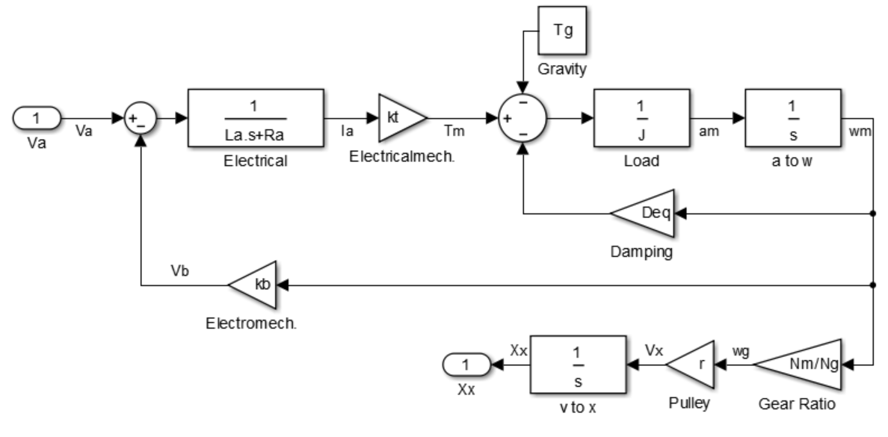

Figure : Block diagram in Simulink for system

A block diagram was created to aid in analysis of the electrical equivalent model. Figure 3 shows the Simulink diagram of the open-loop transfer function G(s), which was derived by using both standard Circuits II approaches as well as Mason’s Gain Rule. In order to determine the transfer function, , using Masons Gain Rule the loop gains () and forward gain () were determined from the block diagram shown in Fig 3; a more detailed explanation of the steps can be found in the appendix. Table 4 shows the coefficients of the numerator and denominator for in terms of the variables provided in Fig. 1 and in the format dictated by (1).

 (1)

Table : Coefficients of system’s transfer function

|  |  |
| --- | --- |
| Label | Values determined from |
|  |  |
|  |  |
|  |  |
|  |  |
|  | 0 |

Table 5: System Component specifications

|  |  |  |
| --- | --- | --- |
| Element | Value | Units |
|  | 7500 |  |
|  | 250 |  |
|  | 11 |  |
|  | 151.6 |  |
|  | 75.8 |  |
|  | 0.117 |  |
|  | 0.92 |  |
|  | 54.8 |  |
|  | 4.87 4.94 |  |
|  | 5.01 4.94 |  |
|  |  |  |
|  |  | teeth |
|  |  | teeth |
|  |  |  |

The summarized system component specifications of are shown in Table 5.

The compensator design chosen was to apply a lag compensator, since the base transfer function was much too fast. The process to find the gain and Gc(s) was the same as described in EE 315. That process was performed as follows, first the gain was determined using the required steady state error. Then the phase margin was calculated using the desired percent overshoot. The required phase found was used to determine the frequency of the pole. The value for factor ‘a’ was chosen from looking at a graph of normalized transfer functions and varying ‘a’ factors. This value of ‘a’ was then used to determine the frequency of the zero and open-loop transfer function was put in the form of . Then that transfer function (Gc) was put into series with the gain (K) and original transfer function (G(s)), all of which were turned into a closed-loop function and analyzed to see if it met all specifications.

## Design

## Original Compensator

Starting from where the project was previously completed in Part 2, the system must now account for additional parameters and variables. The first parameter that was addressed was the mass when the elevator is fully loaded, it was determined that the mass of an average person would be 62 kg and at full capacity the elevator should hold 10 people, therefore an addition mass of 620 kg must be added to the system. Once the new transfer function was determined it was time to place a gain and compensator transfer function to get the system within specifications.

The original compensator design that we develop was a lab compensator with followed the procedure laid out in EE 315. To begin one must have a target overshoot percentage and target steady state error, the percent overshoot chosen for this system is 12% and steady state error is 0.1. Using (1) through (4) these specifications are able to determine that the phase margin is 56.37° , desired error constant Kp is 10 and phase is -114.63°

(1)

(2)

(3)

(4)

Utilizing the MatLab script, EE315_LagCompDesin.m, it was determined that the actual gain of the system was 0.0083, so the required gain need to add was found using (5).

(5)

That gain K was then put into series with the original transfer function G(s) and the bode plot of KG(s) was analyzed to determine how much gain the system had at the phase of -114.63°. The gain was found to be 2.48 dB at a frequency of 7.21 rad/s, which means that the compensator need to lower the gain to 0 dB at that frequency. In order the lower the gain a pole is set at two decades before the desired frequency, so the pole location Pc was set to 0.072.Tthen a factor ‘a’ value was chosen from a plot of normalized transfer function which are in the form and have a varying ‘a’. The value of ‘a’ that most closely resulted in a gain of -2.48 dB at 7.21 rad/s, was an ‘a’ of 1.4; therefore the value of Zc was set to 0.101. Now that the full lag compensator design has been chosen, the gain K, lag compensator Gc and original transfer function G(s) are all put into series and closed in a feedback loop, then a step input was applied to the system to compare how well specifications were met. So in total the first design had a gain of 1206 [dB], pole at 0.072 [rad/s], factor ‘a’ of 1.4, and zero at 0.101 [rad/s]. Unfortunely, this system was much to fast and had a very quick rise time of 0.18 s as well as too small of an overshoot at 2.4 %, there a more iteratice approach was taken.

## Compensator using Iterative Approach

There are three factor involved in creating a lag compensator; gain K, pole location Pc, and factor ‘a’. All of these variables were put into loops that slightly changed each of the values one at a time. Then the resulting closed-loop transfer function was plotted for each scenario. After a few hundred scenarios, a few patterns were noticeable.

First, each variable contributed to the end close-loop in a specific fashion; the gain primarily dominated the speed of the system, with a higher K resulting in a lower rise time. The pole determined the time to steady state, with higher values of Pc pulling the steady state time lower. Finally the factor ‘a’ determined the percent overshoot of the system. A summary of these characteristics is illustrated in Fig. 4.

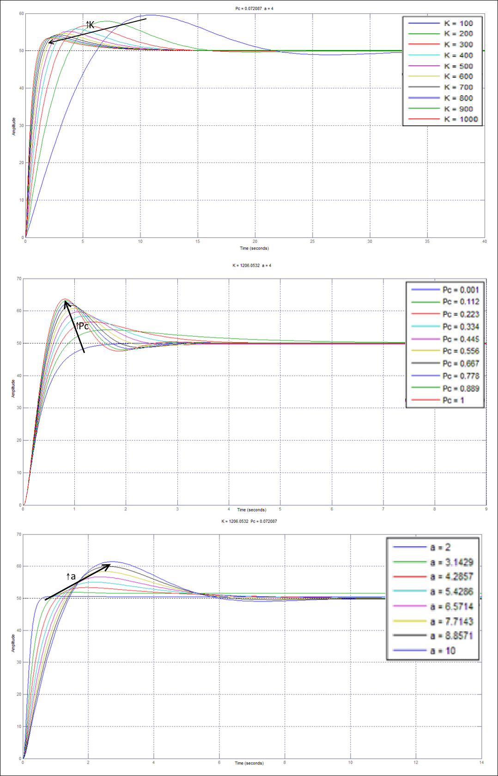

Figure : Illustrations of Characteristics Features of varying K, Pc, and 'a'

When starting the iterations, the range of K was chosen to cover as many values as possible, from 100 to ~ Kmax which was found to be about 7000 in Part Two. The values of Pc were 0.001 to one and factor ‘a’ was chosen to be from two to ten. It was immediately obvious that the value of K was much too high, therefore the K variable was divided in half. Also the value of Pc was too low and the next iteration starts at a minimum value of 0.01. A sample of plots from the maximum ranges chosen is shown in Fig. 5, these plots try to show the full scope of closed-loop transfer functions.

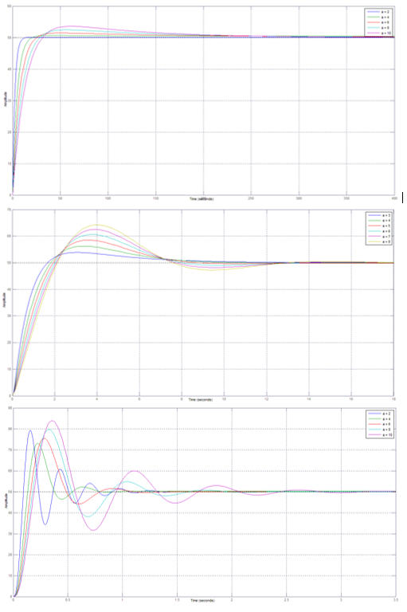

Figure : Sample plots depicting the max ranges of K, Pc and 'a'

The ranges for K and Pc were reevaluated and once again the closed-loop transfer function was analyzed. It was observed that values of K greater than 1000 made the system much too fast. Figure 6 shows another set of sample plots over the range of 100 to 3500 for K, Pc from 0.01 to one, and ‘a’ still from two to ten. Additional some possible transfer function are highlighted with a black overlay.

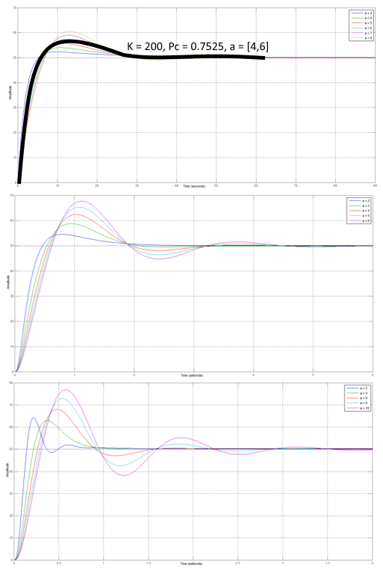

Figure : Sample plots for limited values of K, Pc and 'a'

Since K was causing the system to reach its rise time too fast, much smaller values than original were chosen ranging from 100 to only 400. All other ranges of values were left alone, Fig. 7 shows some sample plots of iterating from K of 100 to 400, Pc from 0.01 to one and ‘a’ from two to ten. On Fig. 7 a couple of individual plots are highlighted and will be used to analyze the system in greater detail than has been previously accomplished.

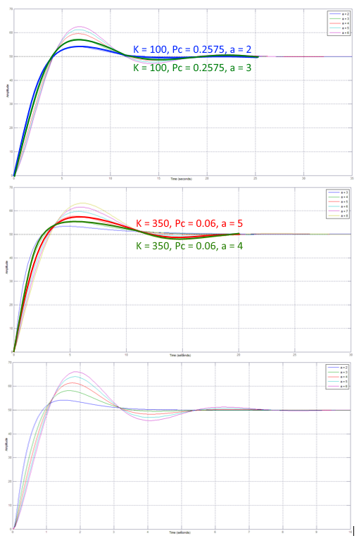

Figure : Sample plots with narrow range of value for K, Pc and 'a'

The previous values were used to create a single system that had a transfer function with a K of 225, Pc of 0.05 and ‘a’ of 4.6. Even this transfer function was still slightly out of specifications and so the value of K was changed on its own, the plots of those variations are shown and Fig. 8 and the results of analyzing versus the specifications are shown in Table 6.

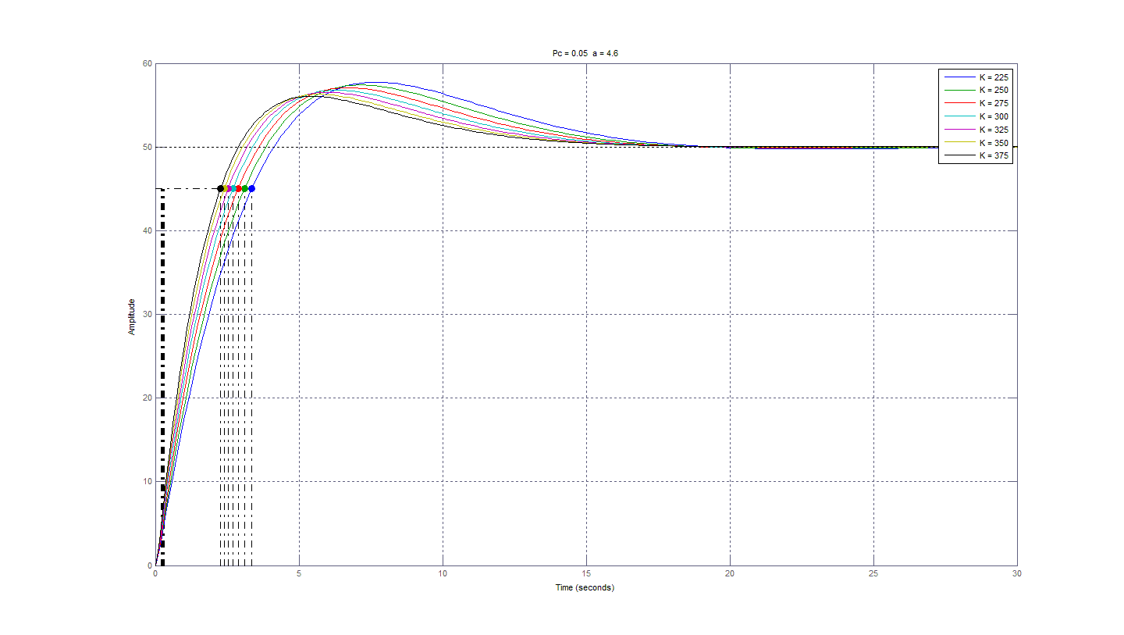

Figure : Plots of varying K to find system with specifications

Table : Result of Closed-Loop Transfer function with varying gain K, Pc = 0.05 [rad/s], and ‘a’ = 4.6

|  |  |  |  |
| --- | --- | --- | --- |
| K | Time to Rise [s] | Max Position [m] | % Overshoot [%] |
| 225 | 3.9 | 57.74 | 15.69 |
| 300 | 3.26 | 56.79 | 13.62 |
| 325 | 3.08 | 56.52 | 13.03 |
| 350 | 2.92 | 56.28 | 12.5 |
| 375 | 2.78 | 56.06 | 12.03 |

It is clear from Table 6 that the matlab system to meets all analyzed specifications was the system that had a gain K of 375, Pc located at 0.05 [rad/s] and a factor ‘a’ of 4.6.

This iterative approach was then repeated for the Simulink system. This iterative approach could largely be automated due to the knowledge gained about the effect of the parameters. The final lag compensator design has the following parameters: K=190, , a=3.89

# Results and Analysis

One of the primary questions that must be asked when simulating a real world system is: How do the non-idealities affect the simulation? The Simulink model attempts to account for some of these non-idealities. A torque source that depends on the weight of the elevator. There are also saturation blocks added into the system on signals that would be physically limited in the real world.

Saturation blocks model account for the limit on the motor drive input voltage. Putting a limiter in for current could dramatically lower the current and torque; which would be a large improvement since currents is as high as 2.2 and motor torque as high as 10.9 . The following analysis will focus on the system with a fully loaded elevator simulated in Simulink; this is so the non-ideal components are included in the final report to the customer.

## Lag Compensator Final Design

The final Lag Compensator design has the following parameters: K=190, , a=3.89. The method of finding these parameters was already mentioned above. The system that resulted from adding this compensator is compared to the design constraints, in Table 6, and specification, in Table 7, that were defined earlier.

Table : How the system response compares to the design constraints



Table : How the system response compares to the design specifications



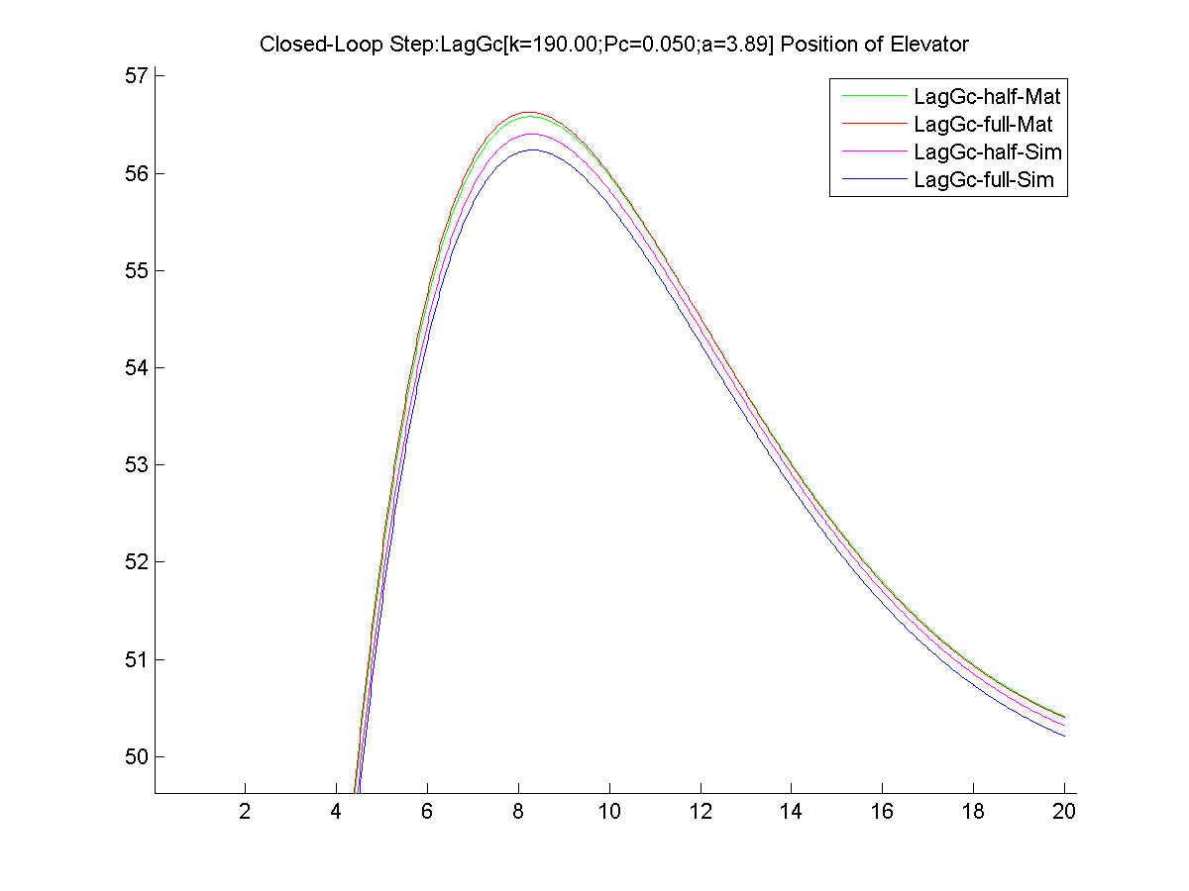

Figure : Position of the Elevator - for both Half and Full loaded elevators using both Matlab and Simulink

The first system shown will be the one that the Lag Compensator was designed for. It is the system that meets the most specs for the system. Many of these specs can be seen in the system below. The system took 4.46 seconds to reach within 2% of the steady state value, and the system reached stayed within 2% of the steady state value after 16.76 seconds. The maximum height was 56.2385 m and correlates to the 12% overshoot the system was designed for.

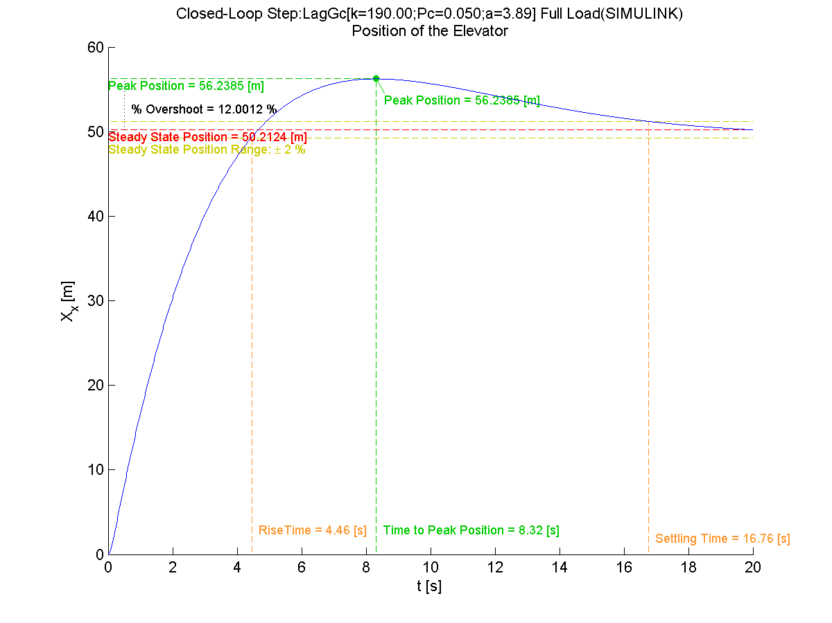

Figure : Position of the Elevator - with a fully loaded elevator in Simulink

The Bode plot shown in Fig. 11 gives an estimation of the system’s response at various inputs. The Lag compensator resembles the normalized lag compensators seen in class; however with the scale determined dominantly by G it is harder to see.

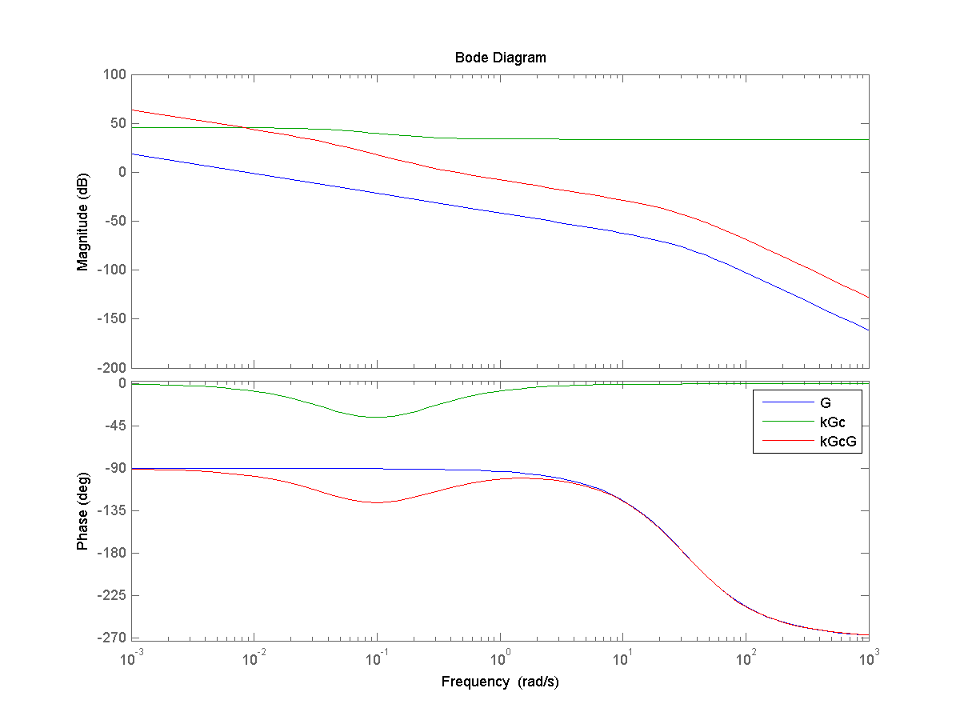

Figure Bode plot for G, kGc and kGcG

Figure 12 below shows a summary involving the motor and armature. The most disappointing of these figures are the and which contain very noticeable spikes at motor start up. The of the motor was violated but it is believed to have occurred because of an error of understanding how the gain was to be distributed. It was assumed that the K designed for the compensator was to be the gain directly provided by the motor drive. If a sufficient portion of this gain had been placed at the compensator then the saturation block before the motor drive input would have solved this issue. Alternatively some groups used a saturation block after their motor drive and this would have kept it under the maximum allowed by the spec. Figure 13 shows some of the resultant signals of the system. The velocity of the motor has a maximum of 18.5 , well under the maximum according to the design spec (20 m/s); however, the acceleration violates the design spec during the motor start up.

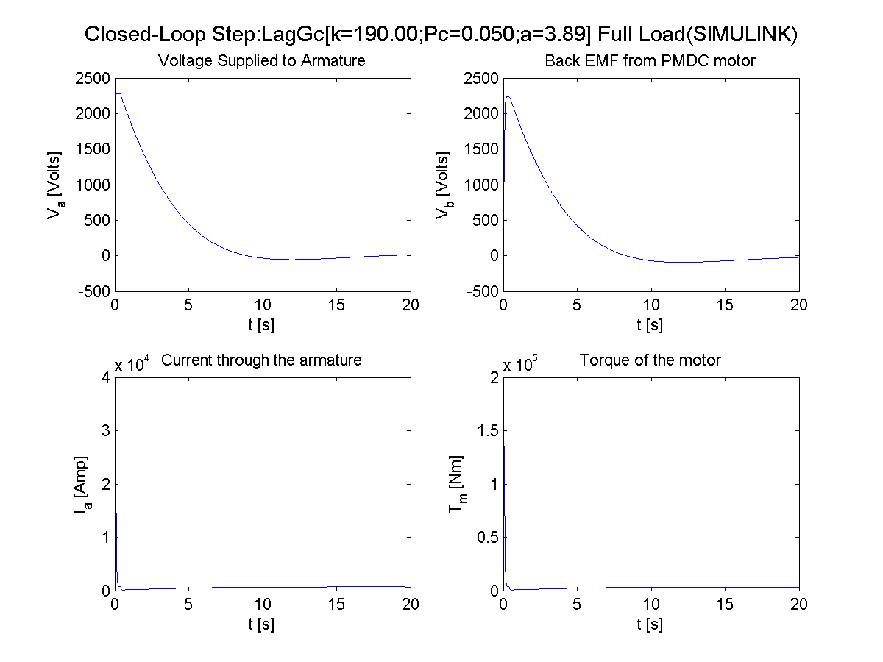

Figure 13 Various intermediate signals from the system with a fully loaded elevator in Simulink

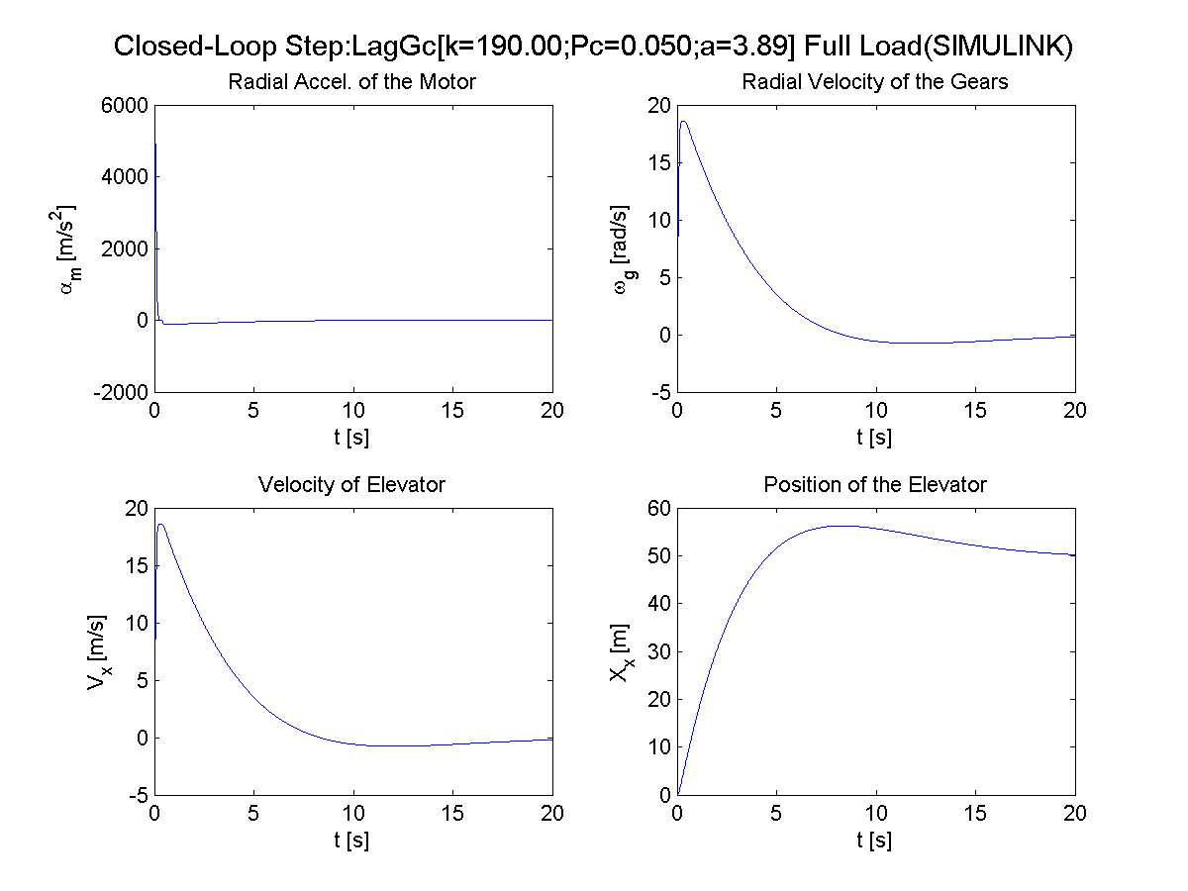

Figure Various output signals from the system with a fully loaded elevator in Simulink

# Conclusions

This portion started with some very novice mistakes; promising specifications and constraints without knowing if they were realizable. The type of compensator required for the system was also a very challenging process that would be much easier with more experience in the area. Thirdly determining if the signal was able to be controlled with saturation or if the signal would break things if they exceed their limit was very difficult without having more real world experience.

Above are mentioned many of the skills that would have been more beneficial while working on the project; however it is this project that is taking the major steps towards understanding some of the more practical things behind designing control systems.

# References

[1] ABB Catalog for DC Motors, Type DMI/ Type DMI/ Type DMI downloaded January 11, 2015.

[2] Norman S. Nise, Control Systems Engineering, 6th Ed. John Wiley & Sons, 2011 (ISBN: 0-470-54756-1)

[3] *Guangzhou CTF Finance Centre - The Skyscraper Center.*

<http://skyscrapercenter.com/building/ctf-finance-centre/176.com>., downloaded Apr. 27, 2015.

[4] *Guidelines for Writing Reports for The Electrical Engineering Program under The Department of Electrical Engineering and Computer Science Approved by EE Faculty Dec. 7, 2008,* web site: [http://www.sdstate.edu/eecs/for-students/](http://www.sdstate.edu/eecs/for-students/loader.cfm?csModule=security/getfile&PageID=774774) downloaded January 11, 2015.

# Appendix

## Hand Written Work

### Solving for Transfer function using circuits approach

Equations by reference

|  |  |
| --- | --- |
| 1. |  |
| 2. |  |
| 3. KVL |  |
| 4. KCL |  |
| 5. |  |
| 6. |  |
| 7. |  |
| 8. |  |
| 9. |  |
| 10. |  |

1 and 2 are by definition. 3 is KVL of the electrical side of motor. 4 is KCL of the mechanical side of motor. 5 is obtained by using 2 and 3 on 4. 6 is obtains by using 2 and 5 on 3. 7 is made by rearranging 6. 8 is a series of small transformations to move between signals and . 9 is created by using 9 to change in 7.

### Solving for Transfer function using Mason’s gain rule

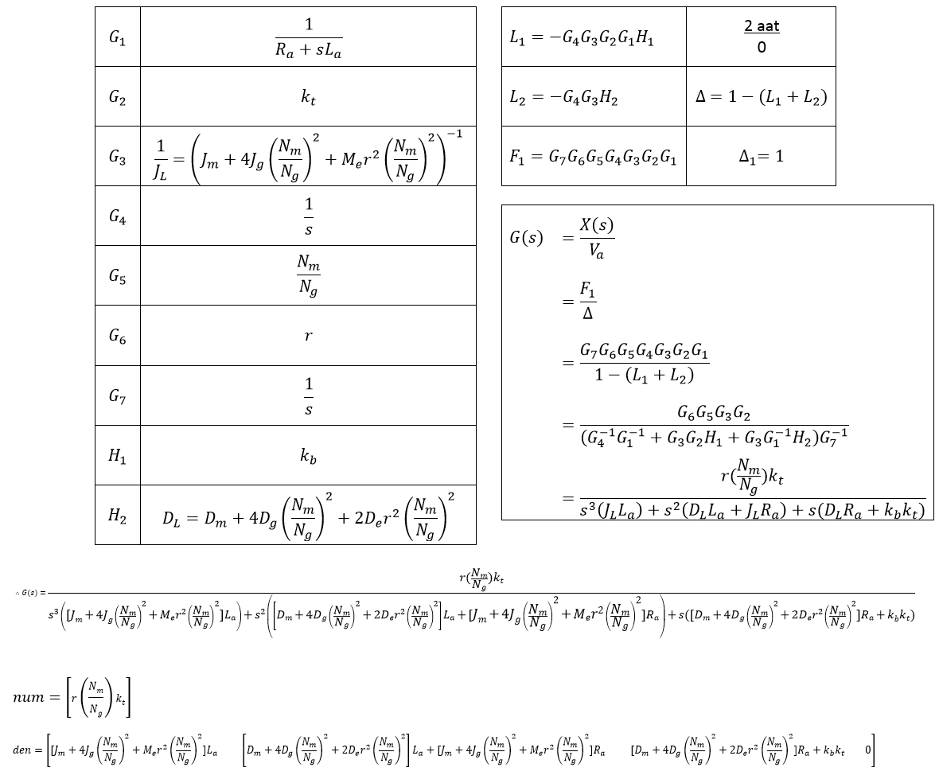

Using the values of G and H as seen from Fig. (5).

Table : Transfer Functions used in Block Diagram in Fig. 3

|  |  |  |
| --- | --- | --- |
| Simulink Name | Variable | Defined as |
| Armature_Y |  |  |
| Motor_Kt |  |  |
| Motor_J |  |  |
| Motor_a2w |  |  |
| Gear_m2g |  |  |
| Gear_w2v |  |  |
| Elevator_v2x |  |  |
| Motor_Kb |  |  |
| Motor_D |  |  |