Software Validation Plan
Table of Contents
Software Validation Plan 1
1. Introduction 2
2. Project Goal and purpose 3
3. Validation Team 4
4. Validation Scope 4
5. Validation Approach 4
5.1 Test Planning 4
5.2 Test Execution 4
5.3 Test Documentation 4
5.4 User Acceptance Testing (UAT) 5
6. Remote Control Validation 5
6.1 Objective 5
6.2 Test Cases 5
6.3 Pass Criteria 5
7. Health Reporting Validation 5
7.1 Objective 5
7.2 Test Cases 5
7.3 Pass Criteria 5
8. OTA Updates Validation 6
8.1 Objective 6
8.2 Test Cases 6
8.3 Pass Criteria 6
9. "Getting Stuck" Detection Validation 6
9.1 Objective 6
9.2 Test Cases 6
9.3 Pass Criteria 6
10. Conclusion 6

1. Introduction
This Software Validation Plan outlines the approach, scope, and activities for validating the software component of the [Project Name]. The primary objective is to ensure that the software meets the specified functional requirements and operates reliably. Particular focus is given to the validation of remote control via a mobile app.

2. Project Goal and purpose

2.1 Software Description

Block Diagram

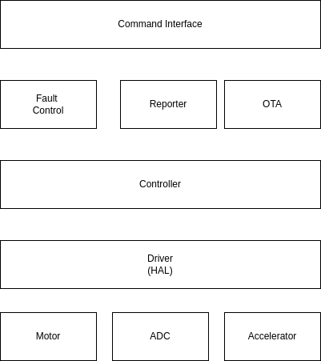

OTA Block

3. Validation Team
The validation team consists of individuals responsible for planning, executing, and documenting the validation activities. The team includes:
- Project Manager: Responsible for overall project coordination.
- Software Developer: Responsible for software testing and validation.
- Quality Assurance Engineer: Responsible for reviewing validation processes and results.
- User Representative: Represents the end-users' perspective during validation.

4. Validation Scope
The validation scope includes the following components of the [Project Name]'s software:
- Remote Control Functionality: Validation of the remote control feature, including the mobile app interface, robot commands, and real-time video feedback.
- Health Reporting: Validation of the system's ability to report health parameters such as battery status, sensor status, system temperature, and connectivity status.
- Over-the-Air (OTA) Updates: Validation of the OTA update functionality, including security, reliability, and user notification.
- Detection of "Getting Stuck": Validation of the system's capability to detect and respond to "getting stuck" scenarios effectively.

5. Validation Approach
The validation approach consists of the following key activities:

5.1 Test Planning
- Define specific test cases and scenarios for each functional requirement identified in the Functional Requirement Specification (FRS).

5.2 Test Execution
- Perform the defined test cases and scenarios on the software to evaluate its compliance with the FRS.

5.3 Test Documentation
- Record detailed test results, including pass/fail outcomes, observations, and any issues encountered during testing.

5.4 User Acceptance Testing (UAT)
- Involve end-users in the validation process to ensure that the software meets their expectations and usability requirements.

6. Remote Control Validation

6.1 Objective
To validate the remote control functionality of the software, including user commands, robot movements, and real-time video feedback through a mobile app.

6.2 Test Cases
- Verify the mobile app's ability to establish a secure connection with the robot.
- Test the responsiveness of the mobile app's user interface.
- Execute various remote control commands (e.g., move forward, backward, left, right, start, stop, emergency stop) and ensure the robot responds accurately.
- Validate real-time video feedback for clarity and minimal latency.
- Test the mobile app's error-handling capabilities when connectivity issues arise.
- Evaluate the ease of use and intuitiveness of the mobile app interface through User Acceptance Testing (UAT).

6.3 Pass Criteria
- The mobile app successfully establishes a secure connection with the robot.
- Remote control commands are executed accurately, and the robot responds as expected.
- Real-time video feedback is clear with minimal latency.
- The mobile app handles connectivity issues gracefully.
- End-users find the mobile app interface intuitive and user-friendly during UAT.

7. Health Reporting Validation

7.1 Objective
To validate the system's ability to report health parameters, including battery status, sensor status, system temperature, and connectivity status.

7.2 Test Cases
[Define specific test cases for health reporting validation.]

7.3 Pass Criteria
[Specify the pass criteria for health reporting validation.]

8. OTA Updates Validation

8.1 Objective
To validate the OTA update functionality, including security, reliability, and user notification.

8.2 Test Cases
[Define specific test cases for OTA updates validation.]

8.3 Pass Criteria
[Specify the pass criteria for OTA updates validation.]

9. "Getting Stuck" Detection Validation

9.1 Objective
To test the system's ability to detect and respond to "getting stuck" scenarios effectively.

9.2 Test Cases
[Define specific test cases for "getting stuck" detection validation.]

9.3 Pass Criteria
[Specify the pass criteria for "getting stuck" detection validation.]

10. Conclusion
This Software Validation Plan outlines the validation approach, scope, and activities for ensuring the software's compliance with functional requirements. By focusing on remote control via a mobile app and other critical functionalities, we aim to provide a robust and reliable [Project Name] that meets user expectations and requirements.
[Signature]
[Project Manager] - [Date]

