PROJECT REPORT
LIBGRAM
LIBRARY MANAGEMENT SYSTEM
A Java 21 Desktop Application using Swing and CSV-Based Persistence
course
[ MASTER OF COMPUTER APPLICATION ]
Submitted by:
Yeshwant Shetgaonkar Roll No. 2661
Yash Gaonkar Roll No. 2660
Under the guidance of:
[Sir Hanumant Redkar]
Submitted To
Goa Business School - Goa University, Taleigao, Goa

TABLE OF CONTENTS
.

Field | Details
Project title | LibGram — Library Management System
Student name(s) | [Full names]
Roll number(s) | [Roll numbers]
Programme / semester | [Course, year, semester]
Department | [Department]
Institution / affiliation | [College and university]
Project guide
Submission date | [28 october 2026

Certificate
This is to certify that the project report entitled “LibGram — Library Management System” is submitted by [Student Name(s)] bearing roll number(s) [Roll Number(s)] of [Programme / Department], [Institution Name], in partial fulfilment of the academic requirements for [Course / Degree].
The report describes the analysis, design, implementation, and testing of a Java desktop application. Complete the signatures, dates, and institutional seal according to the college format.
Role | Name / Signature | Date
Project Guide | ________________ | ________
Head of Department | ________________ | ________
Examiner, if required | ________________ | ________

Abstract

LibGram is a desktop Library Management System implemented using Java 21 and Swing. It supports book and member catalogues, lending and returns, reservations, charges, payments, notifications, and settings.
The project uses a layered design: Swing UI components call services; services implement business rules; repository interfaces isolate data access; CSV-backed repositories persist records; and model classes represent domain entities. The application includes documented safeguards such as atomic file replacement, backups and recovery, single-instance locking, logging, salted password hashes, and a plain-JDK regression suite.
This report covers requirements, design, development phases, implementation, testing, limitations, and future enhancements. Screenshots of the actual running product and verified test output must be added to complete the evidence.

1. Introduction
LibGram brings common library workflows into a single desktop application. It is built on Java 21 application with Swing UI panels, services, repository interfaces, CSV implementations, domain models, tests, and packaging scripts.
This app is mainly built to help the rural libraries digitize their catalog and maintain the necessary records in one place. The rural libraries in goa lack the huge budget to implement the other software that are available in the market. Also these software are designed for medium to large scale and are specifically made for libraries with well organized and categorized books and provide little to no wiggle room while inserting/editing these records. This is why we came up with Libgram which lets these libraries get a affordable, compatible and compact software which meet their regular needs. LibGram is small software (within 10 mb with 2000+ books registered). It is specifically designed to run on a small computing device and to handle libraries with around 2000-5000 books (Can hold more but tested for only upto 5000 books).
LibGramPocket is the software for individuals designed on the same base architecture as LibGram.
Individuals who wish to lend their books to someone or borrow someone’s books can Use LibGramPocket to maintain catalog and records of loans/borrows in one place. The future versions are expected to have a online market place where people can exchange these books with a wider community reach).

2. Background and Motivation
Libraries manage books, members, loans, due dates, reservations, charges, and payments. These records are related, so a change in one workflow may affect several others. We have noticed that many rural libraries in Goa are still keeping their records in old physical registers which isn’t very safe and there are many chances for error and/or unwanted manipulation of records. The most viable option for this problem to use a library management system software. But neither the cost of nor the functionality of the existing options was feasible for these small libraries. This is where the need for a small scale, affordable solution was seen by us.
A desktop system can reduce repetitive data entry and make related records easier to find. The trade-off is that local file storage is simpler to deploy but less suited to multi-computer collaboration than a server-backed system.
- Evidence to attach: source-code reference, test output, screenshot, or team record appropriate to this section.
- Verification note: distinguish implemented behaviour from a proposal or an unverified assumption.

3. Problem Statement
Manual registers or disconnected files can make it difficult to confirm availability, check member eligibility, trace a transaction, calculate charges consistently, or recover from damaged data.
LibGram addresses these concerns with catalogue and member management, circulation workflows, billing-related modules, notifications, and defensive CSV persistence. It does not claim to solve every large-library or multi-branch requirement.
- Evidence to attach: source-code reference, test output, screenshot, or team record appropriate to this section.
- Verification note: distinguish implemented behaviour from a proposal or an unverified assumption.

4. Objectives
The main objective is to provide a working desktop application for common library administration. Another objective is to separate interface code, business rules, storage, and domain entities so that the application is easier to test and maintain.
Reliability and security objectives include atomic file replacement, backups, recovery handling, logs, permission checks, and password hashing. Regression tests are included for important workflows and boundary cases.
- Evidence to attach: source-code reference, test output, screenshot, or team record appropriate to this section.
- Verification note: distinguish implemented behaviour from a proposal or an unverified assumption.

5. Scope
The README states that phases one through nine are implemented and describes recovery-aware CSV storage, rolling backups, single-instance locking, central logs, packaging, demo data, and a plain-JDK regression suite.
The confirmed scope includes catalogues, members, lending, returns, reservations, charges, payments, notifications, authentication, and settings. An installer and administrator export/import wizard are listed as future ideas.
- Evidence to attach: source-code reference, test output, screenshot, or team record appropriate to this section.
- Verification note: distinguish implemented behaviour from a proposal or an unverified assumption.

6. Existing System Analysis
A typical small-library process may rely on paper registers, spreadsheets, or separate files. These methods are familiar but can require repeated updates and manual cross-checking.
This is a general problem context, not a measured audit of a particular library. Add genuine interview notes, observations, or survey results if the team collected them.
- Evidence to attach: source-code reference, test output, screenshot, or team record appropriate to this section.
- Verification note: distinguish implemented behaviour from a proposal or an unverified assumption.

7. Proposed System
LibGram uses a Swing interface over a service layer. Services validate workflows and coordinate repository operations. CSV repositories isolate file access, while model classes represent books, members, loans, reservations, charges, payments, notifications, users, and settings.
The README documents first-launch administrator setup, salted PBKDF2 password hashes, an eight-character minimum password length, and a storage-folder lock.
- Evidence to attach: source-code reference, test output, screenshot, or team record appropriate to this section.
- Verification note: distinguish implemented behaviour from a proposal or an unverified assumption.

8. Stakeholders and Roles
The primary stakeholder is library staff who perform catalogue and circulation tasks. An administrator may also manage account setup, settings, backup, and recovery. Maintainers and evaluators are secondary stakeholders.
The project contains a User role type and PermissionPolicy service. Confirm exact role names and permissions from the code before documenting them as final requirements.
- Evidence to attach: source-code reference, test output, screenshot, or team record appropriate to this section.
- Verification note: distinguish implemented behaviour from a proposal or an unverified assumption.

9. Functional Requirements
The system must support authentication, book management, member management, lending, returns, reservations, charge calculation, payment records, notifications, and settings. Search and filtering help staff locate records.
The service layer should validate required data, duplicate records, member eligibility, borrowing restrictions, and transaction consistency. Treat this list as a baseline and reconcile it with the final specification.
- Evidence to attach: source-code reference, test output, screenshot, or team record appropriate to this section.
- Verification note: distinguish implemented behaviour from a proposal or an unverified assumption.

10. Non-Functional Requirements
The architecture supports maintainability and testability by separating UI, services, repositories, and models. Atomic writes, backups, recovery, and logs contribute to reliability. Password hashing and permission checks contribute to security.
The README documents a performance smoke test for 10,000 books, 2,000 members, 20,000 loans, and 30,000 charges. These are test dataset sizes, not a universal speed guarantee.
- Evidence to attach: source-code reference, test output, screenshot, or team record appropriate to this section.
- Verification note: distinguish implemented behaviour from a proposal or an unverified assumption.

11. Feasibility Study
Technical feasibility is supported by Java 21, standard Swing, and plain-JDK tests. The project provides Windows and Linux/macOS build scripts. Economic feasibility is favourable for a local academic project because it does not require a separate database server.
Operational suitability depends on the intended library size, user training, and whether single-machine file storage is acceptable. Add actual milestone dates for schedule feasibility.
- Evidence to attach: source-code reference, test output, screenshot, or team record appropriate to this section.
- Verification note: distinguish implemented behaviour from a proposal or an unverified assumption.

12. Brainstorming and Idea Generation

Brainstorming and Idea Generation
During the development of LibGram, different ideas were incorporated to create a complete library management application. The main ideas focused on simplifying book and member management, automating lending and return operations, and improving data security.
- Library Operations: Book catalog, member registration, lending, returns, and reservation management.
- Billing System: Automatic charge calculation, dues tracking, and payment recording.
- Notifications: Alerts for loans, returns, reservations, and billing activities.
- Security: Login authentication, role-based permissions, and password protection.
- Data Reliability: CSV-based storage, automatic backups, recovery mechanisms, and application logs.
- User Interface: A Java Swing desktop interface with separate screens for different library functions.
- Testing: Automated test cases to verify functionality, permissions, data handling, and recovery.

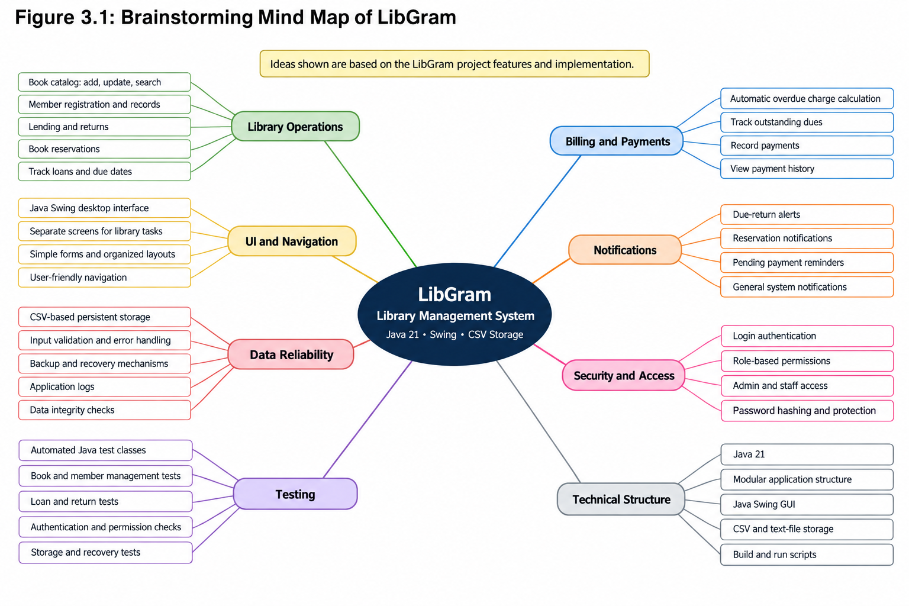

13. Accepted and Rejected Ideas

During the development of LibGram, different approaches were considered to determine the most suitable features and technologies for the library management system.
Accepted Ideas
Idea | Reason for acceptance
Java Swing desktop application | Provides a graphical interface for library operations.
CSV and text-file storage | Enables local data storage without requiring a separate database server.
Book and member management | Supports organizing library records.
Lending, returns, and reservations | Helps manage book circulation.
Billing and payment tracking | Supports overdue charges and payment records.
Authentication and role-based access | Helps protect the application from unauthorized access.
Backup and recovery | Helps protect stored data.
Automated testing | Helps verify application functionality and reliability.
Rejected or Not Selected Ideas
Idea | Reason for not selecting
Web-based application | A desktop application was chosen for the project's implementation scope.
Cloud-based data storage | Local file storage was more suitable for the intended setup.
Separate database server | CSV and text files avoided additional database configuration.
Manual record maintenance | Would not provide the automation required by the system.
Command-line-only interface | A graphical interface was preferred for ease of use.

14. Development Methodology

LibGram was developed using an iterative and modular development approach. The application was divided into separate modules for book management, member management, lending, returns, reservations, billing, notifications, and security. Each module was implemented and tested to ensure that its functionality worked correctly.
The development process involved the following stages:
- Requirement Analysis: Identifying the functional requirements and features of the library management system.
- System Design: Planning the application structure, user interface, data models, and storage mechanisms.
- Implementation: Developing the application using Java 21 and Java Swing, with CSV and text files for data storage.
- Testing: Using automated Java test classes to verify functionality, authentication, permissions, and data handling.
- Debugging: Identifying and correcting errors to improve application reliability.
- Integration: Combining the individual modules into a complete library management application.

15. System Architecture
The source packages follow a layered structure: ui → services → data → model, with CSV files behind repository implementations. The service layer is intended to depend on interfaces rather than concrete file implementations.
Insert or redraw a formal architecture diagram showing the UI, service layer, repository interfaces, CSV implementations, model classes, and storage directory.
- Evidence to attach: source-code reference, test output, screenshot, or team record appropriate to this section.
- Verification note: distinguish implemented behaviour from a proposal or an unverified assumption.
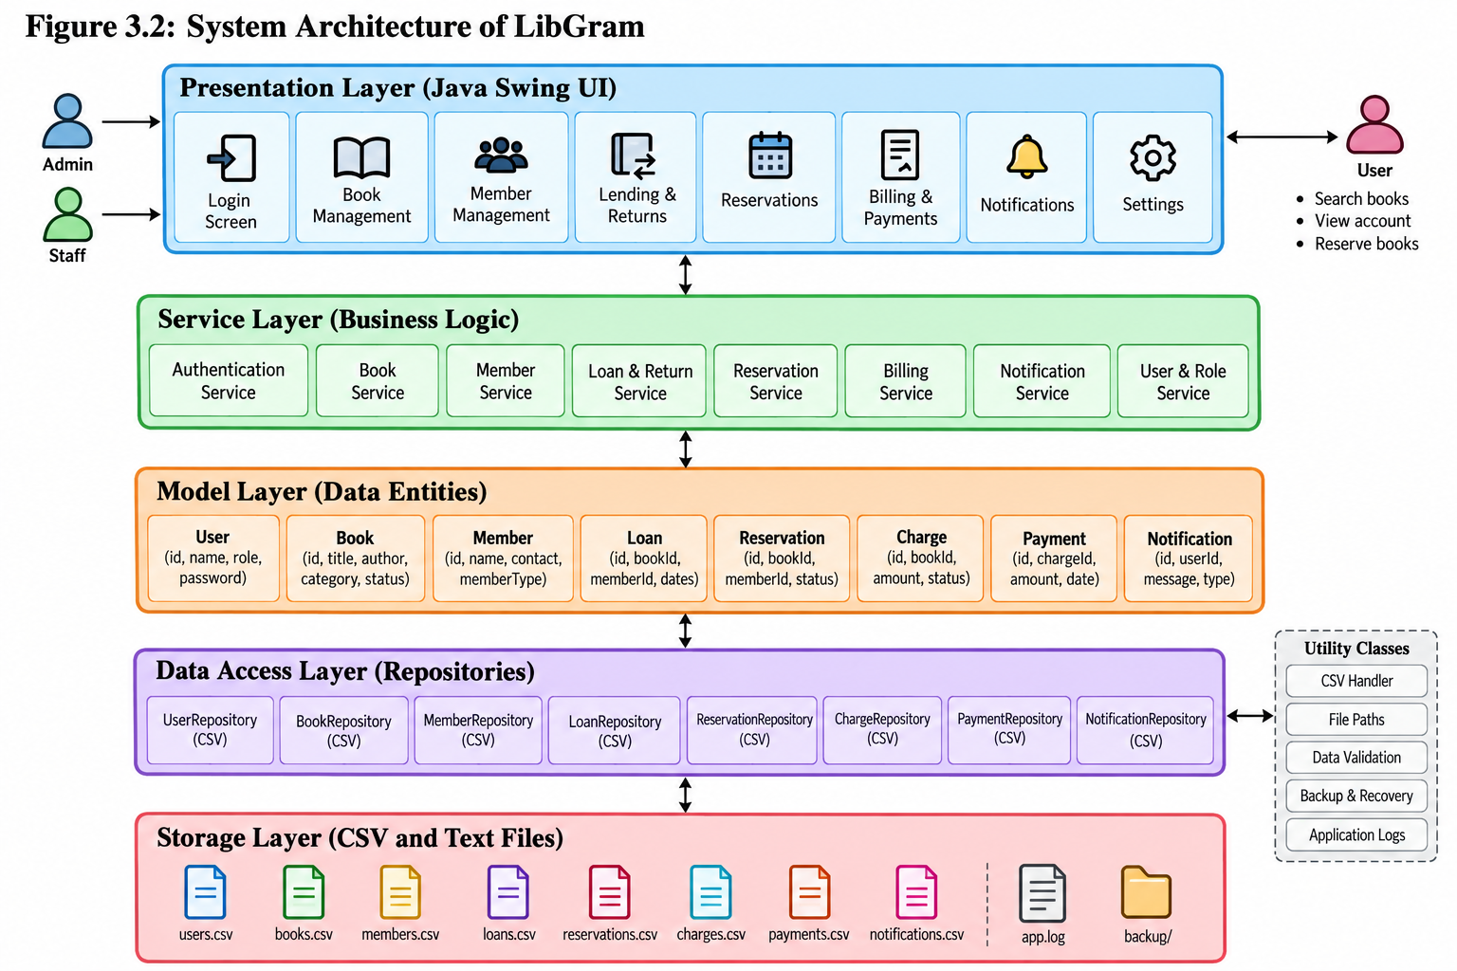

16. Use-Case Diagram
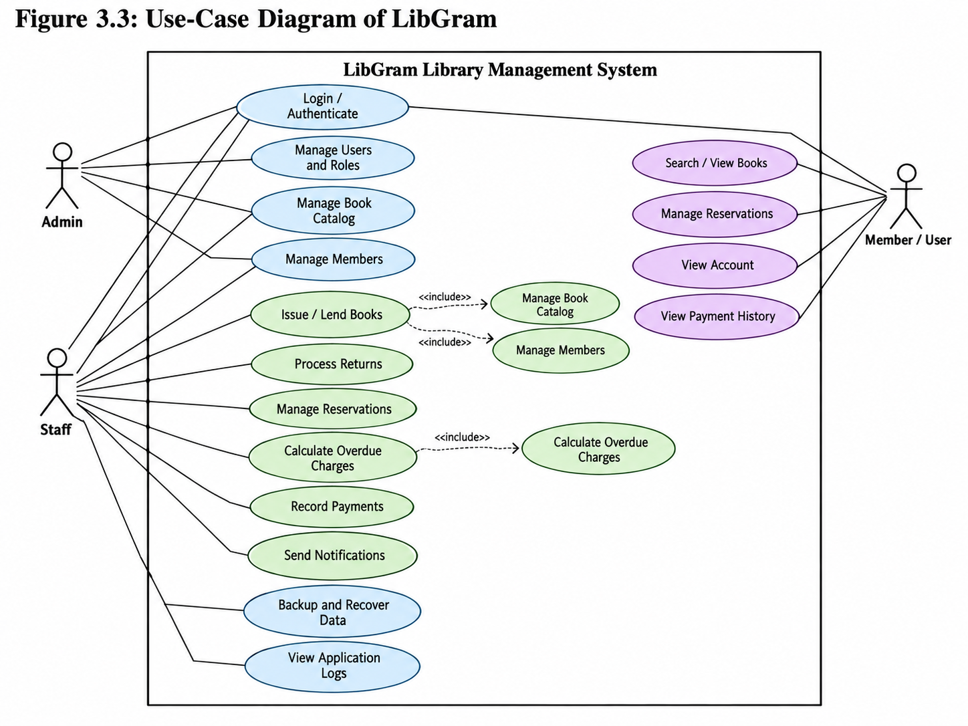

17. Activity Diagram: Lending
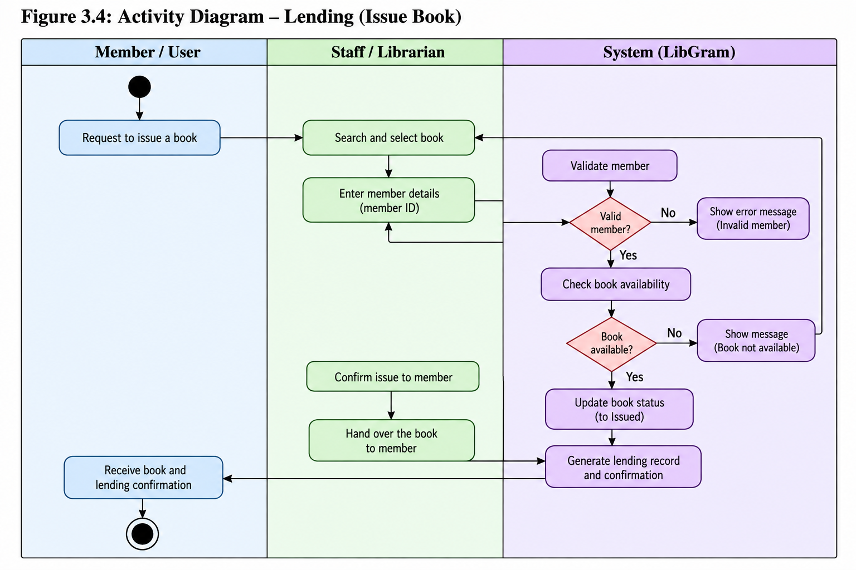

18. Sequence Diagram: Lending
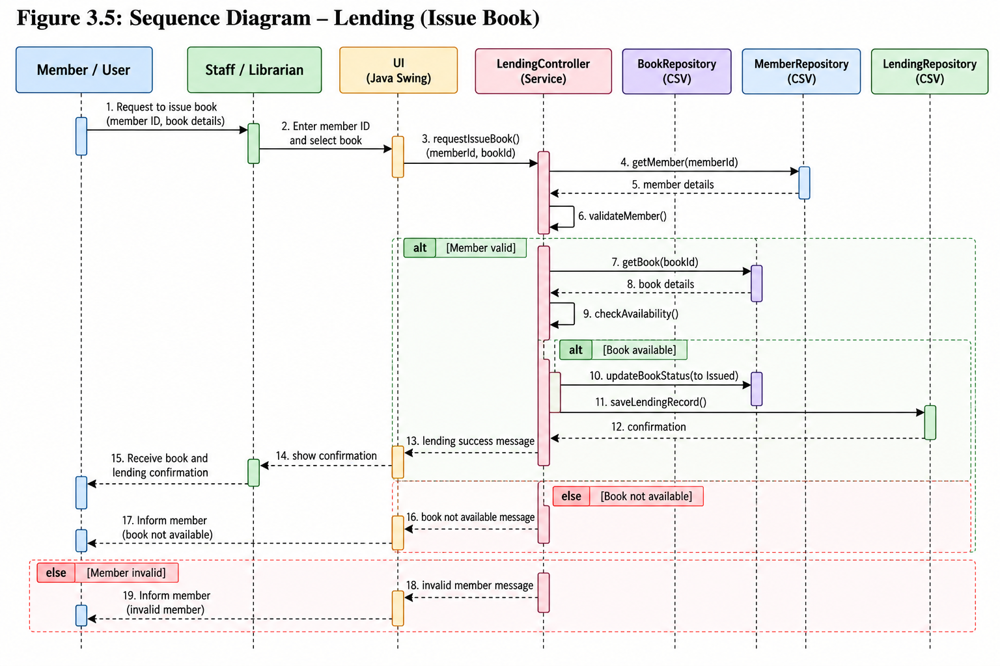

19. Data-Flow Diagram
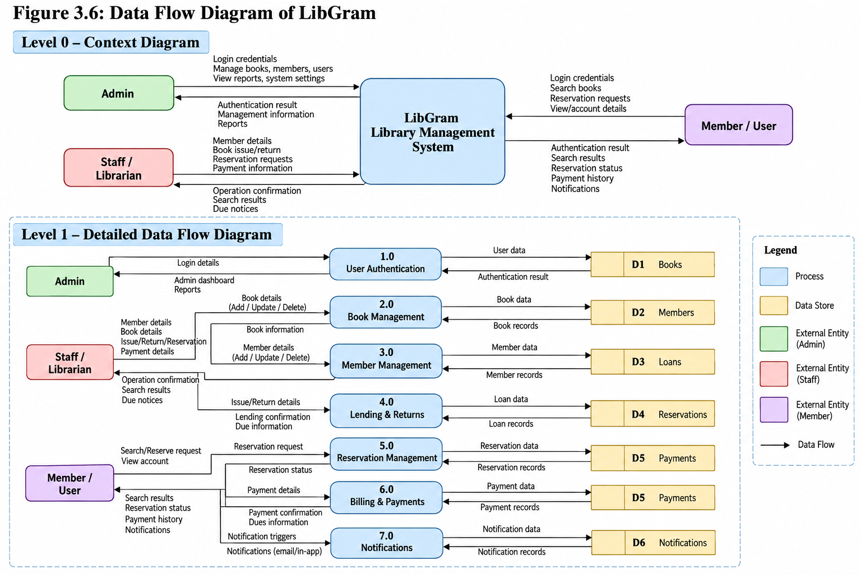

20. Conceptual Class Diagram
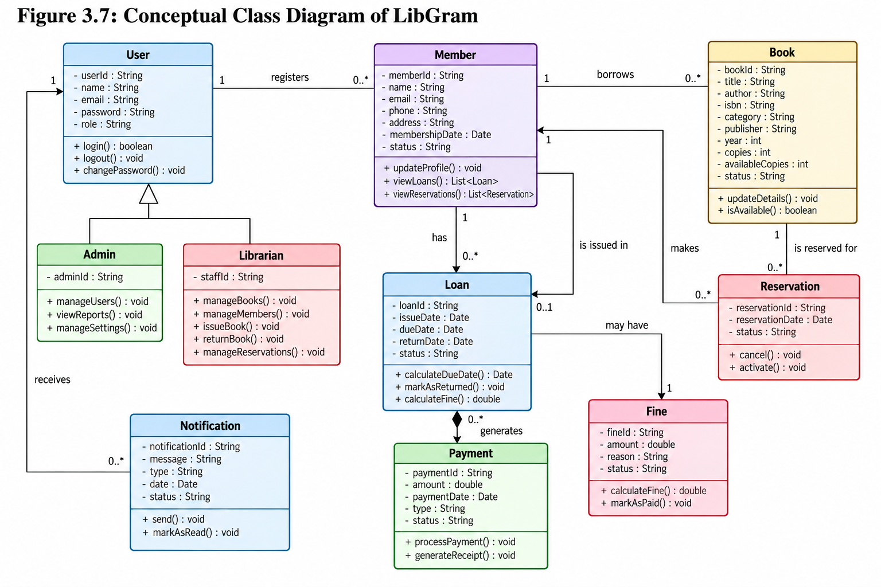

21. Data Model and File Inventory
1. Data Model
LibGram uses a file-based data model to store and manage library information. The application is developed in Java and uses model classes to represent library entities, repository classes to handle data storage, and service classes to implement business rules.
The main data entities are:
Entity | Purpose
User | Stores user account and role information.
Book | Maintains book details and availability.
Member | Stores library member information and membership status.
Loan | Records book lending, due dates, and returns.
Reservation | Manages book reservations.
Charge | Stores charges and their status or type.
Payment | Maintains payment details and methods.
Notification | Stores alerts and notification information.
Settings | Maintains application configuration.
2. File Inventory
The LibGram project is organized into the following directories and files.
Directory / File | Description
src/model/ | Contains data models and related enumerations.
src/services/ | Implements authentication, lending, billing, reservations, and other business operations.
src/data/ | Contains repositories, file-handling utilities, storage paths, and logging.
src/ui/ | Contains Java Swing screens, panels, and dialogs.
storage/books.txt | Stores book records.
storage/members.txt | Stores member records.
storage/users.txt | Stores user account records.
storage/loans.txt | Stores lending and return records.
storage/reservations.txt | Stores reservation records.
storage/charges.txt | Stores charge information.
storage/payments.txt | Stores payment records.
storage/notifications.txt | Stores notification records.
storage/settings.txt | Stores application settings.
storage/backups/ | Contains dated backup files.
storage/logs/ | Contains application log files.
test/ | Contains automated Java test classes and test scripts.
build.bat, build.sh | Build scripts for Windows and Unix-like systems.
run.bat, run.sh | Scripts to launch the application.
LibGram.jar | Packaged Java application.
3. Data Storage and Management
LibGram uses text files for persistent local storage, with repository classes responsible for reading and writing records. For example, CsvBookRepository.java handles book persistence, while CsvLoanRepository.java handles loan records. Utilities such as CsvUtil.java, StoragePaths.java, and StorageLock.java support file processing, storage locations, and storage coordination.

22. Book Catalogue Module

The Book Catalogue Module is a core component of LibGram that manages the library's book collection. It allows authorized users to add, update, search, and maintain book records. Each record contains relevant information such as the book ID, title, author, ISBN, category, publisher, publication year, and availability status.
The module helps staff locate books quickly, maintain accurate catalogue information, and check availability before issuing or reserving a book. It works with the application's data storage and lending functionality to keep book records organized and up to date.
Key functionalities:
- Add new books and update existing book details.
- Search and view books in the catalogue.
- Maintain book identification and classification details.
- Track book availability and status.
- Support lending and reservation operations through book records.
The module improves the organization of library resources, reduces manual record-keeping, and makes book information easier to access.

23. Member Management Module
MemberCatalogPanel, MemberFormDialog, MemberDetailPanel, and MemberSearchPanel support member-facing screens. MemberService and MembershipService handle operations and membership-related rules.
DuplicateMemberEmailException and DuplicateMemberPhoneException indicate explicit handling for duplicate contact information. Capture the member list, form, detail view, and search behaviour.
- Evidence to attach: source-code reference, test output, screenshot, or team record appropriate to this section.
- Verification note: distinguish implemented behaviour from a proposal or an unverified assumption.

24. Lending and Return Module
The source includes LendingPanel, ActiveLoansPanel, LendingService, ReturnService, LoanRules, and event-listener classes. These separate circulation rules from the interface and allow changes to trigger related workflows.
Test successful issue and return, unavailable books, invalid members, borrowing-limit boundaries, and storage failures. Verify exact eligibility rules from LoanRules and service implementations.
- Evidence to attach: source-code reference, test output, screenshot, or team record appropriate to this section.
- Verification note: distinguish implemented behaviour from a proposal or an unverified assumption.

25. Reservations Module
The README states that reservations can be created from the lending screen or Reservations screen using selectable members and books. The Reservations screen supports Ready, Pending, and Closed filters and member/book search.
Test creation, status filtering, member search, book search, and transitions supported by the final implementation. Add screenshots of the reservation list and filters.
- Evidence to attach: source-code reference, test output, screenshot, or team record appropriate to this section.
- Verification note: distinguish implemented behaviour from a proposal or an unverified assumption.

26. Charges and Billing
Charge, ChargeType, ChargeStatus, ChargeCalculator, and ChargeService implement billing-related concepts. A dedicated calculator supports deterministic testing outside the UI and file system.
The project guidance recommends BigDecimal or integer paise rather than floating-point money. Use exact rates and expected values from the source and tests; do not invent financial rules.
- Evidence to attach: source-code reference, test output, screenshot, or team record appropriate to this section.
- Verification note: distinguish implemented behaviour from a proposal or an unverified assumption.

27. Payments and Dues
Payment and PaymentMethod represent payment records. PaymentService and repositories handle operations, while dues panels expose outstanding amounts.
Test amount validation, payment method handling, and balance updates. Use fake member data and capture the dues and payment screens.
- Evidence to attach: source-code reference, test output, screenshot, or team record appropriate to this section.
- Verification note: distinguish implemented behaviour from a proposal or an unverified assumption.

28. Notifications and Events
The source includes Notification, NotificationType, NotificationSeverity, NotificationContext, NotificationService, and event listeners for several business workflows.
The README notes that notification View actions switch to the related menu before opening the referenced screen. Test alert content, severity, and navigation.
- Evidence to attach: source-code reference, test output, screenshot, or team record appropriate to this section.
- Verification note: distinguish implemented behaviour from a proposal or an unverified assumption.

29. Authentication and Authorization
LoginPanel, AuthService, AccountService, User, and PermissionPolicy support authentication and permissions. The README says first launch asks for an administrator account and passwords must be at least eight characters.
The documented design uses salted PBKDF2 hashes. Test correct and incorrect credentials, password validation, and restricted operations at both UI and service layers.
- Evidence to attach: source-code reference, test output, screenshot, or team record appropriate to this section.
- Verification note: distinguish implemented behaviour from a proposal or an unverified assumption.

30. Settings and Configuration
Settings, SettingsDialog, SettingsService, SettingsDefaults, and SettingsChangedListener represent configuration separately from the UI.
Document each visible setting, default, allowed range, and affected workflow after checking the code. Missing settings should use documented defaults.
- Evidence to attach: source-code reference, test output, screenshot, or team record appropriate to this section.
- Verification note: distinguish implemented behaviour from a proposal or an unverified assumption.

31. CSV Persistence
CSV repositories isolate file access. The project guidance specifies UTF-8, headers, correct quoting, a shared CsvUtil, defensive parsing, and loading records before writing changes.
Atomic writes use a temporary file and replacement to reduce partial-write risk. Test commas, quotation marks, line breaks, malformed rows, missing columns, and write failures.
- Evidence to attach: source-code reference, test output, screenshot, or team record appropriate to this section.
- Verification note: distinguish implemented behaviour from a proposal or an unverified assumption.

32. Backup, Recovery, and Single-Instance Lock
The README says the five newest daily backups are retained per data file. An unreadable CSV first attempts an adjacent backup; if recovery fails, the corrupt file is preserved with a timestamped suffix and that file's dataset starts empty.
A storage-folder lock prevents a second LibGram process from using the same folder. Test recovery only with disposable copies, never with the only copy of important data.
- Evidence to attach: source-code reference, test output, screenshot, or team record appropriate to this section.
- Verification note: distinguish implemented behaviour from a proposal or an unverified assumption.

33. Logging and Error Handling
AppLog and the logs directory provide centralised diagnostics. The project guidance recommends specific domain exceptions, user-friendly UI messages, and technical details in logs.
Never log passwords or password hashes. Test validation errors, malformed data, failed file access, and persistence failures, and verify that the UI remains usable.
- Evidence to attach: source-code reference, test output, screenshot, or team record appropriate to this section.
- Verification note: distinguish implemented behaviour from a proposal or an unverified assumption.

34. User Interface Design
The UI package contains a main window, panels, and dialogs. Theme, TitleBar, MenuSection, and ProportionalLayout support consistency and navigation.
The project guidance recommends layout managers, Swing's Event Dispatch Thread, readable empty states, keyboard navigation, sufficient contrast, accessible labels, and resize testing.
- Evidence to attach: source-code reference, test output, screenshot, or team record appropriate to this section.
- Verification note: distinguish implemented behaviour from a proposal or an unverified assumption.

35. Implementation Structure
Main.java is the entry point. Source packages are split into model, services, data, and UI. Build scripts compile the application, run tests, and create a JAR with Main as its entry point.
Use a clean build for final evidence rather than relying on stale compiled output. Keep generated files separate from source and avoid committing personal runtime data.
- Evidence to attach: source-code reference, test output, screenshot, or team record appropriate to this section.
- Verification note: distinguish implemented behaviour from a proposal or an unverified assumption.

36. Build and Run Instructions
The README requires JDK 21. On Windows, run build.bat then run.bat from the LibGram directory. On Linux/macOS, run ./build.sh then ./run.sh. The build creates LibGram.jar.
Run java -version and javac -version first. The README also documents test\run-tests.bat on Windows and ./test/run-tests.sh on Linux/macOS.
- Evidence to attach: source-code reference, test output, screenshot, or team record appropriate to this section.
- Verification note: distinguish implemented behaviour from a proposal or an unverified assumption.

37. Testing Strategy
The archive includes plain-JDK regression tests for phase workflows, charge boundaries, CSV behaviour, recovery, permissions, migration, invariants, and performance smoke checks.
Combine automated tests with manual UI testing. Record the actual operating system, Java version, commands, test count, failures, and corrective actions. A planned test is not proof that it passed.
- Evidence to attach: source-code reference, test output, screenshot, or team record appropriate to this section.
- Verification note: distinguish implemented behaviour from a proposal or an unverified assumption.

38. Test Cases: Authentication and Members
Authentication checks should include correct credentials, incorrect credentials, password length, and permission denial. Member checks should include valid creation, required fields, duplicate email/phone, search, and status filtering.
Use temporary storage and fake records. Fill the actual result column only after running the final version.
- Evidence to attach: source-code reference, test output, screenshot, or team record appropriate to this section.
- Verification note: distinguish implemented behaviour from a proposal or an unverified assumption.

39. Test Cases: Books and Circulation
Catalogue tests should check required fields, duplicate ISBN, search, and editing. Circulation tests should check issue, return, unavailable books, member eligibility, and consistent status changes.
Expected results must be recorded from the actual system. Add terminal or screen evidence for any important test outcome.
- Evidence to attach: source-code reference, test output, screenshot, or team record appropriate to this section.
- Verification note: distinguish implemented behaviour from a proposal or an unverified assumption.

40. Test Cases: Reservations, Charges, Payments
Reservation tests should check creation, filters, search, and status transitions. Billing tests should use exact ChargeCalculator rules for rounding, caps, overdue boundaries, lost-book handling, and refunds where implemented.
The README mentions a disabled-rent pricing snapshot test. Document its exact expected behaviour from the test source rather than assuming a rate.
- Evidence to attach: source-code reference, test output, screenshot, or team record appropriate to this section.
- Verification note: distinguish implemented behaviour from a proposal or an unverified assumption.

41. Recovery and Permission Tests
Recovery tests should verify backup fallback, corrupt-file preservation, and single-instance locking. Permission tests should call service methods directly as well as testing the UI.
Migration and invariant-sequence tests should verify that older records remain readable and workflows do not produce inconsistent loan, charge, or payment states.
- Evidence to attach: source-code reference, test output, screenshot, or team record appropriate to this section.
- Verification note: distinguish implemented behaviour from a proposal or an unverified assumption.

42. Results and Evaluation
The archive provides evidence of a substantial implementation and a broad regression test suite. However, the archive alone does not prove a fresh test pass rate, visual quality of every screen, or measured performance on a particular computer.
Complete this section after a clean build and test run. Include environment, commands, actual test results, known defects, and screenshots of successful workflows.
- Evidence to attach: source-code reference, test output, screenshot, or team record appropriate to this section.
- Verification note: distinguish implemented behaviour from a proposal or an unverified assumption.

43. Limitations
The application is a local desktop system using CSV files. It is not documented as a cloud-hosted, multi-branch application. Single-instance locking protects one storage folder but is not a multi-user database solution.
CSV is less suitable for complex joins, large reporting needs, and strict transactions spanning many entities. The README lists installer packaging and export/import as future ideas.
- Evidence to attach: source-code reference, test output, screenshot, or team record appropriate to this section.
- Verification note: distinguish implemented behaviour from a proposal or an unverified assumption.

44. Future Enhancements
Future work could include the installer and export/import wizard already listed in the README. Other possible enhancements include barcode support, richer reports, audit trails, accessibility review, and a database-backed deployment.
These are recommendations, not completed features. Prioritise them through user feedback and document any security, migration, and maintenance requirements.
- Evidence to attach: source-code reference, test output, screenshot, or team record appropriate to this section.
- Verification note: distinguish implemented behaviour from a proposal or an unverified assumption.

45. Project Management and Task Tracking
The archive contains phase-oriented implementation and tests but no verified team assignment sheet or milestone calendar. Use actual meeting notes, commit history, issue lists, and supervisor feedback to document project management.
List each task, owner, planned and actual dates, status, and deliverable. If one person developed the project, do not invent additional team members.
- Evidence to attach: source-code reference, test output, screenshot, or team record appropriate to this section.
- Verification note: distinguish implemented behaviour from a proposal or an unverified assumption.

46. Risk Analysis
Risks include accidental deletion, malformed CSV data, disk failures, lost credentials, and incorrect charge calculations. The implementation includes mitigations such as atomic writes, backups, recovery, password hashes, permission checks, and tests.
Add probability and impact ratings only if the team has assessed them. Keep evidence for any risk mitigation claimed as completed.
- Evidence to attach: source-code reference, test output, screenshot, or team record appropriate to this section.
- Verification note: distinguish implemented behaviour from a proposal or an unverified assumption.

47. Privacy, Security, and Ethics
Library records can contain personal information. Use fictional demo data, avoid exposing real member details in screenshots, restrict storage-folder access, and keep credentials out of logs.
Academic reporting must distinguish verified implementation from planned work. Do not claim interviews, user approval, or usability testing unless those activities actually occurred.
- Evidence to attach: source-code reference, test output, screenshot, or team record appropriate to this section.
- Verification note: distinguish implemented behaviour from a proposal or an unverified assumption.

48. Conclusion
LibGram demonstrates a modular Java desktop approach to library administration, with Swing UI components, service classes, repository interfaces, CSV persistence, and domain models. The source covers catalogues, members, circulation, reservations, billing, payments, notifications, and settings.
It also documents authentication and permission controls, atomic writes, backup/recovery, logging, single-instance locking, demo data, packaging scripts, and regression tests. Final submission requires verified student details, actual screenshots, and real test results.
- Evidence to attach: source-code reference, test output, screenshot, or team record appropriate to this section.
- Verification note: distinguish implemented behaviour from a proposal or an unverified assumption.

49. Glossary
CSV means comma-separated values; CRUD means create, read, update, delete; GUI means graphical user interface; JDK means Java Development Kit; repository means a component that reads and writes persisted records; service layer means code that coordinates workflows and enforces business rules.
UML means Unified Modeling Language. PBKDF2 is a password-based key derivation function. An atomic write is a replacement strategy intended to avoid a partially written final file. A regression test checks previously working behaviour after changes.
- Evidence to attach: source-code reference, test output, screenshot, or team record appropriate to this section.
- Verification note: distinguish implemented behaviour from a proposal or an unverified assumption.

50. Screenshot and Evidence Register
The ZIP does not include a verified set of runtime screenshots. Capture these from the actual running application and do not treat illustrative diagrams as screenshots. Use fake records, readable framing, figure numbers, captions, and brief explanations.
Capture login/first launch, main window, book catalogue and form, member catalogue and details, lending and active loans, return, reservations and filters, dues/payment, notifications, settings, and successful build/test output.
- Evidence to attach: source-code reference, test output, screenshot, or team record appropriate to this section.
- Verification note: distinguish implemented behaviour from a proposal or an unverified assumption.

51. Installation and User Guide
Extract the archive to a writable folder and open the LibGram directory in a terminal or IDE. Confirm JDK 21. Run build.bat and run.bat on Windows, or ./build.sh and ./run.sh on Linux/macOS.
First launch asks for an administrator account. For a separate demo storage folder, the README documents java -jar LibGram.jar --storage storage-demo. DemoData can create small fake data; DemoData --large creates a documented performance dataset.
- Evidence to attach: source-code reference, test output, screenshot, or team record appropriate to this section.
- Verification note: distinguish implemented behaviour from a proposal or an unverified assumption.

52. Maintenance and Backup Procedure
Runtime data is under storage, logs under storage/logs, and backups under storage/backups. The README states that the five newest daily backups are retained per data file.
Close the application before restoring a backup. Keep a separate copy before manual recovery, periodically verify backups, review recurring log errors, and test recovery on disposable copies.
- Evidence to attach: source-code reference, test output, screenshot, or team record appropriate to this section.
- Verification note: distinguish implemented behaviour from a proposal or an unverified assumption.

53. Demo Plan
A short demonstration can use fake books and members, issue a book, return it, create a reservation, inspect dues, and review a notification if generated by the chosen workflow.
Use the small demo dataset for presentations. Use the large dataset for performance checks. Prepare a script describing each action, expected result, and feature being demonstrated.
- Evidence to attach: source-code reference, test output, screenshot, or team record appropriate to this section.
- Verification note: distinguish implemented behaviour from a proposal or an unverified assumption.

54. Final Submission Recommendations
Replace all bracketed placeholders, verify brainstorming claims, add actual screenshots, run a clean build and test suite, and record real results. Review diagrams against source code and redraw them in the required notation if necessary.
Update the automatic table of contents and page numbers in Word after final layout. Ask the project guide to review certificate, declaration, testing, and conclusion sections.
- Evidence to attach: source-code reference, test output, screenshot, or team record appropriate to this section.
- Verification note: distinguish implemented behaviour from a proposal or an unverified assumption.

55. References and Source Materials
Primary source: supplied MiniProject.zip, especially LibGram README.md, Java source packages, build scripts, test sources, storage file inventory, and BestPractices.md.
Add the exact official Java documentation pages and course materials actually consulted. Follow the institution's required citation style; do not list sources that were not used.
- Evidence to attach: source-code reference, test output, screenshot, or team record appropriate to this section.
- Verification note: distinguish implemented behaviour from a proposal or an unverified assumption.

Appendix A. System Architecture Diagram
The architecture follows the package boundaries documented in the project guidance.
- Swing UI (ui) → Business Services (services) → Repository Interfaces (data) → CSV Repositories → storage/*.txt
- Business services use domain models (model) and enforce validation, business rules, and permissions.
- Storage operations should not be performed directly by Swing panels.

Appendix B. Use-Case Diagram Specification
Use the following actors and use cases to draw a formal UML use-case diagram in draw.io, StarUML, or another diagram tool.
- Actor: Administrator / authorised library staff
- Use cases: Authenticate; Manage Books; Manage Members; Issue Book; Return Book; Manage Reservations; Review Charges; Record Payment; Review Notifications; Configure Settings
- System boundary: LibGram Library Management System

Appendix C. Sequence Diagram Specification
This sequence specification can be redrawn using standard UML lifelines and messages.
- Administrator → Lending UI: select member and book
- Lending UI → LendingService: request loan
- LendingService → LoanRules / related services: validate eligibility
- LendingService → Repository interfaces: save loan and related records
- Repository → CSV storage: atomic file write
- LendingService → Lending UI: success or validation error

Appendix D. Data-Flow Diagram Specification
At context level, the administrator interacts with LibGram, which reads and writes local data and operational logs.
- External entity: Administrator
- Process: LibGram System
- Data stores: users, books, members, loans, reservations, charges, payments, notifications, settings
- Operational stores: logs and rolling backups

Appendix E. Screenshot Capture Checklist
Insert genuine screenshots in this appendix before submitting. The list below is a capture plan, not evidence that screenshots have already been taken.
- Figure 1 — Login / first administrator setup
- Figure 2 — Main window and navigation
- Figure 3 — Book catalogue and add/edit form
- Figure 4 — Member catalogue and detail screen
- Figure 5 — Lending and active loans
- Figure 6 — Return workflow
- Figure 7 — Reservation list and filters
- Figure 8 — Charges, dues, and payment
- Figure 9 — Notifications and settings
- Figure 10 — Successful build and automated test output

Appendix F. Final Verification Checklist
Use this checklist during the final review. Each item should be supported by evidence rather than assumption.
- Student details, course, affiliation, and guide are complete
- Certificate and declaration use the institution's required wording
- Brainstorming and accepted/rejected decisions match real team history
- Diagrams have figure numbers and captions
- Actual application screenshots replace placeholders
- Build and automated tests have been run on the final version
- Test results and known failures are reported honestly
- Future features are labelled as future work
- References follow the required style
- Table of contents and page numbers are updated

