DRIVEMATE
Architecture Design Document
Version 2.0 · May 2026

1. Design Constraints

The following constraints are derived from the system's architecturally significant requirements and govern all major design decisions for DriveMate. Each constraint reflects a non-negotiable quality demand that the architecture must satisfy.

Scalability
- The system must be capable of supporting thousands of concurrent exam sessions during peak hours without degradation in response time or reliability. To achieve this, all backend microservices are designed to be stateless so that they can be replicated horizontally at any time.
- Kubernetes Horizontal Pod Autoscaling is used to automatically provision additional service instances when traffic increases, and to release them when load drops. No manual intervention should be required to scale up or down under predictable peak conditions.
- In-progress exam session state must be stored in a shared cache layer rather than in application memory, so that any running instance of the service can handle a student's request regardless of which instance originally started the session.
- The authentication service must be independently scalable from other services, since password hashing operations are CPU-intensive and can become a bottleneck under peak login traffic.

Performance
- The overall performance target is that 95% of all user-facing requests complete within 3 seconds under normal operating conditions. Certain critical operations have tighter individual targets to ensure a smooth user experience.
- Login and authentication must complete within 300 milliseconds at the 95th percentile, measured under normal peak load. This requires the authentication service to be independently scaled and backed by fast atomic counters for rate limiting.
- Exam generation, from the moment a student requests to start an exam to the moment the first question is displayed, must complete within 3 seconds. This requires pre-indexed question data to be available in memory rather than fetched on demand from the database.
- Progress statistics and chart data must be served from a pre-computed cache and must respond within 200 milliseconds. Real-time aggregation against large historical log tables is strictly prohibited; data must be summarised on a regular schedule and stored in a dedicated aggregation table.
- Course detail pages must respond within 50 milliseconds when content is available in cache, and within 300 milliseconds when a cache miss requires a database fallback. Cache entries are invalidated immediately whenever course content is modified.
- Audio command assets used in driving practice must play back within 100 milliseconds of the triggering action, with no buffering between consecutive commands. All assets must be fully preloaded before the practice session becomes active.
- All list endpoints, including exam history, student search, and question bank, must use pagination. Unbounded queries that load full tables are not permitted under any circumstances, as they present a risk to both performance and system stability at scale.

Security
- All communication between clients and the server must be encrypted using HTTPS with TLS. No sensitive data may be transmitted over unencrypted connections.
- User passwords must be stored exclusively as one-way hashes using Bcrypt with a work factor of at least 12, or Argon2id. Plain-text passwords must never be stored or logged anywhere in the system.
- Authentication is stateless and based on short-lived tokens issued at login. Tokens expire after a short period, typically between 15 and 30 minutes, so that the window of exposure is limited even if a token is intercepted. On logout, the client removes the token immediately and the user loses access.
- Access control is enforced through a centralised Role-Based Access Control service. The four roles in the system are Student, Instructor, Center Manager, and Admin. Each role has a fixed set of permissions that are enforced at the API gateway level. No individual microservice implements its own independent access control logic, ensuring that permission changes propagate consistently across the entire system.
- Correct answers to exam questions must never be included in any data sent to the client. The server-side response serialiser is responsible for stripping answer data before transmitting question payloads. This is automatically verified on every build through contract tests.
- All state transition logic for the driving practice simulation runs exclusively on the server. The client sends user actions and receives the resulting state in return. The server rejects any action that does not follow the valid sequence, preventing manipulation through tampered clients.
- After five consecutive failed login attempts on a single account, the account is temporarily locked. The failed attempt counter is stored in a shared cache with atomic increment operations to ensure consistent enforcement across all running service instances.

Reliability
- The system targets an availability of 99.9% or higher. When a failure occurs, the architecture must support recovery within 30 minutes. Monitoring and alerting infrastructure must detect service failures automatically and notify the responsible team without manual checking.
- Exam submission must be an atomic operation. The system records the student answers, grades the submission, and writes the final result as a single indivisible unit. If any part of this process fails, the entire operation is rolled back and the student receives a clear error with the option to retry safely, with no risk of duplicate or partial records being created.
- The server is the single authoritative source of truth for the exam timer. The start time is recorded server-side when the exam begins. The client displays a countdown for the student's convenience, but the server independently validates the elapsed time on submission and discards any answers received after the deadline.
- The student's answers must be saved automatically and silently every few seconds during an active exam. If the device loses network connectivity, answers must be preserved in local device storage and automatically synchronised when the connection is restored. The auto-save operation is idempotent, meaning that sending the same answers multiple times never creates duplicate records.
- Resetting a student's progress must never delete or modify historical exam records. A reset only clears the progress counters while leaving all past exam data fully intact and accessible for audit or review.

Data Integrity
- Once an exam result is marked as completed, it is permanently immutable. No user, including an Admin, may modify or delete a completed exam result. This ensures the fairness and trustworthiness of all exam records in the system.
- The fatal-question grading logic, which causes an immediate fail verdict when a specific question is answered incorrectly, runs exclusively on the server. The list of fatal questions is loaded from the exam configuration at grading time and is never sent to the client.
- Questions that have appeared in any student's exam history must never be permanently deleted. Instead, a deletion marks the question as inactive while preserving all historical data. Every edit to a question creates a new version record, and all past exam records continue to reference the exact version of the question that was active at the time of the exam.
- An exam configuration can only be saved if the total number of questions across all topics matches the configured total. The server validates this constraint before persisting the configuration and returns a descriptive error identifying the specific topic with an incorrect count.
- Each student may have only one active license tier at any point in time. When a tier change is made, the previous tier is deactivated in the same transaction that activates the new one. All tier changes are logged in an audit record that includes who made the change and when.
- The exam configuration that was active when an exam was generated is captured as a snapshot at that moment. Any subsequent changes made by an Admin only affect future exams and have no impact on exams that are already in progress or completed.
- Spaced repetition system item updates must be committed in the same database transaction as the exam result. If either write fails, both are rolled back together so that the two datasets remain consistent at all times.

Modifiability
- All exam rules, including passing scores, question counts per topic, time limits, and the list of fatal questions, must be stored as data in the database rather than hardcoded in application logic. Admins must be able to modify these rules through the Admin UI, and the changes must take effect for all subsequently generated exams without requiring any code change, build, or service restart.
- License tiers must be defined entirely as configuration data. Adding a new tier through the Admin interface must automatically make it available across the exam engine, student dashboard, and question bank without any code modification or redeployment. No tier identifier may be hardcoded anywhere in the application.
- The 2D road-map configuration for driving practice must be loaded from external configuration files at runtime. A new map type for a different license tier must be deployable by uploading a new configuration file, without requiring a new application release. Map rendering must remain smooth at 60 frames per second or above on mid-range devices, which means any heavy computation must run off the main UI thread.

Usability and Accessibility
- When a student reviews their exam results, incorrect answers must be highlighted in red and the correct answer must be highlighted in green or yellow. Both colour states must meet the WCAG AA accessibility standard, which requires a contrast ratio of at least 4.5 to 1 against the background. This must hold in both light and dark display modes, and compliance is verified automatically in the build pipeline.
- When a student makes an incorrect action during driving practice, a colour-coded alert must appear on screen within 100 milliseconds of the server returning its response. Red alerts indicate a fatal error that ends the session; yellow alerts indicate a point deduction. Each error code maps to a predefined visual state so that the client can render the alert without any additional processing.
- All audio command files used during driving practice must be downloaded and ready before the practice session becomes active. Once the session starts, audio commands must play back within 100 milliseconds of being triggered, with no buffering or delay between consecutive commands.
- During an active exam, the student must be able to navigate freely between questions in any order without losing any previously entered answers or flag states. All answer selections and flags are held in memory on the client side, indexed by question, so that navigating away from and back to a question always shows the student's latest input.
- If the student loses network connectivity during an active exam, a visible but non-blocking offline indicator must appear within 2 seconds of the connection being lost, without covering the question content. When the connection is restored, the indicator disappears automatically and any buffered answers are synced in the background without requiring any action from the student.

2. Quality Attribute Requirements

2.1 Security

2.1.1 Authentication

2.1.1.1 ASR-SEC-01: Stateless Authentication
Importance: H Difficulty: M Source: US-01
Element | Statement
Stimulus | User attempts to log in with credentials
Stimulus Source | User / Attacker
Environment | Normal operation and peak load
Artifact | Auth Service
Response | Passwords are hashed one-way (Bcrypt cost >= 12 / Argon2id) before storage. On valid credentials the system returns an authentication token and redirects to the role-appropriate dashboard. After five consecutive failed login attempts from the same account the account is temporarily locked for a fixed period. JWT is issued as a stateless token; failed-attempt counters are stored atomically in Redis (INCR + SETNX) with TTL = lockout window so lockout is enforced consistently across all gateway instances.
Response Measure | P95 latency <= 300 ms (see ASR-PERF-01). Lockout enforced within 1 request after threshold breach.

2.1.1.2 ASR-SEC-02: Password Reset Security
Importance: H Difficulty: L Source: US-02
Element | Statement
Stimulus | User requests a password reset and clicks the reset link
Stimulus Source | User
Environment | Normal operation
Artifact | Auth Service + Token Store
Response | A password-reset link is single-use only and expires automatically within 15 minutes. Each link contains a unique UUID token. After expiry or first use the link is permanently invalidated. The new password must meet complexity requirements before being saved. Reset tokens are stored in Redis with native TTL = 900 s; no background cleanup job is required. Token invalidation on first use is atomic (DEL key).
Response Measure | Token TTL = exactly 15 min. Reuse attempt returns HTTP 400.

2.1.1.3 ASR-SEC-03: Session Revocation
Importance: H Difficulty: L Source: US-03
Element | Statement
Stimulus | User logs out of the system
Stimulus Source | User
Environment | Normal operation
Artifact | Client App + API Gateway
Response | On logout the client removes the authentication token immediately from local storage. Authentication tokens are issued with a short expiry (15-30 minutes); security relies on short token lifespans and prompt client-side removal. Users cannot access protected resources once the token is removed from the client. A server-side token blacklist is not required for this application.
Response Measure | Token removed from client storage within 1 request. Any subsequent request with the removed token is rejected at the gateway (token expired).

2.1.2 Authorization

2.1.2.1 ASR-SEC-04: Role-Based Access Control (RBAC)
Importance: H Difficulty: M Source: US-04, US-22
Element | Statement
Stimulus | Admin creates a new user account with a role assignment
Stimulus Source | Admin / Manager
Environment | Normal operation
Artifact | User Service + centralised authorisation service
Response | Email addresses are unique across the system. Roles (Student / Instructor / Manager / Admin) are assigned at account creation via RBAC. The system rejects account creation if the email already exists and returns HTTP 409. Role-permission rules are managed in a centralised authorisation service; no individual service implements its own access-control logic. Permission changes take effect system-wide within 5 seconds of being saved.
Response Measure | Duplicate email returns HTTP 409. Role takes effect within 1 request cycle. Permission changes propagate within 5 s.

2.1.3 Data Protection

2.1.3.1 ASR-SEC-05: Answer Confidentiality
Importance: H Difficulty: H Source: US-06
Element | Statement
Stimulus | Student requests exam questions during an active exam session
Stimulus Source | Student / Attacker
Environment | Active exam session
Artifact | Exam API — response serialiser
Response | The exam question response contains only question text and answer options — the correct_answer field is never included. Scoring is performed exclusively on the server by comparing submitted answers against the stored correct answers. The server-side response serialiser excludes correct answer data before any question payload is transmitted to the client. Correct answer exclusion is verified automatically on every build via contract tests.
Response Measure | Zero occurrences of correct_answer in any API response. Verified by automated contract test in CI pipeline.

2.1.3.2 ASR-SEC-06: Exam History Tamper Prevention
Importance: H Difficulty: M Source: US-14
Element | Statement
Stimulus | Admin attempts to delete a question that has appeared in exam history
Stimulus Source | Admin
Environment | Normal operation
Artifact | Question Service
Response | Hard-deletion of questions that have appeared in any student's exam history is strictly prohibited. Deletion sets the question as inactive (soft-delete: deleted = true). Every content edit creates a new version record with a timestamp and editor ID. Historical exam reports always reference the exact question version that was active at the time of the exam. Physical deletion of any referenced question is prohibited at the service layer with a guard clause.
Response Measure | Zero hard-deletes on any question referenced in exam history (DB-level enforcement). Version chain intact for all edits.

2.1.3.3 ASR-SEC-07: Backend-Only State Machine
Importance: H Difficulty: H Source: US-28
Element | Statement
Stimulus | Student performs an out-of-sequence action during a driving practice session
Stimulus Source | Student / Attacker
Environment | Active driving-practice session
Artifact | Driving Practice Service (server-side FSM)
Response | All state-machine logic controlling the driving-practice workflow resides exclusively on the server. The client sends only action events and never computes the next state locally. Any out-of-sequence action (e.g., shifting gear before pressing clutch) is rejected by the server with an error. The server always includes the next valid state in its response so the client can render the correct UI. No state transition logic is shipped to the client.
Response Measure | 100% of invalid action sequences rejected by server. Verified by penetration test. next_valid_state always present in response.

2.2 Performance

2.2.1 Response Time

2.2.1.1 ASR-PERF-01: Login API Latency
Importance: H Difficulty: M Source: US-01
Element | Statement
Stimulus | User attempts to log in
Stimulus Source | Concurrent users
Environment | Normal peak load
Artifact | Auth Service
Response | Authentication requests complete within 300 ms at the 95th percentile under normal peak-load conditions. The Auth Service must be independently scalable to handle the CPU overhead of password hashing under peak load. Infrastructure capacity must be sized to absorb burst traffic while maintaining the response-time target.
Response Measure | P95 <= 300 ms verified by APM (Prometheus / Datadog) during load test.

2.2.1.2 ASR-PERF-02: Student Search Response Time
Importance: M Difficulty: M Source: US-17
Element | Statement
Stimulus | Admin or Center Manager searches for students by name, email, or phone
Stimulus Source | Admin / Center Manager
Environment | Normal operation; dataset of 10,000 student records
Artifact | Student Management Service — PostgreSQL with composite index
Response | Student list search returns results within 500 ms when the dataset reaches 10,000 records. The P95 response time is verified under load test. A composite database index on the searchable fields (name, email, phone) is required. Cursor-based pagination must be used; offset-based pagination is not permitted at this data scale.
Response Measure | P95 < 500 ms at 10,000 records verified by load test.

2.2.1.3 ASR-PERF-03: Exam History Pagination
Importance: M Difficulty: L Source: US-18
Element | Statement
Stimulus | Instructor or Admin views a student's exam history
Stimulus Source | Instructor / Admin
Environment | Normal operation; potentially large exam history
Artifact | Exam History Service — PostgreSQL
Response | Pagination is mandatory for exam history queries — unbounded full-table loads are not permitted. Each page loads within 300 ms. Pagination (limit/offset or cursor-based) is applied; unbounded queries against the exam history table are not permitted.
Response Measure | Each page loads in < 300 ms. Zero unbounded queries against the exam history table.

2.2.1.4 ASR-PERF-12: Exam Generation Latency
Importance: H Difficulty: L Source: US-06
Element | Statement
Stimulus | Student requests to start an exam
Stimulus Source | Student
Environment | Normal peak load
Artifact | Execution Engine (Exam Service)
Response | A student requests exam start; the system selects questions and displays the first question within 3 seconds under normal load. Question selection must use indexed database queries; full-table scans against the question bank are not permitted. In-progress exam state is stored in the database; no in-process or distributed session cache is required.
Response Measure | P95 exam generation < 3 s verified by load test with indexed question pool.

2.2.2 Caching

2.2.2.1 ASR-PERF-04: Progress Statistics from Cache
Importance: H Difficulty: M Source: US-20
Element | Statement
Stimulus | Student or Instructor loads the progress statistics dashboard
Stimulus Source | Student / Instructor
Environment | High read traffic; aggregation job runs on a regular schedule
Artifact | Analytics Service — Redis cache + PostgreSQL aggregation table
Response | Progress statistics are pre-computed on a regular schedule and served from Redis cache or a periodically updated aggregation table. No real-time aggregation queries on large log tables are permitted. The cache refresh interval must be aligned with the aggregation job frequency. Response time is under 200 ms.
Response Measure | Response time < 200 ms. Real-time aggregation on large log tables is prohibited.

2.2.2.2 ASR-PERF-05: Course Detail Cache (TTL 5-10 min)
Importance: M Difficulty: M Source: US-24
Element | Statement
Stimulus | User opens a course detail page
Stimulus Source | Any authenticated user
Environment | High read traffic; normal operation
Artifact | Course Service — Redis (cache-aside, TTL 5-10 min) + PostgreSQL
Response | Course content is cached using a cache-aside pattern with a TTL of 5-10 minutes to handle high read traffic. A cache hit returns within 50 ms. A cache miss falls back to the database within 300 ms. The cache is invalidated immediately whenever course content is updated. Cache key includes licenseCategory + courseId.
Response Measure | Cache-hit < 50 ms. Cache-miss DB fallback < 300 ms.

2.2.2.3 ASR-PERF-07: Progress Chart from Aggregated Data
Importance: M Difficulty: M Source: US-29
Element | Statement
Stimulus | Student or Instructor views the progress chart
Stimulus Source | Student / Instructor
Environment | Normal operation; potentially large raw log tables
Artifact | Analytics Service — periodically updated aggregation table + Redis cache
Response | Progress charts are served from a periodically updated aggregation table — no real-time computation on raw log data is permitted. The chart loads from cache within 200 ms. Chart data is read from the aggregation table; the aggregation job runs on a schedule and the cache reflects the latest computed data.
Response Measure | Chart loads from cache within 200 ms. Real-time computation on raw log data is prohibited.

2.2.3 Concurrency

2.2.3.1 ASR-PERF-08: Async Notification (Non-Blocking UI)
Importance: H Difficulty: L Source: US-21
Element | Statement
Stimulus | Instructor sends a study alert to a student
Stimulus Source | Instructor
Environment | Normal operation
Artifact | Notification Service — background task
Response | When an instructor sends a study alert the request returns immediately and notification delivery is handled in the background so the instructor's interface is never blocked. Notification delivery runs as a background task within the same service; no external message broker is required. Failed deliveries are retried automatically a reasonable number of times before being marked as undeliverable.
Response Measure | UI unblocked immediately after request submission. Delivery completed in background within 30 s under normal load.

2.2.3.2 ASR-PERF-09: SRS Algorithm — Non-Blocking API Response
Importance: M Difficulty: L Source: US-30
Element | Statement
Stimulus | Student requests a suggested practice set
Stimulus Source | Student
Environment | Normal operation
Artifact | Analytics Service — in-process computation
Response | When a student requests a suggested practice set the system analyses their recent incorrect answers using a spaced repetition algorithm and returns a list of recommended questions. The analysis runs against a bounded set of the student's recent exam records and must not perform full-history aggregations. The computation is lightweight and does not delay the main interface. If computation time grows noticeably it may be offloaded to a simple in-process background task; no external worker or message queue is required.
Response Measure | Response returned without noticeable delay. SRS computation bounded to recent exam records only.

2.2.4 Scalability

2.2.4.1 ASR-PERF-10: Exam History Query at Scale
Importance: M Difficulty: L Source: US-18
Element | Statement
Stimulus | Student filters their exam history by date and result
Stimulus Source | Student / Admin
Environment | Student with a long exam history accumulated over time
Artifact | Exam History Service — PostgreSQL with indexed fields
Response | A student with a long exam history filters their records by date and result. Results are returned and rendered within an acceptable time regardless of how many attempts the student has accumulated. The exam history table must be indexed on the fields used for filtering (student ID, date, result); unbounded queries are not permitted. Cursor-based pagination is applied so that large histories do not cause slow page loads.
Response Measure | Filtered results returned within acceptable response time. Zero unbounded queries. Cursor-based pagination applied.

2.2.4.2 ASR-PERF-11: Question Bank Storage Scalability
Importance: M Difficulty: M Source: US-14
Element | Statement
Stimulus | Admin searches question bank by keyword or filter
Stimulus Source | Admin
Environment | Question bank has grown to 5,000 or more questions with embedded images
Artifact | Question Bank Service — PostgreSQL + S3-compatible object storage
Response | The question bank grows to 5,000 or more questions with embedded images. Admin can search and paginate the bank with response time under 500 ms. Question images are stored in object storage; the database holds only URL references. A full-text search index is required to support keyword queries across the question bank. Storage scales without requiring schema migration.
Response Measure | Search response < 500 ms at 5,000+ questions. No schema migration required as bank scales.

2.3 Reliability

2.3.1 Exam Integrity

2.3.1.1 ASR-REL-02: Server-Authoritative Exam Timer
Importance: H Difficulty: L Source: US-08
Element | Statement
Stimulus | Student starts an exam and the client timer begins countdown
Stimulus Source | Student
Environment | Active exam session
Artifact | Exam Service + Client (React Native)
Response | When a student starts an exam the server records the start time. The client manages the countdown display independently. On submission the server verifies that the elapsed time is within the allowed duration; answers submitted beyond the deadline are ignored and the exam is graded at the cut-off point. The server records the exam start time and validates elapsed time on submission as the authoritative check. The client timer drives both the countdown display and the auto-submit trigger.
Response Measure | Server-validated elapsed time on every submission. Answers beyond deadline discarded. Timer drift <= 1 s.

2.3.1.2 ASR-REL-06: Client Time Synchronization Protocol
Importance: H Difficulty: L Source: US-08
Element | Statement
Stimulus | The system periodically synchronizes the exam timer during an active session
Stimulus Source | System
Environment | Active exam session; continuous network connectivity
Artifact | Exam Service (GET /exams/{id}/time) + React Native countdown
Response | The client displays a countdown timer derived from the locally tracked elapsed time. When the timer reaches zero the client submits the exam automatically. The server performs a final time check on receipt and grades only the answers within the allowed window. The client auto-submits when its local timer expires; no proactive server sync is required during the session. The server validates elapsed time on submission as the authoritative check.
Response Measure | Client auto-submit fires within 1 s of local timer expiry. Server validates elapsed time on submission. Clock drift tolerance <= +/- 1 s.

2.3.2 Data Preservation

2.3.2.1 ASR-REL-01: Flag Question — Instant Save & Sync
Importance: H Difficulty: L Source: US-07
Element | Statement
Stimulus | Student taps 'Flag' on a question during an active exam
Stimulus Source | Student
Environment | Active exam session; mobile device (React Native)
Artifact | React Native app (local device storage) + Exam Session Service
Response | Flagging a question saves to local device storage within 10 ms. On submission, all flag states are sent to the server together with the exam answers and are never lost. Flag states are persisted to local device storage immediately upon user action. All flag states are included in the exam submission payload and must be acknowledged by the server before the submission is considered complete.
Response Measure | Flag save < 10 ms to local storage. Zero flag states lost on submission.

2.3.2.2 ASR-REL-03: Idempotent Auto-Save + Offline Sync
Importance: H Difficulty: H Source: US-09
Element | Statement
Stimulus | Network loss during active exam session
Stimulus Source | Student
Environment | Active exam; intermittent or zero connectivity
Artifact | Exam Session Service + React Native app (IndexedDB/LocalStorage)
Response | Auto-save runs silently every 5-10 seconds without interrupting the user. The save operation is idempotent; submitting the same answers multiple times never creates duplicate records. When offline, answers are buffered in local device storage and synced automatically upon reconnection; the client's locally saved version takes precedence as it contains the most recent answers. Auto-save transmits only changed answers per cycle, not the full exam state.
Response Measure | Zero answer loss on reconnect. Duplicate saves ignored (idempotency enforced). Auto-save interval 5-10 s.

2.3.2.3 ASR-REL-05: Soft Reset — History Preserved
Importance: H Difficulty: M Source: US-19
Element | Statement
Stimulus | Admin resets a student's progress
Stimulus Source | Admin
Environment | Normal operation; student has existing exam history
Artifact | Student Progress Service — PostgreSQL
Response | Resetting a student's progress never physically deletes past exam records. After reset, completion percentage and studied-question count return to zero. The full history log remains intact in the database and is auditable at any time. A reset updates only the student's progress counters; it never deletes or modifies historical exam records. Past exam data remains fully accessible for audit purposes after a reset.
Response Measure | History log fully intact after reset (verified by DB query post-reset). No physical deletion of past records.

2.3.3 Fault Tolerance

2.3.3.1 ASR-REL-04: Reliable Atomic Submit & Rollback Safety
Importance: H Difficulty: M Source: US-10
Element | Statement
Stimulus | Student submits a completed exam
Stimulus Source | Student / System
Environment | Normal operation; potential partial database failure
Artifact | Exam Service + PostgreSQL (single database transaction)
Response | When a student submits their exam the system records the answers, grades the submission, and writes the final result in a single atomic operation. If anything fails at any point the entire operation is rolled back and the student receives an error — they can safely retry without risk of duplicate or partial records. Submission, grading, and result writing are enclosed in a single database transaction; a failure at any step rolls back the entire operation with no partial state left behind.
Response Measure | Zero partial submissions. Zero partial results. Student may safely retry a failed submission without creating duplicate records.

2.3.3.2 ASR-REL-07: Exam Result Access & Response Time
Importance: H Difficulty: L Source: US-12
Element | Statement
Stimulus | Student requests their exam result immediately after submission
Stimulus Source | Student
Environment | Normal load; result available synchronously after submission transaction
Artifact | Exam Service — PostgreSQL (indexed result lookup)
Response | A student submits their exam and immediately requests their result. Because grading completes synchronously within the submission transaction the result is available without any delay. Result queries must use indexed lookups; full-table scans against the exam history are not permitted. Response time for result retrieval must stay within 500 ms under normal load.
Response Measure | Result available immediately after submission. Result query returns within 500 ms under normal load.

2.4 Data Integrity

2.4.1 Consistency

2.4.1.1 ASR-DI-02: Kill-Question Logic on Server
Importance: H Difficulty: H Source: US-11
Element | Statement
Stimulus | Student submits exam containing a fatal question answered incorrectly
Stimulus Source | Student
Environment | Active exam grading; fatal-question IDs loaded from ExamConfig snapshot
Artifact | Grading Engine (server-side) + ExamConfig snapshot
Response | The fatal-question scoring logic is implemented exclusively on the server. A single wrong answer on a fatal question results in an immediate fail verdict, regardless of total score. The frontend only displays the result returned by the server. The fatal-question list is loaded from the exam configuration at grading time and is never exposed to the client. The grading logic evaluates fatal questions before computing the total score; a wrong answer on any fatal question short-circuits scoring and immediately produces a fail verdict.
Response Measure | 100% of fatal-question grading performed server-side. Zero fatal-question IDs exposed in any API response.

2.4.1.2 ASR-DI-03: Question Referential Integrity
Importance: H Difficulty: M Source: US-14
Element | Statement
Stimulus | Admin deletes or edits a question that is referenced in exam history
Stimulus Source | Admin
Environment | Normal operation; question referenced in historical exams
Artifact | Question Service — PostgreSQL (question_version table)
Response | Questions that have appeared in any historical exam must never be hard-deleted. Deletion marks the question as inactive (soft-delete). Every content edit creates a new version record with a timestamp. Historical exams always reference the exact question version at the time of sitting. Questions are soft-deleted only; physical deletion is prohibited once a question has appeared in any exam. Each edit produces a new version record; historical exams always reference the question version active at the time of sitting.
Response Measure | Zero hard-deletes on referenced questions (DB-level enforcement). Version chain intact for all edits.

2.4.1.3 ASR-DI-04: Exam Configuration Validation
Importance: H Difficulty: M Source: US-15
Element | Statement
Stimulus | Admin saves an exam configuration with question counts per topic
Stimulus Source | Admin
Environment | Normal operation; Admin configuring exam rules
Artifact | ExamConfig Service — PostgreSQL
Response | The system rejects saving an exam configuration if the sum of questions per topic does not equal the configured total question count. A clear validation error is returned, identifying which topic has an incorrect count. Configuration is validated server-side before it is persisted; the response identifies any topic with a mismatched question count. Client-side validation is supplementary and does not replace server-side validation.
Response Measure | HTTP 400 with topic-specific error message on invalid config. Zero invalid ExamConfig records persisted to DB.

2.4.1.4 ASR-DI-05: One Active License per Student
Importance: H Difficulty: M Source: US-05
Element | Statement
Stimulus | Admin or Center Manager switches a student's license tier
Stimulus Source | Admin / Center Manager
Environment | Normal operation; student has one active license tier
Artifact | License Service — PostgreSQL (single DB transaction) + Audit Log
Response | Each student may have only one active license tier at a time. When switching license tier the previous one is deactivated before the new one is activated. Question banks and courses update automatically. All license-tier changes are logged for audit. Tier switching is performed atomically; the previous tier is deactivated before the new one is activated. All tier changes are recorded in an audit log with the actor and timestamp.
Response Measure | Zero students with two active licenses simultaneously. Audit log entry written atomically with every license-tier change.

2.4.1.5 ASR-DI-06: Partial Course Update (PATCH)
Importance: M Difficulty: L Source: US-23
Element | Statement
Stimulus | Admin or Center Manager partially updates a course
Stimulus Source | Admin / Center Manager
Environment | Normal operation; course exists and user is authorised
Artifact | Course Service — PostgreSQL
Response | The course-update endpoint accepts partial field updates without requiring the full course payload. Each field is validated by its own type and format rule before being persisted. The response lists all successfully updated fields. Each submitted field is validated independently before being persisted.
Response Measure | No full-form payload required for partial update. Validation errors returned per field. Zero unvalidated fields persisted.

2.4.1.6 ASR-DI-07: SRS_Item Transactional Consistency
Importance: H Difficulty: M Source: US-10
Element | Statement
Stimulus | Student submits a completed exam, triggering an SRS item update
Stimulus Source | Student
Environment | Active exam just completed; SRS_Item records must be updated consistently
Artifact | Exam Service + SRS Service — PostgreSQL (single database transaction)
Response | SRS item records are updated as part of the same transaction as the exam result. If either write fails both are rolled back, ensuring the two are always consistent. SRS item updates are included in the same database transaction as the exam result write; a failure rolls back both together with no inconsistent state left behind.
Response Measure | SRS_Item and exam result always consistent after any transaction outcome. Zero partial updates.

2.4.1.7 ASR-DI-09: Exam Generation Structural Correctness
Importance: H Difficulty: M Source: US-16
Element | Statement
Stimulus | Student requests to start an exam
Stimulus Source | Student
Environment | Normal operation; ExamConfig defines question counts per topic
Artifact | Execution Engine — exam generation logic
Response | A generated exam always contains the exact number of questions per topic specified in the active exam configuration. Answer options are shuffled per question at generation time without altering which option is correct. A generation attempt that cannot satisfy the configuration is rejected with a descriptive error. The question count per topic in every generated exam must exactly match the active exam configuration; a generation attempt that cannot satisfy it is rejected with a clear error. Answer option order is shuffled per question at generation time without altering which option is correct.
Response Measure | Every generated exam matches configured question counts per topic exactly. Rejected generation returns descriptive error. Correct answer identity preserved after shuffle.

2.4.2 Immutability

2.4.2.1 ASR-DI-01: Server-Authoritative Grading & Immutable Result
Importance: H Difficulty: M Source: US-10
Element | Statement
Stimulus | Student submits a completed exam
Stimulus Source | Student / System
Environment | Normal operation + potential failure injection at transaction boundary
Artifact | Exam Service + PostgreSQL (single atomic transaction)
Response | Grading is performed exclusively on the server by comparing the submitted answers against the stored correct answers. Once the result is written it is permanent — no role, including Admin, may alter a completed exam result. The client submits answer selections only; all scoring logic resides on the server. A completed exam result is immutable; no update or delete operation is permitted on it after the transaction commits.
Response Measure | 100% of grading performed server-side. COMPLETED status immutable after transaction commits. Zero client-side grading logic.

2.4.2.2 ASR-DI-08: ExamConfig Snapshot Immutability
Importance: H Difficulty: H Source: US-15
Element | Statement
Stimulus | Admin updates the active exam configuration
Stimulus Source | Admin
Environment | Active exams exist that were generated under the previous configuration
Artifact | ExamConfig Service + Exam entity (config_snapshot JSONB column)
Response | The exam configuration in effect at generation time is snapshotted with the exam record. Subsequent configuration changes do not affect historical exams. The active exam configuration is snapshotted with the exam record at generation time and cannot be altered after creation. Subsequent configuration changes apply only to newly generated exams.
Response Measure | Historical exam records retain their original config_snapshot after any admin configuration change. Verified by integration test.

2.5 Modifiability

2.5.1 Configurability

2.5.1.1 ASR-MOD-01: ExamConfig Without Redeployment
Importance: H Difficulty: M Source: US-15
Element | Statement
Stimulus | Admin changes passing score, question count, or fatal-question criteria via Admin UI
Stimulus Source | Admin
Environment | Normal operation; no code deployment or service restart
Artifact | ExamConfig Service + Admin Web UI
Response | Admin changes the passing score, question count, or fatal-question criteria for a license tier via the UI. The new configuration applies to all subsequently generated exams — no code deployment or service restart is required. All exam rules are stored as data; no exam logic is hardcoded in the application. Configuration changes take effect for all subsequently generated exams without a service restart.
Response Measure | New configuration active for next generated exam. Zero code deployments or service restarts required. Verified by integration test.

2.5.1.2 ASR-MOD-02: LicenseTier as Data, Not Code
Importance: H Difficulty: H Source: US-05
Element | Statement
Stimulus | Admin introduces a new license tier via the configuration UI
Stimulus Source | Admin
Environment | Normal operation; no application code change or redeployment
Artifact | Admin UI + LicenseTier config table + Exam Engine + Student Dashboard + Question Bank
Response | A new license tier is introduced by Admin via the configuration UI. The exam engine, student dashboard, and question bank all apply tier-specific logic dynamically — no application code is changed or redeployed. License tiers are modelled as configuration data; no tier identifiers are hardcoded in the application logic. New tiers introduced via the admin interface are automatically supported by the exam engine, question bank, and student dashboard.
Response Measure | New tier functional immediately after admin configuration. Zero code deployments required. Exam engine, dashboard, and question bank all apply new tier correctly.

2.5.2 Runtime Extensibility

2.5.2.1 ASR-MOD-03: Runtime Map Configurability
Importance: M Difficulty: H Source: US-25
Element | Statement
Stimulus | New license-tier road-map type is deployed as a JSON configuration file
Stimulus Source | Admin / DevOps
Environment | Running application; no new app release or code change
Artifact | Driving Practice Service — runtime map renderer + S3-compatible object storage
Response | A new license-tier road-map type is added to the system. The map renders correctly without releasing a new app version — only a new configuration file is deployed. The map renderer reads its configuration from a file at runtime; no map-specific logic is hardcoded in the application. A new map type can be introduced by deploying a new configuration file without releasing a new app version. Map interactions must render at 60 fps or above on mid-range devices; heavy computation must not run on the UI thread.
Response Measure | New map type renders on existing app build without a release. Hot-load confirmed. >= 60 fps on mid-range (3 GB RAM) device.

2.6 UX / Usability

2.6.1 Feedback

2.6.1.1 ASR-UX-01: Wrong / Correct Answer Highlight
Importance: H Difficulty: L Source: US-13
Element | Statement
Stimulus | Student views exam results after submission
Stimulus Source | Student
Environment | Post-exam results screen; light and dark mode
Artifact | React Native app — answer highlight components + design system color tokens
Response | Incorrect user answers are highlighted in red. The correct answer is highlighted in green or yellow. Both light and dark themes must meet a contrast ratio of at least 4.5:1 (WCAG AA). Answer highlight colours are defined in the design system's colour tokens and applied consistently across both light and dark themes. Contrast ratios for all colour states must meet WCAG AA (4.5:1 minimum) and are verified automatically in the build pipeline.
Response Measure | WCAG AA contrast >= 4.5:1 verified in CI (automated accessibility check) for all colour states in both themes.

2.6.1.2 ASR-UX-02: Instant Error Alert on Road Map (< 100 ms)
Importance: H Difficulty: M Source: US-26
Element | Statement
Stimulus | Student performs an incorrect action on the 2D road-map during driving practice
Stimulus Source | Student
Environment | Active driving-practice session; React Native app
Artifact | React Native app — alert renderer + Driving Practice Service (returns error_code + severity)
Response | When a student performs an incorrect action on the road map a colour-coded alert is displayed within 100 ms. Red alerts indicate a fatal error; yellow alerts indicate a point-deduction error. Each error is mapped precisely to its ID as defined in the traffic law specification. Error feedback is determined server-side and returned in the action response; the client renders the alert immediately upon receiving the response without additional processing. The 100 ms target applies to the time between receiving the server response and displaying the alert, not the full network round-trip.
Response Measure | Alert rendered <= 100 ms from server response receipt. Error IDs correctly mapped to traffic law specification (verified by UI regression test).

2.6.1.3 ASR-UX-05: Offline State Visibility
Importance: M Difficulty: M Source: US-09
Element | Statement
Stimulus | Network connection lost during active exam session
Stimulus Source | Student's device
Environment | Active exam session; intermittent or zero connectivity
Artifact | React Native app — network state monitor + Exam Session Service (idempotent save API)
Response | During an active exam session the network is lost. Within 2 seconds the UI displays a visible offline indicator. The student can continue answering. On reconnect the indicator clears and auto-sync completes without user action. The app detects network loss and displays a non-blocking offline indicator within 2 seconds without obscuring question content. On reconnect the indicator clears and any buffered answers sync automatically without user interaction.
Response Measure | Offline indicator visible <= 2 s after network loss. Zero answer loss during offline period. Auto-sync silent on reconnect.

2.6.2 Efficiency

2.6.2.1 ASR-UX-03: Zero-Latency Audio Playback Experience
Importance: H Difficulty: L Source: US-27
Element | Statement
Stimulus | Student opens the driving-practice screen
Stimulus Source | Student
Environment | Active driving-practice session; React Native app on mobile device
Artifact | React Native app — audio player + Object Storage (audio command MP3 files)
Response | All audio command assets are preloaded when the practice screen loads. Playback latency is under 100 ms from the triggering action. There is no buffering or lag when switching between consecutive commands. All audio assets are preloaded when the practice screen loads; no asset may be lazy-loaded during an active session. The practice session may not enter its active driving state until all audio assets are fully loaded.
Response Measure | Audio playback latency < 100 ms from triggering action. No buffering detected between consecutive command sequences.

2.6.2.2 ASR-UX-04: Exam Navigation Without State Loss
Importance: H Difficulty: L Source: US-06
Element | Statement
Stimulus | Student navigates back and forth between exam questions 20 or more times during a 30-question exam
Stimulus Source | Student
Environment | Active exam session; React Native app
Artifact | React Native app — exam navigation state manager
Response | A student switches back and forth between questions 20 or more times during a 30-question exam. All previously selected answers remain intact. Flag states are preserved. No answer is lost due to navigation. Answer selections and flag states are held in memory indexed by question; navigating between questions never resets or re-fetches previously entered answers. State persistence is verified by an automated test simulating repeated back-and-forth navigation.
Response Measure | Zero answer loss or flag loss across 20+ navigation switches. Verified by automated UI regression test.

3. Architectural Representation

DriveMate adopts a Microservices architecture following the 4+1 View Model, with Kong as the API Gateway, Keycloak as the identity provider, and Consul for per-service configuration management. Each microservice is a stateless NestJS application owning its own PostgreSQL database. Synchronous communication uses REST/HTTP for latency-sensitive operations; asynchronous communication uses RabbitMQ for background events (notifications, user sync, analytics).

3.1 Logical View

The Logical View presents the system's decomposition into functional microservices and their primary responsibilities. It shows how client applications interact with Kong API Gateway, which routes requests to the appropriate microservices. Kong validates JWT tokens via Keycloak on every request. Microservices communicate synchronously via HTTP for latency-sensitive operations (e.g. exam-service fetching questions from question-service), and asynchronously via RabbitMQ for background tasks (notifications, analytics, user sync). Each service reads its runtime configuration from Consul KV. Centralized logging is provided by the ELK stack (Elasticsearch, Logstash, Kibana) — all services ship logs via Winston HTTP transport.

Key services and responsibilities:
Kong API Gateway — single entry point; rate limiting, CORS, declarative routing (DB-less mode).
Keycloak 24.0 — JWT issuance, RBAC enforcement, SSO, realm management.
identity-service — Keycloak admin API integration, token blacklist (Redis), forgot-password flow.
user-service — user profiles, student details, license tier assignment, role sync via RabbitMQ.
exam-service — exam templates (config), exam sessions, atomic scoring, question snapshot.
question-service — question bank CRUD, soft-delete, version history; images in object storage.
course-service — courses, lessons, enrollment, lesson progress.
simulation-service — driving scenarios, server-side FSM for action validation.
analytics-service — pre-aggregated progress stats, spaced repetition algorithm.
notification-service — RabbitMQ consumer, email/push delivery.
media-service — file metadata storage; actual files in Azure Blob Storage.
docs-service — centralized Swagger UI aggregation.
Consul KV — per-service configuration with priority: env vars > Consul > defaults.
ELK Stack — centralized logging (Winston → Logstash → Elasticsearch → Kibana).

PlantUML Source:

@startuml
skinparam defaultFontName Arial
skinparam defaultFontSize 12
skinparam backgroundColor #FFFFFF

skinparam component {
BackgroundColor #D6E4F0
BorderColor #1F4E79
FontColor #1F4E79
}

skinparam rectangle {
BackgroundColor #EEF3FB
BorderColor #1F4E79
FontColor #1F4E79
}

skinparam arrow {
Color #1F4E79
}

actor Student
actor "Admin / Manager\nInstructor" as Admin

rectangle "Client Layer" {
component "Web App\n(React / Vue)" as Web
}

rectangle "Gateway Layer" {
component "Kong API Gateway\n[Rate Limit · CORS · Routing]" as GW
}

rectangle "Identity Layer" {
component "Keycloak 24.0\n[JWT · RBAC · SSO]" as KC
}

rectangle "Config Layer" {
component "Consul KV 1.19\n[Per-service config]" as Consul
}

rectangle "Microservices Layer" {
component "identity-service\n(token blacklist, forgot-pwd)" as Auth
component "user-service\n(profiles, license tiers)" as User
component "exam-service\n(sessions, scoring, config)" as Exam
component "question-service\n(bank, versions)" as QB
component "course-service\n(courses, enrollment)" as Course
component "simulation-service\n(driving scenarios, FSM)" as DP
component "analytics-service\n(stats, SRS)" as SRS
component "notification-service\n(email, push)" as Notif
component "media-service\n(file metadata)" as Media
component "docs-service\n(Swagger aggregation)" as Docs
}

rectangle "Infrastructure Layer" {
database "PostgreSQL 15\n(9 isolated databases)" as PG
database "Redis 7\n(token blacklist)" as Redis
queue "RabbitMQ 3\n(durable event queues)" as MQ
storage "Azure Blob Storage\n(file/object storage)" as Blob
}

rectangle "Observability Layer" {
component "ELK Stack\n(Elasticsearch · Logstash · Kibana)" as ELK
}

Student --> Web
Admin --> Web
Web --> GW : HTTPS/REST

GW --> KC : JWT validation
GW --> Auth : HTTP/REST
GW --> User : HTTP/REST
GW --> Exam : HTTP/REST
GW --> QB : HTTP/REST
GW --> Course : HTTP/REST
GW --> DP : HTTP/REST
GW --> SRS : HTTP/REST
GW --> Media : HTTP/REST
GW --> Docs : HTTP/REST

Auth --> KC : admin API
Auth --> PG
Auth --> Redis : token blacklist

User --> PG
User --> MQ : publish events

Exam --> PG
Exam --> MQ : publish events
Exam --> QB : HTTP/REST

QB --> PG
QB --> Blob

Course --> PG

DP --> PG

SRS --> PG
SRS --> MQ : consume

Notif --> MQ : consume

Media --> PG
Media --> Blob

Docs --> Auth : aggregate Swagger
Docs --> User : aggregate Swagger
Docs --> Exam : aggregate Swagger
Docs --> QB : aggregate Swagger
Docs --> Course : aggregate Swagger
Docs --> DP : aggregate Swagger
Docs --> SRS : aggregate Swagger
Docs --> Media : aggregate Swagger

Consul ..> Auth : config
Consul ..> User : config
Consul ..> Exam : config
Consul ..> QB : config
Consul ..> Course : config
Consul ..> DP : config
Consul ..> SRS : config
Consul ..> Notif : config
Consul ..> Media : config
Consul ..> Docs : config

Auth ..> ELK : logs
User ..> ELK : logs
Exam ..> ELK : logs
QB ..> ELK : logs
Course ..> ELK : logs
DP ..> ELK : logs
SRS ..> ELK : logs
Notif ..> ELK : logs
Media ..> ELK : logs
Docs ..> ELK : logs
@enduml
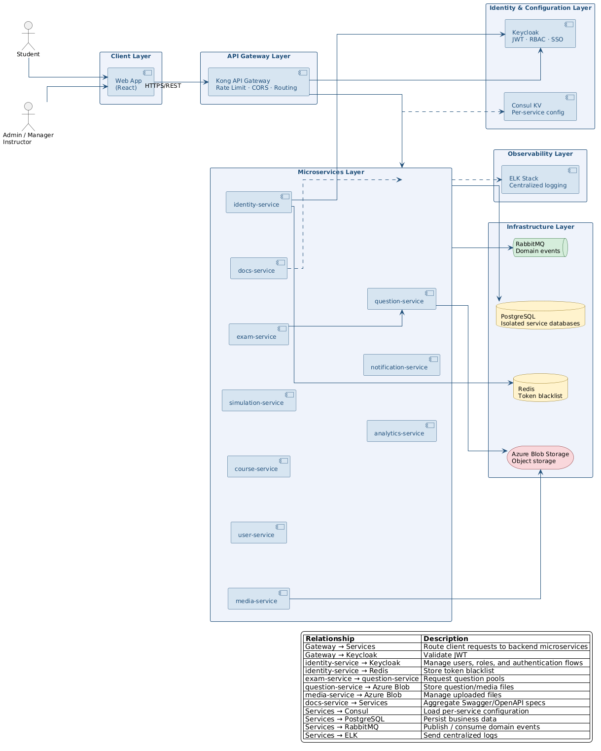

3.2 Implementation View

The Implementation View outlines how services are organized as code artifacts and how they communicate at the implementation level. Each NestJS microservice is an independent TypeScript application in a Turborepo monorepo, deployed as a Docker container. Authentication and authorization are handled by Keycloak guards injected at the module level — no individual service implements its own auth logic. All services share the @repo/common library for DDD base classes, Consul config loading, HTTP response/error helpers, and centralized Winston logging. Prisma v7 generates an isolated client package per service (e.g. @prisma/exam-client) to enforce the database-per-service boundary.

Technology stack:
Backend Microservices: Node.js / NestJS 11 (TypeScript), Turborepo monorepo
Shared Library: @repo/common — DDD base classes (AggregateRoot, Entity, ValueObject), ConsulConfigFactory, AppLoggerModule (Winston + ELK), ApiResponseInterceptor, DomainExceptionFilter
API Gateway: Kong (declarative DB-less, kong.yaml / kong.dev.yaml)
Identity Provider: Keycloak 24.0 (JWT, RBAC, @nestjs/keycloak-connect guards)
Primary Databases: PostgreSQL 15 — 9 isolated databases, one per service
ORM: Prisma v7 with @prisma/adapter-pg; custom client output per service
Cache: Redis 7 — token blacklist (identity-service only)
Message Broker: RabbitMQ 3 — durable queues, noAck: false
Config Management: Consul 1.19 — KV store, per-service namespacing
Object Storage: Azure Blob Storage (via media-service)
Container Orchestration: Docker + Docker Compose
Logging/Observability: Winston → Logstash (HTTP) → Elasticsearch → Kibana
Code Quality: Biome (lint/format), TypeScript strict mode
API Documentation: OpenAPI / Swagger (auto-generated per service, aggregated by docs-service)

PlantUML Source:

@startuml
left to right direction

skinparam defaultFontName Arial
skinparam defaultFontSize 11
skinparam backgroundColor #FFFFFF
skinparam linetype ortho
skinparam nodesep 80
skinparam ranksep 90

skinparam package {
BackgroundColor #EEF3FB
BorderColor #1F4E79
FontColor #1F4E79
}

skinparam component {
BackgroundColor #D6E4F0
BorderColor #1F4E79
}

skinparam database {
BackgroundColor #FFF3CD
BorderColor #856404
}

skinparam queue {
BackgroundColor #D4EDDA
BorderColor #155724
}

skinparam storage {
BackgroundColor #F8D7DA
BorderColor #721C24
}

skinparam arrow {
Color #1F4E79
}

package "Client Application" as Client {
component "Web App\n(React)" as App
}

package "Gateway" as Gateway {
component "Kong API Gateway\n(DB-less, kong.yaml)" as GW
}

package "Identity & Config" as IdConfig {
component "Keycloak 24.0\n(JWT, RBAC, realm)" as KC
component "Consul KV 1.19\n(per-service config)" as Consul
}

package "Backend Microservices\n(NestJS / TypeScript)" as Backend {
component "identity-service" as Auth
component "user-service" as User
component "exam-service" as Exam
component "question-service" as QB
component "course-service" as Course
component "simulation-service" as DP
component "analytics-service" as SRS
component "notification-service" as Notif
component "media-service" as Media
component "docs-service" as Docs
}

package "@repo/common\n(Shared Library)" as Common {
component "DDD Base Classes\n(AggregateRoot, Entity, VO)" as DDD
component "ConsulConfigFactory\n(config loader + Joi)" as CConf
component "AppLoggerModule\n(Winston + ELK HTTP)" as Log
component "ApiResponseInterceptor\n(unified response shape)" as ARI
component "DomainExceptionFilter\n(domain to HTTP error)" as DEF
}

package "Data & Messaging\nInfrastructure" as Infra {
database "PostgreSQL 15\n(9 isolated DBs\nvia Prisma custom clients)" as PG
database "Redis 7\n(token blacklist)" as Redis
queue "RabbitMQ 3\n(durable queues, noAck:false)" as MQ
storage "Azure Blob Storage\n(file/object storage)" as Blob
}

package "Observability\n(ELK)" as Obs {
component "Logstash :5044" as Logstash
database "Elasticsearch :9200" as ES
component "Kibana :5601" as Kibana
}

App --> GW : HTTPS/REST

GW --> KC : JWT validation
GW --> Backend

Auth ..> KC : admin API

Backend ..> Consul : load per-service config
Backend ..> Common : use shared modules
Backend ..> Logstash : send logs

Auth --> Redis : token blacklist

Backend --> PG : persistence
QB --> Blob : question/media files
Media --> Blob : upload metadata/files

User --> MQ : publish events
Exam --> MQ : publish events
SRS --> MQ : consume events
Notif --> MQ : consume events

Exam --> QB : HTTP/REST\nquestion pool

Docs ..> Backend : aggregate Swagger/OpenAPI

Logstash --> ES
ES --> Kibana

note right of Backend
Services:
- identity-service
- user-service
- exam-service
- question-service
- course-service
- simulation-service
- analytics-service
- notification-service
- media-service
- docs-service
end note

note bottom of Backend
Each microservice loads config from Consul,
uses @repo/common modules,
writes logs to Logstash,
and persists data to its own PostgreSQL database.
end note
@enduml
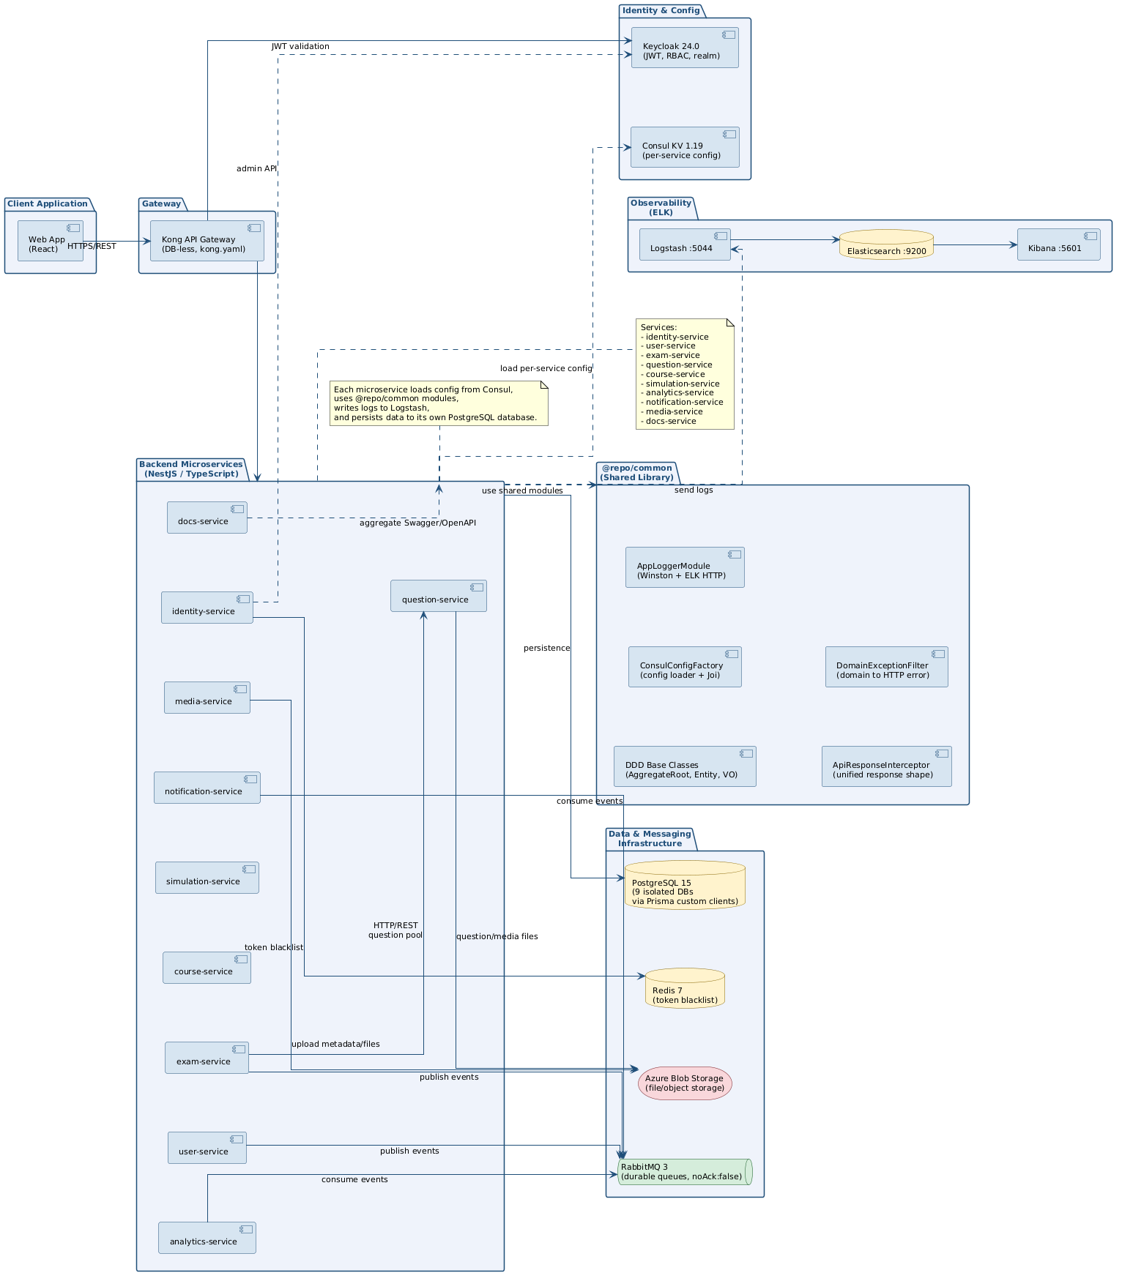

3.3 Deployment View

The Deployment View describes the physical distribution of system components. Two deployment configurations are documented: the development stack (Docker Compose) used during active development, and the production target (Kubernetes) for scalable cloud deployment.

3.3.1 Development Deployment (Docker Compose)

The development stack runs entirely via Docker Compose (docker-compose.yaml for full stack, docker-compose.infra.yml for hybrid mode where services run on the host machine and infrastructure runs in Docker). Kong uses kong.dev.yaml and routes to host.docker.internal:{port} when services run locally. Consul is seeded at startup via the consul-init container using consul-seed-development.json. Mailpit replaces a real SMTP server for email testing.

PlantUML Source:

@startuml
left to right direction

skinparam defaultFontName Arial
skinparam defaultFontSize 10
skinparam backgroundColor #FFFFFF
skinparam linetype ortho
skinparam nodesep 70
skinparam ranksep 90

skinparam node {
BackgroundColor #EEF3FB
BorderColor #1F4E79
FontColor #1F4E79
}

skinparam component {
BackgroundColor #D6E4F0
BorderColor #1F4E79
}

skinparam database {
BackgroundColor #FFF3CD
BorderColor #856404
}

skinparam queue {
BackgroundColor #D4EDDA
BorderColor #155724
}

skinparam storage {
BackgroundColor #F8D7DA
BorderColor #721C24
}

skinparam artifact {
BackgroundColor #E8F6F3
BorderColor #117A65
}

skinparam arrow {
Color #1F4E79
}

title DriveMate — Development Deployment View (Docker Compose)

node "Host Machine\nDocker Compose Stack" as Host {

node "Gateway" as Gateway {
component "Kong API Gateway\nDB-less mode\nkong.dev.yaml\nPort: 8000" as Kong
}

node "Application Services\nNestJS Containers" as Apps {
component "identity-service\nPort: 3001" as Auth
component "user-service\nPort: 3002" as User
component "exam-service\nPort: 3003" as Exam
component "course-service\nPort: 3004" as Course
component "question-service\nPort: 3005" as QB
component "notification-service\nPort: 3006" as Notif
component "analytics-service\nPort: 3007" as SRS
component "simulation-service\nPort: 3008" as DP
component "docs-service\nPort: 3009" as Docs
component "media-service\nPort: 3010" as Media
}

node "Identity & Configuration" as IdConfig {
component "Keycloak\nPort: 8080" as KC
component "Consul KV\nPort: 8500\nconsul-init seeds KV" as Consul
}

node "Data & Messaging Services" as Data {
database "PostgreSQL x9\nPorts: 5432 - 5440\nOne DB per service" as PG
database "Redis\nPort: 6379\nToken blacklist" as Redis
queue "RabbitMQ\nAMQP: 5672\nManagement: 15672" as MQ
}

node "Observability Stack" as Obs {
component "Logstash\nPort: 5044" as Logstash
database "Elasticsearch\nPort: 9200" as ES
component "Kibana\nPort: 5601" as Kibana
}

node "Development Tools" as DevTools {
component "Mailpit\nSMTP: 1025\nWeb UI: 8025" as Mailpit
}
}

cloud "Azure Cloud" as Azure {
storage "Azure Blob Storage\nObject storage for files/media" as Blob
}

Kong --> Auth : HTTP
Kong --> User : HTTP
Kong --> Exam : HTTP
Kong --> QB : HTTP
Kong --> Course : HTTP
Kong --> DP : HTTP
Kong --> SRS : HTTP
Kong --> Media : HTTP
Kong --> Docs : HTTP

Auth --> KC : Admin API
Auth --> Redis : token blacklist

Apps --> PG : database access
Apps --> Consul : load config
Apps ..> Logstash : Winston HTTP logs

User --> MQ : publish events
Exam --> MQ : publish events
SRS --> MQ : consume events
Notif --> MQ : consume events

Exam --> QB : HTTP\nquestion pool

Notif --> Mailpit : SMTP

QB --> Blob : question/media files
Media --> Blob : uploaded files

Docs ..> Apps : aggregate Swagger/OpenAPI

Logstash --> ES
ES --> Kibana

legend bottom
|= Deployment Element |= Purpose |
| Kong | Exposes API routes to backend services |
| Keycloak | Authentication, JWT, RBAC, realm management |
| Consul KV | Stores per-service runtime configuration |
| PostgreSQL x9 | Separate database per microservice |
| Redis | Token blacklist storage |
| RabbitMQ | Asynchronous domain/event messaging |
| Azure Blob Storage | Stores uploaded files and question/media assets |
| Mailpit | Mock SMTP server for local development |
| ELK Stack | Centralized logging and log visualization |
endlegend
@enduml
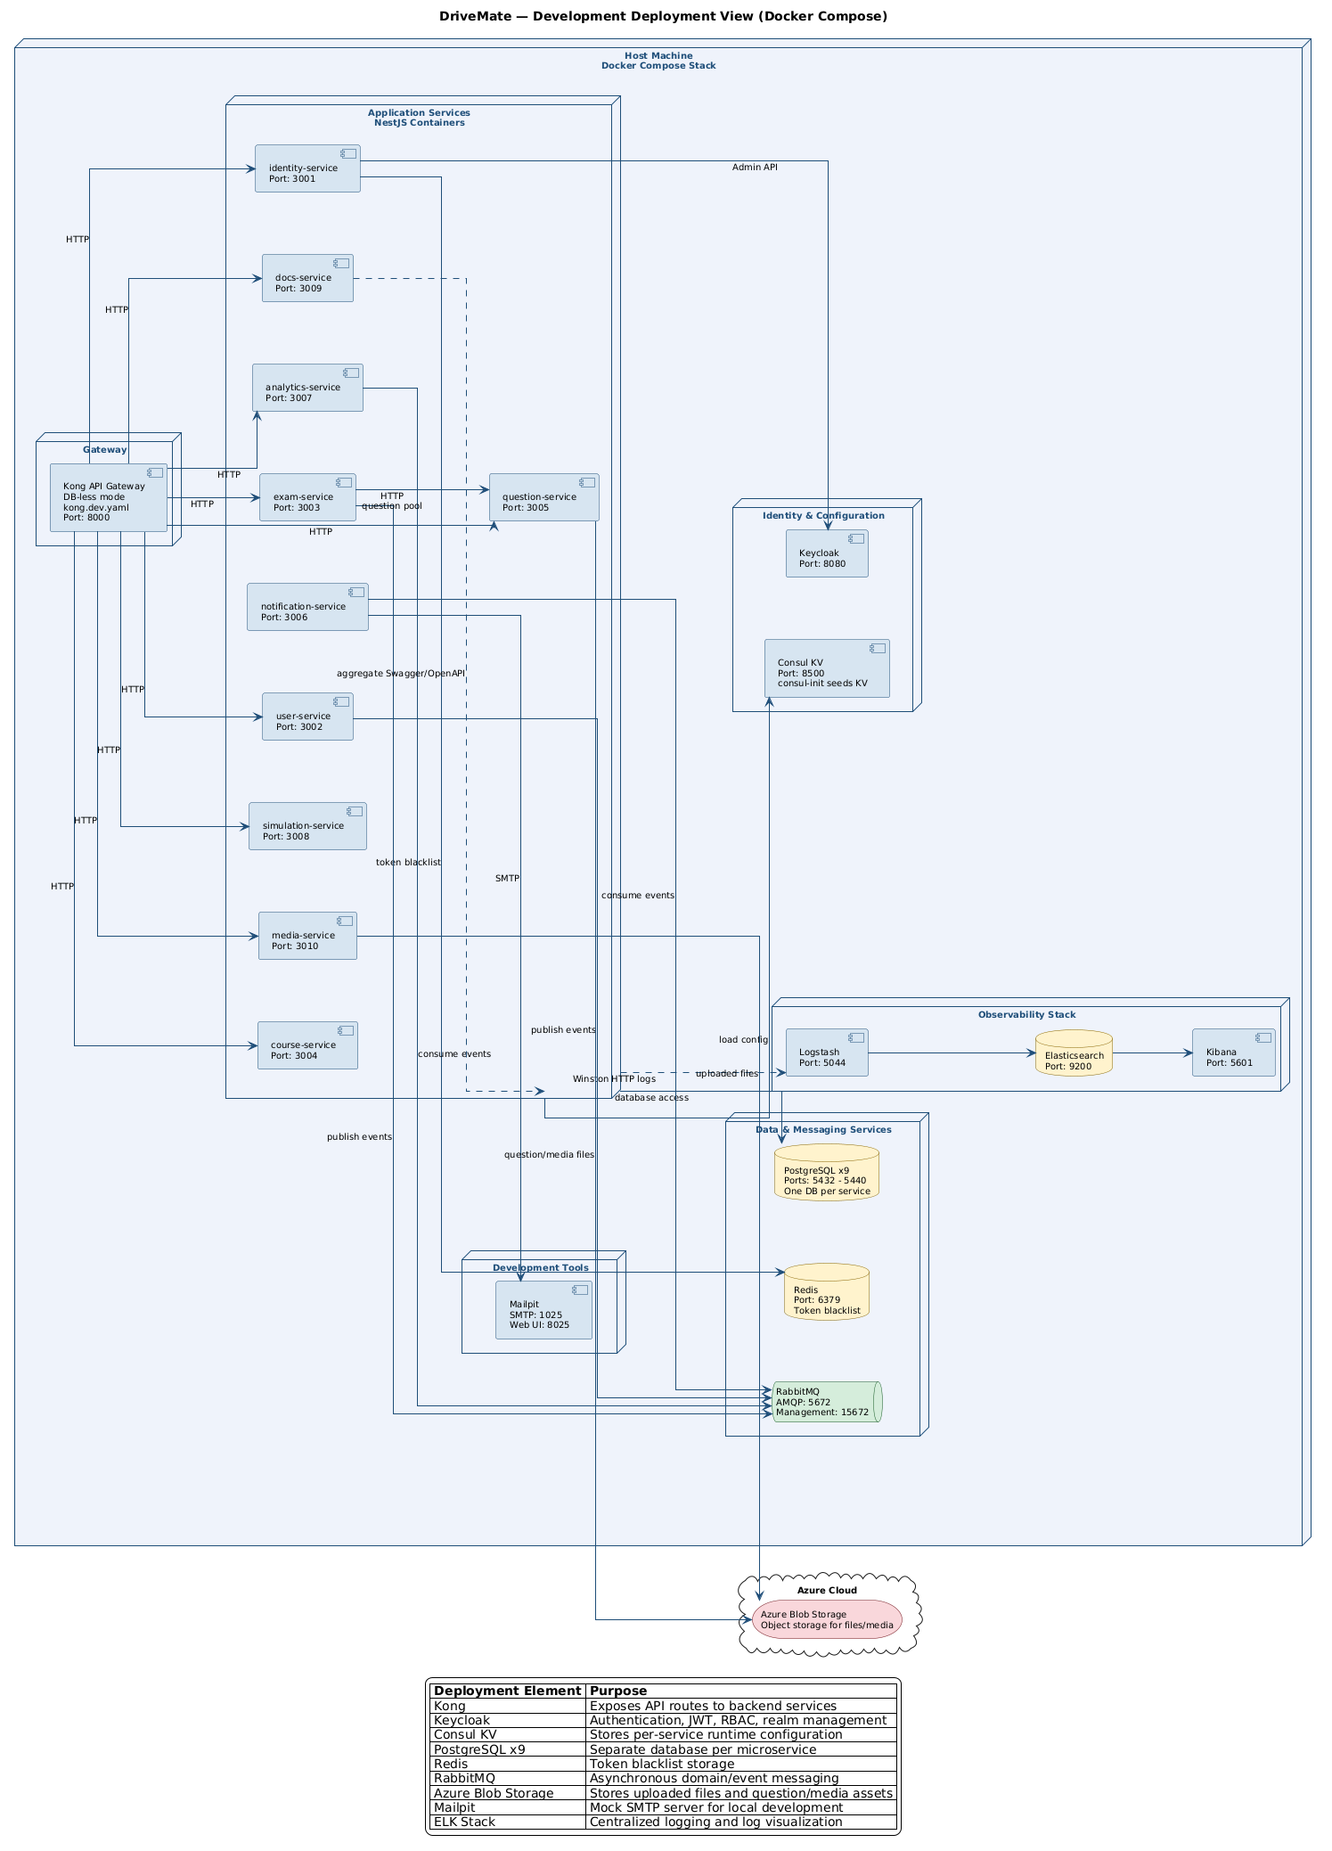

3.3.2 Production Target Deployment (Kubernetes)

For production deployment, all NestJS microservices run as stateless Kubernetes Deployments with Horizontal Pod Autoscaling (HPA) to handle peak exam traffic. External traffic enters through an Nginx Ingress Controller that terminates TLS before forwarding to Kong. Keycloak and Consul are deployed as StatefulSets with persistent volumes. Managed data services (PostgreSQL x9, Redis HA cluster, RabbitMQ cluster with persistent queues) are provisioned independently of the application layer. The ELK stack (Elasticsearch, Logstash, Kibana) provides centralized log aggregation and visualization.

PlantUML Source:

@startuml
left to right direction

skinparam defaultFontName Arial
skinparam defaultFontSize 11
skinparam backgroundColor #FFFFFF
skinparam linetype ortho
skinparam nodesep 80
skinparam ranksep 100

skinparam node {
BackgroundColor #EEF3FB
BorderColor #1F4E79
FontColor #1F4E79
}

skinparam component {
BackgroundColor #D6E4F0
BorderColor #1F4E79
}

skinparam database {
BackgroundColor #FFF3CD
BorderColor #856404
}

skinparam queue {
BackgroundColor #D4EDDA
BorderColor #155724
}

skinparam storage {
BackgroundColor #F8D7DA
BorderColor #721C24
}

skinparam cloud {
BackgroundColor #F4F6F7
BorderColor #566573
FontColor #1F4E79
}

skinparam arrow {
Color #1F4E79
}

title DriveMate — Production Deployment View

cloud "Cloud Provider\nProduction Environment" as Cloud {

node "Kubernetes Cluster" as K8s {

node "Ingress Layer" as IngressLayer {
component "Nginx Ingress Controller\nTLS Termination" as Ingress
component "Kong API Gateway\nDB-less gateway" as GW
}

node "Application Workloads\nStateless Kubernetes Deployments\nHPA-scaled Pods" as Apps {
component "identity-service\nPod(s)" as Auth
component "user-service\nPod(s)" as User
component "exam-service\nPod(s)" as Exam
component "question-service\nPod(s)" as QB
component "course-service\nPod(s)" as Course
component "simulation-service\nPod(s)" as DP
component "analytics-service\nPod(s)" as SRS
component "notification-service\nPod(s)" as Notif
component "media-service\nPod(s)" as Media
component "docs-service\nPod(s)" as Docs
}

node "Identity & Configuration\nStatefulSets + Persistent Volumes" as Stateful {
component "Keycloak\nJWT · RBAC · Realm" as KC
component "Consul KV\nRuntime configuration" as Consul
}

node "Observability Workloads\nELK Stack" as Obs {
component "Logstash\nLog ingestion" as Logstash
component "Kibana\nLog visualization" as Kibana
}
}

node "Managed Data Services\nProvisioned independently" as Data {
database "PostgreSQL x9\nPrimary + Read Replica\nOne DB per service" as PG
database "Redis HA Cluster\nToken blacklist" as Redis
queue "RabbitMQ Cluster\nPersistent queues" as MQ
storage "Azure Blob Storage\nObject storage for files/media" as Blob
database "Elasticsearch\nLog storage" as ES
}
}

actor "External Users" as Users

Users --> Ingress : HTTPS
Ingress --> GW : HTTP/HTTPS\ninside cluster

GW --> KC : JWT validation
GW --> Apps : Route API requests

Auth --> KC : Admin API
Auth --> Redis : token blacklist

Apps --> PG : database access
Apps --> Consul : load config
Apps ..> Logstash : structured logs

User --> MQ : publish events
Exam --> MQ : publish events
SRS --> MQ : consume events
Notif --> MQ : consume events

Exam --> QB : HTTP\nquestion pool

QB --> Blob : question/media files
Media --> Blob : uploaded files

Docs ..> Apps : aggregate Swagger/OpenAPI

Logstash --> ES
Kibana --> ES

legend bottom
|= Production Element |= Responsibility |
| Nginx Ingress Controller | Receives external traffic and terminates TLS |
| Kong API Gateway | Routes API requests to backend services |
| Application Workloads | Stateless NestJS microservices deployed as HPA-scaled Pods |
| Keycloak | Authentication, JWT, RBAC, and realm management |
| Consul KV | Runtime configuration for all microservices |
| PostgreSQL x9 | Isolated database per microservice |
| Redis HA Cluster | Token blacklist and fast key-value access |
| RabbitMQ Cluster | Durable asynchronous event messaging |
| Azure Blob Storage | Stores uploaded files and question/media assets |
| ELK Stack | Centralized log aggregation and visualization |
endlegend
@enduml
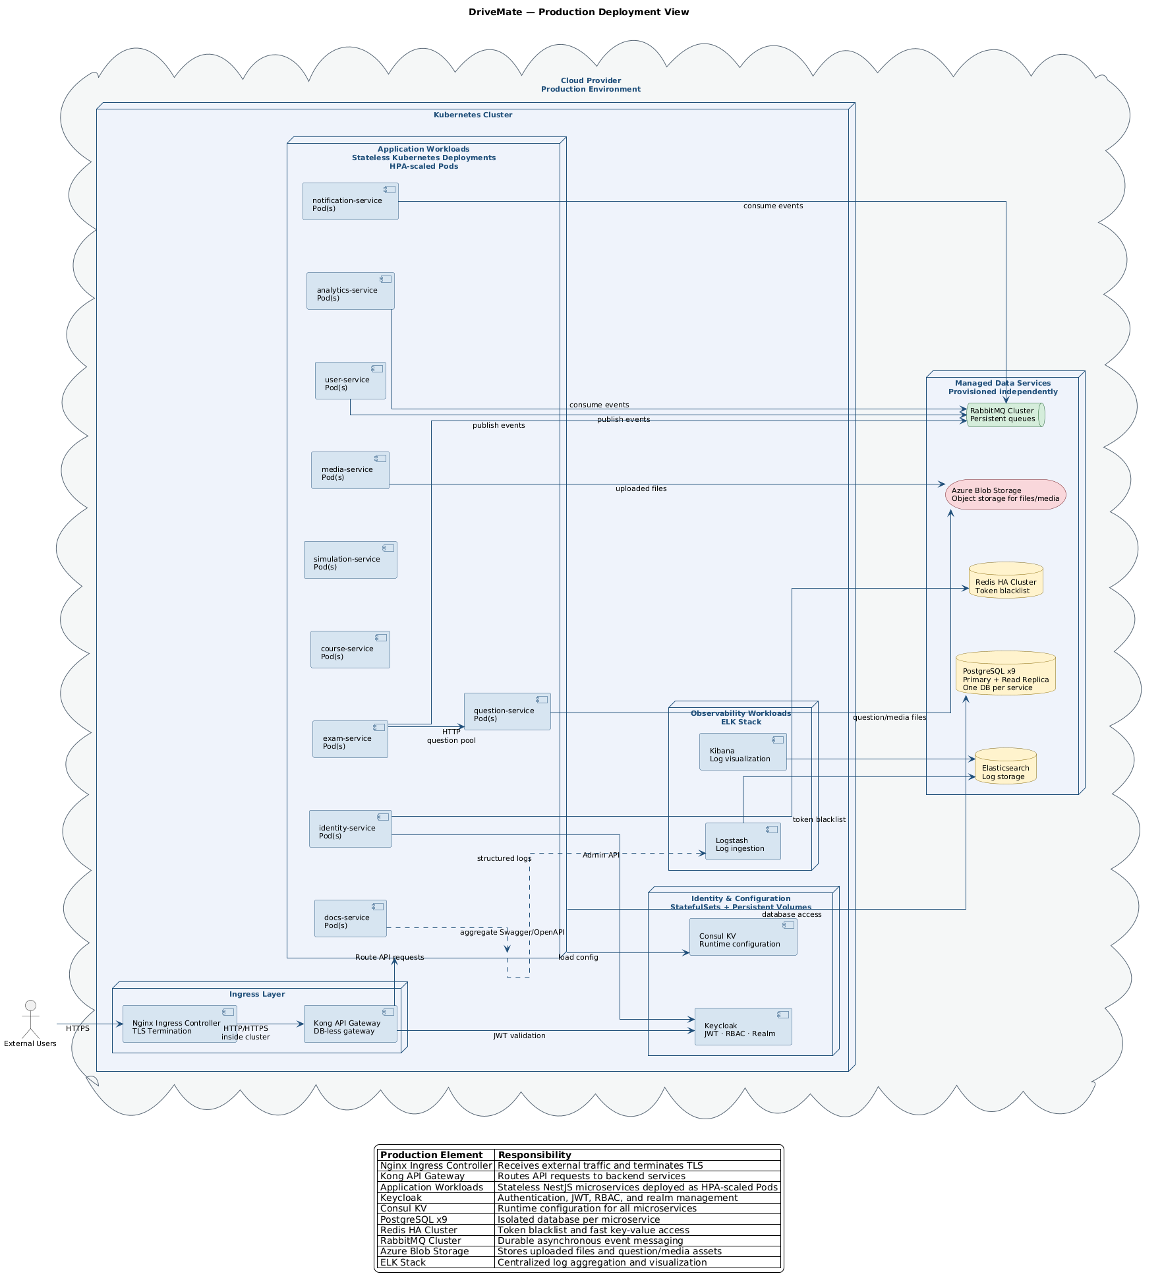

3.4 Data View

The Data View describes the core entities, their relationships, and the data storage strategy. DriveMate applies the database-per-service pattern: each microservice owns an isolated PostgreSQL 15 database with no cross-service foreign keys. Services reference each other only by UUID. Eventual consistency is maintained via domain events published through RabbitMQ.

Database allocation per service:

identity-service → identity_db :5432: IdentityUser, TokenAudit
user-service → user_db :5433: UserProfile, StudentDetail, LicenseAssignmentAudit
exam-service → exam_db :5434: ExamTemplate, ExamSession, ExamSessionQuestion (snapshot)
question-service → question_db :5436: Question, QuestionOption, QuestionTopic
course-service → course_db :5435: Course, Lesson, Enrollment, LessonProgress
simulation-service → simulation_db :5439: SimulationScenario, SimulationSession
notification-service → notification_db :5437: NotificationRecord
analytics-service → analytics_db :5438: ProgressStat, SRSItem
media-service → media_db :5440: MediaFile

Caching Strategy (Redis — identity-service only):
Token blacklist: blacklist:{jti} — TTL = token remaining lifetime; checked by TokenBlacklistGuard on every authenticated request across all services.

Message Queues (RabbitMQ):
user_service_events — consumed by user-service (e.g. identity.user.created).
exam_service_publish — published by exam-service.
analytics_service_events — consumed by analytics-service.
notification_service_events — consumed by notification-service.
media_service_events — consumed by media-service.

Key Schema Highlights:
user_db: UserProfile {id (=Keycloak sub), fullName, email, role, isActive} | StudentDetail {licenseTier (A1–F), enrolledAt} | LicenseAssignmentAudit {oldTier, newTier, changedById, changedAt}
exam_db: ExamTemplate {licenseCategory, totalQuestions, passingScore, durationMinutes} | ExamSession {studentId (cross-service ref), status, score, isPassed} | ExamSessionQuestion {questionContent (snapshot), optionsSnapshot (JSONB), isCorrect, isBookmarked}

PlantUML Source:

@startuml
top to bottom direction

skinparam defaultFontName Arial
skinparam defaultFontSize 9
skinparam backgroundColor #FFFFFF
skinparam linetype ortho
skinparam nodesep 45
skinparam ranksep 55

skinparam rectangle {
BackgroundColor #EEF3FB
BorderColor #1F4E79
FontColor #1F4E79
}

skinparam component {
BackgroundColor #D6E4F0
BorderColor #1F4E79
FontColor #000000
}

skinparam database {
BackgroundColor #FFF3CD
BorderColor #856404
}

skinparam queue {
BackgroundColor #D4EDDA
BorderColor #155724
}

skinparam storage {
BackgroundColor #F8D7DA
BorderColor #721C24
}

skinparam arrow {
Color #1F4E79
}

title DriveMate Data View

rectangle "Core Data" as CoreArea {

rectangle "identity-service\nidentity_db :5432" as IdentitySvc {
database "identity_db" as IdentityDB

component "IdentityUser\n--\nid : UUID PK\nkeycloakId : VARCHAR UNIQUE\nemail : VARCHAR\ncreatedAt : TIMESTAMP" as IdentityUser

component "TokenAudit\n--\nid : UUID PK\nuserId : UUID\naction : VARCHAR\ncreatedAt : TIMESTAMP" as TokenAudit

IdentityDB -- IdentityUser
IdentityDB -- TokenAudit
IdentityUser -- TokenAudit
}

rectangle "user-service\nuser_db :5433" as UserSvc {
database "user_db" as UserDB

component "UserProfile\n--\nid : UUID PK\nfullName : VARCHAR\nemail : VARCHAR UNIQUE\nphoneNumber : VARCHAR\nrole : ENUM\nisActive : BOOLEAN" as UserProfile

component "StudentDetail\n--\nid : UUID PK\nuserProfileId : UUID\nlicenseTier : ENUM\nenrolledAt : TIMESTAMP\nnotes : TEXT" as StudentDetail

component "LicenseAssignmentAudit\n--\nid : UUID PK\nstudentId : UUID\noldTier : ENUM\nnewTier : ENUM\nchangedById : UUID\nchangedAt : TIMESTAMP" as LicenseAudit

UserDB -- UserProfile
UserProfile -- StudentDetail
UserProfile -- LicenseAudit
}
}

rectangle "Exam and Question Data" as ExamQuestionArea {

rectangle "exam-service\nexam_db :5434" as ExamSvc {
database "exam_db" as ExamDB

component "ExamTemplate\n--\nid : UUID PK\nlicenseCategory : ENUM\ntotalQuestions : INT\npassingScore : INT\ndurationMinutes : INT" as ExamTemplate

component "ExamSession\n--\nid : UUID PK\nstudentId : UUID\ntemplateId : UUID\nstatus : ENUM\nscore : INT\nisPassed : BOOLEAN\nstartedAt : TIMESTAMP\nfinishedAt : TIMESTAMP" as ExamSession

component "ExamSessionQuestion\n--\nid : UUID PK\nsessionId : UUID\nquestionId : UUID\nquestionContent : TEXT\noptionsSnapshot : JSONB\nselectedOptionId : UUID\nisCorrect : BOOLEAN\nisBookmarked : BOOLEAN\nansweredAt : TIMESTAMP" as ExamSessionQuestion

ExamDB -- ExamTemplate
ExamTemplate -- ExamSession
ExamSession -- ExamSessionQuestion
}

rectangle "question-service\nquestion_db :5436" as QuestionSvc {
database "question_db" as QuestionDB

component "Question\n--\nid : UUID PK\nlicenseCategory : ENUM\ncontent : TEXT\nexplanation : TEXT\nisActive : BOOLEAN\nisFatal : BOOLEAN" as Question

component "QuestionOption\n--\nid : UUID PK\nquestionId : UUID\ncontent : TEXT\nisCorrect : BOOLEAN\ndisplayOrder : INT" as QuestionOption

component "QuestionTopic\n--\nid : UUID PK\nname : VARCHAR\ndescription : TEXT" as QuestionTopic

QuestionDB -- Question
Question -- QuestionOption
QuestionDB -- QuestionTopic
}
}

rectangle "Learning Data" as LearningArea {

rectangle "course-service\ncourse_db :5435" as CourseSvc {
database "course_db" as CourseDB

component "Course\n--\nid : UUID PK\ntitle : VARCHAR\nlicenseTier : ENUM" as Course

component "Lesson\n--\nid : UUID PK\ncourseId : UUID\ntitle : VARCHAR\ncontent : TEXT" as Lesson

component "Enrollment\n--\nid : UUID PK\nuserId : UUID\ncourseId : UUID\nenrolledAt : TIMESTAMP" as Enrollment

component "LessonProgress\n--\nid : UUID PK\nenrollmentId : UUID\nlessonId : UUID\ncompletedAt : TIMESTAMP" as LessonProgress

CourseDB -- Course
Course -- Lesson
Course -- Enrollment
Enrollment -- LessonProgress
}

rectangle "simulation-service\nsimulation_db :5439" as SimSvc {
database "simulation_db" as SimulationDB

component "SimulationScenario\n--\nid : UUID PK\ntitle : VARCHAR\nlicenseTier : ENUM\ndifficulty : ENUM" as SimulationScenario

component "SimulationSession\n--\nid : UUID PK\nuserId : UUID\nscenarioId : UUID\nscore : INT\ncompletedAt : TIMESTAMP" as SimulationSession

SimulationDB -- SimulationScenario
SimulationScenario -- SimulationSession
}
}

rectangle "Support Data" as SupportArea {

rectangle "analytics-service\nanalytics_db :5438" as AnalyticsSvc {
database "analytics_db" as AnalyticsDB

component "ProgressStat\n--\nid : UUID PK\nuserId : UUID\nexamCount : INT\naverageScore : FLOAT" as ProgressStat

component "SRSItem\n--\nid : UUID PK\nuserId : UUID\nquestionId : UUID\nnextReviewAt : TIMESTAMP" as SRSItem

AnalyticsDB -- ProgressStat
AnalyticsDB -- SRSItem
}

rectangle "notification-service\nnotification_db :5437" as NotifSvc {
database "notification_db" as NotificationDB

component "NotificationRecord\n--\nid : UUID PK\nuserId : UUID\ntype : VARCHAR\nstatus : VARCHAR\ncontent : TEXT\nsentAt : TIMESTAMP" as NotificationRecord

NotificationDB -- NotificationRecord
}

rectangle "media-service\nmedia_db :5440" as MediaSvc {
database "media_db" as MediaDB

component "MediaFile\n--\nid : UUID PK\nownerId : UUID\nblobUrl : VARCHAR\nmimeType : VARCHAR\ncreatedAt : TIMESTAMP" as MediaFile

MediaDB -- MediaFile
}
}

rectangle "Shared Infrastructure Data" as InfraArea {

rectangle "Redis Cache" as RedisArea {
database "Redis 7" as Redis

component "TokenBlacklist\n--\nkey : blacklist_jti\nTTL : token remaining lifetime\nusedBy : TokenBlacklistGuard" as TokenBlacklist

Redis -- TokenBlacklist
}

rectangle "RabbitMQ Queues" as MQArea {
queue "RabbitMQ 3" as RabbitMQ

component "DomainEventQueues\n--\nuser_service_events\nexam_service_publish\nanalytics_service_events\nnotification_service_events\nmedia_service_events" as DomainQueues

RabbitMQ -- DomainQueues
}

rectangle "Object Storage" as BlobArea {
storage "Azure Blob Storage" as Blob

component "StoredObjects\n--\nquestion media\nuploaded files\nlearning assets" as StoredObjects

Blob -- StoredObjects
}
}

IdentitySvc --> RedisArea : blacklist

UserSvc --> MQArea : publish
ExamSvc --> MQArea : publish
MQArea --> AnalyticsSvc : consume
MQArea --> NotifSvc : consume
MQArea --> MediaSvc : consume

QuestionSvc --> BlobArea : media
MediaSvc --> BlobArea : files

legend bottom
|= Rule |= Detail |
| Database-per-service | Each service owns one isolated PostgreSQL database |
| No cross-service FK | External references are stored as UUID only |
| UserProfile.id | Equals Keycloak subject |
| ExamSession.studentId | UUID reference to user-service |
| ExamSessionQuestion.questionId | UUID reference to question-service |
| Exam snapshot | questionContent and optionsSnapshot are copied at exam start |
| Redis | Token blacklist only |
| RabbitMQ | Eventual consistency through domain events |
| Azure Blob | Uploaded files and question/media objects |
endlegend
@enduml
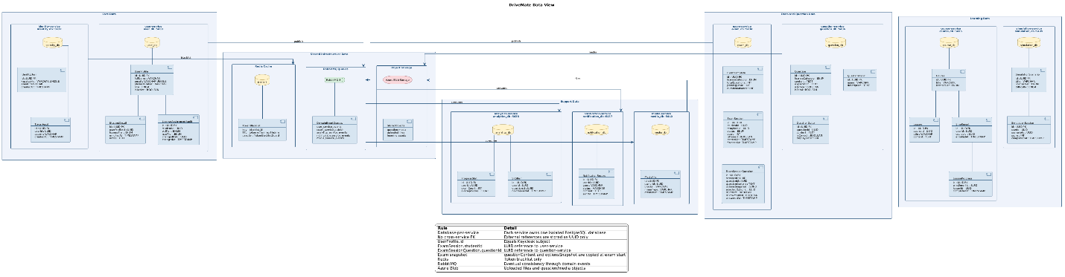

3.5 Process View

The Process View describes how DriveMate handles concurrency, asynchronous tasks, offline resilience, and server-side state control at runtime. Four key process flows are documented below.

Flow 1 — Login via Keycloak:
When a user submits login credentials, the request travels through Kong to the identity-service. The identity-service forwards the credentials to the Keycloak token endpoint; Keycloak handles password hashing, account lockout, and session management internally. On success, a JWT and refresh token are returned to the client. On logout, the identity-service adds the JWT's jti claim to the Redis token blacklist with TTL equal to the token's remaining lifetime. All subsequent requests are checked against the blacklist by TokenBlacklistGuard, which is registered globally across all services.

Flow 2 — Asynchronous Notification:
When an instructor sends a study alert, the notification-service accepts the request and immediately returns HTTP 202 to the instructor's interface without blocking it. The notification task is published to a RabbitMQ queue and consumed in the background. Failed deliveries are retried automatically; messages that exhaust retries are moved to a Dead Letter Queue for inspection. This decoupling ensures that notification delivery never slows down the instructor's UI.

Flow 3 — Offline Sync (Auto-Save):
During an active exam, the client auto-saves answers to the exam-service every 5 to 10 seconds using an idempotent upsert operation. If the network is lost, the client detects the disconnection within 2 seconds and shows a non-blocking offline indicator. Answers continue to be stored locally. When connectivity is restored, the client silently syncs the buffered answers using the same idempotent endpoint, ensuring no duplicates are created regardless of how many retries occur.

Flow 4 — Server-Side FSM (Simulation Service):
All state transition logic for driving practice resides exclusively on the server within simulation-service. The client sends a user action event and waits for the server's response before updating the UI. The simulation-service validates the action against the current FSM state and either advances the state or rejects the action with a structured error containing the error code and severity. The client renders the appropriate feedback within 100 milliseconds of receiving the response. No FSM logic is shipped to the client, preventing manipulation through tampered builds.

PlantUML Source:

@startuml
skinparam defaultFontName Arial
skinparam defaultFontSize 9
skinparam backgroundColor #FFFFFF
skinparam sequence {
ArrowColor #1F4E79
ActorBorderColor #1F4E79
LifeLineBorderColor #1F4E79
ParticipantBorderColor #1F4E79
ParticipantBackgroundColor #D6E4F0
BoxBorderColor #1F4E79
BoxBackgroundColor #EEF3FB
}

title Process View

actor Student
actor Instructor

participant "Client" as Client
participant "Kong" as GW
participant "identity-service" as Auth
participant "Keycloak" as KC
database "identity_db" as IdentityDB
database "Redis" as Redis
participant "exam-service" as Exam
participant "notification-api" as NotifAPI
queue "RabbitMQ" as MQ
participant "notification-worker" as NotifWorker
queue "DLQ" as DLQ
participant "simulation-service" as Sim

== Login ==

Student -> Client : credentials
Client -> GW : POST /auth/login
GW -> Auth : forward
Auth -> KC : token request
KC -> KC : verify credentials
KC --> Auth : JWT + refresh
Auth -> IdentityDB : audit login
Auth --> GW : tokens
GW --> Client : tokens
Client --> Student : login success

== Logout / Blacklist ==

Student -> Client : logout
Client -> GW : POST /auth/logout
GW -> Auth : forward
Auth -> Redis : SET blacklist_jti TTL
Auth --> GW : 200 OK
GW --> Client : logged out

== Async Notification ==

Instructor -> Client : send study alert
Client -> GW : POST /notifications/study-alert
GW -> NotifAPI : create task
NotifAPI -> MQ : publish event
NotifAPI --> GW : 202 Accepted
GW --> Client : accepted
Client --> Instructor : UI not blocked

MQ -> NotifWorker : consume
NotifWorker -> NotifWorker : deliver

alt success
NotifWorker -> NotifWorker : mark delivered
else retryable failure
NotifWorker -> MQ : retry
else max retries exceeded
NotifWorker -> DLQ : dead letter
end

== Offline Auto-Save ==

Student -> Client : answer question

loop every 5-10s
Client -> Client : save local
Client -> GW : PUT answers
GW -> Exam : idempotent upsert
Exam --> GW : saved
GW --> Client : saved
end

... network lost ...

Client -[#red]x GW : request fails
Client -> Client : detect offline
Client -> Client : buffer answers
Client --> Student : offline indicator

... network restored ...

loop until buffer empty
Client -> GW : sync buffered answers
GW -> Exam : idempotent upsert
Exam --> GW : synced
GW --> Client : remove from buffer
end

== Server-side FSM ==

Student -> Client : driving action
Client -> GW : POST action
GW -> Sim : forward action
Sim -> Sim : validate FSM state

alt valid
Sim -> Sim : advance state
Sim --> GW : nextState + feedback
GW --> Client : result
Client --> Student : render new state
else invalid
Sim --> GW : 400 + errorCode + severity
GW --> Client : error
Client --> Student : show alert
end

legend bottom
|= Flow |= Key idea |
| Login | Keycloak handles credentials, hashing, lockout, and tokens |
| Logout | JWT jti is stored in Redis blacklist with TTL |
| Notification | API returns 202; worker delivers asynchronously through RabbitMQ |
| Offline sync | Client buffers answers and retries idempotent upsert |
| FSM | Simulation transitions are validated only on the server |
endlegend
@enduml
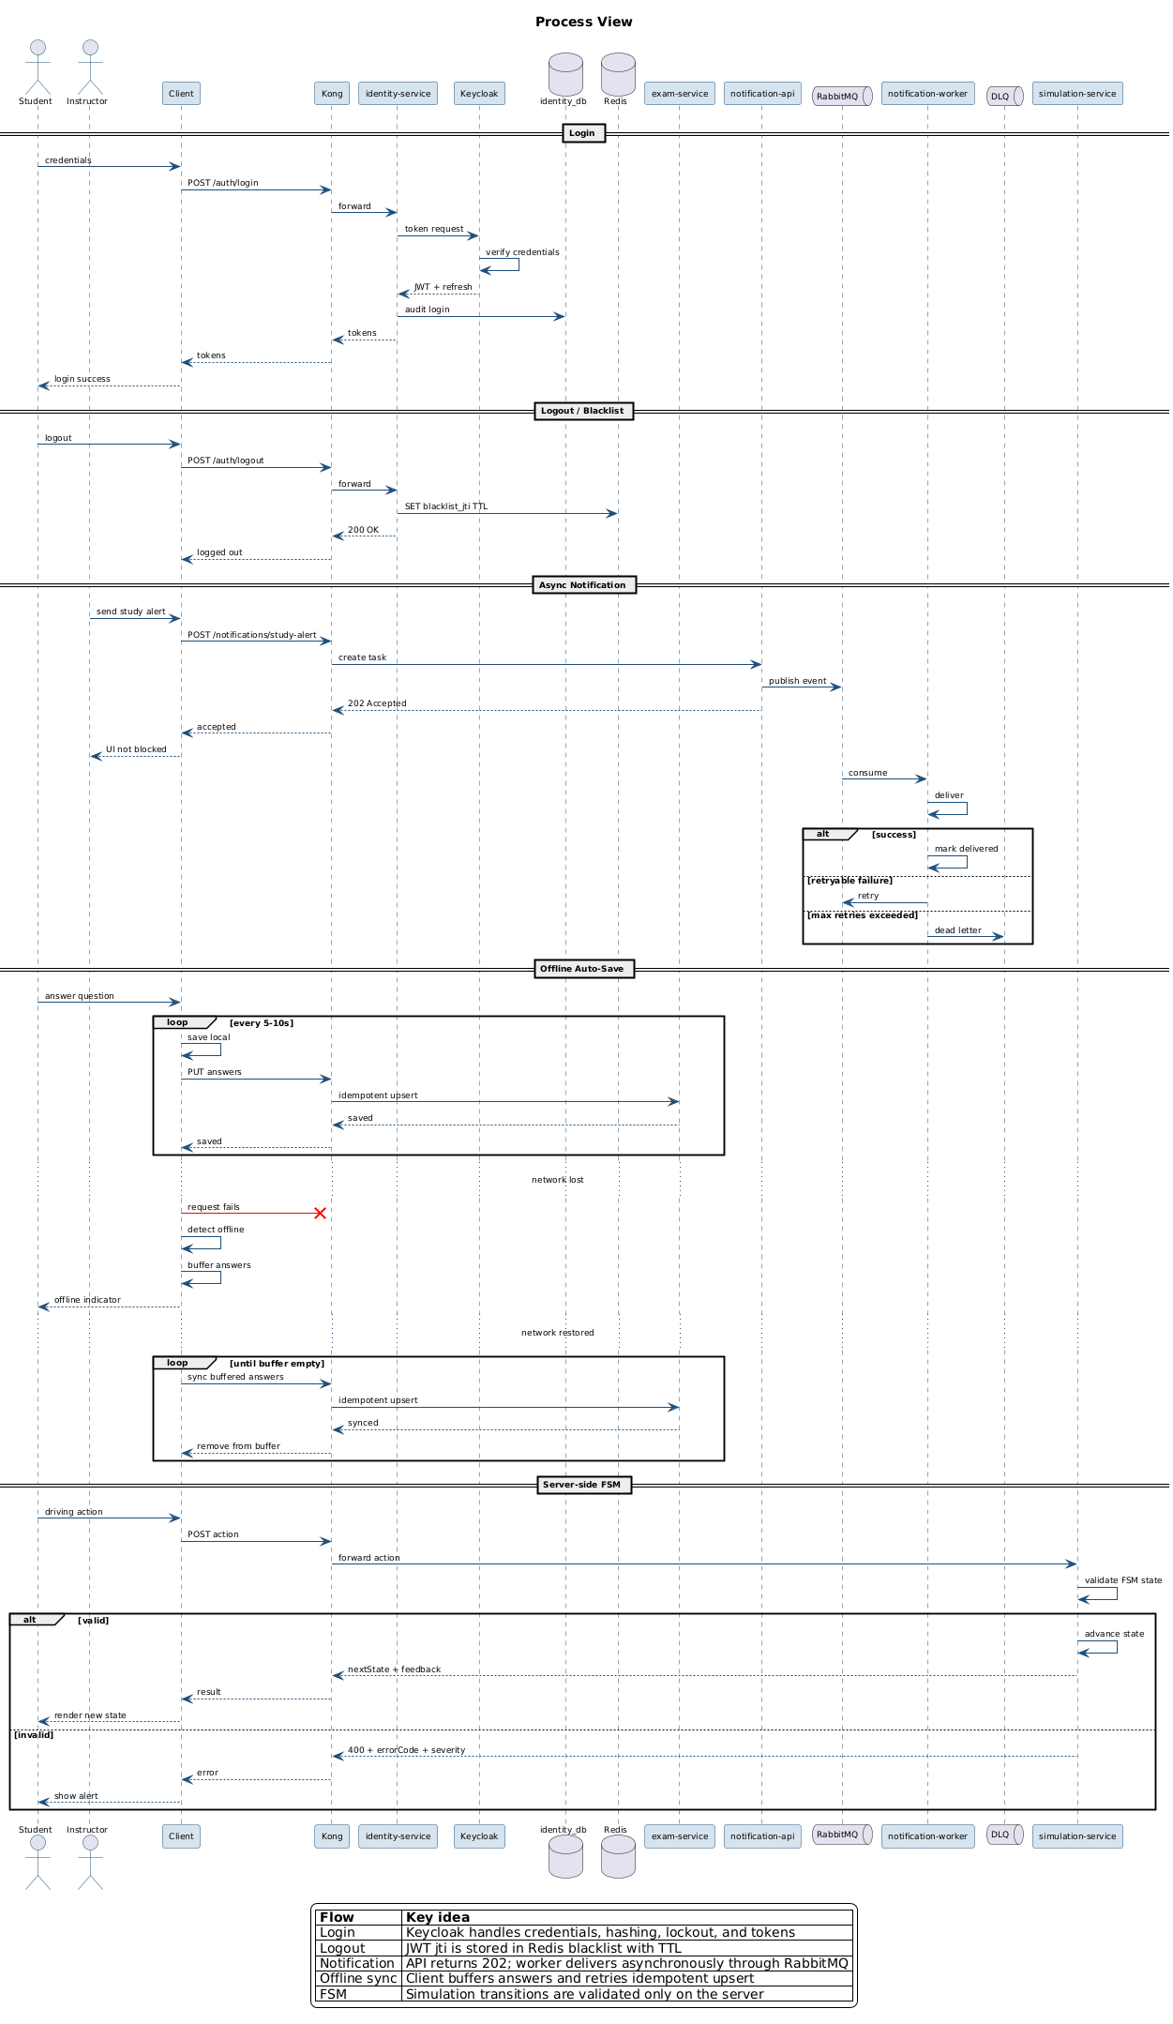

3.6 Scenario View

The Scenario View illustrates how components across multiple architectural layers collaborate to fulfil the four most critical use cases in DriveMate. Each scenario is selected because it exercises multiple quality attributes simultaneously.

3.6.1 Scenario 1: Atomic Exam Submission & Grading

This scenario covers the most critical transactional flow in the system. A student submits their completed exam. The exam-service opens a single database transaction that records all answers, grades the submission by comparing selected answers to stored correct answers, evaluates fatal questions first (a single wrong answer on a fatal question produces an immediate fail verdict), writes the immutable COMPLETED result, and updates SRS Item records — all in one atomic unit. If any step fails, the entire transaction rolls back and the student receives a safe-to-retry error. Once the transaction commits, the COMPLETED status is permanent; no role including Admin may modify it. This scenario exercises ASR-REL-04, ASR-DI-01, and ASR-DI-07.

PlantUML Source:

@startuml
skinparam defaultFontName Arial
skinparam defaultFontSize 10
skinparam backgroundColor #FFFFFF

skinparam sequence {
ArrowColor #1F4E79
ActorBorderColor #1F4E79
LifeLineBorderColor #1F4E79
ParticipantBorderColor #1F4E79
ParticipantBackgroundColor #D6E4F0
BoxBorderColor #1F4E79
BoxBackgroundColor #EEF3FB
}

title Scenario 1 - Atomic Exam Submit

actor Student
participant "Client" as App
participant "Kong" as GW
participant "exam-service" as Exam
database "exam_db" as ExamDB
queue "RabbitMQ" as MQ
participant "analytics-service" as Analytics
database "analytics_db" as AnalyticsDB

Student -> App : submit exam
App -> App : collect answers
App -> GW : POST /exam-sessions/{id}/submit
GW -> Exam : forward request

Exam -> ExamDB : BEGIN

Exam -> ExamDB : lock exam session
Exam -> ExamDB : save answers
Exam -> ExamDB : grade server-side
Exam -> ExamDB : check fatal questions
Exam -> ExamDB : write COMPLETED result
Exam -> ExamDB : write outbox event

alt all DB steps succeed
Exam -> ExamDB : COMMIT
Exam -> MQ : publish ExamCompleted
Exam --> GW : score + pass/fail
GW --> App : result
App --> Student : show result
else any DB step fails
Exam -> ExamDB : ROLLBACK
Exam --> GW : safe-to-retry error
GW --> App : retry prompt
App --> Student : show retry message
end

MQ -> Analytics : consume ExamCompleted
Analytics -> AnalyticsDB : update SRS items

legend bottom
|= Rule |= Meaning |
| Atomic boundary | Exam submission is atomic inside exam_db transaction |
| Server-side grading | Client cannot decide score or pass/fail |
| Fatal question rule | Any wrong fatal question causes immediate fail verdict |
| Immutable result | COMPLETED exam result cannot be modified after commit |
| Safe retry | Failed transaction rolls back fully before retry |
| SRS update | Analytics/SRS update happens after commit through event |
endlegend
@enduml
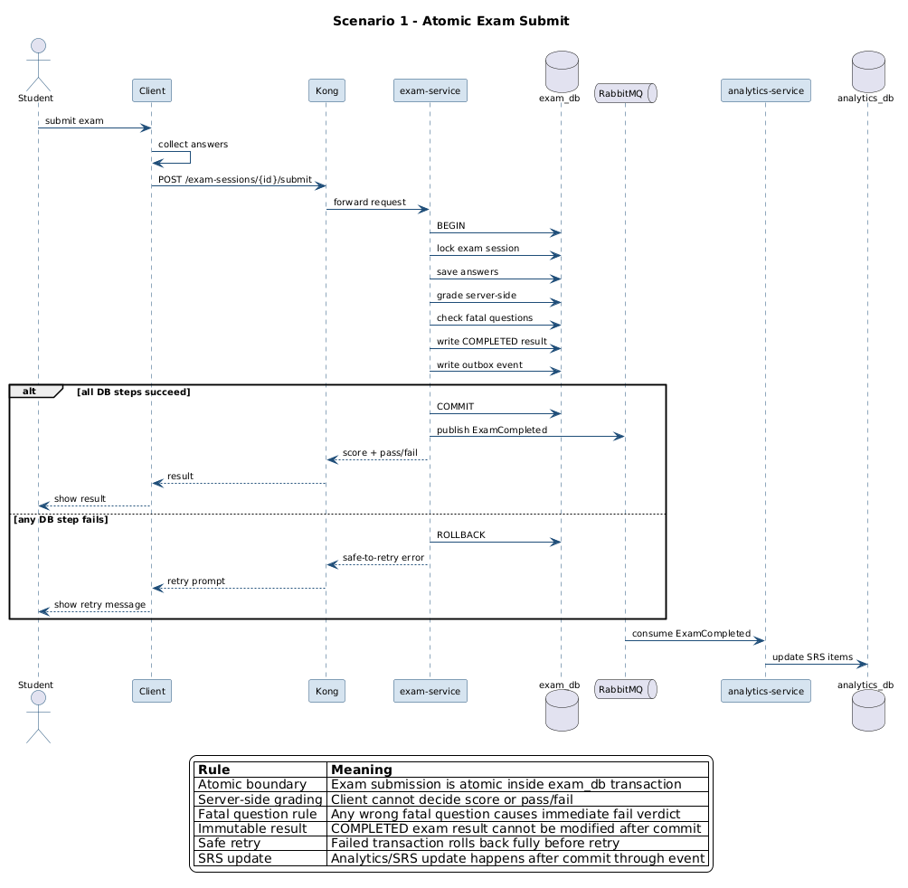

3.6.2 Scenario 2: Driving Practice Session (Server FSM + Audio)

This scenario covers the real-time driving simulation. When the student opens the practice screen, all audio command assets are downloaded and buffered before the session becomes active. During the session, each student action is sent to the server-side FSM in simulation-service for validation. Valid actions advance the state and trigger audio playback with under 100 milliseconds of latency. Invalid or out-of-sequence actions are rejected by the server and a colour-coded alert is rendered within 100 milliseconds of the response: red for fatal errors, yellow for point deductions. No state logic runs on the client. This scenario exercises ASR-SEC-07, ASR-UX-02, and ASR-UX-03.

PlantUML Source:

@startuml
skinparam defaultFontName Arial
skinparam defaultFontSize 10
skinparam backgroundColor #FFFFFF

skinparam sequence {
ArrowColor #1F4E79
ActorBorderColor #1F4E79
LifeLineBorderColor #1F4E79
ParticipantBorderColor #1F4E79
ParticipantBackgroundColor #D6E4F0
BoxBorderColor #1F4E79
BoxBackgroundColor #EEF3FB
}

title Scenario 2 - Driving Practice

actor Student
participant "Client" as App
participant "Kong" as GW
participant "simulation-service" as Sim
participant "Azure Blob\nAudio assets" as Blob

== Start Session ==

Student -> App : open practice screen
App -> Blob : preload audio assets
Blob --> App : audio files ready
App -> App : unlock session

== Action Loop ==

loop each driving action
Student -> App : perform action
App -> GW : POST /simulations/{id}/actions
GW -> Sim : forward action

Sim -> Sim : validate FSM state

alt valid action
Sim -> Sim : advance state
Sim --> GW : nextState + audioCommand
GW --> App : result
App -> App : render state
App -> App : play audio
App --> Student : feedback under 100 ms
else invalid action
Sim --> GW : errorCode + severity
GW --> App : error response
App -> App : render alert
App --> Student : red / yellow feedback
end
end

legend bottom
|= Rule |= Meaning |
| Audio preload | Practice session starts only after required audio assets are buffered |
| Server-side FSM | simulation-service owns all transition rules |
| Client responsibility | Client sends actions, renders state, and plays audio |
| Valid action | Server advances FSM and returns next state |
| Invalid action | Server rejects action with error code and severity |
| Red alert | Fatal simulation error |
| Yellow alert | Point deduction |
| UX target | Feedback is rendered within 100 ms after server response |
| Security | No FSM state-transition logic is shipped to the client |
endlegend
@enduml
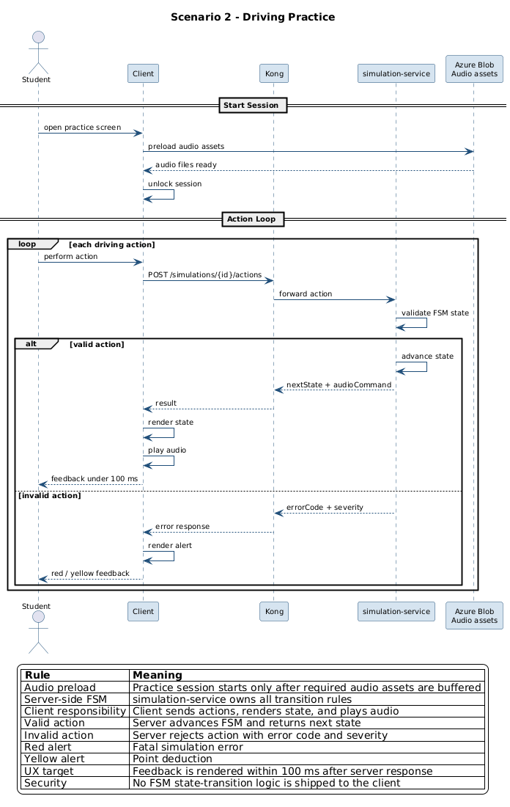

3.6.3 Scenario 3: Offline Exam & Auto-Sync

This scenario covers exam resilience under network loss. During a normal exam session the client auto-saves answers to the exam-service every 5 to 10 seconds using an idempotent endpoint so that duplicate saves never create duplicate records. When the network is lost, the client detects the disconnection within 2 seconds and displays a non-blocking offline banner without covering the question content. The student continues answering and the client stores all new answers locally. When connectivity returns, the offline indicator clears automatically and the buffered answers are synced silently without any student action. On final submission, all answers — including those saved offline — are included in the atomic submission payload. This scenario exercises ASR-REL-03 and ASR-UX-05.

PlantUML Source:

@startuml
skinparam defaultFontName Arial
skinparam defaultFontSize 10
skinparam backgroundColor #FFFFFF

skinparam sequence {
ArrowColor #1F4E79
ActorBorderColor #1F4E79
LifeLineBorderColor #1F4E79
ParticipantBorderColor #1F4E79
ParticipantBackgroundColor #D6E4F0
BoxBorderColor #1F4E79
BoxBackgroundColor #EEF3FB
}

title Scenario 3 - Offline Sync

actor Student
participant "Client" as App
participant "Kong" as GW
participant "exam-service" as Exam

== Normal Auto-save ==

Student -> App : answer questions

loop every 5-10s
App -> App : save local draft
App -> GW : PUT /exam/sessions/{id}/answers
GW -> Exam : idempotent upsert
Exam --> GW : saved
GW --> App : save ACK
end

== Network Loss ==

App -[#red]x GW : request fails
App -> App : detect offline within 2s
App -> App : show non-blocking banner

Student -> App : continue answering

loop while offline
App -> App : buffer answers locally
App -> App : update local draft
end

== Network Restored ==

App -> App : detect reconnect

loop until buffer empty
App -> GW : sync buffered answers
GW -> Exam : idempotent upsert
Exam --> GW : sync ACK
GW --> App : remove synced items
end

App -> App : clear offline banner
App --> Student : offline changes synced

== Final Submission ==

Student -> App : tap submit
App -> App : flush pending local buffer
App -> App : build complete answer payload

alt online
App -> GW : POST /exam/sessions/{id}/submit
GW -> Exam : atomic submit
Exam --> GW : score + result
GW --> App : final result
App --> Student : show result screen
else still offline
App -> App : keep submit pending
App --> Student : show offline banner
end

legend bottom
|= Rule |= Meaning |
| Auto-save | Client saves answers every 5-10 seconds |
| Idempotent upsert | Repeated saves update the same answer record |
| Offline detection | Client detects network loss within about 2 seconds |
| Non-blocking UI | Offline banner does not cover question content |
| Local buffer | New answers are stored locally while offline |
| Silent sync | Buffered answers sync automatically after reconnect |
| Final submit | Payload is built from the latest local answer state |
| Atomic submit | exam-service finalizes answers and result in one transaction |
endlegend
@enduml
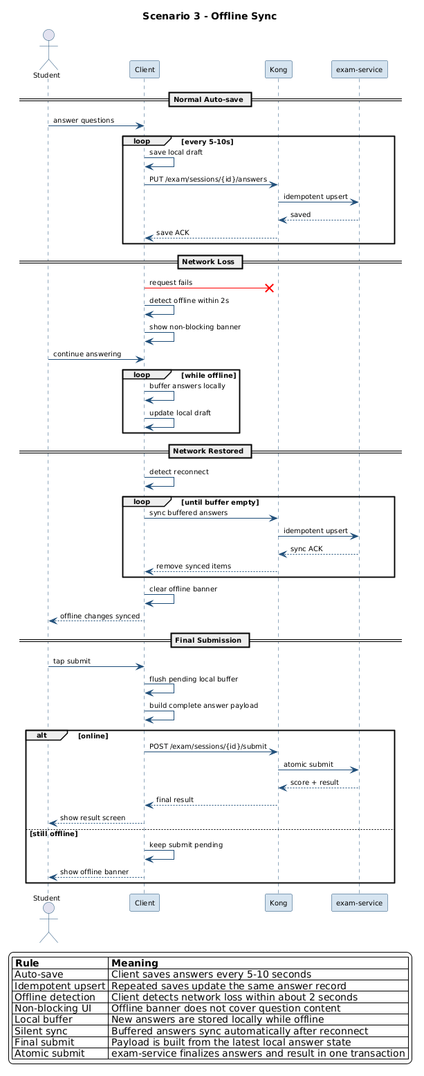

3.6.4 Scenario 4: Exam Generation & Answer Confidentiality

This scenario covers exam creation and the enforcement of answer confidentiality. When a student starts an exam, the exam-service loads the active ExamTemplate and immediately snapshots the question content as immutable JSON blobs attached to each ExamSessionQuestion record — future question edits cannot affect this exam. Questions are selected using indexed database queries grouped by topic to match the configured counts exactly; full-table scans are prohibited. Before the question payload leaves the server, the Response Serialiser strips the isCorrect field from every option object. The entire generation flow completes within 3 seconds at the 95th percentile. This scenario exercises ASR-PERF-12, ASR-DI-09, and ASR-SEC-05.

PlantUML Source:

@startuml
skinparam defaultFontName Arial
skinparam defaultFontSize 10
skinparam backgroundColor #FFFFFF

skinparam sequence {
ArrowColor #1F4E79
ActorBorderColor #1F4E79
LifeLineBorderColor #1F4E79
ParticipantBorderColor #1F4E79
ParticipantBackgroundColor #D6E4F0
BoxBorderColor #1F4E79
BoxBackgroundColor #EEF3FB
}

title Scenario 4 - Exam Generation

actor Student
participant "Client" as App
participant "Kong" as GW
participant "exam-service" as Exam
database "exam_db" as ExamDB
participant "question-service" as QuestionSvc
database "question_db" as QuestionDB
participant "ResponseSerializer" as RS

Student -> App : start exam
App -> GW : POST /exam/sessions/start
GW -> Exam : generate exam

Exam -> ExamDB : load active template

Exam -> QuestionSvc : request question set
QuestionSvc -> QuestionDB : indexed query by\ncategory + topic
QuestionDB --> QuestionSvc : questions + options
QuestionSvc --> Exam : internal question list

Exam -> Exam : validate template counts
Exam -> Exam : shuffle options
Exam -> ExamDB : create ExamSession
Exam -> ExamDB : create ExamSessionQuestions\nsnapshot JSONB

alt template satisfied
Exam -> RS : build response payload
RS -> RS : remove isCorrect fields
RS --> Exam : safe payload
Exam --> GW : exam ready
GW --> App : questions without answers
App --> Student : show first question
else template not satisfied
Exam --> GW : HTTP 400
GW --> App : descriptive error
App --> Student : show error
end

legend bottom
|= Rule |= Meaning |
| Template loading | exam-service loads active ExamTemplate from exam_db |
| Indexed selection | question-service queries question_db by indexed category/topic fields |
| No full scan | Question selection must not scan the full question table |
| Snapshot strategy | ExamSessionQuestion stores immutable question/options JSONB |
| Future edits safe | Later edits in question_db do not affect this exam |
| Server-only correctness | isCorrect may exist internally but never leaves the server |
| ResponseSerializer | Removes isCorrect from every option before response |
| Performance target | Exam generation completes within 3 seconds at P95 |
endlegend
@enduml
