DOCUMENT HISTORY AND INFORMATION

History of Amendments:
Date | Version | Modified Section | Summary of Change | Author
24/10/17 | 0.1 | ALL | Initial Draft | Chúc Ngân

Distributed for Review
This document has been distributed for the following to review:
Name | Title & Company | Issue Date | Revision
Approvals
This document requires the following approvals:
Name | Signature | Title | Issue Date

Associated Documents
This document is associated with the following other documents:
Name | Title and Originator’s Reference | Source | Issue Date | Version

Table of Contents
1 Introduction 3
2 Purpose 3
3 Scope 3
4 Definitions, Acronyms and Abbreviations 3
5 Overview 3
5.1 Use case diagram 3
5.2 Entity relationship diagram 3
6 Functionality Requirements: Ordering Process 3
6.1 Product Selection 3
a. Browse Categories 3
b. Product Search 4
6.2 Accessing the Product Page 5
a. Product Images 6
b. Product Name 6
c. Product Price 6
d. Product Options 7
e. Product Quantity 7
f. Product Description Information 10
g. Reviews and Comments 11
h. Number of Products Sold: 11
i. Seller Information: 11
j. Shipping Policy 11
6.3 Product Addition to Cart Process 12
a. "Add to Cart" Button 12
b. Notification of Product Added to Cart 14
c. Shopping Cart Update 15
d. “Buy Now” Button Functionality 16
6.4 Shopping Cart Features 16
a. View Shopping Cart Details 16
b. Product Information 16
c. Total Amount 17
d. Cart Handling Options 17
e. Functionality to Select One or More Products: 18
f. Functionality for Purchase Limit Notification: 19
g. Functionality to Remove Products: 20
h. Display Related Products: 20
i. Automatic Voucher Application: 20
j. Change Total Amount 22
k. Function of the "Checkout" Button: 23
7 Non-functional requirements 23
7.1 Performance 23
7.2 Scalability 23
7.3 Security 23
7.4 Portability 23
7.5 Audit 24
7.6 Error handling 24
7.7 Infrastructure 24
7.8 Look and feel 24
7.9 Legal 24
7.10 Training 24
7.11 User Documentation & Help Screen Requirements 25
7.12 Support & Supportability 25
7.13 Reliability 25
7.14 Design Constraints 25
7.15 Purchased Components 25
7.16 Interfaces 25
7.17 Test 26
7.18 Data 26

Introduction
.

Purpose

Scope
.

Definitions, Acronyms and Abbreviations
<TBD>

Overview

Use case diagram

UC | Name | Description
UC001
UC002
UC003
UC004
UC005
UC006

Entity relationship diagram

# | Entity | Description
1
2
3
4
5
6
7
8
9
10
11
12
13

Functionality Requirements: Ordering Process

Product Selection

Browse Categories

Users can browse product categories from the navigation bar or the homepage.
When clicking on a category, the system will navigate to the product listing page of that category, with filters such as price, rating, brand, condition, etc

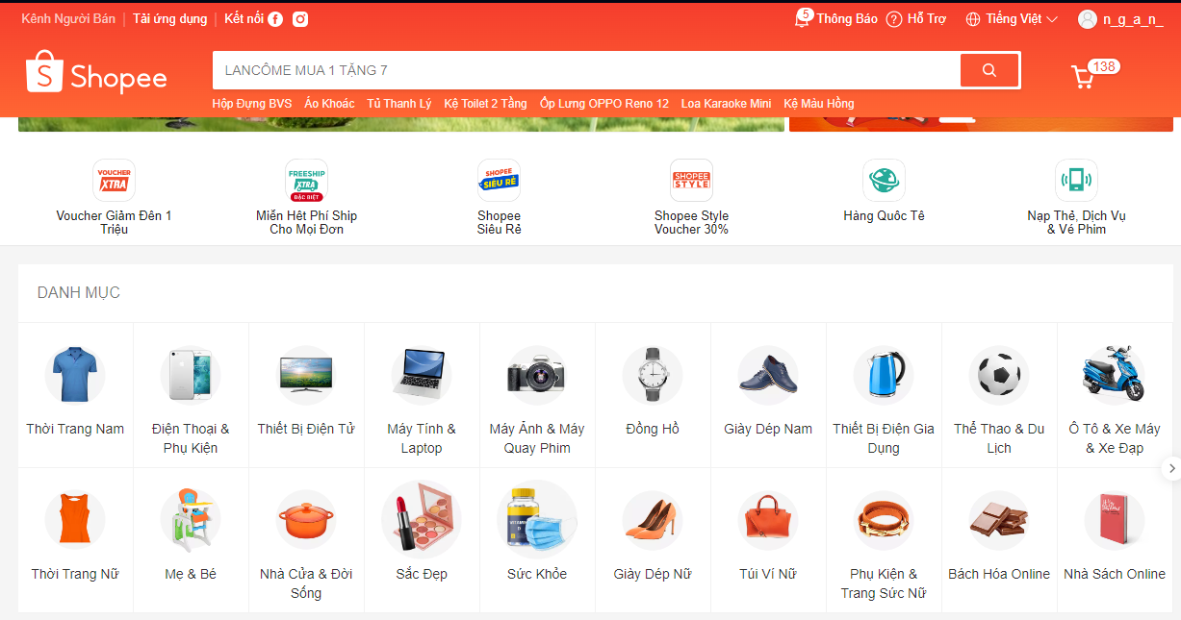

Product Search

On the search bar, users can enter the product name or related keywords.
The system will provide instant search suggestions or display the results after the user presses "Enter" or clicks the search icon.
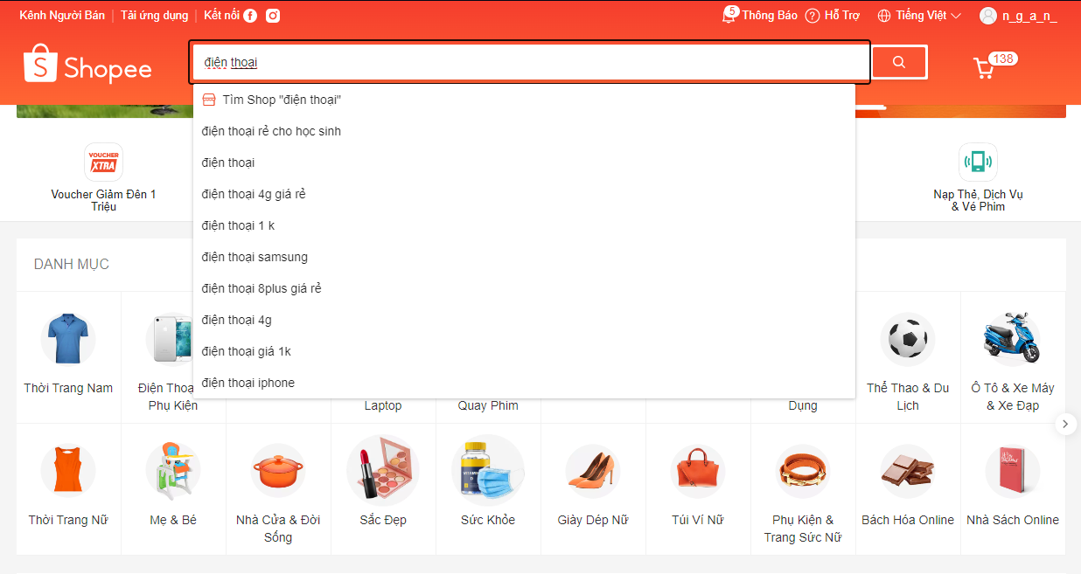

Accessing the Product Detail Page

Product list
When the user clicks on the product name or image from the list, the system will navigate to the Product Detail Page, displaying the following information:

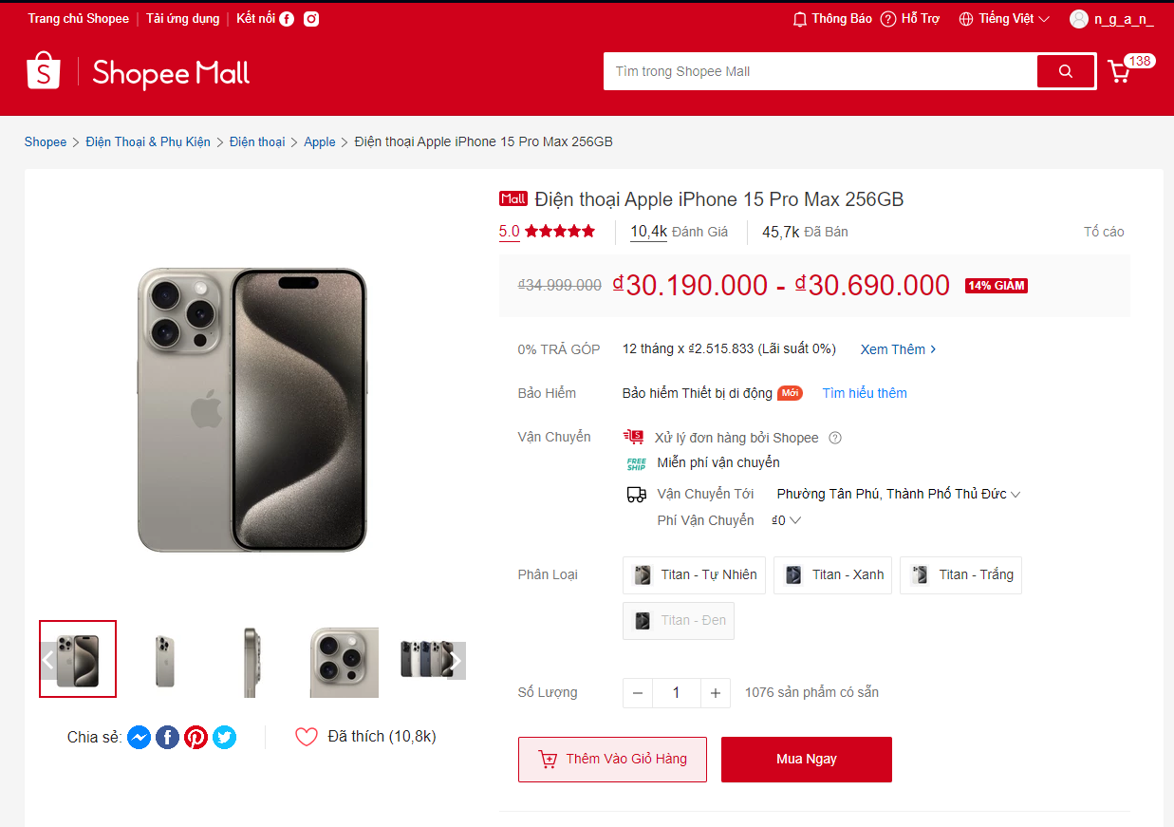

Product Images
High-quality images from multiple angles (front view, side view, close-up, etc.).
Users can click on the image to zoom in or select a different image by clicking on the thumbnails below.
Images are displayed in a slider with smooth transition effects.

Product Name
The full product name is prominently displayed and easy to read, positioned to the right of the image.
The name may include information such as the brand, product type, and key specifications (e.g., Apple iPhone 15 Pro Max - 256GB).

Product Price
The current price of the product is displayed in large, easy-to-read text.
If there is a discount, the system shows both the original price (crossed out) and the discount percentage.
For example: 15,990,000₫ (original price) → 12,990,000₫ (20% discount).

Product Options
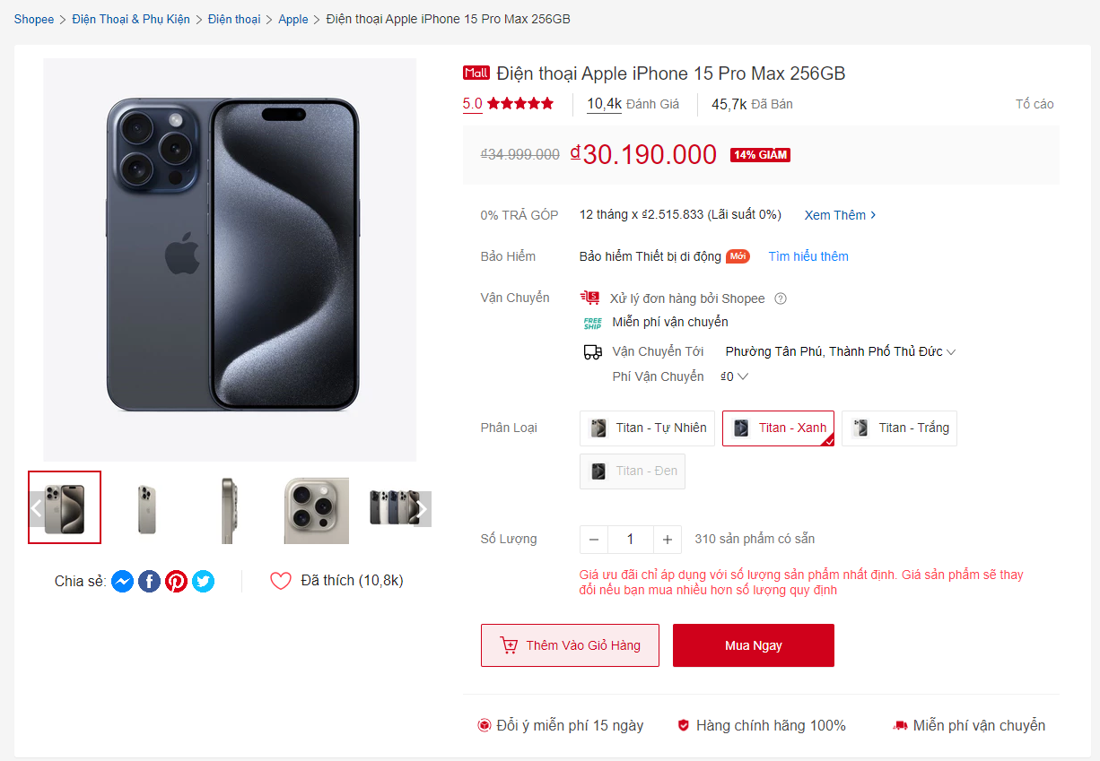
If the product has multiple options (e.g., color, size, capacity), users can choose from these options.
Options can be displayed as:
- Selectable buttons, each with a clear image illustrating the color or size.
- For example, users can easily choose between Natural Titanium and Blue Titanium, or between 128GB and 256GB capacity with a single click.
As soon as the user clicks on an option, the product price is immediately updated to reflect their selection. If there is a price difference between the options, the user will see a clear change, making it easier for them to decide.
Limited Quantity Notification:
- If the product has a limited quantity, the system will display a prominent notification in red next to the selected option: "Discount price applies only to a certain quantity. The price will change if you purchase more than the specified amount."
- This notification not only provides important information but also creates a sense of urgency, encouraging users to make a quick decision.

Product Quantity
Quantity Input Interface:
- Quantity Input Field: A quantity input field will appear, allowing users to enter their desired quantity. The default value will be set to 1, ensuring that users can quickly add the product to the cart without needing to make any changes if they are purchasing just one item.
- Increment/Decrement Buttons: Next to the quantity input field, there are two buttons (+ and -) that allow users to increase or decrease the product quantity quickly. Users can simply click the + button to increase the quantity or the - button to decrease it.
Increment/Decrement Functionality:
- Increase Quantity: When the user clicks the + button, the product quantity will increase by one unit, allowing them to easily adjust the desired quantity up to the maximum limit permitted by the system.
- Decrease Quantity: Similarly, when the - button is pressed, the quantity will decrease. If the current quantity is 1, the user will not be able to reduce it further, ensuring that at least one product remains in the cart.
Quantity Input Notifications:
- When the user adjusts the product quantity in the input field, the system will immediately respond with notifications to ensure the user is always updated on the product's status and price. Below are two important notifications that users may encounter:
  - Price Change Notification
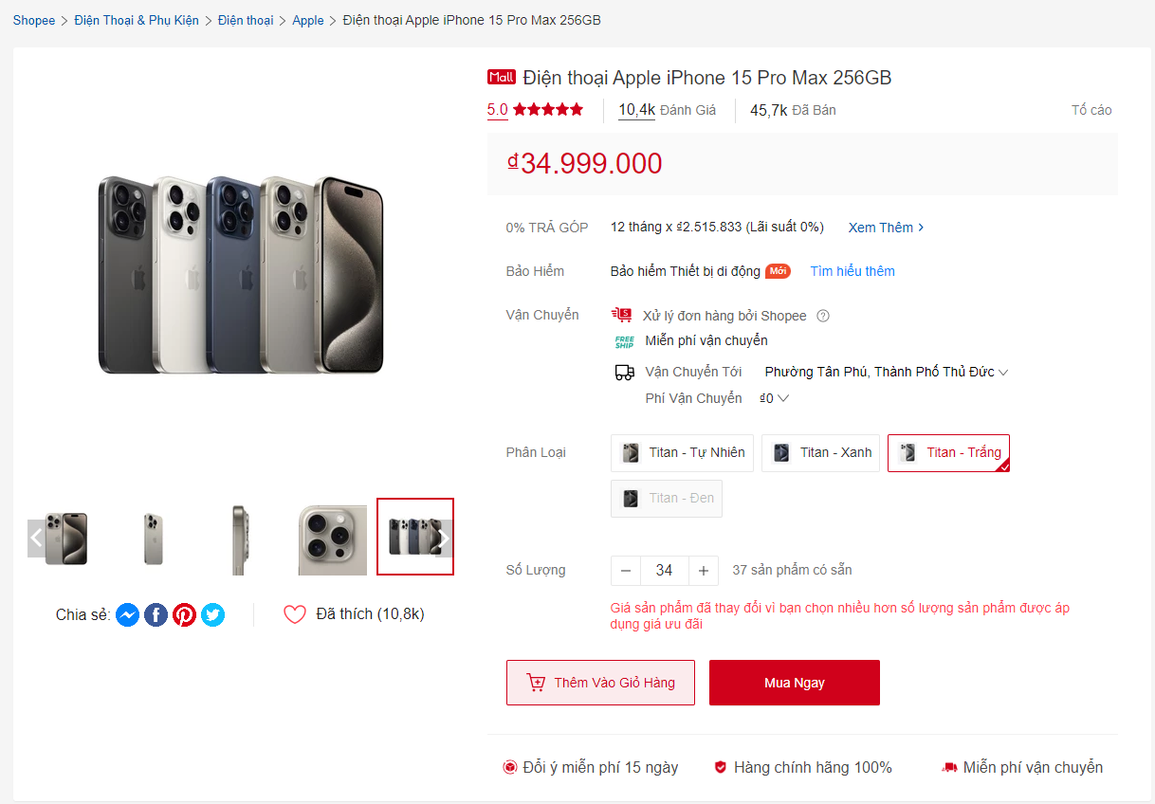
    - Notification Content: " The product price has changed because you selected a quantity exceeding the limit for the promotional price."
    - When It Appears: This notification will be displayed when the user attempts to select a quantity exceeding the limit set for the discounted price.
    - Function: It helps the user understand that if they select a quantity larger than the threshold, the product price will increase. This notification encourages the user to reconsider their quantity selection and may prompt them to explore pricing for different quantities.

- Notification About Maximum Quantity Reached
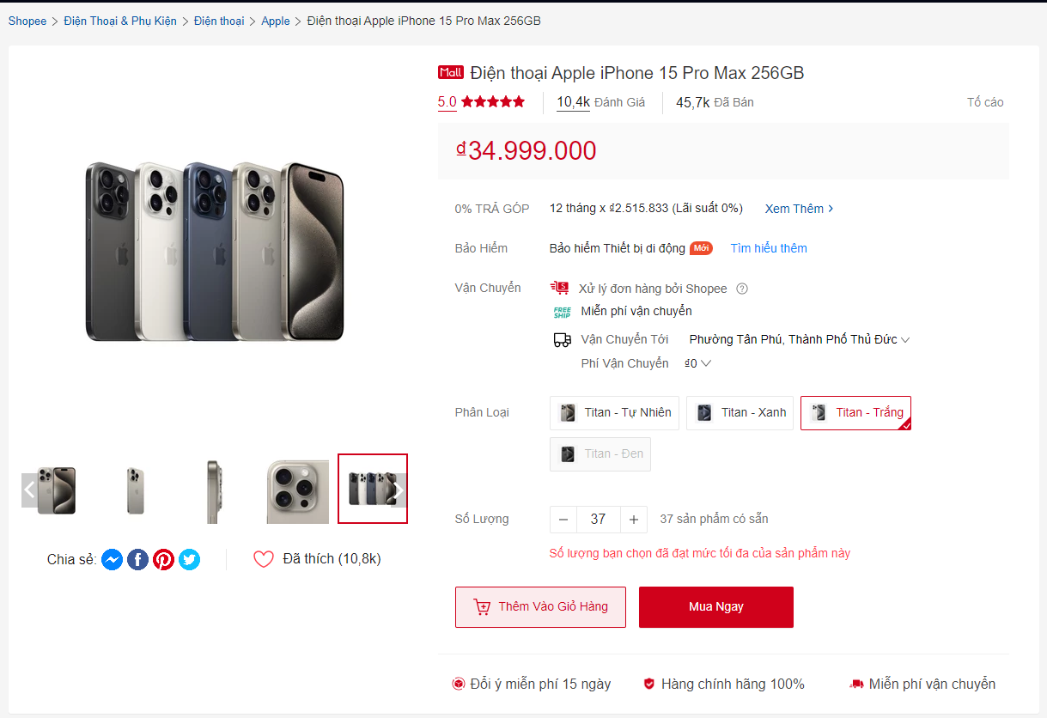
- Notification Content: "The quantity you selected has reached the maximum limit for this product."
- When It Appears: This notification will be displayed when the user selects a quantity that has reached the maximum limit allowed by the system.
- Function: This notification informs the user of the purchasing limit, helping them decide whether to purchase other items or choose a different product if they need to buy more..
- Instructions for Users
  - If the user receives the notification that the product price has changed, they can adjust the quantity to a permissible amount to receive the discounted price.
  - If they receive the notification about the maximum quantity reached, the user should reconsider the amount they wish to purchase and may need to contact the supplier or explore other options if they need to buy more than allowed..

Product Description Information
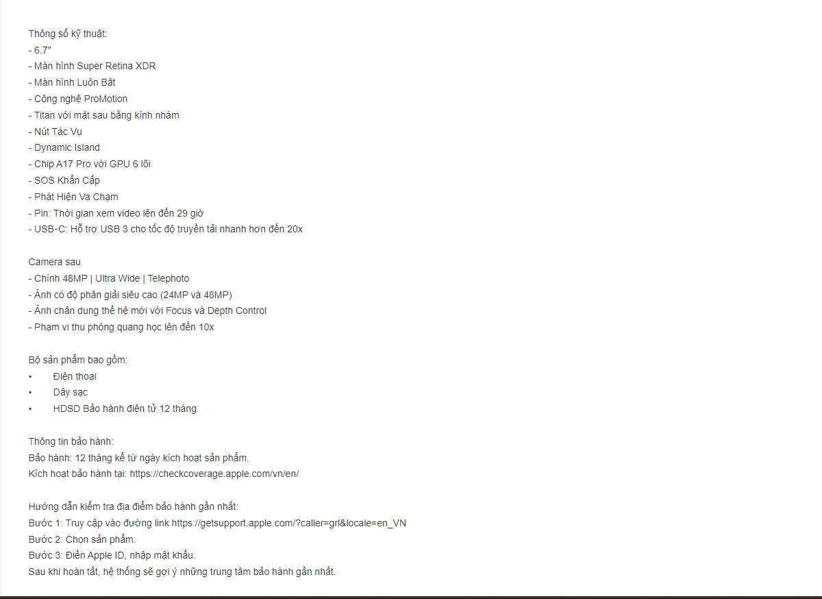
A brief description including key features and highlighted specifications.
It may include details such as: weight, material, technology, warranty.
If there is more detailed information, the system will display a "See More" button to expand the content.

Reviews and Comments
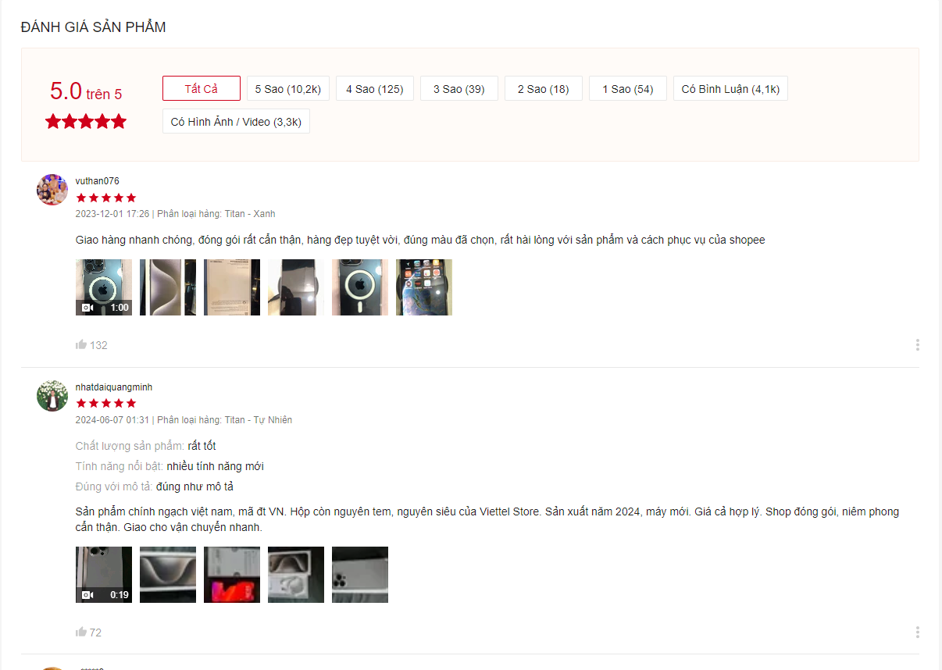

Display Ratings:
- Displays an average rating from 1 to 5 stars, along with the total number of reviews.
Customer Comments Section:
- Below the ratings section is a list of reviews from previous customers, including real product images uploaded by buyers.
Review Filtering Options:
- Users can filter reviews based on the following criteria:
  - Star rating (from 1 to 5 stars).
  - With images.
  - With detailed comments.
.

Number of Products Sold:
The number of products sold will be displayed right below the product name, for example: “1,500 products sold”.

Seller Information:
This section displays basic information about the seller, including:
- Shop name.
- Overall shop rating.
- Badges such as Favorite Shop, Trusted Shop, Fast Shipping.
- A "View Shop" button to see detailed information about the shop and its other products.

Shipping Policy

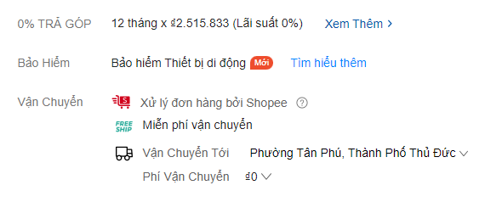
Users enter their shipping address or postal code to view the shipping cost and estimated delivery time.
Display available shipping options such as express delivery or standard delivery with the corresponding fees.

Product Addition to Cart Process
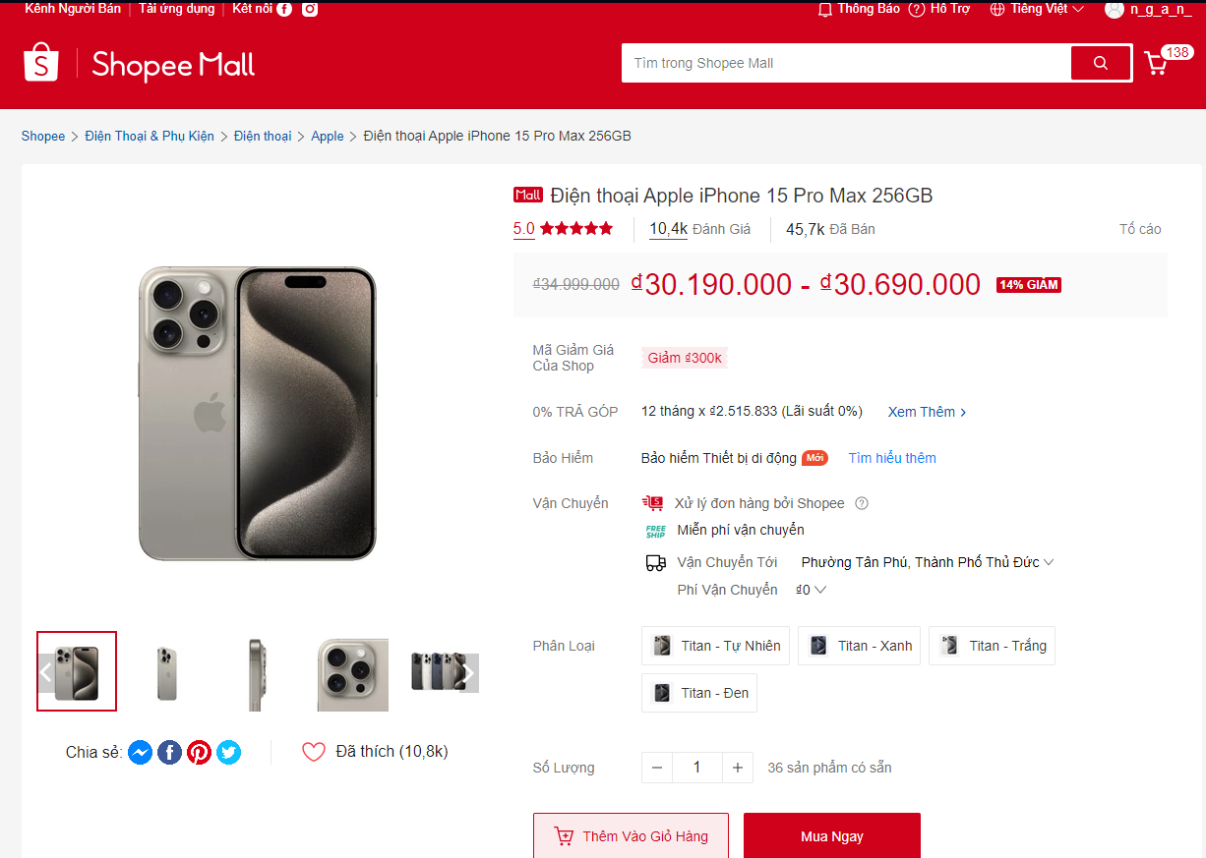

"Add to Cart" Button
Button Features:
- Design:
  - The "Add to Cart" button is designed to stand out, typically with a contrasting color for easy recognition.
- Placement:
  - This button is positioned directly below the product quantity section and to the left of the "Buy Now" button, providing convenience for users once they have selected their desired quantity and options.
.
- Functionality:
  - When the user clicks the "Add to Cart" button, the system will check:
    - Quantity: Has the user entered a quantity? Does the entered quantity exceed the allowed maximum limit?
    - Options: The system will verify if the user has selected product options (if any). If no option has been selected, a notification will appear: "Please select a variant."
- Guidance:
  - Additional small hints can be displayed next to product options, reminding users that they need to select an option before adding the product to the cart.
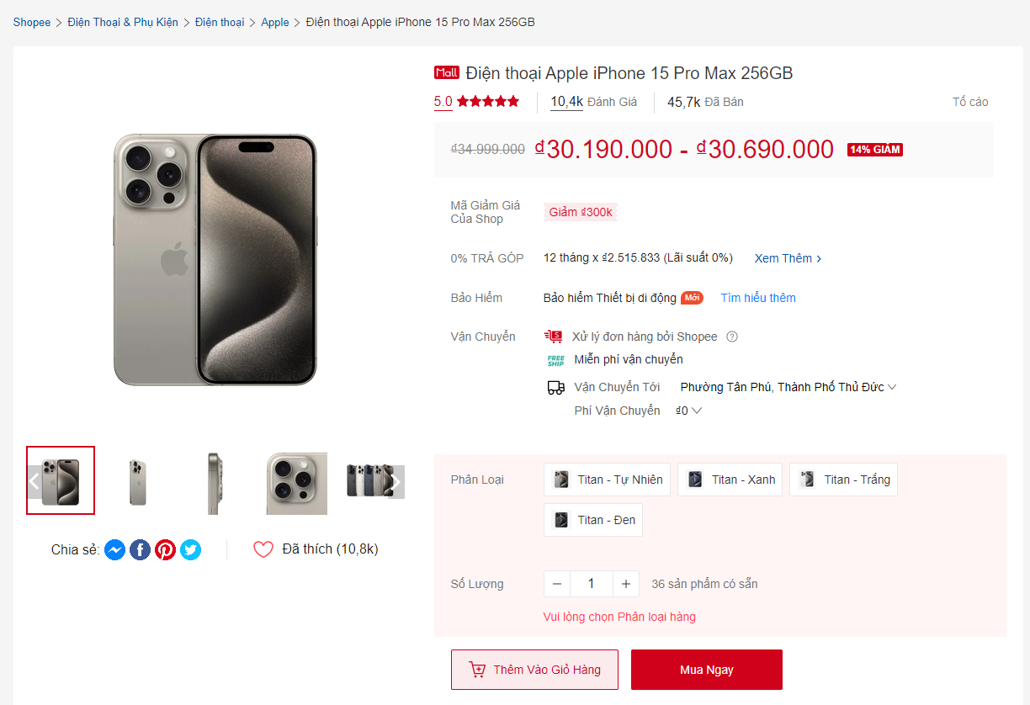

Notification of Product Added to Cart
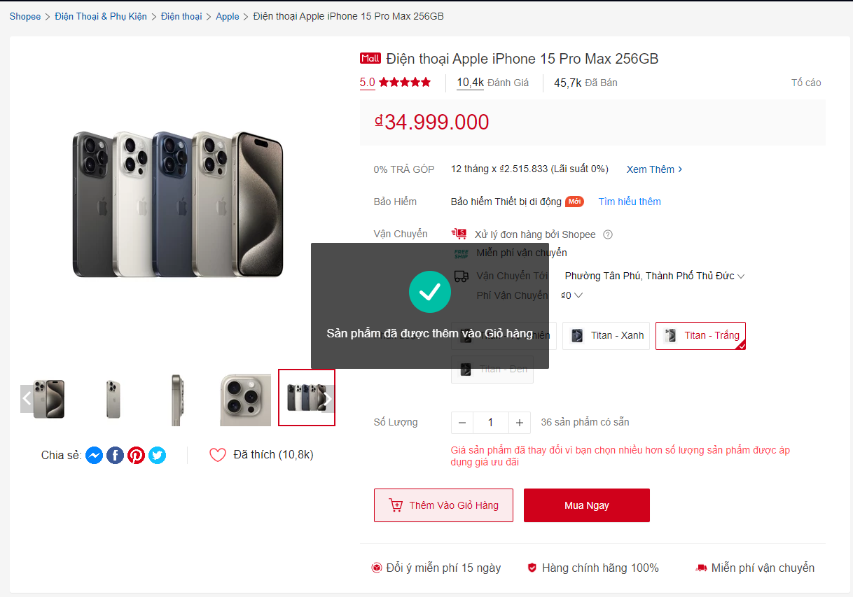

When the Product is Successfully Added:
- A popup notification will appear immediately, confirming that the product has been successfully added to the cart.
- Notification Content:
  - "The product has been added to your cart!"
Popup Display:
- The popup should disappear automatically after a few seconds if the user doesn't interact with it.

Shopping Cart Update
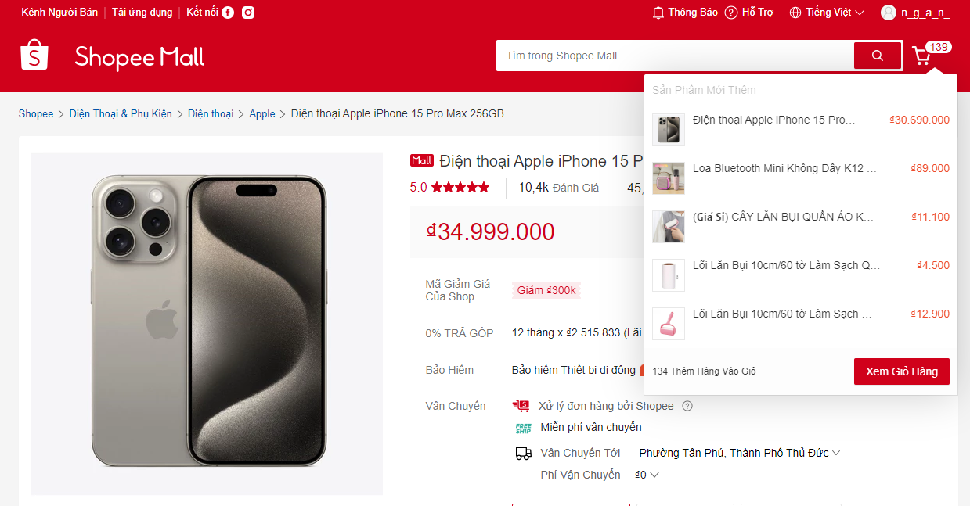
Update Shopping Cart Icon:
- After a product is successfully added to the shopping cart, the cart icon in the top corner of the page will automatically update to display the number of products currently in the cart.
Shopping Cart Detail View Feature:
- Users can click on the cart icon to view details of the products that have been added, including the product name, quantity, price, and options, as well as the total amount to be paid.
Mouse Hover Feature:
- When users hover over the cart icon, a popup will appear displaying information about some recently added products. This popup will include:
  - Product List:
    - The name and thumbnail image of each recently added product in the cart.
    - The quantity added to the cart.
    - The price of each product.
  - “View Cart” Button:
    - elow the product list, there will be a “View Cart” button allowing users to quickly navigate to the cart page to see the full list and proceed to checkout.
Popup Design:
- The popup should be designed to be clear and visually appealing, with a transparent background so that users can still see the content behind it. Product information will be arranged in chronological order of addition to the cart, with the most recently added products displayed at the top.
.

“Buy Now” Button Functionality
Position: The “Buy Now” button is usually located next to the “Add to Cart” button, just below the quantity selection and product options. It is designed to be prominent and easily visible to attract users' attention.
Functionality: When the user clicks the “Buy Now” button, the system will perform the following steps:
- Confirm Quantity and Options:
  - The system will check if the user has entered the product quantity and selected options (if any). If not, a notification will appear asking the user to complete the information before proceeding.
- Add Product to Cart:
  - If all information is completed, the product along with the quantity and options will be added to the cart.
- Redirect to Cart Page:
  - Immediately after the product is successfully added, the system will automatically navigate the user to the cart page. Here, the user will see detailed information about the selected product and can review it before proceeding to checkout.

Shopping Cart Features

View Shopping Cart Details
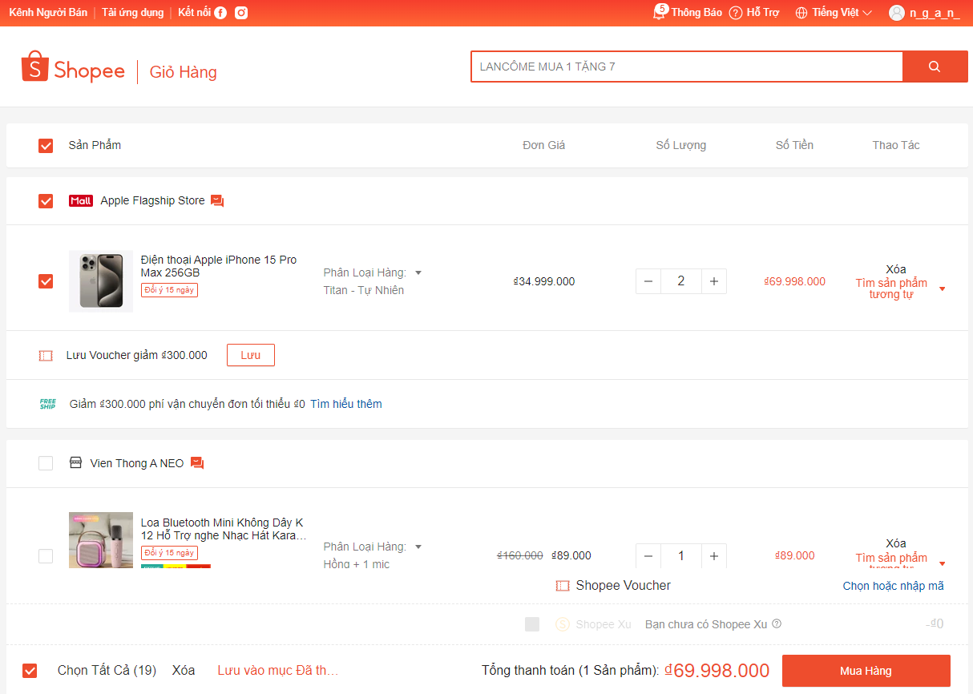
The shopping cart page is where users can view and manage the products they have added to the cart. The interface of the shopping cart page will display information clearly and understandably, allowing users to check before proceeding to checkout.

Product Information
The shopping cart page will display all products added to the cart, including:
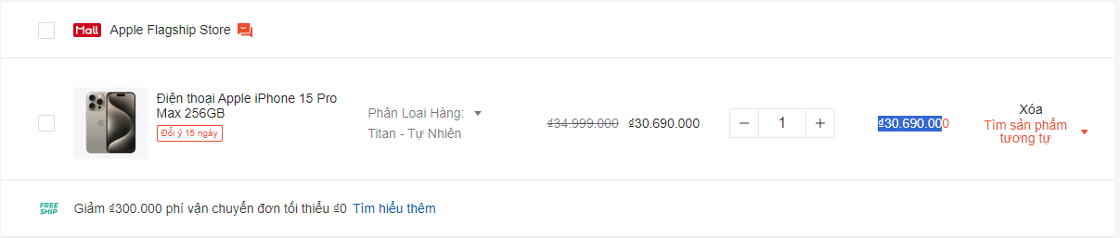

- Product Name: Clearly displays the name of each product.
- Product Image: Provides a thumbnail image to help users easily identify the product.
- Selected Quantity: Displays the quantity of the product that the user has selected.
- Price per Product: Shows the price of each product, helping users understand the individual cost.
- Total Price for Each Product: Calculates and displays the total price for each product based on the selected quantity (Price per Product x Quantity).
- Product Options (if any): If the product has multiple options (such as color, size), information about the selected option will also be displayed.

Total Amount
Below the list of products, the total amount to be paid will be calculated and displayed clearly, including:
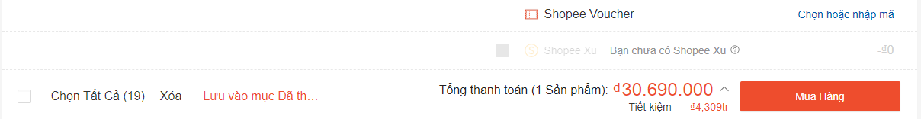

- Total Price of All Products in the Cart: Calculates the total cost of all selected products.
- Discount Amount (if any): Displays the amount saved after applying any discounts.

Cart Handling Options
Update Quantity:
- Users can change the quantity of products by using the increase (+) and decrease (-) buttons or by entering a new quantity in the input field.
- The system will automatically update the total amount instantly when the product quantity changes.
Change Product Classification:
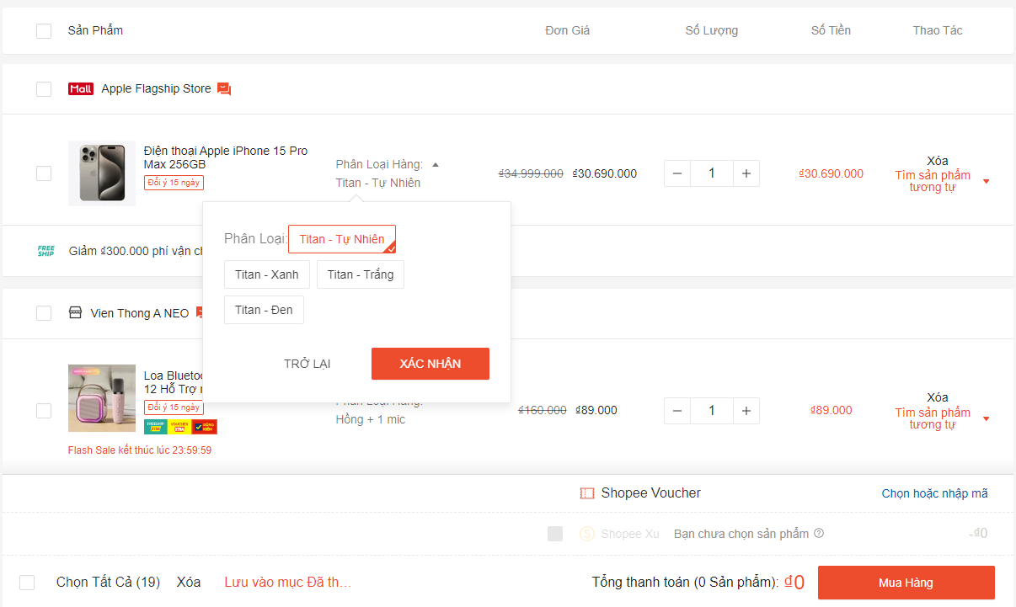
- Users can select one or more products in the cart to change their classification, making cart management more convenient. The system will provide an option to select the products they want to change.
- Option Buttons:
  - Confirm Button:
    - When the user clicks the "Confirm" button, the system will apply the classification changes to the selected products and update the cart.
  - Back Button:
    - When the user clicks the "Back" button, the popup will close, and the user can return to manage the cart without making any changes.

Functionality to Select One or More Products:
- Each product in the cart will have a checkbox next to it, allowing users to select the products they want.
- Users can check multiple products at once or only select a single product

Functionality for Purchase Limit Notification:
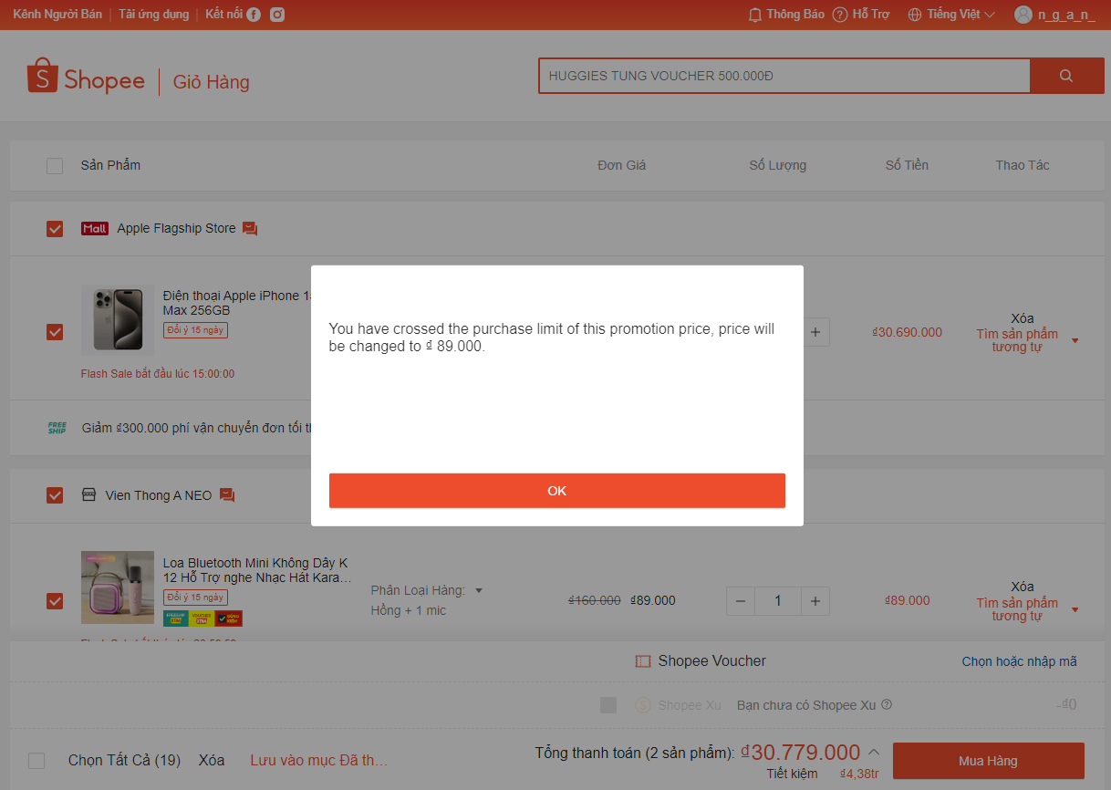
- When Does the Notification Appear?
  - This notification will appear when the user attempts to add a quantity of a product that exceeds the allowed limit for promotional pricing.
  - For example, if the promotional price applies to a product only when the user purchases a maximum of 3 units, and they try to purchase 4 units, this notification will be displayed.
- Notification Content:
  - Message: The notification will inform the user that they have exceeded the maximum quantity to receive the promotional price and that the price will switch to the regular (or new) price for the excess products.
  - New Price: The notification will specify the new price of the product, for example, "The price will change to ₫ 89,000."
- Impact on the Cart:
  - Price Update: The system will automatically update the price of the product in the cart. The user will see this new price displayed clearly on the cart page and product detail page.
  - Alert: The notification will help the user be clearly aware of the purchase limit and the effect of exceeding this limit on the product price, allowing them to adjust the quantity of products in the cart.
.

Functionality to Remove Products:
Users can easily remove one or more products from the cart if they decide not to purchase them anymore. In the cart, next to each product, there will be a delete icon for users to easily identify and interact with. Alternatively, users can check all products at the bottom left and click the delete button next to it to remove all products.

Display Related Products:
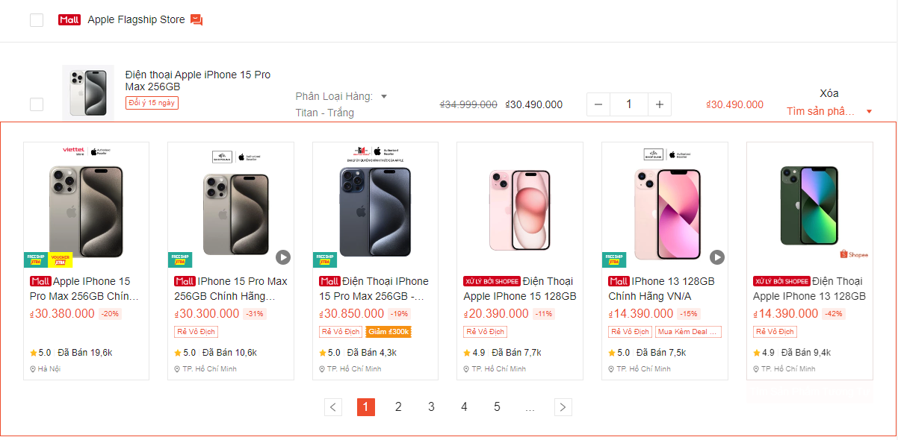
The cart page will display a "Find Similar Products" button next to the products in the cart. The system will use information about the products that the user has added to the cart to suggest similar or complementary products, which may include:
- Products of the same type (e.g., same brand, same category).
- Best-selling or popular products that many customers purchase together.

Automatic Voucher Application:
If users have a voucher code, they can enter the code into the corresponding field on the cart page. The system will automatically check the validity of the voucher code:
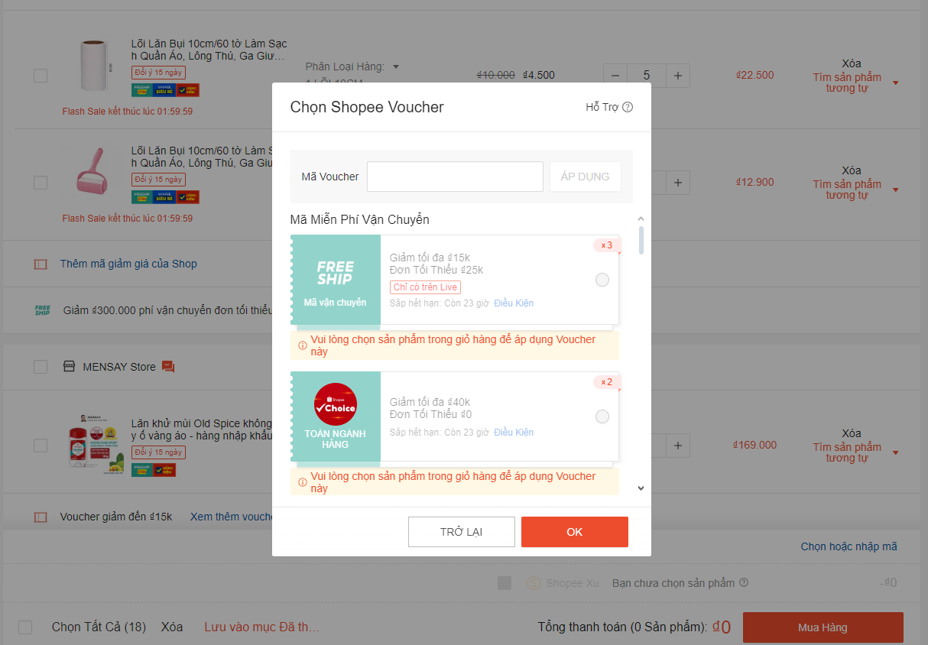
- Enter Voucher Code
  - Users can enter the voucher code into the corresponding field on the cart page. This voucher input field should be clearly designed and easily recognizable.
- Check Validity
  - As soon as the user clicks the "Apply" button after entering the voucher code, the system will check the validity of the voucher:
    - Successfully Applied: If the voucher code is valid and meets the usage conditions (e.g., not expired, meets minimum spending requirements):
      - The discount from the voucher will be automatically applied to the total amount.
      - Success Notification: The system will display a popup notification with content like:
        - "Voucher has been successfully applied! You have saved ₫ [discount amount]."
      - This popup will have two buttons:
        - OK: Close the notification.
        - Back: Close the notification and keep the voucher input field open so the user can continue editing.
    - Not Applied: If the voucher code is invalid or does not meet the conditions:
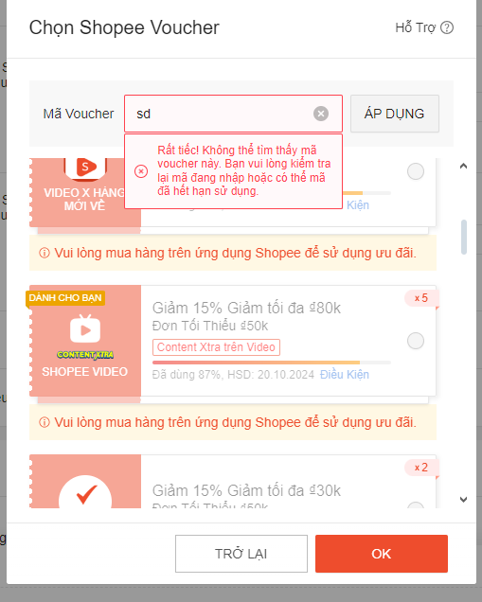

  - The system will display a notification like:
    - "Sorry! This voucher code cannot be found. Please check the code you entered, or it may have expired."
  - In this case, the voucher will not be applied, and the voucher input field will not have options for other codes.

Change Total Amount
Update Total Amount
- The total amount to be paid will be automatically updated as soon as the voucher is successfully applied, allowing the user to clearly see the actual amount they need to pay.
- The system will prioritize applying the voucher with the highest discount if there are multiple valid vouchers, and the user will be notified of which voucher has been applied.
Manage Vouchers
- Display Valid Vouchers
  - If there are valid vouchers, the system will display a list of applicable vouchers, allowing the user to select one of them.
  - If there are no valid vouchers, the voucher input field will remain unchanged but will not allow the selection of any other codes.
- Default Voucher
  - The system will prioritize selecting the default voucher to apply the highest discount, if this voucher exists and is valid.
  - The user will see a notification saying, "The default voucher has been applied with the highest discount" when the default voucher is selected.

Function of the "Checkout" Button:
Design of the Checkout Button
- The "Checkout" button will be designed large and prominently, typically with contrasting colors for easy identification.
- The position of this button will be clearly visible on the shopping cart page, below the total payment amount, and may be accompanied by an icon such as a shopping cart or payment method to attract the user’s attention.
Navigate to the Payment Page
- When the user clicks on the "Checkout" button, the system will perform the following steps:
  - Save the product information in the shopping cart for payment processing.
  - Redirect the user to the payment page, where they will complete the purchase process.

Non-functional requirements

Performance
Requirements relating to Performance
No. | Requirement
1.
2

Scalability
Requirements relating to Scalability
No. | Requirement
1. | It must scale to the expected number of users for SD system

Security
Requirements relating to Security
No. | Requirement
1. | Just use standard authentication and authorization mechanism

Portability
Requirements relating to Security
No. | Requirement
1. | For the up-coming release, the Service Directory is expected to work with Internet Explorer version 6.0 or later and Firefox.

Audit
Requirements relating to Audit
No. | Requirement
1. | None required at present.

Error handling
Requirements relating to Error handling
No. | Requirement
1. | Proactive notification of problems. System must provide sufficient context in the notification to assist in the diagnosis and repair of the problem. Varying levels of notification will be needed for different classes of error for instances: logging errors to log files, logging errors to event viewer, sending emails.

Infrastructure
Requirements relating to Infrastructure
No. | Requirement
1. | All services inside Service Directory are expected to be hosted under https for security purposes. Shaw-trust to confirm if they can provide an appropriate SSL infrastructure.

Look and feel
Requirements relating to Look and feel
No. | Requirement
1. | See section 6. The look and feel should also be similar to the screen mock-ups provided with the FRS for new ‘CID’ and should have the same feel as MS Dynamics.

Legal
Requirements relating to Legal issues
No. | Requirement
1. | None required at present.

Training
Requirements relating to Training
No. | Requirement
1. | None required at present.

User Documentation & Help Screen Requirements
Requirements relating to User Documentation
No. | Requirement
1. | An icon will be provided in the corner of each screen that can be clicked to load a page of help for that screen. The help text will be maintained by Shawtrust. This is in scope of Phase 2

Support & Supportability
Requirements relating to Support
No. | Requirement
1. | Fully support during UAT and 3 month warranty support

Reliability
Requirements relating to Reliability
No. | Requirement
1. | Availability: The Service Directory is expected to run all the time 24 hours a day and 7 day a week without service failing to respond. There should be no un-handled Exception to be occurred inside the Services.

Design Constraints
Requirements relating to Design
No. | Requirement
1. | The design must take this requirement into consideration for everything that the system may do and how this could be supported
2. | The design must follow principles for design in CID system

Purchased Components
Requirements relating to Components
No. | Requirement
1. | None required at present.

Interfaces
Requirements relating to Interfaces
No. | Requirement
1. | None required at present.

Test
Requirements relating to Testing
No. | Requirement
1. | None required at present.

Data
Requirements relating to Data
No. | Requirement
1. | None required at present.

