DPS(damage per second)

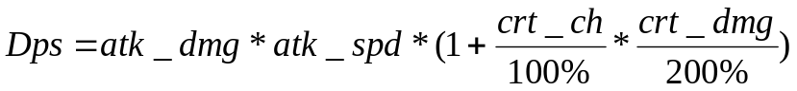 (1)

atk_dmg – attack damage. This feature provides the initial damage value of basic attacks. Its minimum value is a base attack damage, that champion has at the first level without any items, that increasing it (45.45 Karthus 1 lvl). The highest attainable attack damage by a playable champion is 1658(from here http://leagueoflegends.wikia.com/wiki/Attack_damage)
atk_spd – attack speed. Amount of attack, that champion makes per second. Its minimum value is a base attack speed, that champion has at the first level without any items, that increasing it(0.579 attacks per second). Maximum value is 2.5 attacks per second.
crt_ch – critical strike chance. The percent chance that a basic attack will critically strike to deal increased damage. Critical strike chance ranges from 0% to 100%
crt_dmg – critical strike damage. The percent of damage, that critical strike deals.
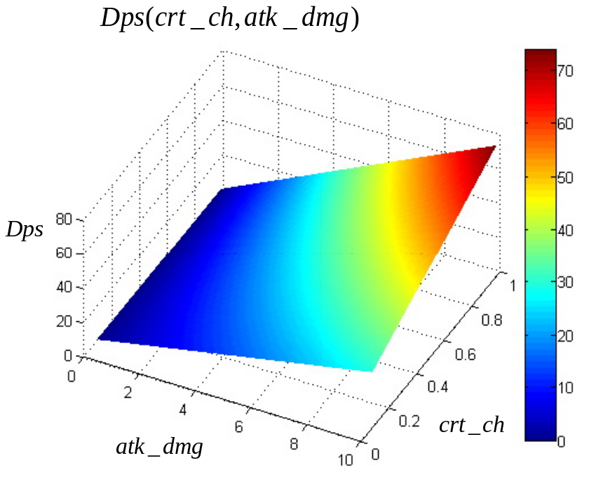
Fig. 1. Dps as a function of attack damage and critical strike chance
Fig. 1 illustrates the example of DPS (1) as a function of attack damage and critical strike chance. One can see that 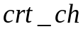 is a very important feature. And also the proportionality is well notiaceable.

Attack damage

(2)

atk_dmg₀ – The basic attack damage, that champion has at the first level. (minimum value is 45.45 – Karthus 1 lvl maximum value is 61.3 – Maokai 1 lvl)
lvl – The champion’s level(maximum 18)
atk_dmg_{lvl} – The value of attack damage, that is added when champion gets level up(minimum value is 2.2 – Thresh maximum value is 4.2 – Cho’Gath, Skarner)
atk_dmg_{itm} – The value of attack damage is increased by items.
atk_dmg_{bd} – The value of attack damage is increased by buffs and abilities or decreased by debuffs.

Attack speed

According the game principles and the info I have analyzed, the attack speed can be determined as a function of the following parameters

,
(3)

where

atk_spd₀ - The basic attack speed, that champion has at first level. This amount ranges from 0.579 to 0.694 and depends on the champion. It is the most important value for attack speed.
atk_spd_{lvl} - The percent value of attack speed, that is added when champion gets level up This amount ranges from roughly 0% to 4% and depends on the champion.
atk_spd_{itm} – The percent value of attack speed is increased by items
atk_spd_{bd} – The percent value of attack damage is increased by buffs and abilities or decreased by debuffs.

Critical strike chance

The critical strike chance is determined as follows

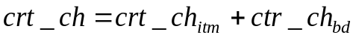 (3)

crt_ch_{itm} –– The percent value of critical chance is increased by items
crt_ch_{bd} - The percent value of critical chance is increased by buffs and abilities or decreased by debuffs.

Critical strike damage

Critical strike damage takes value 200% by default, but can be increased to 250% with “Infinity Edge” or “Lord Van Damm’s Pillager”.
Hence, using the equations (1)-(3), the DPS can be defined as follows

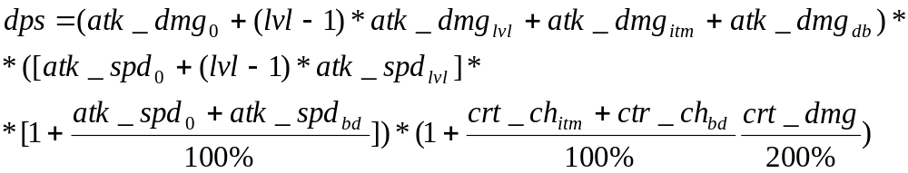(4)
This equation will be investigated in detail in the future project phases.

We need to know the cost of the unit increase for every stat in order to analyze and find the solution that increases the damage in the most cost effective way.
For this purpose the stat’s gold values can be derived from the cheapest basic item that provides only that stat. I have performed these calculations, similar things were performed here (http://leagueoflegends.wikia.com/wiki/Gold_efficiency.)

Example of calculation.

Cloth armor cost 300 gold and increases armor at 15. So we have to spend 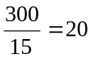 gold to increase armor at 1.

Champion Statistic | Base Item | Item Cost | Stat Raised | Gold / Stat Bonus
Attack Damage | Long Sword | 360g | 10 AD | 36
Ability Power | Amplifying Tome | 435g | 20 AP | 21.75
Armor | Cloth Armor | 300g | 15 Armor | 20
Magic Resistance | Null-Magic Mantle | 400g | 20 MR | 20
Health | Ruby Crystal | 475g | 180 HP | 2.64
Mana | Sapphire Crystal | 400g | 200 MP | 2
Health Regeneration | Rejuvenation Bead | 180g | 5 Hp5 | 36
Mana Regeneration | Faerie Charm | 180g | 3 Mp5 | 60
Strike Chance | Brawler's Gloves | 400g | 8% CSC | 50
Attack Speed | Dagger | 400g | 12% AS | 33.33
Movement Speed | Boots of Speed | 325g | 25 MS | 13

Table 1. The cost of unit increases of stats

One should notice that Cooldown reduction, life steal, and spell vamp are not found alone on any item, so their gold values are calculated using the least gold efficient, lowest-tier items available: Kindlegem, Vampiric Scepter, and Hextech Revolver. Armor penetration and magic penetration are not presented here, as the gold values derived from their lowest-tier items are misleadingly low.

Champion Statistic | Base Item | Item Cost | Stat Raised | Gold / Stat Bonus
Cooldown Reduction | Kindlegem | 850g | 200 Health  10% CDR | 2.64g / Health  32.2g / %CDR
Life Steal | Vampiric Scepter | 800g | 10 AD  10% LS | 36g / AD  44g / %LS
Spell Vamp | Hextech Revolver | 1200g | 40 AP  +12% Spell Vamp | 21.75g / AP  27.5g / %SV

Table 2. The cost of unit increases of specific stats

