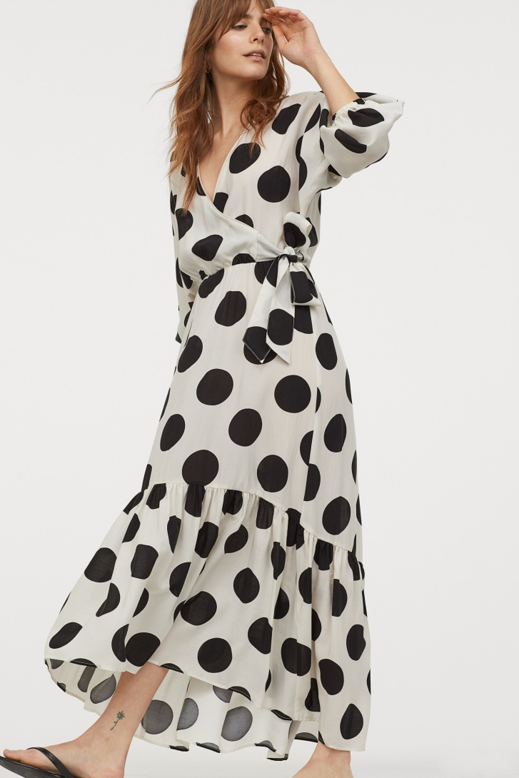[Lyocell Dress](https://www2.hm.com/en_us/productpage.0857570001.html)

$ 19.99  
Cream/dotted

Type: dress

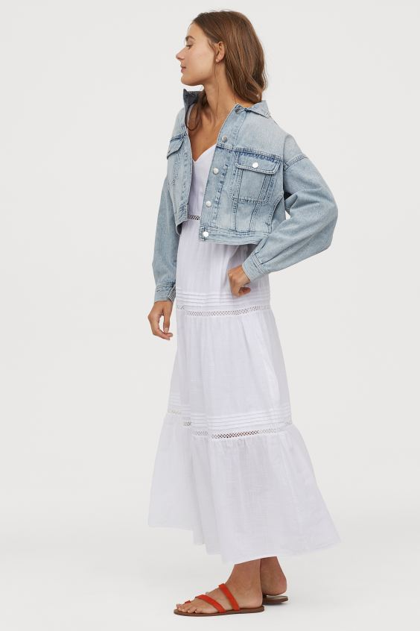

V-neck Cotton Dress

$39.99

SAVE AS FAVORITE

White

Calf-length dress in airy, woven cotton fabric with a linen feel. V-neck, narrow, adjustable shoulder straps, and fitted bodice with concealed zipper at back and hook-and-eye fastener at top. Gathered seam at waist with inset, hole-embroidered trim and flared skirt with pin-tucks and inset, hole-embroidered trim. Lined in soft, woven cotton fabric.

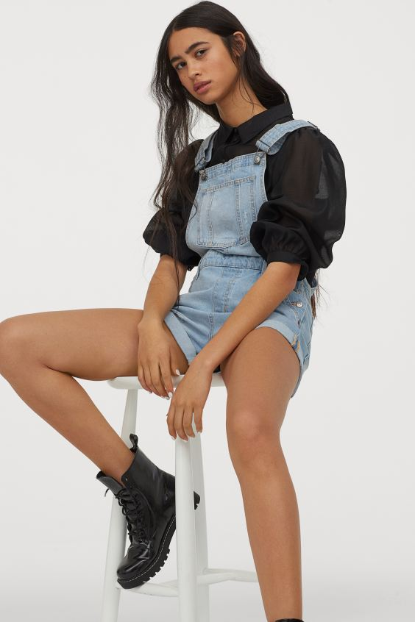Denim Overall Shorts

$39.99

Light denim blue

Overall shorts in washed cotton denim with heavily distressed details. Adjustable suspenders, mock fly, and buttons at sides. Bib pocket, side pockets, and back pockets. Sewn foldover cuffs at hems.

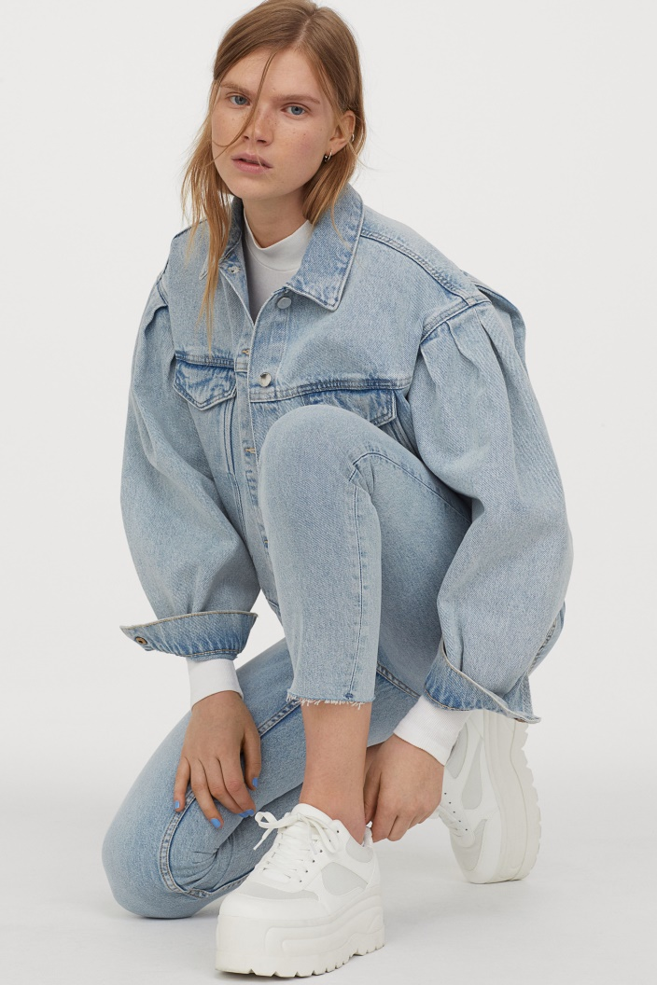Boxy Denim Jacket

$39.99

Light denim blue/washed

Boxy jacket in cotton denim with a collar and buttons at front. Heavily dropped shoulders, wide puff sleeves with pleats, and cuffs with concealed snap fastener. Chest pockets with flap and concealed snap fastener and diagonal front pockets.

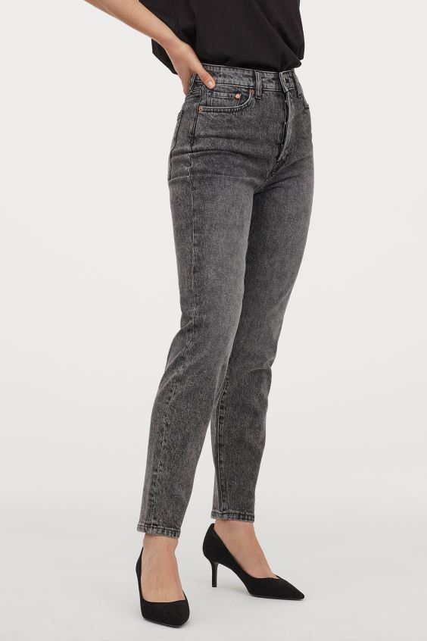Mom High Ankle Jeans

$29.99

Gray

5-pocket, ankle-length jeans in washed stretch cotton denim. Extra-high waist and straight legs. Slightly looser fit. Cotton content is partly recycled.

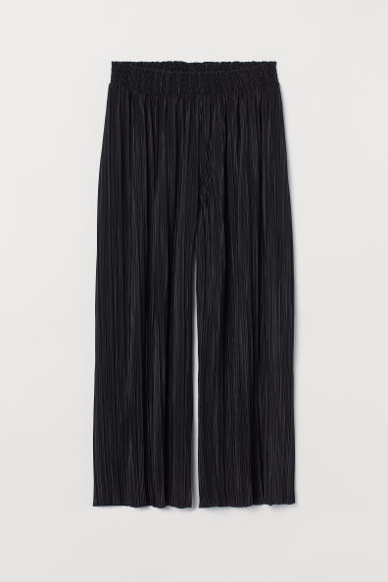

Pleated Culottes

$17.99

Calf-length pants in pleated jersey with a sheen. High waist with elasticized smocking. Straight, wide legs.

Patterned T-shirt

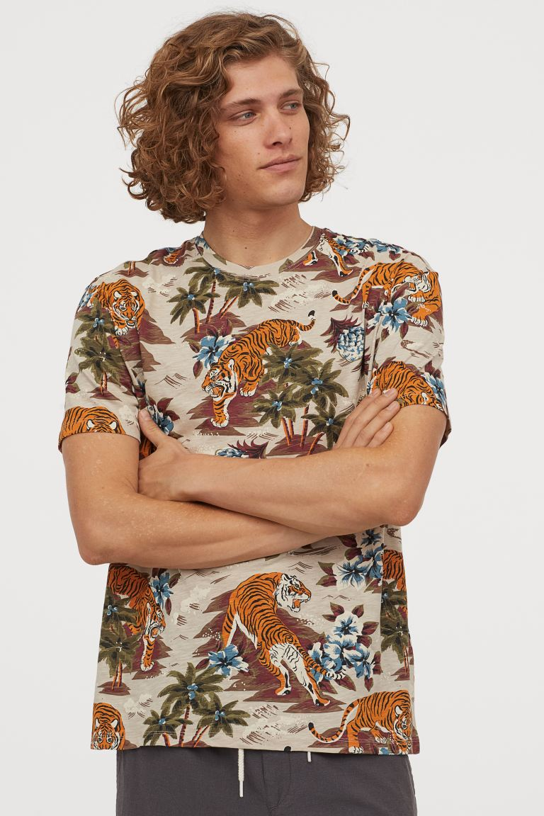$14.99

SAVE AS FAVORITE

Beige/tigersCrew-neck T-shirt in cotton slub jersey with a printed pattern.

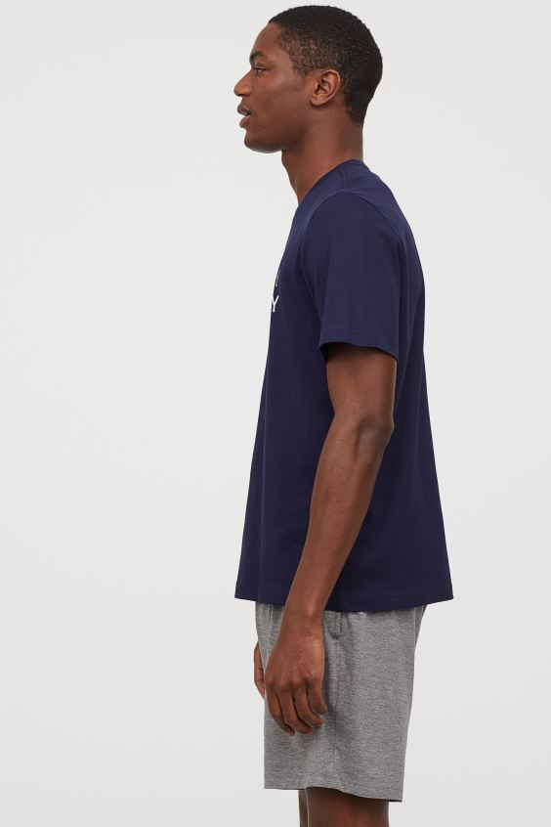Pajama T-shirt and Shorts

$19.99

SAVE AS FAVORITE

Dark blue/Less Monday

Pajama T-shirt and shorts in cotton jersey. T-shirt with a motif on chest. Patterned shorts with an elasticized waistband, side pockets, and mock fly.

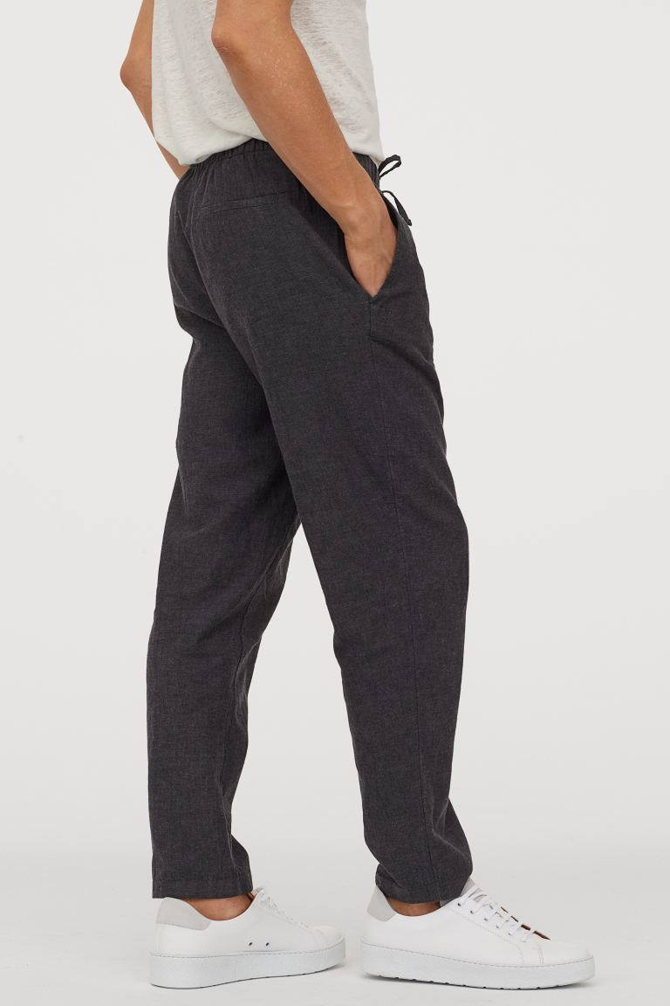Relaxed Fit Linen Pants

$34.99

Relaxed-fit pants in washed linen. Covered, elasticized waistband with drawstring and zip fly with hook-and-eye fastener. Side pockets, welt back pocket, and tapered legs.

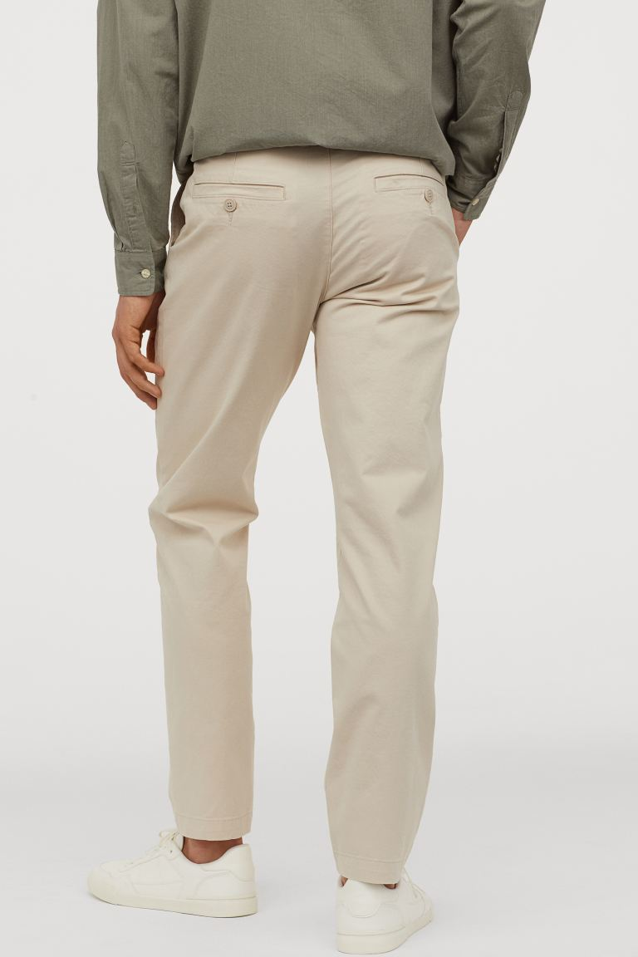

Slim Fit Chinos

$29.99

SAVE AS FAVORITE

Light beige

Chinos in extra-stretchy cotton twill. Zip fly, side pockets, coin pocket, and welt back pockets with button. Slim Fit – close-fitting at thighs, knees, and ankles for a tailored silhouette.

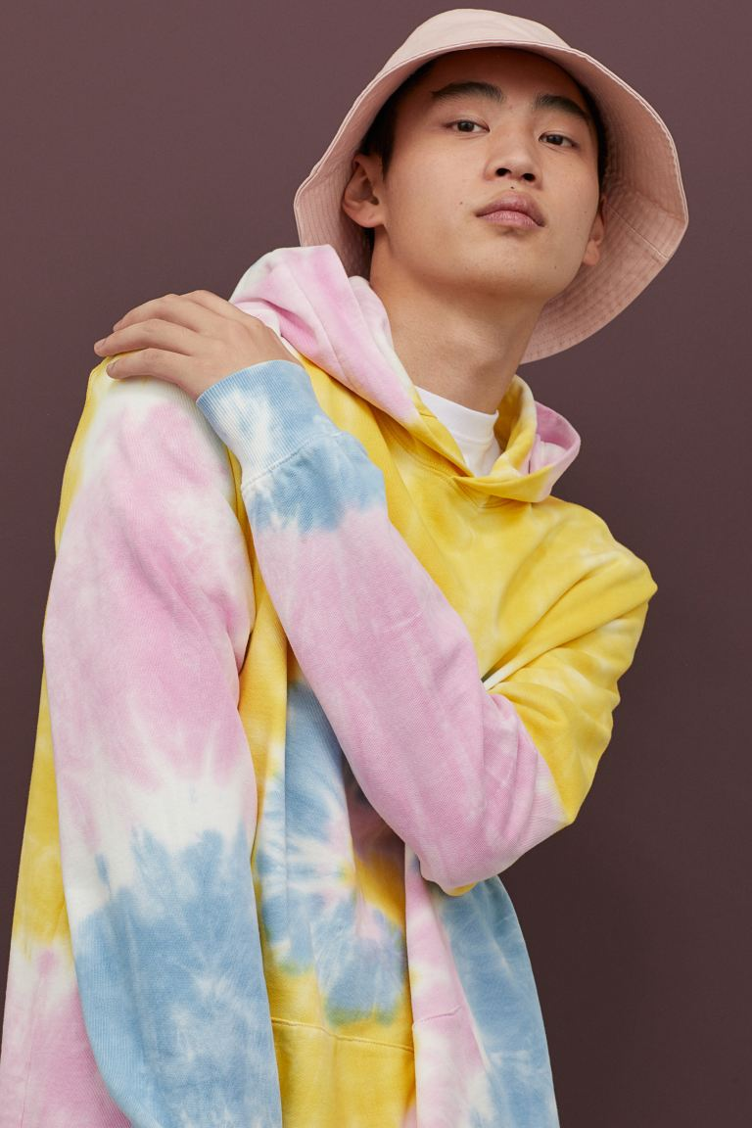Batik-dyed Hoodie

$34.99

SAVE AS FAVORITE

Yellow/batik-patterned

Sweatshirt in cotton fabric with a double-layered, wrap-front hood. Kangaroo pocket and ribbing at cuffs and hem.

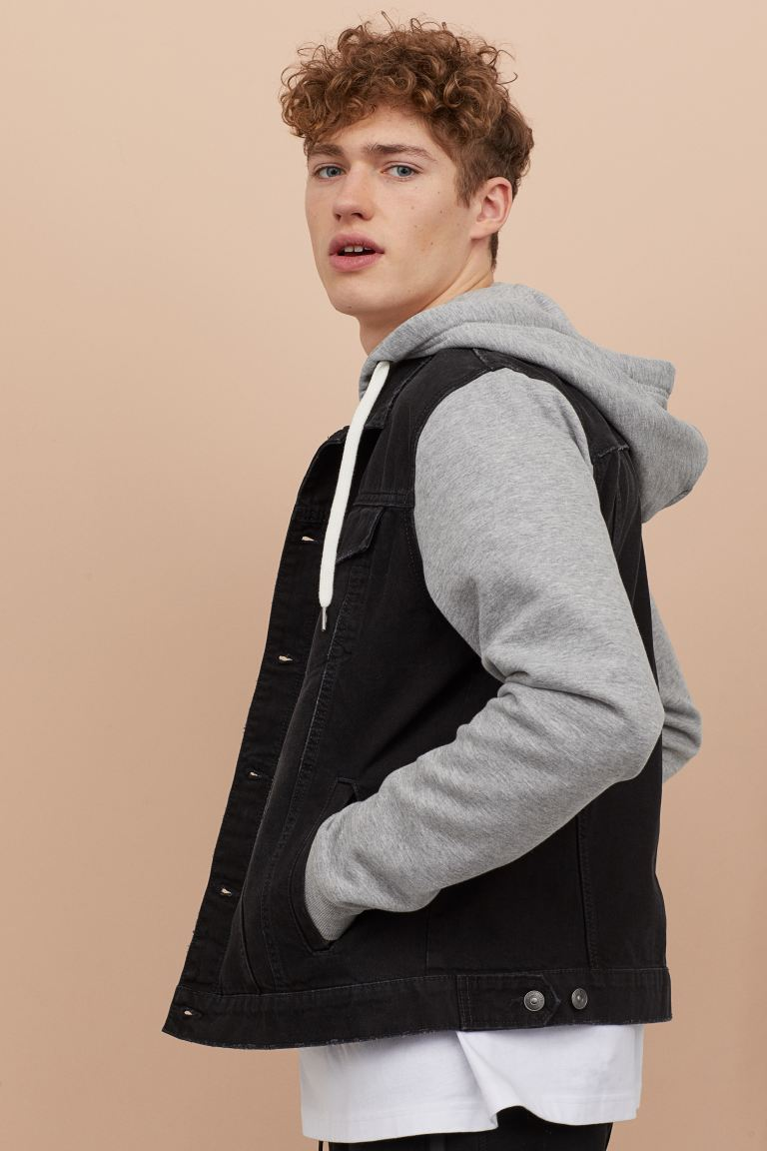

Hooded Denim Jacket

$49.99

SAVE AS FAVORITE

Black/light gray melange

Jacket in washed denim with a jersey-lined, drawstring hood and sleeves in sweatshirt fabric. Collar, buttons at front, chest pockets with flap and button, and side pockets. Ribbing at cuffs and adjustable tab at sides of hem. Unlined.