BASIC V-NECK T-SHIRTDETAILS

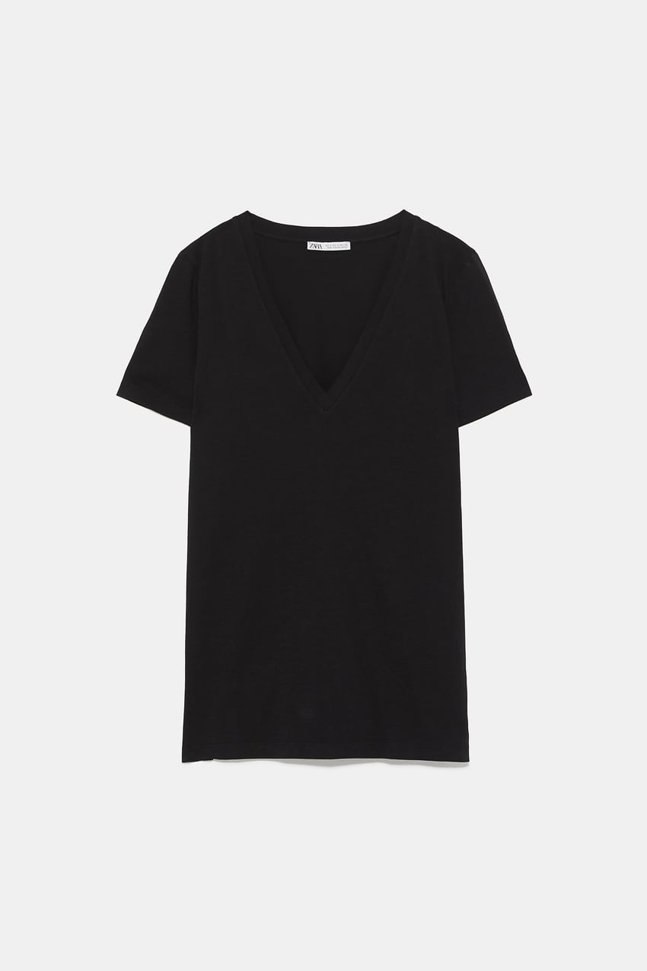

9.90 USD  
V-neck T-shirt with short sleeves.

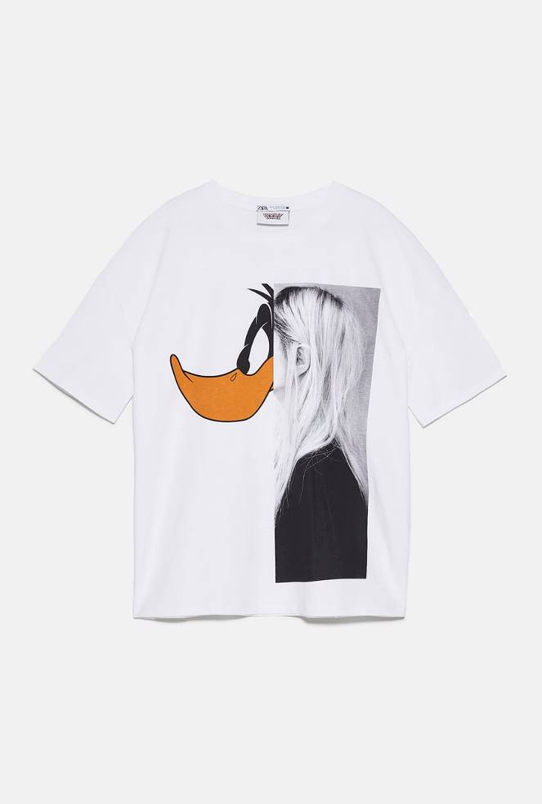

LOONEY TUNES © &™ WARNER BROS. T-SHIRT  
25.90 USD  
Round neck T-shirt with short sleeves. Front print detail of Looney Tunes © &™ Warner Bros.

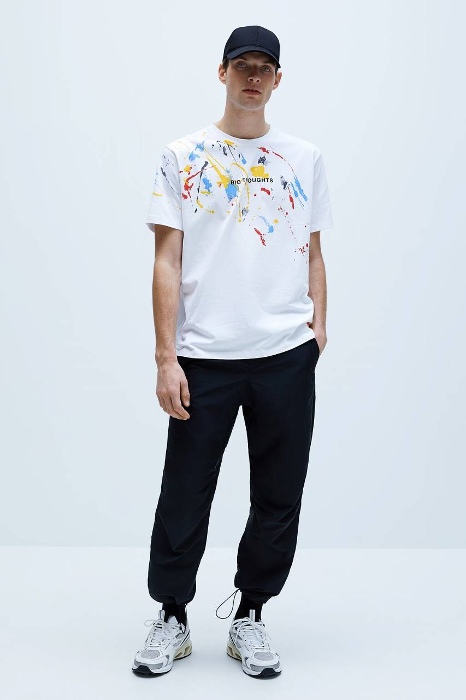

SPLATTER PRINT T-SHIRTDETAILS

29.90 USD  
Round neck T-shirt with short sleeves. Splattered paint effect with text.

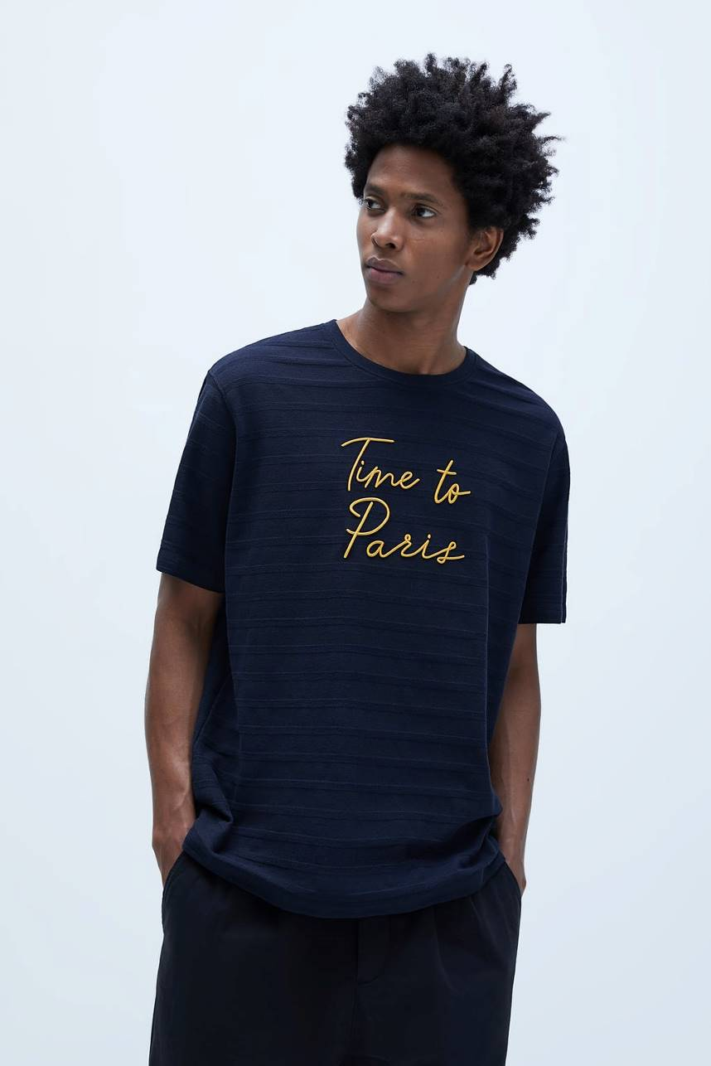

T-SHIRT WITH TONAL EMBROIDERYDETAILS

25.90 USD  
Roomy T-shirt with round neck and short sleeves. Contrasting embroidered text at front.  
Color: Blue navy, Black, White

TWEED HOODIEDETAILS

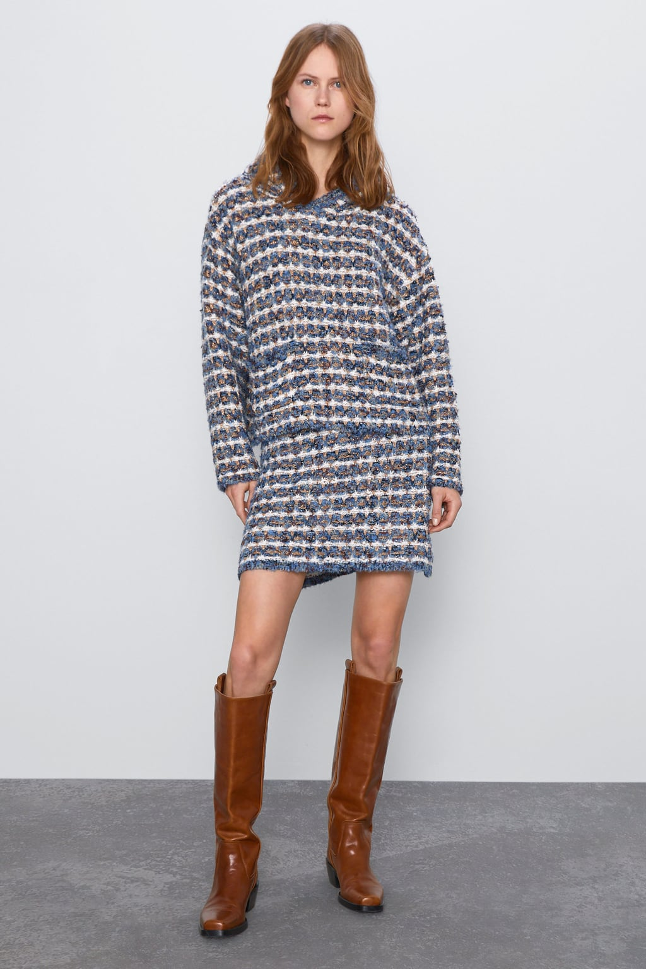

69.90 USD  
High collar knit sweatshirt with hood and long sleeves. Front patch pockets. Metallic thread appliqué.

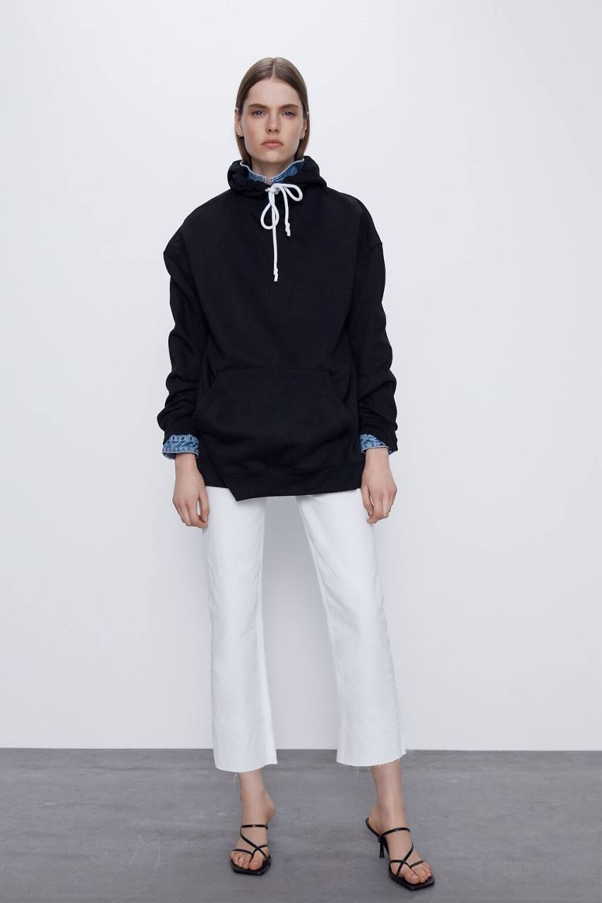  
EDITED OVERSIZED POUCH POCKET SWEATSHIRTDETAILS

29.90 USD  
Customizable oversized sweatshirt with adjustable drawstring hood and long sleeves. Front pouch pocket.

BASIC HOODIE SWEATSHIRTDETAILS

~~39.90 USD~~25.99 USD-30%  
Loose fit sweatshirt with adjustable hooded collar and long sleeves. Front pouch pocket. Ribbed trim.

PHOTOGRAPHIC PRINT HOODIEDETAILS

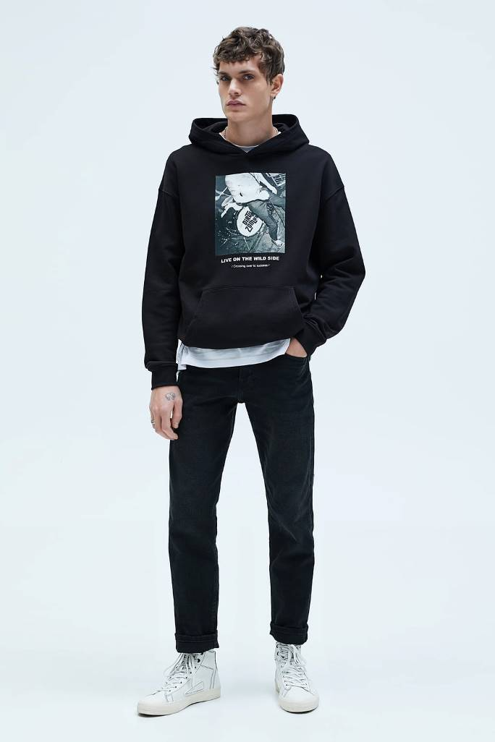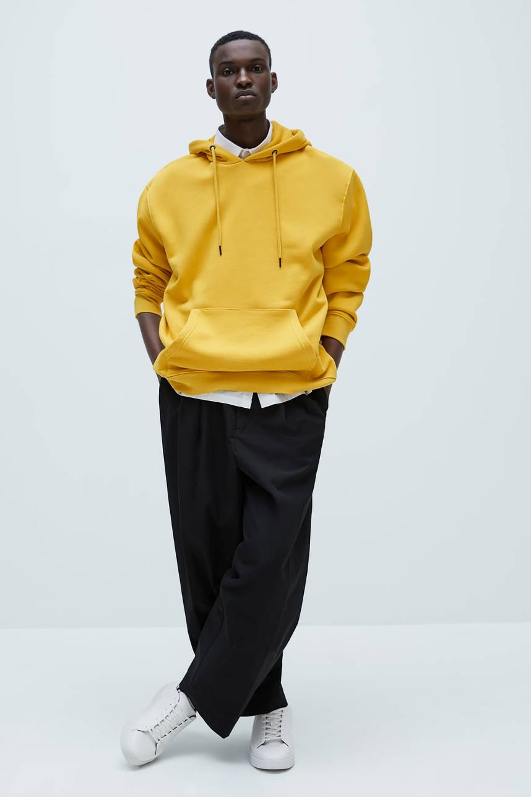

49.90 USD  
Roomy sweatshirt with hooded collar and long sleeves. Front pouch pocket. Ribbed trim.

PLEATED PANTSDETAILS

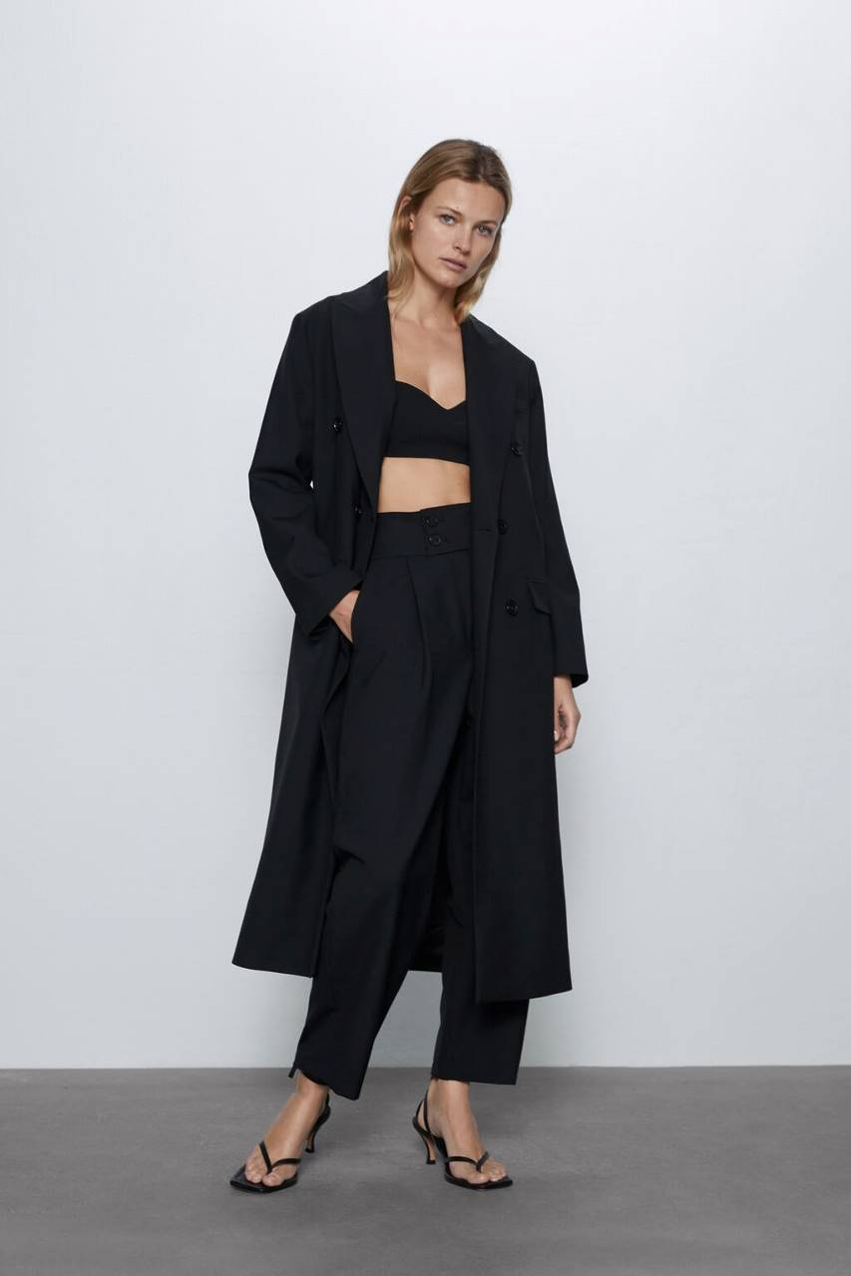

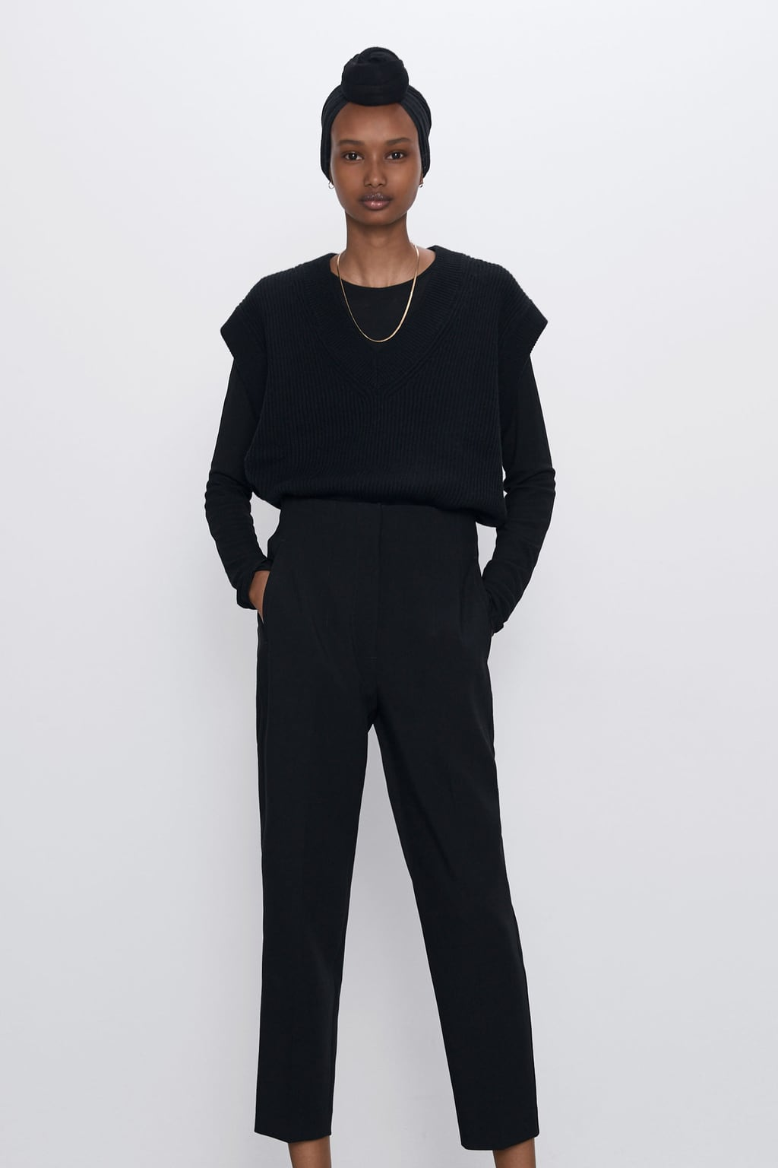69.90 USD  
High-waisted pants with side pockets and back welt pockets. Front pleat detail. Front zip and button closure.  
  
  
  
  
  
  
  
  
  
  
  
  
  
  
  
HIGH-WAISTED PANTSDETAILS

39.90 USD  
High-waisted pants. Front welt pockets. Pronounced front and back seam detail. Front zip, inner button, and metal

PLAID PANTS WITH CHAINDETAILS

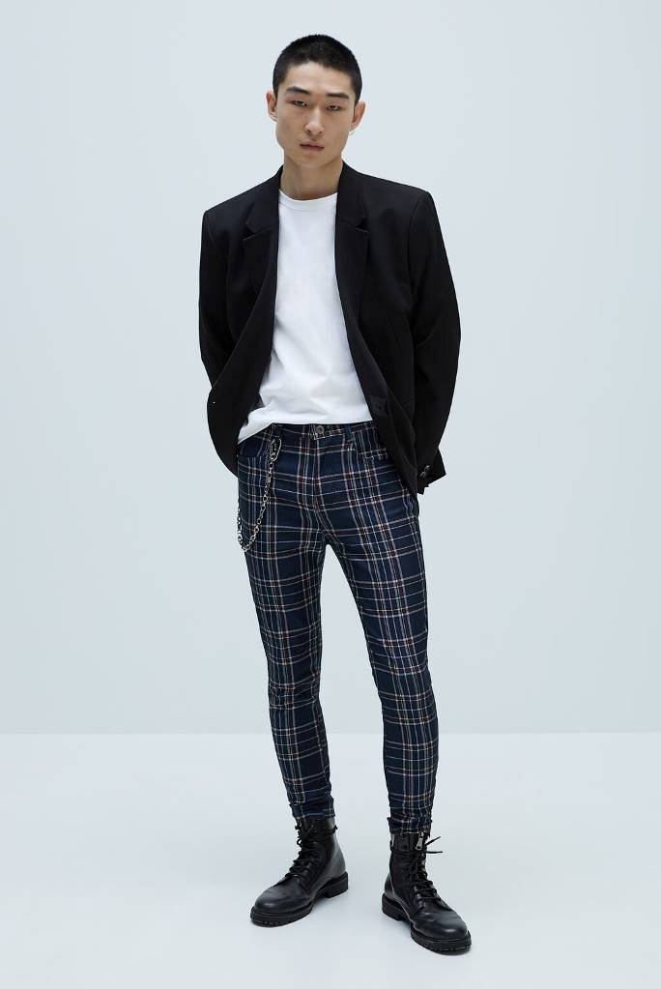

~~59.90 USD~~35.99 USD-35%  
Skinny fit stretch pants with removable accessory at waist. Five pockets. Front zip and button closure.

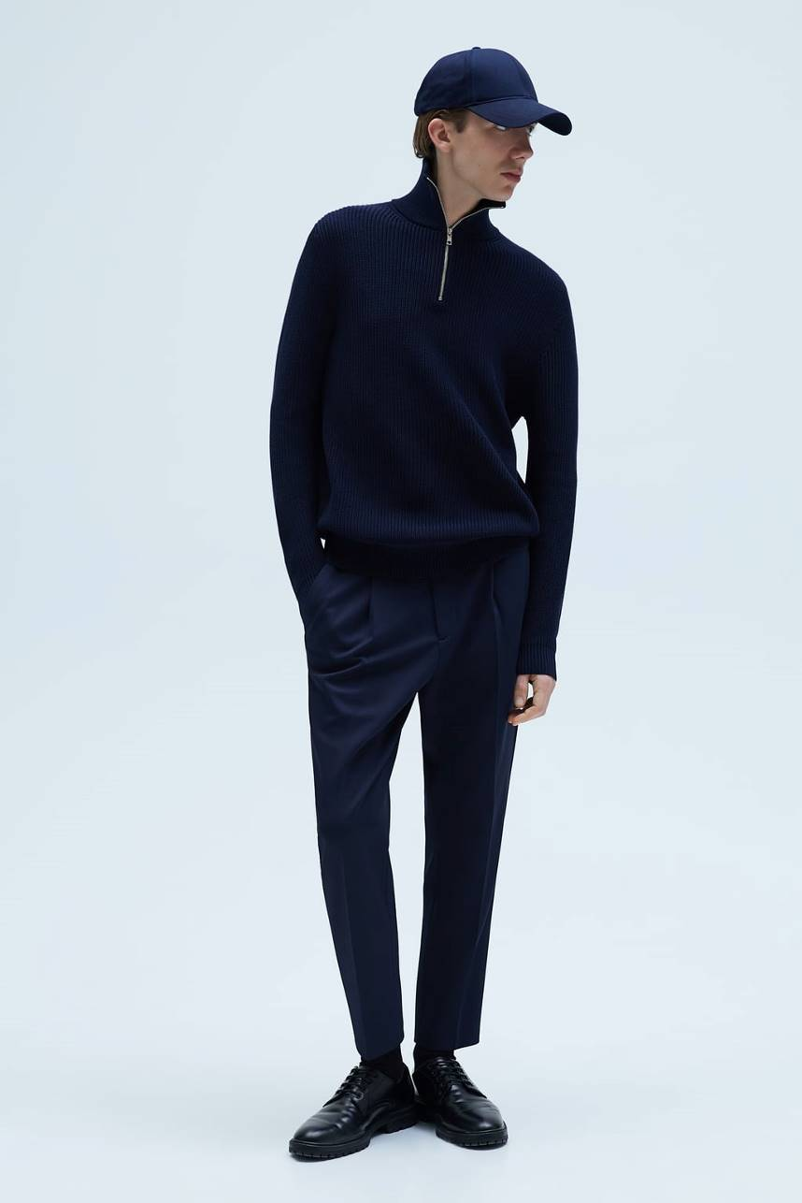

TEXTURED STRETCH KNIT PANTSDETAILS

49.90 USD  
Pants made of 4-way stretch fabric, with high elasticity and

PLEATED SHORTSDETAILS

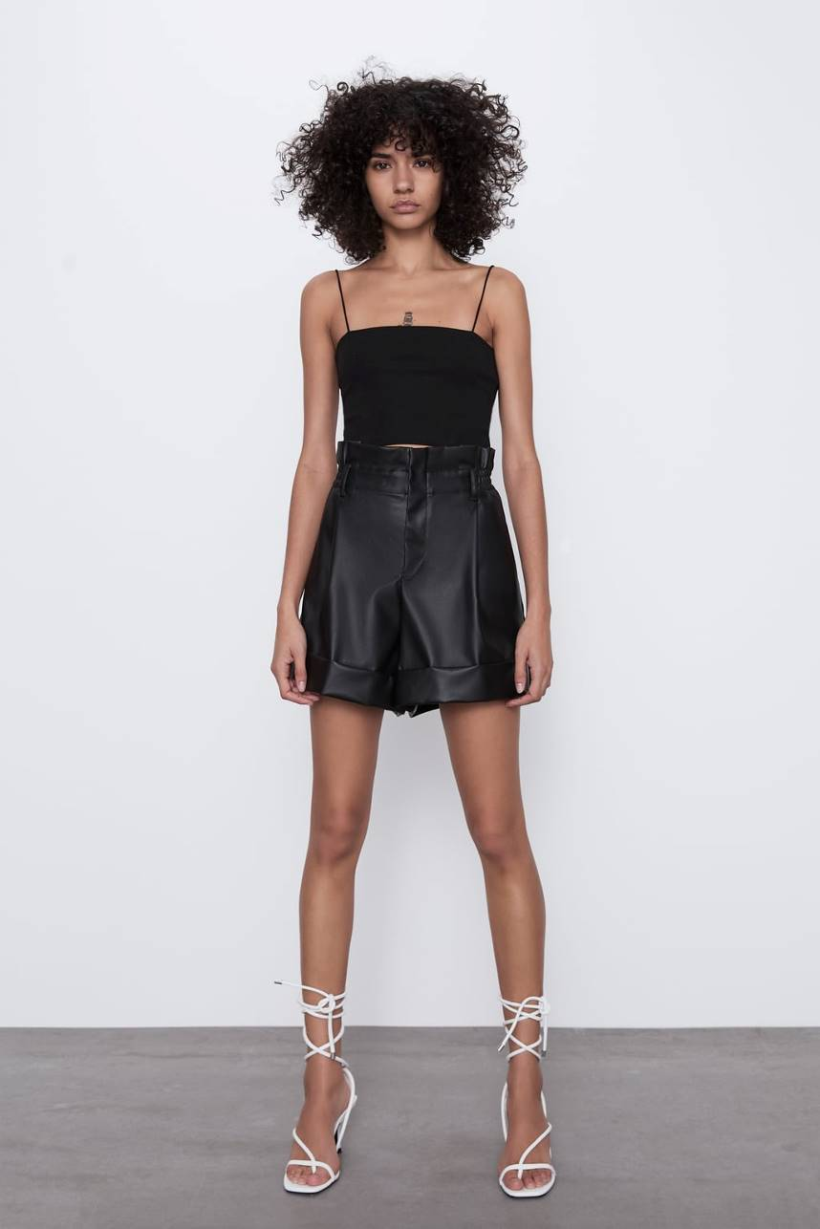

39.90 USD  
High-waisted shorts with side pockets and false back welt pockets. Front pleat detail. Front zip and metal hook closure.

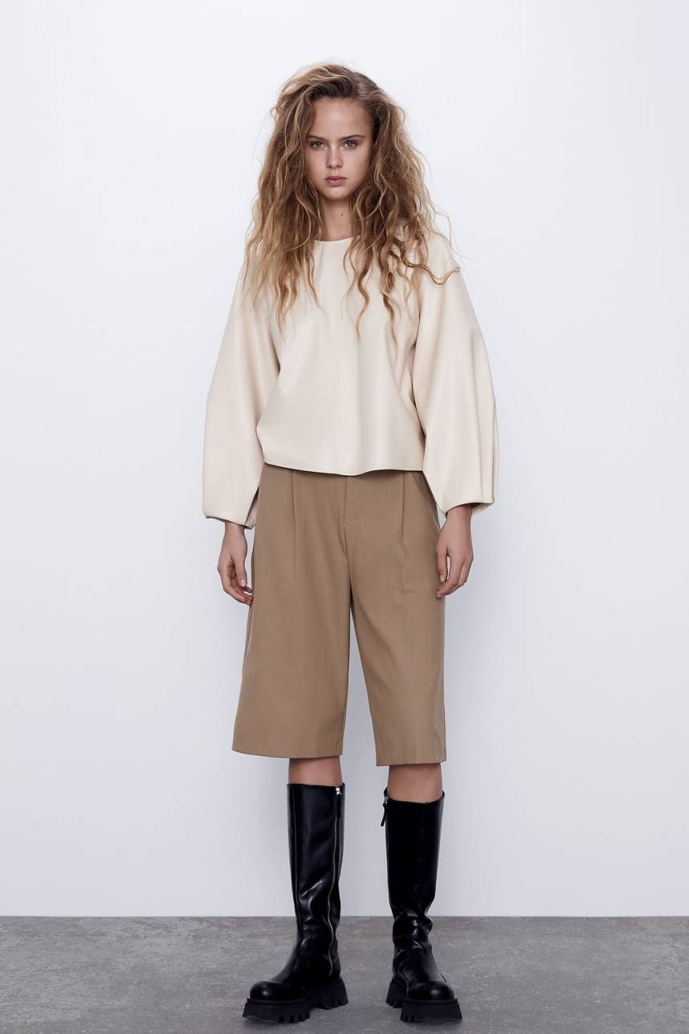  
  
  
  
  
WAXED EFFECT SHORTSDETAILS

39.90 USD  
High-waisted shorts with paperbag elastic waistband. Side pockets and back false welt pockets. Cuffed hem.

PATCHES DENIM SHORTSDETAILS

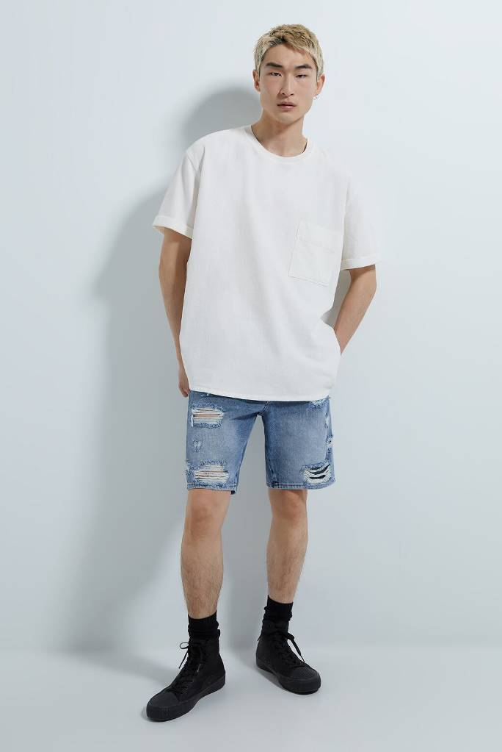

49.90 USD  
Denim shorts with washed effect and rips with interior patch. Five pockets. Front zip and button closure.

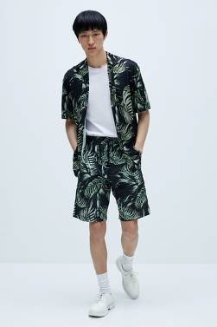

TROPICAL PRINT SHORTSDETAILS

39.90 USD  
Shorts with adjustable elastic drawstring waistband. Front pockets and back patch pocket.