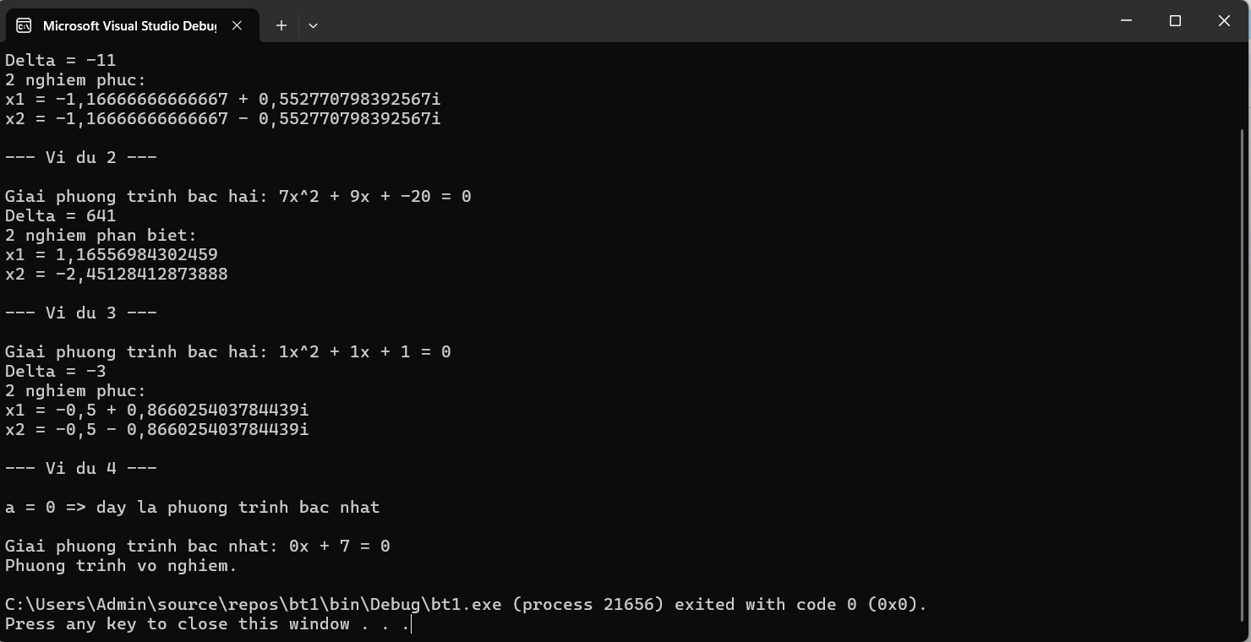
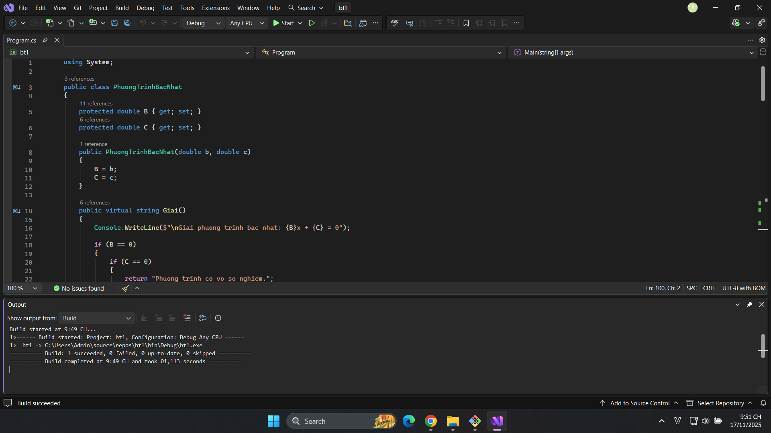
https://github.com/NHD-shinra/0440_NguyenHuuDat_BT1.git

